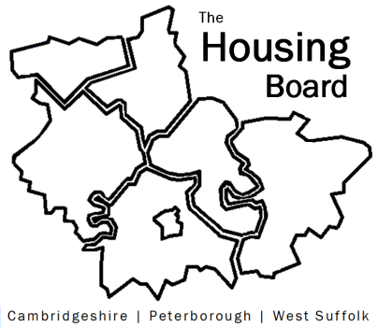
The Housing Board
Cambridgeshire | Peterborough | West Suffolk
Meeting from 10:00 to 12:00, Friday 6 August 2021
To be held online via Microsoft Teams: please open the meeting invite to click on the link
A G E N D A
 | Item |  | Lead
 | Welcome/apologies  Actions of previous meeting to approve, and matters arising.  Meeting papers available at www.cambridgeshireinsight.org.uk/housingboard |  | David Greening
 | Facilitating improved broadband infrastructure for tenants |  | David G
Review of what we all know about
- Modern approaches to housing management (requested at Feb “year planning session” – gather ideas for future agenda item)
- Conditions in existing homes
- Empty homes
- Under occupation & overcrowding
(Round table to compare notes!)
 | Feedback on Changing Futures  Feedback meeting on 30 July with MHCLG, summary highlights to be shared |  | Sue Bee
 | Discussion around sub-regional budget for 2021/22  Emails have been sent to individual partners – review of position |  | Sue Bee
 | Updates  - MAIC stats (do we want to continue these?) and Covid issues  - HRS re-commissioning and partner update  - Vaccination uptake - data gathered by Lisa from supported housing providers (note) |  | Sue Bee
 | AOB
 | 2021 meeting dates (10am – 12 noon):  3 September  1 October | 5 November  3 December

