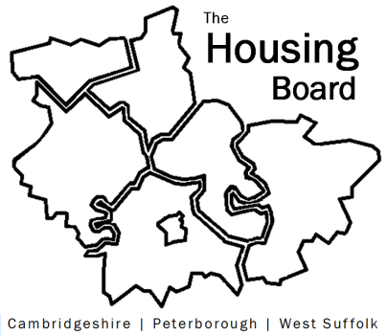
The Housing Board
Cambridgeshire | Peterborough | West Suffolk
Meeting from 10:00 to 12:00, Friday 2 July 2021
To be held online via Microsoft Teams: please open the meeting invite to click on the link
A G E N D A
 | Item |  | Lead
 | Welcome/apologies  Actions of previous meeting to approve, and matters arising.  Meeting papers available at www.cambridgeshireinsight.org.uk/housingboard |  | Dan Horn
 | How Caring Together supports Carers |  | Karen Leete  Caring Together
 | Hoarding Protocol update |  | Stuart Brown
 | Home-Link outcome stats for 2020/21 |  | Heather Wood
 | Criminal Justice update:  - Integrated Offender Management  - New Police and Crime Commissioner |  | Sue Beecroft on behalf  of Cristina Strood  via e-mail
 | Changing Futures – general update, and task to start partner mapping |  | Sue Beecroft
 | Election of new chair and vice chair for housing board |  | All
 | Updates  - MAIC stats and Covid issues  - HRS re-commissioning and partner update |  | Sue Beecroft  Lisa Sparks
 | AOB
 | 2021 meeting dates (10am – 12 noon):  6 August  3 September  1 October | 5 November  3 December

