MAIC stats as at 21 June, for Housing Board 2 July 2021
Individual lines:
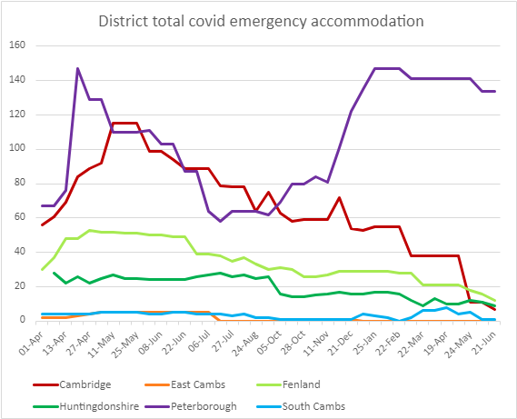
Cambs and Peterborough “stacked” lines
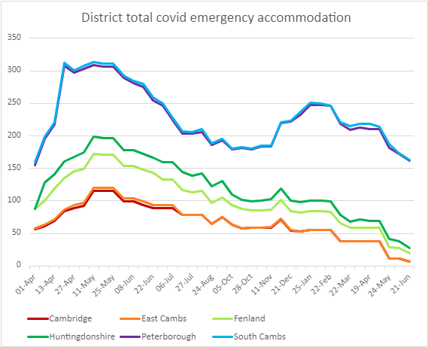

 | Cambridge | East Cambs | Fenland | Huntingdonshire | Peterborough | South Cambs
01-Apr | 56 | 2 | 30 |  | 67 | 4 | 159
06-Apr | 61 | 2 | 37 | 28 | 67 | 4 | 199
13-Apr | 69 | 2 | 48 | 22 | 76 | 4 | 221
20-Apr | 84 | 3 | 48 | 26 | 147 | 4 | 312
27-Apr | 89 | 4 | 53 | 22 | 129 | 4 | 301
04-May | 92 | 5 | 52 | 25 | 129 | 5 | 308
11-May | 115 | 5 | 52 | 27 | 110 | 5 | 314
18-May | 115 | 5 | 51 | 25 | 110 | 5 | 311
25-May | 115 | 5 | 51 | 25 | 110 | 5 | 311
01-Jun | 99 | 5 | 50 | 24 | 111 | 4 | 293
08-Jun | 99 | 5 | 50 | 24 | 103 | 4 | 285
15-Jun | 94 | 5 | 49 | 24 | 103 | 5 | 280
22-Jun | 89 | 5 | 49 | 24 | 87 | 5 | 259
29-Jun | 89 | 5 | 39 | 26 | 87 | 4 | 250
06-Jul | 89 | 5 | 39 | 27 | 64 | 4 | 228
20-Jul | 79 | 0 | 38 | 28 | 58 | 4 | 207
27-Jul | 78 | 0 | 35 | 26 | 64 | 3 | 206
03-Aug | 78 | 0 | 37 | 27 | 64 | 4 | 210
24-Aug | 64 | 0 | 33 | 25 | 64 | 2 | 188
07-Sep | 75 | 0 | 30 | 26 | 62 | 2 | 195
05-Oct | 63 | 0 | 31 | 16 | 69 | 1 | 180
21-Oct | 58 | 0 | 30 | 14 | 80 | 1 | 183
28-Oct | 59 | 0 | 26 | 14 | 80 | 1 | 180
04-Nov | 59 | 0 | 26 | 15 | 84 | 1 | 185
11-Nov | 59 | 1 | 27 | 16 | 81 | 1 | 185
07-Dec | 72 | 1 | 29 | 17 | 101 | 1 | 221
21-Dec | 54 | 1 | 29 | 16 | 122 | 1 | 223
11-Jan | 53 | 0 | 29 | 16 | 135 | 4 | 237
25-Jan | 55 | 0 | 29 | 17 | 147 | 3 | 251
08-Feb | 55 | 0 | 29 | 17 | 147 | 2 | 250
22-Feb | 55 | 0 | 28 | 16 | 147 | 0 | 246
08-Mar | 38 | 0 | 28 | 12 | 141 | 2 | 221
22-Mar | 38 | 0 | 21 | 9 | 141 | 6 | 215
05-Apr | 38 | 0 | 21 | 13 | 141 | 6 | 219
19-Apr | 38 | 0 | 21 | 10 | 141 | 8 | 218
10-May | 38 | 0 | 21 | 10 | 141 | 4 | 214
24-May | 11 | 0 | 18 | 12 | 141 | 5 | 187
07-Jun | 11 | 0 | 16 | 11 | 134 | 1 | 173
21-Jun | 7 | 0 | 12 | 9 | 134 | 1 | 163

SB 1st July 2021

