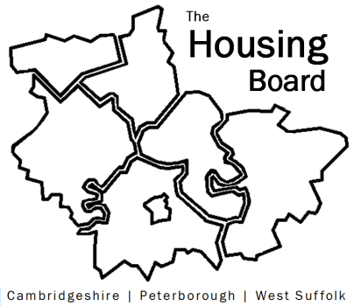
The Housing Board
Cambridgeshire | Peterborough | West Suffolk
Meeting from 10:00 to 12:00, Friday 4 June 2021
To be held online via Microsoft Teams: please open the meeting invite to click on the link
A G E N D A
 | Item |  | Lead
 | Welcome/apologies  Actions of previous meeting to approve, and matters arising.  Meeting papers available at www.cambridgeshireinsight.org.uk/housingboard |  | Suzanne Hemingway
 | Cambridgeshire and Peterborough Future Parks Introduction |  | Rob Pearce  Future Parks Programme Director  and  Linda Thomas  Futurebright Solutions
 | Outcome of Hardship Metrics data collection |  | Damian Roche
 | Discussion on low uptake of Debt Advice |  | Nigel Howlett
 | Joint Tenancies |  | Karen Mayhew
 | Updates  - MAIC stats and Covid issues  - Changing Futures bid outcome  - HRS re-commissioning and partner update |  | Sue Beecroft  Sue Beecroft  Lisa Sparks
 | AOB
 | 2021 meeting dates (10am – 12 noon):  2 July  6 August  3 September | 1 October  5 November  3 December

