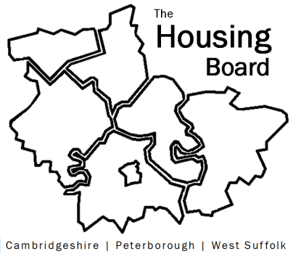
The Housing Board
Cambridgeshire | Peterborough | West Suffolk
Meeting from 10:00 to 12:00, Friday 30 April 2021
To be held online via Microsoft Teams: please open the meeting invite to click on the link
A G E N D A
 | Item |  | Lead
 | Welcome/apologies  Actions of previous meeting to approve, and matters arising.  Meeting papers available at www.cambridgeshireinsight.org.uk/housingboard |  | Suzanne Hemingway
 | New homes and Government proposals  Social Housing White Paper, Planning reforms, Affordable Housing Programme and the right to shared ownership. |  | All
 | Construction and low carbon  Review of partnerships & links across the area around. |  | Discussion
 | Evidence base for Local Plans - how this will impact housing delivery, including Housing Needs of Specific Groups (GLHearn report update).  (Gypsy and traveller assessment to come to Board later in the year) |  | SB and all
 | Changing Futures  Update on draft bid, to be submitted 6 May. |  | SB
 | Updates  - MAIC stats and Covid issues  - HRS partner update |  | Sue Beecroft  Lisa Sparks
 | AOB
 | 2021 meeting dates (10am – 12 noon):  4 June  2 July  6 August | 3 September  1 October  5 November  3 December

