Integrated Commissioning Board
COVID-19 – Discharge to Assess Bed Provision
19th November 2020
Background
On 21st August 2020, the Government published a new “Hospital Discharge Service – Policy and Operating Model” which set out the continuation of the Discharge to Assess (D2A) process. This process operates to the fundamental principle that long term care needs should not be determined whilst a person is still in hospital at an early stage in their recovery. The process therefore seeks to move people into a place where their ongoing care needs can be assessed on discharge from an acute hospital.
With this in mind, the model will seek to adhere to the ‘Home First’ principle wherever possible through the use of Pathway 0 and 1 below. However, it is recognised that a small percentage of people will be unable to return home immediately. Short Term Bed Based provision under pathway 2 which is funded for up to 6 weeks will therefore be required.
The new policy is in force until 31st March 2021 and there is no guarantee that it will continue beyond that date, although current expectations are that it will.
Under the D2A model, individuals are transferred from an acute hospital at the point where they no longer require acute hospital care through one of four pathways:
- Pathway 0: home with no support from health or social care;
- Pathway 1: home with temporary support from health or social care through Reablement or Intermediate Care Teams
- Pathway 2: community bed-based service for a temporary period of time to recover (including Reablement flats)
- Pathway 3: community bed based or home with domiciliary care support with complex assessment and long term needs
Allocation of people to appropriate pathways within the community is managed through the multiagency single point of access (SPA) with support from Brokerage Team situated within the CCG and Local Authority.
Whilst the system have, on the whole, had the ability and capacity to reorganise existing teams and resource around these pathways, pathway 2 has required some more development.
This report will aim to provide the Integrated Commissioning Board with an overview of approach taken by the system to implementing pathway changes to enable pathway 2 to become operational and planned next steps beyond March 2021.
Pathway 2: Short Term Community Bed Based Services
Commissioners from across health and social care have worked to extremely tight timescales to ensure capacity is available to support the short term rehabilitation and recovery needs of people being discharged from hospital under pathway 2 this winter. Given the short timescales a full procurement exercise has not been feasible in the immediate term. The system has therefore worked in partnership to use the capacity we currently commission very differently, and work closely with the market and commissioned providers to do this.
Demand and Capacity
To support development of this pathway, a demand model has been developed by the Council’s Business Intelligence team using a range of sources including current hospital discharge statistics. This model has been developed in conjunction with Business Intelligence colleagues from CCG and CPFT, other NHS system partners and with input from Health and LA commissioners.
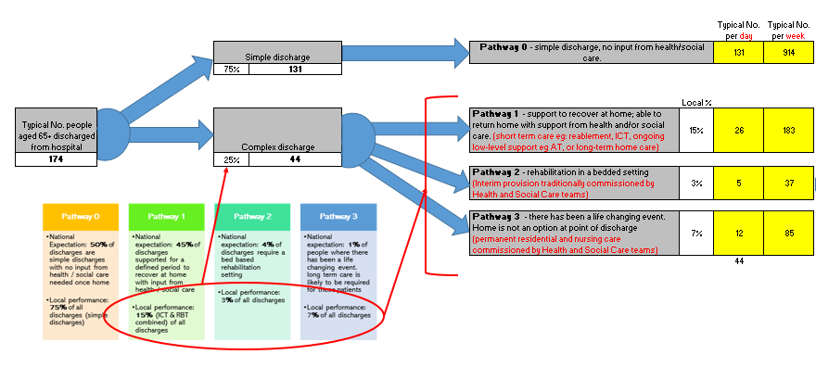
Figure 1: Demand Model: Discharge to Assess Pathway
The model forecast that 161 short term D2A Beds are required to meet peak demand with an assumed average length of stay of 5 weeks.
Across health and social care, 147 beds already commissioned to provide short term support were identified:
Provision | Number of Beds | Location | Provider | Commissioner
Health Interim Beds | 109 | 4 Locations across the County | Independent Sector with extensive therapeutic support from CPFT | CCG
Interim Beds | 22 | A large number of homes across the County | Independent Sector | PCC/CCC
Reablement Flats | 16 | 3 Locations | Independent Sector | PCC/CCC
Total | 147

In response to the forecasted shortfall, the CCG commissioned an additional 20 health interim beds for an initial 12 week period, bringing the total number of short-term beds to 167.
Approach
Historically, access to the capacity detailed above depends on whether an individual is assessed as having health or social care needs on discharge from hospital as provision has been commissioned in isolation by either the CCG or the Council.
To support development of a more joined up, person centred approach to developing pathway 2 of the D2A Model, a new approach has been taken. Where a person is unable to return home on pathway 0 or 1, the system will seek to allocate them to a short term D2A using the following approach:
A. High level support for people with Physio/OT therapy requirements before returning home – current Health Interim beds AND in-patient rehab beds. Total of 129 beds
B. Middle level, needs “convalescence” type of approach - LA interim beds - Can be supported, as before, by primary care and community rehab. Total of 22 beds
C. Low level, Reablement flats. Total of 16 beds

People will be matched by the SPA to the most appropriate setting rather than whether they are following a health or social care pathway. It is paramount that, in order for people to be optimised in their independence, they are placed in the D2A setting which best meets their needs, and that wraparound services need to be in place to support them effectively.
As part of this process, The SPA will also allocate a case manager to support the individual to return home as soon as possible.
Benefits and Risks
Benefits | Risks
- A more person centred and outcome focused approach to meeting the needs of individuals unable to return home following discharge from hospital  - Enables best utilisation of capacity available across the system  - Good spread of capacity geographically across the county preventing a single point of failure  - Ensures a joined up and consistent approach to triage and management of pathway 2  - Prevents deconditioning and promotes therapeutic intervention to reduce admissions to residential care  - Reduces delay on discharge from hospital | - A surge which exceeds the level of capacity assumed within the demand model. In this case, spot purchasing of capacity will be required.  - Existing capacity contains different types of beds from residential to nursing. There is a risk that the balance may not be completely aligned to need. Close monitoring required.  - Occurrence of an outbreak across any one of these facilities will result a significant reduction of capacity for a temporary period of time.

Financial Implications
The approach outlined above has not only developed a more person centred approach, but will enable the system to achieve value for money. With the exception of the additional health interim beds which have been commissioned for 12 week period, no additional funding has been required as capacity being used already forms part of the base budget within either the CCG or the Local Authority.
In the event demand exceeds current capacity, additional funding will be required to support spot purchase of short term placements. A process has been agreed to support this but at present, this has not been required.
Next Steps
Local authority and health commissioners intend to monitor the use of this capacity closely and draw upon any learning taken between now and March 2020 to inform the development and recommissioning of a longer term approach and model which is robust, based on local evidence and experience to date and able to meet need.

