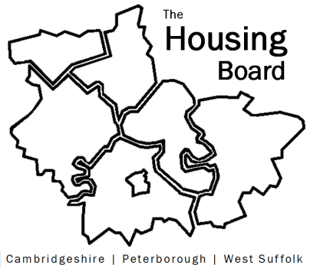
The Housing Board
Cambridgeshire | Peterborough | West Suffolk
Meeting from 10:00 to 12:00, Friday 9 April 2021
To be held online via Microsoft Teams: please open the meeting invite to click on the link
A G E N D A
 | Item |  | Lead
 | Welcome/apologies  Actions of previous meeting to approve, and matters arising.  Meeting papers available at www.cambridgeshireinsight.org.uk/housingboard |  | Suzanne Hemingway
 | Domestic Abuse Bill |  | Sharon Crosby, Standing Together  Vickie Crompton
 | Update on Changing Futures |  | Sue Beecroft
Updates
- Agreeing our agenda plan for 2021/22 (all, draft att)
- MAIC stats & Covid issues (sue)
- HRS partner update (lisa)
 | AOB
 | 2021 meeting dates (10am – 12 noon):  7 May  4 June  2 July  6 August | 3 September  1 October  5 November  3 December

