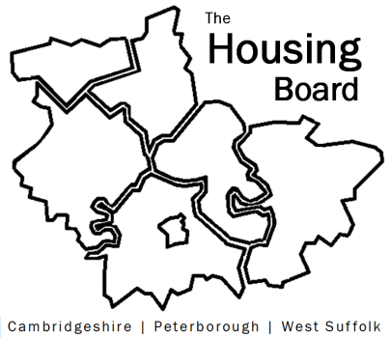
The Housing Board
Cambridgeshire | Peterborough | West Suffolk
Meeting from 10:00 to 12:00, Friday 5 March 2021
To be held online via Microsoft Teams:
please open the meeting invite to click on the link
A G E N D A
 | Item |  | Lead
 | Welcome/apologies  Actions of previous meeting to approve, and matters arising.  Meeting papers available at www.cambridgeshireinsight.org.uk/housingboard |  | Suzanne Hemingway
 | Progress on Economic Hardship (papers attached) |  | Damian Roche
 | Low uptake of Debt Advice (compared to previous years)  Factors influencing this and future demand |  | Nigel  Howlett
 | Terms of Reference following February’s review (and associated items)  Diagram – draft, would help to get comments |  | Sue Beecroft
 | Clinical Commissioning Group structures:  North and South Alliances, Primary Care Networks, social prescribers (draft note attached) |  | Sue Beecroft
Updates
- Any news on Changing Futures?
- Numbers in Covid emergency accommodation
- Housing related support providers forum
- Cambs Insight: updated Registered Provider data here https://cambridgeshireinsight.org.uk/housing-providers/
- Outline of budget for Housing Board work in 2021/22

 | AOB
 | 2021 meeting dates (10am – 12 noon):  9 April  7 May  4 June  2 July  6 August | 3 September  1 October  5 November  3 December

