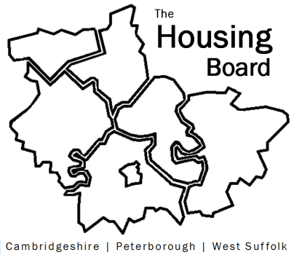
The Housing Board
Cambridgeshire | Peterborough | West Suffolk
Meeting from 10:00 to 12:00, Friday 5 February 2021
To be held online via Microsoft Teams: please open the meeting invite to click on the link
A G E N D A
 | Item |  | Lead
 | Welcome/apologies  Actions of previous meeting to approve, and matters arising.  Meeting papers available at www.cambridgeshireinsight.org.uk/housingboard |  | Dan Horn
 | Review our terms of ref (att)  Including  - our 4 priority areas  - draft diagram - being updated, still work in progress (att) |  | Dan?
 | Review agenda suggestions from our survey monkey last year (note att) |  | Sue B
 | Round table to gather further ideas, plus other thoughts / concerns about the coming year |  | All
 | Plan to write up into new terms of ref, and agenda plan for 2021 |  | Sue
Updates
- Numbers in emergency covid accommodation (Sue)
- Issues highlighted on HRS calls (Lisa?)
 | AOB
 | 2021 meeting dates (10am – 12 noon):  5 March  9 April  7 May  4 June  2 July | 6 August  3 September  1 October  5 November  3 December

