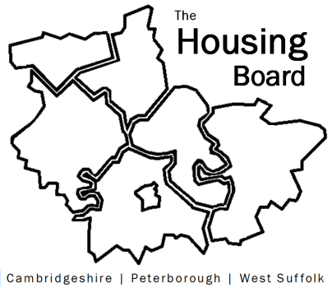
The Housing Board
Cambridgeshire | Peterborough | West Suffolk
Meeting from 10:30 to 12:00, Friday 18 December 2020
To be held online via Microsoft Teams: please open the meeting invite to click on the link
A G E N D A
 | Item |  | Lead
 | Welcome/apologies  Actions of previous meeting to approve, and matters arising.  Meeting papers available at www.cambridgeshireinsight.org.uk/housingboard |  | Suzanne Hemingway
 | Housing Related Support? |  | Lisa Sparks
 | Not sure of title, Data Collection? |  | Oliver Morley
 | What Works Forum  Feedback from the Sub Regional Homeless meeting discussion |  | Jon Collen
 | Diamond Affordability Analysis  Maybe at February review meeting instead? |  | Sue Beecroft
 | Supported Housing Schemes - people with disabilities, homeless, etc.  Maybe at February review meeting instead? |  | Sue Beecroft
 | Updates  - MAIC stats  - SHMA progress (now called Housing Requirement Study)  - Sub Regional budget  - Housing Related Support ? |  | Sue Beecroft  Lisa Sparks
 | AOB
 | 2021 meeting dates (10am – 12 noon):  5 February 2021 – review/planning  5 March  2 April  7 May  4 June  2 July | 6 August  3 September  1 October  5 November  3 December

