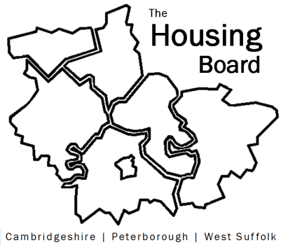
The Housing Board
Cambridgeshire | Peterborough | West Suffolk
Meeting from 10:30 to 12:00, Friday 4 December 2020
To be held online via Microsoft Teams: please open the meeting invite to click on the link
A G E N D A
 | Item | Lead
 | Welcome/apologies  Actions of previous meeting to approve, and matters arising.  Meeting papers available at www.cambridgeshireinsight.org.uk/housingboard | Suzanne Hemingway
 | Coming out of Lockdown 2.0  Clinically vulnerable (county council plan to support self-isolation) and sharing capacity | All
 | Frequency of Housing Board meetings going forward  Results of the survey sent out | Sue Beecroft
 | Updates  - MAIC stats  - SHMA progress  - Sub Regional Budget  - Housing related support update | Sue Beecroft  Sue Beecroft  Sue Beecroft  Lisa
AOB
(DAHA? DG/HW)
Next meeting date:
18 December 10:30 am – 12.00 pm

