Housing Board survey, November 2020
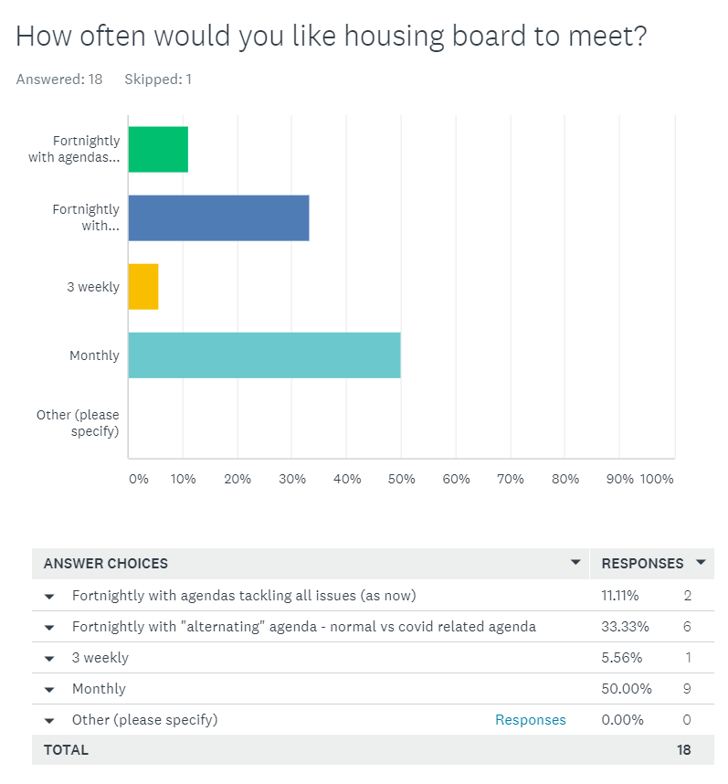

Conclusion: Monthly

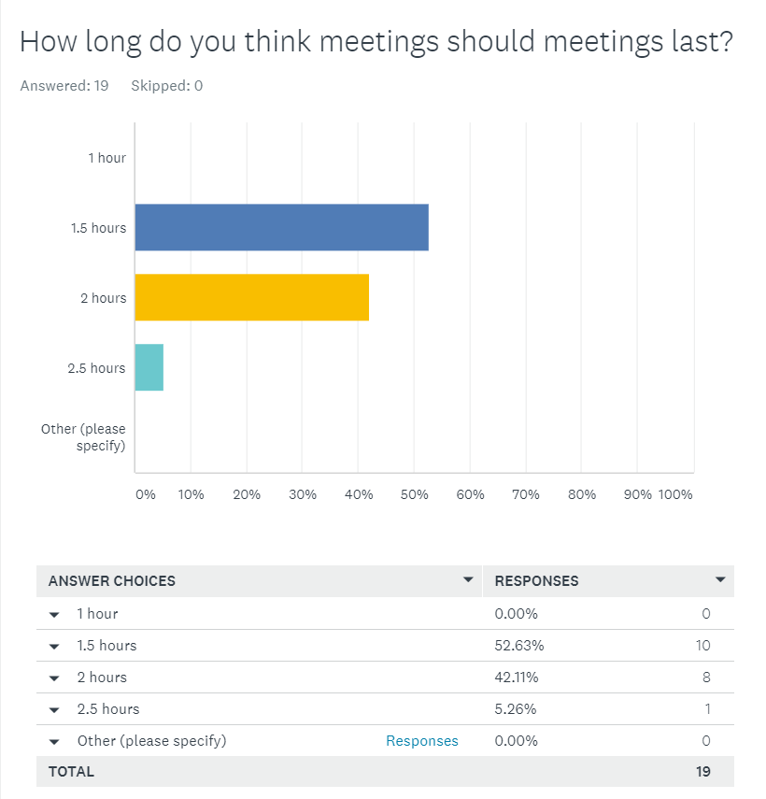
Conclusion: 1.5 hours, some support for 2.
If we meet monthly once again, maybe we can agree on 1.5 to 2 hours in order to cover what we ned to?
- Kevin Scanlon – Counting Every adult Housing First project (Cambs County). Leads project relevant to the Board and part of the MEAM work
- CPFT MASH
- Marek Zamborsky would check re CCG key links
- Community Rehabilitation Company, other providers such as YMCA perhaps
- Belinda Child, head of housing & health improvement, PCC/CCC. There are regularly agenda items relevant to Belinda’s service area, think it would be mutually beneficial to invite her to attend
- Should be based on agenda items if there are specific needs or issues. For example public health when required, probation service when required etc. Flexibility is probably best rather than having partners that have no specific interest, attend a meeting when not required.

- Some of the evidence base for Local Plans and how this will impact on housing delivery e.g. gypsies and travellers, housing for specific groups, etc. As well as a focus on some of the govt proposals around the Social Housing White Paper, planning reforms, affordable housing programme and the right to shared ownership
- Housing First / Making Every Adult Matter – overview and linkage
- Updated offender and victims needs assessment will be available from 7th Dec. Not sure if you will want to consider at a future meeting or perhaps feed into the Arc 4 follow up working group. Perhaps we can discuss once the report is available? PCC elections rescheduled to May 2021 so a new police and crime plan will be in development following that with newly elected PCC. I am sure we will want to engage with the Board as part of that process but just need to think about timing once plans emerge. Thanks :)
- Developing older persons' housing - modern approaches Housing management - good practice themes Review ToR and priority themes Maybe we should have an external partner slot where we invite a partner to present on something they want to talk to us about. I appreciate this does happen periodically anyway. Just an additional request - can we have the papers a bit earlier so we can digest and make more effective contributions
- Would be good to have an update when the new Domestic Abuse Bill has been passed - suspect Julia Cullum or Vickie Crompton at County would be able to deliver this
- Wider support packages to help people into independent living - budget skills, cooking, mentoring support. How to maximise housing solutions through the private rented sector.
- At the last Peterborough Homelessness Forum meeting (which hasn't met since pre-pandemic) I raised a concern that it appeared that we were not housing as many stat homeless households as I would expect us to despite the levels of homelessness. I'd be interested to see some analysis of this across the region to see if this is an issue and whether we are missing an opportunity to tackle the issue better
- The main items the we can foresee are probably already on the workplan. I'm sure other topics will come up though in these ever changing times!

19 respondents:
- Helen Reed
- Suzanne Hemingway
- Julie Fletcher
- Rob Hill
- Cristina Strood
- Joe Keegan
- Nigel Howlett
- Elaine Field
- David Greening
- Lisa Sparks
- Dan Horn
- Ali Manji
- Karen Mayhew
- Matthew Ryder
- Anne Keogh
- Damian Roche
- Azma Ahmad-Pearce
- Jon Collen
- Sue Beecroft

