**HRS Procurement & Redesign Update - 02.12.20**

**Purpose:**

* To provide a general overview on progress to date with the HRS review and redesign work.
* To share the early draft models which have been developed so far.
* To provide an outline of the potential procurement approach.

**Market Engagement:**

Market Engagement events are being planned for the New Year to provide a further opportunity for discussion with providers. Dates will be circulated as soon as they are available.

**Client engagement:**

Clients feedback was sought from young people earlier in the year.

The ‘Counting Every Adult’ Co-production group are involved in discussions around the ‘Streets to Homes’ model being proposed for Cambridge. Members of this group are also now attending the redesign group chaired jointly by the County and City Council and made up of providers and partners.

Covid 19 has made this element of the redesign work much more challenging and we are considering the best way to engage with more people with lived experience across the County.

**redesign models:**

The draft models included in this briefing were shared with the County’s Member Reference Group earlier this month and District Housing Leads represented on the sub regional Housing Board. Both groups were asked to treat them as confidential.

The models to be delivered in the Cambridge City area (including South Cambs) have been developed with providers and partners. There will be similar opportunities for people to help further develop the models covering the other areas of the County.

At present all the models are still drafts, therefore we can continue to refine and develop them to ensure the final model will be effective, sustainable and deliverable.

**Outline procurement approach:**

(models described are illustrated by the diagrams included below)

**Adult homelessness support services:**

Cambridge Proposal for a ‘Streets to Home’ model procured jointly with Cambridge City (subject to governance agreement from both parties) and also covering South Cambs.

* County would be lead commissioner due to higher contribution - includes accommodation with support, resettlement support and wraparound services
* Discussion happening with redesign group about whether should be procured as 1 lot or split e.g. separate lot covering accommodation based support services
* Single assessment process & assessment hub (not necessarily attached to accommodation)
* Dedicated move-on / step down units / shared houses (number may fluctuate) (single & mixed sex)
* Preference would be for partnership bids to retain local expertise and knowledge and provide choice for clients
* Provision of female only accommodation / support option
* Use of City’s existing ‘Inform’ system for referrals and reporting

FDC/HDC/ECDC Proposal:

* 1 single lot across all areas
* Single assessment process
* Hub & Spoke approach with an accommodation based support service in Fenland (area within cluster with highest rough sleeper / single homeless need) & dispersed units of shared accommodation with visiting support in Fenland HDC & EDC (new provision for these areas)
* Provision of female only accommodation / support option

**Young person’s homelessness support services:**

Cambridge & FDC/HDC/ECDC Proposals

* 1 single lot per district
* Single assessment process
* Dedicated move-on / step down units / shared houses (number may fluctuate) (single & mixed sex)
* Preference would be for partnership bids to retain local expertise and knowledge and provide choice for clients

Additional Cambridge specific elements:

* Community support team could include a navigator post to support LGBTQ+ clients across the service (could be part time)
* Use of Inform for referrals and reporting

**Contract length**:

Based on the Soft Market Testing feedback and feedback from the redesign groups and partners, we would be seeking contracts of 5 years with an option to extend for a further 2 years.

This will enable sufficient time to support providers in delivering the level of change we want to see, and for us to work with providers to embed and also further develop the new models.

**Outline Procurement Timetable:**

***Please note that these dates are provisional so may still be subject change***

|  |  |
| --- | --- |
| **Event** | **Date** |
| Tender goes live | early May |
| Tender responses submitted | early June |
| Evaluation/ moderation of tenders | early July |
| Governance approval to award contract | mid September |
| New contract commences | 01.01.22 |

**Redesign of Young Person’s Housing Related Support services**

**Cambridge including South Cambs**

**Part 1: Referal Pathway**

**Aim:** To provide a single point of access to all Young Persons HRS services (and potentially other services as well)

**Proposed Process:**

* All referrals are made via INFORM
* Referrals can be made to multiple providers depending on yong person’s preferences and needs
* All referrals responded to within an agreed timeframe
* Single assessment - One service contacts client and arranges to interview / assess – assessment shared with other service (by consent) if multiple referrals have been made
* Services update INFORM to show whether client has been accommodated or refused
* Use of exisiting JAP panel as a forum to discuss;
  + transfer of clients between services, where it has been identified that they would be better supported by a different service – Transfer information to also be recorded on INFORM
  + options / updates for clients who have been unable to access services support

**Challenges:**

* Not all referral agencies currently have access to INFORM or use it regularly enough to maintain a current log in
* If more licences are required this will incur a cost
* Additional development of INFORM will be needed which will incur a cost
* Providers also have ‘in house’ systems to update – duplication
* ‘Single Assessment’ needs to capture sufficient details for all providers to be able to make an informed decision

**Opportunites:**

* Data captured on INFORM for all referrals – improved data reporting and data capture, better information on demand etc
* INFORM able to provide data reports to cover some contract monitoring
* Single referral form that can be used to by agencies and individuals to refer to all services
* Consistent approach to referrals across the area

**Part 2: Accommodation and Support**

**Aim:** To have a range of accommodation and support options foryoung people who are homeless or at risk of homelessness which;

* will be able to meet the varying needs of clients in the best way possible
* takes account of good practice
* helps to address gaps identified by the HRS review available

Range of services to include provision of support in designated accomodation and in the community.

**Model:**

* Entry point depends on identified needs, client preferred service options and availability
* Flexibility for clients to move between higher and lower support options as needs change
* Staffed accommodation based services providing a range of options to meet varying needs. Support provided in different locations may be variable to allow a range of needs to be met within a single provision, but the overall range of supported accommodation must also be able to specifically provide the following;
  + Support for those with complex needs with access to 24hr support (not necessarily on site)
  + Provision of some ‘female only’ accommodation (could be a specific building or separate section of a larger building)
* ‘Step down’ and shared accommodation (variety of sizes and locations, single and mixed sex) to provide an opportunity to further develop independent living skills for those ready to move on and to provide an alternative to large hostel accommodation for those who need it
* Visiting Community Support Service that follows the client through step down and in to the community but can also offer support to those already living in the community e.g. support whilst living in the family home, with a relative or friend or in temporary accommodation. Team to include a navigator post to support LGBTQ+ clients across the service (part or full time).
* Flexible duration of stay/support to suit needs, but with a strong focus on ‘move-on’ and development of independence.



**Fenland / East Cambs / Hunts:**

**Aim:** To have a greater range of accommodation and support options foryoung people who are homeless or at risk of homelessness which;

* will be able to meet the varying needs of clients in the best way possible
* takes account of good practice
* helps to address gaps identified by the HRS review available

**Referrals:**

* Referrals can be made to multiple providers depending on yong person’s preferences and needs
* ‘Single Assessment Process’ – Use of standardised assessment form and where multiple referrals have been made, one service contacts client and arranges to interview / assess – assessment then shared with other service (by consent)
* All referrals responded to within an agreed timeframe
* Use of a Panel as a forum to discuss;
  + transfer of clients between services, where it has been identified that they would be better supported by a different service
  + options / updates for clients who have been unable to access services support

**Model:**

* Entry point depends on identified needs, client preferred service options and availability
* Flexibility for clients to move between higher and lower support options as needs change
* Staffed accommodation based services providing a range of options to meet varying needs. Support provided in different locations may be variable to allow a range of needs to be met within a single provision, but the overall range of supported accommodation must also be able to specifically provide the following;
  + Support for those with complex needs (preferably in more than 1 location) with access to 24hr support (not necessarily on site)
  + Provision of some ‘female only’ accommodation (could be a specific building or separate section of a larger building – preferably in more than 1 location)
* ‘Step down’ and shared accommodation (variety of sizes and locations, single and mixed sex) to provide an opportunity to further develop independent living skills for those ready to move on and to provide an alternative to large hostel accommodation for those who need it
* Flexible duration of stay/support to suit needs, but with a strong focus on ‘move-on’ and development of independence.

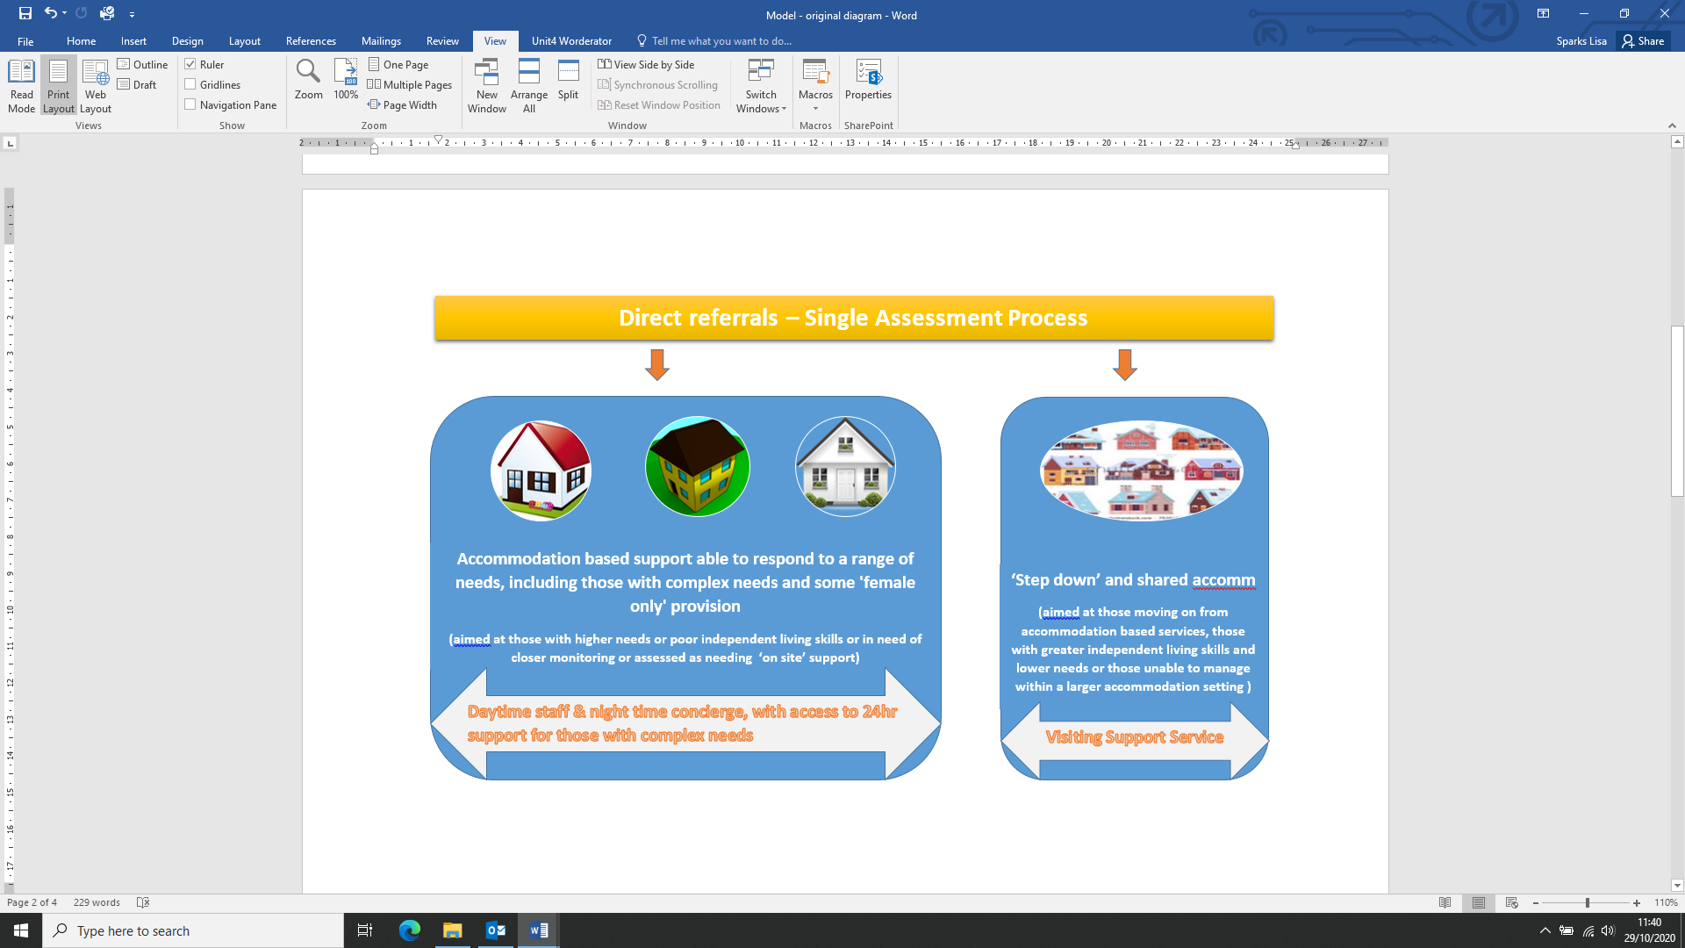

**Redesign of Housing Related Support services for Homeless Adults**

**Fenland, Hunts & East Cambs**

**Aim:**

To commisison a model which;

* delivers some additional HRS provision within Huntingdosnhire and East Cambridgeshire.

have a greater range of accommodation and support options foryoung people who are homeless or at risk of homelessnes

* takes account of good practice
* helps to address gaps identified by the HRS review available

**Model:**

* ‘Hub and Spoke’ model – hub based in Fenland to refelct higher levels of rough sleepeing and single homelessness
* Staffed accommodation hub service providing a range of options to meet varying needs, including those with complex needs and provision of some ‘female only’ accommodation or support.
* ‘Spoke’ small dispersed units of shared accommodation in key location across all 3 districts – support delivered from hub or through other co-located arrangements (single and mixed sex)
* Flexible duration of stay/support to suit needs, but with a strong focus on ‘move-on’ and development of independence.
* Referrals directed through ‘Hub’
* Single assessment process

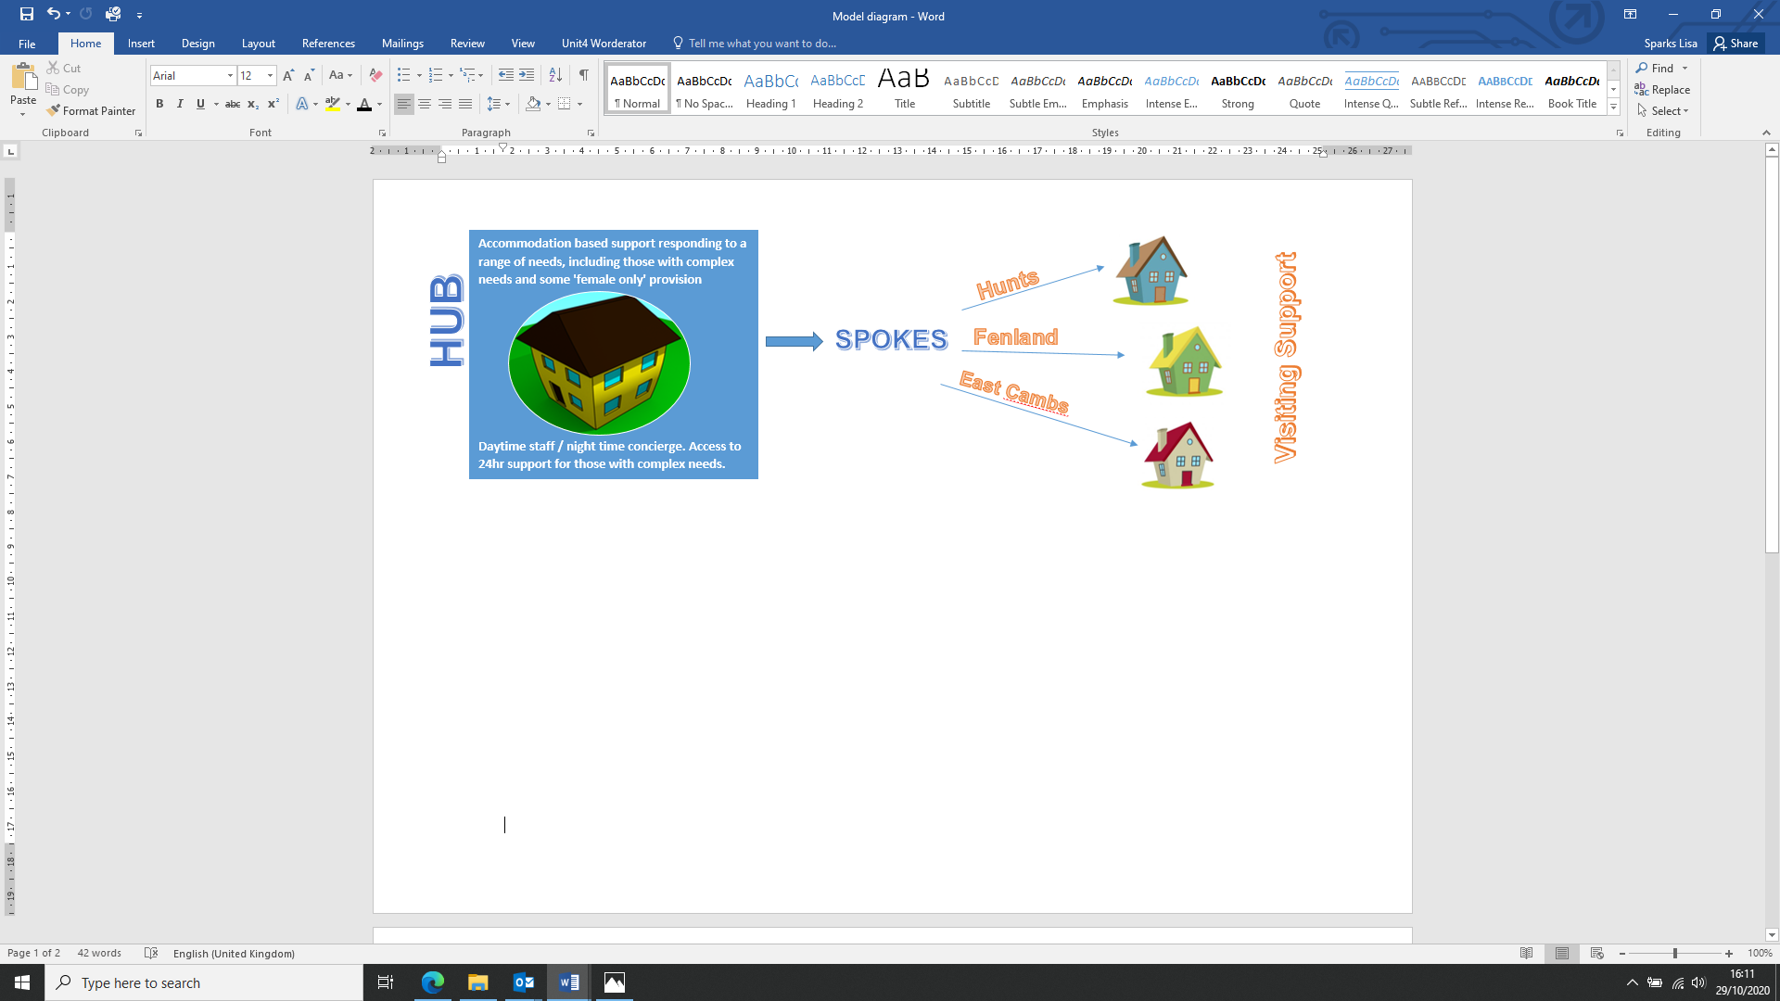

**‘Streets to Home’ Service (Summary version)**

**Why is a new approach needed?**

We know that hostels have helped many people find a route out of homelessness, but we also know that for those with more complex needs and chaotic lives, hostels may not be a viable option.

We are also aware that not everyone begins their journey out of homelessness at the same point and therefore having a set pathway that people are expected to progress through may be counterproductive for some people.

Developing a ‘Streets to Home ‘Service’ will allow Cambridge City Council and Cambridgeshire County Council to work collaboratively to commission a single joined up service which can provide a variety of support options.

**What is already happening?**

The City and County Councils are already working together to develop Housing First, which will provide an alternative to hostel accommodation for some of the City’s most complex rough sleepers.

The City Council is also piloting some other new approaches;

* modular homes
* using three-bedroom general needs properties in low demand as shared accommodation
* procuring more privately-rented homes for rough sleepers

**What is the ‘Streets to Home’ approach?**

The ultimate aim in developing this service will be to deliver a model that helps us reduce the number of people on the street, and increase the number of people with support needs who are able to live in their own stable accommodation.

The ‘Streets to Home’ approach should;

* ensure each individual has a lead professional to support them through the stages of their journey out of homelessness
* offer flexible, personalised support, planned with the individual
* be adaptive and proactive in their support offer
* ensure access to ongoing support for as long as it is needed
* be focussed on tenancy attainment and then tenancy sustainment;
* be skilled at facilitating access to specialist support (such as drug and alcohol services) at the point it may be needed
* develop strong partnerships with other local non-commissioned and voluntary groups in order to maximise the opportunities for clients and minimise duplication
* build on the successes achieved during the Covid 19 pandemic, by refocusing volunteer-based services on sustaining those in accommodation and delivering fewer services to those on the streets

**Referral and Pathway arrangements:**

It is important that those accessing services can do so quickly and easily. Having a dedicated point of access for services can help this. However we accept that a ‘single’ point of access to services may not work for everyone, so it’s important assessments can still be undertaken ‘in situ’ for some people.

We want Streets tpo Home’ to encourage a flexible system that can facilitate access to services at the point which is best for the individual, taking account of their needs and circumstances and, wherever possible, allowing them to choose the option that is best for them.

**Scope of the service:**

The diagrams below (*Fig 1 & Fig 2*) illustrates the range of services that would potentially be delivered through the ‘Streets to Home’ model and what a new pathway could look like.

*Fig 1*

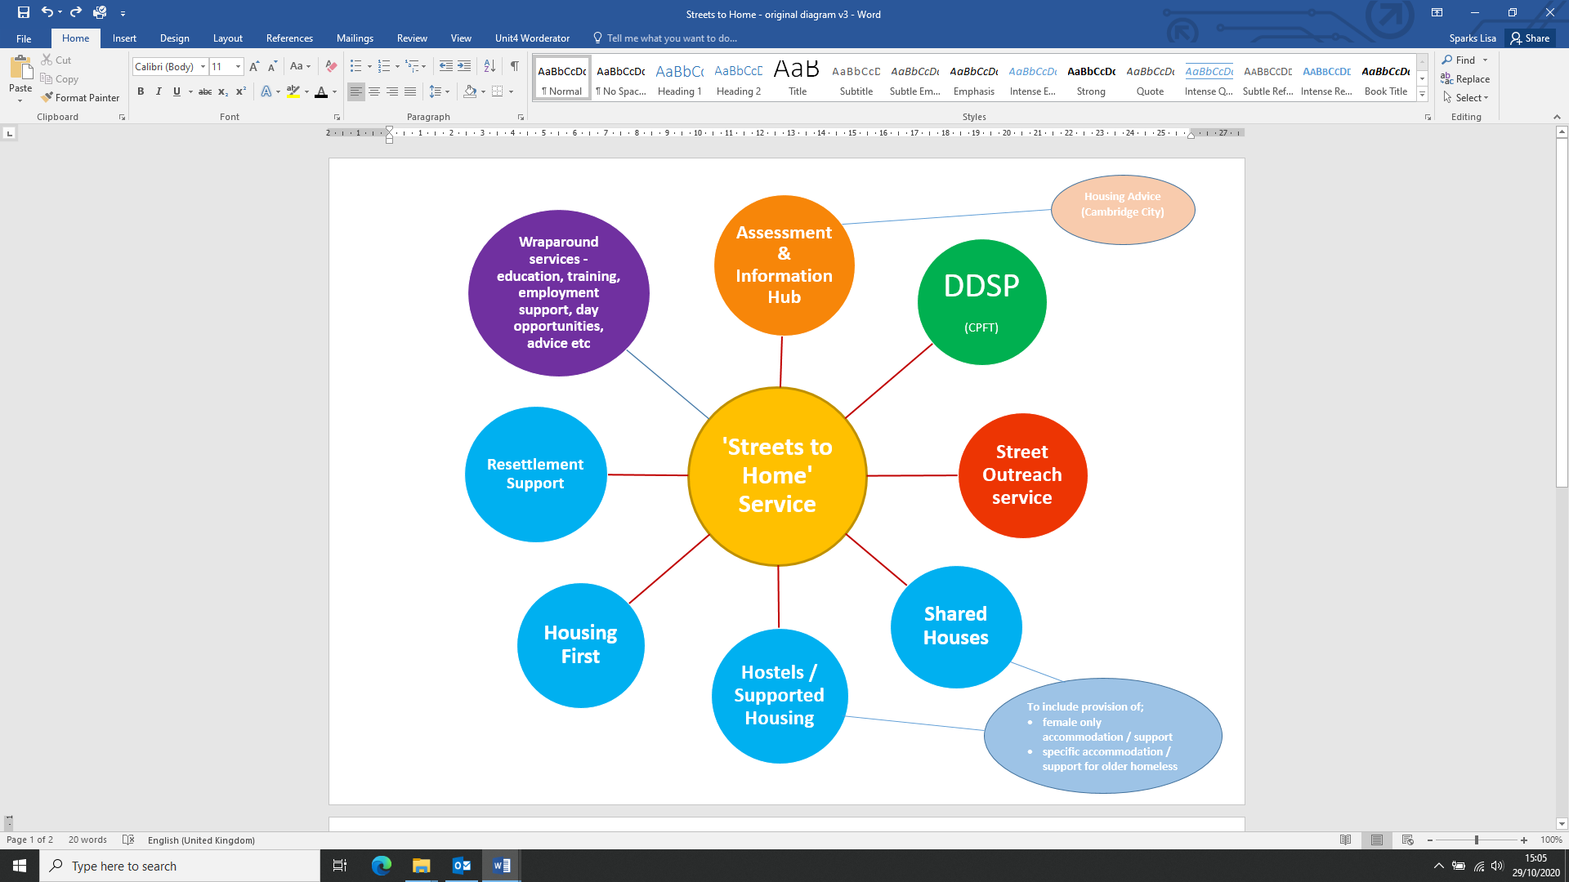

*Fig 2