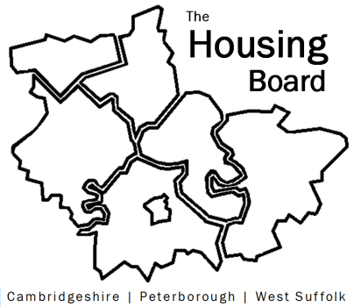
The Housing Board
Cambridgeshire | Peterborough | West Suffolk
Meeting from 10:30 to 12:00, Friday 6 November 2020
To be held online via Microsoft Teams: please open the meeting invite to click on the link
A G E N D A
 | Item | Lead
 | Welcome/apologies  Actions of previous meeting to approve, and matters arising. Meeting papers available at www.cambridgeshireinsight.org.uk/housingboard | Suzanne Hemingway
 | Lockdown 2.0  Round table update – issues arising, things to feed into the county-wide groups we need help tackling? | All
 | Support providers  Feedback from Housing Related Support providers and issues they are facing | Lisa Sparks
 | Hardship metrics  Note attached for conversation with Oliver Morley of HDC about updating rent arrears data in future | Sue Beecroft
 | Updates  - MAIC stats (to follow)  - Next Steps bids – capital has now been announced  - Sub-regional funding 2021/22 – mention | Sue Beecroft
AOB
- Sue Beecroft attending Drug & Alcohol Reference Group currently – please shout if you’d like to attend in Sue’s place
- Frequency of meetings - votes so far

Next meeting date:
20 November 10:30 am – 12.00 pm

