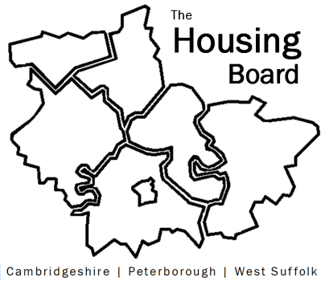
The Housing Board
Cambridgeshire | Peterborough | West Suffolk
Meeting from 10:30 to 12:00, Friday 20 November 2020
To be held online via Microsoft Teams: please open the meeting invite to click on the link
A G E N D A
 | Item | Lead
 | Welcome/apologies  Actions of previous meeting to approve, and matters arising.  Meeting papers available at www.cambridgeshireinsight.org.uk/housingboard | Suzanne Hemingway
 | Short Term Accommodation for Care Leavers  Presentation from County Council Transformation Team. | Esther Baffa-Isaacs  ( Fiona Storey, Joe Gilbert,  Philip Turton )
 | Social Prescribers  Plan to run some training. | Sue Beecroft
 | Updates  - MAIC stats – and future of them  - SHMA progress  - Sub Regional Budget. | All Sue Beecroft
 | AOB
 | Housing Related Support update for district partners  After 11:40am Districts only stay on until 12 noon | Districts
Next meeting date:
4 December 10:30 am – 12.00 pm

