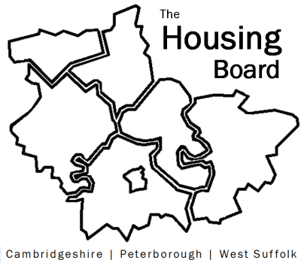
The Housing Board
Cambridgeshire | Peterborough | West Suffolk
Meeting from 10:30 to 12:00, Friday 9 October 2020
To be held online via Microsoft Teams: please open the meeting invite to click on the link
A G E N D A
 | Item | Lead
 | Welcome/apologies  Actions of previous meeting to approve, and matters arising. Meeting papers available at www.cambridgeshireinsight.org.uk/housingboard | Suzanne Hemingway
 | Covid Planning and Recovery Groups  Key housing aspects, recovery themes and areas which need most support or help. | Val Thomas / Iain Green  & Sue Beecroft
 | Progress on ARC4 report  Nominations for senior leaders group so far  What are the elements for Task and Finish group? | Suzanne Hemingway
 | Updates  - Health: track and trace / recovery groups and housing  - MAIC stats  - Next Steps bids – update on capital projects?  - The new Domestic Abuse Bill | Val Thomas / Iain Green  Sue Beecroft  All  Vickie Crompton
 | AOB
Next meeting date:
23 October 10:30 am – 12.00 pm

