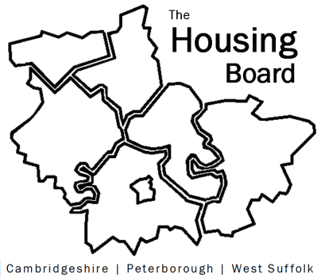
The Housing Board
Cambridgeshire | Peterborough | West Suffolk
Meeting from 10:30 to 12:00, Friday 23 October 2020
To be held online via Microsoft Teams: please open the meeting invite to click on the link
A G E N D A
 | Item | Lead
 | Welcome/apologies  Actions of previous meeting to approve, and matters arising. Meeting papers available at www.cambridgeshireinsight.org.uk/housingboard | Suzanne Hemingway
 | Lettings Policy  Main item for the morning’s discussion | Heather Wood
 | The new Domestic Abuse Bill  …plus, invitation for Housing Board rep on the Domestic Abuse Board | Vickie Crompton
 | Updates  - MAIC stats (were emailed round after our last meeting)  - Next Steps bids – update on capital projects? (verbal)  - Housing Related Support update | Sue Beecroft  All  Lisa Sparks
 | AOB
Next meeting date:
6 November 10:30 am – 12.00 pm

