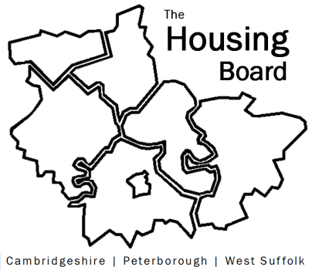
The Housing Board
Cambridgeshire | Peterborough | West Suffolk
Meeting from 10:30 to 12:00, Friday 14 August 2020
To be held online via Microsoft Teams: please open the meeting invite to click on the link
A G E N D A
 | Item | Lead
 | Welcome/apologies  Actions of previous meeting to approve, and matters arising. Meeting papers available at www.cambridgeshireinsight.org.uk/housingboard | Suzanne Hemingway
 | CPCA Allocations | Emily Mulvaney
 | Housing Related Support Draft Strategy  2 documents already circulated on 29/07/2020 11.49 am :  DRAFT Housing Related Support Commissioning Strategy for Cambridgeshire & Peterborough – (consultation draft HRS and consultation feedback) | Sue Beecroft
Updates
- Housing and Covid Recovery
- District next steps plans
- MAIC stats
- Update from RP partners
 | AOB
Future meeting dates:
28 August 10:30 am – 12.00 pm
11 September 10:30 am – 12.00 pm

