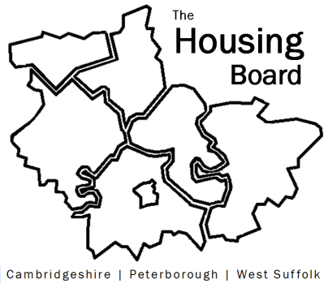
The Housing Board
Cambridgeshire | Peterborough | West Suffolk
Meeting from 10:30 to 12:00, Friday 11 September 2020
To be held online via Microsoft Teams: please open the meeting invite to click on the link
A G E N D A
 | Item | Lead
 | Welcome/apologies  Actions of previous meeting to approve, and matters arising. Meeting papers available at www.cambridgeshireinsight.org.uk/housingboard | Suzanne Hemingway
 | Outline of planned drugs / alcohol bid for Cambridgeshire and Peterborough | Joe Keegan (10.30)
 | Progress on  - Draft Housing Related Support Strategy  - ARC4 report and incorporating East Cambs  - Our plan to take forward the Arc4 actions from CPSB… shall we convene a smaller group to work on this? | Lisa Sparks  Suzanne H
 | Summary of Next Steps bids | Sue Beecroft
 | People with No Recourse  - How many people are still being accommodated by Councils  - What do we all plan to do when the deadline expires next Weds beyond which we can no longer accommodate? | All
 | Updates  - Health: track and trace / recovery groups and housing (tentative)  - MAIC stats  - Housing related support update | Val Thomas and Iain Green  Sue Beecroft  Lisa Sparks
 | AOB
Future meeting dates:
25 September 10:30 am – 12.00 pm

