**Cambridgeshire & Peterborough Homelessness Transformation Project**

Cambridgeshire County Council

Main Report

September 2020



**Email: Businessteam@arc4.co.uk**

**Telephone: 0800 612 9133**

**Website:** [**www.arc4.co.uk**](http://www.arc4.co.uk)

*© 2020 arc4 Limited (Company No. 06205180)*

Table of Contents

1. Introduction 18

Methodology 18

2. Housing Market in Cambridgeshire 20

Home Ownership 20

Social Housing Sector 23

Private Rented Sector 27

3. Understanding the Need – Housing Related Support 31

Housing Related Support Provision 31

Housing Related Support Review Findings 33

Identified issues and gaps 35

Key findings and Recommendations 38

Gaps & Future Commissioning 44

Recommendations 47

4. Understanding the Need - Homelessness in Cambridgeshire & Peterborough 48

Homelessness in Figures 48

The National Picture 48

Levels of Homelessness across Cambridgeshire & Peterborough 51

Operational Service delivery Overview 79

Local Good Practice 89

Recommendations 96

5. Temporary Accommodation 97

Cambridge 97

East Cambridgeshire 97

Fenland 97

Huntingdonshire 97

South Cambridgeshire 97

Co-operation and Joint Procurement 103

Diversifying housing delivery 105

Empty Homes 106

Build to Rent 107

Re-designation of Stock 108

Recommendations 111

6. Cambridgeshire & Peterborough Homelessness Prevention Trailblazer 112

Background 112

Partnership Working 113

Joint Protocol Work 113

Prevention Casework 114

Trailblazer Data 114

National Research 125

How well does the Trailblazer Service work? 128

The Future of the Trailblazer Service 129

Recommendations 131

7. Rough Sleeping 132

The National Picture 132

Rough sleeping across Cambridgeshire and Peterborough 134

Local Responses and Issues 137

Recommendations 151

8. Consultation Feedback 152

View of Housing Options Teams 152

The Views of Partners 154

Supported Housing Providers 161

Customer’s Views 163

9. Identified Opportunities & Barriers 182

Introduction 182

How might services be transformed? 183

Young Persons Homelessness Team 185

Complex Needs Multi-Disciplinary Team 195

Choice Based Lettings 201

Other Opportunities 203

Social Housing 204

Reducing Social Housing Evictions 208

Accessing and Sustaining Private Rented Accommodation 211

Cross Authority Working 214

Strategic and Operational Practice 215

Local Connection 215

Operational Tools 215

Data and Performance 216

Sub-Regional Reviewing Officer 217

Recommendations 218

10. Recommendations and Next Steps 219

Understanding the Need – Housing Related Support 220

Demand on Housing Options services 221

Understanding the Need - Homelessness in Cambridgeshire & Peterborough 222

Temporary Accommodation 223

Cambridgeshire & Peterborough Homelessness Prevention Trailblazer 223

Rough Sleeping 224

Identified Opportunities & Barriers 225

Appendix A: Profile of Cambridgeshire & Peterborough 226

Combined Authority 226

Population projection summary 228

Household projections summary 230

Area Profiles 231

Appendix B: National Picture and Policy 234

Legislative Context – Homelessness Reduction Act 2017 234

Strategies & Reports 234

Anticipated Future Levels of Homelessness 239

Other factors likely to impact upon homelessness levels 240

Summary 241

Appendix C: Local Policies & Strategies 242

Think Communities 242

District Homelessness Strategies 244

Appendix D: Affordability of the PRS 252

Appendix E: Homelessness in Figures 258

a) Cambridge 258

b) South Cambridgeshire 279

c) East Cambridgeshire 299

d) Fenland 316

e) Huntingdonshire 336

f) Peterborough 358

Appendix F: Housing Association survey 374

Introduction 374

Coverage 374

Evictions 374

Strengths 375

Barriers 375

Homelessness Preventions 376

Prevention 376

Additional services & gaps 376

Future Levels of Homelessness 377

Appendix G: Housing Options and Homelessness Services 378

a) Cambridge 378

b) East Cambridgeshire 387

c) South Cambridgeshire 388

d) Fenland 397

e) Huntingdonshire 406

f) Peterborough 415

Appendix H: Staff Focus Groups 423

a) Cambridge 423

b) South Cambridgeshire 428

c) Fenland 432

d) Huntingdonshire 436

e) Peterborough 440

Appendix I: Partner survey 445

Introduction 445

Coverage 445

Strengths 445

Improvements to services 447

Barriers 447

Homelessness Preventions 448

Prevention 451

Additional services & gaps 453

Supported Housing Providers 454

Future levels of homelessness 454

Additional comments 456

Appendix J: Customer Survey 457

Introduction 457

Respondents 457

Geographical area 459

Housing Problem 460

Housing Options 461

Rough Sleeping 463

Supported Accommodation 465

Additional Comments 474

Appendix K: Customer Focus Groups Consultation 475

What do customers think of the services they are getting? 475

What do customers think of the council run services? 475

What about the future of services and provision? 476

List of Tables

Table 2.1 Housing market tenure in Cambridgeshire 20

Table 2.2 Dwelling type and bedrooms 21

Table 2.3 House prices by district 22

Table 2.4 Summary of affordability by tenure across districts, (percentage of households unable to afford) 2009/10 23

Table 2.5 Income to house price ratio 23

Table 2.6 Comparison of applicants and lets 25

Table 2.7 Comparison of applicants vs lets by bedroom size 26

Table 2.8 Local Housing Allowance Rates 2019/20 by Broad Rental Market Area 28

Table 2.9 Private rental prices by district 29

Table 2.10 Shortfall between the rents and LHA allowance 30

Table 3.1 HRS provision across Cambridgeshire 31

Table 3.2 HRS provision across Peterborough 33

Table 4.1 Number of assessments recorded under the HRA 2017 across Cambridgeshire 54

Table 4.2 Number of households LAs are working with under the different duties 55

Table 4.3 No of Referrals received under Duty to Refer 57

Table 4.4 Household composition split between singles and families owed a prevention duty across Cambridgeshire 2018/19 58

Table 4.5 Household composition split between singles and families owed a relief duty across Cambridgeshire 2018/19 59

Table 4.6 Number of households with a support need across Cambridgeshire 2018/19 60

Table 4.7 Percentage of clients owed a duty with a support need 61

Table 4.8 Number of applicants who may be hidden homeless across Cambridgeshire 62

Table 4.9 Reasons for homelessness across Cambridgeshire 2018/19 63

Table 4.10 Two main causes of homelessness for each LA 64

Table 4.11 Number of evictions by reason for each LA between 2015-2019 66

Table 4.12 Total number of cases prevented and success rate across Cambridgeshire 68

Table 4.13 Type of accommodation secured across Cambridgeshire 2018/19 70

Table 4.14 Total number of cases relieved and success rate across Cambridgeshire 71

Table 4.15 Type of accommodation secured across Cambridgeshire 2018/19 72

Table 4.16 Main duty decisions for households where homelessness could not be prevented or relieved 73

Table 4.17 Comparison of main duty decisions and acceptances 73

Table 4.18 Number of duties owed and outcomes 75

Table 4.19 Outcomes of households no longer owed a duty 75

Table 4.20 Annual number of cases per officer 81

Table 4.21 Number of caseloads per officer across Cambridgeshire 81

Table 4.22 Two main causes of homelessness 83

Table 5.1 Snapshot of households in temporary accommodation per year across Cambridgeshire 99

Table 5.2 Snapshot of households in temporary accommodation on last day of the quarter of each year 100

Table 5.3 Number of TA placements and avg length of stay 101

Table 5.4 Snapshot of households in Bed & Breakfast across Cambridgeshire 101

Table 5.5 Number of households in B&B 2018/19 102

Table 6.1 Number of referrals by LA 2017-2019 115

Table 6.2 Comparison of outcomes from referrals by LA 2017-2019 117

Table 6.3 Comparison of prevention outcomes for LAs 118

Table 6.4 Successful prevention rate each year 119

Table 8.1 Local connection 161

Table 8.2 Responses to Q2 ‘Which area did you become homeless in?’ 166

Table 8.3 Responses to Q4 ‘What do you think led to your housing problem?’ 167

Table 8.4 Responses to Q8 ‘At what stage did you make contact with the Housing Options Service?’ 168

Table 9.1 Number of approaches by age 186

Table A.1 Total population change 2020-2031 by local authority area 228

Table A.2 Percentage change in population by age group 2020-2031 229

Table A.3 Total household change 2020-2031 by local authority area 230

Table A.4 Percentage change in households by HRP age group 2020-2031 231

Table D.1 Local Housing Allowance Rates 2019/20 by Broad Rental Market Area 252

Table D.2 Cambridge City: Comparison of average Private Sector Rent per calendar month (2019) with LHA (2019/20) by ward 253

Table D.3 East Cambridgeshire: Comparison of average Private Sector Rent per calendar month (2019) with LHA (2019/20) by ward 254

Table D.4 South Cambridgeshire: Comparison of average Private Sector Rent per calendar month (2019) with LHA (2019/20) by ward 255

Table D.5 Fenland: Comparison of average Private Sector Rent per calendar month (2019) with LHA (2019/20) by ward 256

Table D.6 Peterborough: Comparison of average Private Sector Rent per calendar month (2019) with LHA (2019/20) by ward 257

Table E.1 Number of approaches to Housing Options service 2017/18-2018/19 258

Table E.2 Number of assessments and outcomes recorded under the HRA 2017 259

Table E.3 Number of Duty to Refer cases received in 2018/19 260

Table E.4 Family composition of households owed a prevention duty 260

Table E.5 Family composition of households owed a relief duty 261

Table E.6 Age profile of those owed a prevention or relief duty 261

Table E.7 Ethnicity of households owed a prevention or relief duty 262

Table E.8 Number of clients owed a duty with a support need 262

Table E.9 Nature of identified support needs 263

Table E.10 Number of applicants who may be hidden homeless 264

Table E.11 Main reasons of homelessness 264

Table E.12 Type of accommodation when duty was owed 266

Table E.13 Number of cases where prevention duty came to an end in 2018/19 266

Table E.14 Number of cases where prevention duty ended with secure accommodation 267

Table E.15 Main prevention activity 268

Table E.16 Number of cases where relief duty came to an end in 2018/19 268

Table E.17 Number of households where relief duty ended with secure accommodation 269

Table E.18 Main relief activity 270

Table E.19 Main duty decisions where homelessness could not be prevented or relieved 270

Table E.20 Reasons for priority need 271

Table E.21 Discharge of those owed the full homeless duty 271

Table E.22 Temporary accommodation stock profile 273

Table E.23 Number of households placed in TA 274

Table E.24 Number of households placed into B&B 276

Table E.25 Annual spend on nightly paid emergency accommodation 276

Table E.26 Number of individuals reported 277

Table E.27 Number of approaches to Housing Options service 2017/18-2018/19 279

Table E.28 Number of assessments and outcomes recorded under the HRA 2017 280

Table E.29 Number of Duty to Refer cases received 281

Table E.30 Family composition of households owed a prevention duty 281

Table E.31 Family composition of households owed a relief duty 282

Table E.32 Age profile of those owed a prevention or relief duty 282

Table E.33 Ethnicity of households owed a prevention or relief duty 283

Table E.34 Number of clients owed a duty with a support need 283

Table E.35 Nature of identified support needs 284

Table E.36 Number of applicants who may be hidden homeless 285

Table E.37 Main reasons of homelessness 285

Table E.38 Type of accommodation when duty was owed 287

Table E.39 Number of cases where prevention duty came to an end in 2018/19 288

Table E.40 Number of cases where prevention duty ended with secure accommodation 289

Table E.41 Main prevention activity 289

Table E.42 Number of cases where relief duty came to an end in 2018/19 290

Table E.43 Number of households where relief duty ended with secure accommodation 290

Table E.44 Main relief activity 291

Table E.45 Main duty decisions where homelessness could not be prevented or relieved 291

Table E.46 Reasons for priority need 292

Table E.47 Discharge of those owed the full homeless duty 292

Table E.48 Annual spend on B&B and nightly paid temporary accommodation 297

Table E.49 Number of approaches to Housing Options service 2017/18-2018/19 299

Table E.50 Number of assessments and outcomes recorded under the HRA 2017 300

Table E.51 Number of Duty to Refer referrals received 300

Table E.52 Number of Duty to Refer referrals received by public body 300

Table E.53 Family composition of households owed a prevention duty 301

Table E.54 Family composition of households owed a relief duty 301

Table E.55 Age profile of those owed a prevention or relief duty 302

Table E.56 Ethnicity of households owed a prevention or relief duty 302

Table E.57 Number of clients owed a duty with a support need 303

Table E.58 Nature of identified support needs 303

Table E.59 Number of applicants who may be hidden homeless 304

Table E.60 Main reasons of homelessness 305

Table E.61 Type of accommodation when duty was owed 306

Table E.62 Number of cases where prevention duty came to an end in 2018/19 307

Table E.63 Number of cases where prevention duty ended with secure accommodation 307

Table E.64 Main prevention activity 308

Table E.65 Number of cases where relief duty came to an end in 2018/19 308

Table E.66 Number of households where relief duty ended with secure accommodation 309

Table E.67 Main relief activity 309

Table E.68 Main duty decisions where homelessness could not be prevented or relieved 310

Table E.69 Reasons for priority need 310

Table E.70 Discharge of those owed the full homeless duty 311

Table E.71 Number of approaches to Housing Options service 2017/18-2019/20 316

Table E.72 Number of assessments and outcomes recorded under the HRA 2017 317

Table E.73 Number of Duty to Refer referrals received 317

Table E.74 Family composition of households owed a prevention duty 318

Table E.75 Family composition of households owed a relief duty 318

Table E.76 Age profile of those owed a prevention or relief duty 319

Table E.77 Ethnicity of households owed a prevention or relief duty 319

Table E.78 Number of clients owed a duty with a support need 320

Table E.79 Nature of identified support needs 320

Table E.80 Number of applicants who may be hidden homeless 322

Table E.81 Main reasons of homelessness 322

Table E.82 Type of accommodation when duty was owed 324

Table E.83 Number of cases where prevention duty came to an end in 2018/19 324

Table E.84 Number of cases where prevention duty ended with secure accommodation 325

Table E.85 Main prevention activity 326

Table E.86 Number of cases where relief duty came to an end in 2018/19 326

Table E.87 Number of households where relief duty ended with secure accommodation 327

Table E.88 Main relief activity 327

Table E.89 Main duty decisions where homelessness could not be prevented or relieved 328

Table E.90 Reasons for priority need 328

Table E.91 Discharge of those owed the full homeless duty 329

Table E.92 Annual placements in temporary accommodation and B&B 332

Table E.93 Annual spend on B&B and nightly paid temporary accommodation 333

Table E.94 Number of households assisted to access PRS with a loan, bond or grant 335

Table E.95 Staffing budget 335

Table E.96 Number of approaches to Housing Options service 2017/18-2019/20 336

Table E.97 Number of assessments and outcomes recorded under the HRA 2017 337

Table E.98 Family composition of households owed a prevention duty 338

Table E.99 Family composition of households owed a relief duty 338

Table E.100 Age profile of those owed a prevention or relief duty 339

Table E.101 Ethnicity of households owed a prevention or relief duty 339

Table E.102 Number of clients owed a duty with a support need 341

Table E.103 Nature of identified support needs 341

Table E.104 Number of applicants who may be hidden homeless 343

Table E.105 Main reasons of homelessness 343

Table E.106 Type of accommodation when duty was owed 345

Table E.107 Number of cases where prevention duty came to an end in 2018/19 345

Table E.108 Number of cases where prevention duty ended with secure accommodation 346

Table E.109 Main prevention activity 346

Table E.110 Number of cases where relief duty came to an end in 2018/19 347

Table E.111 Number of households where relief duty ended with secure accommodation 347

Table E.112 Main relief activity 348

Table E.113 Main duty decisions where homelessness could not be prevented or relieved 348

Table E.114 Reasons for priority need 349

Table E.115 Discharge of those owed the full homeless duty 349

Table E.116 Annual spend on B&B and nightly paid temporary accommodation 355

Table E.117 Number of households assisted to access PRS with a loan, bond or grant 357

Table E.118 Staffing budget 357

Table E.119 Number of approaches to Housing Options service 2018/19-2019/20 358

Table E.120 Number of assessments and outcomes recorded under the HRA 2017 359

Table E.121 Family composition of households owed a prevention duty 359

Table E.122 Family composition of households owed a relief duty 360

Table E.123 Age profile of those owed a prevention or relief duty 360

Table E.124 Ethnicity of households owed a prevention or relief duty 361

Table E.125 Number of clients owed a duty with a support need 361

Table E.126 Nature of identified support needs 362

Table E.127 Number of applicants who may be hidden homeless 363

Table E.128 Main reasons of homelessness 364

Table E.129 Type of accommodation when duty was owed 365

Table E.130 Number of cases where prevention duty came to an end in 2018/19 366

Table E.131 Number of cases where prevention duty ended with secure accommodation 366

Table E.132 Main prevention activity 367

Table E.133 Number of cases where relief duty came to an end in 2018/19 367

Table E.134 Number of households where relief duty ended with secure accommodation 368

Table E.135 Main relief activity 368

Table E.136 Main duty decisions where homelessness could not be prevented or relieved 369

Table E.137 Households placed in B&B 372

Table F.1 Coverage/Operating Areas for Housing Associations 374

Table G.1 Staffing structure 387

Table I.1 Responses to QB. ‘Which districts do you operate in/work with?’ 445

Table I.2 Local connection 454

Table J.1 Ethnicity 457

Table J.2 Gender 458

Table J.3 Age 458

Table J.4 Household Type 458

Table J.5 Responses to Q1 ‘Which area are you originally from?’ 459

Table J.6 Responses to Q2 ‘Which area did you become homeless in?’ 459

Table J.7 Responses to Q4 ‘What do you think led to your housing problem?’ 460

Table J.8 Responses to Q8 ‘At what stage did you make contact with the Housing Options Service?’ 461

Table J.9 Responses to Q21 ‘How would you rate the accommodation that you are now in?’ 466

### List of Figures

Graph 2.1 Comparison of applicants vs lets 25

Graph 2.2 Comparison of applicants vs lets by bedroom size 26

Figure 4.1 Breakdown of homelessness outcomes 2018/19 48

Figure 4.2 Homeless acceptances 1998 onwards 50

Figure 4.3 Households in temporary accommodation 2002 to 2019 50

Graph 4.4 Number of approaches to Housing Options Services across Cambridgeshire 52

Graph 4.5 Number of caseloads per officer (average) across Cambridgeshire Jan/Feb 2020 53

Graph 4.6 Number of assessments recorded under the HRA 2017 across Cambridgeshire 2018/19 54

Graph 4.7 Comparison of demand and assessments under the HRA 2017 across Cambridgeshire 2018/19 55

Figure 4.8 Comparison of prevention and relief duties across Cambridgeshire 2018/19 56

Graph 4.9 Percentage of household composition owed both a prevention and relief duty across Cambridgeshire 2018/19 57

Graph 4.10 Household composition owed a prevention duty 58

Graph 4.11 Household composition owed a relief duty 60

Graph 4.12 Number of households with a support need across Cambridgeshire 61

Graph 4.13 Number of applicants who may be hidden homeless 62

Graph 4.14 Top five reasons for homelessness across LAs 64

Figure 4.15 Number of evictions by reason for each LA between 2015-2019 65

Graph 4.16 Number of cases owed a prevention duty vs accommodation secured 69

Graph 4.17 Comparison of successful prevention rate to national prevention rate 70

Graph 4.18 Number of cases owed a relief duty vs accommodation secured 71

Graph 4.19 Comparison of successful relief rate to national relief rate 72

Graph 4.20 Comparison of main duty decisions and acceptances 74

Graph 4.21 Outcome of households no longer owed a duty 76

Graph 4.22 Number of caseloads per officer (average) across Cambridgeshire 82

Graph 5.1 Snapshot of households in TA per year 99

Graph 5.2 Snapshot of households in TA by yearly quarter 100

Graph 5.3 Snapshot of households in B&B 102

Graph 6.1 Number of referrals by LA 2017-2019 115

Graph 6.2 Homelessness timescales by LA 2017-2019 116

Figure 6.3 Comparison of outcomes from referrals by LA 2017-2019 118

Graph 6.4 Homelessness reasons by prevention outcome by LA 2017/18 120

Graph 6.5 Homelessness reasons by prevention outcome by LA 2018/19 121

Graph 6.6 Homelessness reasons by prevention outcome by LA 2019/20 122

Graph 6.7 Top 5 referral agencies by LA 2017-19 123

Graph 6.8 Prevention tools used by LA 2017/18 124

Graph 6.9 Prevention tools used by LA 2018/19 124

Graph 6.10 Prevention tools used in each LA 2019/20 125

Figure 7.1 The causes of homelessness and rough sleeping 132

Figure 7.2 Number of people sleeping rough in England on a single night 134

Graph 7.3 Number of people found rough sleeping across Cambridgeshire and Peterborough 135

Graph 7.4 Verified rough sleepers in Cambridge 136

Figure 9.1 Positive Pathways Model 182

Figure 9.2 Diagram of LA homelessness services moving forward 184

Figure 9.3 Customer Journey Pathway diagram 185

Figure A.1 Population projections by age group 2020-2031 229

Figure A.2 Household projections by age group 2020-2031 231

Chart E.1 Support Needs 263

Chart E.2 Reasons for Homelessness 265

Chart E.3 Total number of homeless decisions 272

Chart E.4 Total number of homeless acceptances 272

Chart E.5 Households in temporary accommodation by year 273

Chart E.6 Households in temporary accommodation by quartile 274

Chart E.7 Average length of stay in temporary accommodation 275

Chart E.8 Households in Bed & Breakfast by year 275

Chart E.9 Households in Bed & Breakfast by quartile 276

Chart E.10 Rough sleeping – Cambridge City 277

Chart E.11 Verified rough sleepers in Cambridge 278

Chart E.12 Support needs 284

Chart E.13 Reasons for homelessness 286

Chart E.14 Total number of homeless decisions 293

Chart E.15 Total number of homeless acceptances 293

Chart E.16 Households in temporary accommodation (annual) 294

Chart E.17 Snapshot of households in temporary accommodation (quartile) 295

Chart E.18 Households in Bed & Breakfast (annual) 296

Chart E.19 Households in Bed & Breakfast (quartile) 296

Chart E.20 Rough sleeping – South Cambridgeshire 297

Chart E.21 Support needs 304

Chart E.22 Reasons for homelessness 305

Chart E.23 Total number of homeless decisions 312

Chart E.24 Total number of homeless acceptances 312

Chart E.25 Households in temporary accommodation (annual) 313

Chart E.26 Households in temporary accommodation (quartile) 314

Chart E.27 Rough sleeping – East Cambridgeshire 315

Chart E.28 Support needs 321

Chart E.29 Reasons for Homelessness 323

Chart E.30 Total number of homeless decisions 330

Chart E.31 Total number of homeless acceptances 330

Chart E.32 Households in temporary accommodation (annual) 331

Chart E.33 Households in temporary accommodation (quartile) 332

Chart E.34 Households in Bed & Breakfast 333

Chart E.35 Expenditure on temporary accommodation 334

Chart E.36 Rough sleeping - Fenland 334

Chart E.37 Support needs 342

Chart E.38 Reasons for homelessness 344

Chart E.39 Total number of homeless decisions 350

Chart E.40 Total number of homeless acceptances 351

Chart E.41 Households in temporary accommodation (annual) 352

Chart E.42 Households in temporary accommodation (quartile) 352

Chart E.43 Households in Bed & Breakfast (annual) 354

Chart E.44 Households in Bed & Breakfast (quartile) 354

Chart E.45 Expenditure on temporary accommodation 355

Chart E.46 Rough sleeping - Huntingdonshire 356

Chart E.47 Support needs 363

Chart E.48 Reasons for homelessness 364

Chart E.49 Total number of homeless decisions 370

Chart E.50 Total number of homeless acceptances 370

Chart E.51 Households in temporary accommodation 371

Chart E.52 Households in Bed & Breakfast 372

Chart E.53 Rough sleeping - Peterborough 373

*This report takes into account the particular instructions and requirements of our client. It is not intended for and should not be relied upon by any third party and no responsibility is undertaken to any third party.*

*arc4 Limited accepts no responsibility or liability for, and makes no representation or warranty with respect to, the accuracy or completeness of any third party information (including data) that is contained in this document.*

*Registered Address: arc4, 41 Clarendon Road, Sale, Manchester, M33 2DY*

*Email :* [*businessteam@arc4.co.uk*](mailto:businessteam@arc4.co.uk) *Web :* [*www.arc4.co.uk*](http://www.arc4.co.uk)

*arc4 Limited, Registered in England & Wales 6205180 VAT Registration No: 909 9814 77*

*Directors Helen Brzozowski and Michael Bullock*

# Introduction

* 1. The five Cambridgeshire authorities, Peterborough City Council, together with Cambridgeshire County Council commissioned arc4 to undertake a needs assessment to inform a shared future commissioning strategy to tackle homelessness together with identifying the barriers and opportunities to achieve system change, which will lead to a sustainable model of future delivery of homelessness services, whilst taking account of local need.
  2. Through the transformation of homelessness services across Cambridgeshire and Peterborough it is anticipated that the following outcomes can be achieved:
* Ending of the need for anyone to sleep rough over the next 10 years;
* Reduction in the use of temporary accommodation;
* Reducing the numbers of people who become homeless;
* Reducing the trauma and disruption of homelessness through improving access to services at the right time across the public sector, and reducing the ‘revolving door’ cycle; and
* Increasing the supply of the right type of accommodation to meet need.
  1. This report identifies a number of opportunities, alongside drawing on national good practice, to enable the Cambridgeshire and Peterborough local authorities to develop a sustainable model of delivery which makes the best use of collective resources, seeks to prevent further cost escalation and identify more cost-effective options, and joins forces across agencies and services where it makes sense to do so.
  2. While this work has primarily focused on the delivery of the district and city council’s statutory homelessness functions, there is a clear overlap with a range of other homelessness and rough sleeping services, and as such some of the identified opportunities and recommendations may relate to wider homelessness services, including those commissioned by the county council.
  3. At the time of undertaking this work, Cambridgeshire County Council had commenced drafting their Housing Related Support Commissioning Strategy, which will inform future commissioning priorities while setting out clear commissioning principles.
  4. The needs assessment element of this project, together with key findings and emerging recommendations have helped to inform the development of the county’s Draft Commissioning Strategy.

## Methodology

* 1. Alongside analysing all available data to understand the extent and nature of homelessness across Cambridgeshire and Peterborough considerable time was spent with each of the Housing Options teams (with the exception of East Cambridgeshire), including interviews with managers and focus groups with frontline staff.
  2. This was complemented by a number of focus groups with service providers including rough sleeping services and housing related support services.
  3. Customer engagement was critical to the project and a number of customer focus groups were held across Cambridgeshire and Peterborough within a range of supported housing projects.
  4. Further consultation was undertaken with frontline staff, partner agencies, supported housing providers and customers in the form of questionnaires.
  5. This work has been complemented by a desktop study of relevant local strategic documents, together with a horizon scan including researching best practice and innovation in the sector.
  6. Emerging findings and potential opportunities were explored with both the Project Group overseeing delivery of this review and the Cambridgeshire and Peterborough Housing Board, in advance of drafting the final report and recommendations.
  7. An overview of the sub-region, together with the national and local policy framework can be found in appendices A, B and C.

# Housing Market in Cambridgeshire

## Home Ownership

* 1. The table below provides an overview of the housing market across Cambridgeshire and Peterborough.

|  |  |  |  |  |  |
| --- | --- | --- | --- | --- | --- |
| Table 2.1 Housing market tenure in Cambridgeshire | | | | | |
| **Local Authority** | **Tenure (%)** | | | **Total** | **Base (households)** |
|  | Owner occupied | Private Rented | Affordable (rented and shared ownership) |
| Cambridge | 47.5 | 27.8 | 24.7 | 100.0 | **46,714** |
| East Cambridgeshire | 68.5 | 15.7 | 15.7 | 100.0 | **34,614** |
| Fenland | 70.0 | 17.0 | 12.9 | 100.0 | **40,620** |
| Huntingdonshire | 71.2 | 15.1 | 13.6 | 100.0 | **69,333** |
| South Cambridgeshire | 70.3 | 13.4 | 16.4 | 100.0 | **59,960** |
| Peterborough | 59.3 | 20.3 | 20.4 | 100.0 | **74,023** |
| East of England | 67.6 | 16.0 | 16.4 | 100.0 | 2,423,035 |

Source 2011 Census KS402EW

* 1. The 2011 Census reported that across the sub-region, the proportion of households living in owner occupied dwellings exceeded the regional average in four districts, with Huntingdonshire having the highest proportion. Households privately renting was highest in Cambridge. Cambridge also had the highest proportion living in affordable housing (social rented and shared ownership dwellings).
  2. The table overleaf details the dwelling type of properties. Although the majority of dwellings are houses across all districts, almost 40% of dwellings in Cambridge are one and two bedroom flats. Bungalows account for 26% of dwellings in Fenland. Smaller one and two bedroom houses account for between 12.1% and 15.5% of dwelling stock across the sub-region.

|  |  |  |  |  |  |  |  |  |  |  |
| --- | --- | --- | --- | --- | --- | --- | --- | --- | --- | --- |
| Table 2.2 Dwelling type and bedrooms | | | | | | | | | | |
| **District/Region** | **Dwelling type and number of bedrooms** | | | | | | | | | |
| 1/2 bedroom houses | 3 bedroom houses | 4 or more bedroom houses | 1 bedroom flats | 2 bedroom flats | 3 or more bedroom flats | 1 bedroom bungalow | 2 bedroom bungalow | 3 or more bedroom bungalow |
| Cambridge | 12.1 | 34.1 | 12.8 | 19.0 | 16.2 | 3.5 | 0.7 | 1.0 | 0.6 |
| East Cambridgeshire | 15.5 | 35.7 | 21.1 | 4.0 | 3.7 | 0.2 | 2.4 | 9.6 | 7.9 |
| Fenland | 14.0 | 36.1 | 14.6 | 5.0 | 3.8 | 0.3 | 2.3 | 14.1 | 9.8 |
| Huntingdonshire | 12.6 | 39.3 | 26.1 | 5.7 | 5.4 | 0.4 | 0.8 | 4.9 | 4.9 |
| South Cambridgeshire | 13.8 | 36.6 | 26.9 | 2.9 | 3.6 | 0.3 | 2.3 | 7.5 | 6.2 |
| Peterborough UA | 13.6 | 42.6 | 17.0 | 9.1 | 7.1 | 0.7 | 1.7 | 4.1 | 4.3 |
| East of England Region | 12.7 | 38.5 | 17.3 | 8.7 | 8.3 | 1.0 | 1.4 | 6.7 | 5.4 |

Source: 2019 Valuation Office Agency

### House Prices

* 1. In most of the country, real house prices have not risen in the last decade; however, they have increased by 30% in London, 8% in the South East and 10% in the East of England since 2007. [1] Increases in property prices makes it hard for young adults to raise a deposit, [2] with the proportion of young adults who would need to spend more than six months’ income on a 10% deposit for the median property in their area increasing from 33% to 78% in the last 20 years.[3] The IFS concludes that these rising house prices have benefited older generations at the expense of younger ones, thereby increasing intergenerational inequalities. [4]
  2. The table below sets out house prices in 2019 by district. Highest prices were reported in Cambridge followed by South Cambridgeshire, with lowest prices in Fenland.

|  |  |  |
| --- | --- | --- |
| Table 2.3 House prices by district | | |
| **District/Region** | **Lower quartile (£)** | **Median (£)** |
| Cambridge | £338,500 | £440,000 |
| East Cambridgeshire | £227,250 | £291,000 |
| Fenland | £150,000 | £185,000 |
| Huntingdonshire | £210,090 | £275,000 |
| South Cambridgeshire | £283,600 | £364,897 |
| Peterborough UA | £148,000 | £190,000 |
| East of England Region | £210,000 | £282,500 |

Source: Land Registry Price Paid data 2019

* 1. The following table taken from the Cambridgeshire SHMA 2013 details the percentage of households unable to afford rent or purchase across all tenure types. This data is 10 years old, given that house prices have increased over this period it is anticipated that the proportion of households unable to afford will have increased.

|  |  |  |  |  |  |
| --- | --- | --- | --- | --- | --- |
| Table 2.4 Summary of affordability by tenure across districts, (percentage of households unable to afford) 2009/10 | | | | | |
|  | **Housing Association rent** | **Maximum Affordable Rent** | **50% shared ownership** | **Lower quartile rent** | **Lower quartile purchase** |
| Cambridge | 19% | 41% | 35% | 45% | 63% |
| East Cambridgeshire | 16% | 23% | 23% | 27% | 44% |
| Fenland | 15% | 22% | 27% | 27% | 38% |
| Huntingdonshire | 11% | 18% | 22% | 20% | 36% |
| South Cambridgeshire | 13% | 25% | 29% | 30% | 47% |
| Forest Heath | 16% | 39% | 20% | 33% | 41% |
| St Edmundsbury | 14% | 26% | 24% | 30% | 44% |

Source: 2009/10 SHMA update Chapter 10 table 18

* 1. The table below details the income to house price ratio across Cambridgeshire and Peterborough, indicating that home ownership is beyond the reach of those on lower incomes.

|  |  |
| --- | --- |
| Table 2.5 Income to house price ratio | |
| **Local Authority** | **Income to House Price Ratio 2018** |
| Cambridge | 12.95 |
| East Cambridgeshire | 10.7 |
| Fenland | 8.45 |
| Huntingdonshire | 9.44 |
| South Cambridgeshire | 10.25 |
| Peterborough | 6.79 |

Source: ONS

## Social Housing Sector

* 1. The supply of new social housing has been in decline since the late 1980s and has contracted sharply in the past decade: 6,463 new homes for social rent were made available in 2017-18 compared to 24,670 a decade earlier in 2006/7, making up just under 3% of all new dwellings (in contrast, 47,355 affordable homes were delivered in England in 2017-18, an increase of 12 per cent compared to 2016- 17).[5] The shortage of social housing has led to over 1.15 million households on local authority waiting lists, with waiting times running into decades in areas of the highest demand, and recent research from Centrepoint found that more than eight in ten housing associations thought the lack of social housing particularly affected young people’s ability to access housing they can afford.
  2. Following a Government decision to reduce social sector rents (by 1% a year) for four years from April 2016, housing benefit expenditure for the social rental sector has been falling. Beyond that period Government has now announced that rent increases of CPI plus 1% a year can resume, and has subsequently dropped a proposal to apply the private sector LHA limits to the social rented sector. According to the CIH, both these measures will enhance the investment capacity of social landlords.[6]
  3. However, CIH also estimate that between 2012 and 2020, almost a quarter of a million social rented homes will be ‘lost’, either through right to buy, conversion to affordable rented properties or demolished as part of regeneration schemes.[7]
  4. Social housing authorities have sought to control waiting lists and restrict eligibility in order to prioritise those in greatest need or those seen as making a 'positive contribution' through employment or volunteering. Many homeless organisations report that people who are homeless and/or sleeping rough face major obstacles and restrictions in accessing local authority social housing or even their waiting lists. One of the consequences of the Localism Act 2011 introducing restrictions to accessing waiting lists for groups of people deemed ‘non-qualifying’ has meant in practice that people with a history of rent arrears, a record of anti-social behaviour, with previous convictions or no local connection are excluded.
  5. Further, there is evidence that many housing associations, mainly in response to the risks created by welfare reform, are using affordability assessments to assess whether applicants will be able to afford their rent.[8] Homeless organisations have reported that many housing associations are requiring excessive amounts of rent in advance (varying from several weeks to months) and/or rent guarantors, thereby, excluding individuals moving on from homelessness accessing this social housing.
  6. Home-Link is the sub-regional Choice Based Lettings partnership, all social housing properties are let through Home-Link. The individual district housing registers and allocations continue to be managed locally.
  7. The following table and graph compare the number of households on the Housing Register to the number of annual lets.

|  |  |  |
| --- | --- | --- |
| Table 2.6 Comparison of applicants and lets | | |
| **Local authority** | **Applicants** | **Lets** |
| Cambridge | 2,537 | 540 |
| South Cambridgeshire | 1,218 | 306 |
| East Cambridgeshire | 1,411 | 467 |
| Fenland | 734 | 336 |
| Huntingdonshire | 3,004 | 685 |
| Peterborough | 3,501 | 630 |

Source: Local Authority Data

Graph 2.1 Comparison of applicants vs lets



Source: Local Authority Data

* 1. This demonstrates that demand for social housing is very high, and significantly outstrips supply.
  2. The following table and graphs provide a more detailed analysis comparing demand and supply for different property types.

|  |  |  |  |  |  |  |
| --- | --- | --- | --- | --- | --- | --- |
| Table 2.7 Comparison of applicants vs lets by bedroom size | | | | | | |
| **Local authority** |  | **1 bed** | **2 bed** | **3 bed** | **4+ bed** | **Total** |
| Cambridge | Applicants | 1,699 | 609 | 178 | 51 | 2,537 |
| Lets | 216 | 243 | 71 | 10 | 540 |
| South Cambridgeshire | Applicants | 620 | 391 | 156 | 51 | 1,218 |
| Lets | 107 | 142 | 51 | 6 | 306 |
| East Cambridgeshire | Applicants | 719 | 479 | 169 | 44 | 1411 |
| Lets | 182 | 195 | 77 | 13 | 467 |
| Fenland | Applicants |  |  |  |  | 734 |
| Lets |  |  |  |  | 336 |
| Huntingdonshire | Applicants | 1,566 | 940 | 381 | 117 | 3,004 |
| Lets |  |  |  |  | 685 |
| Peterborough | Applicants | 1,436 | 1,064 | 694 | 307 | 3,501 |
| Lets | 331 | 204 | 81 | 14 | 630 |

Source: Local Authority Data

Graph 2.2 Comparison of applicants vs lets by bedroom size



Source: Local Authority Data

* 1. In all areas the greatest demand is for one bedroom accommodation, followed by two bedroom accommodation.

## Private Rented Sector

* 1. The private sector doubled in size between 2001/02 and 2011/12,[9] and demand from under-35s has also been growing across Great Britain in more recent years. Under 35 year old single people reliant on benefits find it increasingly difficult to access the private rented market.
  2. A survey by Centrepoint highlighted that almost nine in ten landlords (89 per cent) reported not letting any shared accommodation,[10] of particular significance given that many young people will only be entitled to housing benefit at the level of the local shared accommodation rate (see ‘welfare reform’). Respondents to the Centrepoint survey stated that they did not provide shared housing because their property was unsuitable for sharing (62%), not the right size (61%), there were a lack of amenities (61%), or they simply did not want to let this kind of accommodation (36 %).
  3. 20% did not let shared accommodation because they were not prepared to deal with any extra regulation or costs involved and a small number (7%) indicated that they were actively put off by local planning and licensing conditions. Landlord groups have also raised concerns about the mandatory licensing of greater numbers of shared properties, and the impact this will have on the supply of shared accommodation.
  4. Centrepoint research showed that 58% of landlords were worried about a tenant engaging in antisocial behaviour or misusing the property. Other concerns were around damage to the property (55%), and the tenancy requiring an increased level of management by the landlord (47%).[11]
  5. Centrepoint research has identified that official and unofficial policies imposed by mortgage lenders, insurance companies and lettings agents can also act as barriers to people reliant on benefits accessing accommodation in the private sector. 43% of private landlords used a lettings agent to identify and select prospective tenants, with 22% of these landlords having no input into the lettings process at all.[12] 40% used a mortgage to finance some of their rental properties, with 18% of these reporting having mortgage conditions around letting to people on housing benefit or universal credit. 15% of landlords also reported insurance conditions specifically mentioning tenants on benefits and for these; 37% could not let to these tenants and a further 28% would have to pay increased premiums to do so. It is worth noting though that 81% of landlords who were subject to these clauses would still not be likely to let to tenants on housing benefit or universal credit if these clauses were removed.[13]
  6. Shelter research highlights how from April 2011 to 2014, private rents grew on average by 6.8%. Further, a survey by Centrepoint found 48% of all landlords required a cash deposit from a prospective tenant equal to or less than one month’s rent, and 32% required a deposit greater than the value of a month’s rent.[14]

### Affordability of the PRS

* 1. The analysis considers the price of renting a property in the Private Rented Sector (PRS) and how this compares with Local Housing Allowance (LHA) rates.
  2. The following tables set out the 2019 private rental prices by district and the LHA rate applicable to the property. Any shortfall in the price is met by the household. The LHA rates across the study area are presented in Table 2.8. In general, analysis shows that the LHA rates fall well short of prevailing market prices.

|  |  |  |  |
| --- | --- | --- | --- |
| Table 2.8 Local Housing Allowance Rates 2019/20 by Broad Rental Market Area | | | |
| **Broad Rental Market Area>>>** | **Cambridge** | **Peterborough** | **Huntingdonshire** |
| Study area districts covered>>> | Cambridge City, East Cambridgeshire, South Cambridgeshire, | Fenland, Peterborough | Huntingdonshire |
| **Weekly LHA** |  |  |  |
| Shared | £80.52 | £57.15 | £63.50 |
| 1 bedroom | £133.72 | £94.81 | £111.28 |
| 2 bedrooms | £153.79 | £118.52 | £133.67 |
| 3 bedrooms | £178.71 | £136.29 | £159.56 |
| 4 bedrooms | £238.28 | £173.46 | £204.05 |
| **Monthly LHA** |  |  |  |
| Shared | £348.92 | £247.65 | £275.17 |
| 1 bedroom | £579.45 | £410.84 | £482.21 |
| 2 bedrooms | £666.42 | £513.59 | £579.24 |
| 3 bedrooms | £774.41 | £590.59 | £691.43 |
| 4 bedrooms | £1,032.55 | £751.66 | £884.22 |

* 1. The following table compares Local Housing Allowance rates to prevailing lower quartile and median market prices.

|  |  |  |  |  |  |  |  |  |
| --- | --- | --- | --- | --- | --- | --- | --- | --- |
| Table 2.9 Private rental prices by district | | | | | | | | |
| **Number of bedrooms** |  | **Peterborough UA** | **Cambridge** | **East Cambs** | **Fenland** | **Huntingdonshire** | **South Cambs** | **East of England** |
| Room | LQ | £335 | £450 | .. | £293 | £380 | £470 | £370 |
| Median | £395 | £525 | .. | £347 | £400 | £520 | £440 |
| LHA | £247.65 | £348.92 | £348.92 | £247.65 | £275.17 | £348.92 |  |
| Studio | LQ | £425 | £725 | £420 | £350 | £450 | £495 | £450 |
| Median | £495 | £780 | £525 | £390 | £473 | £625 | £550 |
| LHA |  |  |  |  |  |  |  |
| One bedroom | LQ | £495 | £850 | £550 | £425 | £525 | £695 | £540 |
| Median | £525 | £950 | £600 | £475 | £575 | £750 | £650 |
| LHA | £410.84 | £579.45 | £579.45 | £410.84 | £482.21 | £579.45 |  |
| Two bedroom | LQ | £600 | £1,075 | £675 | £540 | £675 | £825 | £650 |
| Median | £650 | £1,250 | £725 | £595 | £725 | £895 | £775 |
| LHA | £513.59 | £666.42 | £666.42 | £513.59 | £579.24 | £666.42 |  |
| Three bedroom | LQ | £675 | £1,230 | £835 | £650 | £795 | £950 | £750 |
| Median | £740 | £1,350 | £900 | £700 | £850 | £1,050 | £900 |
| LHA | £590.59 | £774.41 | £774.41 | £590.59 | £691.43 | £774.41 |  |
| Four bedroom | LQ | £870 | £1,600 | £1,200 | £825 | £1,000 | £1,200 | £1,080 |
| Median | £1,000 | £1,900 | £1,300 | £895 | £1,200 | £1,375 | £1,350 |
| LHA | £751.66 | £1,032.55 | £1032.55 | £751.66 | £884.22 | £1032.55 |  |

Source: Valuation Office Agency Rental Statistics 2018/19

* 1. LHA rates in Fenland are most likely to cover private rents. However, across the remaining districts there is a significant shortfall in rent. The table below shows the shortfall between the rents and the LHA allowance. This shortfall is greatest in Cambridge where, for instance, a household renting a two bedroom lower quartile property would need £400 each month to cover the rent after LHA has been accounted for. These shortfalls mean that the private rented sector is increasingly unaffordable to households reliant upon housing benefit across Cambridgeshire.

|  |  |  |  |  |  |  |  |
| --- | --- | --- | --- | --- | --- | --- | --- |
| Table 2.10 Shortfall between the rents and LHA allowance | | | | | | | |
| **LHA Number of bedrooms** | **District** | **Peterborough UA** | **Cambridge** | **East Cambs** | **Fenland** | **Huntingdonshire** | **South Cambridgeshire** |
| Predominant BRMA Area>>>> | Peterborough | Cambridge | Cambridge | Cambridge | Huntingdon | Cambridge |
| Room | LQ | (£86.67) | (£100.12) |  | £56.88 | (£104.08) | (£120.12) |
| Median | (£146.67) | (£175.12) |  | £2.88 | (£124.08) | (£170.12) |
| Studio | LQ | (£13.03) | (£143.95) | £161.05 | £231.05 | £33.54 | £86.05 |
| Median | (£83.03) | (£198.95) | £56.05 | £191.05 | £10.54 | (£43.95) |
| One bedroom | LQ | (£83.03) | (£268.95) | £31.05 | £156.05 | (£41.46) | (£113.95) |
| Median | (£113.03) | (£368.95) | (£18.95) | £106.05 | (£91.46) | (£168.95) |
| Two bedroom | LQ | (£85.00) | (£406.75) | (£6.75) | £128.25 | (£94.17) | (£156.75) |
| Median | (£135.00) | (£581.75) | (£56.75) | £73.25 | (£144.17) | (£226.75) |
| Three bedroom | LQ | (£82.79) | (£453.46) | (£58.46) | £126.54 | (£101.67) | (£173.46) |
| Median | (£147.79) | (£573.46) | (£123.46) | £76.54 | (£156.67) | (£273.46) |
| Four bedroom | LQ | (£116.27) | (£564.18) | (£164.18) | £210.82 | (£113.35) | (£164.18) |
| Median | (£246.27) | (£864.18) | (£264.18) | £140.82 | (£313.35) | (£339.18) |

* 1. A more detailed analysis for each local authority broken down by ward can be found in Appendix D.

# Understanding the Need – Housing Related Support

## Housing Related Support Provision

* 1. The tables below detail the housing related support provision currently commissioned by Cambridgeshire County Council and Peterborough City Council.

| Table 3.1 HRS provision across Cambridgeshire | | | |
| --- | --- | --- | --- |
| **Cambridgeshire** | | | |
| **Service** | **Provider** | **Client group** | **District** |
| Cambridge Youth Foyer | Riverside Group | Young People | City |
| Queen Anne House | YMCA Trinity | Young People | City |
| Whitworth House | Orwell Housing Assoc | Young People | City |
| Wisbech Foyer | Axiom (Longhurst Group) | Young People | FDC |
| Paines Mill Foyer | Axiom (Longhurst Group) | Young People | HDC |
| Kings Ripton Court | Salvation Army | Young People | HDC |
| Castle Project | Richmond Fellowship | Young People | City |
| Peter Maitland Court (young parents) | CHS Group | Young People | City |
| Railway House | CHS Group | Young People | City |
| Ely Young People's Project | CHS Group | Young People | EDC |
| The Staithe | CHS Group | Young People | FDC |
| Cambridge Refuge | Cambridge Women's Aid | Domestic Abuse | City |
| Hunts refuge | Refuge | Domestic Abuse | HDC |
| Fenland refuge | Refuge | Domestic Abuse | FDC |
| Extra Care | Multiple suppliers | Older People | All Cambs |
| HRS OP South Cambs | SCDC | Older People | SDC |
| HRS OP Fenland, Hunts & East | Age UK | Older People | FDC / HDC / EDC |
| HRSOP | Cambridge City | Older People | City |
| An Lac House | Abbeyfield Cambridge Vietnamese Society | Older People | City |
| Controlled Drinkers Project | Jimmy's | Alcohol Problems | City |
| Jimmy's Assessment Centre | Jimmy's | Rough Sleepers / Single Homeless | City |
| Abbey Street Move-On | Jimmy's | Single Homeless | City |
| 222 Victoria Road | Riverside Group | Single Homeless | City |
| Willow Walk | The Riverside Group | Rough sleepers / Complex Needs | City |
| Housing Related Support Grant | Cambridge Cyrenians | Single Homeless | City |
| Home and Community Support- Homeless | Cambridge Cyrenians | Single Homeless | City |
| Princes Walk | Futures HA | Single Homeless | FDC |
| The Ferry Project | Luminus | Single Homeless | FDC |
| Corona House | CHS Group | Single Homeless | City |
| Cambridge Cluster, Vicarage Terrace & Fern Court | Sanctuary Housing | Mental Health | City |
| Green Road | Suffolk Mind | Mental Health | SDC |
| Offender Accommodation | Luminus Group | Ex- Offenders | HDC and FDC |
| Jubilee Project | Cambridge Cyrenians | Ex- Offenders | City |
| Russell Street | CHS Group | Learning Disability / Physical Disability | City |
| Fenland Traveller Sites | FDC | Gypsies & Travellers | FDC |
| Hunts Traveller Site | Luminus | Gypsies & Travellers | HDC |
| Countywide Floating Support * | P3 (People, Potential Possibilities) | Generic & specialist | All Cambs |

|  |  |  |
| --- | --- | --- |
| Table 3.2 HRS provision across Peterborough | | |
| **Peterborough** | | |
| **Service** | **Provider** | **Client group** |
| Fair View Court, New Haven and Peterborough Foyer plus 3 drop-in services | Axiom Housing Association | Single Homeless, Young People at Risk and Generic |
| Temporary Hostel provision | Cross Keys Homes | Homeless Families |
| Mayor's Walk | Genesis HA | Single Homeless |
| Eastlands | Home Group | People with Mental Health Problems |
| Time Stop and The Cresset | YMCA Trinity Group | Young People at Risk and Single Homeless |
| Women's Refuge | Peterborough Women's Aid | Domestic Abuse |
| Cambridge & Peterborough Floating Support (joint CCC & PCC service) | P3 | Ex-offenders, substance misuse, mental health and chronically excluded |

## Housing Related Support Review Findings

* 1. A Commissioning Review of housing related support services was carried out in 2017. One of the key recommendations from the review was that a full Housing Related Support (HRS) Review should be carried out across Cambridgeshire and Peterborough, which would then inform the development of a Joint Supported Housing Commissioning Strategy.
  2. For the Cambridgeshire HRS services, a £1m savings target was set. The aims of the HRS Review were as follows:
* To provide an understanding of the needs of clients being supported;
* To understand the Strategic Relevance of all services;
* To identify opportunities for transformation of supported housing and consider new / innovative approaches to service delivery;
* To identify opportunities for joint commissioning;
* To determine the best procurement option for services i.e. tender and contract or grant award or spot purchase;
* To ensure that commissioned services are providing good value for money;
* To identify areas where savings could be achieved across CCC HRS services;
* To gather the views of providers and partners; and
* To understand what outcomes services are achieving for clients.
  1. Cambridgeshire County Council currently spend £6.9m on commissioned housing related support services, whilst Peterborough City Council spend £1.1m.
  2. The review identified that the majority of services being commissioned are being well utilised, are strategically relevant and are contributing positively towards the priorities of the County Council, Peterborough City Council and other statutory partners. Both providers and partners have strongly emphasised the contribution that housing related support services make to the prevention agenda.
  3. Whilst partners valued current services, most felt that changes were needed to ensure commissioned services are providing the right support for clients, including those with multiple complex needs. A variety of service delivery models are needed to ensure this, including both accommodation based services and floating / visiting support.
  4. There needs to be a partnership approach to implementing changes that takes account of wider plans, policies and priorities. Partners also felt that access to wrap around services such as education, training and employment are important elements of the support pathway, particularly for homeless people, along with effective resettlement preparation to enable them to retain a tenancy.
  5. The most commonly identified gaps in provision were:
* access to move-on accommodation;
* ‘step down’ support;
* long term visiting support / support placements;
* supported accommodation and community support for those with complex and/or enduring needs;
* additional teenage parent accommodation (including options for young couples); and
* additional floating support capacity.
  1. The client needs data collected indicated that many services are supporting a significant number of people with quite complex needs. The challenge of accessing, timely, appropriate and affordable move-on is also having an impact on the length of stay at services. Delays in moving people on are also having an adverse effect on throughput so that those in need of services are waiting longer for vacancies.
  2. The review data suggests that there are a significant number of clients moving between different supported housing/hostel services, rather than moving on to independent living.
  3. Achieving the £1m savings target for the Cambridgeshire HRS services is very challenging. Whilst the review helped identify a number of potential areas where savings could be made, these proposals alone will not deliver the full £1m savings target. It recommended that further work needs to be done to identify how this could be delivered, and where possible this needs to fit with any wider transformation work around homelessness and housing.
  4. The following recommendations were made as a result of this review:

1. Develop a ‘Joint Supported Housing Commissioning Strategy’ for Cambridgeshire and Peterborough to enable a strategic approach to future service commissioning;
2. Use the Cambridgeshire and Peterborough Housing Board to provide strategic oversight and governance for Housing Related Support Services across Cambridgeshire and Peterborough for the future;
3. Develop a robust ‘Value for Money’ methodology, which can be consistently applied to all Housing Related Support services;
4. Work with Cambridge Housing Society to see how their ‘Cost Benefit Analysis’ work could be applied to Housing Related support services to better demonstrate cost savings, cost avoidance and outcomes;
5. Undertake a ‘move-on’ audit to look in detail at what the barriers to move-on are for services, and establish whether any actions can be taken to help reduce or remove some of these;
6. Introduce contracts in place of grants for Peterborough’s housing related support services to align with development of a ‘Joint Supported Housing Commissioning Strategy’ and enable longer-term development of services;
7. Work with the relevant commissioner to determine an outcome for any services, which are identified as delivering poor outcomes and / or poor value for money;
8. Undertake more targeted work around service gaps to inform future commissioning arrangements;
9. Introduce a standard performance and monitoring framework for all commissioned Housing Related Support Services;
10. Complete ‘Community Impact Assessments’ for all services, which could be affected by the savings proposals to ensure that risks and consequences are clearly identified;
11. Ensure that all agreed savings proposals are robust, deliverable, take full account of current contract arrangements and have a clear timescale attached to them; and
12. Extend the timeframe for achieving the £1m savings target across Cambridgeshire’s Housing Related Support services to enable a more structured and long-term approach that aligns with transformation work already happening locally in relation to homelessness and housing.

## Identified issues and gaps

* 1. While the main focus of arc4’s transformational review has focused on statutory homeless functions delivered by local authority Housing Options teams, there was clear overlap with commissioned housing related support provision.
  2. In addition to the time spent with the Housing Options teams a consultation event was held with supported housing providers, and two focus groups were held with rough sleeping service providers in Cambridge and Fenland.
  3. The issues identified through these meetings are detailed below:

### Cambridge City Council

* 1. Consultation with Housing Options staff and some providers identified a concern in relation to a high number of evictions from supported accommodation, however it is also noted that there is a high level of provision within the city.
  2. There were 54 homelessness assessments undertaken in 2018/19 due to evictions from supported accommodation, accounting for 9% of all homelessness reasons.
  3. Some concern was raised by both service providers and Housing Options Officers in relation to evictions due to service charge arrears.
  4. There is a lack of move on options from supported accommodation. There appears to be a high reliance on social housing as the primary move on option. Better use of the private rented sector may assist to improve move on, and the council has opened up the Housing Benefit Plus scheme to support move on. It is, however acknowledged that there are a range of challenges in relation to accessing the private rented sector including the need for guarantors and rent in advance, poor credit histories, and competing demands on the PRS from professionals and students.

### Fenland

* 1. There is good quality provision via the Ferry Project which provides 24 units of supported accommodation alongside night shelter provision, that can accommodate up to 18 individuals. The project is fully integrated into the community and is a place of change. There are also 30 units of move on accommodation.
  2. Concerns were expressed regarding the future of housing related support services, with a fear that in cutting HRS services both people and costs will just be moved across the system. A better understanding of need is required based on data and evidenced need to inform future service provision.
  3. There is a gap in the provision of supported accommodation for clients with poor mental health.

### Huntingdonshire

* 1. There are two young people’s projects within the area that are funded through Cambridgeshire County Council, however, there is no commissioned provision for supported accommodation for those over the age of 25 years. Although there is some non-commissioned supported provision available, for example, through Amicus.
  2. There is a gap in the provision available, particularly for clients with complex support needs who are unable to sustain their own tenancies and whose needs are too high to access Amicus provision.
  3. There are concerns about the future of housing related support services, with no detailed needs assessment work having been undertaken at a district level to inform future demand for services. A better understanding of need is required based on data and evidenced need to inform future service provision.

### Peterborough

* 1. Annual cutbacks to supported housing have affected staffing levels. There was a view that there is not enough supported provision to meet the need, with particular gaps in relation to meeting the needs of complex single people, complex couples and complex families.
  2. There was a view that there was an oversupply of young person’s provision, whereas the demand that the Housing Options service was seeing was for general provision for couples and singles with complex needs.

### South Cambridgeshire

* 1. This is no supported accommodation within South Cambridgeshire. The Housing Options service is able to access supported accommodation for young people within the city, however there is no general supported accommodation that clients over the age of 25 can access. Clients can be advised to access Jimmy’s but the Housing Options service is not able to make direct referrals.
  2. There is a need for supported accommodation for people with complex and high support needs. These clients are unable to access and sustain other housing options and there is very much a need for specialist provision for clients with high support needs.

### Provider Views

* 1. Providers felt that there was very good joint working amongst providers to meet need and respond to identified issues.
  2. While they felt that collaboration was good between homelessness services, joint working with other public bodies was poor i.e. – police, NHS, probation, housing etc.
  3. There were a range of joint agency meetings in place but a view that these weren’t sufficiently action focused to bring about change.
  4. In relation to challenges the following were identified:
* Homelessness levels are increasing, any cuts to services would impact on the ability to respond to the increasing levels and costs;
* While providers have a good relationship with each other they do all have different approaches with concern being expressed as to how well this works for the service user;
* In a number of areas there are a lots of well-intentioned street outreach groups, however they are not always working for the benefit of the individual;
* There is not enough affordable housing, without addressing this key issue homelessness cannot be effectively tackled;
* All areas that correlate with homelessness services – health/housing/mental health/drug services – are not geographically under one governance structure;
* Different contractual terms of commissioned services in Peterborough (grant) compared with Cambridgeshire (contracts);
* Lack of suitable supported accommodation for homeless older people with high support needs;
* Lack of move on options;
* Services mainly located in the cities; this has the potential to act as a draw;
* Services are seeing an increase in aggressive behaviour amongst service users;
* Service users’ needs are becoming increasingly complex;
* Reduced funding is impacting on the ability to keep multiple hubs open;
* Local Housing Allowance does not cover market rents;
* There is a lack of non-time limited supported accommodation, moving people on when they will never manage a tenancy causes failure and has a huge impact upon the individual;
* Many services, if not all, have already had cuts year on year and are already significantly reduced;
* Poor travel infrastructure;
* Lack of provision to cope with those with the most complex needs; and
* Lack of joined up response and suitable provision for those with poor mental health.

## Key findings and Recommendations

### Evictions from Supported Housing

* 1. Within Cambridge concerns were raised by providers and the Housing Options team at the number of supported accommodation providers who were evicting due to service charge arrears, there was a view that this happens frequently. Examples were quoted whereby residents accrued service charge arrears due to going into prison, and the hostels held the client liable for the arrears.
  2. The county council and supported accommodation providers should work together to review their service charges with a view to reducing where possible, and to consider whether it is appropriate to evict due to service charge arrears, drawing on existing good practice.
  3. The county council may wish to explore with providers good practice in relation to needs and risk assessment at move-in which consider eviction/abandonment history and use this information to develop and support work strategies to prevent this re-occurring.
  4. The county should work with providers to consider how they can develop a partnership approach to reduce abandonments and evictions, drawing on good practice including utilising the PIE approach and promoting reflective practice by staff, it may also wish to procure joint training on reducing evictions and/or use Homeless Link’s Reducing Evictions & Abandonments toolkit. <https://www.homeless.org.uk/our-work/resources/reducing-evictions-and-abandonments-toolkit>

### Complex Needs

* 1. There was a strong view amongst both housing providers and from Housing Options teams that there was a gap in the provision of housing related support for those with complex needs, including those with poor mental health and dual diagnosis. All services were witnessing an increase in the complexity of need that clients were presenting with. It was also identified by providers that for a certain cohort of very complex individuals that their needs were unlikely to reduce, and that for some they would continue to need to live in a supported housing environment.
  2. Mental health was a re-occurring issue identified by local authorities and providers, with often no suitable accommodation placement available for those with the most complex needs. There is a need to ensure that mental health services can be more closely aligned to provide support to those in supported accommodation, and to assist with move on to ensure smooth transitions.

|  |
| --- |
| Good PracticeMental Health Outreach Worker – Wrexham County Borough Council The North Wales Homeless Health Needs Audit identified a high prevalence of mental health issues for those that were homeless (91%) and the majority of these did not feel that their mental health needs were being met by services. In response to this, alongside an increasing number of Housing Options clients who were struggling to get access to appropriate mental health services, Wrexham Council created a post for a Mental Health Outreach Worker to be based within the Housing Options team.  The outreach worker is employed by Hafal, which is a charity for people with serious mental illness and their carers. Hafal’s Recovery Programme is based on modern principles of self-management and empowerment, offering clients a methodical way of achieving recovery by focusing on improving all areas of their life.  The outreach worker is based within Housing Options, but all clinical supervision is undertaken by Hafal. The outreach worker works with clients identified by the team and identifies what support is needed and what services are involved with those individuals, this has ranged from GP, DWP (Benefits) Links with CMHT, CAIS, drug and alcohol services etc. Many of the clients that the team works with lack some insight into their own mental health and don’t recognise that they are ill or don’t recognise the importance of treatment and compliance.  The outreach worker has ensured a more holistic assessment of client’s needs, the ability to undertake enhanced risk assessments to ensure any accommodation placement is suitable, and the ability to quickly refer clients into mental health services. |

### Emergency Accommodation Provision

* 1. Although there is dedicated accommodation available for rough sleepers in most areas, it was identified that there was no guarantee of an offer of emergency accommodation for anyone sleeping rough across Cambridgeshire and Peterborough. This is a significant gap and one that should be addressed urgently to ensure that all rough sleepers have an offer of accommodation. This is explored in more detail in the rough sleeping chapter.

### Move on

* 1. Move on was a significant issue, with provision often becoming blocked, due to a lack of suitable and affordable move on options. There was a perception that private rented accommodation was too expensive, and not suitable for the clients with the highest need, barriers were also identified in relation to accessing social housing for those with former arrears or a history of anti-social behaviour.
  2. There is a need for a coordinated approach to move on and this is detailed more in the rough sleeping chapter with a number of recommendations.
  3. Peer support to facilitate and assist with move on is another option that should be explored. The literature on mental health peer work finds three basic contributions of peer support. The first is to inspire others, give them hope through self-disclosure and by being an example of recovery. The second expands on this role-modelling function, and the third aspect of peer support focuses on how the peer relationship is based on trust, acceptance, understanding, and an empathy born of shared experience which the client receiving the peer support finds easier to share than they might do with a professional who has never ‘been there’. When it provides support that involves these three aspects, peer support has also been found to increase participants’ sense of hope and control and their ability to effect changes in their lives, to increase their self-care, their sense of belonging in the community and satisfaction with various aspects of their life, and to reduce recipients’ levels of depression and psychosis.
  4. Groundswell’s report ‘The Escape Room Creating an evidence base of the critical success factors that have enabled people to successfully move on from homelessness’ provides a useful resource in the critical factors to moving on. <https://groundswell.org.uk/wp-content/uploads/2018/10/Groundswell-The_Escape_Plan_Report-2008.pdf>
  5. Homeless Link’s report on Housing First and Peer Support details how peer support can be a success factor in Housing First provision. <https://hfe.homeless.org.uk/sites/default/files/attachments/Housing%20First%20guidance%20for%20peer%20mentoring_1.pdf>.

### Floating Support

* 1. There was a view that the current floating support provision does not meet the high demand for it, and that the support provided does not cater for clients with high support needs, including those transitioning out of supported housing. Concern was expressed that without the right support to move on, accommodation was at risk of breaking down creating cycles of homelessness.
  2. Providers felt that support was needed for longer periods of time and it needed to be responsive based upon need.
  3. Concern was also raised in relation to the lack of transition support aimed at supporting those leaving supported accommodation, including a lack of time to prepare for move on, alongside practical support in moving together with support post move. More generally there was a view that there was a lack of support to develop ongoing support networks and tackle isolation.
  4. Given the high demand for floating support consideration needs to be given as to what might need to change, and how other services may be able to meet identified gaps. A possible route to explore is whether social housing providers are able to provide low level support to their new tenants for a short period of time, and where a need for longer ongoing support is identified to then refer to the commissioned floating support provider.
  5. Many providers are offering some form of transition support outside of the HRS contract. Consideration should be given as to how this positive approach can be built upon, including whether all supported housing providers can provide some transition support to clients moving on from their accommodation, either within their existing contract, or with amendments to their contract, or whether this needs to be a stand-alone commissioned service.
  6. Ideally a tiered approach to a floating support contract would provide more flexibility in meeting the changing support needs of clients, stepping up and down as required.

|  |
| --- |
| Good PracticeFloating Support Reading MBC has recently re-commissioned their floating support provision, so it operates on a tiered basis. The traditional ongoing support model is still available to those who need it, but there is an increasing emphasis on offering ‘short sharp interventions’, where someone might see a support officer a couple of times. They simply ask what is needed (rather than completing a lengthy assessment process) and might provide a furniture voucher, help with a UC claim, etc.  Commissioned voluntary sector provider, Launchpad, provides a range of services to prevent homelessness (see: https://www.launchpadreading.org.uk/our-work/preventing- homelessness/ for more details). This includes:   * 3 x 4 hour weekly drop-in surgeries at their offices for people experiencing housing problems; * The two-tier floating support to help maintain a tenancy and/or find and set up another (accessed via referral from the council, probation, social work, or potentially through self-referral at the drop-in); * A jointly-funded housing solicitor who can provide advice and advocacy for those at risk of eviction, needing to challenging disrepair, rent increases, etc.; and * Hosting the MEAM Coordinator on behalf of Reading MBC so that the multi-agency response to those ‘in a difficult housing situation with a number of deep-rooted and complicated issues’ can be coordinated promptly and effectively. |

### Housing First

* 1. Housing First is a housing and support approach which:
* Gives people who have experienced homelessness and chronic health and social care needs a stable home from which to rebuild their lives;
* Provides intensive, person-centred, holistic support that is open-ended; and
* Places no conditions on individuals; however, they should desire to have a tenancy.
  1. The Housing First approach was first developed in New York by Pathways to Housing in 1992. It has since been widely adopted in the USA and become central to the national homelessness strategies in Canada, Denmark, Finland and France, demonstrating widespread success.
  2. In England, since 2010, a growing number of local areas have established Housing First services to meet an identified need.
  3. There are a number of Housing First developments across the county, with some just beginning to be occupied at the time of the review. It is too early to comment on the success of the approach within Cambridgeshire, but it is likely that this will provide an innovative and targeted response to meeting the housing and support needs of some of the most complex individuals in the area.
  4. In terms of the future of Housing First there are three reasons why Housing First may not work. The first is lack of access to sufficient, consistent funding. Some of the initial Housing First pilots in England collapsed, not because they failed to deliver, but because the money ran out. Within Cambridgeshire it will be essential to ensure that a long term funding stream is identified to give the programme security and longevity.
  5. Secondly, Housing First needs a supply of affordable, adequate, secure housing, but the private rented sector within Cambridgeshire is expensive, insecure and can be poor quality. There is not enough social housing and “affordable” housing is often not actually affordable.  To overcome this commitment needs to be sought from social housing providers as part of the programme and accommodation from the private rented sector will need to be leased on a longer term basis.
  6. Lastly, ending homelessness requires an integrated strategy. In Finland, which has effectively ended homelessness, Housing First services were used as part of an integrated strategy that also included prevention, new housing, a lot of other homelessness services and involved health and social care. In Finland Housing First was only used to tackle long-term homelessness among vulnerable people, for which it is built, not every form of homelessness.
  7. As such Housing First will only be part of the longer term solution within Cambridgeshire and joined up approaches with health and social care will be critical to its success.
  8. It is likely that Housing First will provide an essential part of the supported housing response to tackling homelessness, but it is likely that a range of other services and provision, including traditional psychologically informed supported housing projects will also need to be part of the long term solution.

## Gaps & Future Commissioning

* 1. There were views from both providers and the local authorities that there was a lack of supported housing provision in some areas and that this was a significant gap, however the current evidence base is not sufficient to understand where and what the need is, and how this may best be met.
  2. In areas with a lack of commissioned housing related support provision there is a heavy reliance on the Intensive Housing Management element of Housing Benefit to fund the support element of projects. Should there be any future changes to this funding element there is a risk that services would not be sustainable.
  3. Providers felt that many people would migrate to the city to access provision, given the limited availability of services in other parts of the county. Data from Jimmy’s Assessment Centre in Q3 of 2019/20 indicates that 60% of all of those accommodated have a local connection, relating to 40 guests. Of those with no local connection, 11 had a local connection to other parts of the county (4 – East Cambridgeshire, 4 – Peterborough, 3 – South Cambridgeshire). A total of 15 clients had no local connection to any of the districts in Cambridgeshire.
  4. Issues were also identified in relation to where clients are accommodated in supported housing from out of area, they are then unable to successfully move on into social housing in that area where they have established a support network and successfully resettled, due to the local connection criteria within the Lettings Policy. In these situations successful move on from supported accommodation can be adversely impacted upon by the current local connection restrictions. An improved cross-county approach to local connection needs to be adopted, whereby reciprocal agreements can be put in place to respond to identified cases where a client needs to resettle in another part of the county. These agreements can be regularly monitored through Home Link Partnership to ensure that no one local authority has an unbalanced demand placed upon them.
  5. A more detailed Supported Housing Needs Assessment to inform future commissioning that includes modelling in order to identify future need based on client group and area, providing both short term and longer-term projections, would provide a robust evidence base for future commissioning.
  6. There is also no single point of access for housing related support services or a single referral form to access supported housing. There would be value in establishing a Supporting People Gateway service in order to provide a streamlined customer journey, reduce staff time completing numerous referrals, effectively manage demand and meet need, and provide useful commissioning intelligence.

|  |
| --- |
| Good Practice – Supported Housing GatewayLiverpool City Region – Mainstay Mainstay provides a Gateway to housing and support services across the Liverpool City Region. It was created to improve access to short-term HRS services for single persons (*and couples in some circumstances*) within the region.  The main benefit is one comprehensive assessment for access to all services linked via an IT System that reduces the need for homeless people to repeat their histories on each occasion that they present at a Mainstay service and is able to document the ongoing accommodation and support needs of clients.  The main benefits are:   * Avoids multiple assessments for service users and accommodation providers; * All services will share information and have access to client records meaning that information about persons is up to date and accurate; * Persons will be prioritised for available vacancies by housing status meaning accommodation is offered to those in priority need first; * Assessment Points will be available 24 hours a day at numerous locations within the city; * Applicants can be matched via the system to the most appropriate service for their needs reducing the amount of evictions and abandonments due to inappropriate placements; * Decisions will be based on agreed timeframes with accommodation providers meaning that applicants and assessing organisations will receive the outcome of decisions quickly; * Multiple referrals can be made meaning that assessing services can quickly receive decisions from a number of different accommodation providers within a short timeframe; and * Establishing effective pathways through services for particular types of applicants with a particular focus on those hardest to accommodate. |

* 1. There are a wide range of organisations that benefit from the provision of supported accommodation, but who make no financial contribution to its provision i.e. probation, health, criminal justice etc. A pooled budget approach to joint commissioning may both better meet demand, ideally through increased funding, but also provide a more joined up approach that better meets the multi-faceted needs that clients present with. Such a joined up approach would provide value for money, with the evidence clearly suggesting that investing in a joined up prevention approach will save money for a range of partners compared with a fragmented approach to crisis intervention.

|  |
| --- |
| Good Practice – Pooled BudgetsIntegrated Commissioning – Plymouth The challenges of increasing demand for health and care services and severe financial pressures meant that a transformational shift was needed. Despite working to different geographical footprints, CCG and local authority leaders joined forces to bring about whole system change for the city and the development of a can do, solutions focused culture. Relationship building with elected members early in the process helped to secure cross party support for a shared vision that the people of Plymouth should have ‘the best start in life’ through to ‘ageing well’ and that this would be delivered through a ‘one system, one budget’ approach.  The appointment of Livewell as the Community Care Interest provider in 2015 was a significant step in the journey towards the delivery of integrated health and social care services for the area.  Wherever possible, staff are co-located to facilitate effective team working across multi-disciplinary teams regardless of who employs them. This includes HR, finance, communications and estate management teams. Tackling the problem of IT systems that don’t talk to each other remains particularly challenging. A current priority is to develop ‘a single view’ of data and information by all relevant professionals, enabling the patient to tell their story once.  Plymouth’s journey towards the integration of health and social care services was driven by the vision of the Health and Wellbeing Board which challenged the system to deliver integrated commissioning, funding and service delivery and to invest in prevention and the promotion of wellbeing.  Plymouth’s Integrated Fund launched on 1st April 2015, pooling the city’s budgets for Wellbeing, Children and Young People, Community and Enhanced services, for both local authority and CCG spend, with no shadow period. At the same time, the local authority’s adult social care staff TUPE transferred to the appointed integrated provider of adult health and social care, which started to see significant improvement in delivery in 2015/16.  The vision set out by local leaders was one based on the growth agenda for the city. The system was clear that in order to address the challenges posed by changing demographics and disparity of need across the health and wellbeing landscape, a whole system approach was required which included access to improved housing, employment, education and skills. This ‘one system, one budget, delivering the right care in the right place at the right time’ approach enabled cross party support for the city.  Joint strategic leadership was key and the relationship between the Director of Public Health, Strategic Leader for People and Chief Operating Officer for the CCG ensured that where blockages were identified a solution focused approach was maintained. This was particularly apparent with the development of the Integrated Fund. Plymouth worked with Bevan Brittan LLP to develop the Section 75 agreement, financial framework and risk share arrangements. Where budgets couldn’t legally be pooled, they were aligned.  Net pooled funds include: Public health, Leisure services, Housing services, Children’s services (including the schools grant (DSG)), Adult social care, Primary care (CCG and PCC), Community health services, Acute provision and Running costs.  <https://www.plymouth.gov.uk/sites/default/files/IntegratedCommissioningSystem.pdf> |

|  |
| --- |
| Recommendations  * Work with supported accommodation providers to review how evictions and abandonments can be reduced. * Ensure that future commissioning takes into account the increasing complexity of need that clients are presenting with and is able to meet this within a supported housing environment. There is also likely to be a need for long term supported provision with those with enduring complex needs, this may need to be jointly commissioned with social care colleagues. * Develop an emergency accommodation offer for anyone sleeping rough across Cambridgeshire and Peterborough. * There is a need for a co-ordinated approach to improve move on into both private rented accommodation and social housing. * There is a need to review how the demand for floating support for social housing tenants can be better met through social landlords. * There is a need to consider how contracts can be re-configured or re-contracted to provide a more flexible floating support model and transition support that can step up or down to meet client’s individual needs. * Review local connection arrangements to support move on from supported housing through reciprocal arrangements. * Undertake a more detailed needs assessment to understand the need in terms of overall demand, locality and client need for the future commissioning of housing related support. * Establish a single gateway for housing related support services. * Explore opportunities for integrated commissioning across Cambridgeshire and Peterborough. |

# Understanding the Need - Homelessness in Cambridgeshire & Peterborough

* 1. This section focuses on the demand for statutory homelessness services across Cambridgeshire and Peterborough, profiling the nature of homelessness locally and reviews responses to prevent and relieve homelessness, comparing success rates and operational practice. It makes a number of recommendations in relation to how operational service delivery could be improved.

## Homelessness in Figures

## The National Picture

* 1. In September 2019 MHCLG published its fourth quarterly statistical release since the Homelessness Reduction Act came into effect. The table below summarises the breakdown of outcomes each quarter in 2018/19 under the HRA. The data is classed as experimental. Following the publication of this data MHCLG have reviewed the data which has resulted in new data reports being published for local authorities, these have not yet been published, there is therefore an acceptance that local data may differ from the published H-CLIC data. This also needs to be taken into account when making any national or regional comparisons.

Figure 4.1 Breakdown of homelessness outcomes 2018/19

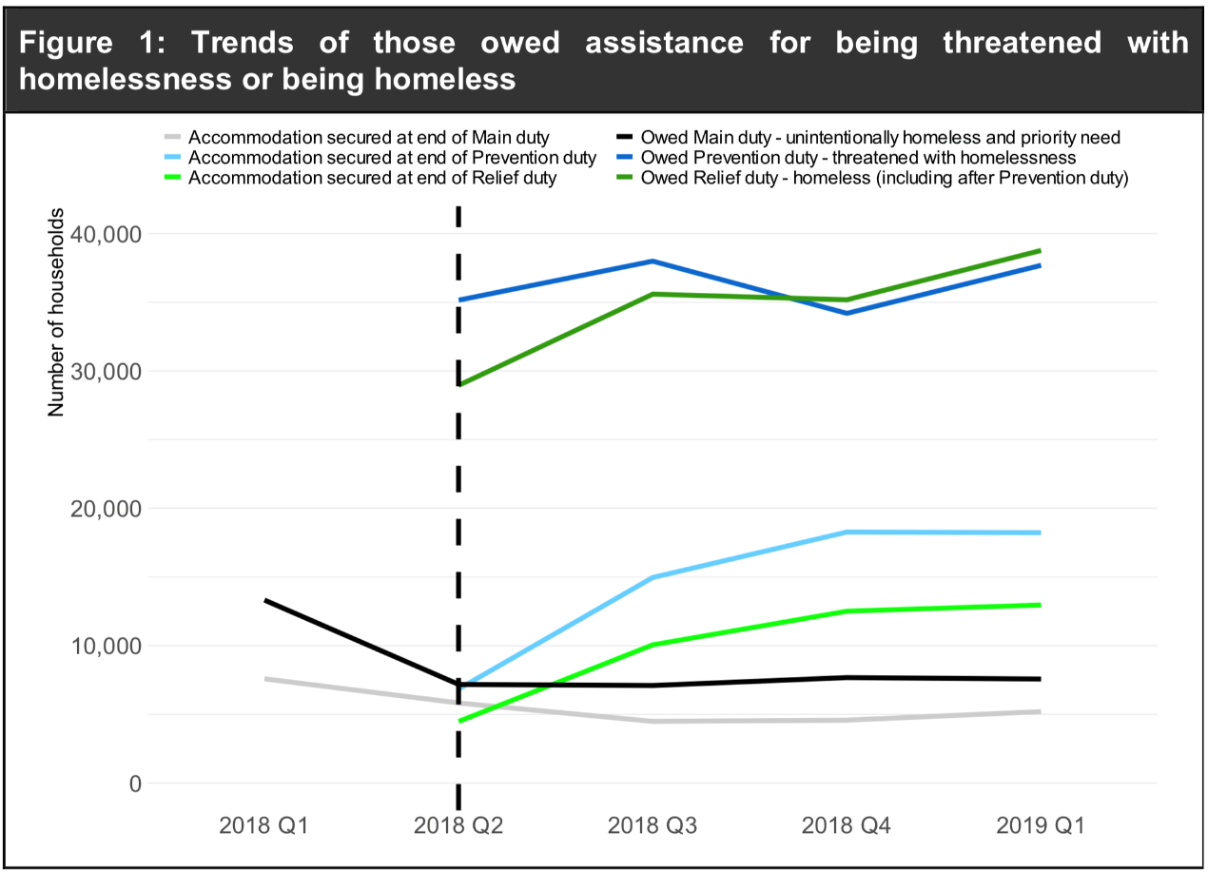

*Source: MHCLG Statutory Homeless Release*

* 1. The following observations can be made from this data and the majority reflect the impact of the HRA in its first year of implementation:
* Over the year from April to June 2018 (Quarter 1) to January to March 2019 (Quarter 4) the number of prevention duties owed increased 7.2%, from 35,150 to 37,690; which would be expected due to the introduction of the HRA, which implemented a prevention duty;
* The number of households where prevention duty ended nearly trebled from 11,030 to 31,930. Of which the number of households who ended the prevention duty with secure accommodation over the year also nearly trebled from 6,840 to 18,220;
* 58% of the 100,800 prevention outcomes during 2018/19 were for accommodation secured. 20% of the outcomes were because the households were homeless;
* From April to June 2018 to January to March 2019 the number of relief duties owed from the initial assessment increased 23.6%, from 26,480 to 32,740;
* The number of households that were homeless at the end of the prevention duty and would be owed a relief duty has more than doubled from 2,470 to 6,030;
* The number of households where the relief duty ended more than doubled from 7,920 to 32,270. Of which the number of households who ended the relief duty with secure accommodation over the year from April to June 2018 to January to March 2019 has also more than doubled from 4,480 to 12,960;
* 43% of the 93,200 relief outcomes during 2018/19 were for accommodation secured. 32% of the outcomes were because 56 days had elapsed and the household was still homeless;
* In the first quarter of 2018/19, main duty acceptances fell. From April to June 2018 to January to March 2019 the number of households owed the main duty has increased 5.4%, from 7,180 to 7,570. This figure has increased over the year due to the lag in households progressing through either/both the prevention and relief duty before reaching an assessment for main duty;
* Between January to March 2019, the most common reason for loss of last settled home was friends or family no longer willing or able to accommodate which accounted for 18,150 households or 25.8% assessed as homeless or threatened with homelessness. The second largest category not including ‘other’ was termination of an assured shorthold tenancy (AST), 14,700 households or 20.9%; and
* 1,780 households were rough sleeping at time of application, 380 of which were in London and 1,400 in the rest of England. This is a 5.8% decrease from the 1,890 households reported in October to December 2018.
  1. The graph below details the number of homeless acceptances quarterly since 1998. The number of main homelessness duty acceptances peaked in Q3 2003 at 35,770 before falling to the previous low of 9,430 in Q4 2009. For Q1 2019 the number of main duty acceptances is 7,570, which has decreased 1.4% from 7,680 in October to December 2018.

Figure 4.2 Homeless acceptances 1998 onwards

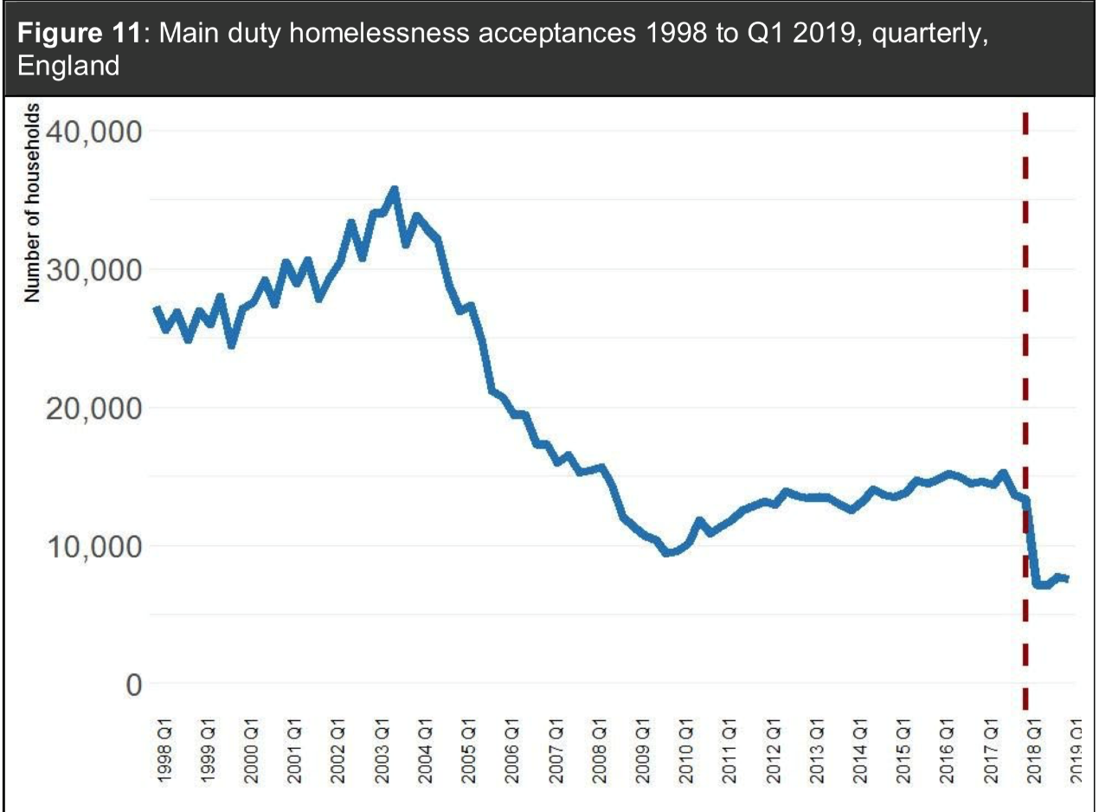

*Source: MHCLG Statutory Homeless Release*

Figure 4.3 Households in temporary accommodation 2002 to 2019

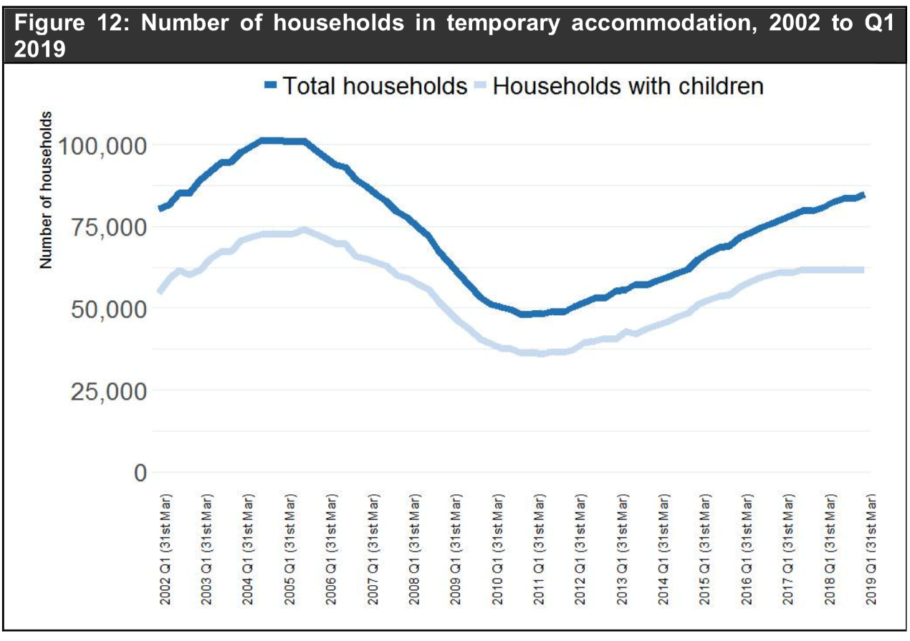

*Source: MHCLG Statutory Homeless Release*

* 1. On 31 March 2019, the total number of households in temporary accommodation arranged by local authorities under homelessness legislation was 84,740. This was 5.0% higher than the 80,720 households reported a year earlier and up 76.5% on the low of 48,010 on 31 December 2010.

## Levels of Homelessness across Cambridgeshire & Peterborough

* 1. Local housing authorities are required to provide homelessness statistics in the forms of quarterly submissions to MHCLG, which records the numbers of households who have approached the council as homeless or threatened with homelessness and what duties are owed. The new Homelessness Case Level Information Classification (H-CLIC) data recording system was developed to record outcomes under the Homelessness Reduction Act. As detailed earlier this data is considered to be experimental, and it is recognised that there may be some variations in the published data compared with local data. To date only the H-CLIC returns for 2018/19 and Q1 of 2019/20 have been published, and these have been published as experimental rather than official or national statistics. Given that this section examines the first year’s data of the new H-CLIC data under the HRA 2017, it is important to understand that there may be issues relating to the quality of the data, therefore some caution should be taken when making comparisons either between local authorities or in comparison to other collected data.
  2. **All of the data contained in this document needs to be read in context. Low figures could result in higher percentages and distort some of the results.**
  3. As stated above this section examines homelessness levels across Cambridgeshire and Peterborough, using H-CLIC data and where possible local data. The same level and quality of data was not provided by all of the local authorities and as such it has not been possible to compare more recent performance, therefore the majority of data that is analysed within this report is a year old and may not reflect current performance. This section is supplemented by individual local authority data analysis reports, which can be found in Appendix E.

### Demand on the Housing Options Service

* 1. The graph below compares demand on the Housing Options services across Cambridgeshire. For many local authorities this information was not compiled prior to the HRA, as such it is not possible to understand the impact of the HRA on overall demand. However, in areas where this was recorded the increase in overall demand following the introduction of the HRA ranged from 26% to 61%. Some of the local authorities felt that the large increase in recorded approaches from people not yet threatened with homelessness within 56 days (‘advice only’ cases) may be due to greater public and agency awareness generated by the introduction of the Act; the ‘duty to refer’, and possibly better recording of pre-statutory presentations.

Graph 4.4 Number of approaches to Housing Options Services across Cambridgeshire



*Source : LA Housing Options*

*\*Includes advice only cases*

* 1. There is no common definition for recording overall demand, and as such it is not possible to make direct comparisons between local authorities. It is recommended that a Cambridgeshire definition is agreed and recorded to ensure meaningful comparisons can be made moving forward.
  2. The graph below compares average caseloads per officer, once again it may not be possible to meaningfully make comparisons across local authorities as some of this data was based on statistics drawn from the Locata system, whereas for others it was either based on officer’s perceptions or based on a range of cases amongst officers. For some local authorities this will include advice cases only, but this is not the case of all of the local authorities. Again, this is an area where a common definition would be beneficial.

Graph 4.5 Number of caseloads per officer (average) across Cambridgeshire Jan/Feb 2020



*Source : LA Housing Options*

*Note: Median number has been used for number of caseloads where a range was given.*

* 1. In most areas staff felt the caseloads had increased following the introduction of the new legislation, linked to both the overall increase in demand together with the length of time that cases remain open under the HRA, initially to a level that was considered unmanageable, however, in most areas managers and officers felt caseloads were now at a manageable level.
  2. It is notable that there is no direct correlation between overall demand and average caseloads. It has not been possible to compare the caseloads in Jan/Feb 2020 to the overall demand using the 2018/19 data as the dates do not correspond, and therefore any analysis would be questionable, however there would be some value in doing this analysis once the full year for 2019/20 was available. Some further analysis of caseloads is made further on in this report.

### Assessments

* 1. The table below compares the number of statutory assessments under the HRA for 2018/19. Assessments are undertaken when the local authority has reason to believe that an applicant is homeless or threatened with homelessness within 56 days. Applicants are assessed as being owed a duty where the local authority is satisfied that the applicant is eligible for assistance and is homeless or threatened with homelessness within 56 days. Those who are threatened with homelessness are owed a ‘prevention duty’ and those who are actually homeless are owed a ‘relief duty’.

|  |  |  |  |  |
| --- | --- | --- | --- | --- |
| Table 4.1 Number of assessments recorded under the HRA 2017 across Cambridgeshire | | | | |
|  | **Assessments** | **Assessed as owed a duty** | **Threatened with homelessness – prevention duty owed** | **Homeless – relief duty owed** |
| Cambridge | 682 | 620 | 302 | 318 |
| South Cambridgeshire | 511 | 498 | 338 | 160 |
| East Cambridgeshire | 456 | 435 | 342 | 93 |
| Fenland | 663 | 631 | 370 | 261 |
| Huntingdonshire | 971 | 958 | 587 | 371 |
| Peterborough | 1,135 | 1,100 | 442 | 658 |

*Source : MHCLG HCLIC data*

Graph 4.6 Number of assessments recorded under the HRA 2017 across Cambridgeshire 2018/19

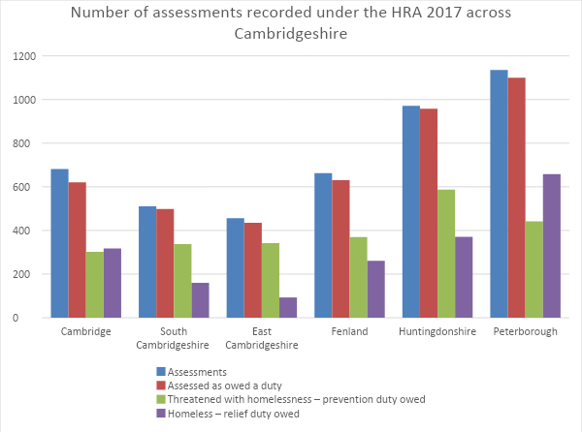

*Source : MHCLG HCLIC data*

* 1. The highest level of recorded assessments and duties owed are in Peterborough and Huntingdonshire.
  2. The graph below compares the overall service demand against the number of assessments. It is notable that a very high level of overall service demand does not result in a statutory assessment in all of the authorities, but this variation is very stark in Cambridge, Fenland and Peterborough. From the data provided it is not clear how many of these are advice only cases, or how many of these are threatened with homelessness prior to 56 days and are referred to the Trailblazer team. This may warrant some further investigation.

Graph 4.7 Comparison of demand and assessments under the HRA 2017 across Cambridgeshire 2018/19

*Source : MHCLG H-CLIC data and Local Authority data*

* 1. The table below breaks down the number of households that the local authorities are working with under a prevention duty compared with a relief duty for 2018/19.

|  |  |  |
| --- | --- | --- |
| Table 4.2 Number of households LAs are working with under the different duties | | |
| **Local Authority** | **% owed a prevention duty** | **% owed a relief duty** |
| Cambridge | 48% | 52% |
| South Cambridgeshire | 68% | 32% |
| East Cambridgeshire | 78% | 21% |
| Fenland | 59% | 41% |
| Huntingdonshire | 61% | 39% |
| Peterborough | 40% | 60% |

*Source : MHCLG H-CLIC data*

Figure 4.8 Comparison of prevention and relief duties across Cambridgeshire 2018/19

*Source : MHCLG H-CLIC data*

* 1. In South Cambridgeshire, East Cambridgeshire, Fenland and Huntingdonshire the local authorities are working with a larger proportion of clients under a prevention duty. This suggests a significant proportion of clients are coming in when threatened with homelessness enabling opportunities for prevention to be maximised, and that responses from the team are timely.
  2. In Cambridge the service is working with a slightly higher proportion of clients under a relief duty, although data from the service shows that the team is working with a significant number of clients prior to the statutory threat of homelessness, and as such these do not show within the H-CLIC data.
  3. In Peterborough the service is working with significantly more people under relief than prevention. Local information indicates a number of barriers that customers face in being able to access the Housing Options service in a timely fashion, this may impact upon the above data, as too does the fact that the service is currently struggling to do prevention work due to capacity and system issues, resulting in people moving from prevention to relief.
  4. Across Cambridgeshire and Peterborough it is essential to encourage customers to seek help from the Housing Options teams at the earliest point in order for opportunities for effective early intervention and prevention to be maximised, and to ensure that the systems and resources are in place to focus on prevention.

### Duty to Refer

* 1. The table below details the number of referrals received under the new ‘Duty to Refer’ which came into force in October 2018.

|  |  |
| --- | --- |
| Table 4.3 No of Referrals received under Duty to Refer | |
| **Local Authority** | **‘Duty to Refer’ received** |
| Cambridge | 231 |
| South Cambridgeshire | 82 |
| East Cambridgeshire | 46 |
| Fenland | 70 |
| Huntingdonshire | 70 |
| Peterborough | - |

*Source : Local Authority Housing Options data*

* 1. Information from local authority teams largely felt that the Duty to Refer was not working as well as it could, with a view that a higher number of referrals, and more timely referrals were needed. There is a need to work with key public bodies across Cambridgeshire and Peterborough to ensure that the quality and number of referrals improves, with a particular focus on making referrals at prevention stage in order to maximise opportunities for effective prevention work.

### Profile of Homeless Households

* 1. The family composition of households owed prevention and relief duties are detailed in the graph below.

Graph 4.9 Percentage of household composition owed both a prevention and relief duty across Cambridgeshire 2018/19

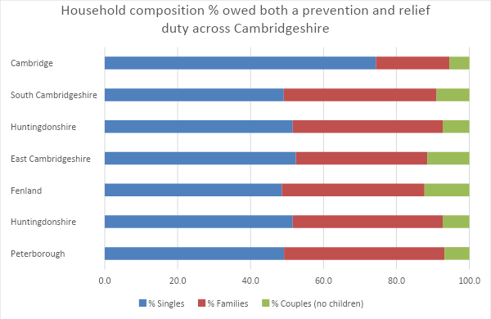

*Source : MHCLG HCLIC data*

* 1. Under the HRA, all of the local authorities reported working with a much larger proportion of single people than under the previous legislation. In most areas single people account for around half of all customers owed a duty, in Cambridge it is notably higher than this with single people accounting for nearly 75% of all those owed a prevention or relief duty.
  2. The tables and graphs below show the household composition of those households owed a prevention duty in 2018/19.

|  |  |  |  |  |  |  |
| --- | --- | --- | --- | --- | --- | --- |
| Table 4.4 Household composition split between singles and families owed a prevention duty across Cambridgeshire 2018/19 | | | | | | |
|  | **No. of Singles – owed a prevention duty** | **No. of Families – owed a prevention duty** | **No. of Couples (no children) – owed a prevention duty** | **% Singles – owed a prevention duty** | **% Families – owed a prevention duty** | **% Couples (no children) – owed a prevention duty** |
| Cambridge | 204 | 74 | 24 | 67.5 | 24.5 | 7.9 |
| South Cambridgeshire | 152 | 154 | 32 | 45.0 | 45.6 | 9.5 |
| East Cambridgeshire | 163 | 134 | 45 | 47.7 | 39.2 | 13.2 |
| Fenland | 129 | 188 | 52 | 35.0 | 50.9 | 14.1 |
| Huntingdonshire | 244 | 289 | 54 | 41.6 | 49.2 | 9.2 |
| Peterborough | 178 | 227 | 37 | 40.3 | 51.4 | 8.4 |

*Source : MHCLG HCLIC data*

Graph 4.10 Household composition owed a prevention duty

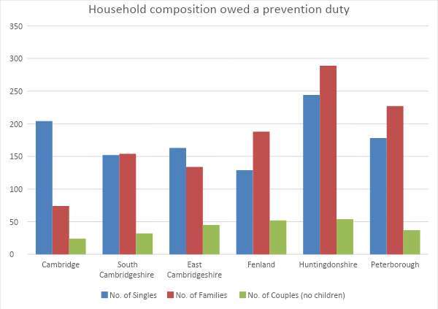

* 1. With the exception of Cambridge and East Cambridgeshire, families make up the largest proportion of those owed a prevention duty, this may indicate that families are more likely to approach the local authority for assistance before they actually become homeless. This contrasts to the table and graphs below which detail the family composition of those households who are owed a relief duty. Single households are significantly over-represented in the homeless population across Cambridgeshire and Peterborough at relief stage. It appears that single people are more likely to approach the service once they are already homeless. More work may need to be done to raise awareness of the service with single people to ensure that they approach the service when there is a threat of homelessness as opposed to once they become homeless.
  2. It is also possible that homelessness may be more difficult to prevent for single people due to a combination of the limited affordable housing options available to single people and the increasing complexity of need that many single people may present with, it is therefore possible that more single people may be moving from prevention to relief. There would be value in undertaking some more detailed data analysis to understand if this is the case by tracking single cases to understand the extent to which they transition from prevention to relief.

|  |  |  |  |  |  |  |
| --- | --- | --- | --- | --- | --- | --- |
| Table 4.5 Household composition split between singles and families owed a relief duty across Cambridgeshire 2018/19 | | | | | | |
|  | **No. of Singles – owed a relief duty** | **No. of Families – owed a relief duty** | **No. of Couples (no children) – owed a relief duty** | **% Singles – owed a relief duty** | **% Families – owed a relief duty** | **% Couples (no children) – owed a relief duty** |
| Cambridge | 257 | 51 | 10 | 80.8 | 16.0 | 3.1 |
| South Cambridgeshire | 94 | 56 | 13 | 57.7 | 34.4 | 8.0 |
| East Cambridgeshire | 65 | 23 | 5 | 69.9 | 24.7 | 5.4 |
| Fenland | 175 | 57 | 25 | 68.1 | 22.2 | 9.7 |
| Huntingdonshire | 250 | 105 | 16 | 67.4 | 28.3 | 4.3 |
| Peterborough | 363 | 257 | 38 | 55.2 | 39.1 | 5.8 |

*Source : MHCLG HCLIC data*

Graph 4.11 Household composition owed a relief duty

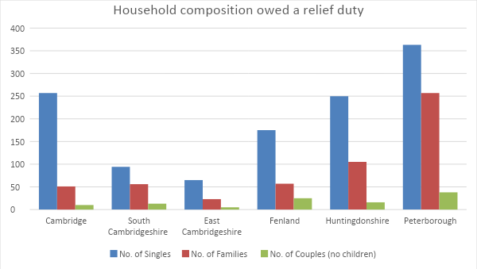

*Source : MHCLG HCLIC data*

### Support Needs

* 1. The table and graph below detail the number of households with a self-identified support need.

|  |  |  |
| --- | --- | --- |
| Table 4.6 Number of households with a support need across Cambridgeshire 2018/19 | | |
|  | **Households with a support need** | **Total support needs** |
| Cambridge | 288 | 746 |
| South Cambridgeshire | 212 | 515 |
| East Cambridgeshire | 348 | 907 |
| Fenland | 497 | 1,546 |
| Huntingdonshire | 151 | 261 |
| Peterborough | 380 | 680 |

*Source : MHCLG HCLIC data*

Graph 4.12 Number of households with a support need across Cambridgeshire

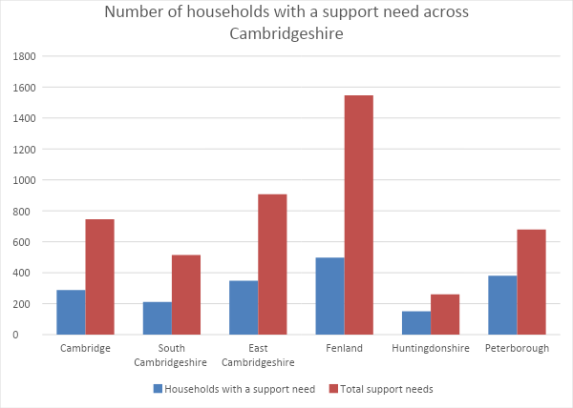

*Source : MHCLG HCLIC data*

* 1. There is a very considerable variation in the number of clients with a support need, and the total number of support needs identified. The table below details the percentage of all clients owed a duty who have a support need.

|  |  |
| --- | --- |
| Table 4.7 Percentage of clients owed a duty with a support need | |
| **Local Authority** | **% of all clients with a support need** |
| Cambridge | 46% |
| South Cambridgeshire | 43% |
| East Cambridgeshire | 80% |
| Fenland | 79% |
| Huntingdonshire | 16% |
| Peterborough | 35% |

*Source : MHCLG HCLIC data*

* 1. This considerable variation indicates that there is likely to be some difference in local interpretation and recording of support needs, improving consistency in interpretation and recording will enable more meaningful comparisons to be made moving forward.
  2. The most prevalent support need for all six authorities was mental health; other frequently occurring support needs include offending history, domestic abuse, repeat homelessness, physical ill health and history of rough sleeping.
  3. Information from all of the Housing Options teams indicates that there are a very high number of complex cases, including both single people and families with multiple and challenging needs. The Housing Options service has struggled to find sustainable solutions for these households. There is currently no way of recording the number of complex cases, or indeed no definition of what qualifies as a complex case.
  4. There is a need to have a better quantitative understanding of the volume of complex cases, alongside understanding if existing provision meets the needs of these customers.

### Hidden Homelessness

* 1. The table and graph below details applicants who may be hidden homeless.

|  |  |  |  |  |  |  |
| --- | --- | --- | --- | --- | --- | --- |
| Table 4.8 Number of applicants who may be hidden homeless across Cambridgeshire | | | | | | |
|  | **2018/19** | | | **2019/20 (Q1+2)** | | |
| NFA | Living with friends | Living with family | NFA | Living with friends | Living with family |
| Cambridge | 61 | 114 | 61 |  |  |  |
| South Cambridgeshire | 43 | 99 | 104 |  |  |  |
| East Cambridgeshire | 33 | 39 | 119 | 19 | 16 | 58 |
| Fenland | 103 | 46 | 147 | 152 | 216 | |
| Huntingdonshire | 108 | 109 | 289 | 43 | 35 | 120 |
| Peterborough | 65 | 102 | 269 |  |  |  |

*Source : MHCLG HCLIC data*

Graph 4.13 Number of applicants who may be hidden homeless

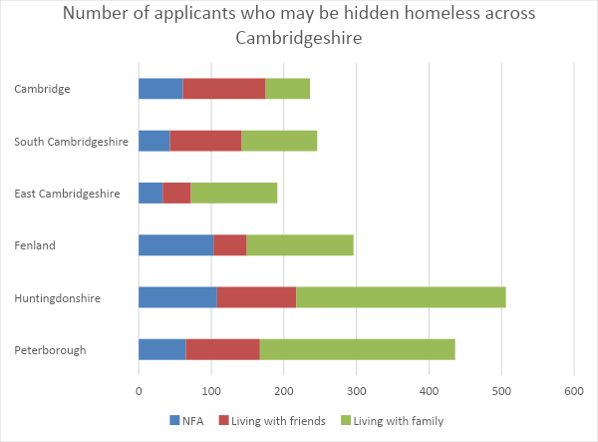

*Source : MHCLG HCLIC data*

* 1. While this only provides an indication to the extent of hidden homelessness and there is considerable variation across the county, there are high numbers in all of the areas of people living with family and friends.

### Reasons for Homelessness

* 1. The table below details the main causes of homelessness for those owed a prevention and relief duty.

|  |  |  |  |  |  |  |
| --- | --- | --- | --- | --- | --- | --- |
| Table 4.9 Reasons for homelessness across Cambridgeshire 2018/19 | | | | | | |
|  | Cambridge | South Cambridgeshire | East Cambridgeshire | Fenland | Huntingdonshire | Peterborough |
| Family or friends no longer willing or able to accommodate | 108 | 69 | 110 | 147 | 247 | 261 |
| End of private rented tenancy – assured shorthold | 79 | 102 | 76 | 161 | 187 | 249 |
| Domestic Abuse | 53 | 47 | 29 | 32 | 63 | 67 |
| Non-violent relationship breakdown | 55 | 58 | 66 | 60 | 90 | 100 |
| End of social rented tenancy | 37 | 49 | 33 | 16 | 112 | 86 |
| Eviction from supported housing | 54 | 2 | 3 | 26 | 40 | 19 |
| End of private rented tenancy – not assured shorthold | 21 | 11 | 10 | 23 | 32 | 14 |
| Other violence or harassment | 16 | 10 | 6 | 11 | 27 | 9 |
| Left institution with no accommodation available | 13 | 2 | 3 | 13 | 22 | 28 |
| Required to leave accommodation provided by Home Office as asylum support | 3 | 0 | 0 | 0 | 0 | 16 |
| Other Reasons | 181 | 148 | 99 | 142 | 138 | 171 |

*Source : MHCLG HCLIC data*

* 1. There is a very high level of cases recorded as other reasons in all of the authorities, this indicates a data recording issue that may need to be addressed to ensure an accurate and detailed understanding of the causes of homelessness across Cambridgeshire and Peterborough.
  2. The graph below illustrates the top 5 main causes of homelessness for each of the local authorities in 2018/19.
  3. Family and friends no longer willing to accommodate and the end of private rented accommodation are the top two causes of homelessness in every local authority.
  4. Relationship breakdown features as a main cause of homelessness for all of the Local authorities, although domestic abuse only features in the top 5 causes in Fenland, although the numbers remain significant in all of the other local authorities.
  5. It is notable that the loss of social housing is one of the main causes of homelessness for four of the local authorities and that the loss of supported accommodation is a significant cause of homelessness in Cambridge.

Graph 4.14 Top five reasons for homelessness across LAs

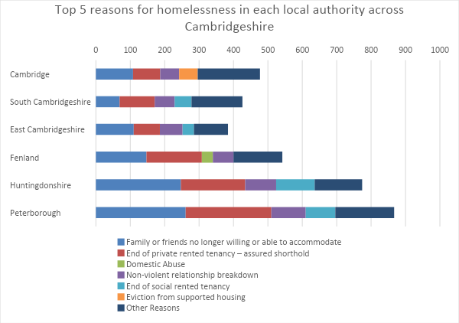

*Source : MHCLG HCLIC data*

* 1. The table below illustrates the two main causes of homelessness for each of the local authorities as a percentage of all duties owed for 2018/19.

|  |  |  |
| --- | --- | --- |
| Table 4.10 Two main causes of homelessness for each LA | | |
| **Local Authority** | **Family or friends no longer willing to accommodate** | **Loss of private rented accommodation** |
| Cambridge | 17% | 13% |
| South Cambridgeshire | 14% | 20% |
| East Cambridgeshire | 25% | 17% |
| Fenland | 23% | 26% |
| Huntingdonshire | 26% | 20% |
| Peterborough | 24% | 23% |

*Source : MHCLG HCLIC data*

* 1. The loss of private rented accommodation is the main cause of homelessness in Fenland and South Cambridgeshire, and the second main cause in the other authorities. Friends and family no longer willing to accommodate is the main cause of homelessness in Cambridge, East Cambridgeshire, Huntingdonshire and Peterborough, and the second main cause for the remaining two authorities.
  2. The graph and table below show the number of evictions from social housing taken from questionnaires completed by the main housing providers over the last four years.
  3. There is some variation across the county, however in many areas evictions from social housing have increased in recent years. It has not been possible to calculate eviction rates against the proportion of social housing stock, and if this can be done it would provide more meaningful comparative data. However, there is the potential to learn from those providers with lower levels of eviction. There is a particular need to consider how social housing evictions can be reduced in Peterborough, Cambridge and Fenland.

Figure 4.15 Number of evictions by reason for each LA between 2015-2019

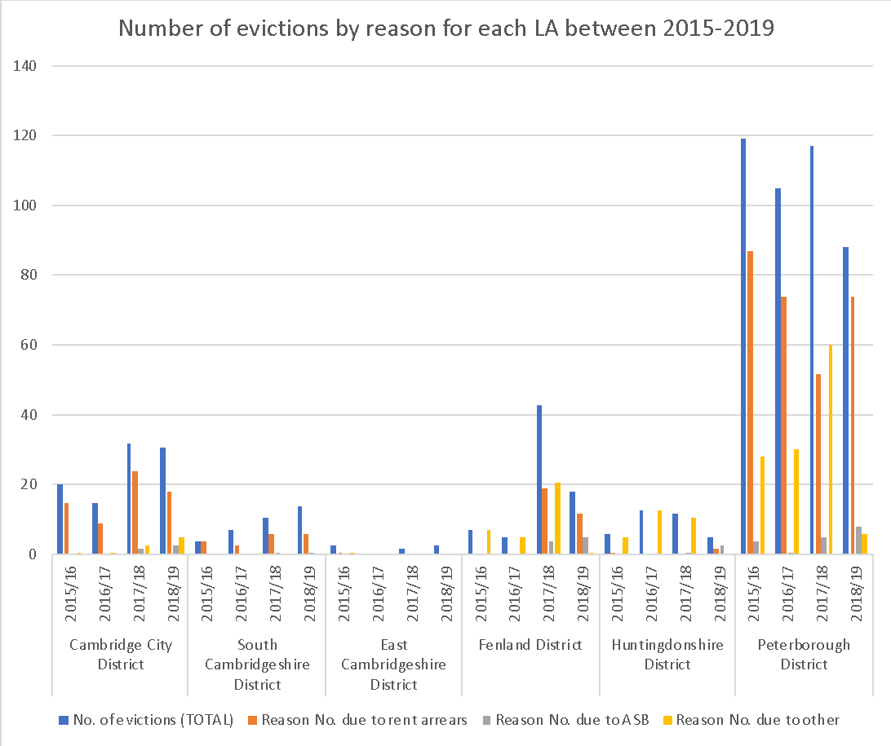

|  |  |  |  |  |  |  |
| --- | --- | --- | --- | --- | --- | --- |
| Table 4.11 Number of evictions by reason for each LA between 2015-2019 | | | | | | |
| **District** | **Financial Year** | **No. of evictions**  **(TOTAL)** | **Reason** | | | |
|  | | | No. due to  rent arrears | No. due to ASB | No. due to other | Other: |
| Cambridge City | 2015/16 | 20 | 15 | 0 | 1 | Abandoned |
| 2016/17 | 15 | 9 | 0 | 1 | Abandoned |
| 2017/18 | 32 | 24 | 2 | 3 | Abandoned |
| 2018/19 | 31 | 18 | 3 | 5 | Abandoned |
| South Cambridgeshire | 2015/16 | 4 | 4 | 0 | 0 |  |
| 2016/17 | 7 | 3 | 0 | 0 |  |
| 2017/18 | 11 | 6 | 1 | 0 |  |
| 2018/19 | 14 | 6 | 1 | 0 |  |
| East Cambridgeshire | 2015/16 | 3 | 1 | 0 | 1 | Reason Not Given |
| 2016/17 | 0 | 0 | 0 | 0 |  |
| 2017/18 | 2 | 0 | 0 | 0 |  |
| 2018/19 | 3 | 0 | 0 | 0 |  |
| Fenland | 2015/16 | 7 | 0 | 0 | 7 | Reason Not Given |
| 2016/17 | 5 | 0 | 0 | 5 | Reason Not Given |
| 2017/18 | 43 | 19 | 4 | 21 | Reason Not Given; Detail not recorded |
| 2018/19 | 18 | 12 | 5 | 1 | Abandonment |
| Huntingdonshire | 2015/16 | 6 | 1 | 0 | 5 | Reason Not Given |
| 2016/17 | 13 | 0 | 0 | 13 | Reason Not Given |
| 2017/18 | 12 | 0 | 1 | 11 | Reason Not Given |
| 2018/19 | 5 | 2 | 3 | 0 |  |
| Peterborough | 2015/16 | 119 | 87 | 4 | 28 | Reason Not Given |
| 2016/17 | 105 | 74 | 1 | 30 | Non Conversion; Reason Not Given |
| 2017/18 | 117 | 52 | 5 | 60 | Detail not recorded; Reasons Not Given; Shared ownership repossession |
| 2018/19 | 88 | 74 | 8 | 6 | Abandonment; Tenancy Fraud |

* 1. Housing association colleagues were invited to participate in a questionnaire survey aimed at identifying a range of information based on their views to more fully understand homelessness across the area and to seek views on Housing Options. Only 8 responded, and only 3 completed the full questionnaire. Full details of their responses can be found in Appendix F.
  2. All of the 8 respondents indicated they work with the local Housing Options when a tenant is threatened with eviction. One organisation was clear that it is written into their internal policies and procedures that Housing Options and/or Homelessness Teams must be contacted prior to eviction.
  3. In relation to the biggest challenges for social housing tenants to successfully maintain their tenancies the following issues were identified:
* Rental payments / Household debt;
* Universal credit / benefit cuts and sanctions;
* Failure to engage when support is initially offered or provided resulting in actions being taken too late; and
* Lack of engagement with court orders and injunctions.
  1. In terms of the services and support offered by housing associations respondents indicated they make the following type of services available:
* Tenancy sustainment teams;
* Neighbourhood Managers;
* Income / Money Advisors;
* Tenancy Support Workers;
* Rough Sleeper Tenancy Support Worker; and
* Members of Multi-Tasking Group (MASG).

### Targeted Interventions at the Main Causes of Homelessness

* 1. Targeted interventions need to be put in place against the main causes of homelessness:

#### Loss of Private Rented Accommodation

* 1. There is a need to ensure that there is a much more targeted approach to preventing people losing their home in the private rented sector. Both landlords and tenants need to be able to access immediate support and advice as soon as difficulties arise in the tenancy. Landlord and tenant liaison/mediation alongside a dedicated resource to resolve any difficulties at the outset will provide an important prevention tool.

#### Family/Friends Evicting

* 1. There is also a need to ensure a much more targeted and pro-active response for households who are being asked to leave by family or friends. Effective and timely mediation, together with home visits, and planned moves into alternative accommodation should be introduced.
  2. Home visits varied across areas, but no local authority consistently conducted home visits in every case of parents/family evicting. Home visits, mediation and use of the Lettings Policy to support planned moves should be put in place.

#### Non-violent Relationship Breakdown

* 1. Access to mediation and relationship counselling services may assist in preventing homelessness, and buying time to enable planned moves into alternative accommodation, again use of the Lettings Policy to support planned moves is likely to reduce emergency cases of homelessness.

#### Domestic Abuse

* 1. Timely access to a range of options, including emergency provision and support, floating support, planned moves and target hardening may assist in helping to prevent and resolve homelessness.

#### Eviction from social housing

* 1. Pre-eviction protocols need to be put in place with all social landlords operating across Cambridgeshire and Peterborough, to ensure that timely referrals are put in place to notify the Housing Options team of any intended eviction activity. More detailed recommendations in relation to social housing evictions are detailed later on within this report.

#### Eviction from supported housing

* 1. Pre-eviction protocols need to be developed between the Housing Options team and support providers to ensure that timely referrals can be made. The county council should also work with providers to reduce evictions and abandonments and share good practice in relation to preventing evictions due to behavioural issues i.e. restorative approaches.

### Prevention and Relief Outcomes

#### Prevention Outcomes

* 1. The table and graph below detail the number of positive prevention outcomes compared to those owed a prevention duty.

|  |  |  |  |
| --- | --- | --- | --- |
| Table 4.12 Total number of cases prevented and success rate across Cambridgeshire | | | |
|  | **Households owed prevention duty** | **Secured accommodation for 6+ months** | **% of successful prevention** |
| Cambridge | 238 | 128 | 53.8 |
| South Cambridgeshire | 286 | 180 | 62.9 |
| East Cambridgeshire | 291 | 184 | 63.2 |
| Fenland | 320 | 200 | 62.5 |
| Huntingdonshire | 452 | 283 | 62.6 |
| Peterborough | 340 | 163 | 47.9 |

Source: MHCLG HCLIC data

Graph 4.16 Number of cases owed a prevention duty vs accommodation secured

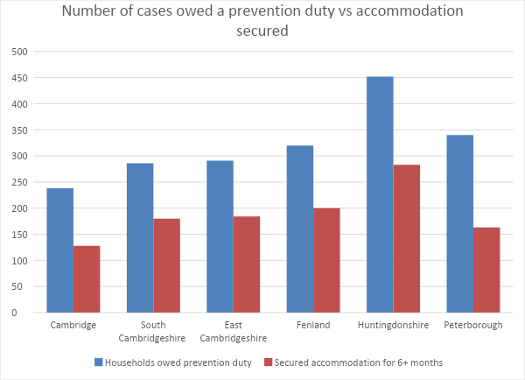

Source: MHCLG HCLIC data

* 1. In 2018/19 the national successful prevention rate was 58%, four of the Cambridgeshire authorities achieved a higher success rate than this. Cambridge’s success rate is slightly lower than the national prevention rate, however, it is noted that the team achieves a number of successful prevention outcomes prior to the 56 day threat of homelessness which does not feature on the H-CLIC data. Peterborough’s success rate is significantly lower than the national average.

Graph 4.17 Comparison of successful prevention rate to national prevention rate

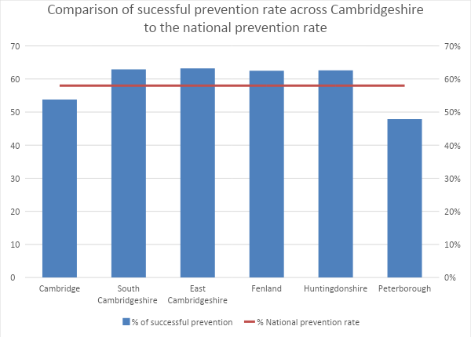

Source: MHCLG HCLIC data

* 1. The table below details the type of accommodation secured to successfully prevent homelessness. Social housing was the most successful prevention outcome in Cambridge, South Cambridgeshire, East Cambridgeshire, and Huntingdonshire. Private rented accommodation is the most successful prevention outcome achieved in Fenland and Peterborough.

|  |  |  |  |  |  |  |  |
| --- | --- | --- | --- | --- | --- | --- | --- |
| Table 4.13 Type of accommodation secured across Cambridgeshire 2018/19 | | | | | | | |
|  | **Social housing** | **Private rented sector** | **Staying with family** | **Staying with friends** | **Owner Occupier** | **Other** | **Not known** |
| Cambridge | 74 | 43 | 6 | 4 | 1 | 0 | 0 |
| South Cambridgeshire | 110 | 47 | 10 | 3 | 0 | 3 | 7 |
| East Cambridgeshire | 78 | 72 | 23 | 1 | 3 | 5 | 2 |
| Fenland | 46 | 125 | 19 | 3 | 0 | 4 | 3 |
| Huntingdonshire | 207 | 63 | 7 | 3 | 0 | 0 | 3 |
| Peterborough | 50 | 84 | 18 | 6 | 1 | 4 | 0 |

Source: MHCLG HCLIC data

* 1. The services are generally more successful in helping households to secure alternative accommodation rather than enabling them to remain in their existing accommodation. In order to improve prevention outcomes, the service should work with customers at the earliest stage possible to identify if early intervention work would enable them to remain in their existing accommodation.
  2. While family/friends evicting is the one of main causes of homelessness across Cambridgeshire and Peterborough there are very few recorded outcomes where homelessness is being prevented through successful negotiation/mediation work to secure the return to family and friends. This is a possible area for future focus to ensure a more targeted approach to preventing homelessness due to this cause.

#### Relief Outcomes

* 1. The table and graph below detail the number of positive prevention outcomes compared to those owed a prevention duty.

|  |  |  |  |
| --- | --- | --- | --- |
| Table 4.14 Total number of cases relieved and success rate across Cambridgeshire | | | |
|  | **Households owed relief duty** | **Secured accommodation for 6+ months** | **% of successful prevention** |
| Cambridge | 292 | 121 | 41.4 |
| South Cambridgeshire | 193 | 65 | 33.7 |
| East Cambridgeshire | 108 | 44 | 40.7 |
| Fenland | 258 | 117 | 45.3 |
| Huntingdonshire | 383 | 122 | 31.9 |
| Peterborough | 445 | 157 | 35.3 |

Source: MHCLG HCLIC data

Graph 4.18 Number of cases owed a relief duty vs accommodation secured

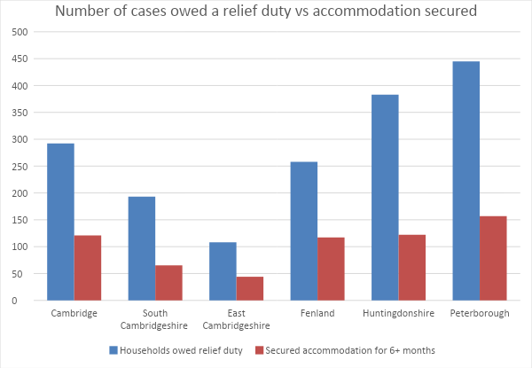

Source: MHCLG HCLIC data

* 1. In 2018/19 the national successful prevention rate was 43%, only Fenland has a relief rate higher than this, with Cambridge and East Cambridgeshire close to this level, and Huntingdonshire, South Cambridgeshire and Peterborough significantly below this rate.

Graph 4.19 Comparison of successful relief rate to national relief rate

Source: MHCLG HCLIC data

* 1. The table below details the type of accommodation secured to successfully relieve homelessness. Social housing was the most successful relief outcome in all of the local authority areas, and private rented accommodation the second most successful. In some areas there are a high number of outcomes recorded as not known, suggesting a data recording issue that needs to be addressed.

|  |  |  |  |  |  |  |  |
| --- | --- | --- | --- | --- | --- | --- | --- |
| Table 4.15 Type of accommodation secured across Cambridgeshire 2018/19 | | | | | | | |
|  | **Social housing** | **Private rented sector** | **Staying with family** | **Staying with friends** | **Owner Occupier** | **Other** | **Not known** |
| Cambridge | 51 | 23 | 2 | 0 | 0 | 5 | 40 |
| South Cambridgeshire | 14 | 9 | 1 | 1 | 0 | 1 | 39 |
| East Cambridgeshire | 17 | 15 | 0 | 1 | 0 | 1 | 10 |
| Fenland | 44 | 36 | 9 | 7 | 0 | 3 | 18 |
| Huntingdonshire | 50 | 15 | 3 | 0 | 1 | 0 | 56 |
| Peterborough | 67 | 59 | 14 | 7 | 0 | 8 | 2 |

Source: MHCLG HCLIC data

* 1. There may be opportunities to improve both prevention and relief outcomes by improving access to the private rented sector, although it is recognised that there are significant affordability issues in relation to this.

### Main Duty Decisions

* 1. The table below details the number of main duty decisions for households where homelessness could not be prevented or relieved.

|  |  |  |  |  |  |
| --- | --- | --- | --- | --- | --- |
| Table 4.16 Main duty decisions for households where homelessness could not be prevented or relieved | | | | | |
|  | **Total main duty decisions** | **Homeless + priority need + unintentionally homeless (acceptance)** | **Homeless + priority need + intentionally homeless** | **Homeless + no priority need** | **Not homeless** |
| Cambridge | 136 | 65 | 27 | 24 | 20 |
| South Cambridgeshire | 132 | 87 | 15 | 19 | 11 |
| East Cambridgeshire | 35 | 20 | 2 | 12 | 1 |
| Fenland | 54 | 34 | 5 | 13 | 2 |
| Huntingdonshire | 227 | 189 | 6 | 30 | 2 |
| Peterborough | 508 | 381 | 34 | 84 | 9 |

Source: MHCLG HCLIC data

* 1. The table and graph below compare the number of main duty decisions and acceptances as a percentage of all duties owed, which enables more detailed and meaningful comparisons.

|  |  |  |  |  |
| --- | --- | --- | --- | --- |
| Table 4.17 Comparison of main duty decisions and acceptances | | | | |
| **Local Authority** | **Total number of main duty decisions** | **% of all assessments that result in a main duty decision** | **Total number of s.193 duties owed** | **% of all assessments that result in a s.193 duty being owed** |
| Cambridge | 136 | 22% | 65 | 10% |
| South Cambridgeshire | 132 | 27% | 87 | 17% |
| East Cambridgeshire | 35 | 8% | 20 | 5% |
| Fenland | 54 | 8.5% | 34 | 5% |
| Huntingdonshire | 227 | 24% | 189 | 20% |
| Peterborough | 508 | 46% | 381 | 35% |

*Source : MHCLG HCLIC data*

Graph 4.20 Comparison of main duty decisions and acceptances

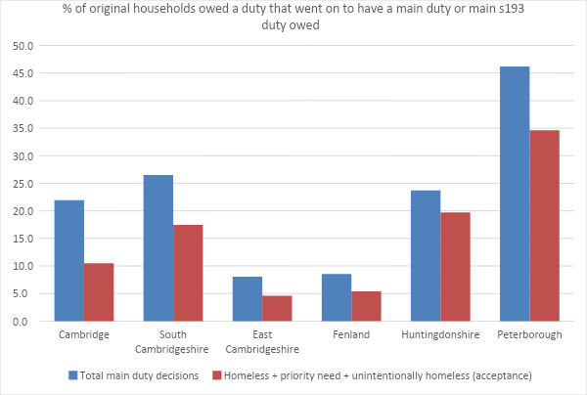

Source: MHCLG HCLIC data

* 1. Three of the local authorities are making full duty decisions for around a quarter of all those owed an initial duty; this is considerably lower for the other two authorities at around 8%. Peterborough is making final duty decisions for almost 50% of all those owed an initial duty.
  2. Both East Cambridgeshire and Fenland have a very low percentage of cases (5%) that result in a s193 (full duty) being owed. This varies significantly across the county with two of the authorities having close to 20% of total assessments resulting in a full duty being accepted and one has around a third resulting in a full duty being accepted.
  3. The reason for this significant variation is not fully understood. A combination of data is examined below and it does suggest for the two authorities with the highest number of duties owed, a bigger proportion of these clients go on to have a full duty owed. Both Huntingdonshire and Peterborough owed approximately 1,000 households an initial duty, and 35% of these went on to have a full duty owed in Peterborough and 20% in Huntingdonshire. However, in South Cambridgeshire a total of just under 500 households were owed an initial duty and 17% went on to have a full duty owed.
  4. Fenland owed the third highest number of initial duties with only 5% of these going on to be owed a full duty, it also has the highest combined level of successful prevention and relief outcomes as an overall percentage of cases owed. It is also of note that despite a similar level of initial duties being owed the total number of temporary accommodation placements is significantly lower in Fenland than in Cambridge.

|  |  |  |  |  |  |
| --- | --- | --- | --- | --- | --- |
| Table 4.18 Number of duties owed and outcomes | | | | | |
| **Local Authority** | **Total number of prevention and relief duties owed** | **Successful prevention outcomes** | **Successful relief outcomes** | **Annual TA placements** | **Number of assessments that result in a s.193 duty being owed and % of all those owed a duty** |
| Cambridge | 620 | 128 (54%) | 121 (41%) | 249 | 65 (10%) |
| South Cambridgeshire | 498 | 180 (63%) | 65 (34%) | 108 | 87 (17%) |
| East Cambridgeshire | 435 | 184 (63%) | 44 (41%) | 41 | 20 (5%) |
| Fenland | 631 | 200 (63%) | 117 (46%) | 69 | 34 (5%) |
| Huntingdonshire | 958 | 283 (63%) | 122 (32%) | 426 | 189 (20%) |
| Peterborough | 1,100 | 163 (48%) | 157 (35%) | - | 381 (35%) |

* 1. The table and graph below detail how the main s193 duty was brought to an end. The majority of households were offered social housing under part 6 of the Housing Act 1996. A very low number of households had the full duty discharged through an offer of private rented accommodation, an increased focus on this area may help local authorities to move households on from temporary accommodation. A private sector discharge policy, whereby households know that the full duty may be ended by an offer of private rented accommodation, may encourage households to consider offers of private rented accommodation earlier on in the process.

|  |  |  |  |  |
| --- | --- | --- | --- | --- |
| Table 4.19 Outcomes of households no longer owed a duty | | | | |
|  | **Housing Act 1996 Pt6 social housing offer** | | **Private rented sector offer** | |
| Accepted | Refused | Accepted | Refused |
| Cambridge | 72 | 3 | 0 | 0 |
| South Cambridgeshire | 51 | 13 | 12 | 0 |
| East Cambridgeshire | 10 | 1 | 4 | 0 |
| Fenland | 42 | 0 | 2 | 0 |
| Huntingdonshire | 158 | 2 | 2 | 0 |
| Peterborough |  |  |  |  |

Source: MHCLG HCLIC data

Graph 4.21 Outcome of households no longer owed a duty



Source: MHCLG HCLIC data

* 1. There is a need to ensure that there is a much more targeted approach to preventing people losing their home in the private rented sector. Both landlords and tenants need to be able to access immediate support and advice as soon as difficulties arise in the tenancy. Landlord and tenant liaison/mediation alongside a dedicated resource to resolve any difficulties at the outset will provide an important prevention tool.

#### Family/Friends Evicting

* 1. There is also a need to ensure a much more targeted and pro-active response for households who are being asked to leave by family or friends. Effective and timely mediation, together with home visits, and planned moves into alternative accommodation should be introduced.
  2. Home visits varied across areas, but no local authority consistently conducted home visits in every case of parents/family evicting. Home visits, mediation and use of the Lettings Policy to support planned moves should be put in place. Information from MHCLG suggests that many local authorities have implemented home visits in the case of parental evictions and there is evidence to suggest that this approach achieves improved outcomes (Tamworth Council have successfully adopted this approach). It may also be worth exploring if these home visits could be undertaken digitally using video web based platforms.

#### Non-violent Relationship Breakdown

* 1. Access to mediation and relationship counselling services may assist in preventing homelessness, and buying time to enable planned moves into alternative accommodation, again use of the Lettings Policy to support planned moves is likely to reduce emergency cases of homelessness.

#### Domestic Abuse

* 1. Timely access to a range of options, including emergency provision and support, floating support, planned moves and target hardening may assist in helping to prevent and resolve homelessness.

#### Eviction from social housing

* 1. Pre-eviction protocols need to be put in place with all social landlords operating across Cambridgeshire and Peterborough, to ensure that timely referrals are put in place to notify the Housing Options team of any intended eviction activity. More detailed recommendations in relation to social housing evictions are detailed later on within this report.

#### Eviction from supported housing

* 1. Pre-eviction protocols need to be developed between the Housing Options team and support providers to ensure that timely referrals can be made. The county council should also work with providers to reduce evictions and abandonments and share good practice in relation to preventing evictions due to behavioural issues i.e. restorative approaches.

|  |
| --- |
| Recommendations  * Develop a Cambridgeshire wide definition to record overall demand on Housing Options services to ensure that meaningful comparisons can be made moving forward. * It is essential to encourage customers to seek help from the Housing Options teams at the earliest point in order for opportunities for effective early intervention and prevention to be maximised, and to ensure that the systems and resources are in place to focus on prevention. * Single people are significantly over-represented at relief stage, a more detailed analysis is needed to understand why and remedial actions should be put in place. * There is a need to work with key public bodies across Cambridgeshire and Peterborough to ensure that the quality and number of referrals improves under ‘Duty to Refer’, with a particular focus on making referrals at prevention stage in order to maximise opportunities for effective prevention work. * Work needs to be done to raise awareness of the Housing Options services with single people to ensure that they approach the service when there is a threat of homelessness as opposed to once they become homeless. * There is need for consistency in identifying and recording support needs across Cambridgeshire and Peterborough. * There is a need to have a better quantitative understanding of the volume of complex cases, alongside understanding if existing provision meets the needs of these customers. * There is a very high level of cases where the cause of homelessness is recorded as other reasons in all of the authorities; this indicates a data recording issue that may need to be addressed to ensure an accurate and detailed understanding of the causes of homelessness across Cambridgeshire and Peterborough. A number of other date recording issues have also been identified. * The main causes of homelessness across Cambridgeshire and Peterborough are loss of private rented accommodation and friends and family evicting, targeted prevention options need to be put in place to address these causes. * Targeted interventions against the main causes of homelessness as detailed on pages 99 – 100 should be implemented. * There is a need for a more focused approach to preventing homelessness due to family and friends evicting. * There is potential to make better use of the private rented sector in bringing the s.193 duty to an end and moving households on from temporary accommodation. |

## Operational Service delivery Overview

* 1. A review of each of the local authority Housing Options and homelessness services was conducted through time spent on site (with the exception of East Cambridgeshire), interviews with managers, focus groups with frontline staff and data analysis. A summary of the individual reviews can be found in Appendix G, together with the focus group notes in Appendix H. The key findings from this work are detailed below.

### Summary of Key Findings

* 1. Overall, all of the authorities, with the exception of one, have very much embraced the prevention agenda, with a focus on delivering positive and sustainable customer outcomes. Following the implementation of the Homelessness Reduction Act all of the authorities have restructured the way in which they work in order to meet their new statutory duties alongside the pressures of increasing customer demand.

### Service Culture

* 1. For all of the Cambridgeshire authorities there is an incredibly strong focus on achieving positive prevention outcomes for clients. Within these teams, staff morale is high and officers are very motivated to achieve the best possible outcomes for customers. Within Peterborough staff morale is low and this is very much linked to the high pressure within the team, which is process driven, rather than outcome focused.

### Structures & Service Delivery

* 1. The structures and staff resources vary significantly across the teams, although all teams increased their frontline staff resource in advance of the Homelessness Reduction Act 2017 in order to respond to both an overall demand in service and an increased paperwork burden.
  2. All of the frontline teams have Housing Options Officers who undertake generic roles which include delivering housing advice, undertaking housing assessments, creating and managing Personal Housing Plans, prevention and relief casework and final determinations. This approach provides a streamlined process, ensuring that customers have one officer managing their case.
  3. For those teams where officers also continue to manage final duty cases in temporary accommodation officers state that often these cases fall to the bottom of the priority list. While this is understandable in that resources need to be focused on those clients who are threatened with homelessness or currently homeless, given the general increasing use of temporary accommodation, it is important for there to be an on-going focus on moving clients on from temporary accommodation.
  4. It is suggested that all of the teams individually and collectively consider the best way in which to do this, this could include ensuring adequate case management time to focus on working with clients in temporary accommodation, ensuring all households in temporary accommodation have a move on plan that is regularly reviewed, regular temporary accommodation meetings, and dedicated resources within the team to focus specifically on move on.
  5. In some teams the Core Housing Options Officer role is supported by other specialist posts, which support core service delivery. These posts varied significantly across the teams, and include a Court Officer (Huntingdonshire), Complex Case Officer (South Cambridgeshire), Visiting Officer (Peterborough), Accommodation Finders (Cambridge), and Homeless Prevention Officer (Cambridge). There would be value in the authorities discussing the outcomes linked to these specialist posts to identify good practice that could be replicated.
  6. In some areas generic officers within the teams have specialisms, which ensures that the team’s knowledge is kept up to date and that appropriate and tailored responses can be provided to customers, alongside providing consistency at any partnership meetings. These specialist areas include Domestic Abuse, Armed Forces Covenant, Care Leavers, MAPPA. This is an area that could be replicated across the county.

### Resources & Demand

* 1. All of the local authorities identified an increase in demand following the implementation of the Homelessness Reduction Act. There is no consistent way in which overall demand data is captured and it is suggested that moving forward a Cambridgeshire and Peterborough definition would ensure consistent data capture and enable more accurate comparisons.
  2. All of the authorities have seen an increase in demand from single people, and while this varies from area to area, in general terms single people account for approximately 50% of all clients in most authorities and around 75% in Cambridge. In all areas single people are significantly over-represented in terms of the number of clients owed a relief duty.
  3. Caseloads vary significantly across the teams and don’t always correlate with customer demand and staff resources available.
  4. The table below details the number of Generic Housing Advisers and compares the total demand on the service, working out an annual number of cases per officer. It is important to note that this is a crude analysis as it does not factor in the other roles and resources across the service, nor does it take into account the complexity of cases that staff will be working with, the proportion of cases that are families and singles or the fact that under the HRA cases will remain open/active for a much longer period of time. It also doesn’t take into account other differences in service delivery i.e. some services will have staff to manage cases in TA, where for other local authorities Housing Advisers will be expected to manage cases in TA under the main duty, work undertaken by teams pre 56 day threat of homelessness etc. It also doesn’t take into account the range of housing options available to the team and the overall housing supply, whereby for some local authorities they may have access to a more ready supply of, or more affordable, accommodation options and can therefore close cases more promptly.
  5. It is therefore important to understand that this table only provides basic comparative information and that no absolute conclusions should be drawn from this, however, moving forward the local authorities may wish to do a much more detailed piece of work that makes these comparisons and takes into account wider resources.

|  |  |  |  |  |  |  |  |
| --- | --- | --- | --- | --- | --- | --- | --- |
| Table 4.20 Annual number of cases per officer | | | | | | | |
| **2018/19** | **Number of Full time Housing Advisers/Housing Options Officers** | **Annual Overall Service Demand** | **Annual Case Per Officer** | **Annual Total number of assessments** | **Annual Assessments per officer** | **Annual Total number of prevention and relief duties owed** | **Annual Prevention and Relief duties per officer** |
| Cambridge | 13 | 1482 | 114 | 682 | 52.5 | 620 | 48 |
| East Cambs | 3 | 544 | 181 | 456 | 152 | 435 | 145 |
| Fenland | 4 | 1792 | 448 | 663 | 165.75 | 631 | 158 |
| 6 (including 2 support workers) | 1792 | 299 | 663 | 111 | 631 | 105 |
| Huntingdonshire | 7 | 1452 | 207 | 971 | 139 | 958 | 137 |
| 9 (including 2 assistants) | 1452 | 161 | 971 | 108 | 958 | 106 |
| Peterborough | - | - | - | - | - | - | - |
| South Cambs | 4.5 | 745 | 165 | 511 | 114 | 498 | 111 |

Source: Housing Options Information and H-CLIC data

* 1. The table below details the average caseload at the time of completing the report as provided by each team. Please note that the timeframes for the table above is based on full year 2018/19 data and the table below details caseloads in January/February 2020. MHCLG report that the average caseload for officers is between 35-40 cases but where local authorities manage demand and systems well, the caseload is between 20-25 per officer. However this approach involves regular management support.

|  |  |
| --- | --- |
| **Table 4.21 Number of caseloads per officer across Cambridgeshire** | |
|  | **No. of caseloads per officer (average)** |
| Cambridge | 87 |
| South Cambridgeshire | 20-30 |
| East Cambridgeshire | 30-40 |
| Fenland | 30 |
| Huntingdonshire | 50-60 |
| Peterborough | 50-60 |

*Source : LA Housing Options*

Graph 4.22 Number of caseloads per officer (average) across Cambridgeshire



*Source : LA Housing Options*

*Note: Median number has been used for number of caseloads where a range was given*

* 1. When comparing the above two tables there does appear to be some interesting variations which the local authorities may wish to examine in more detail. However, it does suggest that a highly resourced team does not necessarily result in smaller caseloads.
  2. The data in relation to caseloads, resources and demand within this report does pose more questions than it answers and suggests that there may be some merit in doing some more detailed analysis. It is suggested that this work is completed once the full 2019/20 year data is available.
  3. There is significant variation in how the teams manage, triage, duty, emergency cases and appointments, together with case work time and the burden of paperwork. This is an area where there could be value in comparing approaches to learn what works well, and what could be replicated.

### Service Delivery & Customer Pathway

* 1. Each of the local authorities deliver their services in a slightly different way and this reflects both the resources available and their geographical location, together with the make-up of the district. This means that there are variations with some services being predominantly telephone based and others conducting the majority of their work on a face to face basis. Given the significant differences of each of the local teams, adopting an approach that best meets the needs of its communities and makes the best use of available resources in managing customer demand, is the right approach. It would not make sense to try to adopt a common approach, however there would be value in the local authorities jointly discussing their approaches to service delivery and managing the customer pathway in order that any good practice or learning can be shared.

### Causes of Homelessness

* 1. The two main causes of homelessness across Cambridgeshire and Peterborough are family and friends no longer able to accommodate and the end of private rented accommodation.

|  |  |  |
| --- | --- | --- |
| Table 4.22 Two main causes of homelessness | | |
| **LA** | **Family/Friends no longer able to accommodate** | **End of AST** |
| Cambridge | 17% | 13% |
| East Cambs | 25% | 17% |
| Fenland | 23% | 26% |
| Huntingdonshire | 26% | 20% |
| Peterborough | 24% | 23% |
| South Cambs | 14% | 20% |

Source : H-CLIC data

* 1. Family & Friends Evicting – this is the main cause of homelessness in Cambridge (17% of all cases), East Cambridgeshire (25% of all cases), Huntingdonshire (26% of all cases), and Peterborough (24% of all cases), and the second main cause in Fenland (23% of all cases) and South Cambridgeshire (14%).
  2. In a number of authorities, it was thought that the high level of parental evictions may be linked to aspirations and expectations around accessing social housing. There was a commonly held belief that many customers view homelessness as the route to accessing social housing, and in some cases parents and adult children collude to create a threat of homelessness.
  3. In none of the housing authorities were home visits conducted routinely in all cases of parental evictions, introducing this approach is likely to lead to increases in prevention outcomes, however this does need to be linked to other housing options. Ensuring that the Lettings Policy supports planned moves is also critical, Home-Link needs to be seen as the main route to access social housing.
  4. Being able to use the Lettings Policy, alongside home visits and mediation may help to promote planned moves into social housing and remove the perception that ‘homelessness is the route to social housing’. There may also be the need for specialist mediation services or mediation training for staff.
  5. While this approach can be delivered at a local level, working in partnership across the county would enable good practice to be shared and a consistent approach developed.
  6. End of Private Rented Accommodation – this is the main cause of homelessness in Fenland (26% of all cases) and South Cambridgeshire (20% of all cases), and the second main cause in Cambridge (13%), East Cambridgeshire (17%), Huntingdonshire (20%) and Peterborough (23%).
  7. Cambridge City’s Housing Advice service has had considerable success in its Section 21 work, whereby a dedicated resource checks the validity of s21 notices and seeks to prevent homelessness from the private rented sector; this approach has had considerable success in preventing homelessness and securing new or extended tenancies. Much of this success is attributable to having a dedicated resource to focus on this area of work. These outcomes don’t feature in the H-CLIC data returns. It may be advisable to discuss this approach further with MHCLG as other local authorities in other parts of the country record such outcomes on their H-CLIC returns.
  8. Adopting a countywide approach to this work is likely to have a positive impact on the numbers of households becoming homeless from the private rented sector. There are a number of possibilities that could be explored that include adopting a similar and consistent approach within each local authority area, creating a joined up approach to this with some joint posts to deliver this service across the area, or identifying this as a future area for the Trailblazer team to focus on.
  9. Across Cambridgeshire and Peterborough there is a need to ensure that there is a much more targeted approach to preventing people losing their home in the private rented sector. Both landlords and tenants need to be able to access immediate support and advice as soon as difficulties arise in the tenancy. Landlord and tenant liaison/mediation alongside a dedicated resource to resolve any difficulties at the outset will provide an important prevention tool. Again, there would be clear advantages to creating a Cambridgeshire approach to this area of work, either through a common approach, dedicated posts or through the Trailblazer.

### Prevention and relief activity

* 1. There is variation in what proportion of customers are approaching the services prior to becoming homeless compared with those who are already homeless.
  2. In East Cambridgeshire, South Cambridgeshire, Fenland and Huntingdonshire the Housing Options services are working with a higher proportion of clients under prevention rather than relief, indicating that customers are accessing the service prior to becoming homeless.
  3. In Cambridge City the service is working with a relatively similar proportion of people under relief and prevention, while Peterborough is working with the majority of customers at relief stage.
  4. In Cambridge staff felt that in many cases clients were deliberately accessing the service only once homelessness was imminent or they were already homeless in order to be able to access social housing through the homelessness route.
  5. There is a need to continue to raise awareness of the service amongst customers and partner agencies to encourage clients to come in at an earlier stage, alongside this some work will need to be done to focus on customer expectation and aspiration.
  6. All of the services had success in both preventing and relieving homelessness through accessing social housing and private rented accommodation. For Cambridge, South Cambridgeshire, East Cambridgeshire and Huntingdonshire their most successful way of preventing homelessness is through an offer of social housing, whereas for Fenland and Peterborough their most successful approach was through an offer of private rented accommodation. For all of the authorities the most successful way in which they have been able to relieve homelessness is through an offer of social housing.
  7. Given the overall size of the private rented housing market and the success in Fenland and Peterborough there may be some scope to increase access to the private rented sector to further improve prevention and relief outcomes; however, it is accepted that affordability is a huge barrier to being able to do this.
  8. It is also acknowledged that customer expectation and aspiration in relation to accessing social housing is a barrier in being able to get clients to engage with prevention and relief work in some areas, and may also be a barrier to considering private sector offers. There is clearly considerable work to be done with customers in relation to their expectations and this is an area where the authorities could work together.

### Access to Housing Options, Advice and Information

* 1. Access to the private rented sector is a considerable issue for all of the local authorities, market rents are significantly above LHA levels, and many of the Housing Options teams struggle to successfully access this market for their clients.
  2. Homeownership is reducing nationally due to ‘would be’ first time buyers being unable to access mortgages due to high house prices and high deposit requirements. This is having an impact upon the private rented market, with these ‘would be’ first time buyers accessing private rented accommodation, placing increased pressure on the private rented market with demand exceeding supply.
  3. As a result of this the private rents are inflated, resulting in a gap between actual rent levels and the Local Housing Allowance. The increased demand on the private rented sector means that private landlords have a greater choice in relation to prospective tenants, which results in landlords choosing working professional households over those that are reliant on welfare benefits. In most parts of Cambridgeshire & Peterborough many households on low incomes and those in receipt of Local Housing Allowance struggle to find affordable accommodation in the private rented sector or landlords willing to accept housing benefit. For some, the need for upfront deposits, agent’s fees and lender requirements to avoid the benefit dependent make the sector inaccessible. This problem has further been exacerbated with the introduction of universal credit.
  4. Despite this some of the local authorities have had considerable success in securing access to the private rented sector through a number of innovative schemes, which are detailed within the good practice section of this report. There would be value in exploring how these successful schemes could be rolled out or replicated across the county.

### Pressure Points

* 1. The pressure points detailed below were identified as affecting all of the local authorities across Cambridgeshire and Peterborough.

#### Funding

* 1. Many of the homelessness services operating across the county are based on grants from MHCLG and other short term funding streams. This also includes funding for a number of core staff within the Housing Options teams. The Trailblazer programme was based on grant funding, with no long term funding available, and mixed commitments from the local authorities moving forward. Concern was expressed by the local authorities on the heavy reliance on Government grants, and the short-term nature of this funding (often with a commitment only made on an annual basis). Without this funding services would be cut dramatically, with a negative impact upon customer outcomes, and impacts upon other mainstream budgets.
  2. A longer term approach is required that is not reliant on short term funding. There is a need for the system to improve in order to be able to compensate for any reductions in funding. There may also be a need to lobby MHCLG to seek longer term funding commitments to ensure financial certainty and the ongoing viability of various projects and services. Internally there is also a need to raise awareness of the true cost of delivering homelessness services, and the savings that are achieved through investing in prevention.

#### Access to affordable private rented accommodation

* 1. The affordability of the housing market makes it very difficult for many clients to access the private rented sector as detailed above. In all areas there are significant gaps between market rents and LHA rates, and all of the authorities find it challenging to access this market for their clients. There can also be some reluctance from customers to consider this as a viable housing option.

#### Complexity of Need

* 1. The Housing Options services are seeing an increase in the complexity of need that clients are presenting with. This is especially true for single homeless people who may have multiple needs. Very often their needs do not fit into any one service area and responses to them from public sector agencies can be fragmented, reactive, often ineffective and have a high cost. Often existing supported accommodation services are not able to meet their needs.
  2. The threshold to access social care and mental health services has increased, so clients who would have once qualified for assistance are no longer getting the support that they need. This is coupled with the fact that many of these services only focus on clients in crisis, with a loss of preventative strands of work, resulting in client’s needs increasing as they are not getting early help.
  3. All of the authorities feel that homelessness has become the safety net for these clients, however the services don’t have access to the support and skills needed to meet these client’s needs, and as such any accommodation option that can be secured is highly likely to breakdown creating a repeating cycle of homelessness.

#### Relationship with social care and mental health services

* 1. The councils all report a significant gap in the response from social care and mental health services in responding to the complex needs of its clients. There are a high number of revolving door cases, that the councils are finding it increasingly difficult to find sustainable housing options for.
  2. Some of these individuals are considered by the Housing Options services to not be able to successfully maintain a tenancy due to their social care/mental health needs, however these clients are not considered to meet the threshold of social care, often because they are unwilling to engage in an assessment process or have dual diagnosis.
  3. The lack of adequate responses from social care and mental health services is a significant gap, and until a more joined up response is developed homelessness for clients with high and complex needs is unlikely to be resolved.
  4. These clients are currently having a significant impact upon the public purse, not only from a housing perspective, but also on the criminal justice system and health.

#### 16/17 year old joint protocol

* 1. Significant issues were identified by all of the local authorities Housing Options teams in relation to a joined up approach to meeting the housing, support and care needs of 16/17 year olds from children’s services.
  2. While a joint protocol is in place, feedback from frontline Housing Advisers is that social care practitioners aren’t acting in line with the protocol. This is thought to be linked to the high staff turnover of social workers, whereby new staff are unaware of the protocol, alongside budget pressures whereby social care are reluctant to pick up the costs for placements, resulting in young people not getting the services they are entitled to.
  3. There is no independent advocate, resulting in young people being misinformed of their rights. The Housing Options services describe young people being ‘batted’ between services and not getting the support and assistance they need and are legally entitled to.

#### Customer expectation/aspiration

* 1. Generally speaking, a high proportion of clients accessing the Housing Options services want to access social housing. This desire to access social housing is identified as a barrier in client’s willingness to consider private rented options and in some cases some teams felt that this results in collusion between families to create situations of homelessness in order to access social housing.

#### Duty to Refer

* 1. The majority of the local authorities felt that the Duty to Refer wasn’t working successfully, the level of referrals received is lower than expected, although this did vary across the county. Where referrals were received there were issues around the appropriateness of referrals, and where they were appropriate the majority were received at relief stage, with missed opportunities for prevention work.
  2. Moving forward it will be necessary to continue to provide training for partner organisations, and in the longer term identify how they may be able to assist in the delivery of personal housing plans.

#### Access to Social Housing

* 1. While all of the councils are part of the Cambridgeshire Home-Link CBL partnership and signed up to a common allocations policy, issues were identified with the policy not being applied consistently across the sub-region.
  2. Many of the local authorities identified issues that many of their clients with either former rent arrears or anti-social behaviour struggle to access social housing, this was also an issue identified by supported housing providers during focus groups. There was a general view that housing providers were becoming increasingly risk averse. There was concern expressed that often the most vulnerable, often in the greatest housing need struggle to be able to access the most secure form of affordable accommodation.

There were also concerns raised by some local authorities who had transferred their housing stock, that the stock transfer housing providers were interpreting the policy differently, in one Local Authority area the stock transfer organisation was applying their own policy rather than the Home-Link Policy.

#### Temporary Accommodation

* 1. The majority of the local authorities reported on an increasing use of temporary accommodation and heavy reliance on B&B or other nightly paid emergency accommodation.
  2. Increasing use of temporary accommodation is thought to be linked to a number of factors including:
* Under the HRA relief duty households in priority need will be accommodated for 56 days through the relief duty, before a main duty determination can be made. This results in increasing the length of stay for clients;
* Poor move on from temporary accommodation linked to the lack of affordable move on options;
* Lack of affordable options within the private rented sector;
* Supply of social housing provision;
* Increased number of placements of single person households and the general shortage of affordable one bedroom accommodation;
* The increasing complexity of need that clients are presenting with, and the lack of options for these clients;
* Registered providers completing risk assessments on suitability of tenants, and becoming increasingly risk averse; and
* General increase in demand on services.
  1. In addition to the above a number of local challenges were identified for each of the local authorities, which are covered in the detailed individual local authority reports contained in Appendix G.

## Local Good Practice

* 1. A wide range of good practice and innovation is happening across the county, and this is detailed below.

### Cambridge City Council

#### Housing Benefit Plus

* 1. Housing Benefit Plus has been introduced by the council to assist clients to access the private rented sector through paying a direct subsidy to top up the LHA to cover the market rent. This scheme is aimed at clients who have a good chance of being able to access employment in the near future, which would then make the accommodation affordable and sustainable. The scheme will pay a subsidy of up to £300 a month for a maximum of 2 years. This is funded through DHP for clients who access accommodation within the city, and through Flexible Support Grant for those accessing accommodation outside of the city.

#### Town Hall Lettings

* 1. Town Hall Lettings is the council’s Social Lettings Agency run by Cambridge City Council. The scheme procures and manages 1, 2 and 3-bed shared properties exclusively for people in housing need within Cambridge and surrounding areas. Tenancies are ASTs for one year and renewable annually. The service for tenants includes property quality/suitability and affordability checks; a dedicated team who support new tenants during move-in and afterwards if problems arise.
  2. The service for landlords includes providing guarantees around rent and damage cover; full management service, including advice on property standards, drawing up tenancy agreements and carrying out repairs; tenant vetting.
  3. The council has an accommodation finder agreement with South Cambridgeshire and Huntingdonshire, whereby they charge a small amount to secure properties for them.

#### Single persons service

* 1. The Single Homelessness Service (SHS) was launched in the autumn of 2013. Since then, it has helped over 500 homeless people into accommodation across Cambridgeshire and West Suffolk.
  2. The SHS now exists as a partnership between Cambridge City Council, Huntingdonshire District Council and South Cambridgeshire District Council. It works with clients with low support needs to access shared accommodation.

#### Section 21 notice work

* 1. The council has achieved huge success in being able to prevent homelessness through its section 21 notice work.
  2. The council has a dedicated resource to check the validity of s21 notices and seek to prevent homelessness from the private rented sector. In 2018/19 there were 150 presentations from households receiving a section 21 notice. Of the 150, only eight notices were found to be valid at first presentation. Of the 142 found to be invalid:
* In 42 cases, negotiation by an officer achieved an agreement that the tenant could remain until they found a new home;
* In 14 cases a new AST was issued by the landlord; and
* In 28 cases the tenancy was allowed to continue on existing terms as a periodic AST.
  1. A significant number of these positive outcomes are not reflected in the H-CLIC data as the work is conducted 56 days prior to the threat of homelessness, or due to the fact that the notice needs to be valid in order for the household to be considered at risk of becoming homeless.

### Fenland District Council

#### Prevention Bell

* 1. The Housing Advice team has a prevention bell within the office, which is rung any time that a team member achieves a prevention or relief outcome. This is a positive way of sharing and recognising success and achieving positive staff morale.

#### Landlord Rent Solutions

* 1. Fenland have had considerable success in accessing the private rented sector through their Landlord Rent Solutions project. Fenland District Council and the Cambridgeshire & Peterborough Trailblazer Project have developed a free help and advice service to private sector landlords. It aims to provide fast and effective housing management support to landlords with rental properties in Fenland**.** The service can:
* Assist with debt issues, including rent arrears;
* Coach tenants on tenancy obligations, including rent payments;
* Mediate;
* Help to avoid the expense and inconvenience of evictions;
* Help steer landlords through the requirements of new legislation and regulations;
* Find suitable tenants; and
* Provide rent deposits and rent in advance.
  1. This approach has enabled the council to increase access to the private rented sector. Providing landlords with a single point of access has helped encourage landlords to work with the local authority to provide accommodation for their clients. This approach has also resulted in establishing a strong relationship with a Local Lettings Agency, who have become the biggest provider of properties to the council.
  2. The team also uses DHP to top up rents, and will pay the six month top up in one payment as an enhanced deposit in advance. The team has also had some success in negotiating reductions in rent levels.
  3. The landlord forum has been critical to the success of the improved approach, using this as a platform for landlords to talk to other landlords about their experience of working with the council.

#### Joined up partnership working

* 1. Operation Pheasant tackles the complex issues of migrant exploitation, illegal gangmasters and poor conditions in private rented housing, particularly in Wisbech.
  2. The co-ordinated action, which is spearheaded by Cambridgeshire police, also involves HM Revenue and Customs, the Gangmaster Licensing Authority, Cambridgeshire Fire & Rescue, Home Office Immigration Enforcement and the Private Sector team. The work of Operation Pheasant led to the imprisonment of two Latvian gangmasters who were exploiting vulnerable migrant workers.
  3. The project was nominated for the LGC’s Partnership of the Year award, which recognises partnerships that have undertaken innovative and sustainable work to successfully address local challenges.

#### Housing First

* 1. The council, working in partnership with the county council and the Ferry Project have piloted an initial Housing First approach. The driving force behind this was based upon being able to meet the needs of an individual client who was not able to successfully sustain any other accommodation. The individual had had a long history of sleeping rough; through a staged transition from the streets into accommodation. The individual has slept in the Housing First accommodation every night, which is seen to be huge progress. There is an intention to extend this approach.

### Huntingdonshire

#### Court Officer

* 1. The team has a dedicated Court Officer that has been very successful in being able to defend court proceedings and prevent evictions from social housing.

#### Huddle Boards

* 1. The Housing Advice team has a ‘huddle board,’ which is used for the team to review at the beginning of the week what’s going on, and then reflect back at the end of the week and celebrate any successes. This helps to ensure effective communication, and ensure that the team can reflect back on what’s worked well and less well, and ensure that successes, however small, are celebrated.

#### Oxmoor Project

* 1. The aim of the Think Communities agenda is to create a shared vision, approach and priorities for building community resilience across Cambridgeshire and Peterborough partner organisations.
  2. The Oxmoor Project is already working to the principles of this agenda. Huntingdonshire Community Safety Partnership (CSP) has long identified the Oxmoor area of Huntingdon as an area with a high degree of vulnerability among its resident population. This has resulted in high demand on county council, district council, police and other public services. As part of the pilot Oxmoor Project a range of key agencies will be based in the community in a joint working space to provide a team around the family approach/problem solving approach. The Housing Advice have committed to being part of this project.

#### Co-location of Services

* 1. A number of key services are located at the council’s offices in Huntingdon, including the Job Centre and Citizen’s Advice Bureau. This co-location of services alongside the Housing Advice service creates an improved customer offer ensuring that the customer can have a range of needs met under one roof, but also promotes positive partnership working and effective referral arrangements.
  2. In addition to this, Change Grow Live, who deliver the commissioned drug and alcohol services will attend the council officers once a month so that the council is able to arrange appointments for their clients. Everyone Health also runs a surgery from the council’s offices.

### South Cambridgeshire

#### Shire Homes

* 1. Shire Homes is the council’s Private Sector Leasing Scheme, which the council established as a private company. It sits alongside the Housing Advice team, and currently leases 40 properties, including one HMO, which are then rented to Housing Advice customers on ASTs on either a 6 or 12 month term.
  2. Shire Homes takes on all management responsibilities and offers the landlord a guaranteed rent. They will try to negotiate with the landlord to accept LHA rent levels, however the council will agree to a higher rent in order to have access to accommodation. The council recognises that in order for the scheme to be successful it will need to invest in the scheme, but this is more sustainable than increasing the provision and cost of temporary accommodation.
  3. Landlords are offered a three year lease, with a break clause after one year. The scheme has been successful with landlords who are part of the scheme either bringing more properties into the scheme or directly purchasing properties to lease through the scheme.
  4. A 4 bed HMO is currently being piloted, and an additional member of staff has been employed using funding from MHCLG to provide support to these clients. If this approach is successful further HMOs will be established, and the profit made from these can be used to provide long term funding for the staff member.
  5. There is the opportunity for this scheme to lease and manage properties on behalf of neighbouring authorities, although South Cambridgeshire is not willing to take on the risk associated with this and therefore would need the neighbouring authorities to cover this risk through a fee.
  6. The scheme does not charge RIA or deposits and as such this could be a financially viable scheme for other LAs to pay into.
  7. Shire Homes is often targeted at those clients who have no other options so for clients found to be intentionally homeless or who have no priority need, this means that all clients have options open to them. As a result of this some of the outcomes achieved through Shire Homes are not reflected in H-CLIC returns as the offers are sometimes made after a negative main duty decision.

|  |
| --- |
| Good Practice – Housing OptionsSouth Norfolk District Council South Norfolk District Council is made up of 119 civil parishes with a population of around 124,000 and approximately 47,000 households. Whilst senior officers quite openly appreciate it may not have the same number of people to deal with as a large urban local authority, it firmly believes that each and every person that approaches the council for help should be given the best possible advice to prevent homelessness. The council believes the earlier it intervenes the better the outcome for any of its residents. Its philosophy is not only to prevent homelessness but also identify other areas that could impact detrimentally on its community – and has set about doing this in a rather unique way.  Over the past few years the council has shifted its whole dynamic in terms of supporting those in housing need by becoming totally prevention focused. In essence, it has moved to a more generic focused approach thus reducing the handovers between prevention work and homelessness work and totally concentrating on the customer’s needs. This approach has enabled customers to take ownership of their temporary accommodation journey. This has been done through the ‘Support and Move On Contract’ providing clear written, and more importantly mutually agreed, actions and timescales ensuring the best possible outcomes. This includes procuring specialist property for singles and families with support needs and therefore reducing the need of B&Bs for singles and ending the use of shared facilities for families.  The council has also implemented a new approach (since 2016) that gets at the very heart of some of the issues that can cause homelessness in the first place. The financial independence, resilience, skills and training (FIRST) approach provides residents with skills and resources to maintain their independence, avoid debt and achieve their potential. It is a holistic support package, which seeks to improve the resilience of residents by providing the earliest one to one help. It is part of the council’s unique ‘Help Hub’ (see below) approach, which draws together the expertise of a number of partners. Areas that FIRST officers provide support on include:   * **Money first** – achieving independent living and preventing debt or continued financial difficulty. Through early identification of needs, the council’s support staff work with residents to improve their budgeting and money management skills, allowing them to achieve financial independence. Long term this will reduce homelessness cases for the council and rent arrears for housing providers. * **Home first** – provides support to residents from entry into temporary accommodation to ensure they are able to successfully move on into stable and suitable accommodation and have the skills to maintain it. When leaving temporary accommodation support staff will continue to support tenants or link them into suitable provision, to overcome issues and understand the importance of their tenancies thus avoiding arrears and any breach of their tenancy agreement. This is preventing repeat homelessness cases and ensuring successful relationships between the tenants, private landlords and the council. * **Jobs first** – FIRST officers work with existing jobs services to support residents to gain skills and access opportunities they need to compete in the job market. This is leading to greater education, skills and training attainment levels and gaining suitable and sustainable employment.   Customers can access FIRST through external services such as advice services or housing providers or directly through the unique ‘Help Hub,’ which is located in the council itself.   * **The Help Hub**   The Help Hub is a collaborative model that focuses on ensuring families and vulnerable people remain on a universal pathway, preventing escalation of need, reducing duplication and inefficiency across sectors, freeing up resources to focus intensely on reducing the number of families and communities in greater need.  ‘The Early Help Collaborative Hub’ is located in the former redundant postal room on the ground floor of the council building. It embeds a cross-team working culture where partners disseminate vital information and pull together to provide support for those that need it. The multi-disciplinary team consists of 27 partners which include public health, DWP, Norfolk Constabulary, South Norfolk Youth Advisory Board, Norfolk Youth Offending Team, Homestart, children’s services, Norfolk Adult Social Care, drug and alcohol support teams and all local registered providers besides the council’s housing team.  The hub ensures that this multi-agency approach provides tailored support to meet the needs of the people at the earliest moment possible. It has a commitment to:   * + provide swift access to support for all residents who are experiencing difficulties;   + work collaboratively, with a one-culture approach to sharing information and intelligence so residents only have to tell their story once but receive all the support they require;   + work with children, families and individuals in their localities as one single team to offer a holistic and tailored support package;   + deliver a no wrong door culture, so residents have simpler access to support services; and   + align resources and remove duplication to maximise the utilisation of resources.   The council believes that this approach has ensured that delivery has not been stifled by any drawn out process and protocols that individual services may impose enabling a culture that provides seamless support there and then for those that need it. Anyone approaching the hub merely signs a consent form, which allows the services to work together and share the person’s personal information so they work up the most appropriate package of support.  The council consider that this type of approach slows the initial increasing trajectory of problems by tackling issues at the earliest opportunity and identifying the root cause, preventing escalation and reoccurrence. The council have evidence to show this approach in particular has helped vulnerable families and children into a safe and secure environment and away from the high need and costly levels provided at crisis stage.   * Resourcing the hub   The hub is ultimately about using current resources but more effectively and efficiently. All partners who signed up to the hub were initially not asked to contribute funding but to commit to transferring existing resources, in essence different staff and cultures, to work together.  The ultimate rationale for adopting the hub and developing a series of other localised hubs is all about improving outcomes for families and vulnerable people. However, the long-term savings and resource efficiency realised through this approach can’t be overlooked. |

|  |
| --- |
| Recommendations  * All of the teams individually and collectively consider the best way in which to manage cases in temporary accommodation, this could include ensuring adequate case management time to focus on working with clients in TA, ensuring all households in TA have a move on plan that is regularly reviewed, regular TA meetings, and dedicated resources within the team to focus specifically on move on. * Review the outcomes linked to specialist posts to identify good practice that could be replicated across the sub-region. * There is no consistent way in which overall demand data is captured and it is suggested that moving forward a Cambridgeshire & Peterborough definition would ensure consistent data capture and enable more accurate comparisons. * Following the end of the financial year 2019/20 a more detailed analysis of demand, caseload and resources should be undertaken in order to benchmark across the sub-region. * There is significant variation in how the teams manage triage, duty, emergency cases and appointments, together with case work time and the burden of paperwork. This is an area where there could be value in comparing approaches to learn what works well, and what could be replicated. * Local authorities should jointly review their approaches to service delivery and managing the customer pathway in order that any good practice or learning can be shared. * In relation to family and friends evicting there is a need to introduce routine home visits, access mediation and ensure that the Lettings Policy supports planned moves. While this approach can be delivered at a local level, working in partnership across the county would enable good practice to be shared and a consistent approach developed. * Explore with MHCLG how the outcomes achieved through Cambridge City’s Section 21 work can be reported as prevention outcomes. * Across Cambridgeshire and Peterborough there is a need to ensure that there is a much more targeted approach to preventing people losing their home in the private rented sector. Both landlords and tenants need to be able to access immediate support and advice as soon as difficulties arise in the tenancy. Landlord and tenant liaison/mediation alongside a dedicated resource to resolve any difficulties at the outset will provide an important prevention tool. * Cambridge City’s Section 21 work is identified as an area of good practice, adopting a countywide approach to this work is likely to have a positive impact on the numbers of households becoming homeless from the private rented sector. * There is a need to continue to raise awareness of the Housing Options services amongst customers and partner agencies to encourage clients to come in at an earlier stage, alongside this some work will need to be done to focus on customer expectation and aspiration. * There are a number of successful initiatives in enabling access to the private rented sector, these could be built upon to develop a Cambridgeshire & Peterborough competitive offer. * Review the identified good practice and consider how these approaches could be rolled out across Cambridgeshire and Peterborough. |

# Temporary Accommodation

* 1. The provision of temporary accommodation varies across the county, with a summary for each of the local authorities provided below, no details were provided for East Cambridgeshire or Peterborough.

## Cambridge

* 1. Cambridge City Council’s temporary accommodation is mainly provided from within council housing stock, the exception being a block of 10 single person units leased from a housing association. At the time of the report there were 104 discreet TA units of varying sizes, all of which are within Cambridge.

## East Cambridgeshire

* 1. The council has access to 3 temporary accommodation hostels, providing a total number of 24 units of temporary accommodation across East Cambridgeshire.

## Fenland

* 1. The council manages its own temporary accommodation, which consists of a 7-unit hostel, 9 units leased from Clarion and 5 units leased from Chorus. The use of B&B accommodation is minimal, the service uses Housing Network to secure nightly accommodation as this is a more cost effective option.

## Huntingdonshire

* 1. Huntingdonshire District Council is not a stock holding local authority and has a portfolio of TA provided by a number of RP providers, as well as accessing nightly paid accommodation through private providers and local B&B landlords. The TA provided by RP's ranges from premises with some shared facilities to self-contained flats and houses. B&B and nightly paid accommodation is used where there is no availability within RP stock.

## South Cambridgeshire

* 1. The council’s temporary accommodation comprises of 30 x 1 and 2 bed self-contained units in Waterbeach run by Sanctuary Housing, 4 x rooms in shared house in Sawston run by Sanctuary Housing, 29 council properties used for temporary accommodation (mix of 1, 2 and 3 beds).  The council also uses temporary accommodation managed by Sanctuary in East Cambridgeshire when vacancies arise, together with, B&B, Travelodge and nightly lets for emergencies.
  2. The table and graph below provide the annual snapshot figure for the total number of households accommodated in temporary accommodation at the end each financial year for the last five years.

### Households in Temporary Accommodation

|  |  |  |  |  |  |
| --- | --- | --- | --- | --- | --- |
| Table 5.1 Snapshot of households in temporary accommodation per year across Cambridgeshire | | | | | |
|  | **2014/15** | **2015/16** | **2016/17** | **2017/18** | **2018/19** |
| Cambridge | 91 | 79 | 75 | 52 | 90 |
| South Cambridgeshire | 44 | 55 | 60 | 46 | 58 |
| East Cambridgeshire | 8 | 8 | 14 | 11 | 14 |
| Fenland | 21 | 16 | 18 | 20 | 15 |
| Huntingdonshire | 101 | 108 | 129 | 135 | 155 |
| Peterborough | 93 | 121 | 242 | 360 | 349 |

Source: MHCLG P1E data & H-CLIC data

Graph 5.1 Snapshot of households in TA per year



Source: MHCLG P1E data & H-CLIC data

* 1. The use of temporary accommodation based on the snapshot figure indicates that it has significantly increased over the last five years in Peterborough, and increased more gradually in Huntingdonshire, while in the other areas it has remained relatively stable, with more gradual increases. In Cambridge the use of temporary accommodation appeared to reduce significantly in 2017/18 but has since increased back to previous levels.
  2. The table below provides the same data, but on a quarterly basis since the introduction of the HRA in order to map the impact of the new legislation on the use of temporary accommodation, there are however considerable gaps in the data, making it difficult to draw any conclusions.

|  |  |  |  |  |  |  |  |
| --- | --- | --- | --- | --- | --- | --- | --- |
| Table 5.2 Snapshot of households in temporary accommodation on last day of the quarter of each year | | | | | | | |
|  | Q1 2018/19 | Q2 2018/19 | Q3 2018/19 | Q4 2018/19 | Q1 2019/20 | Q2 2019/20 | Q3 2019/20 |
| Cambridge | 63 | 77 | 71 | 90 |  |  |  |
| South Cambridgeshire | 48 | 46 | 50 | 58 |  |  |  |
| East Cambridgeshire | 22 | 12 | 8 | 14 | 20 | 19 | 20 |
| Fenland | 24 | 18 | 17 | 15 | 15 | 16 |  |
| Huntingdonshire | 121 | 145 | 146 | 155 | 164 | 133 | 115 |
| Peterborough | 367 | 349 | 310 | 349 |  |  |  |

Source: MHCLG HCLIC data

Graph 5.2 Snapshot of households in TA by yearly quarter



Source: MHCLG H-CLIC data

* 1. The table below shows the total number of temporary accommodation placements for 2018/19 and the average length of stay. This provides more meaningful data than the snapshot data. (No data was provided for East Cambridgeshire or Peterborough).

|  |  |  |
| --- | --- | --- |
| Table 5.3 Number of TA placements and avg length of stay | | |
| **Local Authority** | **Number of households placed in TA** | **Average Length of Stay** |
| Cambridge | 249 | 96 days |
| East Cambridgeshire | 41 | 84 days |
| Fenland | 69 | 70 days |
| Huntingdonshire | 426 | 171 days |
| South Cambridgeshire | 108 | 166 days |
| Peterborough | - | - |

Source: Local authority data

* 1. The number of placements varies significantly and does not directly reflect the overall demand on the service, for example, Cambridge and Fenland owed a very similar number of prevention and relief duties (approximately just over 600) but there were significantly less temporary accommodation placements in Fenland. While Fenland has had more success in terms of preventing and relieving homelessness, it is likely that there are some other reasons for this disparity. This disparity is also true in East Cambridgeshire and South Cambridgeshire, again there was a relatively similar level of assessments, however the use of temporary accommodation and duration of stay was much higher in South Cambridgeshire.
  2. The average length of stay in temporary accommodation is significantly longer in South Cambridgeshire and Huntingdonshire, than the other authorities. Some further investigation as to how households are managed and supported to move on may identify some good practice that could be replicated across the area. It is recommended that Housing Options teams continue to work with households in temporary accommodation to review their housing options and plan their move into settled accommodation through individual move on plans.
  3. The table and graph below provide annual snapshot data for the number of households accommodated in Bed & Breakfast (B&B) accommodation on the last day of the financial year. There are some gaps in the data.

|  |  |  |  |  |  |
| --- | --- | --- | --- | --- | --- |
| Table 5.4 Snapshot of households in Bed & Breakfast across Cambridgeshire | | | | | |
|  | **2014/15** | **2015/16** | **2016/17** | **2017/18** | **2018/19** |
| Cambridge |  |  | 26 | 12 | 2 |
| South Cambridgeshire | 0 | 0 | 1 | 0 | 1 |
| East Cambridgeshire | 0 | 0 | 0 | 0 | 0 |
| Fenland | 0 | 0 | 0 | 0 | 0 |
| Huntingdonshire |  | 23 | 30 | 20 | 15 |
| Peterborough | 22 | 48 | 124 | 143 | 92 |

Source: MHCLG P1E data

* 1. The use of B&B is more of an issue for some of the local authorities than others. In East Cambridgeshire B&B accommodation has not been used since 2012.

Graph 5.3 Snapshot of households in B&B



Source: MHCLG P1E data

* 1. The table below details the number of households accommodated in B&B accommodation in 2018/19.

|  |  |
| --- | --- |
| Table 5.5 Number of households in B&B 2018/19 | |
| **Local Authority** | **Number of households placed in B&B** |
| Cambridge | 98 |
| East Cambridgeshire | 0 |
| Fenland | 45 |
| Huntingdonshire | 171 |
| South Cambridgeshire | 23 |
| Peterborough | - |

Source: Local Authority data

* 1. While this analyses some data in relation to temporary accommodation and makes some recommendations moving forward there is a need to more fully understand the current and future demand for temporary accommodation through a more detailed temporary accommodation review. This review should consider how best the future demand for temporary accommodation can be met, in which forms of accommodation, and an options appraisal for future delivery and management arrangements. This review should respond to the immediate need, but should also take a longer term approach to ensure a model that is flexible and responsive to the changing demand, it should also include an options appraisal for future delivery and management arrangements. The review will result in a more effective strategic approach to temporary accommodation provision and its management across Cambridgeshire.
  2. Other potential options that the Cambridgeshire and Peterborough local authorities should consider include a more joined up approach to procuring temporary accommodation.

## Co-operation and Joint Procurement

* 1. There can be significant advantages to neighbouring councils cooperating with each other in procuring accommodation for temporary accommodation, including emergency provision, and private rented sector (PRS).
  2. Reduced competition between councils, which can push prices of accommodation up in areas where neighbouring councils are procuring accommodation in each other’s local area, then it is often easy for accommodation suppliers to take advantage of this market position by using this potential competition to increase prices.
  3. It is also sometimes the case that councils procuring accommodation in areas, which are less expensive than their own area, may not know the local market well enough to get the best price, but buy because they are still saving money compared to prices in their own area. When this happens, it can push up prices for the ‘host’ council.
  4. In some cases, there can even be a ripple effect where an exporting council can price a host council out of its own area so that that council then itself exports to an even cheaper area. This has clear implication for the public purse, and is likely to have negative impacts on residents, who end up living in less good quality accommodation, further from their home area than might otherwise be the case. By cooperating on keeping accommodation prices down, these effects can be minimised.
  5. Joint procurement can avoid duplication of effort. If councils are able to work together to procure accommodation, this can avoid several officers all going after the same property, and also rationalise the position for landlords and agents.
  6. A more rational allocation of properties may be achieved. If, as sometimes happens, a number of councils are all looking for properties across the whole combined territory of those councils, this can lead to residents of ‘Council A’ having to move to ‘Council B’, often having to change schools and move further from their support networks. At the same time residents of ‘Council B’ have to move to the territory of ‘Council A.’ A more cooperative approach which rationalised the allocation of properties so that people could stay closer to home would clearly have some advantages.
  7. Within Cambridgeshire and Peterborough there would be benefits to jointly procuring nightly paid accommodation, harnessing the power of a joined up commissioning approach.
  8. The authorities may also wish to consider how the South Cambridgeshire’s Leasing Scheme Shire homes could be used to provide temporary accommodation for the area.

|  |
| --- |
| The London Inter Borough Accommodation Agreement The London Inter Borough Accommodation Agreement (IBAA) is an interesting example of local authorities being able to act powerfully together in the temporary accommodation marketplace. The IBAA has existed since 2011, to record and monitor out of borough placements in London, and is a development of earlier agreements.  Building on this arrangement and faced with rapidly rising costs of nightly paid accommodation across London, and a drop in the supply of leased accommodation, the London boroughs acted collectively to set the maximum prices they would pay for nightly paid accommodation in each of the London sub-regions.  The IBAA monitoring was extended in 2014 to include rates paid for nightly accommodation. It was gradually extended to cover in and out of borough placements, as well as leased placements, so that now all placements and rates are monitored at a pan-London level. The London boroughs have jointly commissioned and developed the CarePlace – IBAA monitoring system to record and report on all placements and help them manage costs, in a display of collaborative working, supported primarily by the London sub-regional housing officers. |

## Diversifying housing delivery

* 1. To help increase the number of homes built each year, new ways of building housing e.g. Modern Methods of Construction, are being explored. An example of this is modular builds creating self-contained high quality units, taking around 3-6 months to develop with a life-span of 60 years. This involves a partnership approach between private investment companies, local authorities, voluntary sector, designers and developers. They make best use of dormant land whilst more sustainable options are worked up and are affordable options that are within LHA levels with low running costs and the further encouragement of employment.

|  |
| --- |
| Good Practice – Temporary AccommodationLadywell Development, LB Lewisham <https://www.rsh-p.com/projects/place-ladywell/> Rogers Stirk Harbour + Partners’ partnered with Lewisham Council in 2014 to create a deployable residential development using a volumetric construction method on the site of the former Ladywell Leisure Centre.  This temporary housing development provides 24 x 2 bedroom flats with several commercial units at ground level subdivided in different ways – includes leisure facilities and cinema. Lewisham Homes, the Council’s main social housing partner, manages the building.  All units exceed the current space standard requirements by 10%, helping the Council to meet an existing shortfall in high quality temporary and two-bed accommodation whilst it develops new build and estate regeneration programmes for the Ladywell site and others.  The construction techniques used creates high quality housing for Lewisham Council to a short programme and for reduced costs.  Planning permission for PLACE/Ladywell is until 2020 whilst a wider masterplan for the area is agreed and implemented. In March 2019, it was announced that the PLACE/Ladywell site will be redeveloped into 200 permanent homes, with 50% of these being social homes.  This modern construction method and tenure blind approach to the design allows for the simple reconfiguration of the building elsewhere. The PLACE/Ladywell building will be taken down and put up again elsewhere in Lewisham. The Council has planning permission for a pop-up village of 34 flats, two and three bedroom, on Edward Street in Deptford, to take homeless families out of nightly paid temporary accommodation. |

## Empty Homes

* 1. The growing demand for affordable housing makes working with property owners to get empty homes back into use extremely important and an efficient way to access more housing for homeless people.

|  |
| --- |
| Good Practice – Temporary AccommodationEnfield, Keeping House: Leasing from elderly homeowners <https://mylife.enfield.gov.uk/enfield-home-page/content/information-and-advice/keeping-house-scheme/> The Keeping House Scheme has been set up by Enfield Borough Council for people living in long term care who own a vacant property in the borough of Enfield. The scheme works by leasing homes from elderly homeowners who are in long term care, for use as temporary accommodation.  The scheme enables people to lease their house to the local authority in return for a guaranteed rent, for a fixed period of time. The council offers grants towards the cost of any repairs needed to bring a home up to rental standard.  The scheme leased 15 homes in its first year and saved an estimated £90,000, or £6,000 per household.  The initiative pairs increasing supply of properties for temporary accommodation with addressing some of the barriers that mean that the existing stock is used inefficiently. |

## Build to Rent

* 1. Build to rent is a distinct asset class within the private rented sector, and has been defined in the National Planning Policy Framework as

*‘Purpose built housing that is typically 100% rented out. It can form part of a wider multi-tenure development comprising either flats or houses, but should be on the same site and/or contiguous with the main development. Schemes will usually offer longer tenancy agreements of three years or more, and will typically be professionally managed stock in single ownership and management control.’*

* 1. However, build to rent developments are not typically required to provide housing for low income earners and are less accessible to these households. Improving access to the PRS involves build to rent schemes that offer affordable housing for people who may need Housing Benefit to meet the cost of their rent.

|  |
| --- |
| Good PracticeChesterfield House, Wembley, London Borough of Brent <https://www.hubgroup.co.uk/projects/chesterfield-house/> This build to rent scheme will provide 239 homes to be completed by 2020, which Realstar will operate via its Uncle brand. The scheme will have 171 open market BTR units. In addition to homes at market rents, the scheme will provide 35 homes at 80 per cent market rent and 33 at Local Housing Allowance rate (or 70 per cent market rent), whichever is the lower.  The section 106 agreement for the site sets out options for the management of the Local Housing Allowance rate housing. This includes an option that the local authority nominates households to the Local Housing Allowance rate homes to enable it to discharge its statutory housing duties into the dwellings in perpetuity.  Nomination of eligible households on the Housing Register into DMR housing extends the approach of LB Brent using the PRS to prevent homelessness, albeit into a product required to be discounted to a lower more affordable rent level than the full open market rents in the private rented sector. |

## Re-designation of Stock

* 1. Local authorities can consider how low demand or stock that is no longer fit for purpose could be re-designated to provide temporary accommodation

|  |
| --- |
| Good Practice – Temporary AccommodationKnowles House, Brent Brent Council converted a council owned elderly person’s home that was no longer in use to temporary accommodation in 2014 using an arrangement where it employed a private sector managing agent to do the necessary conversion works to a 40 room hostel, and recoup the funds spent on conversion from the management fee paid for the property by the council over two years.  This was financially more advantageous to the council than using B&B and the accommodation was of a better standard, but most of the rooms still shared facilities, and only temporary planning permission was obtained for the change of use.  The council has now embarked on a much more ambitious redevelopment of the site to provide 90 small self-contained units of temporary accommodation, a community café, and a children’s play area. The site will also provide a separate block of units for people with extra care needs, who are currently living in expensive and relatively outdated accommodation.  The temporary accommodation units will be a mix of two and three beds, with some wheelchair access units included, and will be much better quality than self-contained hotel annexes which are typically studios with no separate sleeping or kitchen area. However, the new two and three bed units do have a small footprint i.e. 40m2 for a two bed, and the accommodation is intended for short term use. The design of the units allows for connecting doors between the units to be locked or unlocked depending on the size of families living there at any one time, thus making it possible to house a large family in their own fully self-contained large unit, by temporarily combining a two and three bed.  It is anticipated that there will be a long term need for this hostel accommodation, but the design also envisages the possibility of low cost conversion to full sized accommodation in the future by converting a two bed to a one bed, a three bed to a two bed etc. |

|  |
| --- |
| Other Good Practice/InnovationLondon Borough of Brent’s property company Invest 4 Brent (I4B) As a consequence of the review of temporary accommodation and PRS provision in the council’s temporary accommodation reform plan, Brent has decided to make a capital investment of up to £170 million over three years to purchase and develop accommodation for homeless households, of which £100 million is available to purchase 300 properties over two years which will be held by the council’s new company I4B.  The properties are being acquired by a team of employees brought into the council who are looking mainly for two and three bed properties within Brent or within 90 minutes travel distance by public transport. Management and maintenance are being contracted out to external providers.  In other councils this is set up differently with management and maintenance carried out by the council under a service level agreement (SLA) and acquisition being contracted out.  The council wishes to make a long term investment over 30 to 40 years in order to reduce the risk of property market fluctuations but has control of when to sell or whether to let any properties at market rent if necessary. |

|  |
| --- |
| Good Practice – Temporary AccommodationBrighton & Hove City CouncilProcurement arrangements Temporary accommodation is contracted on a corporate basis so that it can also be used by adult social care and children’s services. This means that the same accommodation can be used to meet duties under the Care Act, Children Act 1989 (accommodation for families under Section 17), and the National Assistance Act.  The council has developed framework agreements and dynamic purchasing systems (DPS) for the delivery and management of temporary accommodation, but has found DPS to be more effective because it can be more responsive to changes in the market.  The council has its own direct leasing scheme which both leases and manages properties. This is provided on behalf of neighbouring Lewes District Council as well as Brighton & Hove. This benefits both councils as Brighton & Hove has greater negotiation power and systems already in place, whereas Lewes has more affordable accommodation, compared to the local LHA rate. The arrangement is that the first offer of accommodation procured in Lewes goes to Lewes District Council, but if Lewes do not need the property then Brighton & Hove will take it. Brighton & Hove manage all the properties for both councils.  The council currently has a stock of around 1,000 units which were procured at below LHA levels. Housing Revenue Account assets used as temporary accommodation Brighton is also combining redevelopment of Housing Revenue Account (HRA) assets with providing temporary accommodation at lower cost. The council has set up a separate investment company to lease HRA properties for use as long term temporary accommodation let at LHA rates.  The revenue generated from LHA rents enables void properties needing major works to be refurbished, and also provides a capital receipt to the HRA to bring the remainder of the HRA stock up to decent homes standard.  The five year anniversary of this venture has just passed and all 499 refurbished properties have now been leased. Modular housing Brighton has also established a modular and system build pilot scheme to deliver new affordable rented homes on small, constrained garage sites. The first of these sites was advertised and received seven expressions of interest.  The scheme is now being worked up with the preferred developer, who prefers a leaseback arrangement of the homes once they have developed them.  In addition, the council has 50 per cent nomination rights to the YMCA modular housing scheme of 21 units set up as transitional accommodation for under 35 year olds. Council land was leased to the YMCA at a peppercorn rent, which may increase when the YMCA’s loan to build the units has been paid off. |
| Recommendations  * Ensure that all households in temporary accommodation have a move on plan that is reviewed regularly. * Consider undertaking a more detailed review of temporary accommodation, including current and future demand, types of accommodation and management arrangements across Cambridgeshire and Peterborough. * Evaluate the merits of jointly procuring temporary accommodation, including nightly paid accommodation. * Consider how Shire Homes could provide temporary accommodation across the area through a leasing scheme. * Evaluate how identified good practice could be implemented across the sub-region. |

# Cambridgeshire & Peterborough Homelessness Prevention Trailblazer

## Background

* 1. Cambridgeshire and Peterborough’s homelessness prevention trailblazer project was initially funded by MHCLG for two years to look at new and creative ways to reduce homelessness in the area, with a particular focus on early intervention and prevention.
  2. The vision of the service is that *“by empowering all public facing staff to identify the risk of homelessness and work together to prevent it, we make homelessness the unacceptable outcome”*.
  3. The Trailblazer partnership works to ensure that:
* Homelessness becomes the “unacceptable outcome”;
* Homelessness specialists are employed who link housing advice and other early help teams, to spot potential homelessness and coordinate actions to prevent it;
* Public-facing staff get homelessness prevention training, supported by e-learning;
* Partners are helped to spot early warning signs of homelessness, and know who to turn to for help, for example through a housing health-check tool; and
* Frontline staff get training to enable them to deal with “difficult interactions” and help secure better long term outcomes for the people they are helping.
  1. Late in 2018, the project got approval to continue for a further twelve months beyond its original funding. This has since been extended to September 2020.
  2. The Trailblazer team aims to help people who have more than 56 days’ notice of homelessness. Local authority Housing Options teams will deal with anyone who has 56 days’ notice or less. Where there is a threat of homelessness in advance of the 56 day threat the Trailblazer team will work to try and prevent the homelessness through early intervention work.
  3. Trailblazer officers give advice to public sector professionals on legislation and other housing matters, giving staff in other professions the skills needed so they can deal with homelessness queries themselves.
  4. The Trailblazer service has helped to create new pathways so there is “no wrong front door” meaning if people need help, they will find it. The team works to signpost and refer people to other agencies where appropriate.
  5. There are two distinct strands of the Trailblazer work:
  6. The first is very much about improving partnership responses, through a range of work, including the development of joint protocols, which will provide an ongoing legacy; and the second is the casework response working directly with anyone at risk of homelessness.

## Partnership Working

* 1. At the beginning of the project public sector partners adopted a memorandum of cooperation to make homelessness the unacceptable outcome.
  2. The trailblazer prevention officers formed a hub, based in a number of public sector organisations, including:
* Children’s services;
* Adult social care;
* District council teams;
* Housing Options teams;
* Council housing teams in Cambridge & South Cambridgeshire;
* Housing associations; and
* Voluntary organisations.
  1. By acting as housing navigators in the Multi Agency Safeguarding Hub and the Early Help Hub, Trailblazer prevention officers have helped to make the links with other teams such as education, health and the police.
  2. Through the Trailblazer work the Landlord & Rent Solutions was developed to provide a service to private landlords. It is free of charge. Trailblazers promote and market the service to encourage private landlords to work with the local authority to help house the clients in housing need.
  3. The service includes mediation, debt advice and money advice to tenants, benefit applications, referrals to support agencies and much more, alongside promoting existing schemes such as Town Hall Lettings in Cambridge, and Shire Homes in South Cambridgeshire.
  4. The Trailblazer project has also worked to build good relationships with other sectors on behalf of local authority Housing Options teams, for example criminal justice services, hospital discharge teams, children’s and adult social services, and fire and rescue services.
  5. Trailblazer training initiative funded 12 public sector workers from a variety of organisations to be trained on delivering this homelessness training to other workers. Motivational training is based on the idea that positive and early engagement with individuals helps raise awareness, and highlights personal responsibility for issues, which might have led to homelessness.

## Joint Protocol Work

* 1. The Trailblazer team has successfully developed a number of joint protocols, leading to improved partnership responses and better customer outcomes.
  2. The Criminal Justice Joint Protocol works to improve the housing pathway for people with experience of the criminal justice system. Following an event co-hosted by the Trailblazer team and the Police and Crime Commissioner, which 60 practitioners attended, a joint protocol was developed. Through this protocol emergency instances of homelessness following release from prison have been avoided. Partners across housing and criminal justice agencies have developed their understanding of wider pathways and the protocol clarifies expectations at different stages, with an emphasis on early referral.
  3. The Trailblazer team has also successfully developed a Hoarding Protocol with a range of social housing providers to prevent homelessness linked to hoarding. The approach recognises that hoarding is linked to mental health issues with the aim that housing providers will not evict.
  4. The team is currently working on a protocol with mental health service and drug and alcohol service providers to ensure a more joined up response to clients with complex and multiple needs. There are also plans to develop a countywide hospital discharge protocol.

## Prevention Casework

* 1. There are currently 2 Trailblazer Officers and a Manager, this was a reduction from 3 officers following reduced funding. The service provides casework for any client threatened with homelessness before the 56-day legal threat of homelessness. Referrals are received from Housing Options teams alongside a range of partner agencies.
  2. The service seeks to prevent homelessness arising through early intervention work, where this is not possible cases will be referred back to local Housing Option teams.

## Trailblazer Data

* 1. The referrals and outcomes of the Trailblazer service are analysed below, although it is difficult to directly make annual comparisons as the year 1 ran from July 2017 to March 2018, year 2 covers April 2018 – March 2019, and year 3 provides data from April 2019 – Mid March 2020, but is based on reduced staffing levels. East Cambridgeshire chose not to continue to contribute to funding the project in year 3, and the referrals from Peterborough in year 3 were significantly reduced due to a range of factors including sickness of the Trailblazer Officer covering the area.

### Referrals

* 1. Table 6.1 and Graph 6.1 below set out the number of referrals received in each local authority between 2017 and 2019.
  2. There were 1,537 referrals in total across the three years of the scheme. Most referrals (659) were made during 2018/19, however this may be a reflection of the fact that this shows a full year’s worth of data in comparison to the other two years. The spread of referrals was quite uneven over the six districts, with a particular focus in Fenland, representing 37.2% of overall referrals across the 3 years.  This may be linked to the fact that Fenland hosts the Trailblazer service.

|  |  |  |  |  |  |
| --- | --- | --- | --- | --- | --- |
| Table 6.1 Number of referrals by LA 2017-2019 | | | | | |
| **Local Authority** | **Year** | | | **Total** | |
| **2017/18** | **2018/19** | **2019/20** | **TOTAL (No.)** | **TOTAL %** |
| Cambridge | 64 | 144 | 75 | 283 | 18.4 |
| South Cambridgeshire | 23 | 47 | 55 | 125 | 8.1 |
| East Cambridgeshire | 16 | 19 | 0 | 35 | 2.3 |
| Fenland | 204 | 255 | 112 | 571 | 37.2 |
| Huntingdonshire | 91 | 122 | 73 | 286 | 18.6 |
| Peterborough | 67 | 72 | 98 | 237 | 15.4 |
| TOTAL | 465 | 659 | 413 | 1,537 | 100.0 |

Source: Cambridgeshire and Peterborough Homelessness Prevention Trailblazer Project

Graph 6.1 Number of referrals by LA 2017-2019

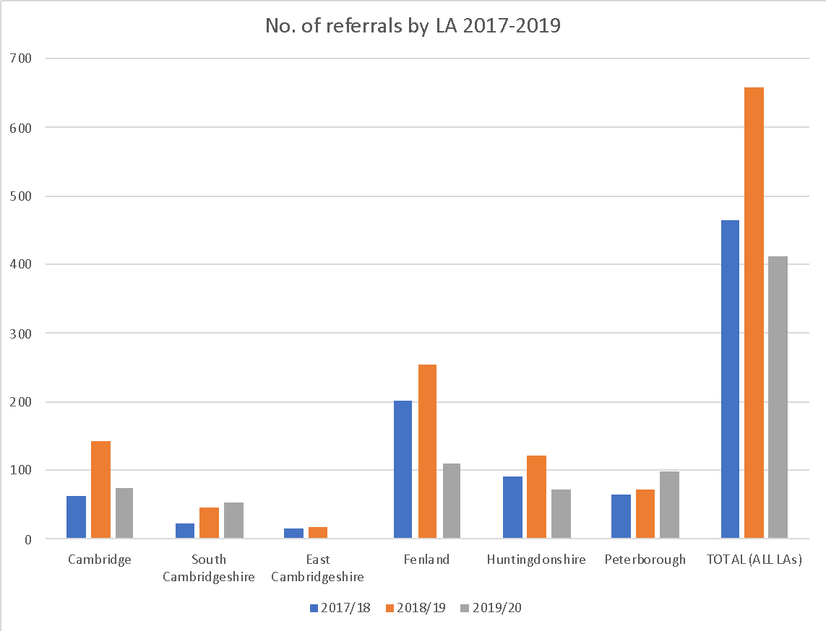

Source: Cambridgeshire and Peterborough Homelessness Prevention Trailblazer Project

* 1. Interestingly the number of referrals from each local authority area does not correlate with the overall demand on services, for example in 2018/19 Fenland and Cambridgeshire undertook a similar level of homelessness assessments, but Fenland referred nearly twice as many clients to the Trailblazer service.

### Homelessness timescales

* 1. Graph 6.2 below shows the homelessness timescales across the local authorities between 2017 and 2019. The vast majority of referrals are for those threatened with homelessness pre-56 days. The percentage of suitable referrals (i.e. pre 56 days) has increased from 69% in year 1 & 2 to 81% in year 3.

Graph 6.2 Homelessness timescales by LA 2017-2019

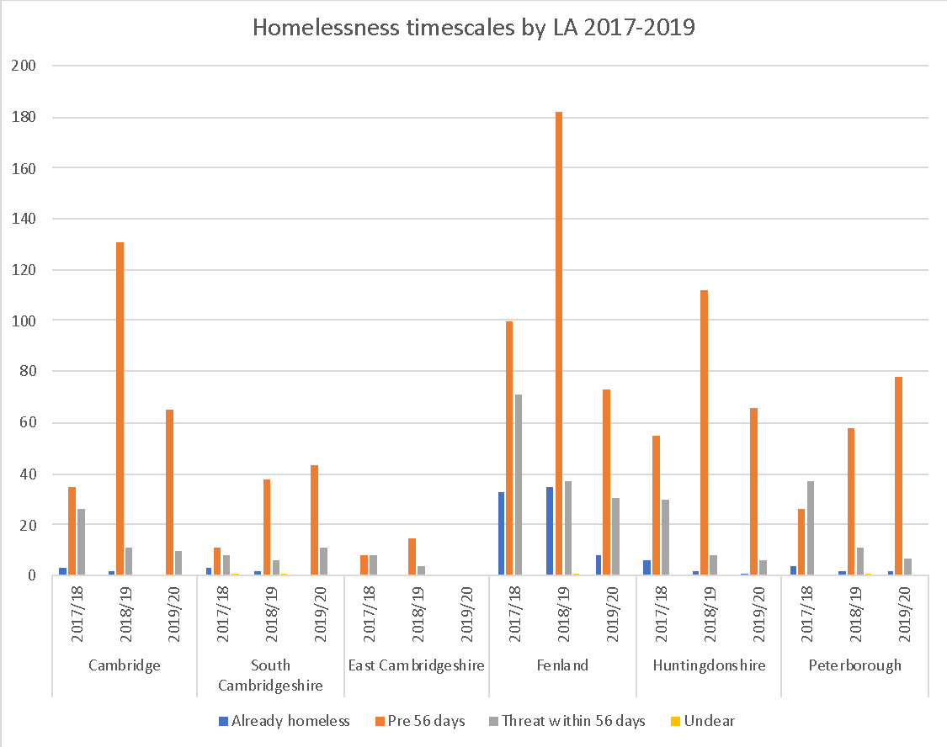

### Outcomes

* 1. Table 6.2 and Graph 6.3 below compare the numbers of different outcomes that resulted from referrals in each local authority between 2017 and 2019.
  2. Out of 1,493 referral outcomes (this excludes missing data on outcomes from Peterborough City Council for 2019/20), 438 referrals were prevented from becoming homeless by being able to remain in exiting accommodation, this represents 29.3% of overall outcomes across all LAs for all 3 years. A further 116 households were prevented from becoming homeless by securing alternative accommodation (7.8%). This is followed by 372 (24.9%) advice only outcomes and 315 (21.1%) referrals to housing options teams.
  3. In total 554 cases were prevented from homelessness which represents 37% of all referrals.

|  |  |  |  |  |  |  |  |  |  |
| --- | --- | --- | --- | --- | --- | --- | --- | --- | --- |
| Table 6.2 Comparison of outcomes from referrals by LA 2017-2019 | | | | | | | | | |
| **Local Authority** | **Year** | **Outcome** | | | | | | | **TOTAL** |
| **Advice only** | **Prevention: able to remain** | **Prevention: alternative accommodation** | **Referred to HOT** | **Relief** | **Unclear** | **Uncontactable** |
| Cambridge | 2017/18 | 18 | 22 | 6 | 14 | 1 | 0 | 3 | 64 |
| 2018/19 | 40 | 60 | 1 | 12 | 0 | 2 | 29 | 144 |
| 2019/20 | 27 | 20 | 4 | 13 |  | 1 | 10 | 75 |
| South Cambridgeshire | 2017/18 | 5 | 11 | 0 | 3 | 1 | 1 | 2 | 23 |
| 2018/19 | 12 | 13 | 2 | 12 | 0 | 0 | 8 | 47 |
| 2019/20 | 7 | 18 | 4 | 20 |  | 1 | 5 | 55 |
| East Cambridgeshire | 2017/18 | 1 | 8 | 3 | 3 | 0 | 0 | 1 | 16 |
| 2018/19 | 1 | 5 | 0 | 11 | 0 | 0 | 2 | 19 |
| 2019/20 |  |  |  |  |  |  |  | 0 |
| Fenland | 2017/18 | 45 | 58 | 28 | 33 | 18 | 0 | 22 | 204 |
| 2018/19 | 37 | 76 | 23 | 66 | 4 | 2 | 47 | 255 |
| 2019/20 | 20 | 23 | 7 | 40 |  | 4 | 18 | 112 |
| Huntingdonshire | 2017/18 | 16 | 37 | 13 | 17 | 1 | 0 | 7 | 91 |
| 2018/19 | 37 | 29 | 5 | 26 | 0 | 2 | 23 | 122 |
| 2019/20 | 30 | 10 | 9 | 12 |  | 2 | 10 | 73 |
| Peterborough | 2017/18 | 26 | 14 | 8 | 10 | 5 | 0 | 4 | 67 |
| 2018/19 | 36 | 16 | 3 | 8 | 3 | 0 | 6 | 72 |
| 2019/20 | 14 | 18 | | 15 | 0 | 1 | 6 | 54 |
| TOTAL (No.) | | 372 | 438 | 116 | 315 | 33 | 16 | 203 | 1,493 |
| TOTAL % | | 24.9 | 29.3 | 7.8 | 21.1 | 2.2 | 1.1 | 13.6 | 100.0 |

Source: Cambridgeshire and Peterborough Homelessness Prevention Trailblazer Project

Figure 6.3 Comparison of outcomes from referrals by LA 2017-2019

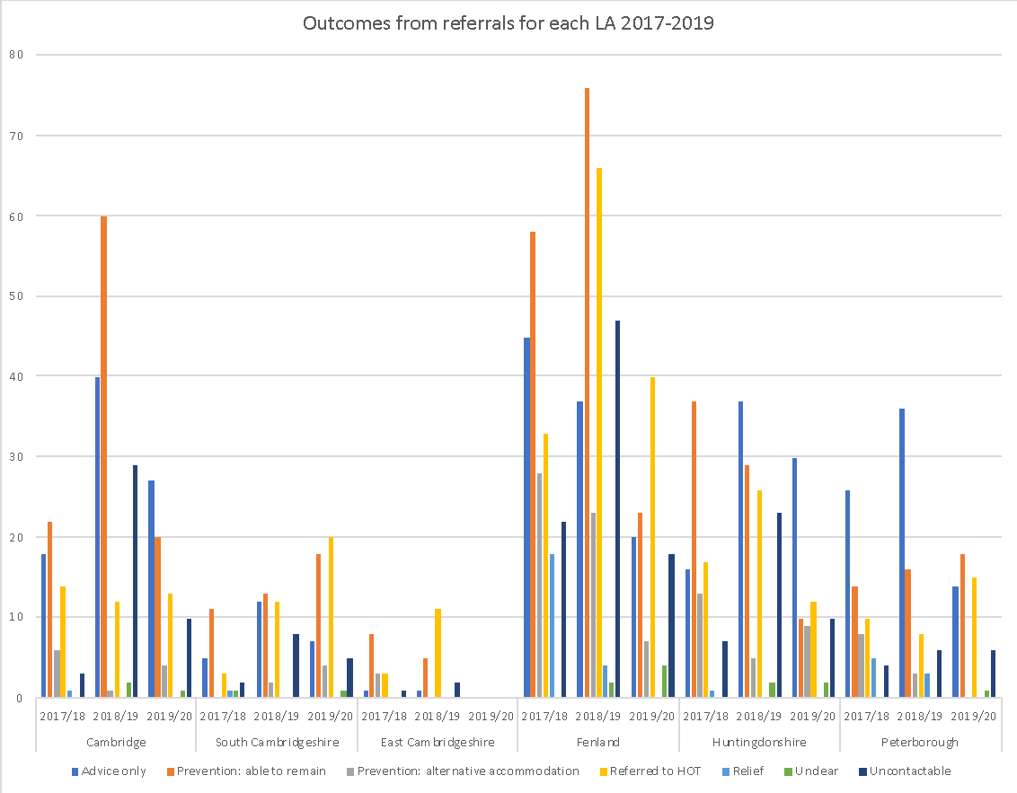

Source: Cambridgeshire and Peterborough Homelessness Prevention Trailblazer Project

* 1. The table below compares prevention outcomes for each Local Authority.

|  |  |  |  |
| --- | --- | --- | --- |
| **Table 6.3 Comparison of prevention outcomes for LAs** | | | |
| **Local Authority** | **Number of referrals to the Trailblazer** | **Number of preventions achieved** | **% of referrals that result in a prevention** |
| Cambridge | 283 | 113 | 40% |
| East Cambridgeshire | 35 | 16 | 46% |
| Fenland | 571 | 215 | 38% |
| Huntingdonshire | 286 | 103 | 36% |
| South Cambridgeshire | 125 | 48 | 38% |
| Peterborough | 237 | 48 | 20% |

* 1. Generally, the percentage of successful prevention outcomes achieved is relatively consistent across the sub-region ranging from 36-46%. The exception to this is Peterborough where there is a much lower success rate.
  2. The table below shows the successful prevention rate for each year of the project.

|  |  |  |  |
| --- | --- | --- | --- |
| **Table 6.4 Successful prevention rate each year** | | | |
| **Year** | **Number of Referrals** | **Number of Preventions Achieved** | **% of successful preventions achieved** |
| Yr 1 | 465 | 208 | 45% |
| Yr 2 | 659 | 233 | 35% |
| Yr 3 | 413 | 113 | 27% |

* 1. While over the lifetime of the project the prevention success rate is 37% the table above demonstrates that there is a year on year reduction in the number of successful preventions achieved as an overall percentage of referrals received.
  2. While the staffing levels have reduced in year 3, the number of referrals also reduced, so it unlikely that this is the main reason for the reduction in the number of successful preventions achieved.
  3. In response to the reasons for this reduction the Trailblazer team report an increase in the complexity of cases referred and a reduction in the prevention pot that was available to the team.

### Reasons by outcome

* 1. Graphs 6.4-6.6 show the homelessness reasons by prevention outcome (prevention: able to remain and prevention: alternative accommodation) by each LA for 2017-2019.
  2. For both years 2018/19 and 2019/20 the Trailblazer team were most successful in preventing homelessness that was caused due to rent arrears on registered provider dwellings. In 2018/19, 91 out of 233 cases were prevented across all LA areas representing 39.1% of cases overall. In 2019/20, 28 out of 94 cases were prevented across all LA areas representing 29.8% of cases overall.
  3. In 2017/18, the team were most successful in preventing homelessness due to other reasons (e.g. homeless in emergency, sleeping rough or in hostel, returned from abroad) representing 20.7% of all cases (43 out of 208); as well as homelessness due to rent arrears on private sector dwellings also representing 20.7% of all cases (43 out of 208). This is closely followed by prevention in relation to rent arrears on registered provider dwellings representing 16.8% of all cases (35 out of 208).

Graph 6.4 Homelessness reasons by prevention outcome by LA 2017/18

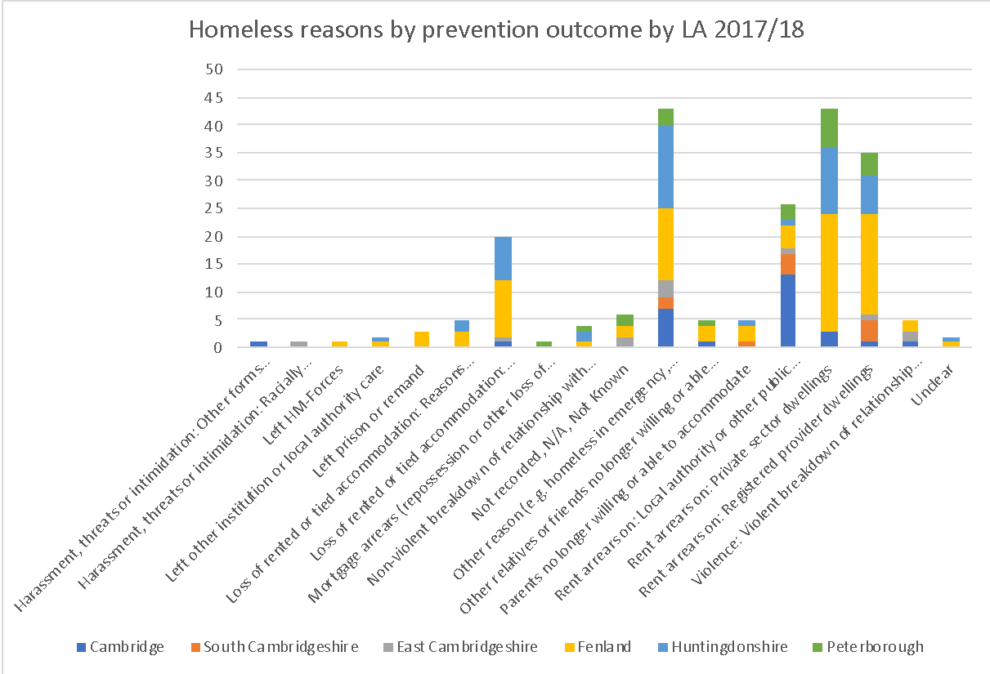

Graph 6.5 Homelessness reasons by prevention outcome by LA 2018/19

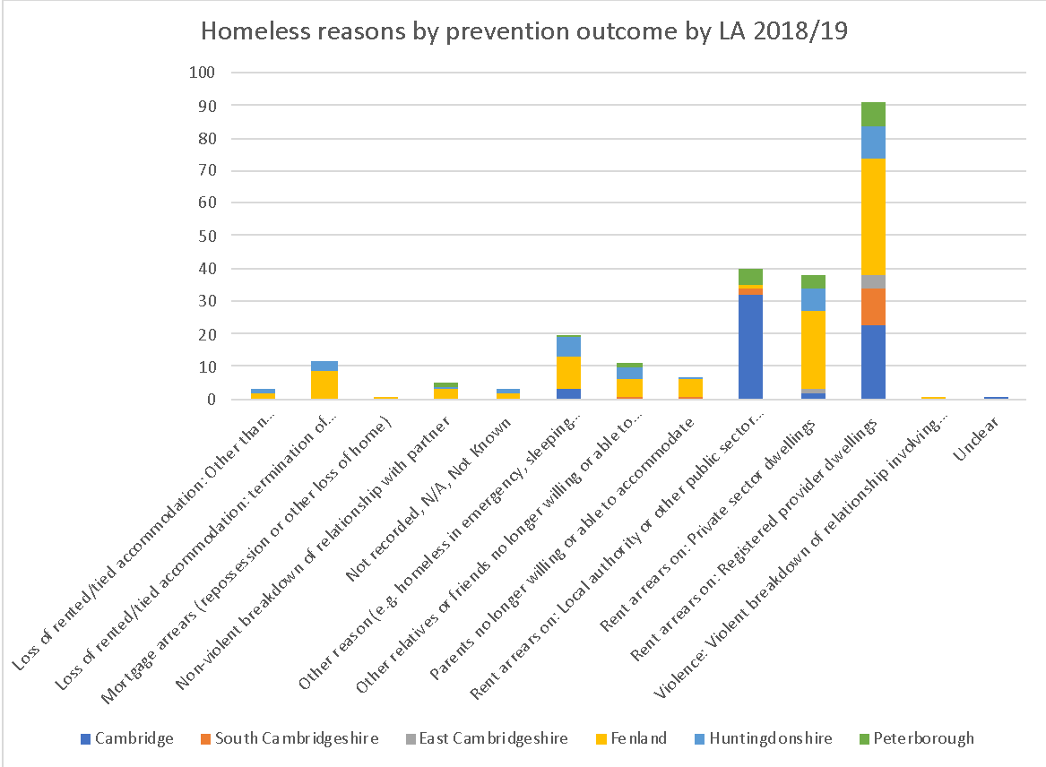

Graph 6.6 Homelessness reasons by prevention outcome by LA 2019/20

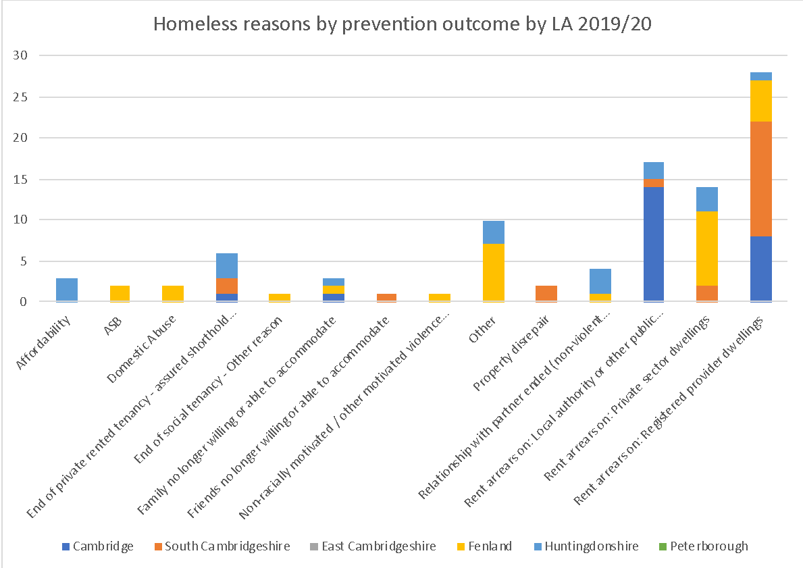

Sources: Cambridgeshire and Peterborough Homelessness Prevention Trailblazer Project

### Referring agencies

* 1. Graph 6.7 shows the top 5 referral agencies from each LA across the 3 years. The most referrals came from City Homes Housing Association where 110 referrals were made to Cambridge City Council. The highest referrals from referral agencies in each LA are:
* South Cambridgeshire – Flagship Homes Housing Association (22)
* East Cambridgeshire – CCC Children’s Services – Early Help (9)
* Fenland – Fenland DC Housing Options Team (95)
* Huntingdonshire – Huntingdonshire DC Housing Options Team (106)
* Peterborough – Peterborough City Council (72)

Graph 6.7 Top 5 referral agencies by LA 2017-19



Sources: Cambridgeshire and Peterborough Homelessness Prevention Trailblazer Project

### Prevention tools

* 1. Graphs 6.8-6.10 show the prevention tools used by each local authority. The most widely used prevention tool across the 3 years was advice and information. Focusing on advice and information, in 2017/18, there were 208 out of 568 cases using this prevention tool representing 36.6% of cases. In 2018/19 there were 216 out of 512, representing 42.2% of cases. Finally, in 2019/20 there were 78 out of 132, representing 59.1% of cases.

Graph 6.8 Prevention tools used by LA 2017/18

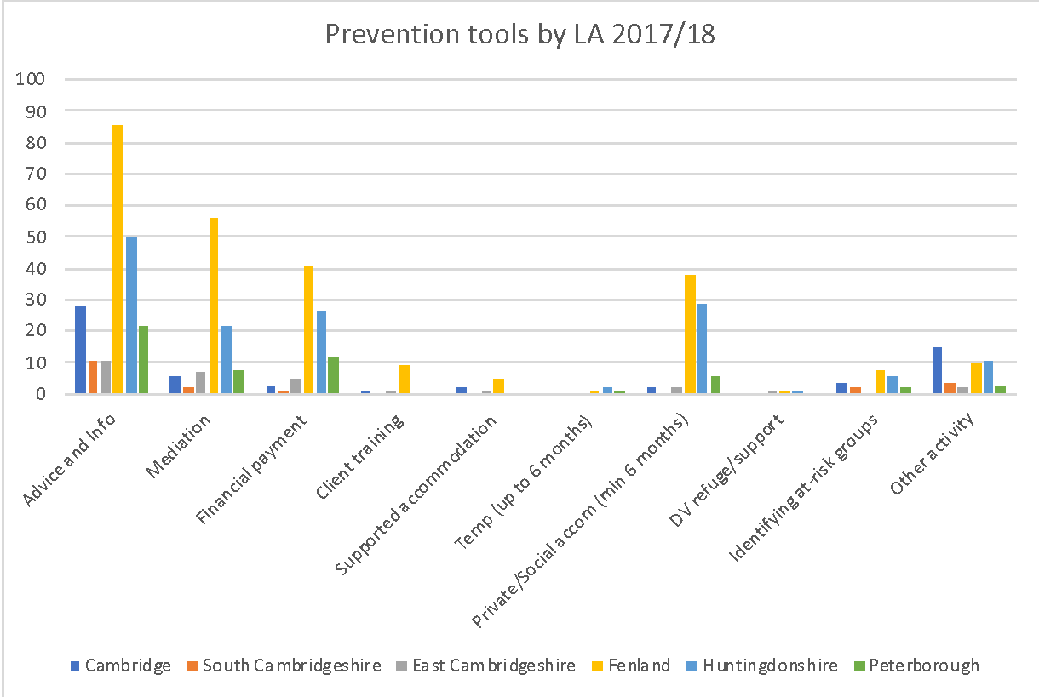

Graph 6.9 Prevention tools used by LA 2018/19

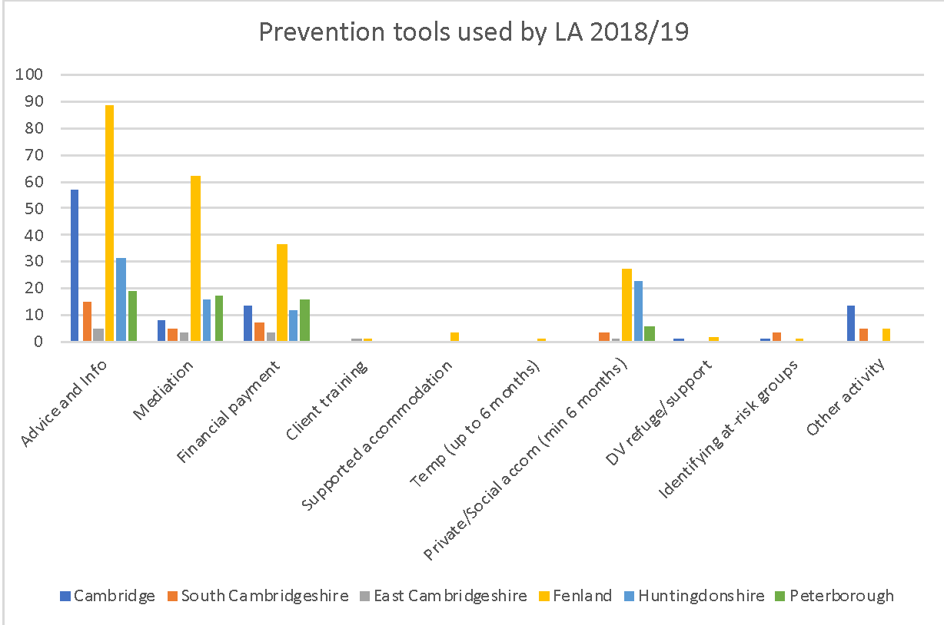

Graph 6.10 Prevention tools used in each LA 2019/20

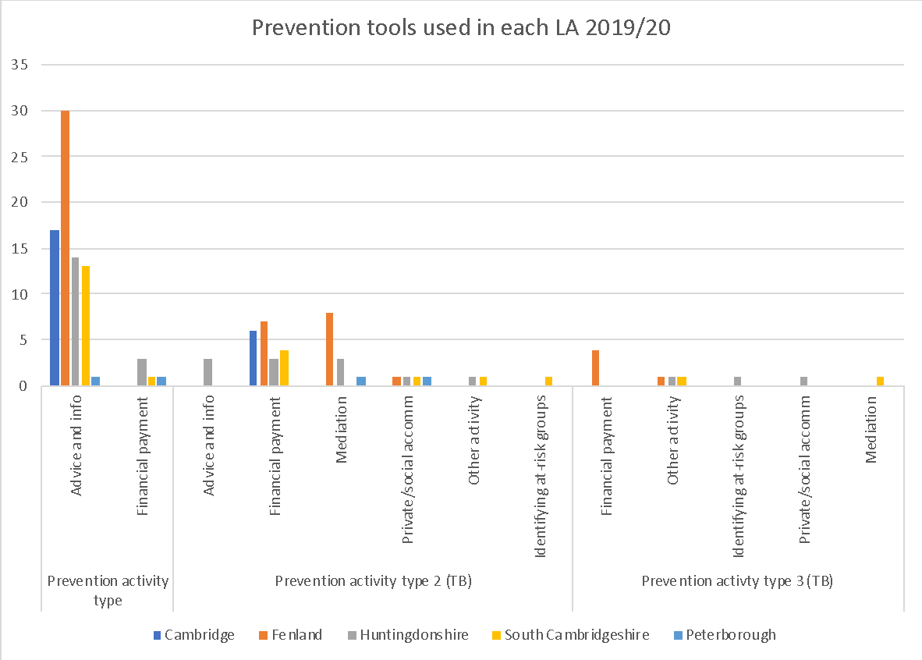

## National Research

* 1. In 2018 the MHCLG commissioned an evaluation of a number of Trailblazer initiatives operating across England[15], including the Cambridgeshire & Peterborough project. The Evaluation report identified the following critical success factors for the design of effective approaches to prevent homelessness:
* The provision of advice and assistance to people at risk of homelessness as an early intervention strategy;
* Packages of advice and information to address the multiple risk factors associated with homelessness, covering things such as finance, tenancy management, independent living, education, employment, and other areas;
* Flexible support and housing options based on good case-management. This may include offering supported and temporary stable accommodation when appropriate as a transitional option;
* Specialist tailored support for vulnerable groups (e.g. young people, people with mental health difficulties, offenders, care leavers, and people experiencing domestic abuse);
* Linkages to a well-coordinated network of broader support; and
* Measures to build relationships with landlords in regard to their understanding of the risks to homelessness, opening access to the private rented sector, deposit schemes, and negotiating protocols for arrears and evictions.
  1. A qualitative review of a number of case study areas, which included Cambridgeshire & Peterborough, identified the following success factors and challenges for effective delivery of homelessness prevention activities:
* There was a shared view that effective preventative work requires a more flexible, helping mindset than that of a conventional Housing Officer. Getting staff in place with such a mindset was an initial reported challenge but all areas had found ways to achieve this and cited it a key success factor;
* Trailblazer staff had typically been located close to, but not necessarily within, mainstream housing teams in the case study areas. This was thought to be effective in making provision more approachable to residents while still ensuring that linkages between preventative work and other housing services could be maintained;
* Case study areas said they had found a ready audience amongst third sector organisations and other housing services for collaborating on homelessness prevention. Progress had been more uneven in engaging wider audiences (e.g. private landlords and health providers) but where new links had been successfully established these were seen as significant;
* The identification of residents at risk of homelessness by front line staff and more data-based approaches had both been employed in the case study areas, and interviewees typically saw ongoing roles for both;
* Going out to engage with residents in their own homes was reported to be more effective in establishing contact than the alternatives of relying on self-referrals or initial contact by letter and phone. There were also perceived benefits associated with conducting ongoing casework with residents in their own home;
* Participating in the programme had reinforced the belief of interviewees in the efficacy of intervening early to prevent homelessness. Equally staff in some areas reported difficulties in finding time to perform preventative work due to pressures to take on cases where a crisis point had already been reached; and
* Collecting evidence on the local causes of homelessness and the effectiveness of local preventative approaches was considered a success factor. Evidence was being used to inform the design of local preventative activities, garner internal support for investment in prevention, and build consensus with local partners.
  1. Emerging outcomes of Trailblazer activities in the case study areas were identified as:
* Residents who had come into contact with local Trailblazer activities described ways in which this had removed or reduced the risks to them becoming homeless, through: better enabling them to meet housing costs; mediating landlord and family member disputes to prevent eviction; securing new accommodation where existing housing was at risk; and support with drug and alcohol issues where these were impacting on their housing situation; and
* Examples were also given in case studies of ways in which local Trailblazer activities were - at least starting to - promote homelessness prevention more widely in their areas. This was through: shifting attitudes amongst mainstream staff towards a more preventative and joined-up outlook; creating new delivery models that other housing teams were starting to adopt; and making new links between housing and non-housing providers that provide the foundation for future collaboration.
  1. The key learning on the effective delivery of homelessness prevention activities is identified as:
* Recruiting individuals with non-housing backgrounds, retraining existing housing staff, and devolving elements of frontline delivery to third sector partners are all options for how local authorities can staff prevention roles;
* A degree of separation between mainstream housing and homelessness prevention teams may be desirable, but not at the expense of ongoing dialogue between the two;
* There is value in local authorities exploring the use of different models of colocation as part of their response to the Homelessness Reduction Act;
* Engaging organisations that are not used to collaborating with local authority housing services about homelessness prevention may take time, resources, and dedicated personnel but be worth this investment;
* Effective identification of at-risk residents by frontline staff have been underpinned by upfront engagement work with the organisations concerned, face-to-face training, and processes to ensure referrals can be made with residents’ informed consent;
* Local data sharing agreements with other organisations should be sought early if local authorities intend to introduce data-based approaches to identify those at risk;
* Local authorities should include provision for some element of outreach work as part of their response to the Act;
* Local authorities should carefully consider how resources are allocated to early preventative work, and how their deployment is monitored and protected;
* Justifying expenditure on research may not be easy but the benefits reported in the case study areas provide a strong case for trying to do this. In order to fully realise these benefits, evidence should be actively used and shared with local partners; and
* There may be additional value in MHCLG facilitating further opportunities for the Trailblazer areas to share learning from their experience with each other, and to further share examples of the practical resources, intervention designs and lessons learnt with other local authorities.

## How well does the Trailblazer Service work?

* 1. The Trailblazer has no secured funding for the project beyond September 2020, with mixed commitments from the local authorities. The annual budget for the programme in 2020 is £136,700.
  2. The work of the Trailblazer is held in high regard by most of the local authorities, although there is some variation to the extent to which district and city councils have bought into and engaged with the project. Those that have ‘bought in’ have seen the biggest benefit in terms of the value that is placed on the project.
  3. In relation to the partnership strand of the work there is common view that the work of the Trailblazer team has significantly improved partnership working across Cambridgeshire. The Criminal Justice Joint Protocol work is considered to be highly valuable, and is leading to improved partnership working and better client outcomes. The planned joint protocol work in relation to mental health/substance misuse and hospital discharge is considered to be important pieces of work.
  4. It is however, recognised that will be an ongoing need to ensure that these protocols are refreshed and services remain aware that they are in place, and up to now the Trailblazer team has provided capacity to ensure that this happens.
  5. There are potentially a number of other key areas where further partnership work is required moving forward including social housing evictions and preventing homelessness from the private rented sector.
  6. In relation to the prevention casework element of the Trailblazer programme a number of the district teams refer to this as the service ‘front door’ or triage service. There was a view that the service reduces the pressure on frontline Housing Options services and provides a much needed additional resource. Teams generally considered the service to provide effective casework, which leads to positive outcomes for clients. It is recognised by most that if the Trailblazer service was not there the pressure on local teams would increase, and customer outcomes would not be as positive.
  7. However, it is recognised that the reduction in officers has had an impact on the level of service that is offered and that Trailblazer Officers are currently carrying very high caseloads, which will impact upon the level and quality of outcomes achieved.
  8. The data indicates that the Trailblazer service is successful at preventing homelessness with an overall success rate of 37% over the lifetime of the project. However, it is important to recognise that the successful prevention rate of the service has reduced from 45% in year 1 to 27% in year 3.
  9. The service is most successful at preventing homelessness that has arisen due to rent arrears in the private rented and social housing sector, loss of private rented accommodation and where a client is homeless in an emergency. Moving forward it may make more sense to direct referrals based on where the service is most likely to have success.
  10. It is also of note that the outcomes achieved through the Trailblazer team aren’t recorded on H-CLIC returns as these largely occur prior to the legal 56 day threat of homelessness. It is therefore important that the outcomes that the team does achieve continue to be analysed and reported locally, but that this information continues to be fed back to MHCLG to promote the approach but to also lobby the Ministry to reconsider its approach as to what counts as prevention statistics. There is clearly a large number of early intervention prevention outcomes being achieved across the sub-region that are not being fed into national statistical recording.
  11. A cost benefit evaluation undertaken by the Trailblazer Board in 2019 identified that for every £1 spent on the Homeless Prevention Trailblazer team it is estimated that £18 is saved by preventing homelessness and preventing districts from having to make homelessness decisions.
  12. This excludes the potential savings coming from:
* Temporary accommodation budgets not needed where the person is able to stay in their existing home, who might otherwise have had to go into TA;
* Savings to health budgets where the Trailblazer team has helped get a person discharged from hospital who would otherwise have represented a “delayed transfer of care”;
* Savings to the criminal justice system where preventing homelessness or repeat homelessness removes one of the factors which may have led to offending or re-offending; and
* Securing new private rented lets and building new relationships with landlords who may well continue to bring more homes into the supply for families who were facing homelessness.
  1. Therefore, the savings to the wider public purse are likely to be much greater than those estimated above. The financial case for the Trailblazer approach is compelling.
  2. Using wider data sources there may be value in using some of the recent Trailblazer case studies to work out the actual cost of the Trailblazer intervention and then compare this against the counter-factual cost to identify the savings made to both housing services and the wider public purse. This may help to provide a compelling argument for funding contributions from other key agencies (i.e. criminal justice, health, social care etc.)

## The Future of the Trailblazer Service

* 1. The Trailblazer delivers positive outcomes both in terms of improved partnership working and upstream prevention outcomes (although these outcomes aren’t recorded at a national level through H-CLIC).
  2. As detailed above the programme delivers financial savings to the public purse, and also, importantly, delivers improved personal outcomes, with individuals prevented from losing their homes, and the associated impacts of this. These individual personal outcomes shouldn’t be overlooked when considering the success of the programme.
  3. The Trailblazer programme provides an important resource for more strategic and service development approaches across Cambridgeshire & Peterborough that district councils may not have the capacity to progress. This cross-county work is a very important part of the programme and the outcomes that have been achieved.
  4. The Trailblazer project also provides the opportunity to identify and share positive operational practice across the area, however it appears that this opportunity has not been realised with very little common practice in place. Work through this transformation project identified that local authorities weren’t aware of what their neighbouring boroughs were doing and what initiatives are in place. It is clear that all of the local authorities are grappling with similar issues, and it is evident that by working together more effectively authorities could develop common approaches and initiatives reducing local pressure and sharing the workload.
  5. Given the success of the Trailblazer project to date and the clear argument that preventing homelessness at the earliest opportunity saves money, and reduces the pressure on frontline homelessness services there is a clear argument and evidence base to continue to deliver the Trailblazer project.
  6. However, further consideration needs to be given as to what this should look like moving forward and how this can be funded.
  7. Consideration should be given as to whether the Trailblazer programme needs clearer separation between the partnership development element and casework approach.
  8. The strategic development and partnership work are critical elements of work that are required to continue to transform homelessness responses, however there may be merit in separating this out from the casework element of the project.
  9. It may therefore be appropriate to employ a strategic post across the sub-region to progress partnership working and strategic planning and development, potentially including taking some of the recommendations from this report forward. It is suggested that this is separated from operational service delivery.
  10. The casework approach has considerable value and has already demonstrated its success, but there is a need to consider whether this should be delivered from a centralised team, or through local offices. There are merits to both approaches, a centralised approach ensures consistency of service delivery, shared resources across the area, prevents the resource being pulled in to deal with urgent cases and ensures consistent data recording. Whereas, a localised approach, which might include an officer based in each team or one shared between two teams, would have more of a local presence which is likely to lead to an increase in referrals, more joined up service for customers, more integrated approach with better links to local options, the management function could also be picked up by individual local authorities, however there is a risk that in this approach this specialised resource could be pulled in to cover urgent cases or staff absences.
  11. Both options would need careful consideration by the Board, however to lose either element of the project (partnership development and casework) moving forward would be a huge loss, and have a negative impact on homeless prevention approaches.
  12. However, given the reduction in the prevention success rate of the team over the last year, consideration is needed as to how the casework is focused in future to ensure that prevention outcomes are improved, this will include effective management and governance arrangements. It may be sensible to focus the work of the Trailblazer team on the areas where it is likely to have the greatest impact, data indicates that this is on social housing and private rent arrears, loss of private rented accommodation and emergency homelessness.
  13. The Trailblazer programme does provide a clear platform to deliver other cross-county services/projects, and the Board needs to define what the next phase of the Trailblazer programme will look like and identify how this can be resourced.

|  |
| --- |
| Recommendations  * Ensure that outcomes from the Trailblazer team continue to be analysed and reported locally, but that this information continues to be fed back to MHCLG to promote the approach but to also lobby the Ministry to reconsider its approach as to what counts as prevention statistics. * Build upon the recent Trailblazer case studies work to quantify the actual cost of the Trailblazer intervention and then compare this against the counter-factual cost to identify the savings made to both housing services and the wider public purse. Use this information to develop a compelling argument to seek funding from other key agencies to provide ongoing funding for the programme. * In the future there may be value in separating out the strategic/partnership development functions from casework delivery. Consideration should be given to funding a countywide post to provide a dedicated resource to developing this area of work including new protocols, promoting partnership working etc. * The early intervention element of the Trailblazer service should continue however this needs to be reviewed to ensure that prevention outcomes are improved. Across the partnership area there is a need to redefine what the future of the operational Trailblazer service should be, including where this should sit, how this should be delivered, management and governance arrangements, and which causes of homelessness it should be targeted at. |

# Rough Sleeping

* 1. Rough sleeping is defined as *“People sleeping, about to bed down (sitting on/in or standing next to their bedding) or actually bedded down in the open air (such as on the streets, in tents, doorways, parks, bus shelters or encampments). People in buildings or other places not designed for habitation (such as stairwells, barns, sheds, car parks, cars, derelict boats, stations, or "bashes" which are makeshift shelters, often comprised of cardboard boxes)”*.
  2. Rough sleeping is the most visible form of homelessness, and often has the most detrimental impact on an individual, compared with other less visible forms of homelessness.
  3. The causes of rough sleeping are typically described as either structural or individual. Structural explanations locate the causes of homelessness in broader forces, and individualist explanations focus on the personal vulnerabilities and circumstances of those who experience rough sleeping.
  4. Homelessness is often the consequence of a combination and culmination of these factors, which can be interrelated and reinforced by one another. Causes and relationships between these factors vary across the life course.

Figure 7.1 The causes of homelessness and rough sleeping

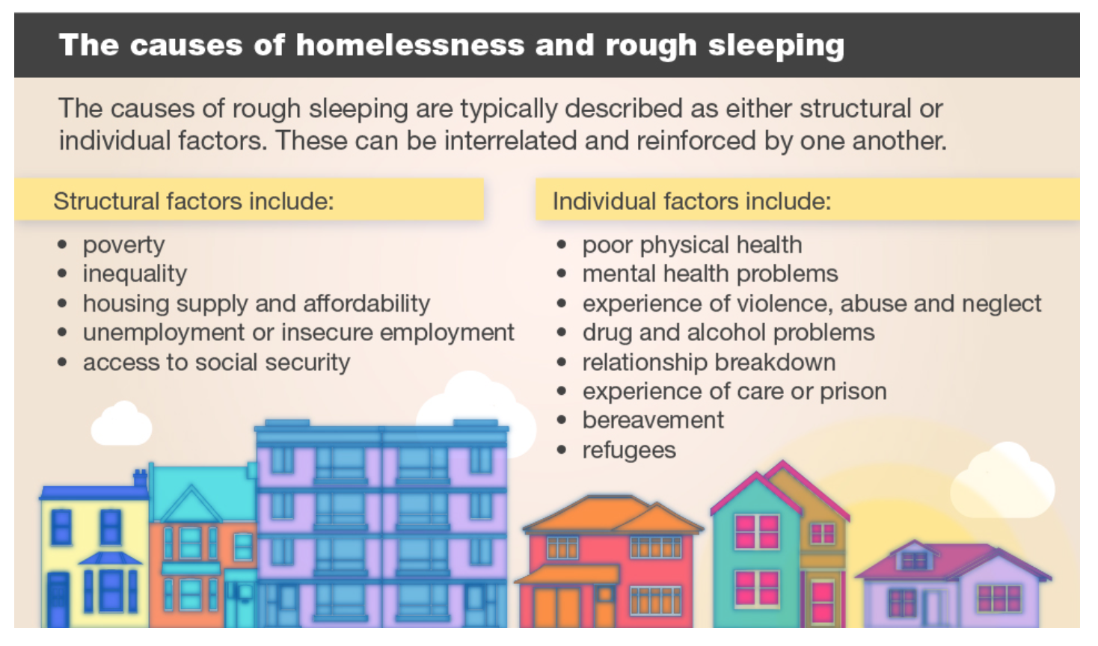

Source: Public Health England

## The National Picture

* 1. In February 2019 MHCLG published its rough sleeping statistical release for Autumn 2019, which includes the following findings:
* The number of people estimated to be sleeping rough on a single night has fallen for the second year in a row from its peak in 2017 but remains higher than 2010 when the snapshot approach was introduced.
* There were 4,266 people estimated to be sleeping rough on a single night in autumn 2019. This is down by 411 people or 9 % from last year and down 10 % from the peak in 2017 but is up by 2,498 people or 141 % since 2010.
* Over three quarters of local authorities in England are part of the Government’s Rough Sleeping Initiative (RSI) to end Rough Sleeping.
* Across these 244 local authorities there were 3,863 people estimated to be sleeping rough on a single night in autumn 2019. This is down by 514 people or 12 % from last year.
* In the 83 local authorities who have been receiving funding since 2018, there were 2,474 people estimated to be sleeping rough on a single night in autumn 2019. For these local authorities this is down by 294 people or 11 % from last year and down by 942 people or 28 % from 2017.
* In the remaining 73 local authorities that are not part of the RSI the number of people estimated to be sleeping rough is up by 103 people or 34 % compared to last year, from 300 people in 2018 to 403 people this year.
* The number of people estimated to be sleeping rough in London has decreased for the first time in six years and is the largest decrease since 2010. There were 1,136 people estimated to be sleeping rough in London on a single night in autumn 2019. This is down by 147 people or 11 % from last year. The South West of England was the only region where there was notable increase in the number of people sleeping rough, all other regions were broadly similar or decreased with London and the West Midlands decreasing the most.
* The majority of people sleeping rough in England are male, aged over 26 years old and from the UK. This is similar to previous years.
* There was a 5% decrease in rough sleeping in the East of England in 2019 compared with the previous year.

Figure 7.2 Number of people sleeping rough in England on a single night

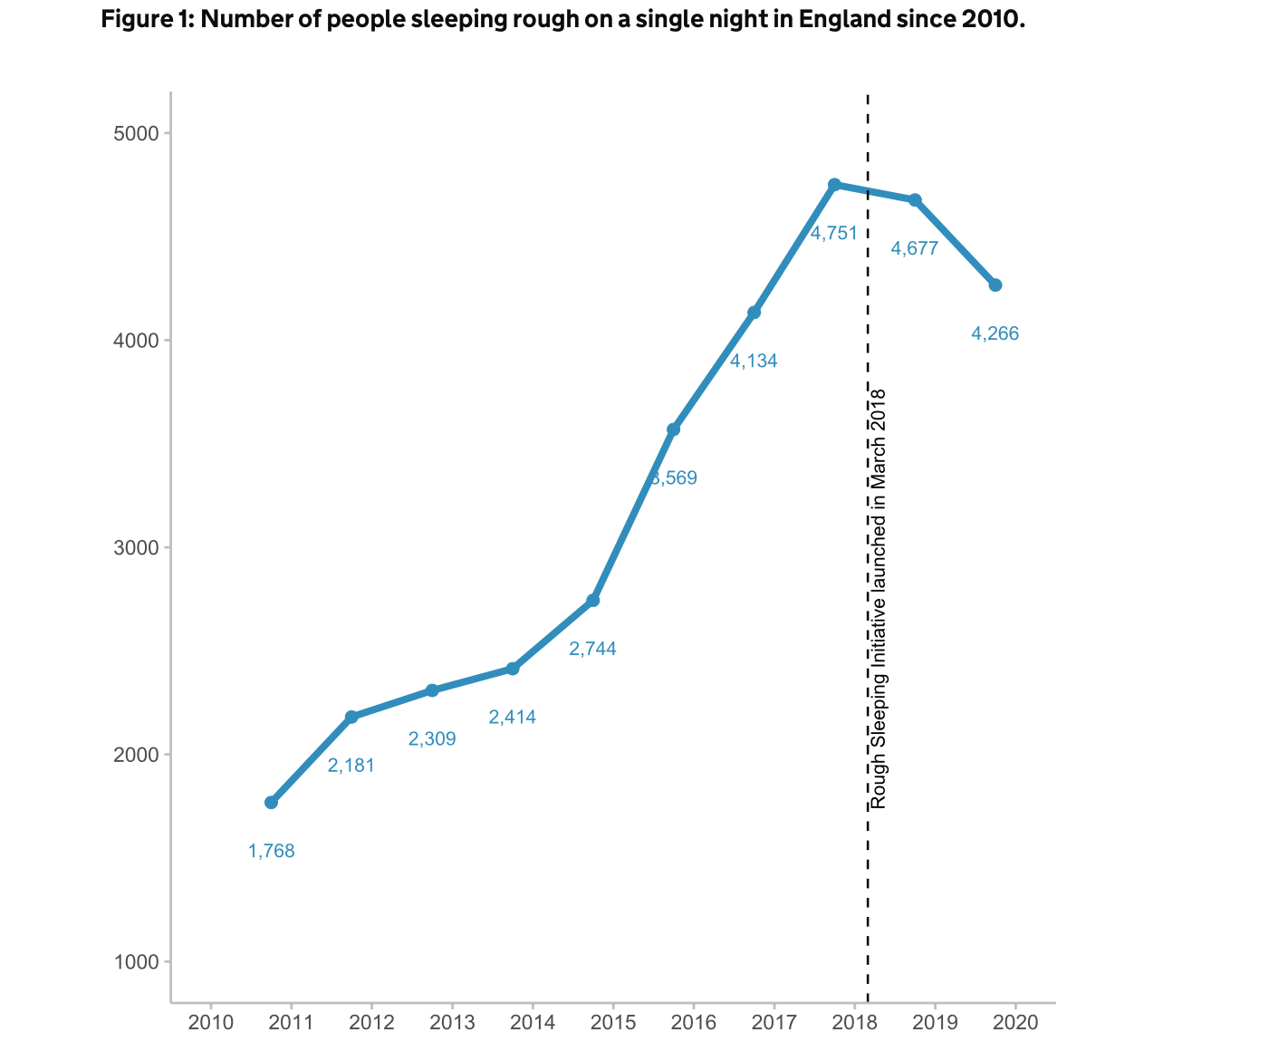

Source: <https://www.gov.uk/government/publications/rough-sleeping-snapshot-in-england-autumn-2019/rough-sleeping-snapshot-in-england-autumn-2019>

## Rough sleeping across Cambridgeshire and Peterborough

### Levels of Rough Sleeping

* 1. The graph below details rough sleeping levels across Cambridgeshire and Peterborough taken from the annual snapshot figure reported to MHCLG. It is recognised that this only provides an indication of the level of rough sleeping as it is based on a snapshot on a single night. Local data and intelligence where available helps to build up a more accurate understanding of the extent of rough sleeping.

Graph 7.3 Number of people found rough sleeping across Cambridgeshire and Peterborough

Source: MHCLG Rough Sleeping Statistics

* 1. Since 2015 there has been significant increases in rough sleeping in Peterborough, Cambridge and Fenland. Levels of rough sleeping remain low in Huntingdonshire South Cambridgeshire and East Cambridgeshire.
  2. Huntingdonshire, together with South Cambridgeshire and East Cambridgeshire was successful in securing funding to deliver a street outreach service, this will be delivered by P3 and comprise of a Rough Sleeping Co-ordinator. Referrals will come to the council directly or through StreetLink who will then contact the outreach service. The council will undertake assessment in order to assess if there is a duty to accommodate. Within Huntingdon there is a public perception that there is a higher number of rough sleepers than the evidence suggests, and many of those who may be accessing services such as soup kitchens are vulnerably housed rather than rough sleeping.
  3. Local data and intelligence from the local authorities and commissioned outreach services operating in Cambridge and Fenland provide a more detailed evidence base as to the extent of rough sleeping.

#### Cambridge

* 1. At the last official Count in November 2019 a total of 33 rough sleepers were identified. Further verification work at the time of the count suggested that this figure was probably closer to 40.
  2. This is the third highest level in the East of England and based upon the population size is one of the highest rates per head of population in the region.
  3. Data and intelligence suggest that on average there are around 40 people sleeping rough at any one time. Organisations that provide food report that they are feeding between 19 -50 on any given night, although some of these individuals are vulnerably housed.
  4. Winter Comfort provides the city’s day centre and there are between 80-90 individuals accessing services there on a daily basis.
  5. While there are a higher number of males sleeping rough, services have seen an increase in women sleeping rough in recent years, these women tend to have complex high support needs.
  6. In 2018 158 unique individuals were counted as sleeping rough during the year. The graph below, taken from Cambridge’s Homelessness Review shows the profile of rough sleepers. The half year figures for 2019/20 indicate there is an even split between those new to the streets (flow) and those who have been rough sleeping for some time (stock).

Graph 7.4 Verified rough sleepers in Cambridge

*Please note incomplete year

Source: Cambridge Homelessness Review 2019

#### Fenland

* 1. At the last official Count a total of 11 rough sleepers were identified, although this reduction in the number compared with the previous year is linked to the cold weather provision funded with money from MHCLG.
  2. The council, together with its partners has a very good intelligence of its rough sleeping population. The service is currently working with 51 clients, including those in emergency/night shelter provision.
  3. The partnership uses a traffic light system to understand its rough sleeping population; 9 are ready to move on 17 are in need of further support and 23 are entrenched.
  4. Rough sleeping is very much concentrated in Wisbech, and very much linked to gangmasters and migrant workers, around 65% of the rough sleeping population are from the EU, with the remaining being British nationals.

#### Peterborough

* 1. The last official rough sleeping Count in November 2019 identified 37 rough sleepers, however local intelligence indicates that there is an average of 29 rough sleepers recorded each month. The majority of rough sleepers are male, and of those identified through the official Count, 22 were from the UK and 13 from the EU.
  2. No other additional data or information was provided for Peterborough.

## Local Responses and Issues

### Prevention

* 1. Across Cambridgeshire there is no focused prevention work that is undertaken specifically for clients at risk of rough sleeping. As part of the homeless assessment, no work is completed by the team that would identify risk factors that may indicate that a person is at an increased risk of going on to sleep rough.
  2. In order to prevent the flow of new rough sleepers on to the street, embedding a targeted prevention approach is essential. Such an approach would seek to identify a range of risk factors that would indicate that a person is at an increased risk of rough sleeping if their housing/homelessness situation is not resolved, and ensure that targeted interventions are then put in place to prevent the individual from rough sleeping. A number of prevention trailblazers have been operating across England, and learning from these can be implemented locally.

|  |
| --- |
| **Good Practice****No First Night Out** **No First Night Out (NFNO) is an innovative approach to preventing people from sleeping rough for the first time.**It is a cross-borough project run jointly by the City of London and Tower Hamlets local authorities. The lead authority for the project is the City of London Corporation.  The NFNO team provides upstream rough sleeping interventions through a group of community-based referral partners, and a unique pan-London network of private rented sector and specialist accommodation providers. The project profiled a ‘typology’ of those at most risk of rough sleeping to help the team identify those at greatest risk. It recognises that the trauma of rough sleeping starts the first night of sleeping on the street and aims to prevent this.  The project works with individuals identified as being at risk of rough sleeping for the first time covers all aspects of a person's life. The NFNO team works within the strengths-based model, adopting motivational interview techniques to encourage clients to feel empowered and committed to the process.  NFNO takes a collaborative approach to an individual's move on and uses resources available through partner organisations to quickly put clients on the road to resolving any potential barriers to sustainable accommodation, including: existing debt or benefits issues, physical and mental ill health, tenancy and employment, training and education skills gaps. Strong links with the Crisis PRS scheme was invaluable in supporting people into accommodation.  Strong partnerships are central to the success of the project. NFNO has a diverse partnership group united by a Memorandum of Understanding which contains the core commitments from partners and their in-kind contributions to the project. Strong relationships between a variety of statutory, voluntary and support services, all focussed on improving homelessness response for local people, are the key to NFNO’s success. The project identifies the importance of a casework approach with strong links with agencies such as JCP and CAB.  <http://nfno.org.uk> |

* 1. Developing a prevention service across Cambridgeshire & Peterborough will reduce the flow of new rough sleepers on to the streets.

### Housing Options Assessments

* 1. There was mixed practice in relation to undertaking formal homelessness assessments for rough sleepers, this happened consistently in some areas, but was not the case in other areas. Where a local authority has reason to believe that an individual is homeless or threatened with homelessness then the local authority has a duty to undertake an assessment to establish if the individual is eligible and homeless or threatened with homelessness, and if this is the case will owe a prevention or relief duty and will then work with the individual to develop a personal housing plan. Furthermore, if the individual is homeless and in priority need the local authority will have a duty to provide temporary accommodation. In authorities where this isn’t consistently happening for all rough sleepers, these individuals will not be receiving the help and assistance that they are legally entitled to, including an assessment to understand if there is a duty to provide temporary accommodation.
  2. In areas with high numbers of rough sleepers this may have an impact upon Housing Options teams and for some rough sleepers there may be a reluctance to visit statutory organisations for a formal assessment. These barriers could be overcome by Housing Options Officers undertaking assessments within local day centres, or by commissioning another organisation to undertake these assessments on behalf of the local authority.

|  |
| --- |
| **Good Practice****Homelessness Assessments** Cardiff City Council’s Outreach Service, which is delivered by the local authority, undertake all homelessness assessments on behalf of the Housing Options service. This approach works well as the team already have an established rapport with the rough sleeping population, and clients are not required to go to the council offices or tell their story to different and multiple members of staff. |

### Assertive Outreach

* 1. Assertive outreach is provided in both Cambridge and Fenland by Change Grow Live. The outreach services work closely with the local authority and other key partners.
  2. Within Fenland it is becoming increasingly challenging to reconnect individuals to home areas, in previous years the services had successfully reconnected 40 individuals in one year, but in the last 2 years they have only successfully reconnected 10 individuals.
  3. Within the city there was a view that people from other areas would sleep rough in the city due to service provision and begging opportunities. No data was provided to understand the extent to which the rough sleeping population within Cambridge is made up of people with no local connection, although neighbouring boroughs with no or limited hostel provision advised that they would make customers aware of the provision available in the city.
  4. For those with no local connection the outreach service works with partners to reconnect them back to their home area, but this can be difficult to achieve especially when there is limited provision in their home area. Service users with very complex needs can be reluctant to move out of the area, severing ties with the support that they have in the city.

### Emergency Accommodation Provision

* 1. Within Cambridge Jimmy’s is the city’s assessment centre and provides 26 units of short term emergency accommodation and resettlement support. The service provides a resettlement and re-connection service to work with clients to find a more suitable place to live long-term, together with en-suite rooms, laundry facilities and freshly prepared daily meals.
  2. The intended aim is that clients should reside in this accommodation for 28 days and then move in to more suitable second stage accommodation based upon the client’s needs. However, clients are residing at Jimmy’s for much longer periods of time, linked to a lack of flow and move on within the overall accommodation pathway. Information from Cambridge’s Homelessness Review 2019 states that at the end of the second quarter of 2019-20 nine guests had been resident for between 57 and 84 days; three guests had remained for between 85 and 100 days, and nine guests had stayed for more than 100 days – one for 307 days and one for 461 days.
  3. In March 2018 the average waiting time for a rough sleeper to have to wait for a bed at Jimmy’s was 6 nights, this had increased in 11 nights in January 2020.
  4. Alongside the lack of move on the other significant reason that is adding to longer stays within Jimmy’s is due to older rough sleepers (often with ongoing substance misuse issues and histories of ASB and housing debts) who do not easily fit into existing mainstream accommodation provision for older people.
  5. During the winter there is also a Winter Night Shelter, alongside SWEP provision, which is available when SWEP is activated. This is the main respite provision for clients with no recourse to public funds.
  6. Currently there is no accommodation offer available to rough sleepers when the existing provision at Jimmy’s and the winter emergency provision is full.
  7. An effective outreach service is dependent upon the ability to be able to access emergency or direct access accommodation to ensure that as soon as a client chooses to engage with services and come off the streets an offer of accommodation can be made available.
  8. At the moment the outreach team are unable to make this offer, and unless emergency provision can be made available to anyone sleeping rough in the city then it will be very difficult for services to work towards the Government’s target of ending rough sleeping by 2024.
  9. There is a need for emergency provision that can be made available to any individual choosing to engage with services. The current system that is in operation does not support service users to begin that journey off of the street, failure to be able to make an offer of accommodation to anyone that the outreach team is working with means that opportunities to get people off of the street at the point when they want to engage are lost.
  10. It is also critical that there is an offer of emergency accommodation for anyone new to the street, to ensure that an immediate offer of accommodation can be made in an environment that is safe and affords dignity, and reduces the likelihood of an individual’s needs increasing and becoming more complex.
  11. Alongside the need to ensure that emergency accommodation is available to all rough sleepers there is a need to review the overall accommodation pathway and current assessment centre model.
  12. Within Fenland the Ferry project provides 24 units of supported accommodation alongside Night Shelter provision, that can accommodate up to 18 individuals. The project is fully integrated into the community and is a place of change. There are also 30 units of move on accommodation. The Night Shelter beds are allocated on a nightly basis, however residents are able to rebook the following morning for that night, up to a maximum of 28 nights. This flexible model takes into account that EU individuals may work a night shift so may not need accommodation on consecutive nights.
  13. The council received funding from MHCLG for Cold Weather provision based on the high rough sleeping count return in 2018. This has enabled additional emergency bed provision, however, this provision resulted in a lower count figure in 2019 meaning that the council is unlikely to receive this funding again, however without this provision the number of rough sleepers is likely to increase. There are currently 20 beds provided through this project and on average there are usually 16 service users accessing this provision.
  14. The cold weather provides a really good opportunity to engage with clients who may otherwise not be accessing services. The cold weather provision is also the main respite available to those with no recourse to public funds, although the Ferry Project also has the ability to fund night shelter beds using charitable donations.
  15. Given that the funding of this provision is not confirmed for the following financial year there is a need to ensure that the council raises the above concerns with MHCLG. More widely there is a need for the Cambridge Housing Partnership to engage with MHCLG to raise these concerns and lobby for greater long term funding certainty in order for longer term strategic response to ending homelessness.
  16. Move on was also identified as an issue within Fenland, specifically for clients with former rent arrears or a history of anti-social behaviour.
  17. There is a need to work with social landlords and seek a commitment from them to end rough sleeping by assisting with move on, this may involve making exceptions to the normal lettings policy in relation to arrears and anti-social behaviour where changed behaviour can be demonstrated.

|  |
| --- |
| **Good Practice**Swindon’s Temporary Winter Housing Provision The project focused on 12 people who had been sleeping rough for a sustained period of time in Swindon and who then voluntarily opted to take part in a 10-week programme between January and March 2018. They were accommodated in temporary night shelter accommodation and worked together as a community, with the support of partner agencies to address their basic needs before given a housing offer at the end of the 10-week programme. The objective was to see if this highly chaotic group were able to benefit from this support. The results have been encouraging, not only with the majority of those rehoused, but also in reducing rough sleeping in Swindon and providing a clear focus for a disparate range of voluntary homelessness organisations in Swindon.  The main drivers behind this project were:   * An opportunity in the cold and wet winter months to engage with a hard to reach group who otherwise would choose to exist as best as they could by sleeping rough; * An opportunity to access a recently decanted former Health Centre in the town centre which was available and ready to use with minimum work required; and * The Swindon Multi-agency Rough Sleeping Panel had identified a cohort of 12-14 who would benefit from temporary winter supported housing provision.   The project was not set up to be a night shelter or a direct access hostel. The emphasis for the project was to be an opportunity for a group of individuals coming together as a community, living together and supporting one another.  To maximise the contribution of a range of well-meaning but disparate support groups. |

|  |
| --- |
| Current assessment facility modelsLB Lambeth Lambeth has a well-established assessment centre. This is a standalone facility, including 28 beds in single rooms (though couples may double up). The length of stay is 28 days. Referrals are received from Street Outreach and the Housing Options service. Move-on is into Lambeth’s Supported Accommodation Pathway for single homeless people, PRS accommodation or reconnection to home area.  There is multi-agency input at the assessment centre from local mental health and substance misuse services. This approach ensures that all service users receive a full and accurate needs assessment and also promotes access into support services.  Having a standalone assessment centre is considered to promote a very responsive service – there is always somewhere for outreach workers to take service users immediately – and ensures there is a single and consistent approach for all referral agencies. LB Tower Hamlets Tower Hamlets does not have a standalone assessment centre. Outreach staff are able to refer new rough sleepers to London No Second Night Out hubs.  Assessment and placement within Tower Hamlets are carried out by HOST (housing options staff). HOST carries out eligibility checks and makes a decision about accommodation, which may include immediate supported hostel accommodation.  In addition, there are a number of 28-day assessment beds within local hostels – which aim to offer a flexible route into accommodation for chaotic rough sleepers. Westminster City Council Westminster has a standalone 40-bed assessment centre based within a former hostel. The service is run by a local day centre and opened in 2017. Service users may stay up to 30 days in the centre. This length of time is considered necessary to support relationship-building with rough sleepers, so that meaningful assessment can take place and is also a realistic timeframe for arranging move-on accommodation.  Westminster has developed the assessment centre in response to evidenced need for accommodation for rough sleepers who do not access other No Second Night Out accommodation in London and who are at risk of becoming entrenched.  On-site mental health support at the assessment centre is provided via an externally commissioned organisation. This enables more effective diagnosis of long-term conditions and short-term psychosis and facilitates casework.  Westminster City Council considers the service model utilised within its assessment centre has been highly successful. During its first 18 months of operation there were 159 sustained reconnections – a significant increase on previous figures. The large number of reconnections from the centre has also positively impacted on levels of begging in Westminster. |

|  |
| --- |
| Good PracticeA Bed Every Night – Greater Manchester The Greater Manchester authorities adopted the A Bed Every Night (ABEN) programme, to provide a bed for any rough sleeper or individual at imminent risk of rough sleeping not owed a statutory duty to temporary or other accommodation. This approach was adopted with full agreement of local authority leaders and also key partners from the region, confirmed through the Combined Authority, GM Reform Board and GM Homelessness Action Network.  The focus of the ABEN programme is the provision of basic immediate-access, emergency accommodation. Its aim is to provide an immediate ‘pick-up’ of vulnerable people from the streets and to prevent the need for rough sleeping for those at imminent risk.  The cohort of people served by ABEN are mostly single homeless people excluded from mainstream services, often through current or past behaviour linked to complex needs, or through the lack of any priority need in the statutory homelessness system or wider public services including probation and social care. |

### Begging

* 1. While begging is not an issue within Fenland it is a significant issue in Cambridge City Centre, although there is a misconception that there is organised begging taking place. Work undertaken by the outreach service identified that around 90% of those begging were out of money and using drugs.
  2. Cambridge Street Aid is an alternative giving campaign and has had some success. There may be some value in learning from alternative giving campaigns operating across England, and in particular the A Bed Every Night scheme in Manchester, that links donations to the provision of emergency accommodation for all rough sleepers.

|  |
| --- |
| Good Practice – alternative giving campaignsA Bed Every Night – Manchester A bed every night provides emergency accommodation for anyone from Greater Manchester and since November 2018 it has helped 900 people, of which 285 now have their own accommodation. The project is due to enter its second phase with £1.5m funding from the NHS and will provide closer joined up working with health services.  The project is linked to a website where members of the public can donate to the project, and see what their donation can buy. There has been significant publicity surrounding the project with billboards carrying the slogan of ‘A bed every night, so no one sleeps rough in Manchester.’  [www.bedeverynight.co.uk](http://www.bedeverynight.co.uk) Greater Change – Oxford Oxford entrepreneur Alex McCallion has set up ‘Greater Change’, a smartphone app which members of the public can use to donate to homeless individuals. The inspiration behind the app was a need to respond to the need for cashless technology and to enable those living on the streets to save for long-term goals – rather than being forced to spend their money on short-term solutions.  The founder states that, despite the public giving “a significant amount of money” to the homeless, the donations “rarely make a long-term difference” due to the cash seldom being “spent on long-term solutions.”  This focus on the longer-term financial goals, aimed at helping individuals escape homelessness, is hugely important. Everyone has the right to adequate housing – but with much of the change given to those living on the streets going towards more immediate necessities (such as food and drink), the prospect of saving for a sustainable future of housing and employment can seem daunting.  Homeless people in Oxford who sign up to the scheme are given their own QR code, like the kind used for online ticketing. The code is linked to a restricted fund, similar to fundraising sites such as JustGiving. A caseworker co-manages the account to ensure the money is spent on targets that have been agreed on by the scheme and the individual.  When the QR code is scanned (either through the app or web browser on a smartphone) a page will pop up where you can learn more about the person, their goals, and their story. You can then donate any amount of money to go towards the individual’s aims. In addition to the code, app users can also search for a specific person by name, or be randomly taken to the page of someone in need.  It’s hoped that this form of donation will help individuals gain the financial and emotional stability to sustain their move back into a home or job.  [www.greaterchange.co.uk](http://www.greaterchange.co.uk) Tap for Bristol Tap for Bristol is a brand-new contactless donation system to support people experiencing homelessness in Bristol.  The initiative works to fundraise for homelessness prevention services as well as directly supporting people who are homeless.  The ‘TAP for Bristol’ points, that allow people to tap with a contactless credit or debit card to donate £3, are in shop windows and on hand-held devices.  Every time a member of the public uses ‘TAP for Bristol’ they will donate £3. One tap (£3) could support someone attending a job interview. Two taps could fund a one to one session with a support worker for a young person facing homelessness and three taps can fund a prevention worker, working directly to navigate someone away from crisis or could fund an emergency deposit for a room.  [www.bristolcitycentrebid.co.uk/project/tap-for-bristol-city-centre-bid/](http://www.bristolcitycentrebid.co.uk/project/tap-for-bristol-city-centre-bid/) Homeless Link The Homeless Link report ‘Responses to Begging” may also be a useful resource.  [www.homeless.org.uk/sites/default/files/site-attachments/Responses%20to%20Begging%20Dec2016.pdf](http://www.homeless.org.uk/sites/default/files/site-attachments/Responses%20to%20Begging%20Dec2016.pdf) |

### Day Services

* 1. Cambridge Winter Comfort provides day service 7 days a week. The day centre provides support to those sleeping rough, those accessing night shelter provision and those who are vulnerably housed. The service provides a welfare service alongside opportunities for learning and training.
  2. Within Fenland the Ferry Project provides the Day Hub which provides drop in services for those sleeping rough or at risk of rough sleeping. A range of other services deliver services from the hub, including CLG drug and alcohol services. The hub is funded through Rough Sleeper Initiative Funding, which is made on an annual basis giving the service no long term certainty. This model of service delivery, like many other services across Cambridgeshire and Peterborough, relies on annual bids which raises concerns about the sustainability of this project, and others locally, should funding cease.

|  |
| --- |
| Good PracticeThe Booth Centre The Booth Centre based in Manchester City Centre works to bring about positive change in the lives of people who are experiencing homelessness or at risk of homelessness, to help them plan for and realise a better future.  The Booth Centre is a day centre which provides activities which help people rebuild confidence and learn something new whilst having fun and building social connections.  Advice is available to help people find accommodation and overcome the practical difficulties they are facing.  The Booth Centre is committed to tackling homelessness by working alongside each and every individual who comes to the centre. It works with clients to build on their skills and strengths to enable them to move off of the streets, to develop a purpose, be that employment, education or positive social activities and to develop friendships which will support them in rebuilding their lives.  The centre works with people who are or have been homeless to use their personal experience to help to design and run better services which really work for people.  The Booth Centre provides a wide range of support, including help finding accommodation, getting registered with a doctor, accessing benefits and legal advice, providing support to attend appointments, as well as offering support to tackle mental health, drug and alcohol issues.  [www.boothcentre.org.uk](http://www.boothcentre.org.uk) |

### Accommodation Pathway

* 1. Within Cambridge there was a strong view amongst providers that the current accommodation pathway does not work, there is considerable blockage within the system, with a lack of flow and move on. There was a view that the pathway needed to be reviewed. It is understood that the city council is working closely with the county council to begin to redesign this pathway.
  2. There was a view from providers that there was a need for more alternative move on options, and concern that the private rented sector was unaffordable and did not provide the on-going support and community networks that clients need.
  3. In both areas a number of barriers were identified in clients being able to access social housing, including former arrears, and former anti-social behaviour, and a general lack of priority.
  4. The lack of access to floating support was also identified as an issue. The commissioned floating support service is often at capacity, this means that support is often not in place when the client moves on from supported housing. There was also a view from providers that the time available through this service wasn’t sufficient for the complexity of need for some of the clients moving on from supported accommodation, with a lack of time to establish meaningful relationships between clients and staff. There was also a view that there was a need for transition support, with a more flexible support package available.
  5. Providers also stated that there was no pre-tenancy support available to prepare someone to move on, often people were expected to move into accommodation at very short notice, with no furniture in place.
  6. Social inclusion was also identified as a big gap, once people had moved on from supported accommodation it was very difficult for people to access and build support networks, by not being able to dedicate resources to being able to support people to do this clients were often left vulnerable to be exploited by others, including County Lines and Cuckooing.
  7. There is a need to review the range of move on options available to those leaving supported accommodation including into both the private rented sector and social housing sector. Consideration could be given to developing a PRS access scheme which is available for all supported housing clients. This should draw on key learning from good practice within provision around staff expertise and a pot for bonds/rent in advance. The county may wish to assess the benefits and risks of this scheme being managed by the council or a voluntary sector provider.
  8. In considering the range of housing options available to support move on the Cambridgeshire and Peterborough local authorities may also wish to consider Housing Co-operatives as a potential area to explore. <https://www.housinginternational.coop/co-ops/united-kingdom/>
  9. Although they take different forms, most housing co-ops consist of buildings lived in by an association of members. These members pay a below-market rent, which goes towards upkeep, and properties are managed by members on an unpaid basis. If a window needs to be fixed or a boiler serviced, residents will arrange for a tradesperson to visit the property, and pay for it out of the communal repair fund.
  10. Members of housing co-ops do not usually own equity in their homes; the properties are owned by the legal entity that is the co-operative itself, rather than individual members. However, in some co-ops, member have pooled finances. Lancaster Cohousing, on the back of the river Lune, is one such example. Its members own equity in their homes, which they can sell if they choose to move on. However, this is the exception: most new housing co-ops are developed through a mixture of loan funding from financial institutions, grant funding from the government and local authorities, and lending from other housing co-operatives. For example, the forthcoming Bunker housing co-op in Brighton has been made possible by assistance from the local council, as well as unsecured peer-to-peer lending from other housing co-ops.
  11. Although co-ops offer secure housing to their members for as long as they choose to live there, when members leave, the property reverts to the co-operative, which will then allocate the property to someone on its waiting list.
  12. Housing Co-ops can provide affordable housing solutions, security of tenure and foster a sense of community.

|  |
| --- |
| Good PracticeSocial Sector Investment Many councils and housing associations have strong partnerships and a long history of working together to tackle homelessness. The HRA 2017 encourages local collaboration to enable people to access the right support for them. Whilst local housing authorities have the primary responsibility to tackle homelessness, they cannot do this alone.  **Greater Manchester Homes Partnership Social Impact Bond** <https://www.gmhomespartnership.org/>  The Partnership is a consortium of housing providers across Greater Manchester, formed with the aim of preventing and relieving homelessness in the region. It’s been launched and funded by One Manchester and Trafford Housing Trust – two of Greater Manchester’s largest housing providers – in partnership with Bridges Fund Management. The programme is delivered by Shelter, Great Places and the Brick, and supported by 17 specialist housing providers, who are commissioned to deliver better outcomes for rough sleepers.  The programme has been commissioned on a payment-by-results basis by the Mayor of Greater Manchester, as part of a wider strategy for tackling homelessness in the region. Over a three-year period, providers are working with entrenched rough sleepers to help them off the streets and into a new life. This is done by providing a stable tenancy, alongside the intensive emotional and practical support needed to maintain successful homes and access appropriate health, training and employment services.  This incentivised scheme has meant that 17 partners have provided 300 homes, with over 200 people successfully housed so far and zero evictions. |

### Housing First

* 1. Cambridgeshire & Peterborough have been successful in securing funding from MHCLG to deliver Housing First, which will fund an additional post in the city, to complement the 2 posts funded through the city council.
  2. The aim within the city is to have 10 single units of accommodation and 14 units of custodian accommodation, with an onsite caretaker.
  3. Fenland District Council, working in partnership with the county council and the Ferry Project have piloted an initial Housing First approach. The driving force behind this was based upon being able to meet the needs of an individual client who was not able to successfully sustain any other accommodation. The individual had had a long history of sleeping rough, through a staged transition from the streets into accommodation the individual has slept in the accommodation every night which is seen to be huge progress.

### Gaps in Provision

* 1. There is a lack of supported provision and services more generally for those with poor mental health. The complexity and multiplicity of need of rough sleepers has increased significantly in recent years, and there is a need for services to be able to respond to these, any future commissioning will need to respond to the increasing complexity of need including dual diagnosis.

|  |
| --- |
| Recommendations  * Embed a targeted prevention approach to prevent the flow of new rough sleepers on to the street, identifying those at risk of rough sleeping and ensuring effective interventions are in place to prevent rough sleeping. * Ensure that homelessness assessments are undertaken routinely for all rough sleepers across Cambridgeshire and Peterborough. * Review the accommodation pathway operating within the Cambridge City Centre to ensure that the assessment centre model works, with effective flow and move on. * Ensure that there is an offer of emergency accommodation provision for anyone sleeping rough across Cambridgeshire and Peterborough. * Seek a commitment from social landlords to end rough sleeping by assisting with move on from hostel provision, including making exceptions to the current Lettings Policy in relation to former arrears and anti-social behaviour where changed behaviour can be demonstrated. * Explore a range of move on options including a PRS access scheme and Housing Co-operatives. * Learn from best practice in relation to Alternative Giving Campaigns, and explore the possibility of linking this to the provision of emergency accommodation for all rough sleepers, replicating the A Bed Every Night model. * Ensure that future commissioning of housing related support provision for homeless people responds to the increasing complexity of need including dual diagnosis. |

# Consultation Feedback

* 1. Consultation has been central component of this review, and will continue to be an important element when progressing any of the identified recommendations.
  2. Consultation has been undertaken through a range of different methods with customers, partner agencies and council staff.

## View of Housing Options Teams

* 1. As previously detailed focus groups were held with five of the Housing Options teams and the outcomes from this are detailed within chapter 7 and the full results can be found in Appendix H.
  2. In addition to this an online questionnaire was made available to frontline Housing Options Officers to complete. A total of 18 responses were received (9 – Cambridge City, 2 – South Cambridgeshire, 2 – East Cambridgeshire, 1 – Huntingdonshire, 4 – Fenland).
  3. The Housing Options teams identified the following strengths in relation to service delivery:
* Positive team working;
* Innovative approaches to prevention;
* Effective prevention work;
* Good communication between teams and with customers;
* Passion for the job;
* Diverse range of housing options available;
* Trauma informed approach; and
* Knowledgeable staff.
  1. The following areas for improvement were identified:
* Some gaps in multi-agency working especially in relation to mental health;
* Cost of the private rented sector;
* Some area of collaborative working with clients could improve;
* Need to improve links with other services;
* Need to improve relation with private rented sector and improve access; and
* Bureaucracy relating to the Homelessness Reduction Act.
  1. Limited barriers were identified in accessing the Housing Options services, with the majority of services considering themselves to be very accessible, those that were identified were:
* Isolated location of the office (South Cambridgeshire);
* Customers not aware of all of the help available;
* Unaffordable options; and
* Stigma attached to going into council buildings.
  1. In relation to the impact of the HRA the following were identified:
* Working with customers earlier and for longer;
* Providing a better service to those not in priority need;
* Increased resources to deal with increased demand;
* Increased workloads and administration;
* PHPs are a positive for customers;
* Longer time to work with customers is proving successful in finding them options;
* Higher caseloads; and
* Increasing numbers of people in temporary accommodation.
  1. In response to when most customers accessed the service there was some notable difference between local authorities responses; staff from Fenland and South Cambridgeshire stated that most customers accessed the service at 56 days prior to homelessness, in Huntingdonshire and East Cambridgeshire staff reported that most customers approached at around 28 days prior to homelessness, where as in Cambridge staff responded that most customers accessed the service when homelessness was imminent.
  2. In identifying what stopped Housing Options teams from being able to successfully prevent homelessness the following factors were identified:
* Cost of living;
* Local Housing Allowance rates compared with market rents;
* Clients former housing history;
* Lack of social housing;
* Former rent arrears;
* Lack of affordable private rented accommodation;
* Customers not engaging or approaching too late;
* Customer expectation; and
* Fierce competition for the private rented sector.
  1. In response to how easy it is for customers to access supported housing the following responses were made:
* Lack of supported housing provision or limited supply;
* Length of referral form was identified as a barrier;
* Interview process was seen as another barrier;
* Lack of provision for those with high needs, including mental health; and
* Long waiting lists.
  1. In terms of overall provision, the following gaps were identified:
* Lack of provision for those with multiple and complex needs;
* Lack of options for those who have been excluded;
* Lack of affordable housing;
* No provision for those with poor mental health but who don’t meet the threshold to access mental health supported provision;
* Lack of affordable private rented provision;
* Various councils turning customers away due to having no local connection, even though the local connection criteria should not be applied until later in the process;
* Recovery/abstinence based supported housing;
* Female only provision;
* More Housing First provision;
* Ex-offenders most difficult to house; and
* Lack of provision for non UK- citizens.
  1. The following opportunities for collaboration were identified:
* Specialist temporary accommodation provision for those with complex needs could be provided jointly by a sub-regional approach
* Improvements to cross council working, improving referral processes.

## The Views of Partners

* 1. Partner agencies were invited to participate in a questionnaire survey aimed at identifying a range of information based on partners’ views to more fully understand homelessness across the area and to seek views on Housing Options services. The consultation opened on January 21st 2020 and closed on 11th February 2020. A total of 16 separate responses to the survey were obtained. The key findings are detailed below. The full response can be found in Appendix I.
  2. A range of agencies responded from each of the local authority areas.
  3. The survey began by asking respondents what they consider to be the strengths of the Housing Options service. Responses for the different local authority areas are detailed below:

### General comments

* All areas now giving more of a focus on prevention; a wide network of partners who support the councils in doing their work;
* Have the ability to lever in funding from other sources, in particular the MHCLG;
* Motivational interviewing training has been undertaken countywide; and
* There are some really positive initiatives to try to support those with specific needs, such as the work done to help those fleeing domestic abuse.

### Cambridge City

* Inform referral process not utilised to its full potential and not used by all services;
* Well managed and informative;
* Sometimes lack of understanding of the complex issues faced with young homeless clients;
* Lack of move on options for young people, lack of choice for young people as opposed to other clients on the housing register; and
* Cambridge supply very detailed information on personal housing plans and on s184 letters – provides a very clear picture of the council's decision making process.

### East Cambridgeshire

* Very easy to work with, get results and joint working with this team has been great, even offered to let us hot desk in their offices.

### Huntingdonshire

* The Housing Options team are proactive in making referrals to our temporary accommodation scheme and supporting the team when there are issues with rent and behaviour.

### Fenland

* This is dependent on who you are working with but staff are knowledgeable and easy to work with;
* Easy application form/prioritise vulnerable adults; and
* When homeless people are ready to bid, a move on form is completed which accelerates access to housing.

### Peterborough

* Close working relationship and on site co-location of the Rough Sleeper Outreach Team at our day time centre for rough sleepers;
* I have not come across any strengths/not aware of any particular strengths;
* Very difficult to contact via phone as no direct access, staff have to email and when they would like a response this has not also been easy; and
* Approachable and willing to be flexible in their approach when we have people ready to move on. Long standing relationships at a management level.

### Improvements to services

* 1. The survey asked partners how the Housing Options could improve the service that it offers. Suggestions for improvements included:
* Providing more comprehensive information about the risk of the referred person to ensure a safe placement;
* Ongoing development of cultural understanding of value that the voluntary/faith sectors bring to the sector;
* Developing partnerships; work closely with different agencies; joint work when conducting support visits;
* Being more receptive to the needs of service users (especially young people) and better explanation to users;
* Could be easier to access – easier and quicker ways to contact;
* Access to more properties and more beds available;
* An increase of the LHA to meet market rents – some form of subsidy/incentive for young people;
* More understanding of supported housing providers, more regular meetings with providers and housing options; Invite Home Options to visit other LAs; Fully utilising HARP applications and move on options;
* Make a much more significant break with the pre-HRA mindset and make much more use of discretionary powers;
* Preventing homelessness earlier – profiling groups who may be more prone to homelessness. Having a dedicated homelessness team in all areas in not necessarily the best use of resources – pooling across the areas;
* Surgeries in supported housing services – outreach to services rather than people always having to go to them;
* More thorough checks when people apply to go on the register so we can manage expectations;
* Drop in sessions like East Cambridgeshire conduct would make the service easier to access on a more regular basis; and
* Recognise possibility of people falling between the gaps in provision – particularly challenging when people have complex needs.
  1. The following barriers were identified in relation to accessing the Housing Options service:
* Out of hours officers may or may not be fully aware of the close on the ground working relationship we have;
* Lack of understanding/lack of support;
* Accessibility – it can take a very long time to speak to anyone on the phone; not as easy to get face to face appointments now;
* Accessing home options can feel intimidating and daunting to young people. Legislative jargon can also be a barrier;
* An over-strict definition of intentional homelessness, and a too high threshold for priority need;
* Needing to attend offices at fixed locations;
* For those with additional complexity the system does not really take account of their needs especially single homeless people;
* It is not a person centred approach and it can seem like a system that treats everyone the same without recognising needs;
* People sometimes have difficulty in getting a homelessness application accepted;
* If clients have old rent debt then they are excluded from the process even if they have turned their lives around. The debt acts as a barrier to move forward;
* Young people can feel like they are not listened to, that their needs are not taken seriously;
* It can be challenging for organisations working countywide to understand multiple pathways/policies; and
* Practical barriers around individuals who don't have recourse to public funds, and it can be difficult for individuals with chaotic lives to access the support;
  1. The survey asked partners what barriers they encounter in preventing homelessness. A variety of barriers were identified including:
* Increase in complex needs – limited support or referral routes;
* Local connection criteria;
* Assumption of intentional homelessness by offending;
* Not getting referrals soon enough in order to prevent at early stages;
* Lack of joined-up thinking across the wider community; Not all services involved want to joint work for the greater outcome;
* Lack of suitable move on provision and appropriate supported affordable housing (especially for young people);
* Lack of preventative services, such as mental health and drug and alcohol services;
* Home-Link banding discriminates against intermittent rough sleepers and hostel residents;
* There is a need for a more generic approach – support with everything type approach using pooled funding;
* Preventing people being homeless on release from prison – works for people who want to engage but not for those who don't – try new approaches that work on a strengths based approach to help engage them;
* Another challenge is addressing dual diagnosis in respect of substance misuse and mental health issues;
* Reluctance to prioritise rent payments. Difficulty in getting chaotic, unwell clients any sort of support worker. They need ongoing support in making payments;
* Time it takes to get a UC payment; No recourse to public funding; The current system of zero hours contracts; Lack of meaningful employment with secure contracts;
* Personal behaviours and behaviours of gang masters;
* Young people not being listened to by statutory services;
* Internal CJ systems could be improved to ensure housing referrals can be made as early as possible; improve co-ordination between multiple housing services and criminal justice agencies;
* Challenges with obtaining housing for specific groups e.g. those with some convictions / history, individuals moving out of abusive households (non-domestic abuse), EU nationals classified as long-term sick etc.

### Prevention

* 1. Partners were asked what more could be done to prevent homelessness in their district. Responses included:
* Increase in preventative work; more active support prior to becoming homelessness;
* Greater housing provision; more accessible hostels; more diverse provision of supported accommodation; more suitable move on properties;
* More accessible advice via drop ins, hubs etc; also more transparency about what support is available to people e.g. promotion online;
* Increase resources in mental health services and substance abuse support;
* Homeless strategy to incorporate health and social care etc;
* Wrap-around care and support and patience for those who are struggling to engage or make progress;
* Remove artificial division between County and District responsibilities;
* Amend Home-Link banding so it does not discriminate against intermittent rough sleepers and hostel residents;
* Increase in Housing First; longer term funding arrangements that allow development and partnership working;
* Some sort of effort to get private rents reduced; higher LHAs; more support for clients who struggle to manage their finances; a financial pot to pay off rent debt;
* Speed up UC payments; people with no recourse to public funds need more housing support;
* Better regulation of gang masters and how they house people;
* More affordable housing options for young people; more capacity for supported housing for young people;
* Continuing improvements to co-ordination between housing/criminal justice agencies;
* Need to take a more person-centred multi-agency approach – ‘team around the person’;
* Social landlords need to be encouraged to place major emphasis on housing people and providing care and support to develop, achieve and maintain independence; and
* Try to map the release processes from prison and hospitals to ensure housing has been secured prior to releasing people; also open up different routes into housing which might recognise the specific challenges some people with complex needs have.
  1. Partners were then asked whether they feel that there are any services, schemes or projects needed that could help to prevent people from becoming homeless in their district. Responses included a lot of the same comments as above, but also:
* Inward investment for health services, equality of funding across Cambridgeshire;
* Continued development of the Garden House as a hub for working with people sleeping rough;
* Support framed around the journey not the house; specialist support for NRPF and EU citizens; specialist support and accommodation for complex needs and those "too far gone" for normal services and within the confines of the Care Act;
* A more diverse offer in terms of supporting clients with substance misuse issues. One problem in particular is clients who need an alcohol detox but are homeless;
* Increased response to mental health and young people in crisis; Respite beds/therapeutic community;
* The current public sector bodies need to work together and more effectively, no additional services are required these just need to partner better and be more flexible in their solutions and quicker to act;
* Funding to further extend Centre 33 model of homelessness prevention to areas outside Cambridge City;
* Opportunity to work with probation redesign to co-commission services to support offenders into settled accommodation;
* Better links with private rented accommodation providers for move on; and
* Invest some time into mapping people's routes to homelessness to provide rich data to help us to understand which services would add the most value.

### Gaps

* 1. The survey asked partners what additional services they feel either the council or other agencies should be providing to people who are homeless or threatened with homelessness and what gaps exist. Responses included:
* Drop in centres in the day - people who can explain;
* More outreach support; Mental health outreach team; drug outreach services;
* Easier access to services;
* Mental health and substance misuse connected services working in a more joined up manner;
* Wider move on opportunities and looking at financial solutions to expensive move on;
* Increasing services, not cutting services;
* Multi-disciplinary support workers across different sectors;
* Broader range of housing options for those with substance misuse issues;
* Increased Housing First offer; spot purchasing of emergency beds, for crisis situations;
* Support workers to get direct debits set up;
* Better signposting to existing services; better coordination of support; health services responding more quickly, barriers to access support need to be removed; and
* Much greater support with managing money, tenancies, benefit claims, earlier intervention to prevent placement breakdown.
* Not enough resource to offer the intensive support some people need to sustain a tenancy;
* Actual prevention - service users get told to report homeless the day of release rather than anything be done whilst in custody;
* Lack of housing stock and poor connections with private landlords;
* There is no long term support for people who are always going to struggle with their tenancy due to mental health or learning disability;
* Primary care health interventions e.g. a dedicated GP practice like in Cambridge;
* Specialist primary care workers that visit support services - surgeries. To engage young people at the earliest point and prevent further crisis;
* Access for young people across all areas to meet their housing/homelessness needs;
* Rehabilitation and specialised style accommodation for entrenched drug / alcohol users; and
* Missing a provision for vulnerable people who are victims of street sexual exploitation.

## Supported Housing Providers

* 1. Supported housing providers were asked to identify how many of their clients accommodated have a local connection to the areas of Cambridge, South Cambridgeshire, East Cambridgeshire, Huntingdonshire, Fenland, Peterborough, London and other areas. Responses to this question are detailed in Table 8.1.

|  |  |  |  |
| --- | --- | --- | --- |
| Table 8.1 Local connection | | | |
| **Project in:** | **Local connection to:** | **2018** | **2019/20** |
| Cambridge City | Cambridge City | 30 | 5 |
| South Cambridgeshire | 2 | 3 |
| Peterborough |  | 1 |
| Other areas | 3 | 2 |
| Huntingdonshire | Cambridge City | 2 |  |
| Huntingdonshire | 8 |  |
| Fenland | Fenland | 249 | 300 |
| Other areas | 8 | 10 |
| Peterborough | Fenland |  | 3 |
| London |  | 30 |

* 1. The survey then asked supported housing providers what types of project they provide. The following types of projects were identified:
* Ex-offender project;
* Floating support;
* Supported housing accommodation for young women at risk of homelessness;
* Substance Misuse Services; and
* Homeless Hostels and Young Persons/Young parent’s accommodation;
* Move on accommodation; and
* Drop in support.

### Future levels of homelessness

* 1. The survey asked partners whether they anticipate any future trends or problems that may lead to an increase in homelessness for any specific client groups. Responses given included:
* Where tightening of budget constraints may affect the balance between statutory and discretionary offers to move further towards just statutory;
* Registered sex offenders; individuals who cannot return to the place where they have a local connection;
* Decisions to target the use of B&B accommodation;
* Housing associations wanting a month's rent in advance – causes evictions;
* Needs increasing due to increased mental health and substance misuse presenting and lack of associated support; increasing crack presentations; increase in complex needs;
* Reduced supported housing options and higher thresholds to entering services; sanctions and higher living costs impact on choice too;
* Increase in house prices and rents;
* As those with lower needs are helped, the proportion of those with higher needs will increase;
* Housing supply not matching demand generally; Lack of affordable/social housing;
* Universal Credit; benefit sanctions/delays and poverty;
* Shutting down/limiting HRS services with reduced budgets;
* The impact of Brexit – possible increase in homelessness in Eastern Europeans;
* Growing population and fragile public services – increased demand;
* Tighter controls and higher thresholds for priority need will reduce the number of people being offered housing through the LA; and
* Changes in employment contracts.
  1. Following on from this question, the survey asked whether the above responses were based on any information or evidence. Responses included:
* Day to day observations of leading multi-agency hub;
* Case studies;
* Lots of referrals into our service due to above reasons;
* Noticeable in case management records;
* Council's own data and recent reports from Crisis and Shelter;
* Evidenced in commissioning processes;
* Daily experience of clients;
* Based on Government proposals;
* Population data available from CCC;
* Service fragility evidenced by scale of savings needing to be made by Upper Tier authorities; and
* Based on the client groups we are now seeing and the types of move on options and services available to them.

### Additional comments

* 1. Finally, the survey asked partners to provide any additional comments. These included:
* It is vitally important that the present review, and the linked HRS Review, and Cambridge City Council's statutory review of its homelessness strategy, and any review/extension/disposition of the Trailblazer Project, form an integrated piece of work, drive joined up thinking and engage the wider community through, for example, It Takes a City;
* We are currently trailing housing first on a small scale, 1 bed. This is going well and we are looking to develop a second bed in the next 3 months;
* There is a need for greater coordination for statutory services and those from voluntary sector organisations, coming together to develop a system which together we can deliver better services; and
* Peterborough now has the Counting Every Adult team in place, this is a positive step and we would like to see this continue and expand.

## Customer’s Views

### National Research

* 1. In 2018 the Mayday Trust published a report ‘Wisdom from behind closed doors – capturing the voices of people living in supported accommodation, rough sleeping and sofa surfing.’[16] The report is based on conversations with over 80 individuals who are housing in supported housing, rough sleeping or sofa surfing and pulls together their experiences and how they feel about the services and accommodation they have received. Many of these findings resonate with views expressed across Cambridgeshire and Peterborough.
  2. The report found that people wanted a home where they could feel safe and secure, where they would receive a warm welcome; where they could just get on with their lives. There were 10 key things that people wanted these are:
* The Right to Move On – People stated that once they had transitioned out of their need for support and had secured employment they then couldn’t afford to live in supported accommodation, leaving them facing an uncertain future. This meant that supported accommodation created perverse incentives not to seek employment, especially where individuals had former housing debts which they needed to clear.
* Understanding a Situation – People felt that they often had no choice but to make their personal situations worse in order to be prioritised for housing or simply escape the cold. “The high rent charges for supported accommodation and a lack of options for people once they secure employment mean they are at risk of becoming trapped or becoming anxious and gaining a mental health diagnosis. This situation can escalate to people becoming institutionalised or gaining a status as ‘complex needs;”
* Stability over Instability – People felt dehumanised by the current system and often experienced severe anxiety due to having to move multiple times in a short period. Hierarchical and Pathway approaches to accommodation are still used today. This means people regularly have to ‘prove’ that they are ‘tenancy ready’ in order to progress to the next stage of accommodation, regardless of their skills or experience. People reported feeling humiliated and worthless; they expressed a desire to settle down, a place where they didn’t need to move after periods of time, somewhere they could make their own. Mayday’s Response is that “the psychological impact of multiple accommodation moves and having to ‘prove’ your worthiness in order to secure accommodation is significantly underestimated. There is growing research on the ‘Housing First’ models for the most entrenched rough sleepers which demonstrate more successful approaches to tackling long term homelessness.”
* Somewhere to Call Home – By being given substandard housing people were left feeling worthless and insignificant. Having a decent standard of accommodation, particularly when you have been through a tough time, is so important. “Many people felt devalued and disrespected by the standard of their accommodation. Often those who looked after their accommodation felt ignored in comparison to people who disrespected and damaged their property. People also shared that they felt they couldn’t really question the suitability or standard of accommodation because they should just be grateful for what they were given.”
* A Human Welcome – When asked how people felt when moving into supported accommodation many said they felt lonely and it was like living in an ‘empty shell’. “Moving into a new home is stressful, especially if you’re transitioning from being on the streets, so being alone in a new place with a sparsely furnished room can sometimes feel just as isolating. This transition from being homeless to moving into accommodation was a significant issue for the people who talked to us. It was important to feel welcomed and to have information both on the local area and who to contact in case things go wrong.”
* Positive Connections – Relationships, connections and relational approaches are hugely important but complicated and personal to each individual. “What people told us on this subject varied; some wanted to get away from other ‘vulnerable’ people, whilst others benefited from making friends. What was clear is that the majority of connections were driven by a need to survive, to avoid being a target and to stay safe, rather than genuine friendship.” Mayday is gradually moving to smaller numbers of people sharing accommodation. In bigger schemes people are introduced to their immediate neighbours but communal activities are kept to a minimum as people are encouraged to socialise outside their accommodation and in the local community.
* Treating People as People – People stated they wanted to feel normal. In some circumstances people were avoiding accessing services out of fear of becoming trapped and labelled. Staying on the streets or sofa-surfing was a way of clinging onto some form of normality. “While the focus of many services has been to ‘empower’ by helping people gain confidence and self-belief, there is little recognition that these services are based on a system that continually focuses on weaknesses and deficits. By pathologising normal responses to trauma, people accessing these services are often left alienated and disenfranchised. Mayday is currently embedding a person-led approach ... (we have) swapped ‘Housing Assessments’ for ‘Housing Conversations’. The latter aims to move us from assessing whether we want to accommodate a person, to seeing if we have suitable accommodation for a person.”
* The Right Advice – People stated that the smallest of problems could spiral out of control. Often this was down to people being given the wrong advice or jumping to the wrong conclusion. Most people found it difficult to navigate the housing system, with some people receiving misinformation or not being informed of their right to appeal decisions. Many failed to asked questions just because they didn’t want to make a fuss or because they felt that they wouldn’t be listened to.
* Removing the Labels – People were reluctant to disclose where they lived to potential new friends, employers and services. “Whether perceived or real, people believed that they would be judged or stigmatised because they lived in a hostel or supported accommodation. Many felt humiliated or embarrassed to say that they were homeless. This presented yet another barrier for people to overcome and allow them to move forward with their lives.”
* Having Control – Many people said that past experience of abuse and trauma meant they didn’t feel comfortable in supported accommodation. Others said that they felt that they had to share their traumatic experiences to prove that they were worthy of accommodation. “The women we spoke to on the streets had particular concerns about hostels, especially about sharing a space with men, who they thought would be excessively drinking, taking drugs and causing trouble. Many experienced abuse in the past and they did not feel they could live with men they didn’t know. People found homeless service applications unnecessarily complex and invasive. They felt they had to describe all of their traumatic life experiences in order to evidence that they were ‘worthy’ of a safe roof over their heads.”

### Customer survey

* 1. Customers were invited to participate in a questionnaire survey aimed at identifying a range of information based on customers’ views on the service they received from both the Housing Options Team and Supported Housing Providers. The consultation opened on January 21st 2020 and closed on 11th February 2020. A total of 80 separate responses to the customer survey were obtained. The key findings from the consultation are detailed below, and the full findings can be found in Appendix J.
  2. The majority of customers responding to the survey were of White British ethnicity (58), representing 72.5% of all respondents. Half (50%) of the respondents were Male (40) whilst 36.3% were Female (29).
  3. Nearly half of the respondents (42.5%) were within the 18-24 age category (34). No customers ‘Over 65’ responded to the survey.
  4. The majority of respondents were ‘Single’ persons (67), representing 83.8%. 7 respondents had children in their household, all with 1 child except for one respondent who stated that they have 4 children.

### Geographical area

* 1. The survey began by asking customers which area they are originally from. The largest number of respondents came from Peterborough (29), representing 36.3% of all respondents; whilst the smallest number came from Fenland (3), representing 3.8%.
  2. Customers who chose ‘Other (please state)’ accounted for 16.3% (13) of respondents and listed the following as places they come from: Lincolnshire; Berkshire; Essex; London; Great Shelford; Lancashire; West Yorkshire; Care leaver and Refugee (Ethiopia).
  3. The survey asked customers in which area they became homeless in. Table 8.2 shows how many respondents became homeless in different geographical areas. The largest number of respondents became homeless in Peterborough (32), representing 40% of all respondents; whilst the smallest number became homeless in East Cambridgeshire (4), representing 5%.
  4. Customers who chose ‘Other (please state)’ accounted for 11.3% (9) of respondents and listed the following as places they became homeless in: Leicestershire; Berkshire; Brighton; Essex; Walthamstowe; HaverHill; Lancashire and West Yorkshire.

|  |  |  |
| --- | --- | --- |
| Table 8.2 Responses to Q2 ‘Which area did you become homeless in?’ | | |
|  | **TOTAL (No.)** | **TOTAL (%)** |
| Cambridgeshire City Council | 17 | 21.3 |
| East Cambridgeshire District Council | 4 | 5.0 |
| Fenland District Council | 6 | 7.5 |
| Huntingdonshire District Council | 7 | 8.8 |
| Peterborough City Council | 32 | 40.0 |
| South Cambridgeshire District Council | 5 | 6.3 |
| Other (please state) | 9 | 11.3 |
| **TOTAL** | 80 | 100.0 |

* 1. The survey then asked customers whether they got help in the area that they became homeless in and accessed services when they became homeless. 60 respondents stated ‘Yes’, representing 75%, whilst 14 respondents stated ‘No’ (17.5%). 6 respondents (7.5%) did not answer.
  2. Those respondents who did not access help and services in the place where they became homeless were subsequently asked where they did so. 6 of those stated Cambridgeshire City Council, 3 stated Peterborough City Council and 3 stated ‘Other’. While the numbers are small this does indicate that people are accessing services within the Cities where there is a greater level of provision.

### Reasons for homelessness

* 1. In response to what individuals felt had led to their housing problem the most common reason for homelessness amongst the respondents was ‘Parent or other relation asked me to leave’ (18), representing 22.5% of responses.

|  |  |  |
| --- | --- | --- |
| Table 8.3 Responses to Q4 ‘What do you think led to your housing problem?’ | | |
|  | **TOTAL (No.)** | **TOTAL (%)** |
| Eviction from social housing | 5 | 6.3 |
| Eviction from private rented accommodation | 11 | 13.8 |
| Eviction from supported housing or hostel | 1 | 1.3 |
| Couldn't afford the mortgage | 1 | 1.3 |
| Couldn't afford the rent | 3 | 3.8 |
| Parent or other relation asked me to leave | 18 | 22.5 |
| Friend's asked me to leave | 1 | 1.3 |
| Relationship breakdown | 11 | 13.8 |
| Domestic abuse | 4 | 5.0 |
| Leaving armed forces | 0 | 0.0 |
| Leaving prison | 4 | 5.0 |
| Other (please state) | 17 | 21.3 |
| Not answered | 4 | 5.0 |
| **TOTAL** | 80 | 100.0 |

### Help with housing problem

* 1. 50 respondents (62.5%) approached Housing Options for help with their housing problem and 2.5% of customers approached Citizens Advice.
  2. The survey then asked customers whether they knew where to go to get help. 44 customers responded to this question with ‘Yes’ (55%), 15 responded ‘No’ (18.8%), whilst 19 responded ‘I needed some help to find out where to go’ (23.8%).
  3. This indicates that there is a need to raise awareness of the range of services and help available.

### Housing Options

* 1. 58 respondents (72.5%) of customers had made contact with their Housing Options Team and 25% stated that they had not.
  2. Following on from this, the survey asked customers at what stage did they make contact with the Housing Options Service. Table 8.4 shows that most respondents, 33 (41.3%), stated that they made contact with the Housing Options Service ‘As soon as I realised I had a housing issue’.

|  |  |  |
| --- | --- | --- |
| Table 8.4 Responses to Q8 ‘At what stage did you make contact with the Housing Options Service?’ | | |
|  | **TOTAL (No.)** | **TOTAL (%)** |
| As soon as I realised I had a housing issue | 33 | 41.3 |
| 5 to 8 weeks before I was due to become homeless | 0 | 0.0 |
| 28 days (4 weeks) before I became homeless | 5 | 6.3 |
| A week before I become homeless | 1 | 1.3 |
| On the day I became homeless | 17 | 21.3 |
| Other (please state) | 19 | 23.8 |
| Not answered | 5 | 6.3 |
| **TOTAL** | 80 | 100.0 |

* 1. 59 respondents (73.8%) stated that the Housing Options Service helped them with their housing issue. Whereas, 16 (20%) of respondents stated that it did not. Respondents were then asked to provide details on this. The majority of responses were positive in nature and included examples of the help that was given to the customers by the Housing Options Service. The type of help mostly given included:
* Finding temporary accommodation;
* Help with filling in application forms;
* Signposted to areas of support and help;
* Explanation of options;
* Referral to other services and hostels (see below).
  1. Respondents were then asked to detail which person or service they felt was most helpful in assisting them to resolve their housing issue. The majority of responses included help from a council, however other responses included:
* New Haven;
* Future Housing;
* Cambridge Cyrenians;
* Jimmy's;
* YMCA Timestop;
* Garden House;
* IDVA team;
* CPFT;
* Housing Officer;
* CGL;
* Castle Service;
* Center 33;
* Probation/Police;
* Wintercomfort;
* Mandela House;
* Social worker/social care;
* Hospital;
* Myself;
* Family/friends;
* Mental Health;
* Outreach;
* PCT and Cross Keys;
* Jobcentre; and
* Outside Links.
  1. Following on from this, respondents were asked to detail how this person or service helped them. Responses included:
* Referrals to several different places;
* Help with applications/forms;
* Finding/providing accommodation;
* Help with benefits/debt;
* Signposting to services;
* Help with registering for housing/bidding;
* Support with drug/alcohol issues;
* Listening;
* Gave information and options;
* Use of internet/phone; and
* Emotional and mental health support.

### Rough sleeping

* 1. 48 respondents (60%) stated that they had slept rough, whilst 28 (35%) stated that they have not.
  2. The majority of respondents had been homeless within the last couple of years. Responses regarding length of rough sleeping varied, however the highest number of responses related to a period of 2-3 days (8); 1-2 weeks (7), 1-3 months (7) and 1-2 years (7).
  3. The survey then asked customers what services they saw or were aware of when they were rough sleeping. A high number (12) of respondents stated ‘None’ in response to this question. Following this, 9 respondents referred to a ‘Council’.
  4. Customers were then asked what services helped them when they were sleeping rough. Again, a high number of respondents stated ‘None’ in response to this question. 6 respondents stated ‘Council’. Other responses again included previously stated services and agencies such as:
* Axiom Huntingdon Floating Support;
* Futures Housing;
* CPFT;
* The Garden House;
* Longhurst Group (The New Haven Hostel);
* Ferry Project;
* CGL;
* 50 Back Packs/Vision;
* Center 33;
* Church;
* Social worker;
* Salvation Army;
* Outreach;
* Wintercomfort;
* Jimmy’s;
* New Horizon; and
* Homeless people.
  1. The next question asked respondents whether there was anything that meant the rough sleeper chose to keep sleeping rough rather than access services. 44 respondents (55%) responded ‘No’, 17 (21.3%) responded ‘Yes’, whilst 19 (23.8%) did not answer. For those who chose ‘Yes’ to the above question, they were asked to provide details. Responses included:
* Mental health/depression;
* Other service users were stealing from me and the staff were of no help;
* Not getting any help, had no option and friends and family would put me up every so often but some nights I would have nowhere;
* Too proud, wanted to do it myself - in denial;
* Involvement with alcohol, drugs and crime;
* The stigma associated with being at a night shelter - I thought I would be unsafe;
* Didn't really know what to do;
* I knew my mum would take me back after a couple of days;
* No accommodation;
* Was living with ex-girlfriend;
* My dog;
* Told many times couldn't get help as just a single man;
* Felt like I should be punished, I deserved it but it was too cold;
* Still thought I could return despite it not being a good relationship once I realised then tried to help myself.
  1. The survey then asked whether customers accessed any day services or emergency accommodation. 38 respondents (47.5%) responded ‘No’, whilst 29 (36.3%) responded ‘Yes’. Help from the Day Centres/Emergency accommodation included: Having a shower;
* Use of phone and internet;
* Help to find accommodation;
* A play to stay; somewhere to feel safe;
* Food, hot meal, breakfast;
* Advice e.g. benefits;
* Washing, keeping standards together;
* Emotional support;
* A chat;
* Clothes and hygiene;
* Getting settled in; and
* None.
  1. Out of those who responded, 29 (60.4%) found the day services/emergency accommodation to be a safe environment, whilst 19 (39.6%) did not.
  2. In terms of activities at the day centre/emergency accommodation, responses were mixed. 9 respondents stated that there were no activities, whilst 6 stated that there were. The following were mentioned:
* Having a shower;
* Use of a phone and internet/computers;
* Chess;
* Alcohol and drug treatment;
* Arts/sports etc;
* Hair cut/hot drink; and
* Footcare and massages.

### Supported Accommodation

* 1. The survey went on to ask customers what accommodation they are now in. the most common responses were: homeless hostel, YMCA Timestop and Castle service. Other types of accommodation mentioned included:
* Supported hostel/accommodation;
* Temporary supported accommodation;
* Private rented housing;
* Social Housing/Housing Association;
* Sheltered single homeless accommodation;
* Cambridge Cyrenians;
* New Haven;
* Foyer;
* My own property;
* Kings Ripton Court;
* Salvation Army;
* Permanent Flat/Flat; and
* Redpoll Place - self-contained.
  1. The survey then asked customers how they would rate the accommodation that they are now in. 76.3% of respondents stated, ‘Very good’ or ‘Good’, whilst no respondents stated, ‘Very poor’. Respondents were asked to provide details. Both positive and negative comments were received including:

Positive -

* Staff support/good support – very helpful;
* A safe environment/security;
* Brilliant, like a hotel feel;
* Very clean and comfortable;
* Staff are patient and understanding;
* The way they house people is very good. I have a structured plan while here;
* Weekly support sessions by keyworker;
* I like having my own room/space of my own - privacy;
* It has provided me with a roof over my head;
* I can cook my own food and do my laundry;
* Room is big enough for me and children and the play area;
* Lots to do – social games;
* I get on with residents;
* Suitable for my needs; and
* Helping me become me again, learning to budget, pay bills, cooking, cleaning, and finding myself, and gaining confidence.

Negative -

* I didn't want to be in Cambridge because of family/former classmates;
* I’m always being kept awake by my neighbours. I report them but they never listen to staff and sometimes they knock on my door and run away;
* The hostel needs a makeover;
* The rent is a bit expensive, I have to use my universal credit funds to top up the rent every month;
* No fridge, no microwave, no curtains;
* Noise, bad tempers, antisocial behaviour;
* The chance of getting good housemates is 50/50;
* When there’s trouble staff don't always know and it ends up us sorting it;
* I need my own place for my daughter.
  1. 85% of customers stated that they were receiving all the support that they needed., whilst 5 people responded that they were not. Details in relation to the support received are detailed below.

Positive -

* Support with referrals, applications, appointments;
* Finding suitable independent move on accommodation; help finding my own place;
* Attending probation and drug services;
* Support with tenancy set up and budgeting my money, and support to link in with health services;
* Support worker helped me to source white goods, and furniture from different companies;
* Helpful advice, help with benefits;
* A mental health nurse who is great in supporting those with mental health support;
* Staff are always willing to help;
* Help with living skills, confidence, getting involved in the activities;
* Emotional support;
* Weekly visits with support/key worker;
* Help with looking for training and work;
* Cooking and cleaning;
* Given room and utilities to use; and
* Feels safe, clean facilities, toilet and Showers etc.

Negative -

* They are understaffed;
* Very limited intimate action;
* No one available; and
* Would like more help to get a job.

### Accommodation design

* 1. Customers were asked what their hostel or supported accommodation would look like if they could design it themselves. 13 respondents would design it in the same layout as where they are currently accommodated. However, other respondents gave various ideas including:
* Rooms would have ensuite; own cooking facilities;
* Have a games room, TV, pool table, a gym; a fun, communal place;
* You could have your own furniture and lots of storage space;
* Modern and up-to-date; a cleaner;
* Self-contained accommodation with support 24/7;
* Good safe place with security 24/7;
* More interactive with service users with day trips, game nights and group sessions between clients;
* Welcoming, relaxing, small houses; friendly environment;
* Bigger rooms; more family sized rooms; bigger gardens; bigger laundry;
* Supported accommodation with less people;
* Would have more training and education for better chance of getting a career and certificates in a formal setting;
* Family and friends should be allowed to visit their loved ones;
* Homes not hostels – they can cause antisocial behaviour considering the majority of tenants have individual problems and needs. I like that a house on a street isn't noticeably a hostel and don't feel stereotyped;
* When a person arrives we would assess their abilities and have a deal with companies who could offer work to our residents;
* Hot meal once a day, someone to check I have eaten;
* More technology access for residents;
* The kitchens would be kept open every night, all night in case we are hungry;
* Mother and Baby (Full term or premature) / Father and Baby hostels;
* It would be tailored to each individual;
* Extreme vetting of occupants to minimise disruptions; and
* One where people can come and go as they please.

### Support

* 1. Customers were then asked how the council and its partners can better support people out of rough sleeping and homelessness. Responses included:
* More (semi) independent accommodation for the rough sleepers;
* Not dumping foster care leavers in hostels;
* Help them find warm places to stay where they don’t have to pay;
* Educate people as to what is available to them; more advertisement;
* Build/provide more accommodation;
* Move single person occupancy in the local area;
* Sending council members out to homeless people to let them know their options, talking to rough sleepers directly and maybe take a mental health person too;
* Doing exactly what they are doing already;
* More hostels; more social housing; more housing with support; more supported smaller accommodation;
* Wheels on meals for people who really struggle with no cooking;
* Have a more specific plan for those who are younger, so they don't have to wait months to be rehomed and they know where they are going;
* More funding;
* Don’t make so many loop holes to be jumped through because it’s a long process;
* Clear protocols and procedures need to be followed and people need to feel like they will progress in housing so more would commit to the services available;
* Put a cap on private rental properties;
* Cut the red tape, simplify the housing assessment, have practical persons in the homeless team, have a cold weather accommodation that doesn't wait for 3 days of cold;
* Empty homes - turn them into homeless persons’ home;
* Put people in a Bed and Breakfast until they can get somewhere to live;
* Have a phone line for only homeless / rough sleeping and more than one staff to answer phone/e-mails;
* A quicker process;
* Provide bicycles and bicycle trolley;
* Reduce time spent in temporary accommodation;
* Stop treating single men as nobodies because 90% of the time it’s the system that has made them homeless; and
* Try make more community places for homeless people to go.

### Services

* 1. In response to what customers thought worked well a variety of services were mentioned. In terms of improvements that are needed to services, 9 respondents stated that no improvements were needed. Similar responses were given here as in response to the question on how the council and its partners can better support people above. Additional responses included:
* Easier access to services;
* Flexibility in support provided in order to meet the needs of the individual;
* More staff/resources;
* Better mental health accommodation/services;
* To make the paperwork shorter and easier as a lot of people struggle and available in hard copy;
* Listening to the individuals struggle, understanding their personality and circumstance and providing suitable accommodation tailored to that individual;
* Don’t allow any new claims from outside the town until you have dealt with what you have in town currently;
* Rent and service charges are too high;
* Better training, more people skills, be more caring;
* Young mum's housing;
* Provide activities e.g. gym, pool table, consoles;
* More common meals and study areas;
* It should be better thought through where children are placed; and
* Stop the curfew.
  1. The survey then asked whether anything could have prevented the customers from becoming homeless or rough sleeping. 31 respondents (38.8%) responded ‘Yes’ whilst 38 (47.5%) responded ‘No’. Responses included:
* If I had not been in trouble with the police;
* I could have paid my rent; Arrears paid off but I couldn't afford them;
* Not dumping foster care leavers in hostels;
* My situation and lifestyle made homelessness inevitable;
* Family support;
* Alcohol dependency;
* Support with my finances at the time I was struggling with my rent; support when losing job, not after eviction;
* Getting an affordable house, not to go into private renting;
* Relationship breakdown with partners and families;
* I was not on my partners tenancy but not registered so when she passed on the housing agency evicted me;
* I was in denial;
* Not taking family relationships for granted;
* My mental health was a mess and my relationship with my father was no better;
* Access to help with family situation;
* I was living with my friend who then died so I had nowhere else to live;
* While I was in prison, the council should have worked with staff in prison to avoid me from sleeping rough after my release;
* I left private rented accommodation due to landlord that refused to communicate. Council allowed me to be unintentionally homeless after leaving accommodation;
* Seeking help with my mental health earlier;
* The council paying full rent;
* If I hadn't gone to London;
* My own behaviour;
* Council not shutting property down;
* I was evicted by the court;
* Landlord wanted to sell the property;
* More knowledge about housing and how to apply; and
* Refugee living in semi-independent with social worker but then stopped when turned 18.

### Multiple hostel/support accommodation stays

* 1. The survey then asked respondents whether they have stayed in more than one hostel/supported accommodation project. 38 respondents (47.5%) responded ‘Yes’, whilst 35 (43.8%) responded ‘No’. This is quite a high proportion of customers who have had multiple hostel stays.
  2. The survey then asked respondents if they have stayed in hostels more than once what could they have done differently to stop them from losing/leaving the hostel accommodation. A few stated that there was ‘nothing/ they could have done differently, whilst others responded with:
* I would not have got into a fight;
* Emergency beds only; longer stay in short stay hostel;
* More support; female only support;
* Communication;
* If I would have avoided socialising with other tenants, taking narcotics and letting other homeless individuals stay;
* Support for mental health in the community;
* Bullying could stop;
* Left accommodation, for job or otherwise;
* Damage to room and too many warnings;
* My behaviour;
* Give me a house;
* More shelves in the room. Not big enough; and
* Dangerous people.
  1. Customers were then asked what other support they feel was needed. Some respondents responded to this question with ‘none, whilst others responded:
* Outreach support;
* Support with drinking;
* More understanding staff and management;
* Female key worker, may have helped;
* More funding, more support and more staff;
* More help with Mental Health; diagnosis earlier;
* I didn't know what my options were and what services were available;
* Help with moving on into a more stable housing;
* More homes to be built, where staff come and support individuals who are struggling to maintain their tenancies;
* Better sign posting for day centres;
* Communication between housing towards the hostel;
* House people quicker;
* General help with organising my life; help with benefits;

### Additional Comments

* 1. Finally, the survey asked respondents to provide any additional comments, these included:
* The foster system should not dump care leavers in hostels;
* We need more money and more resources;
* More funding needed;
* Project Worker who I work with is fabulous;
* Looking forward to moving into independent living;
* Having an in house medical professional allowed me jurisdiction when talking to others regarding my behaviour. Cyrenians have allowed me to progress for several years gaining new qualifications, getting active and going back into education; and
* Homelessness is a very pressing issue. Landlords make people homeless.

### Customer Focus Groups

* 1. In addition to the questionnaire a number of focus groups were held to directly hear the views of service users across Cambridgeshire and Peterborough. Below are the key findings from the sessions. The full details from the Focus Groups can be found in Appendix K.
  2. The following projects were visited in order to allow group discussion and consultation to take place:
* The Ferry Project – 2 customers one-to-one
* Jimmy’s (Newmarket Road) – group x 4
* Jimmy’s (East Road) – group x 6
* Cambridge Co-Production Group – group x 6
* Chorus Offender Project – group x 4
* The Light Project – 1 customer one-to-one
* Longhurst Adult Hostel – group x 4
* CHS Group (Ely) – Young people’s project - group x 3
* CHS Group (Corona House) – group x 10
  1. The feedback about services and the care and support being given by staff across all the providers visited was unanimously positive and warm. Customers made the following observations about the provision:
* A few customers said it was ‘Like having an extended family’;
* A number of customers noted that some of the rules can be applied too strictly on occasion; and
* Many customers said ‘We need more of it’ and one commented that the service was ‘clearly running on thin resources’.
  1. Customers’ views were sought on the council services they had engaged with during their period of homelessness. Alongside this their past and journey into homelessness was discussed to gain an insight into what prevention measures might need to be considered. Feedback from customers included:
* Some people not priority and hence forgotten about e.g. young men / no addiction problems;
* Concerns local services not up-to-date about the provision available;
* More housing is needed;
* Outreach work is essential;
* Counting of rough sleepers is not accurate. In Peterborough, the service noted a volume of 1 new rough sleeper every day;
* Staff need to be compassionate and show empathy – sense of ‘tick box’ from time to time;
* Some customers are advised to go to Cambridge;
* People rough sleeping for long periods – months and years;
* However, there was a view that people are not going to change until they are ready; and
* Mixed thoughts on Housing First – some thought it was a good idea but for others the prospect was a bit scary if not ready.
  1. Discussions about the future of services with customers brought out some strong and passionate views. One provider talked about ‘organisational violence’ in relation to some of the changes being imposed by one of the local authorities. Customers overall voiced the need for change and for genuine involvement through co-production. Feedback included:
* A customer quoted ‘If you always do, what you always did, you will always get what you always got’;
* Where is the co-production? Where is the ‘community’ approach to service design and re-commissioning?;
* NHS not really engaged and we have a gap between NHS, housing and social services;
* Customers referenced the MEAM approach and the need for Trauma Informed Services;
* The ‘Fulfilling Lives’ programme was also referenced; and
* It was noted by a number of customers that private sector landlords are not interested in people on benefits which is not helped by the gap between the rent required by the landlord and the LHA rate level that individuals can claim.

# Identified Opportunities & Barriers

## Introduction

* 1. Throughout this report there are a number of recommendations and good practice examples cited, however this section of the report focuses on the main opportunities to significantly transform homelessness services across Cambridgeshire and Peterborough.
  2. Any transformation of services should be based upon the Positive Pathways model, a national framework developed by St Basils.

Figure 9.1 Positive Pathways Model

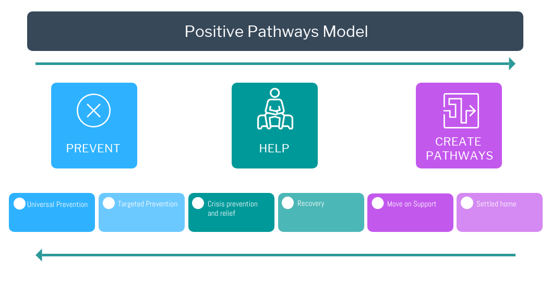

* 1. While it may appear linear, it is recognised that experience of life, especially in the occurrence of something like homelessness, is seldom linear. The pathway could be expressed as circular, reflecting the fact that in a settled home it is universal prevention that enables and maintains that existence.

|  |  |
| --- | --- |
|  | **Definition** |
| Universal Prevention | This is what prevents homelessness without having any directly perceived relationship to homelessness prevention. Those things in society and life that are protective factors. In homelessness terms it is those things which support and protect, health, income, relationships, secure accommodation. |
| Targeted Prevention | This is the provision or interventions which have a designed purpose in preventing homelessness or related issues, for examples, housing advice, leaving care pathway, DHP, bond schemes. |
| Crisis Prevention & Relief | This is where homelessness crisis is imminent or occurring, requiring emergency accommodation. The objective is for any crisis to be as brief and have as a small as impact as possible. Examples include temporary accommodation, hostels, rough sleeping services. |
| Recovery | This is the work required in re-establishing the protections against homelessness and often dealing with the causes and impact of homelessness. This may include financial, health, relationships rebuilding. |
| Move-on support | This is what is required for the physical, emotional and cognitive moving on from a homelessness experience. For example, it may be very practical matters like the logistics of moving, or the emotional support to deal with change and challenge. |
| Settled Home | This is attaining the desired state of protection against homelessness, while also clearly requiring access to affordable, secure accommodation. |

Source: St Basils Positive Pathway

* 1. In taking forward any of the recommendations within this report the Cambridgeshire and Peterborough authorities should consider how services can be developed using the positive pathway model.

## How might services be transformed?

* 1. The local authorities’ Housing Options teams operating across Cambridgeshire and Peterborough are all unique, and operate in a way that best meets the needs of their local communities. The requirement for a local service presence that is uniquely designed to best meet the local need is evident, and it makes sense for this model of service delivery to continue. There are, however, clear areas where a different approach to service delivery may be warranted, either in response to particular service challenges, or where a collaborative approach can deliver improved service outcomes or deliver financial savings.
  2. These suggested approaches for transformation are discussed in detail below. The diagram illustrates what local authority homelessness services could look like moving forward.
  3. On the outer ring district and city councils continue to deliver local statutory homelessness and prevention services to its core customers at a local level (there are however opportunities for shared approaches and systems, which are detailed later), with the county council continuing to deliver it statutory functions and commission housing related support services. The green ring highlights where there are opportunities to deliver and transform services to achieve joined up responses to preventing and relieving homelessness.

Figure 9.2 Diagram of LA homelessness services moving forward

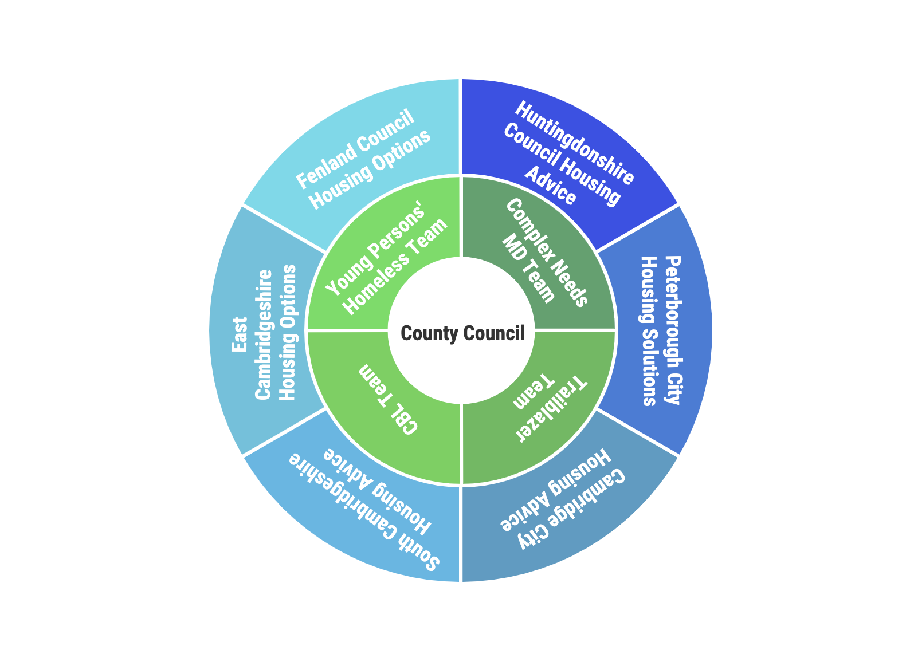

* 1. A customer journey pathway based around this possible model of delivery is shown below.

Figure 9.3 Customer Journey Pathway diagram

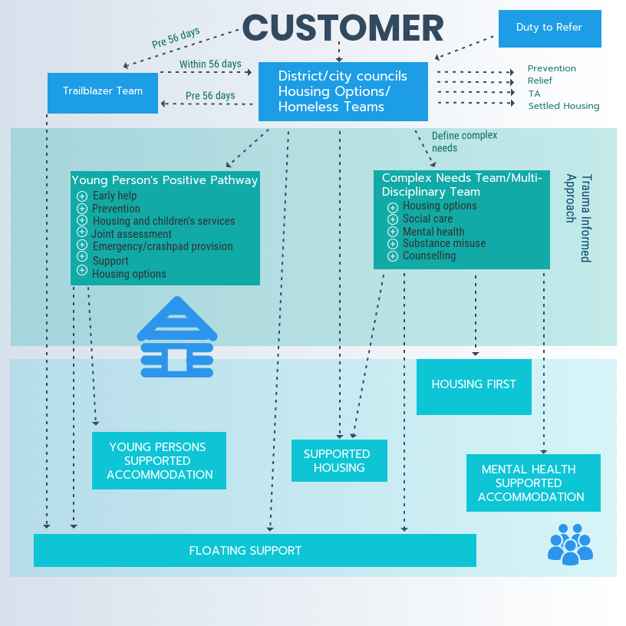

## Young Persons Homelessness Team

* 1. All 6 of the local authorities reported significant issues in relation to meeting the needs of 16/17 year olds, with a lack of a joined up response from children’s services. While a joint protocol is in place, operational practice does not appear to reflect this, and concern was raised in relation to the outcomes being achieved for young people due to the lack of the joined up response.
  2. It is therefore recommended that a solution to this may be the establishment of a centralised young person’s homeless team, made up of Housing Advisers and Children’s Services Practitioners, based upon the St Basil’s Young Person’s Positive Pathway. The Positive Pathway Framework aims to give a clear framework to better prevent young people aged 16 – 25 from becoming homeless. It also sets out the sort of services and support needed to help young people who do become homeless to build a more positive future.
  3. There are five stages to the Positive Pathway, but these are not intended to be sequential or linear:

1. Information and advice for young people and families which is available to everyone in the local area;
2. Early Help, targeted at young people and their families who may be at higher risk of homelessness;
3. A Prevention Hub - using a joint approach between Housing, Children’s Services and other partners to resolve a housing crisis quickly. This also contains a single access point or gateway to commissioned accommodation and support;
4. Commissioned accommodation and flexible support, based on what works well and developed according to local needs; and
5. A range of housing options for young people – affordable and safe housing options when young people are ready to succeed living independently
   1. The Cambridgeshire and Peterborough authorities have the opportunity to develop a whole-systems, integrated approach to preventing youth homelessness in the first place and supporting, where necessary, young people’s planned moves to independence through a positive pathway. The premise for this should be about developing services and practices which invest in universal housing options advice and targeted early intervention rather than just reacting to crisis. This model is based upon the provision of seamless, easy to use services, making better use of scarce resources through joining up and co-ordinating of services. This includes pooling the budgets of council services and other agencies where it is effective to do so, and building on local knowledge, existing community assets and voluntary effort.
   2. The positive pathway model enables the provision of information and advice for young people and their families across all stages of the pathway, not only about housing, but on other aspects of young people’s lives as they make the transition to adulthood.
   3. There are a number of good practice examples cited below from which the Cambridgeshire authorities could develop a local model, this includes both examples of centralised services, or a joined up model replicated locally at a district level.
   4. The number of approaches within each local authority from 16 & 17 year olds is relatively low although this number increases when all under 25 year olds are included.

|  |  |  |  |
| --- | --- | --- | --- |
| Table 9.1 Number of approaches by age | | | |
| **Local Authority 2018/19** | **16-17** | **18-24** | **Total** |
| Cambridge | 6 | 147 | 153 |
| East Cambridgeshire | 8 | 99 | 107 |
| Fenland | 4 | 157 | 161 |
| Huntingdonshire | 20 | 200 | 220 |
| Peterborough | 8 | 245 | 253 |
| South Cambridgeshire | 4 | 63 | 67 |
| Total | 50 | 911 | 961 |

* 1. Using the available data the authorities will need to decide the best way in which to deliver this approach, but a centralised model is likely to lead to the greatest efficiencies and consistency, while a split model may provide a more localised service working closely with a range of local youth services.
  2. The pathway needs to include:
* Early intervention and universal prevention;
* Prevention – including mediation;
* Joint Assessments carried out by Housing Options & Children’s Services staff;
* Access to Emergency beds/crashpads;
* Access to full range of housing options and the necessary support to sustain accommodation;
* Access to Young Person’s Supported Housing; and
* Access to education, employment and training, and wider support services.

|  |
| --- |
| Good Practice – Youth HomelessnessNorth Yorkshire North Yorkshire County Council and the 7 district and borough councils commission a Young People’s Pathway frameworked on the St Basils Positive Pathway to Adulthood. Each housing authority hosts a hub with a multi-agency team of housing options and homelessness prevention workers from Children and Families Services and the voluntary sector working together to prevent and relieve homelessness. The services procedures are aligned with the Homelessness Reduction Act.  Prevention activity includes mediation with families, a joint working protocol to refer 16/17 year old who may require accommodation for a Child in Need Assessment on day one of enquiry and work with the private sector to prevent tenancy breakdown or find alternative accommodation. There is an option of advocacy for young people from the start of contact.  Emergency accommodation is provided through a commissioned Nightstop Service (for up to 14 nights) available both in and out of hours with the addition of 2 out of hours beds in the 24/7 provision accessed through the Emergency Duty Team. Young people who require supported accommodation have their support needs assessed by the Hub based on the Homelessness Outcomes Star framework. They are then allocated by the Hub to the commissioned provider that can best meet their needs. The Hub also monitor voids. Options include Supported Lodgings, 24/7 shared accommodation and dispersed accommodation. If a young person needs to be accommodated in a neighbouring housing authority their assessment goes with them. |

|  |
| --- |
| Good Practice – Youth HomelessnessBirmingham’s Youth Hub The Youth Hub is a multi-agency service, delivered in partnership between St Basils and Birmingham City Council’s Housing Options and Birmingham’s Children’s Trust. The Youth Hub works with all young people in housing need, including care leavers, young people in custody and young parents. It offers specialist youth focused services to prevent and relieve homelessness, including housing options, advice and family mediation. Trained staff undertake housing needs and risk assessments, referring young people into specialist services where necessary.  The Youth Hub offers a variety of different services including:   * Assistance in preventing homelessness – family mediation; access to floating support and landlord liaison/ negotiation; * Carrying out statutory assessments in partnership with the local authority; * Advice and help applying for a range of housing options, for example, supported lodgings, supported accommodation, private and social housing; * Benefits advice; * Advice on accessing education, training and employment; * Specialist support services including health needs, drugs and alcohol misuse support and mental health services; * Access into suitable short stay/emergency accommodation if needed; and * Accessible via Duty to Refer or a central telephone line called Youthline.   The Youth Hub also provides a “gateway” into commissioned supported accommodation for all young people in housing need in Birmingham. |

|  |
| --- |
| Good Practice – Youth HomelessnessNorthamptonshire: preventing homelessness among young people and care leavers The number of young people becoming homeless in Northamptonshire has decreased after the introduction of strategies aiming to improve the response to youth homelessness, which included a highly effective housing protocol for care leavers.  In 2016, led by Northampton Borough Council, Northamptonshire’s seven local housing authorities and children’s services developed and agreed on a new housing protocol for care leavers with housing and tenancy-related support needs. The protocol has been the catalyst for a more consistent and coordinated approach between the local housing authorities and children’s social care departments. The protocol provides clear and consistent procedures and improved referral processes and interventions, and emphasises effective multi-agency working. As a result, relationships between local statutory and voluntary organisations have improved, and young care leavers receive the support necessary to avoid homelessness and have an optimum start in life.  The success of the protocol relies on the following key factors:   * Effective information sharing between local housing authorities, children’s services, and support providers. With the young person’s written permission, relevant information is shared at the earliest opportunity. This sharing of information aids referrals and the joint assessment of the young people’s needs. * An individual pathway plan is developed for each young person, featuring a detailed assessment of their needs and a coherent strategy of how these will be met. This plan is developed and carried out in collaboration with all relevant agencies. * Social workers and personal advisors prepare care leavers for independent living on an emotional as well as a practical level, with the Leaving Care Team particularly focusing on helping young people develop independent living skills. * The availability of various housing options for care leavers, such as moving into supported housing, moving to social rented housing, or remaining with former foster carers. Young people are encouraged to move into independent accommodation at a time appropriate for them and not necessarily when they reach 18. * Assistance in accessing social rental housing is available for all care leavers, covering advice and support in accessing, managing and sustaining their tenancies. For example, Personal Advisers will complete a Housing Referral Form, accompany the young person to their Housing Options interview, and liaise with social landlords as the young person progresses on to bidding, and securing accommodation   Communication, joint working, and problem-solving have been at the core of the protocol’s success. By promoting greater consistency within the young people’s support plans and access to services, the protocol avoids a “cliff edge” move out of care and prevents homelessness among young people. |

|  |
| --- |
| Good Practice - Youth Homelessnesstalk2sort - highly effective early intervention mediation service talk2sort is a Homelessness Mediation Service which supports young people and families across the county of Leicestershire and is provided by The Bridge (East Midlands). talk2sort focuses on reducing conflict, improving relationships and communication and improving mental health and emotional wellbeing. The service offered is free, impartial, non-judgemental and confidential, and only requires one person to want to engage.  The project is funded by Public Health England, Children in Need and Charnwood Borough Council (DHCLG Homelessness Prevention Fund). Public Health’s funding is based on an understanding of the inter-related nature of mental health and wider social factors. Public Health recognises the importance of reducing inequalities with a desire to explore ways to address young people’s mental health needs outside the clinical model. A representative reported in an interview that although initially ‘a bit of a leap investing in mediation,’ talk2sort has become a ‘value for money service which is filling a gap,’ and without the service individuals would possibly present with more complex problems at a later stage.  The project has achieved exceptional outcomes. In 2015/16, 119 young people were supported, 83% of whom remained at home, while 17% were accommodated by other relatives, 92% also reported feeling more positive, and 90% reported improved communication in the family home.  *“I think family mediation helps everyone get their view across and you find a lot that once the parent actually realises how their kid feels, they tend to get overwhelmed and cry, because they didn’t feel their kid felt like that, because they didn’t listen. Once they realise that letting them open up and letting them have their say a lot more changes. It changes better (Young Person)”.*  The success of talk2sort is built on the following key principles:   * The service is offered before families reach a crisis point. Drop-in services are offered at schools and colleges, and the service is well advertised, with many referrals being received by word of mouth; * One-to-one meetings are offered to young people and family members prior to joint mediation sessions; * The service employs specialist mediators who use a range of creative and participatory approaches to help families explore their problems; * The service adopts a flexible approach to delivery. There is no time limit on support, it is offered at flexible times (including evening appointments) and at locations where people feel safe and comfortable; * Partnership working is at the heart of the service, based on well-established relationships with referral agencies and other services; * The service is future focussed and supports young people and families to identify for themselves realistic and achievable ways of moving forward; and * The low-cost prevention service generates significant cost savings to other, more expensive areas of public sector expenditure, including housing, health and social care. |

|  |
| --- |
| Good Practice – Youth HomelessnessHull – Passport to Property The Passport to Property programme is an integral part of Hull City Council’s young people’s accommodation hub, delivered in partnership between Targeted Youth Support Services and the Housing Service.  It’s a prevention tool that is used where appropriate to assist young people to make planned moves out of the family home, rather than leave at a point of crisis. It in effect delays a move, and incentivises young people and their families to work towards a move when the young person is ready.  Offering both group and individual sessions the scheme aims to help young people further develop their skills and confidence to make positive and successful transitions to independent living and prevent homelessness through making planned moves with the family supporting the young person.  The programme is also offered to other young people who need skills and confidence to make positive and successful transitions to independent living or maintain an existing tenancy.  Upon completion, the participants receive an improved banding on the Choice Based Lettings Scheme, which enables young people to bid for social housing and a small furniture package to help them get started when they move into their new tenancy.  The programme provides an accredited ten-step approach covering key areas of support ranging from rights and responsibilities, budgeting and income, to keeping safe and avoiding isolation. Sessions are delivered both in local community settings, including across all the city’s colleges of Further Education and also can also be delivered within family settings.  The different sessions are supported by a wide range of partners to provide additional advice and support regarding education and training opportunities and how to access other support services.  On completion, additional wrap around resettlement support and/or accommodation options can also be accessed through the accommodation hub where required. |

|  |
| --- |
| Good Practice – Youth Homelessness1st Base Greenwich 1st Base in Greenwich, based at The Point, provides housing options and support services for 16-17 year olds, young people aged 18- 24 years and care leavers aged 18-24 who are at risk of homelessness, as part of an integrated youth service.  1st Base prevents homelessness, assists young people to remain or return home where it is safe to do so, and provides holistic assessments and integrated services to meet needs.  The Point is a fully integrated one stop service led by children’s services, in partnership with housing, health, and third sector providers. The service was established to provide targeted youth support to the most vulnerable young people, with particular focus on improving health and well-being, access to education employment and training, personal and community safety. Delivering key services within a young person friendly and welcoming environment, The Point succeeds in attracting young people who are otherwise disengaged from services, to attend for EET activities, sexual health screening, substance misuse services as well as the 1st Base Housing Inclusion Service. The 1st Base Team consists of Housing Inclusion Officers who work closely with Social Workers to a joint working protocol between Housing and Children Services to better support our young people. The Housing Inclusion Officer is responsible for completing a personalised housing plan (PHP) based on housing and support needs and works with young people and families to find solutions that prevent homelessness. 1st Base carry out home visits, work with those in custody, offer floating support to young people and families in their homes, arrange respite accommodation, informal mediation and act as the gateway to all young people’s supported housing and floating support in the borough. Housing Inclusion Officers work with young people 16-24 to develop independent living skills and to sustain accommodation, including young people in social housing, supported housing who are at risk of homelessness and those 18+ who are not in priority need but need support to access and manage in the private sector. |

|  |
| --- |
| Good Practice Youth HomelessnessBristol Youth MAPS Bristol Youth MAPS is a multi-agency co-located youth homelessness prevention hub, which was commissioned by the local authority in October 2017. The first 18 months have been a process of learning and development, particularly in relation to partnership working which have seen real improvements for young people at risk of homelessness, and a much more joined up service tailored to the needs of the young person:   * Co-location – MAPS enables young people to access a youth-oriented housing adviser in the same place as a statutory homelessness assessment and family work which is much more joined up than previously; * Improved systems –MAPS also provides a virtual hub connecting youth housing services. Case Review panels enable key partners to explore barriers and solutions for “hard-to-house” young people. These developed relationships have led to a much overdue update of the local Referral and Eviction Protocol for young people which has significantly improved the multi-agency response; * Helping young people to remain at home – MAPS was set up on the premise that, where safe, young people achieve better outcomes when they remain with their family. Whilst this can be challenging, there have been successes in helping young people to stay at home. Key to this has been mediation work alongside clear messages about the difficult reality of finding housing in Bristol for young people; and   Evidence of reducing referrals to supported housing, emergency accommodation and numbers of 16 and 17 year olds becoming looked after through homelessness through more work to prevent homelessness. |

|  |
| --- |
| Good Practice – Youth HomelessnessNottinghamshire County Council – Housing Related Support Commissioning Nottinghamshire County Council has two sets of arrangements in place for the commissioning of supported accommodation which young people experiencing homelessness, looked after children and care leavers aged 16 -21 can access as part of their transition to adulthood. The young people’s element of the county council’s housing related support budget was pooled in 2015 with the 16+ placement budget to achieve the scale of the provision.  Underlining the planning for the new model was a recognition that new provision needed to be able to support all young people, including those with multiple and complex needs and young people with an offending background.  There are two types of placements available: The main 16+ provision has 227 units of accommodation for homeless 16/17 year olds, LAC and Care Leavers transitioning from residential or foster placements and vulnerable homeless young people aged over 18. These services provide choice around housing options for young people via the provision of ‘core’ and ‘cluster’ accommodation which is grouped into 6 areas of the county. The ‘core’ services are staffed 24 hours a day and have appropriate levels of staffing to support young people presenting with a range of needs. In addition to the core service, there are ‘cluster’ units of accommodation which may be self-contained or small shared houses where staff provide visiting support. The support provided is responsive to the young person’s needs and may increase or decrease to meet the needs of the young person.  Individual placement agreements commissioned via a Dynamic Purchasing System with approved providers that are able to provide support for young people who need a greater level of support than is readily available within the main 16+ provision. These placements are sourced as a step down from residential before moving into the main provision, or where it is clear the Looked After child would not be able to sustain their accommodation within the main provision. There are a range of accommodation options available which include solo placements with staff available 22 hours a day, and small settings with visiting support.  A package of support is individually tailored and is responsive to the young person’s needs. Within the main provision, young people typically enter a core service then progress on into cluster accommodation as their independence, resilience and ability to manage a tenancy improves. However, some young people may move directly into the cluster accommodation if this is deemed more suitable. Some young people may require a move from a more independent cluster property back into the more supported ‘core’ service if their needs would be met more appropriately in that setting. Similarly, some young people will move from the core service into a higher needs placement if this is more suited to their needs.  The commissioners believe that there has been improved value for money, compared to previous spot purchasing arrangements, and the quality of service delivery is high.  The commissioning model that has developed is a reflection of strong partnership working between the county council and all the 7 district councils in Nottinghamshire. This has led to a high level of consistency across the district councils, which is expressed in the Care Leavers Offer, supporting care leavers to find suitable housing, and offer priority on Nottinghamshire housing waiting lists. Care leavers are also exempt from paying Council Tax in all the districts and have access to free leisure facilities. |

## Complex Needs Multi-Disciplinary Team

* 1. Multiple and complex needs are persistent, problematic and interrelated health and social care needs which impact an individual’s life and their ability to function in society.  They are likely to include; repeat street homelessness, mental, psychological and physical health problems, drug and/or alcohol dependency, and offending behaviour. People with complex needs are more likely to experience violence and abuse, including domestic violence, live in poverty and have experienced trauma in childhood and throughout their lives.
  2. They have ineffective contact with services, partly due to the fact that most public services are designed to deal with one problem at a time and to support people with single, severe conditions. Lacking effective support from services, people easily end up in a downward spiral of mental ill health, homelessness, drug and alcohol problems and crime.
  3. While relatively small in number, this group imposes disproportionate costs on Government and society. Current commissioning processes for services relevant to this group typically do not consider how having simultaneous needs can potentially exclude them from help when they need it the most.
  4. When people with multiple and complex needs try to fit into inappropriate systems, they often experience increased negative outcomes and become more unwell through exclusion. Services themselves can also experience service disruption when they are not designed to cope with the behaviours associated with trauma. In this way those most in need are often overlooked precisely because their needs are so great.
  5. Increasing complexity of need was a significant issue faced by all of the local authorities in Cambridgeshire & Peterborough, as too was the lack of a joined up response from mental health and social care services. Locally homeless individuals with complex needs do not fit into any one service area and responses to them from public sector agencies can be fragmented, reactive, often ineffective and have a high cost.
  6. The threshold to access social care and mental health services has increased, so clients who would have once qualified for assistance are no longer getting the support that they need. This is coupled with the fact that many of these services only focus on clients in crisis, with a loss of preventative strands of work, resulting in clients’ needs increasing as they are not getting early help.
  7. All of the authorities feel that homelessness has become the safety net for these clients, however the services don’t have access to the support and skills needed to meet these client’s needs, and as such any accommodation option that can be secured is highly likely to breakdown creating a repeating cycle of homelessness.
  8. At the moment it is not possible to quantify the scale of homeless clients presenting with complex needs across Cambridgeshire, anecdotal information from the Homelessness teams suggests that this is a significant and growing issue. Support needs are now recorded through H-CLIC returns, and across Cambridgeshire and Peterborough mental health is the most prevalent support need, with 1,012 individuals identifying a mental health support need in 2018/19.
  9. There is a need in the first instance to define and quantify complex needs across Cambridgeshire, and then develop a bespoke and joined up response to meet the multiple and challenging needs of this client group.
  10. There is no national definition of what complex needs means in relation to homelessness. In helping to define what complex needs means in relation to homelessness across Cambridgeshire examples of other definitions are given below, and the Cambridgeshire authorities may wish to consider these in developing their own definition.

|  |
| --- |
| Complex Needs DefinitionsAll Party Parliamentary Group The All Party Parliamentary Group launched an inquiry into ‘complex needs.’ In 2013 and defined complex needs as follows:  A person with ‘complex needs’ is someone with two or more needs affecting their physical, mental, social or financial wellbeing.  Such needs typically interact with and exacerbate one another leading to individuals experiencing several problems simultaneously.  These needs are often severe and/or long standing, often proving difficult to ascertain, diagnose or treat.  Individuals with complex needs are often at, or vulnerable to reaching crisis point and experience barriers to accessing services; usually requiring support from two or more services/agencies.  Someone described as having complex needs will have (although not limited to) a co-morbidity of two or more of the following:   * Mental health issues * Substance misuse issues * A dual diagnosis of mental health and substance misuse issues * A physical health condition * A learning disability * A history of offending behaviour * A physical disability * Employment problems * Homelessness or housing issues * Family or relationship difficulties * Domestic violence * Social isolation * Poverty * Trauma (physical, psychological or social)   These needs are often severe, long- standing, difficult to diagnose and therefore to treat. Ongoing inequalities continue to exist and are only likely to increase as people live longer with a wider range of needs. Housing First Housing First Principles define multiple and complex needs as persistent and interrelated health and/or social care needs, which impact an individual’s life and ability to function in society. These may include:   * Entrenched street homelessness, repeat service use or being otherwise vulnerably housed * Mental, psychological or emotional health needs * Drug and/or alcohol dependency * Contact with the criminal justice system * Physical health needs * Experience of domestic violence and abuse.  Making Every Adult Matter (MEAM) People facing multiple needs and exclusions are in every community in Britain:   * **They experience several problems at the same time**, such as mental ill health, homelessness, drug and alcohol misuse, offending and family breakdown. They may have one main need complicated by others, or a combination of lower level issues which together are a cause for concern. These problems often develop after traumatic experiences such as abuse or bereavement. They live in poverty and experience stigma and discrimination. * **They have ineffective contact with services.** People facing multiple needs usually look for help, but most public services are designed to deal with one problem at a time and to support people with single, severe conditions. As a result, professionals often see people with multiple needs (some of which may fall below service thresholds) as ‘hard to reach’ or ‘not my problem’. For the person seeking help this can make services seem unhelpful and uncaring. In contrast to when children are involved, no one takes overall responsibility. * **And they are living chaotic lives.** Facing multiple problems that exacerbate each other, and lacking effective support from services, people easily end up in a downward spiral of mental ill health, drug and alcohol problems, crime and homelessness. They become trapped, living chaotic lives where escape seems impossible, with no one offering a way out. |

* 1. Following the development of a Cambridgeshire definition of complex needs, there is then a need to be able to quantify the number of homeless individuals across the area who have complex needs. There is no national recording system; therefore a local system will need to be created to be able to quantify this locally. In this area the Cambridgeshire authorities may wish to lobby MHCLG to develop a national definition of complex needs and ensure that this can be reported through H-CLIC; this is not an issue that Cambridgeshire authorities are grappling with alone, nearly all local authorities that arc4 have worked with are seeing an increase in the complexity of needs that clients are presenting with and a lack of joined up responses in meeting this need.
  2. Once a clearer understanding of the scale of the issue is known then an identified opportunity through this project is the establishment of a centralised multi-disciplinary Complex Needs Team, this would be a person centred, asset based approach, and would be based upon the co- location of the following:
* Housing Options Advisers;
* Mental Health Practitioners;
* Social Care Practitioners;
* Substance Misuse;
* Criminal Justice (Probation); and
* Therapeutic services.
  1. Direct access will be needed to emergency accommodation provision, and would also link into the supported housing pathway. Any future remodelling or commissioning will need to take into account the high prevalence of mental health, including dual diagnosis and the need for a specific skill-base amongst staff in those services.
  2. This new multi-disciplinary team could also be the direct referral route for Housing First provision.
  3. There may be an opportunity to seek corporate commitment to this new approach across a number of key organisations through the Think Communities programme, this is an ideal opportunity to unite key public sector organisations behind a common set of goals and priorities which support the development of communities, providing a system wide approach in which partners listen, engage and align with communities and with each other, to deliver public service and support community-led activity. A similar example of this operates in Doncaster and details are provided below.

|  |
| --- |
| Good Practice – Complex NeedsDoncaster Complex Needs Alliance The Doncaster Complex Needs Alliance is a ‘whole - systems approach’ to transform outcomes for people with complex lives, and in doing so aim to reduce the disproportionate demand and cost of public services which this relatively small group of people cause.  The holistic service offer is person centred and asset based, emphasises prevention and early intervention, and manages demand through proactively identifying, engaging, supporting, and accommodating people living complex lives, allowing them to integrate, over time, into mainstream society.  **Complex Lives team** is made up of a core dedicated front line outreach and case workers, providing capacity to identify, engage, triage, and provide a strong accommodation and support plan for people living complex lives – focused on recovery, resettlement, empowerment and inclusion.  The team will comprise a core group of staff who are responsible for outreach, engagement and the management and coordination of work with people living complex lives. They are described as ‘all - rounders’ - generalists with key skills in creating relationships and trust, with experience of managing interdependent issues like homelessness, drug and alcohol addiction, mental ill health, offending behaviour and the chaotic and complex lifestyle issues surrounding this.  The team will have a core membership with a number of connected elements:-   * Engagement and outreach - making connections with people on the streets or in vulnerable/unstable accommodation situations and supporting them to access services and support. * Making Every Adult Matter case - workers - managing and coordinating very complex cases, with small caseloads of approximately 5-7. * Navigators, managing and coordinating less complex cases, with larger caseloads of 15-20. * Amber workers - with a specialism is supporting sex workers (employed by Changing Lives).   The core team will work with a wider group of associate specialist staff from other disciplines, for example drugs and alcohol, mental health, key workers in supported housing and floating support, welfare benefits and employment support - who will both deliver work directly to people living complex lives and act as consultants to case managers.  The complex lives team will be the consistent point of contact for people living complex lives and their champion in co-defining their assets, needs and outcomes. They work flexibly and provide personalised responses to individual strengths and needs - a strongly asset based approach. They start by seeking stability, whilst trying to reconnect people into their networks (using the three conversations model), drawing upon an ecosystem of formal and informal support available in the community (see below).  When crisis occurs, the team manages step up into acute settings, ensuring the person maintains their connection into the community and is discharged as quickly as possible.  They take a proactive approach, seeking to activate demand, meeting and working with people where they are. Their working hours go beyond a 9-5 window.  **The Complex Lives Asset Menu** consists of   * An ecosystem of formal and informal community and service based support, focused on helping people living complex lives to stabilise, resettle and recover. Support is focused on everything from reconnecting with friends and family (where appropriate), broader community support, and maintaining positive relationships, to employment training, building life skills and other activities and routines that can help stave off boredom and develop positive habits.   The menu includes a mixture of a) support commissioned directly by the Alliance from the VCS community, and b) peer and community led support for recovery, making direct use of the experience and perspective of people who themselves have experience of complexity. The Team are able to identify with their clients the right support among the wider web of services available and they have the right connections and influence to broker timely access to them. This support is geared towards stabilisation, resettlement, recovery and inclusion.  Feedback from the Complex Lives Team and current and former users of services will be able to directly influence commissioning and design of services.  **Doncaster Housing Plus Pathway** is an accommodation and support pathway that builds from the needs and aspirations of people living complex lives, managed as a highly coordinated system directly by the Complex Lives Alliance, with a ‘move in, move-on’ culture.  Commissioned by the Alliance and designed to operate alongside and with the support of the Complex Lives Team, the model is a Doncaster adaptation of the Housing First model - which considers Housing as a basic human right, and provides wrap around support on a highly assertive but non-conditional basis.  The Doncaster model will ensure a range of hostel, supported accommodation and move on options are in place to meet needs, managed as a pathway – with a single, coordinated point of access to ensure people are routed to appropriate support. More appropriate dispersed community based accommodation will be available with support services integrated by design. This will be a pathway of graded and flexible accommodation all with an assertive support offer, the goal of which is to move people into ever greater independence, but where accommodation is not conditional on take up of support (but is subject to general tenancy conditions).  In all accommodation clients will work with their case manager from the Complex Lives Team or key workers around regular cycles of action and reflection in a consistent and quality controlled way. Once a person has achieved stability, they create their long term plan focussed on recovery and reintegration. Step up and step down are facilitated as necessary. This provides personalised responses rather than following standardised pathways.  The pathway and its coordination will ensure that where street homelessness occurs a ‘No Second Night Out’ policy can be upheld, where a person is stable but still in need of intensive support the right supported accommodation is easily accessible, and where a person is ready for greater independence they and the complex lives team have options available in the community.  **Doncaster Changing Lives Fund** is a support fund that can enable rapid removal of practical barriers to progression for people living complex lives. The Fund operates as an easily accessible but accountable direct resource, available to people living complex lives supported by the Complex Lives Team and key workers acting in a support and advocacy role - i.e. the initiative and commitment to resolve the issues concerned comes from the individual. It provides small amounts to deal with incidental items (phones, haircuts etc..) or mini - grants to help people with move on - i.e. furniture packs for people moving into independent accommodation or other individual requests for help. The Fund includes contributions from services and also the direction of funds from the anti - begging campaign - positioned as an alternative to giving to people who beg.  **Complex lives prevention and demand management** - The Alliance will over time shift the balance of its focus on tertiary prevention to secondary prevention and managing the flows of demand for acute services. This includes a proactive approach to engaging with latent demand in the system - ‘opening - up’ the system to demand at secondary prevention level, to prevent it escalating.  The initial focus of the Complex Lives model is on tertiary prevention - ensuring effective resettlement of people living complex lives and reducing the likelihood of them re- entering the system on a revolving door basis. However, the Complex Lives Alliance model must place an increasing emphasis over time on secondary prevention and managing demand coming into the system - otherwise it will continually ‘fill - up’ at the acute end of services.   * Work with individuals and families in unstable accommodation situations, with homelessness prevention work that follows the ‘Doncaster Housing Plus’ wrap around model; * Work with young people at risk of homelessness, including care leavers; * Pre-emptive work with Prison leavers; * A clear and effective approach with people newly arriving in Doncaster, with a focus on reconnecting people back with their networks and families, ensuring Doncaster does not act as a magnet for demand as a result of this model.   The approach to managing demand should not be about limiting access to the system, but about finding ways to significantly open up and encourage people to self-help and receive support at the secondary prevention level, taking an assertive approach. |

## Choice Based Lettings

* 1. Across Cambridgeshire social housing is allocated through a sub-regional Choice Based Lettings scheme known as Home Link. Home Link is the Choice Based Platform for letting social housing properties through a common allocation policy across Cambridgeshire and West Suffolk. Peterborough operate a standalone Choice Based Lettings scheme with their main social housing providers.
  2. The Home-Link scheme and the lettings policy were designed through collaboration between the partner organisations, with the aim of having as much consistency in the letting of social housing as is possible in a very diverse area.
  3. The sub-regional Home-Link manager and administrator are based within South Cambridgeshire and oversee the operation of the partnership. The allocation functions, including the management of the housing register are delivered at a local district/city level by the Cambridgeshire authorities, with the exception of Fenland where this function is contracted out to their LSVT, Clarion.
  4. Throughout this review a number issues were raised by the local authorities in terms of consistency of service delivery and application of the Lettings Policy, this was specifically the case in relation to registered providers’ interpretation of the policy, with instances being cited where registered providers were applying their own Allocation Policies over the common Lettings Policy.
  5. Despite requests it was not possible to ascertain the current level of resources and costs of operating the Home-Link scheme across the partnership. At the time of undertaking this project a review of the Lettings Policy was underway.
  6. It is recommended that an independent options appraisal be commissioned to consider the future options for delivering Choice Based Lettings across Cambridgeshire. It is highly likely that a centralised service delivery model would deliver financial savings that could be re-invested in other homelessness services, including future funding of the Trailblazer service. A centralised service is also likely to improve consistency of delivery, particularly in relation to the application of the Allocations Policy.
  7. The options appraisal should consider:
* The overall cost of delivering the service and benchmark this to other similar partnerships to understand value for money;
* Fragmentation of service delivery;
* The customer journey including alignment with Housing Options advice;
* Consistency of service delivery in relation to the application of the Lettings Policy and access to advice;
* Potential areas of duplication and opportunities for streamlining;
* Opportunities to improve the customer journey including opportunities for integration and alignment;
* An appraisal of a number of future delivery options; and
* Opportunities to deliver financial savings through these proposed options.
  1. Centralising the Home-Link service could include a range of options including:
* Co-locating all Home-Link staff, ideally on to a single site (initially making no changes to employer or employment conditions, simply a change of workplace). This could improve consistency of service delivery including interpretation of the allocations policy, alongside the potential for financial savings. A local presence in each LA could be retained to provide the public with information, advice and assistance about the allocation of social housing and provide assistance in making applications, however this could be a function that could be delivered by Housing Options teams or customer service staff;
* Seconding all Home-Link staff to a single body (this could be a local authority or a registered provider);
* Employing all Home-Link staff via a single body (this could be a local authority or a registered provider);
* Developing a Shared Service across the local authorities; and
* Creating a limited company to administer Home-Link.

## Other Opportunities

### Commitment to Collaborate

* 1. Cambridgeshire & Peterborough may wish to develop a Commitment to Collaborate with the aim for all public services to commit to proactive ways of identifying and addressing the risks of homelessness, and in doing so create a culture of public service collaboration that can better support vulnerable people.
  2. This would build upon the memorandum of cooperation developed through the Trailblazer programme by encouraging public bodies and partner agencies to review their activity and identify opportunities to design out homelessness. The development of a toolkit would enable organisation to undertake a review, identify gaps and opportunities to prevent and relieve homelessness, and make positive changes.
  3. The toolkit could include:
* Explanation/education around homelessness, including breaking some unhelpful perceptions e.g. homelessness is rough sleeping, homelessness is bad luck/nothing can be done about it;
* The purpose of the toolkit and how to use it;
* Explanation of the steps to take/methodology;
* Turning issues into actions;
* Making commitments and pledges that have traction;
* Templates;
* Case studies, illustrations, examples;
* FAQ’s; and
* Where to get help/advice/resources.

|  |
| --- |
| Good Practice – Partnership WorkingWest Midlands Combined Authority Commitment to Collaborate The West Midlands Combined Authority has set up a Taskforce is to ‘design out homelessness’; that is to identify and tackle the structural, policy and operational factors that lead to homelessness or fail to protect against homelessness. The model adopted by the Taskforce, is based upon the Positive Pathway Models for Young People, which identify and enhance the protective factors within the universal space and target homeless prevention at the earliest possible opportunity. The Taskforce in partnership with the Chartered Institute of Housing and Crisis and have used the Pathway model to improve understanding and encourage other public sector bodies and their partners to develop a voluntary Commitment to Collaborate (C2C) to prevent and relieve homelessness. The WMCA is currently developing an attractive, user-friendly toolkit for dissemination, promotion and effective use of the C2C model |

## Social Housing

### Role of Social Housing

* 1. Both local authorities and support providers raised a number of concerns in the ability of vulnerable clients to be able to access social housing. These concerns included:
* Homeless clients often unable to access social housing due to former tenant arrears or former anti-social behaviour, even where behavioural changes can be demonstrated;
* Rigid approach to former rent arrears, whereby many clients would take years/decades to be able to clear the arrears by paying an affordable amount every week;
* Affordability checks can be a potential barrier;
* Limited opportunities for clients to move on from supported housing into social housing;
* Social landlords seeking rent in advance resulting in affordability issues for new tenants;
* When clients are let social housing, the expectation is that they move into the property immediately, giving no time to prepare for move on or to purchase the essentials. This poses a risk to the sustainability of the tenancy;
* The condition of social housing properties when they are re-let; and
* Lack of new social housing supply.
  1. There is a need for the Cambridgeshire and Peterborough authorities to engage with honest dialogue with social housing providers and agree what the role of social housing provision should be, including a commitment to support vulnerable members of community and work to prevent and relieve homelessness.
  2. Commitments should be sought in the following key areas:
* To operate flexible allocations and eligibility policies which allow individual applicants’ unique set of circumstances and housing history to be considered.
  + Housing associations should assess nominated households on an individual basis, considering reasons for any historic rent arrears or antisocial behaviour. Assessments should seek to understand whether any previous issues are relevant to the person’s ability to succeed in their tenancy now. The trigger for the issues and the support available at the time should be considered.
* To offer constructive solutions to applicants who aren’t deemed eligible for an offer of a home.
  + There will be situations where a local authority or housing association decides offering someone a home is too great a risk to take if someone has struggled to succeed before.
  + In these cases, housing associations should offer a constructive and supportive approach to mitigate perceived risk of tenancy failure. Optional tenancy training should be offered to the excluded applicant with targeted support and information addressing any previous causes of tenancies failing.
  + It may be appropriate to delay an allocation until tenancy training is completed, or for the training to be completed while the tenant is offered a probationary or introductory tenancy.
  + Housing associations should work with their local authorities to identify registered applicants close to nomination that are considered unsuitable for an allocation; and offer pre-tenancy training in advance. It is also vital to make sure eligibility and allocations criteria are aligned to prevent inconsistencies in approach. These can lead to applicants feeling confused and frustrated with the allocations process.
* -To commit to meeting the needs of vulnerable tenant groups.
  + Housing associations should have specific policies, procedures and partnerships to support access to their properties for vulnerable homeless people. This approach should continue in supporting vulnerable tenants to sustain and succeed in their tenancies.
  + Housing associations should be seeking to understand the levels of need for vulnerable groups and propose ways they can meet that need. Their understanding should be informed by local authority homelessness strategies.
  + Local authorities and housing associations have already adopted a range of good practice in responding to domestic abuse. This is underpinned by better training and awareness by frontline housing and homelessness staff.
  + It is important to identify and respond to domestic abuse before it results in a homeless application. To support this, housing associations should commit to the CIH ‘Make a Stand’ pledge. This pledge has been developed by CIH in partnership with the Domestic Abuse Housing Alliance (DAHA) and Women’s Aid. It sets out how all housing organisations should support people who live and work in housing who are experiencing domestic abuse.

|  |
| --- |
| Good Practice – Access for Vulnerable GroupsYour Homes Newcastle (YHN) YHN are an arm’s length management organisation (ALMO) responsible for managing Newcastle City Council’s homes. YHN is a partner of Tyne and Wear Homes CBL scheme, which operates across the North East of England.  YHN has several projects specifically aimed at making accessing social housing easier for vulnerable groups, including a support and progression team including:   * A dedicated pathways team that assists people with support needs to access suitable accommodation and live independent and successful lives by work specifically with;   + people who are moving on from temporary and supported accommodation,   + people who are fleeing domestic violence and need rehousing due to this   + people who are unable to return home after a stay in hospital   + people who are in need of suitable housing either following a stay in hospital due to mental health difficulties, or because their current accommodation is unsuitable   + people moving into general needs tenancies after being in the armed forces   + refugees who have recently received their status and who have to leave NAS accommodation * An OSIC Level 1 certified member of staff to support EEA nationals who are applying to YHN to establish a legal status and improve access to social housing in the future. * Young people’s support and progression workers who support care leavers into their own tenancies. The progression workers are qualified social workers and they also work with young people who are identified as children in need (section 17 of the Children Act 1989) to support them into suitable homes or to remain at home, where it is safe to do so. * A system that flags up where an applicant reports having a support need which leads to contact being made to complete a pre- tenancy risk assessment. This assessment is used to facilitate a discussion about possible barriers to a successful tenancy. The aim is to recommend appropriate support an applicant may need at the point of sign up (or before) to help them sustain a tenancy. * Qualified social workers who support unaccompanied minors to live in general needs housing stock.   YHN focuses on building resilience among their customer base by supporting them to sustain their tenancies and engage within their community. They want to support access to social housing for the tenants that need it most by engaging with applicants at the allocation stage and ensuring they get the help they need. YHN’s tenancy turnover is 8.2 per cent which is significantly lower than any other social landlord within their bench marking group. |

* To work in partnership to provide a range of affordable housing options which meet the needs of all homeless people in their local communities.
  + Housing associations should provide access to a range of housing options for homeless people. Housing solutions to homelessness should be varied to meet the diverse needs and circumstances of homeless people.
  + Social housing is one of the most cost effective solution to homelessness, ‘Housing solutions to homelessness’. So, housing associations should maximise their supply of social housing, wherever possible, and proactively support homeless people to access that supply. However, there is potential for homes of different tenure types and different rent levels to end the homelessness of some people.

|  |
| --- |
| Good Practice – Shared TenanciesNewydd Housing Association Newydd Housing Association runs Rooms4U – a shared housing pilot across Mid and South Wales. With partner housing associations in the local area, the Rooms4U project addresses the housing needs of single households on the common housing register. It does this by developing and supporting shared tenancies in the social and private rented sector.  Applicants for the project are prioritised on housing need. They are then supported to complete tenancy training and are matched into two and three bedroom accommodation offered on licence agreements. Rooms4U employs a dedicated project officer to manage the pilot and provide light touch, ongoing support to the shared tenancies. |

* -To ensure that properties offered to homeless people should be ready to move into.
  + Working with local authorities and the local voluntary sector housing associations should only offer homes that are ready to live into people moving out of homelessness.
  + Social housing properties without furniture and white goods, carpets and wall coverings, will deter people on low incomes from accepting them. Consequently, people on low incomes are often pushed towards private rented sector properties. These properties are usually ready to move into, but offer less security and higher rents.
  + To prevent this happening, housing associations should, through networking and the local voluntary sector, identify sources of cheap or free furniture and white goods. Alternatively, they could help tenants access affordable financing for these materials themselves.

## Reducing Social Housing Evictions

* 1. Eviction from social housing features in the top 5 main causes of homelessness in 4 out of 6 of the Cambridgeshire and Peterborough authorities. There is a particular need to consider how social housing evictions can be reduced in Peterborough, Cambridge and Fenland.
  2. It is recommended that the local authorities and the main registered providers develop a joint early arrears project to prevent rent arrears escalating and reduce homelessness.
  3. By reinvesting negative spend money (i.e. chasing rent arrears, anti-social behaviour, repairing properties, pursuing evictions and then allocating the homes again once they are empty) and redirect this spend into activities that can sustain tenancies and alleviate poverty homelessness from social housing could be significantly reduced.
  4. There are a number of pilot schemes operating in North Wales, and a similar model could be developed across Cambridgeshire, either through a strand of the Trailblazer programme, or as a standalone project.

|  |
| --- |
| Good Practice – Reducing Evictions in Social HousingClwydAlyn ClwydAlyn, North Wales Housing Association has 6,000 homes across seven counties in North Wales, as well as supported living schemes, care services and other tenures. Until last year, it had been evicting about 19 or 20 households a year, however in April 2019 the association brought in its new policy – working towards no evictions.  Since then, it has evicted only three households, two of whom were no longer living at the property. This new approach has led an 80% reduction in evictions.  Wales & West Housing Association, had developed a similar approach about eight years ago. The association, which has about 12,500 homes, serves around 20 notices seeking possession a year now, this approach has led to a reduction of evictions from 40 -50 annually to low single figures.  ClwydAlyn have re-examined the organisational mission, “what we are here for”. The answer, the association decided, was poverty. The organisation considered the statistics on the areas in which it operates and saw that people in the poorest neighbourhoods still had a lower life expectancy.  The organisation reviewed its “negative spend” – money the association was pouring into chasing rent arrears, anti-social behaviour, repairing properties, pursuing evictions and then allocating the homes again once they are empty.  The aim was to avoid spending some of this money and instead redirect it into activities that can sustain tenancies and alleviate poverty. The housing association recognised that evicting does not really solve the problem for that individual or family, as they will still need to be accommodated.  Over the last eight months the organisation has made small changes, by approaching tenancy problems in a different way, and fundamentally changing the culture of the organisation  The approach has been to develop a better relationship with tenants, and to intervene early – when the first rent payment is missed rather than when arrears are out of hand.  Suzanne Mazzone, head of income and service improvement at Clwyd-Alyn, says: “If they’ve gone over by £500 or £1,000, it’s beyond people’s ability to think how they’re going to manage that. When the first payment is missed we need to find out why and offer support. It’s much easier to manage then.”  Housing officers also meet every four weeks and discuss cases. If things are not working, the answer is not to send out demand letters. Instead they try different approaches, which could involve switching the case to a different housing officer, for example.  The solution might be helping the tenant move to a more affordable or suitable property. A move may also be used to help in anti-social behaviour cases, if the problem is localised.  The approach moves away from adversarial relationship, with tenants getting letters through the door demanding payment, instead the approach is a rapid personal response based on ‘you’ve missed a payment, how can we help you?’”  Both Clwyd-Alyn and Wales & West speak of looking at each case individually and considering if the cause is “can’t pay” or “won’t pay”. The latter makes up only a few cases. |

|  |
| --- |
| Good PracticeManaging Arrears – Prevention Pilot Flintshire County Council In response to an increase in rent arrears for council tenants, housing solutions, supporting people and estate management have worked together to develop an early response for any council housing tenant across Flintshire who falls into rent arrears.  The aim of the project is to:-   * Maximise the rent income to the council; * Reduce the level of arrears and the number of households falling into arrears; and * Reduce the number of households referred to housing solutions at risk of homelessness as a result of non-payment of rent.   The objectives of the project are to:   * Develop and pilot a delivery model through a multi-team approach; * Target activity at those tenants in the early stages of arrears; * Develop a range of interventions which have the most impact in terms of sustaining tenancies; and * Evaluate the project after 6 and 12 months to establish which elements of the project can inform wider team approaches.   The aim of this service is to provide early intervention and prevent rent arrears building up. The hub is made up of 2 Housing Solutions Support Officers and 2 income officers. The team focuses on addressing rent arrears whilst they are at a low level before they become unmanageable.  Tenants who miss one month’s rent payment trigger an intervention from the team, who will contact them, including undertaking home visits to understand the reason why the arrears have begun to accumulate. The team will work proactively with the tenant and put any necessary support or measures in place to help them manage their money and maximise their incomes, and at the same time ensure that tenants understand their rent responsibilities and ensure rent payments or arrangements are made.  This early engagement helps the team to identify the tenants who can’t pay from those that won’t pay. Court action will follow for tenants who won’t pay.  Whilst the hub is very much in its early days the team has been successful in addressing low level rent arrears by having different kinds of conversations with tenants at a much earlier stage.  The initial results of the pilot over an initial two week period has shown significant improvements in collections, with £7.9k being recovered in just 55 hours of work. As a cost benefit exercise, the pilot shows a 9:1 return on investment. |

|  |
| --- |
| Good PracticeWest Midlands Housing Association Partnership Housing associations and local authorities through the West Midlands Housing Association Partnership have committed to a number of objectives to end homelessness. A key commitment is the resolve to not evict any tenant into homelessness. The partnership is in its infancy, but aims to meet this challenging commitment through a mixture of reciprocal agreements and pre-eviction planning.  Currently, West Midlands housing associations and Dudley local authority are sharing prevention approaches and then working together to reduce the risks of eviction. Where ending a tenancy is the only way forward, a programme of ‘leaving well’ will be triggered using all the support on offer in the locality to avoid a route to rough sleeping. |

## Accessing and Sustaining Private Rented Accommodation

* 1. As detailed earlier within the report the private rented sector is largely considered unaffordable for benefit dependent households, with significant gaps between LHA levels and market rents. However, despite the affordability challenge many of the Cambridgeshire and Peterborough authorities have had significant success in accessing private rented accommodation through a range of initiatives and innovative approaches.
  2. The approach to access the private rented sector and the range of initiatives is somewhat fragmented across the area, and up until now, there does not appear to have been a joined up approach which builds upon established local good practice.
  3. It is recommended that the Cambridgeshire and Peterborough local authorities review the range of initiatives operating locally, alongside considering national best practice, that increases access to the private rented sector in order to develop a co-ordinated Cambridgeshire offer that shares good practice and resources while responding to local housing market conditions.
  4. There are identified opportunities to expand Shire Homes outside of South Cambridgeshire, and is recommended that this is explored, alongside Housing Benefit Plus and Town Hall Lettings, alongside some of the other local schemes.
  5. The current level of information available to landlords and property owners looking to rent out their properties is limited and variable. There is a need to revisit and improve on-line information available through the council’s own website detailing the type and level of support and advice available to landlords / owners and type of “schemes” offered. A clear marketing approach is needed that can compete with letting agency websites.
  6. Through improved information there is an opportunity to proactively market the advice, support and incentive schemes provided by the councils to landlords and owners. This is particularly important for those owners / landlords who are not “professional” and who consequently may be more interested in options and services including fixed period rent guarantee schemes, the provision of full management services.
  7. Some local Cambridgeshire local authorities have found their local landlord’s form to be very successful, consideration may also be given to the value of relaunching local landlord forums, or joining together with a neighbouring authorities.

|  |
| --- |
| Good Practice – Private Rented SectorEthical Lettings Agency Ethical Lettings is a Social Enterprise (Community Interest Company) operating across Teeside, working help people and families in housing need, including those affected by homelessness.   Since 2016, they have helped over 300 people in Teesside who were affected by homelessness. They have found over 25% of these a home of their own, and provided free housing advice and assistance to others.  Ethical Lettings offers a range of expert lettings and management services for all types of residential landlord at fair fees, with no hidden costs or mark-ups, delivering proven financial returns for landlords and investors. They work to match tenants on its register with properties before they become vacant. Ethical Lettings do not charge fees to tenants and provide support and advice to tenants including navigating Universal Credit.  The sister company The Ethical Housing Company, also buys properties directly from owners.  https://www.ethicallettingsagency.co.uk |

|  |
| --- |
| Good Practice – Private Rented SectorHome Turf Lettings, Bath Home Turf Lettings is a not-for-profit social enterprise that specialises in letting private rented accommodation to tenants on low incomes and in housing need. It works to make it easy, safe and affordable for landlords to rent their properties to those who face barriers in finding housing due to the ever increasing level of rents and upfront charges in the private rented market.  Working across the South Gloucestershire, Bristol and Bath & North East Somerset areas, Home Turf Lettings provides landlords with a comprehensive and professional lettings and property management service, with a particular focus on an area of the rental market with which landlords have often struggled.  As part of a housing charity, they are experts in the Local Housing Allowance market. The team also has a wealth of experience in housing and the private rented sector, creating and maintaining successful tenancies for tenants and landlords.  <https://www.hometurflettings.co.uk> |

* 1. It is equally important that homelessness is successfully prevented from the private rented sector. Loss of private rented accommodation is one of the main causes of homelessness across Cambridgeshire and Peterborough. Again, there are a number of successful local approaches to preventing homelessness from this sector, most notably the Section 21 work undertaken by Cambridge City Council. There is scope for this approach to replicated across the county, or to become a feature of the Trailblazer service.
  2. Both landlords and tenants need to be able to access immediate support and advice as soon as difficulties arise in the tenancy. Landlord and tenant liaison/mediation alongside a dedicated resource to resolve any difficulties at the outset will provide an important prevention tool. Consideration could be given to funding a dedicated resource to work with landlords and tenants with the aim of early intervention, prevention and establishing and maintaining trusting and strong relationships with private landlords (a more affordable option may include a shared post with a neighbouring authority).
  3. Where landlords are asking tenants to leave accommodation because they are choosing to sell their accommodation, there would be value in speaking to the landlord to identify their reasons for this decision and consider whether any package of support or full management/rent guarantee scheme would help them reverse their decision. This provides a potential opportunity/supply of landlords for the Social Lettings Agencies or the local authority to work with – i.e. the council can remove all of the risks/worries from the landlord and have guaranteed access to this accommodation for their clients.
  4. Future supply could also be affected if landlords choose to leave the market. The current government is considering introducing no fault evictions. There is clearly a risk here that landlords will want to be even more risk adverse and perhaps even less likely to want to rent to housing options clients – so another potential barrier for housing options teams to overcome. However, there may also be an opportunity here – if private landlords choose to leave the market (especially smaller or accidental landlords) – the council could potentially target these landlords who will want the rental income and not the risk – so could be targeted through leasing /management schemes via the social letting agency etc.

|  |
| --- |
| Good Practice – Preventing Homelessness from the PRSSouthwark Private Rented Sector Prevention Officer In response to Southwark’s increasing private rented sector and a growing number of tenants and landlords requiring advice and support to ensure their rights and responsibilities are observed and protected, Southwark have created a PRS Prevention Officer.  Many tenants need urgent support and intervention against potential offences of harassment and illegal eviction. To ensure it can continue to provide an innovative and high profile homeless prevention service, they have developed the role of Private Rented Sector Prevention Housing Solutions Officers.  The post is knowledgeable in landlord and tenant law and has the skills to effectively mediate and resolve tenancy problems through desk based work and visits, with excellent problem solving skills to deliver results. The objectives of the role are:   * To reduce homelessness and the use of temporary accommodation in the borough; * To provide comprehensive homeless prevention advice and support to resident who rent privately within Southwark; * To provide an effective private sector tenancy advice and undertake Homelessness Reduction Act 2017 assessments and investigation of homeless approaches and applications in line with the councils’ statutory duties under Housing Act 1996 Part 7 and relevant case law for applicants that approach from the private sector; * To assist in implementing the council’s private sector strategy with regard to improving housing conditions for tenants in the borough by providing an advice service to landlords with regard to their rights and obligations; and * o work in partnership with other enforcement teams with Planning and Regulatory services dealing with the private rented sector and assisting with the development of council wide strategies and policies to improve standards and management of private sector housing in Southwark. |

## Cross Authority Working

* 1. It was clear that despite varying local housing market pressures and demand, all of the local authorities operating across Cambridgeshire and Peterborough were grappling with very similar demands, with many shared pressure points. While some very positive cross authority work is in place (Trailblazer, Home-Link, successful sub-regional bids), there are clear opportunities to build upon this, which would deliver both consistent approaches but would also help to reduce workload at a local level.
  2. The review has identified a number of examples where the local authorities are working disparately to address the same issues; there are a number of clear opportunities for the LAs to work together at both a strategic and operational level. There are real opportunities to work more effectively together to address common issues, pressures and potentially reduce the workload.

## Strategic and Operational Practice

* 1. All of the Cambridgeshire and Peterborough authorities have recently developed new Homelessness and Rough Sleeping Strategies. It would therefore be timely to develop either a Cambridgeshire Homelessness Strategy, or simply an action plan. This would provide an opportunity to identify common priorities across Cambridgeshire, that the local authorities could seek to address on a sub-regional basis, this approach is likely to lead to consistent approaches, shared resources, and potential cost savings. It is recommended that a Cambridgeshire Strategic Homelessness Group is developed to ensure that the action plan is developed and delivered, and to ensure that common pressures and issues are tackled strategically and jointly across the sub-region, including rough sleeping.
  2. This could be complemented by an operational group, to share and agree best practice in relation to operational approaches and develop service consistency.
  3. This approach would also help improve communication at both a strategic and operational level, throughout the work undertaken as part of this review it was very evident that there was a lack of communication between authorities, with a lack of awareness of other local authorities initiatives and approaches.

## Local Connection

* 1. Conversations with local authority teams and supported housing providers identified issues in relation to local connection, with varying approaches in place, and some tension, with examples cited where customers are bounced between authorities under the Homelessness Legislation. This was an issue identified by all of the Local Authorities. There was also an issue identified whereby the local connection criteria within the Lettings Policy was not consistent with homelessness local connection criteria, and changes brought in through the Homelessness Reduction Act. As such clients may be accommodated in one local authority area either in supported housing or temporary accommodation, but they were unable to access social housing within this district.
  2. There is a need to review local connection criteria to ensure that a flexible approach is available where needed that works to achieve the best outcomes for clients. A reciprocal arrangement is in place for cases of domestic abuse, and this approach could be widened to include a range of other cases, where it is in the best interest of the client to resettle in a neighbouring area.
  3. There is a need to develop improved cross district working to develop a consistent and joined up approach to local connection issues.

## Operational Tools

* 1. There are clear opportunities to unify letters and templates. A number of local authorities talked of the need to update their paperwork, but this was being done in isolation at a local level. Developing standard Cambridgeshire paperwork, would not only ensure consistency, but would also reduce the burden of work on each local authority by effectively sharing the workload. This approach could extend to
  2. PHP templates, notification letters, assessment forms, website information, factsheets, referral forms and marketing material.

## Data and Performance

* 1. In conducting this review there were some challenges in being able to access the necessary data to analyse levels of homelessness across the sub-region. Given that all of the Cambridgeshire local authorities use a shared Locata system there could be value in exploring the advantages of having a centralised Data and Performance Manager to be able to review and report on homelessness levels, causes and performance across the area. This officer could potentially complete the H-CLIC returns, and provide the Housing Board with quarterly statistical reports covering a range of data and outcomes. This could ensure a more pro-active sub-regional response to identifying trends and issues, and putting remedial actions in place, alongside identifying good practice.

## Sub-Regional Reviewing Officer

* 1. To ensure consistent application of the legislation and share learning in relation to the legislation, Code of Guidance, and caselaw a sub-regional reviewing officer could undertake all s.202 reviews on behalf of all of the local authorities.

|  |
| --- |
| Good Practice – Cross Authority WorkingRegional Reviewing Officer – North Wales The Regional Reviewing Officer position was established in 2015 by the North Wales Heads of Housing as a proactive and positive response to the introduction of the Housing (Wales) Act 2014.  The homelessness legislation within the Act increased the number of ‘decision making points’ where an applicant can request a legal review of the decision on their homelessness application made by their local housing authority. Therefore, the North Wales Heads of Housing agreed it was sensible to implement a structured approach through which the challenges against decisions could be effectively managed and, more importantly, ensure there was a consistent approach to the interpretation and the implementation of homelessness legislation across North Wales local authorities.  In addition to their primary role of managing the legal reviews, the Regional Reviewing Officer, provides additional support to North Wales local authorities, this includes the following:   * undertaking reviews of homelessness case files, ensuring legislation is being applied correctly, quality standards are attained and providing appropriate guidance where professional development is needed; * providing training to local authorities on the homelessness legislation; * mitigating the potential for legal challenges by providing guidance on sensitive cases pre-decision; and * identifying and disseminating examples of best practice models, summary of relevant case law, etc., across the North Wales local authorities. |

|  |
| --- |
| Recommendations  * Develop a Young Persons Positive Pathway based on the St Basils Model to prevent homelessness, assess and meet the housing and support needs of young people across Cambridgeshire and Peterborough through a joined up integrated model of service delivery. * Define complex needs in relation to homelessness. * Establish a centralised multi-disciplinary team to meet the needs of homeless individuals with complex needs across Cambridgeshire and Peterborough. * Commission an independent review of Home Link to identify future delivery options and financial savings, including the benefits of moving to a centralised delivery model. * Develop a Cambridgeshire and Peterborough Commitment to Collaborate, whereby partner organisations commit to design out homelessness through early identification and intervention. * Through open dialogue with social housing providers agree what the role and vision for social housing is across Cambridgeshire and Peterborough, including seeking a commitment to meet the needs of vulnerable people and working to end homelessness. * In partnership with the main social housing providers develop an approach to preventing evictions from social housing by intervening early to reduce arrears accruing. * Develop a Cambridgeshire and Peterborough co-ordinated approach to accessing the private rented sector building upon and replicating local good practice. * Develop a sub-regional targeted response to preventing homelessness from the private rented sector, building upon the Section 21 work in Cambridge. * Improve cross-authority working to develop consistent approaches and more effectively share resources, to include:   + Develop a strategic and operational groups to ensure joined up working across the sub-region, focusing on shared priorities through the delivery of a Sub-Regional Homelessness Action Plan;   + Review local connection criteria to ensure a more flexible approach that best meets the needs of individual clients, including extending reciprocal arrangements;   + Develop Cambridgeshire templates for notification letters, PHP templates, assessment forms etc;   + Explore the advantages to employing a Sub-regional Data and Performance Officer to provide regular performance reports.   + Consider the benefits of employing a Sub-regional Reviewing Officer to undertake s202 review and general casefile reviews. |

* 1. The above recommendations need to be read in conjunction with all of the other recommendations that are highlighted throughout this report.

# Recommendations and Next Steps

* 1. A summary of all of the recommendations identified throughout the report can be found here. There are a large number of recommendations, some of which will be relatively straightforward to implement providing a number of quick wins while others will take considerable commitment and effort to implement.
  2. It is acknowledged that it may not be possible or desirable to take all of the recommendations forward. The Cambridgeshire and Peterborough Housing Board will need to review all of the recommendations and prioritise those that it considers to be the most critical to take forward in order to transform homelessness services across the sub-region, alongside identifying a number of quick wins that can be easily implemented.
  3. These recommendations should then be translated into an action plan with clear timescales to ensure that the momentum behind the project is not lost.
  4. In order to transform homelessness services, particularly those that are currently delivered by a number of district councils, and where whole systems change may require the commitment of a number of other agencies and partners, there is a need for a high level of dedication to deliver this change. It should be recognised that achieving this level of transformation will be challenging, however, it is important that all partners remain committed to achieving this change in spite of these challenges in order for the vision of transformation to be realised.

|  |
| --- |
| Understanding the Need – Housing Related SupportRecommendations  * Work with supported accommodation providers to review how evictions and abandonments can be reduced. * Ensure that future commissioning takes into account the increasing complexity of need that clients are presenting with and is able to meet this within a supported housing environment. There is also likely to be a need for long term supported provision with those with enduring complex needs, this may need to be jointly commissioned with social care colleagues. * Develop an emergency accommodation offer for anyone sleeping rough across Cambridgeshire and Peterborough. * There is a need for a co-ordinated approach to improve move on into both private rented accommodation and social housing. * There is a need to review how the demand for floating support for social housing tenants can be better met through social landlords. * There is a need to consider how contracts can be re-configured or re-contracted to provide a more flexible floating support model and transition support that can step up or down to meet client’s individual needs. * Review local connection arrangements to support move on from supported housing through reciprocal arrangements. * Undertake a more detailed needs assessment to understand the need in terms of overall demand, locality and client need for the future commissioning of housing related support. * Establish a single gateway for housing related support services. * Explore opportunities for integrated commissioning across Cambridgeshire and Peterborough. |

|  |
| --- |
| Demand on Housing Options servicesRecommendations  * Develop a Cambridgeshire wide definition to record overall demand on Housing Options services to ensure that meaningful comparisons can be made moving forward. * It is essential to encourage customers to seek help from the Housing Options teams at the earliest point in order for opportunities for effective early intervention and prevention to be maximised, and to ensure that the systems and resources are in place to focus on prevention. * Single people are significantly over-represented at relief stage, a more detailed analysis is needed to understand why and remedial actions should be put in place. * There is a need to work with key public bodies across Cambridgeshire and Peterborough to ensure that the quality and number of referrals improves under ‘Duty to Refer’, with a particular focus on making referrals at prevention stage in order to maximise opportunities for effective prevention work. * Work needs to be done to raise awareness of the Housing Options services with single people to ensure that they approach the service when there is a threat of homelessness as opposed to once they become homeless. * There is need for consistency in identifying and recording support needs across Cambridgeshire and Peterborough. * There is a need to have a better quantitative understanding of the volume of complex cases, alongside understanding if existing provision meets the needs of these customers. * There is a very high level of cases where the cause of homelessness is recorded as other reasons in all of the authorities; this indicates a data recording issue that may need to be addressed to ensure an accurate and detailed understanding of the causes of homelessness across Cambridgeshire and Peterborough. A number of other date recording issues have also been identified. * The main causes of homelessness across Cambridgeshire and Peterborough are loss of private rented accommodation and friends and family evicting, targeted prevention options need to be put in place to address these causes. * Targeted interventions against the main causes of homelessness as detailed on pages 99 – 100 should be implemented. * There is a need for a more focused approach to preventing homelessness due to family and friends evicting. * There is potential to make better use of the private rented sector in bringing the s.193 duty to an end and moving households on from temporary accommodation. |

|  |  |
| --- | --- |
| Understanding the Need - Homelessness in Cambridgeshire & PeterboroughRecommendations  * All of the teams individually and collectively consider the best way in which to manage cases in temporary accommodation, this could include ensuring adequate case management time to focus on working with clients in TA, ensuring all households in TA have a move on plan that is regularly reviewed, regular TA meetings, and dedicated resources within the team to focus specifically on move on. * Review the outcomes linked to specialist posts to identify good practice that could be replicated across the sub-region. * There is no consistent way in which overall demand data is captured and it is suggested that moving forward a Cambridgeshire & Peterborough definition would ensure consistent data capture and enable more accurate comparisons. * Following the end of the financial year 2019/20 a more detailed analysis of demand, caseload and resources should be undertaken in order to benchmark across the sub-region. * There is significant variation in how the teams manage triage, duty, emergency cases and appointments, together with case work time and the burden of paperwork. This is an area where there could be value in comparing approaches to learn what works well, and what could be replicated. * Local authorities should jointly review their approaches to service delivery and managing the customer pathway in order that any good practice or learning can be shared. * In relation to family and friends evicting there is a need to introduce routine home visits, access mediation and ensure that the Lettings Policy supports planned moves. While this approach can be delivered at a local level, working in partnership across the county would enable good practice to be shared and a consistent approach developed. * Explore with MHCLG how the outcomes achieved through Cambridge City’s Section 21 work can be reported as prevention outcomes. * Across Cambridgeshire and Peterborough there is a need to ensure that there is a much more targeted approach to preventing people losing their home in the private rented sector. Both landlords and tenants need to be able to access immediate support and advice as soon as difficulties arise in the tenancy. Landlord and tenant liaison/mediation alongside a dedicated resource to resolve any difficulties at the outset will provide an important prevention tool. * Cambridge City’s Section 21 work is identified as an area of good practice, adopting a countywide approach to this work is likely to have a positive impact on the numbers of households becoming homeless from the private rented sector. * There is a need to continue to raise awareness of the Housing Options services amongst customers and partner agencies to encourage clients to come in at an earlier stage, alongside this some work will need to be done to focus on customer expectation and aspiration. * There are a number of successful initiatives in enabling access to the private rented sector, these could be built upon to develop a Cambridgeshire & Peterborough competitive offer. * Review the identified good practice and consider how these approaches could be rolled out across Cambridgeshire and Peterborough. | |
| Temporary AccommodationRecommendations  * Ensure that all households in temporary accommodation have a move on plan that is reviewed regularly. * Consider undertaking a more detailed review of temporary accommodation, including current and future demand, types of accommodation and management arrangements across Cambridgeshire and Peterborough. * Evaluate the merits of jointly procuring temporary accommodation, including nightly paid accommodation. * Consider how Shire Homes could provide temporary accommodation across the area through a leasing scheme. * Evaluate how identified good practice could be implemented across the sub-region. |

|  |
| --- |
| Cambridgeshire & Peterborough Homelessness Prevention TrailblazerRecommendations  * Ensure that outcomes from the Trailblazer team continue to be analysed and reported locally, but that this information continues to be fed back to MHCLG to promote the approach but to also lobby the Ministry to reconsider its approach as to what counts as prevention statistics. * Using some of the recent Trailblazer case studies work out the actual cost of the Trailblazer intervention and then compare this against the counter-factual cost to identify the savings made to both housing services and the wider public purse. Use this information to develop a compelling argument to seek funding from other key agencies to provide ongoing funding for the programme. * In the future there may be value in separating out the strategic/partnership development functions from casework delivery. Consideration should be given to funding a countywide post to provide a dedicated resource to developing this area of work including new protocols, promoting partnership working etc. * The early intervention element of the Trailblazer service should continue however this needs to be reviewed to ensure that prevention outcomes are improved. Across the partnership area there is a need to redefine what the future of the operational Trailblazer service should be, including where this should sit, how this should be delivered, management and governance arrangements, and which causes of homelessness it should be targeted at. |

|  |
| --- |
| Rough SleepingRecommendations  * Embed a targeted prevention approach to prevent the flow of new rough sleepers on to the street, identifying those at risk of rough sleeping and ensuring effective interventions are in place to prevent rough sleeping. * Ensure that homelessness assessments are undertaken routinely for all rough sleepers across Cambridgeshire and Peterborough. * Review the accommodation pathway operating within the Cambridge City Centre to ensure that the assessment centre model works, with effective flow and move on. * Ensure that there is an offer of emergency accommodation provision for anyone sleeping rough across Cambridgeshire and Peterborough. * Seek a commitment from social landlords to end rough sleeping by assisting with move on from hostel provision, including making exceptions to the current Lettings Policy in relation to former arrears and anti-social behaviour where changed behaviour can be demonstrated. * Explore a range of move on options including a PRS access scheme and Housing Co-operatives. * Learn from best practice in relation to Alternative Giving Campaigns, and explore the possibility of linking this to the provision of emergency accommodation for all rough sleepers, replicating the A Bed Every Night model. * Ensure that future commissioning of housing related support provision for homeless people responds to the increasing complexity of need including dual diagnosis. |

|  |
| --- |
| Identified Opportunities & BarriersRecommendations  * Develop a Young Persons Positive Pathway based on the St Basils Model to prevent homelessness, assess and meet the housing and support needs of young people across Cambridgeshire and Peterborough through a joined up integrated model of service delivery. * Define complex needs in relation to homelessness. * Establish a centralised multi-disciplinary team to meet the needs of homeless individuals with complex needs across Cambridgeshire and Peterborough. * Commission an independent review of Home Link to identify future delivery options and financial savings, including the benefits of moving to a centralised delivery model. * Develop a Cambridgeshire and Peterborough Commitment to Collaborate, whereby partner organisations commit to design out homelessness through early identification and intervention. * Through open dialogue with social housing providers agree what the role and vision for social housing is across Cambridgeshire and Peterborough, including seeking a commitment to meet the needs of vulnerable people and working to end homelessness. * In partnership with the main social housing providers develop an approach to preventing evictions from social housing by intervening early to reduce arrears accruing. * Develop a Cambridgeshire and Peterborough co-ordinated approach to accessing the private rented sector building upon and replicating local good practice. * Develop a sub-regional targeted response to preventing homelessness from the private rented sector, building upon the Section 21 work in Cambridge. * Improve cross-authority working to develop consistent approaches and more effectively share resources, to include:   + Develop a strategic and operational groups to ensure joined up working across the sub-region, focusing on shared priorities through the delivery of a Sub-Regional Homelessness Action Plan;   + Review local connection criteria to ensure a more flexible approach that best meets the needs of individual clients, including extending reciprocal arrangements;   + Develop Cambridgeshire templates for notification letters, PHP templates, assessment forms etc;   + Explore the advantages to employing a Sub-regional Data and Performance Officer to provide regular performance reports. * Consider the benefits of employing a Sub-regional Reviewing Officer to undertake s202 review and general casefile reviews. |

1. IFS (2018) Barriers to homeownership for young adults, Available at: <https://www.ifs.org.uk/uploads/publications/budgets/gb2018/GB9_housing_summary.pdf>
2. IFS (2018) Barriers to homeownership for young adults, Available at: <https://www.ifs.org.uk/uploads/publications/budgets/gb2018/GB9_housing_summary.pdf>
3. IFS (2018) Barriers to homeownership for young adults, Available at: <https://www.ifs.org.uk/uploads/publications/budgets/gb2018/GB9_housing_summary.pdf>
4. IFS (2018) Barriers to homeownership for young adults, Available at: <https://www.ifs.org.uk/uploads/publications/budgets/gb2018/GB9_housing_summary.pdf>
5. Affordable housing supply in England: 2017 to 2018 <https://www.gov.uk/government/statistics/affordable-housing-supply-in-england-2017-to-2018>
6. Wilcox, S., and Williams, P., (2018) Dreams and Reality? Government finance, taxation and the private housing market. Available at: <http://www.cih.org/resources/PDF/Policy%20free%20download%20pdfs/Dreams%20and%20reality.pdf>
7. CIH (2018) ‘More than 150,000 homes for social rent lost in just five years, new analysis reveals’ http://www.cih.org/news-article/display/vpathDCR/templatedata/ cih/news-article/data/More_than_150000_homes_for_social_rent_lost_in_just_five_years_new_analysis_reveals
8. Clarke, A., Morris S. and Williams, P. (2015) How do landlords address poverty York: JRF; Hickman, P, Pattison, B and Preece, J (2018) The impact of welfare reforms on housing associations. Glasgow: University of Glasgow
9. ONS (2014) Trends in the United Kingdom Housing Market, 2014, Access at: <https://www.ons.gov.uk/ons/dcp171766_373513.pdf>
10. Centrepoint (2018) Ready to Move On, Access at <https://centrepoint.org.uk/media/3048/ready-to-move-on.pdf>
11. Centrepoint (2018) Ready to Move On, Access at <https://centrepoint.org.uk/media/3048/ready-to-move-on.pdf>
12. Research by Shelter and the National Housing Federation has highlighted that many lettings agents, including some of the UK’s largest, use blanket ‘No DSS’ policies to exclude tenants receiving benefits irrespective of their ability to afford the rent.
13. Centrepoint (2018) Ready to Move On, Access at <https://centrepoint.org.uk/media/3048/ready-to-move-on.pdf>
14. Centrepoint (2018) Ready to Move On, Access at <https://centrepoint.org.uk/media/3048/ready-to-move-on.pdf>
15. <https://assets.publishing.service.gov.uk/government/uploads/system/uploads/attachment_data/file/791585/Evaluation_of_Homelessness_Prevention_Trailblazers.pdf>
16. Mayday Trust Wisdom from behind closed doors – capturing the voices of people living in supported accommodation, rough sleeping and sofa surfing.’