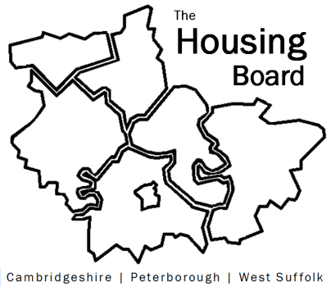
The Housing Board
Cambridgeshire | Peterborough | West Suffolk
Meeting from 10:30 to 12:00, Friday 31 July 2020
To be held online via Microsoft Teams: please open the meeting invite to click on the link
A G E N D A
 | Item | Lead
 | Welcome/apologies  Actions of previous meeting to approve, and matters arising. Meeting papers available at www.cambridgeshireinsight.org.uk/housingboard | TBC (Suzanne H on leave)
 | The Combined Authority’s £100K homes and criteria for accessing  Emma Grima is to present a paper setting out the Allocations Policy and a working guidance document to the Housing and Communities Committee on 14 September, and will circulate via email a draft document for comments. | Emma Grima  CPCA / ECDC (TBC)
 | Progress on arc4 report on homelessness  - Request to include East Cambs in the data and report  - Feedback from ICB  - Summary of feedback on the recommendations (note to circ)  - Draft report to CPSB | Sue Beecroft
 | District next steps plans  Update from Sarah Gove from Mental Health task and finish group | Sarah Gove
 | Housing and Covid Recovery  Draft paper circulated for discussion | Sue Beecroft
 | Updates on  - Public Health & Prevention Sub Group  - Test and Trace picture | Val Thomas (from 11.30am+)
 | Updates  - MAIC stats  - Housing related support Lisa has emailed the Housing Related Support Commissioning Strategy for Cambridgeshire and Peterborough draft document, for consultation next week. Not for wider sharing.  - Update from RP partners | - SB  - LS  - NH / KM
 | AOB
 | Future meeting dates: 14 August and 28 August

