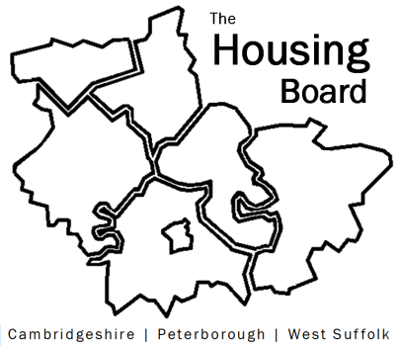
The Housing Board
Cambridgeshire | Peterborough | West Suffolk
Meeting from 10:30 to 12:00, Friday 17 July 2020
To be held online via Microsoft Teams
Open the meeting invite to click on the link
D r a f t A G E N D A
 | Item | Lead
 | Welcome/apologies  Actions of previous meeting to approve, and matters arising. Meeting papers available at www.cambridgeshireinsight.org.uk/housingboard | Suzanne Hemingway  Chair
 | Arc4 recommendations  Feedback from housing board members, plan for CPSB  Item planned for Integrated Commissioning Body to mention  Summary note to be circulated | Suzanne Hemingway  Lisa S / Sue B
 | District next steps plans  Brought to last housing board but needed editing  New summary report circulated with agenda  Next Steps following covid  Thinking through the MEAM approach.  Note for discussion circulated with agenda  (due at 11am) | Sue Beecroft
 | The Combined Authority’s £100K homes and criteria for accessing.  Supporting report here  https://cambridgeshirepeterboroughcagov.cmis.uk.com/Meetings/tabid/70/ctl/ViewMeetingPublic/mid/397/Meeting/1986/Committee/65/SelectedTab/Documents/Default.aspx  (item scheduled for 11.30am) | Emma Grima and Emily Mulvaney, CPCA
 | Updates  - MAIC stats (note circulated)  - Housing related support (note circulated from xxx date)  - Update from RP partners (arrears info being collated)  - Other updates | - SB  - LS / SB  - NH / KM  - All
 | AOB
 | Future meeting dates: 31 July and 14 August

