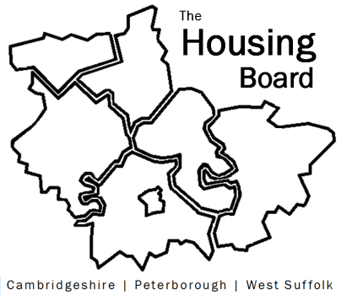
The Housing Board
Cambridgeshire | Peterborough | West Suffolk
Meeting from 10:30 to 12:00, Friday 29 May 2020
To be held online via Microsoft Teams
Open the meeting invite to click on the link
A G E N D A
 | Item | Lead
 | Welcome/apologies  Draft notes of previous meeting to approve, and matters arising. Meeting papers available at www.cambridgeshireinsight.org.uk/housingboard | Suzanne Hemingway  Chair
 | Actions  Please note: table formatted to help highlight the actions, separate from any notes, so notes shaded grey and actions in white. Only actions get a row number! | Suzanne Hemingway
 | CLAS – item to be confirmed (may need to re-schedule for next meeting) | TBC
 | Update on  - Guidance for emergency homeless accommodation  - Test and Trace for Cambridgeshire & Peterborough | Val Thomas
 | Update on allocations incl survey of letting activities | Heather Wood
 | Updates on  - Changes to LHAs – further news from govt  - Update from RPs  - Update for housing related support partners (note)  - MAIC stats and PH needs assessment (note circulated) | - SB/ AK  - KM / NH  - -  - SB
 | AOB | All
Future PROPOSED meeting dates:
- 29 May
- 12 June
- 26 June
- 3 July (already in diaries, may want to review)
- 17 July

