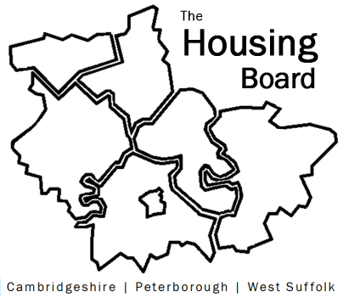
The Housing Board
Cambridgeshire | Peterborough | West Suffolk
Meeting from 9:30 to 12:30, Friday 6 March 2020
Swansley Room (ground floor), South Cambridgeshire Hall, Cambourne
For directions please see https://www.scambs.gov.uk/content/how-find-us
A G E N D A

 | Item | Lead
 | Welcome/apologies  Draft notes of previous meeting to approve, and matters arising. Meeting papers available at www.cambridgeshireinsight.org.uk/housingboard | Suzanne Hemingway  Chair
 | Planning for 2020+  - Quick review of 2019/20 agendas and actions (note to follow)  - What do we want to focus on in 2020/21? (discussion)  - Feedback on terms of reference (you can find the current version here https://cambridgeshireinsight.org.uk/wp-content/uploads/2018/09/housing-board-tors-3-sept-2018.pdf; need updating with current membership etc.)  (9.30 to 10.30) | Suzanne Hemingway, Sue Beecroft
 | Homelessness System Transformation and Housing Related Support review  (11.00) | Lisa Sparks and Arc4
 | Cambridgeshire & Peterborough Combined Authority and the £100K house  (11.45) | Emma Grima, Roger Thompson, Azma Ahmed-Pearce, CPCA
 | AOB
Future meeting dates:
At Swansley Room (ground floor), South Cambridgeshire Hall, Cambourne, 9:30am to 12:30pm

 | • 3 April  • 1 May  • 5 June  • 3 July | • 7 August (?) • 4 September  • 2 October  • 6 November  • 4 December  • 15 January 2021

