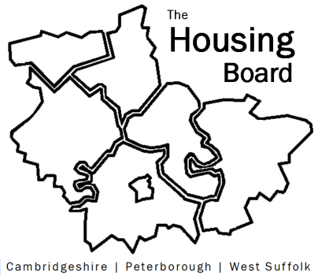
The Housing Board
Cambridgeshire | Peterborough | West Suffolk
Meeting from 10:30 to 11:30, Friday 3 April 2020
On-line at MS Teams
A G E N D A
 | Item | Lead
 | Welcome/apologies  Draft notes of previous meeting to approve, and matters arising. Meeting papers available at www.cambridgeshireinsight.org.uk/housingboard | Suzanne Hemingway  Chair
 | Covid 19  Round table discussion: how are we working together on…  - Homelessness/ rough sleeping  - Prison discharge group  - Update on transformation work  - Update from Housing Providers  - General housing market update – issues for developers / strategic impact?  - Public Health - data request and helping partners with PH aspect of Covid-19  New resources  - Covid newsreel covering updates from mainly local agencies, here (thanks to the Financial Capability Forum) https://cambridgeshireinsight.org.uk/housing/coronavirus-covid-19-newsreel/  - Can Street Support help district communications  - www.streetsupport.net/cambridge | Round table –leads?  - Jon/Heather/Dan?  - Suzanne  - Suzanne  - Nigel / Karen  - Suzanne  - Iain  - Sue B
 | AOB | All
Future meeting dates:
At South Cambridgeshire Hall, Cambourne, - to be replaced with on-line meetings from 10.30 to 11.30 on MS Teams for the foreseeable, starting to run fortnightly from beginning of April:
17 April, 1 May, 15 May, 5 June, 19 June, 3 July, 7 August (?), 4 September, 2 October, 6 November, 4 December, 15 January 2021.

