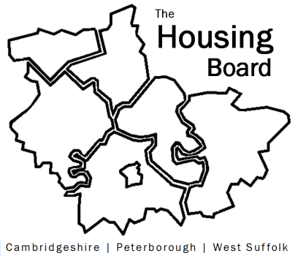
The Housing Board
Cambridgeshire | Peterborough | West Suffolk
Meeting from 10:30 to 11:30, Friday 17 April 2020
To be held online via Microsoft Teams
Open the meeting invite to click on the link
A G E N D A
 | Item | Lead
 | Welcome/apologies  Draft notes of previous meeting to approve, and matters arising. Meeting papers available at www.cambridgeshireinsight.org.uk/housingboard | Suzanne Hemingway  Chair
 | Vulnerable People who are slipping through the net | Dr Dorothy Gregson  Chief Executive,  Office of the  Police and Crime Commissioner
 | Action table at end of 3 April notes | Suzanne Hemingway
 | Update on ARC4 research, and discussion about Trailblazer funding beyond December 2020, in light of Coronavirus | Suzanne Hemingway
 | Brief update on new SHMA | Sue Beecroft
 | Sub-regional budget and raising of invoices for 2020/21 | Sue Beecroft
 | AOB
Future meeting dates:
1 May 2020 (scheduled)
15 May (ad-hoc)
5 June (scheduled)

