#missingmoments Campaign Communications Toolkit

Date: November 1st to December 31st 2019

Background

In March 2019, Public Health launched its emotive stop smoking campaign, #missingmoments, which was focused at a variety of local audiences to stop smoking.

On November 1st 2019, Cambridgeshire County Council Public Health Directorate and Communications Team, in partnership with the local stop smoking service CAMQUIT, who sit within the Everyone Health lifestyle service, will launch the second phase of its emotive stop smoking campaign #missingmoments.

#Missingmoments Campaign

The #missingmoments campaign focuses on the people that are left behind when someone dies from smoking and the key events they are absent from, such as wedding, a birthday or playing with grandchildren. For younger people the campaign will focus upon other losses, such as the damage that smoking can cause to physical looks.

The key target groups are workplaces and migrant communities, particularly routine and manual workers as this workforce sector have higher rates of smoking prevalence.

As part of this work, Public Health has created a series of posters, postcards aimed at different targeted age groups with key messages and a call to action to get a free quit kit.

Aims of the campaign

The aim of the campaign is to:
- Reduce the risk of missing key moments in a family's life and realise the benefits of stopping smoking by,
- Encouraging people to visit the Cambridgeshire’s Be Well website where people can,
- Register for a free QUITKIT and advice on how to give up smoking for good.

Purpose of this toolkit

This toolkit provides resources for partners and stakeholders to share to help raise awareness of this stop smoking campaign to both staff and local communities.

Resources Available

This communications toolkit provides images for the six themes of this campaign.

These resources are available in Polish, Russian, Latvian, Lithuanian and Bulgarian to help reach our migrant communities.

Please visit Cambridgeshire’s Be Well website to access and download these resources in poster size or as double sided postcards.

Hard copies are also available (while stocks last). Please contact Siôn James on sion.james@cambridgeshire.gov.uk to request posters and postcards in Polish, Russian, Latvian, Lithuanian and Bulgarian.

__________________________________________________________________________________

Resources: Posters (available from 4th November 2019)
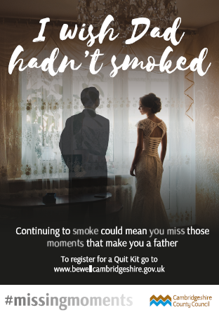
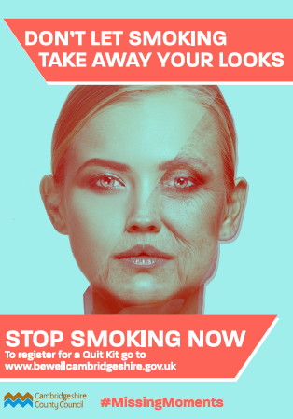
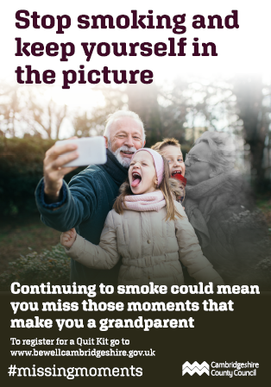

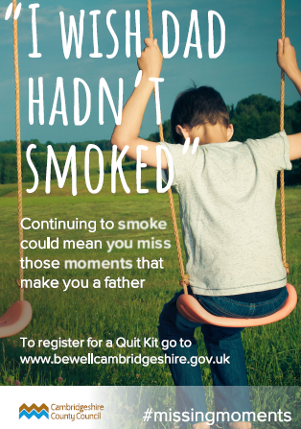
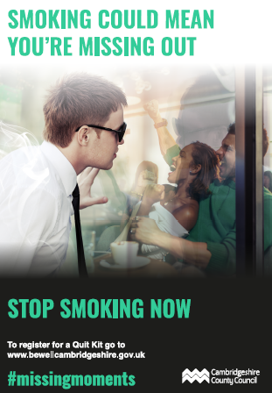

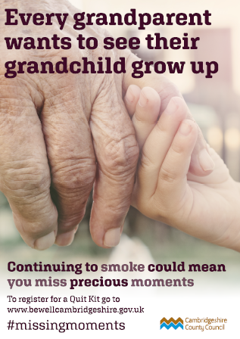

Resources in other languages (available from 2nd December)

Polish Bulgarian Romanian
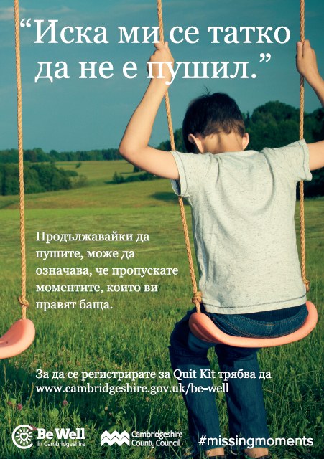
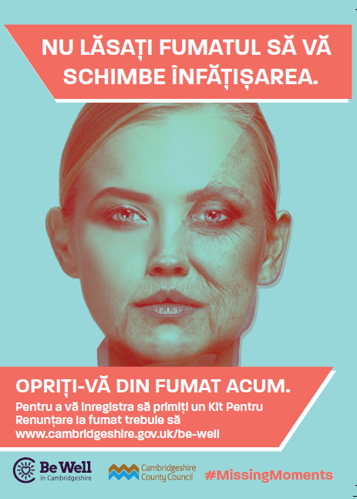
Lithuanian Russian
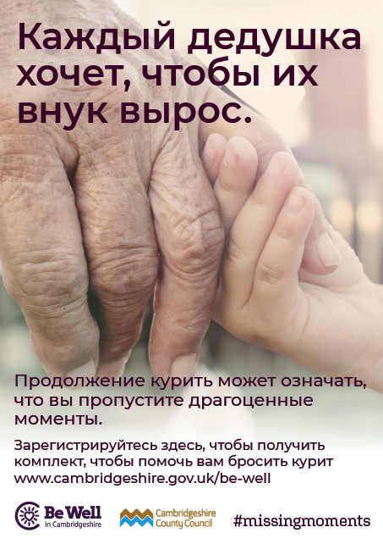
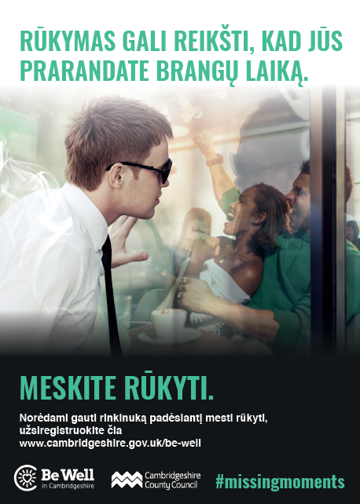

Website copy (to upload to your public website)

#missingmoments Campaign

In partnership with Cambridgeshire County Council Public Health Directorate, [organisation’s name] is supporting #missingmoments, a new emotive stop smoking awareness campaign.

The #missingmoments campaign focuses on the people that are left behind when someone dies from smoking and the key events they are absent from, such as wedding, a birthday or playing with your grandchild.

Targeting workplaces and migrant communities, the aim is to realise the benefits of stopping smoking by reducing the risk of missing key moments in a family's life by encouraging people to visit the Cambridgeshire’s Be Well website where people can get a free quit kit and advice on how to give up smoking for good.

Website copy (for your staff)

#missingmoments Campaign

In partnership with Cambridgeshire County Council Public Health Directorate, [organisation’s name] is supporting #missingmoments, a new emotive stop smoking awareness campaign.

The #missingmoments campaign focuses on the people that are left behind when someone dies from smoking and the key events they are absent from, such as wedding, a birthday or playing with your grandchild.

Along with local GPs, pharmacies, libraries and other partners across Cambridgeshire, [organisation name] is encouraging its staff to realise the benefits of stopping smoking and aims to reduce the risk of its staff missing key moments in their family's life, by encouraging employees to visit Cambridgeshire’s Be Well website, where you can get a free quit kit and advice on how to give up smoking for good.

Targeting both workplaces and migrant communities, a range of campaign resources and ongoing social media will be available in five differing languages to support this campaign.

Staff are encouraged to speak to [organisation health champion or equivalent] for further information or visit Be Well to request a quit kit or get advice from Camquit.

Social media

Cambridgeshire County Council will be delivering a targeted social media campaign across its Facebook and twitter accounts to help raise awareness of this campaign and to the risks associated with smoking.

You are encouraged to follow our posts across your social media channels. Below are a series of additional social media posts you may wish to you to further support the campaign.

Post Text | Post Image
Never miss a moment because of smoking. For help and advice to QUIT visit https://www.cambridgeshire.gov.uk/be-well/ | 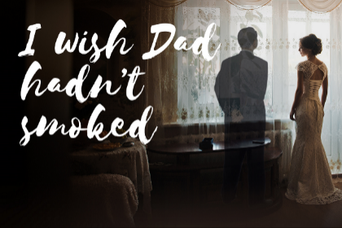
Pictures are memories that last forever. Keep yourself in the picture by choosing to QUIT TODAY.  For help and advice to QUIT visit https://www.cambridgeshire.gov.uk/be-well/ | 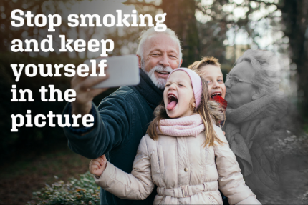
Don’t miss those magic moments through smoking.  Choose to QUIT TODAY. https://www.cambridgeshire.gov.uk/be-well/ | 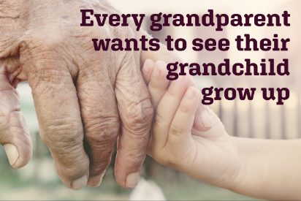
Smoking steals parents. Don’t rob your kids and yourself of those precious moments. We all love “family time”. But what if they don’t have a parent to go with?  Choose to QUIT TODAY. https://www.cambridgeshire.gov.uk/be-well/ | 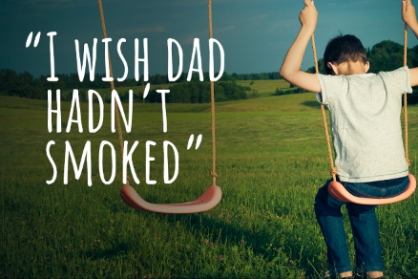
Don’t miss a moment of your children growing up because of smoking. Choose to QUIT TODAY. https://www.cambridgeshire.gov.uk/be-well/

Your daughter’s wedding will be one of the most important days of her life, so don’t let her down. If you continue to smoke you risk missing out on these special moments. Stop smoking now.  For a QUIT KIT visit https://www.cambridgeshire.gov.uk/be-well/ | 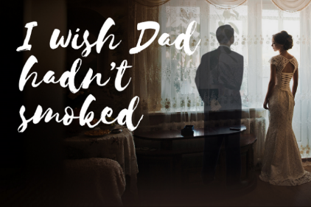

FAQ

What is a QUIT KIT?
A QUIT KIT includes information on the campaign, about stopping smoking independently and the local stop smoking services, access to the closed Facebook support group & Everyone Health marketing freebies. By registering for the kit the client will then be added to a schedule where a series of prompts from the stop smoking service to follow up the clients to monitor and track the smoker journey and progress.

