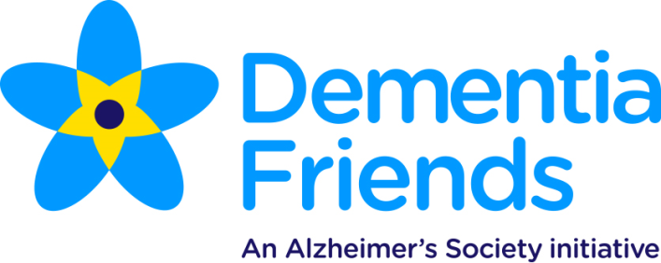

Dear Friends,
Housing 21 has pledged to raise awareness about Dementia through helping our residents, friends, family, those who deliver services to our residents and contractors to become Dementia Friends.
Dementia Friends is an Alzheimer's Society initiative to change people's perceptions of dementia. It aims to transform the way the nation thinks, acts and talks about the condition.
To become a Dementia Friend all you need to do is attend an hour long information session which creates awareness of what dementia is, how it impacts on people's lives and how there are small things in everyday life people can do to help create a more dementia friendly society.
We would like to invite you to attend a Dementia Friend session
At: Skeels Court, Coneygear Road, Huntingdon, PE29 1TD
When: Monday 27th January 2020 @ 11am
Refreshments will be served after the session
R.S.V.P and for more information:- Kirsty Tait
Tel: 0370 1924128
Email: kirsty.tait@housing21.org.uk

