# [PP_CClogo](https://www.cambridgeshire.gov.uk/be-well/)[image001](https://www.healthypeterborough.org.uk/2018-19)

# 

# Public Health Intelligence and knowledge management in Cambridgeshire and Peterborough Councils

Cambridgeshire and Peterborough’s Public Health Intelligence Team provides population health analytics to Cambridgeshire County Council, Peterborough City Council, Cambridgeshire and Peterborough Clinical Commissioning Group and to system partners.

**What is the purpose of this document?**

* To provide an overview of the local public health intelligence and knowledge services.
* To provide an overview of, and links to, key population health intelligence resources.
* To enable you to contact us easily.
* *Please press the* ***Ctrl key and click*** *on any of the graphics and blue hyperlinked text to take you directly to a* ***linked resource****.*

[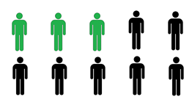](http://www.healthknowledge.org.uk/e-learning)**What is public health intelligence?**

*A framework of knowledge, methods, processes, tools and techniques for:*

* Measuring health and wellbeing risks and determinants, health needs, health outcomes, health status and providing an interpreted narrative describing these in populations.
* Assessing, measuring and describing the impacts of the influences and determinants on health.
* Making comparisons and identifying variation in services, health determinants, outcomes and health status.
* Target setting for health improvement, monitoring performance and checking changes over time.
* Assessing and evaluating services and quantifying the impacts of prevention programmes.
* Overall, it’s knowing where to look for data, information and knowledge and having the ability to use that information safely and effectively in order to support decision making.
* Underpinning all this is an approach that looks at population health questions from the perspectives of person, place and time: an epidemiological approach that considers the distribution, determinants and impacts of health and disease in populations from these various perspectives.

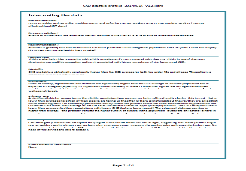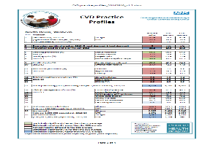

**What do we do in practice?**

*We work with you to …*

* Protect the health of the public.
* Prevent ill-health.
* Promote healthy lifestyles.
* Provide advice on the commissioning of health and care services to meet population needs.

**How do we do this?**

* Provide project based needs analysis, needs assessment and, through the local Health and Wellbeing Board, joint strategic needs assessment (JSNA).
* Give advice on the effective use of information analysis to support decision making for public health, healthcare and local authority services.
* Disseminate and develop the local picture of the Public Health Outcomes Framework (PHOF), and other public health data profiles, to help people to understand and improve health outcomes.
* Identify vulnerable populations and marginalised groups and conduct analytical work to identify and help to reduce inequalities in local health outcomes.
* Produce health and health determinant profiles and local narratives of health.
* [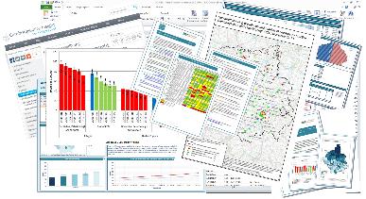](http://cambridgeshireinsight.org.uk/health/)Ensure an understanding of local performance and the impacts of interventions and services on health outcomes.
* Apply the evidence base to local public health and healthcare problems.
* Develop and maintain databases of public health intelligence data.
* Develop, maintain and publicise public health intelligence resources.
* Keep up to date with developments in public health intelligence methods and data releases.
* Provide modelled population based data where local data are not available.
* [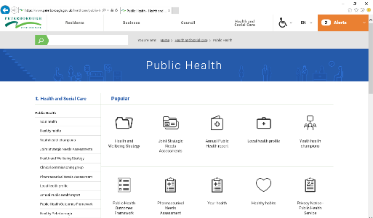](https://www.peterborough.gov.uk/healthcare/public-health/)Provide public health and analytical advice to the NHS, via the Clinical Commissioning Group, the North and South Provider Alliances and the Cambridgeshire and Peterborough Sustainability and Transformation Partnership.
* Deliver the information requirements for the Director of Public Health’s Annual Reports.
* Overall, provide the analytical, public health expertise and local area knowledge to provide a sound local public health intelligence service to the local authorities, the NHS and our system partners.

## Public health intelligence in Cambridgeshire and Peterborough Councils*.*

* There is a joint public health intelligence team covering Cambridgeshire and Peterborough Councils.
* Team email address for Cambridgeshire and Peterborough PHI: [PHI-team@cambridgeshire.gov.uk](mailto:PHI-team@cambridgeshire.gov.uk).
* [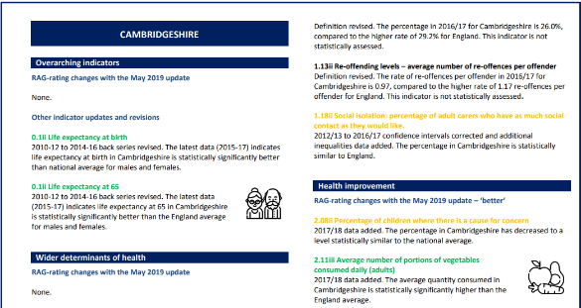](https://cambridgeshireinsight.org.uk/health/)David Lea is the managerial lead for the service and can be contacted on 01480 379494, at [david.lea@cambridgeshire.gov.uk](mailto:david.lea@cambridgeshire.gov.uk) or at [david.lea@nhs.net](mailto:david.lea@nhs.net).

**Public Health England**

[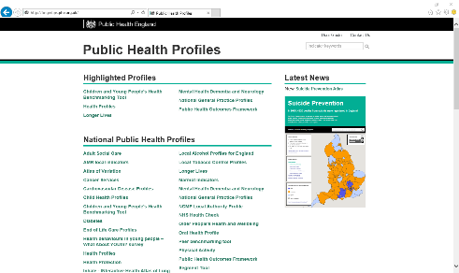](http://fingertips.phe.org.uk/)We work collaboratively with Public Health England’s [Local Knowledge and Intelligence Service (LKIS) East](https://www.gov.uk/government/news/local-public-health-intelligence-online-community). [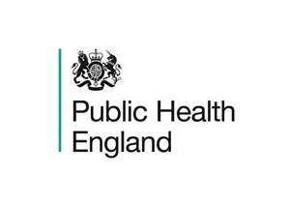](https://www.gov.uk/government/organisations/public-health-england)Public Health England hosts and runs a regional health intelligence network that holds regular meetings to share knowledge, to learn collectively about the use of intelligence resources and to work collaboratively. LKIS East of England can be contacted at [LKISEast@phe.gov.uk](mailto:LKISEast@phe.gov.uk). There is a local LKIS East Knowledge Hub site here <https://khub.net/web/pheeastofengland/> and a national one here <https://khub.net/web/guest/phe> (sign-up is required for access).

Public Health England’s [Fingertips Public Health Profiles platform](https://fingertips.phe.org.uk/) provides a huge range of interactive subject-based population health intelligence resources and data downloads. Public Health England’s [data analysis and tools page](https://www.gov.uk/guidance/phe-data-and-analysis-tools) provides a subject based menu of resources. A signposting guide to [sources of public health intelligence](https://khub.net/group/phe-local-knowledge-and-intelligence-services/group-library/-/document_library/Sz8Ah1O1ukgg/view_file/269273198) is also available (sign-up needed for Knowledge Hub).

**Key online population health intelligence resources, knowledge and library services and training**

**Local Cambridgeshire and Peterborough population health intelligence resources**

**“Public health without information is like pathology without a laboratory”**

**Prof Michael Goldacre**

Currently, some of our web-based resources are found on each of the Council’s websites. Some of the web pages on Cambridgeshire Insight do contain Cambridgeshire and Peterborough information and some of the JSNAs cover both areas.

**Cambridgeshire County Council**

* [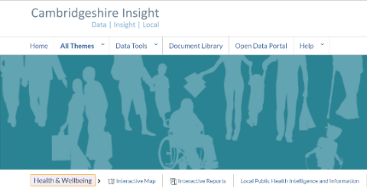](https://cambridgeshireinsight.org.uk/health/)Cambridgeshire Insight [home](https://cambridgeshireinsight.org.uk/) page.
* Cambridgeshire Insight [demography](https://cambridgeshireinsight.org.uk/population/) page.
* Cambridgeshire Insight [health](http://cambridgeshireinsight.org.uk/health/) page.
* Cambridgeshire Insight [area health profiles](https://cambridgeshireinsight.org.uk/health/areas/).
* Cambridgeshire Insight [CCG/NHS healthcare](http://cambridgeshireinsight.org.uk/health/healthcare) page.
* Cambridgeshire Insight public health outcomes framework ([PHOF](http://cambridgeshireinsight.org.uk/health/phof)).
* Cambridgeshire [annual public health report](http://cambridgeshireinsight.org.uk/health/aphr).
* Cambridgeshire Insight joint strategic needs assessment ([JSNA](http://cambridgeshireinsight.org.uk/jsna)) page.
* Cambridgeshire [health and wellbeing strategy](https://cambridgeshireinsight.org.uk/jsna/health-and-wellbeing-strategy/).
* Cambridgeshire County Council [Public Health Directorate home](https://www.cambridgeshire.gov.uk/council/council-structure/senior-managers-and-structure-charts/public-health-directorate/) page.
* Health advice for Cambridgeshire ([Be Well](https://www.cambridgeshire.gov.uk/be-well)).

**Peterborough City Council**

* [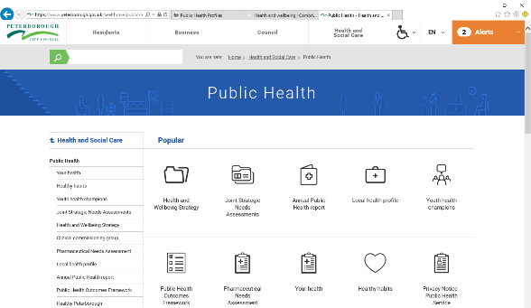](https://www.peterborough.gov.uk/healthcare/public-health/)Peterborough [Public Health Directorate home and resources](https://www.peterborough.gov.uk/healthcare/public-health/) page.
* Peterborough [local health profile](https://www.peterborough.gov.uk/healthcare/public-health/local-health-profile/).
* Peterborough public health outcomes framework ([PHOF](https://cambridgeshireinsight.org.uk/health/phof/)).
* Peterborough [annual public health report](https://www.peterborough.gov.uk/healthcare/public-health/annual-public-health-report/).
* Peterborough joint strategic needs assessment ([JSNA](https://www.peterborough.gov.uk/healthcare/public-health/JSNA/)) page.
* Health advice for Peterborough ([healthy Peterborough](http://www.healthypeterborough.org.uk/)).
* Peterborough [health and wellbeing strategy](https://www.peterborough.gov.uk/healthcare/public-health/health-and-wellbeing-strategy/).

**Public Health England population health intelligence resources**

*Many of these cover local authority and CCG (NHS) data.*

* Public Health England [home](https://www.gov.uk/government/organisations/public-health-england) page.
* Public Health England [Fingertips](https://fingertips.phe.org.uk/) topic and area based health profiles.
* Public health England subject-based [data and knowledge gateway](https://www.gov.uk/guidance/phe-data-and-analysis-tools).
* [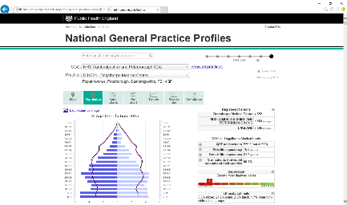](https://fingertips.phe.org.uk/)[Primary care data](http://fingertips.phe.org.uk/profile/general-practice) for England, CCGs and general practices.
* Topic based [health intelligence networks](http://www.ncin.org.uk/cancer_type_and_topic_specific_work/topic_specific_work/health_intelligence_networks) (cancer; CVD; child and maternal health; mental health, dementia and neurology; end of life care).
* Public Health Outcomes Framework [PHOF national site](http://www.phoutcomes.info/) for national PHOF data and data for all local authorities.
* Small area population health data at [Local Health](http://www.localhealth.org.uk/#v=map11;l=en) and [SHAPE](https://shapeatlas.net/).
* East of England Local Knowledge and Intelligence Service [Knowledge Hub](https://khub.net/web/pheeastofengland/welcome-group) page.
* National PHE LKIS [Knowledge Hub](https://khub.net/web/guest/phe) page.
* Public Health England analytical [technical guidance and briefings](http://fingertips.phe.org.uk/profile/guidance).
* Public Health England signposting guide to [sources of public health intelligence](https://khub.net/group/phe-local-knowledge-and-intelligence-services/group-library/-/document_library/Sz8Ah1O1ukgg/view_file/269273198).

**CCG specific intelligence resources**

*Please note that many of the resource links above include CCG and NHS data.*

* [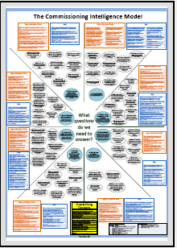](https://www.england.nhs.uk/wp-content/uploads/2012/12/comm-int-model.pdf)NHS England [commissioning support](https://www.england.nhs.uk/commissioning/supporting-commissioners/) home page.
  + NHS England [commissioning intelligence model](https://www.england.nhs.uk/2012/02/commissioning-intelligence-report/) describes the steps in the commissioning cycle, provides example commissioning questions and potential data types and resources to answer them.
  + NHS England [Statistical work areas](https://www.england.nhs.uk/statistics/statistical-work-areas/) and [Data Catalogue](https://data.england.nhs.uk/).
* NHS [Right Care](https://www.england.nhs.uk/rightcare/) home page – Right Care looks at healthcare variation.
* NHS Digital CCG [Outcomes Indicator Set](https://digital.nhs.uk/data-and-information/publications/ci-hub/ccg-outcomes-indicator-set).
* National Institute for Health and Care Excellence (NICE): NICE [home page](https://www.nice.org.uk/), NICE [pathways](https://pathways.nice.org.uk/), NICE [guidance](https://www.nice.org.uk/guidance); NICE [standards and indicators](https://www.nice.org.uk/standards-and-indicators) and NICE [evidence services](https://www.evidence.nhs.uk/).
* Cambridgeshire and Peterborough [CCG home page](http://www.cambridgeshireandpeterboroughccg.nhs.uk/).
* [Cambridgeshire and Peterborough STP Sustainability and Transformation Partnership.](https://www.fitforfuture.org.uk/)

**Other analytical and population health intelligence resources**

* NHS Digital [home](https://digital.nhs.uk/) page – collected data and information resources from the umbrella body for information services in health and social care.
* NHS Digital’s [data and information page](https://digital.nhs.uk/data-and-information) provides an online portal for NHS and other data in spreadsheet form, metadata (data about data) and some methodological information.
* Office for National Statistics [home](https://www.ons.gov.uk/) page - the national producer of official statistics and the recognised national statistical institute of the UK.
* The King Fund – data and policy briefings from the [King's Fund](https://www.kingsfund.org.uk/) independent charity who work to improve health and care in England.

**Library and knowledge management services**

* **[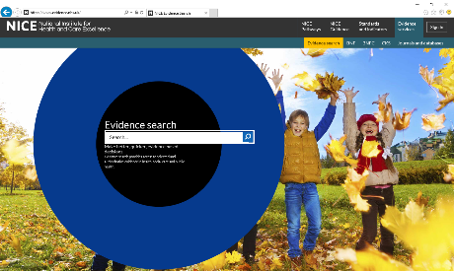](https://www.evidence.nhs.uk/)Local library services** are provided by the [North West Anglia NHS Foundation Trust’s Library Service](https://www.nwangliaft.nhs.uk/a-z-of-services/l/library/), based at Hinchingbrooke Hospital Education Centre and Laxton Library at Peterborough Hospital. Cambridgeshire County Council has a contract with the library to provide current awareness and literature/evidence search services and the Hinchinbrooke Library is also the local administrator for the [NHS OpenAthens](http://www.openathens.net/nhs_users.php) service.
* Library skills training is available.
* Local library services at Hinchingbrooke and Peterborough: contact by phone on 01480 416412 (H) and 01733 678081 (P) or by email at [hch-tr.libraryteam@nhs.net](mailto:hch-tr.libraryteam@nhs.net) (H) and [nwangliaft.laxtonlibrary@nhs.net](mailto:nwangliaft.laxtonlibrary@nhs.net) (P).
* With an **NHS OpenAthens** login you can access the electronic resources purchased by NHS England, your NHS regional library network and by your local healthcare library. Click [here](https://openathens.nice.org.uk/) for NHS OpenAthens account registration.
* **Public Health England** (PHE) also provide knowledge services online and these can be found at <https://phelibrary.koha-ptfs.co.uk/>. A local authority support page is available [here](https://phelibrary.koha-ptfs.co.uk/laph/).
  + Public Health England’s **Discovery Service** is available [here](http://search.ebscohost.com/login.aspx?authtype=athens&profile=eds&groupid=main) (sign-up account required). Discovery services enable searches across content and give access to full text where available. The discovery service allows local authority public health teams to search and access titles currently provided by PHE, along with the nationally procured core content journals and databases.
  + PHE Knowledge Services can also be contacted at [libraries@phe.org.uk](mailto:libraries@phe.org.uk).
* NHS staff can also access some journals free from [Health Information Online](http://library.nhs.uk/).
* The National Institute for Health and Care Excellence (**NICE**) also provide [evidence services](https://www.evidence.nhs.uk/).

[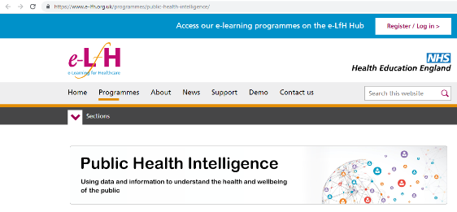](https://www.e-lfh.org.uk/programmes/public-health-intelligence/)

**Public health intelligence and epidemiology learning resources**

* Public Health England (PHE) offer **classroom** **based** **courses** and have developed online support materials in partnership with Health Education England [here](https://www.e-lfh.org.uk/programmes/public-health-intelligence/).
* You can find details of local PHE **classroom based** courses for commissioners and analysts on the PHE LKIS East [Knowledge Hub](https://khub.net/web/pheeastofengland/welcome-group) page.
* PHE have also developed a **population health intelligence training prospectus** and this can be found [here](https://www.oxfordhealth.nhs.uk/library/wp-content/uploads/sites/3/2018/12/FINAL-Training-prospectus-Population-health-intelligence.pdf).
* [Public health online textbook](http://www.healthknowledge.org.uk/public-health-textbook) including statistics and epidemiology.
* Specific public health practitioner and specialist learning for [epidemiology, health information and statistical methods](http://www.healthknowledge.org.uk/e-learning).
* Information covering the range of [Public Health Careers](https://www.healthcareers.nhs.uk/explore-roles/public-health%20).
* Data and information are fun, so enjoy yourself with the late and great Hans Rosling’s [Gapminder](https://www.gapminder.org/) and explore the art of the possible.