Cambridgeshire & Peterborough Ageing Well Dashboard & Data Overview

July 2019

Contents
1. Introduction 2
2. Summary of key findings 2
3. Overview & demographic indicators 4
4. Optimising health & reducing risks early indicators 7
5. Improving wellbeing and wider determinants of health indicators 10
6. Reverse or live well with long term conditions indicators 13
7. Enhanced care & support indicators 16

Introduction

The purpose of this report is to propose and provide an overview of a number of data indicators to comprise an ‘Ageing Well dataset’ to support the Cambridgeshire & Peterborough Ageing Well Board in better understanding local health and wellbeing issues relating to principles of healthy ageing in adults and the commissioning of services and interventions to improve outcomes where required. The dataset is comprised of a number of indications at both district (Cambridge, East Cambridgeshire, Fenland, Huntingdonshire and Cambridgeshire) and local authority (Cambridgeshire and Peterborough) levels, sourced from a range of data providers including Public Health England (PHE), the Office for National Statistics (ONS) and NHS hospital activity data. Data are arranged in to five key areas in line with Public Health England’s ‘Productive Healthy Ageing’ profile: 1. Demographics and mortality, 2. Optimise health and reduce risks early, 3. Improve wellbeing and wider determinants of health, 4. Reverse or live well with a long-term condition, 5. Enhance care and support.
A summary of key findings is provided below and more detailed information follows throughout this report as per the contents outlined above.

Summary of key findings

Indicators that show good healthcare outcomes in Cambridgeshire & Peterborough in relation to ageing well include:
- Directly age-standardised rates of deaths from cardiovascular disease, respiratory disease and cancer are all statistically significantly lower among residents aged 65 and older in Cambridgeshire than in England.
- Life expectancy at 65 is statistically significantly higher than the national average in Cambridgeshire and three of its districts; East Cambridgeshire, Huntingdonshire and South Cambridgeshire.
- Directly age-standardised rates of inpatient admissions in residents aged 65 and older are statistically significantly lower than the Cambridgeshire & Peterborough average in Peterborough, Cambridge, East Cambridgeshire and South Cambridgeshire.
- Directly age-standardised rates of A&E attendances in residents aged 75 and older are statistically significantly lower than the Cambridgeshire & Peterborough average in Cambridgeshire, Cambridge, Huntingdonshire and South Cambridgeshire.
- Recorded osteoporosis prevalence is statistically significantly lower than the national average in all areas of Cambridgeshire & Peterborough with the exception of East Cambridgeshire and South Cambridgeshire.
Indicators that show poor healthcare outcomes in Cambridgeshire & Peterborough with regard to ageing well, that may necessitate further investigation and/or the commissioning of alternative/new interventions to improve outcomes include:
- Life expectancy at 65 is statistically significantly lower than the England average in Peterborough and Fenland.
- Inequality in life expectancy at 65 between residents in most and least deprived areas are notably high for both males and females in Cambridge (in the worst quintile nationally for both males and females) and in Peterborough (in the second-worst quintile nationally for both males and females).
- The directly age-standardised rate of deaths from respiratory disease in residents aged 65 and older is statistically significantly higher in Peterborough than in England.
- Directly age-standardised rates of emergency hospital admissions for falls are statistically significantly higher than the national average in Cambridge for residents aged 65+, 65-79 only and 80+ only.
- Of 47 districts/unitary authorities in the East of England, Fenland has the second-worst score on the Access to Healthy Assets & Hazards (AHAH) index, behind only Norwich. This scores measures difficulty in accessing health services, quality of lived environment and ease of access to fast food outlets, gambling outlets, tobacconists and premises licensed to sell alcohol.
- Of 47 districts/unitary authorities in the East of England, Cambridge has the highest crude rate of noise complaints per 1,000 resident population (14.9/1,000, compared to the England average of 6.3/1,000 and East of England average of 5.0/1,000).
- The estimated dementia diagnosis rate in residents aged 65+ is statistically significantly lower than the England average in Cambridgeshire, East Cambridgeshire, Fenland and South Cambridgeshire.
- The estimated diabetes diagnosis rate is statistically significantly lower than the England average in Cambridge and South Cambridgeshire.
- The proportion of the population reporting depression or anxiety is statistically significantly higher than the national average in Fenland (15.9% compared to 13.7%).
- Directly age-standardised rates of inpatient admissions in residents aged 75 and older are statistically significantly higher than the Cambridgeshire and Peterborough average in Cambridgeshire, Fenland and Huntingdonshire.
- Directly age-standardised rates of A&E attendances in residents aged 75 and older are statistically significantly higher than the Cambridgeshire and Peterborough average in Peterborough and Fenland.

Overview & demographic indicators

Figure 1: Overview & demographic indicators
Indicator | Time Period | Area
 |  | Cambridgeshire |  | Peterborough |  | Cambridge |  | East Cambridgeshire |  | Fenland |  | Huntingdonshire |  | South Cambridgeshire |  | England
 |  | Number | Indicator Value | Number | Indicator Value | Number | Indicator Value | Number | Indicator Value | Number | Indicator Value | Number | Indicator Value | Number | Indicator Value | Number | Indicator Value
% Population Aged 65+ | 2017 | 120,757 | 18.6% | 28,970 | 14.6% | 15,880 | 12.7% | 17,556 | 19.8% | 22,611 | 22.4% | 34,620 | 19.6% | 30,090 | 19.2% | 10,030,511 | 18.0%
Directly age-standardised rate of deaths from cardiovascular disease - 65+ | 2015-17 | 3,745 | 1,040.8 | 956 | 1,113.8 | 657 | 1,188.4 | 538 | 1,052.4 | 747 | 1,108.5 | 945 | 984.6 | 858 | 955.3 | 334,042 | 1,121.0
Directly age-standardised rate of deaths from respiratory disease - 65+ | 2015-17 | 1,929 | 536.8 | 605 | 701.3 | 244 | 431.6 | 226 | 445.3 | 468 | 692.4 | 597 | 625.1 | 394 | 439.3 | 189,450 | 637.7
Directly age-standardised rate of deaths from cancer - 65+ | 2015-17 | 3,783 | 1,066.1 | 976 | 1,146.5 | 511 | 1,014.2 | 511 | 999 | 778 | 1,171.4 | 1,059 | 1,080.9 | 924 | 1,039.1 | 327,676 | 1,105.7
Excess winter deaths index - 85+ | Aug 16 - Jul 17 | 216 | 30.2% | 65 | 35.9% | 54 | 44.6% | 32 | 33.7% | 21 | 14.8% | 40 | 20.8% | 69 | 41.6% | 18,560 | 30.8%

Key
Statistically significantly better than benchmark | In best quintile
Statistically similar to benchmark | In second best quintile
Statistically significantly lower than benchmark | In third quintile
Statistically significantly higher than benchmark | In second worst quintile
Statistically significantly lower than benchmark | In worst quintile

The table above provides overall demographic data for Peterborough, Cambridgeshire and its districts as well as comparative data for three principal causes of mortality in the 65+ population – cardiovascular disease, respiratory disease and cancer, as well as a comparison of the number of excess winter deaths (deaths recorded in December – March each year compared to the average recorded between April and November each year) observed in each local authority.
18.0% of the population of England were aged 65 or older in 2017. It is of note that Cambridgeshire and all of its districts with the exception of Cambridge have a statistically significantly higher proportion of population in the 65+ age group compared to England, whereas conversely Peterborough and Cambridge have statistically significantly lower proportion of their populations aged 65+. This influences a number of indicators within this dataset, such as Quality and Outcomes Framework (QOF) disease prevalence, which are not age-standardised and are therefore likely to show higher disease prevalence within older populations for conditions that tend to present in greater numbers within older age groups, such as cardiovascular diseases, musculoskeletal conditions and dementia.
Figure 2: Directly age-standardised rate of deaths from respiratory diseases among people aged 65 years and over, Peterborough, 2001-03 – 2015-17
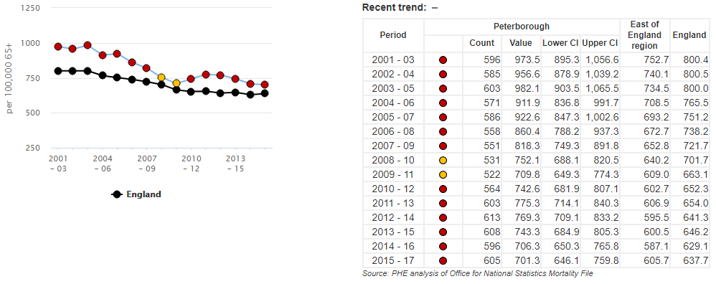
Source: Public Health England
The only indicator within the above table with a statistically significantly worse outcome compared to benchmark (England) for any area of Cambridgeshire and Peterborough is the directly age-standardised rate of deaths from respiratory disease among people aged 65 years and over in Peterborough. Direct age-standardisation is a process whereby age-specific death rates are calculated and weighted in relation to a reference population in order that differences in age structures are accounted for in comparisons (e.g. areas with higher proportions of older residents are not adversely described as ‘less healthy’ due to higher mortality rates, as this would be expected in areas with older populations). Statistical significance refers to an observed differences in outcomes of sufficient difference to be statistically unlikely to have occurred as a result of chance or issues relating to bias and/or confounding.
The figure above shows directly age-standardised rates per 100,000 of deaths in the 65+ population in Peterborough for 15 pooled periods between 2001-3 and 2015-17 and illustrates that Peterborough has had a statistically significantly higher (worse) rate for 13 of these 15 periods, including each of the last six pooled periods between 2010-12 and 2015-17. Respiratory disease is one of the major causes of death in the over 65s in England and is caused by a number of modifiable risk factors including tobacco use, indoor and outdoor air pollution, physical inactivity and an unhealthy diet.

Figure 3: Directly age-standardised rate of deaths from respiratory diseases among people aged 65 years and over, East of England Local Authorities, 2015-17
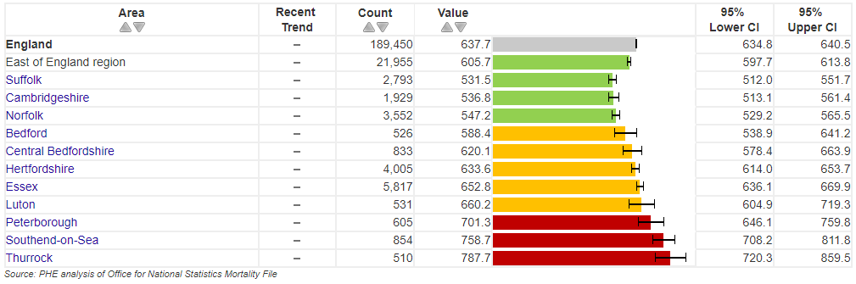
Source: Public Health England
The table above illustrates that Peterborough is one of only three areas within the East of England with a statistically significantly higher directly age-standardised rate of deaths from respiratory diseases among people aged 65 years and over within the East of England. Neighbouring Cambridgeshire has a statistically significantly lower rate than the national average.

Optimising health & reducing risks early indicators

Figure 4: Optimising health & reducing risks early indicators:
Indicator | Time Period | Area
 |  | Cambridgeshire |  | Peterborough |  | Cambridge |  | East Cambridgeshire |  | Fenland |  | Huntingdonshire |  | South Cambridgeshire |  | England
 |  | Number | Indicator Value | Number | Indicator Value | Number | Indicator Value | Number | Indicator Value | Number | Indicator Value | Number | Indicator Value | Number | Indicator Value | Number | Indicator Value
Life expectancy at 65 (Male) | 2015-17 | - | 19.5 | - | 18.2 | - | 19.3 | - | 19.8 | - | 18.3 | - | 19.6 | - | 20.3 | - | 18.8
Life expectancy at 65 (Female) | 2015-17 | - | 21.8 | - | 20.8 | - | 21.2 |  | 22.1 | - | 20.9 | - | 21.8 | - | 22.7 | - | 21.1
Inequality in life expectancy at 65 (Male) | 2015-17 | - | 3.9 (2) | - | 5.1 (4) | - | 8.4 (5) | - | 1.6 (1) | - | 2.4 (1) | - | 2.7 (2) | - | 2.6 (1) | - | 4.9
Inequality in life expectancy at 65 (Female) | 2015-17 | - | 3.9 (3) | - | 4.7 (4) | - | 8.8 (5) | - | 1.7 (1) | - | 1.0 (1) | - | 3.8 (3) | - | 1.1 (1) | - | 4.5
Smoking prevalence in adults 18+ | 2017 | 74,710 | 14.5% | 26,226 | 17.6% | 17,290 | 17.0% | 10,624 | 15.3% | 13,163 | 16.3% | 19,590 | 14.0% | 13,721 | 11.3% | 6,496,890 | 14.9%
Directly age-standardised rate of admission episodes for alcohol-related conditions - Persons - 65+ | 2017-18 | 1,158 | 958 | 266 | 920 | 171 | 1,102 | 156 | 883 | 243 | 1,074 | 312 | 902 | 276 | 917 | 102,145 | 1,016
Directly age-standardised rate of admission episodes for alcohol-related conditions - Male - 65+ | 2017-18 | 727 | 1,311 | 177 | 1,349 | 114 | 1,604 | 99 | 1,228 | 161 | 1,539 | 200 | 1,260 | 154 | 1,124 | 66,182 | 1,459
Directly age-standardised rate of admission episodes for alcohol-related conditions - Female - 65+ | 2017-18 | 432 | 667 | 88 | 562 | 58 | 677 | 57 | 607 | 83 | 687 | 113 | 607 | 121 | 755 | 35,964 | 658

Key
Statistically significantly better than benchmark | In best quintile
Statistically similar to benchmark | In second best quintile
Statistically significantly lower than benchmark | In third quintile
Statistically significantly higher than benchmark | In second worst quintile
Statistically significantly lower than benchmark | In worst quintile

Within the table above, the majority of ‘optimising health and reducing risks early’ indicators show Cambridgeshire and Peterborough areas to be statistically similar or statistically significantly better than England averages. However, there are some observed areas of note with relation to life expectancy at 65 in males and inequalities in life expectancy at age 65 in both males and females.
Figure 5: Life expectancy at 65 (male), Peterborough, 2001-03 – 2015-17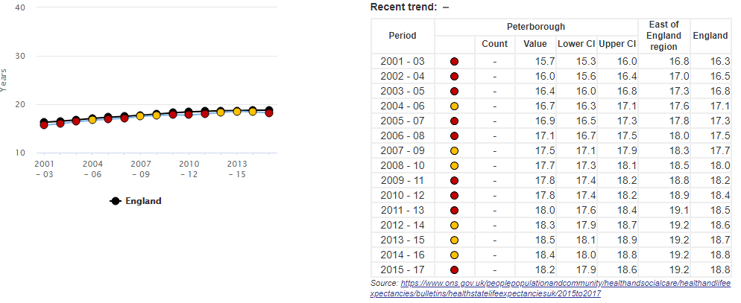
Source: Public Health England
Between 2012-14 and 2014-16, male life expectancy at 65 in Peterborough was statistically similar to England. However, in 2015-17, male life expectancy at 65 in Peterborough fell to 18.2 years which is now statistically significantly worse than the England value which has remained 18.8 years.

Figure 6: Life expectancy at 65 (male), Fenland, 2001-03 – 2015-17
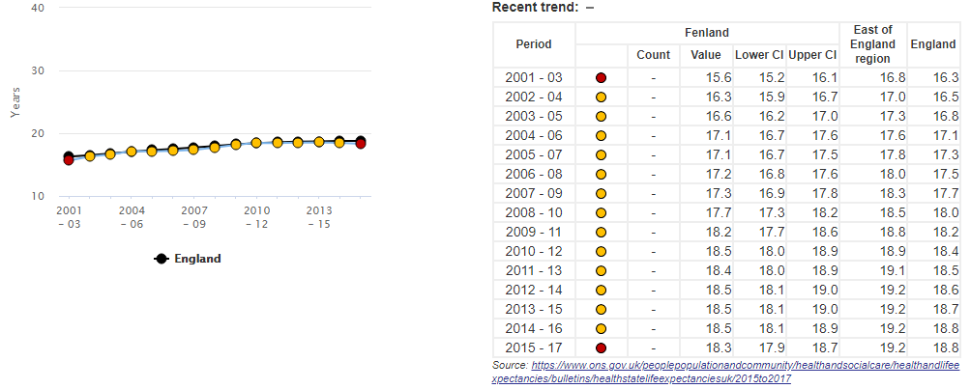
Source: Public Health England
Male life expectancy in Fenland is statistically significantly worse than England in 2015-17, the first time this has been the case since 2001-03.
Of additional note within the table above are high levels of observed variation across Cambridgeshire and Peterborough with regards to inequality in life expectancy at 65 for both males and females in Cambridge and in Peterborough. This is calculated as a comparison of life expectancy values in each area between the most deprived decile and the least deprived decile in each area. In Cambridge, this difference is 8.4 years for males and 8.8 years for females, placing Cambridge within the fifth (worst) quintile in England for this indicator for districts. In Peterborough, the observed difference is 5.1 years for males between the most deprived decile and the least deprived decile and 4.7 years for females; Peterborough is resultantly in the fourth (second worst) quintile in England for this indicator for local authorities.

Improving wellbeing and wider determinants of health indicators

Figure 7: Improving wellbeing & wider determinants of health indicators:
Indicator | Time Period | Area
 |  | Cambridgeshire |  | Peterborough |  | Cambridge |  | East Cambridgeshire |  | Fenland |  | Huntingdonshire |  | South Cambridgeshire |  | England
 |  | Number | Indicator Value | Number | Indicator Value | Number | Indicator Value | Number | Indicator Value | Number | Indicator Value | Number | Indicator Value | Number | Indicator Value | Number | Indicator Value
IDAOPI | 2015 | - | 11.3% (1) | - | 18.5% (3) | - | 11.7% (3) | - | 11.7% (2) | - | 16.4% (4) | - | 9.6% (1) | - | 8.4% (1) | - | 17.8%
Fuel poverty (no statistical significance calculated for this indicator) | 2016 | 24,412 | 9.3% | 8,235 | 10.6% | 5,632 | 11.5% | 3,097 | 8.5% | 4,585 | 10.8% | 6,067 | 8.3% | 5,031 | 8.0% | 2,550,565 | 11.1%
Access to healthy assets and hazards index | 2016 | 90,362 | 14.0% (3) | 17,388 | 9.0% (3) | 8,491 | 6.5% (3) | 18,093 | 20.7% (4) | 48,097 | 48.5% (5) | 8,103 | 4.6% (2) | 7,578 | 4.9% (2) | 11,590,179 | 21.2%
The rate of complaints about noise (crude rate per 1,000) | 2015-16 | 3,273 | 5.1% | 857 | 4.4% | 1,949 | 14.9% | 182 | 2.1% | 366 | 3.7% | 496 | 2.8% | 280 | 1.8% | 347,144 | 6.3%
Fraction of mortality attributable to particulate air pollution (no statistical significance calculated for this indicator) | 2017 | - | 5.4% | - | 5.3% | - | 5.6% | - | 5.2% | - | 5.1% | - | 5.4% | - | 5.4% | - | 5.1%
Health related quality of life for older people (Mean Score) | 2016-17 | - | 0.760 | - | 0.736 | - | 0.767 | - | 0.769 | - | 0.727 | - | 0.761 | - | 0.772 | - | 0.735
IMD score: quality of indoor living environment | 2015 | - | 16.404 | - | 17.714 | - | 31.211 | - | 13.46 | - | 18.486 | - | 9.643 | - | 12.086 | - | 20.517
Average health-related quality of life score for adults who reported having a long term MSK problem | 2016-17 | - | 0.594 | - | 0.583 | - | - | - | - | - | - | - | - | - | - | - | 0.577

Key
Statistically significantly better than benchmark | In best quintile
Statistically similar to benchmark | In second best quintile
Statistically significantly lower than benchmark | In third quintile
Statistically significantly higher than benchmark | In second worst quintile
Statistically significantly lower than benchmark | In worst quintile

Cambridgeshire and Peterborough is known to be an area with high variation with regards to a number of wider/socio-economic determinants of health, including relative deprivation, educational attainment, main employment sectors and quality of housing. Indicators within the table above illustrate these differences, particularly with reference to Income Deprivation Affecting Older People (IDAOPI), which is based on the percentage of the population aged 60+ who receive income support and the Access to Healthy Assets & Hazards Index (AHAH), which looks at access to retail services, health services and quality of physical environment.
The IDAOPI data within the table above shows Cambridgeshire to be in the first (best) quintile of local authorities nationally, with 11.3% of residents aged 60+ receiving a form of income support compared to 17.8% in England. Peterborough is in the third (middle) quintile for local authorities, with 18.5% of applicable residents receiving income support. Across Cambridgeshire, there is a wide degree of observed variation with regards to this indicator. South Cambridgeshire (8.4%), Huntingdonshire (9.6%) and East Cambridgeshire (11.7%) are in the best two quintiles for districts, Cambridge is in the third (middle) district within 11.7% and Fenland is in the fourth (second-worst) quintile with a value of 16.4%.
Data relating to the Access to Healthy Assets & Hazards (AHAH index) illustrates the number and percentage of residents within each area who live in Lower Super Output Areas (LSOAs, geographical groups of approximately 1,500 residents) in the worst 20% of all areas in England as per the AHAH index. These areas have relatively high numbers of fast food outlets, gambling outlets, pubs, bars, nightclubs, off licenses and tobacconists and conversely, relative difficulty in accessing health services including GP surgeries, A&E departments, hospitals, pharmacies and dentists. The quality of the physical environment (access to green spaces and levels of air pollutants) are also incorporated in to the index calculations.
Cambridgeshire, Peterborough, Cambridge, Huntingdonshire and South Cambridgeshire are all in either the second or third-best quintile in comparison to other local authorities/districts for this indicator, whereas East Cambridgeshire is in the fourth quintile for districts with a value of 20.7% and Fenland is in the fifth (worst) quintile with 48.5% of its residents living in LSOAs scored within the lowest 20% of all LSOAs in England as per this index.

Figure 8: Access to Healthy Assets & Hazards Index, 2016: Worst- Performing Districts in the East of England
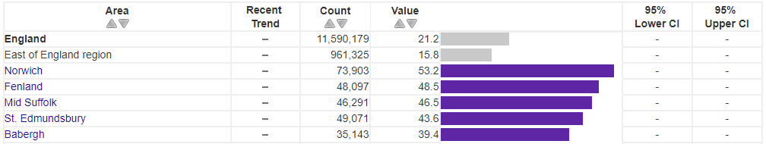
Source: Public Health England
Nationally, 21.2% of residents are living in LSOAs within the worst-performing 20% of all LSOAs as scored by the AHAH index. Within the East of England, this value is 15.8% of residents. Of 47 districts and unitary authorities within the East of England (the worst five of which are pictured above), Fenland has the second-worst proportion of residents living within the worst-performing 20% of LSOAs (48.5%), behind only Norwich (53.2%).
Figure 9: Crude rate of noise complaints per 1,000 resident population, 2015-16: Worst-Performing Districts in the East of England
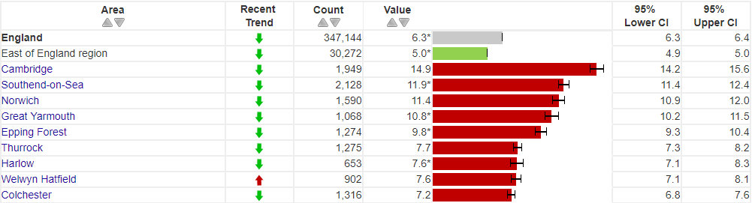
Source: Public Health England
The crude rate of noise complaints per 1,000 resident population in England in 2015-16 was 6.3/1,000 and statistically significantly lower in the East of England (5.0/1,000). Of 47 districts and unitary authorities in the East of England, Cambridge is one of 9 (19.1% of the total) that have a statistically significantly higher crude rate than the national average. The Cambridge rate of 14.9/1,000 (95% confidence intervals = 14.2 – 15.6) mean that the rate of noise complaints in Cambridge is statistically significantly worse than any other area of the East of England. The adverse effects of noise pollution and significant noise-related issues on general health and wellbeing are noted within the Noise Policy Statement for England and Natural Environment White Paper.

Reverse or live well with long term conditions indicators

Figure 10: Reverse or live well with long term conditions Indicators:
Indicator | Time Period | Area
 |  | Cambridgeshire |  | Peterborough |  | Cambridge |  | East Cambridgeshire |  | Fenland |  | Huntingdonshire |  | South Cambridgeshire |  | England
 |  | Number | Indicator Value | Number | Indicator Value | Number | Indicator Value | Number | Indicator Value | Number | Indicator Value | Number | Indicator Value | Number | Indicator Value | Number | Indicator Value
Estimated Diabetes Diagnosis Rate | 2018 | - | 76.3% | - | 82.7% | - | 61.0% | - | 85.1% | - | 85.3% | - | 80.9% | - | 68.2% | - | 78.0%
Directly age-standardised rate of emergency hospital admissions for COPD | 2017-18 | 1,339 | 365 | 504 | 552 | 239 | 497 | 151 | 281 | 349 | 519 | 371 | 355 | 229 | 248 | 128,063 | 415
Cancer diagnosed at early stage (no statistical significance calculated for this indicator) | 2017 | 1,462 | 56.4% | 361 | 54.6% | 226 | 59.3% | 192 | 54.7% | 249 | 52.1% | 404 | 57.6% | 391 | 57.2% | 113,808 | 52.2%
% reporting a long-term musculoskeletal problem | 2017-18 | - | 13.9% | - | 16.3% | - | 8.8% | - | 16.3% | - | 16.1% | - | 16.5% | - | 13.3% | - | 17.0%
% reporting at least two long-term conditions, at least one of which is MSK related | 2017-18 | - | 9.3% | - | 11.2% | - | 5.9% | - | 11.2% | - | 10.9% | - | 11.1% | - | 8.9% | - | 12.1%
Rheumatoid arthritis QOF prevalence 16+ | 2017-18 | 4,455 | 0.7% | 1,041 | 0.6% | 726 | 0.4% | 588 | 0.8% | 959 | 1.0% | 1,258 | 0.8% | 924 | 0.8% | 356,372 | 0.7%
% reporting depression or anxiety, 18+ | 2016-17 | - | 11.7% | - | 12.8% | - | 12.7% | - | 11.1% | - | 15.9% | - | 10.8% | - | 9.0% | - | 13.7%
Estimated dementia diagnosis rate, 65+ | 2018 | 4,686 | 61.0% | 1,336 | 78.3% | 896 | 64.6% | 586 | 56.9% | 915 | 57.7% | 1,420 | 68.8% | 869 | 53.8% | 435,574 | 67.5%
Hypertension QOF prevalence, all ages | 2017-18 | 91,675 | 12.8% | 25,082 | 11.8% | - | - | - | - | - | - | - | - | - | - | 8,141,488 | 13.9%
CHD QOF prevalence, all ages | 2017-18 | 20,249 | 2.8% | 5,221 | 2.5% | - | - | - | - | - | - | - | - | - | - | 1,827,352 | 3.1%
Stroke QOF prevalence, all ages | 2017-18 | 10,693 | 1.5% | 2,724 | 1.3% | - | - | - | - | - | - | - | - | - | - | 1,030,869 | 1.8%
Diabetes QOF prevalence, 17+ | 2017-18 | 33,422 | 5.7% | 11,356 | 6.9% | - | - | - | - | - | - | - | - | - | - | 3,196,124 | 6.8%
Estimated prevalence of common mental disorders, 65+ | 2017 | 10,752 | 8.9% | 3,287 | 11.3% | 1,571 | 9.9% | 1,480 | 8.4% | 2,558 | 11.3% | 2,888 | 8.3% | 2,255 | 7.5% | 1,027,792 | 10.2%

Key
Statistically significantly better than benchmark | In best quintile
Statistically similar to benchmark | In second best quintile
Statistically significantly lower than benchmark | In third quintile
Statistically significantly higher than benchmark | In second worst quintile
Statistically significantly lower than benchmark | In worst quintile

Figure 11: Estimated diabetes diagnosis rate, 2018: Districts & unitary authorities in the East of England with statistically significantly low diagnosis rates:
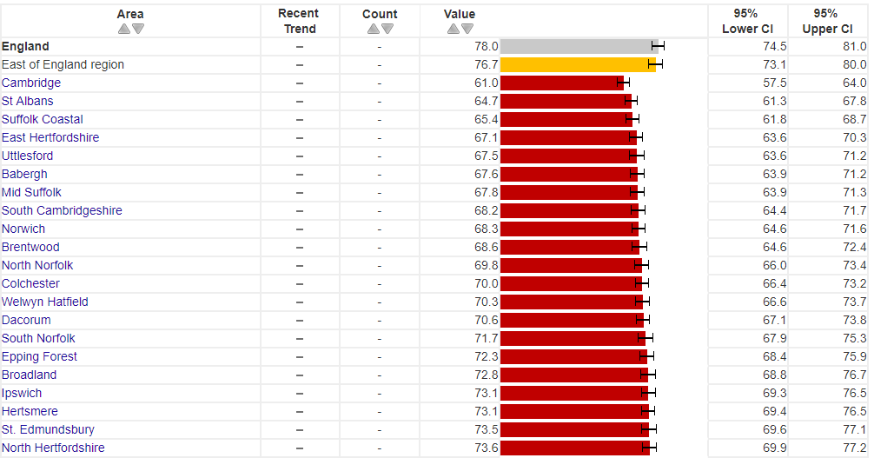
Source: Public Health England
21 of 47 districts/unitary authorities in the East of England have a statistically significantly lower (worse) estimated diabetes diagnosis rate than the national average of 78.0%, including both Cambridge and South Cambridgeshire. Once confidence intervals are incorporated, Cambridge’s value of 61.0 (confidence intervals = 57.5% to 64.0%) is within the seven areas in the East of England with the lowest diagnosis rate (confidence intervals for Cambridge and areas above South Cambridgeshire overlap).
Peterborough, Cambridge and Fenland all have statistically significantly higher directly age-standardised rates of emergency hospital admissions for COPD compared to the national average, whereas all other areas of Cambridgeshire and Peterborough have statistically significantly lower rates.
Rheumatoid arthritis prevalence is statistically significantly higher than the national average of 0.7% in Fenland (1.0%), East Cambridgeshire (0.8%), Huntingdonshire (0.8%) and South Cambridgeshire (0.8%), although as the data are not age-standardised, this could be partly as a result of a greater proportion of older residents within these areas compared to England.
Figure 12: Proportion of residents reporting depression or anxiety, Fenland, 2014/15 – 2016/17
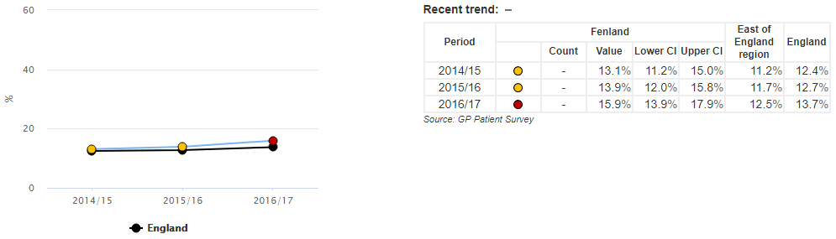
Source: Public Health England
In 2016/17, 15.9% of Fenland residents reported depression or anxiety, statistically significantly worse than the national average of 13.7%. Fenland was statistically similar to England in both 2014/15 and 2015/16. Fenland is one of only four areas in the East of England (of a total of 47) with statistically significantly high proportions of residents reporting depression or anxiety, along with Norwich, Ipswich and Southend on Sea.
The estimated dementia diagnosis rate in 2018 is statistically significantly below the national average of 67.5% in Cambridgeshire (61.0%) and statistically significantly higher than the national average in Peterborough (78.3%). East Cambridgeshire, Fenland and South Cambridgeshire are also statistically significantly worse than England for this indicator.

Figure 13: Enhanced care & support indicators (benchmark – Cambridgeshire & Peterborough):
Indicator | Time Period | Area
 |  | Cambridgeshire |  | Peterborough |  | Cambridge |  | East Cambridgeshire |  | Fenland |  | Huntingdonshire |  | South Cambridgeshire |  | Cambridgeshire & Peterborough
 |  | Number | Indicator Value | Number | Indicator Value | Number | Indicator Value | Number | Indicator Value | Number | Indicator Value | Number | Indicator Value | Number | Indicator Value | Number | Indicator Value
Directly age-standardised rate of inpatient admissions, 75+, DASR per 1,000 | 2017-18 | 40,490 | 746 | 9,355 | 707 | 5,412 | 696 | 5,416 | 690 | 8,186 | 798 | 11,686 | 789 | 9,790 | 722 | 49,845 | 738
Directly age-standardised rate of A&E attendances, 75+ | 2017-18 | 30,608 | 555 | 9,156 | 688 | 4,474 | 554 | 4,718 | 597 | 6,834 | 660 | 7,485 | 503 | 7,097 | 513 | 39,764 | 581

Due to the absence of national benchmark data, the above two indicators use the collective average of Cambridgeshire and Peterborough as benchmark values. The directly age-standardised rate of inpatient admissions in the 75+ age group is statistically significantly lower than the Cambridgeshire and Peterborough average in Peterborough, Cambridge, East Cambridgeshire and South Cambridgeshire and statistically higher than this average in Cambridgeshire, Fenland and Huntingdonshire.
With regards to A&E attendances in the 75+ age group, Peterborough and Fenland have statistically significantly high directly age-standardised rates; all other areas of Cambridgeshire & Peterborough have statistically significantly low rates with the exception of East Cambridgeshire which is statistically similar.

Enhanced care & support indicators

Figure 14: Enhanced care & support indicators (benchmark – England):
Indicator | Time Period | Area
 |  | Cambridgeshire |  | Peterborough |  | Cambridge |  | East Cambridgeshire |  | Fenland |  | Huntingdonshire |  | South Cambridgeshire |  | England
 |  | Number | Indicator Value | Number | Indicator Value | Number | Indicator Value | Number | Indicator Value | Number | Indicator Value | Number | Indicator Value | Number | Indicator Value | Number | Indicator Value
Directly age-standardised rate of emergency hospital admissions due to falls in 65+ | 2017-18 | 2,659 | 2,164 | 602 | 2,041 | 467 | 2,591 | 356 | 2,014 | 506 | 2,177 | 678 | 2,056 | 652 | 2,123 | 220,160 | 2,170
Directly age-standardised rate of emergency hospital admissions due to falls in 65-79 | 2017-18 | 803 | 943 | 179 | 897 | 133 | 1,263 | 95 | 752 | 152 | 951 | 238 | 956 | 185 | 876 | 73,495 | 1,033
Directly age-standardised rate of emergency hospital admissions due to falls in 80+ | 2017-18 | 1,856 | 5,702 | 423 | 5,357 | 334 | 6,440 | 261 | 5,673 | 354 | 5,730 | 440 | 5,246 | 467 | 5,741 | 146,665 | 5,469
Directly age-standardised rate of hip fractures in 65+ | 2017-18 | 654 | 533 | 185 | 625 | 94 | 527 | 82 | 462 | 137 | 593 | 184 | 558 | 157 | 515 | 58,700 | 578
Directly age-standardised rate of hip fractures in 65-79 | 2017-18 | 197 | 232 | 52 | 262 | 28 | 270 | 20 | 159 | 43 | 268 | 61 | 245 | 45 | 216 | 17,413 | 246
Directly age-standardised rate of hip fractures in 80+ | 2017-18 | 457 | 1,404 | 133 | 1,677 | 66 | 1,275 | 62 | 1,343 | 94 | 1,536 | 123 | 1,468 | 112 | 1,381 | 41,287 | 1,539
Osteoporosis QOF prevalence, 50+ | 2017-18 | 1,435 | 0.6% | 187 | 0.3% | 178 | 0.4% | 312 | 1.0% | 151 | 0.3% | 310 | 0.4% | 484 | 0.9% | 130,694 | 0.6%
Care home beds per 100 people, 75+ (no statistical significance calculated for this indicator) | 2018 | 4,465 | 8.3% | 1,272 | 9.8% | 807 | 10.4% | 578 | 7.4% | 980 | 9.6% | 1,211 | 8.2% | 889 | 6.6% | 459,385 | 10.1%
Nursing home beds per 100 people, 75+ (no statistical significance calculated for this indicator) | 2018 | 2,344 | 4.3% | 776 | 5.9% | 549 | 7.1% | 226 | 2.9% | 585 | 5.7% | 485 | 4.3% | 499 | 3.7% | 220,033 | 4.9%
Unpaid carers (Census 2011) | 2011 | 12,078 | 1.9% | 4,342 | 2.4% | 1,589 | 1.3% | 1,637 | 2.0% | 2,944 | 3.1% | 3,464 | 2.0% | 2,444 | 1.6% | 1,256,237 | 2.4%

Key
Statistically significantly better than benchmark | In best quintile
Statistically similar to benchmark | In second best quintile
Statistically significantly lower than benchmark | In third quintile
Statistically significantly higher than benchmark | In second worst quintile
Statistically significantly lower than benchmark | In worst quintile

Of particular note within the table above is that Cambridge has statistically significantly high directly age-standardised rates of emergency hospital admissions due to falls in the 65+, 65-79 and 80+ age groups, whereas all other areas of Cambridgeshire and Peterborough are statistically significantly lower or statistically similar to the national average.
QOF prevalence of osteoporosis is statistically significantly lower than the national average of 0.6% in all areas of Cambridgeshire and Peterborough with the exception of East Cambridgeshire (1.0%) and South Cambridgeshire (0.9%), which are statistically significantly higher than the national average.
Unpaid carers data are available with comparison to a benchmark of England as part of data from the 2011 Census and shows a statistically significantly higher proportion of unpaid carers in Fenland (3.1%) compared to England (2.4%). All other areas are statistically significantly lower than England for this indicator with the exception of Peterborough and East Cambridgeshire, which are statistically similar.
Report prepared by:
Ryan O’Neill
Advanced Public Health Analyst
Public Health Intelligence, Peterborough & Cambridgeshire Public Health
ryan.o’neill@peterborough.gov.uk

https://fingertips.phe.org.uk/profile/healthy-ageing/data#page/6/gid/1938133253/pat/6/par/E12000006/ati/102/are/E06000031/iid/92725/age/27/sex/4
https://www.who.int/gard/publications/Risk%20factors.pdf
https://fingertips.phe.org.uk/search/noise%20complaints#page/6/gid/1/pat/6/par/E12000006/ati/101/are/E07000010/iid/11401/age/1/sex/4

