

**Cambridgeshire & Peterborough Children and Young People’s Health and Wellbeing**

District Outcomes Profile

July 2019

**Contents**

**1.** **Introduction** 4

**2.** **Summary** 5

2.1 Cambridgeshire 5

2.2 Peterborough 7

2.3 Districts 10

2.3.1 Cambridge 10

2.3.2 East Cambridgeshire 11

2.3.3 Fenland 12

2.3.4 Huntingdonshire 13

2.3.5 South Cambridgeshire 14

**3.** **Wider determinants of health** 15

3.1 Child poverty 15

3.2 Family homelessness 16

3.3 Education 17

3.3.1 Good level of development in Reception 17

3.3.2 Phonics screening check in Year 1 19

3.3.3 GCSE’s 20

3.3.4 Pupil absence 21

3.3.5 Not in education, employment or training (NEET) 22

3.4 Children in care 22

3.5 First time entrants to the youth justice system 23

3.6 Children killed and seriously injured 24

**4.** **Health improvement** 25

4.1 Low birth weight 25

4.2 Breastfeeding 26

4.3 Lifestyles 27

4.3.1 Smoking 27

4.3.2 Excess weight in children 28

4.3.3 Childhood obesity 29

4.3.4 Alcohol 32

4.3.5 Substance misuse 33

4.3.6 Sexual health 34

4.4 Teenage conceptions 36

4.5 Decayed, missing or filled teeth 39

**5.** **Health protection** 40

5.1 Vaccinations and immunisations 40

Summary table of all childhood vaccinations 40

5.1.1 MMR 41

5.1.2 HPV 42

5.1.3 Children in care immunisations 43

**6.** **Prevention of ill health** 44

6.1 A&E attendances 44

6.2 Hospital admissions – unintentional and deliberate injuries 45

6.3 Hospital admissions – asthma, diabetes and epilepsy 47

6.4 Hospital admissions – mental health conditions 48

6.5 Hospital admissions – self-harm 49

**7.** **Premature mortality** 50

7.1 Infant Mortality 50

7.2 Child Mortality 51

**8.** **Appendices** 52

8.1 Child Health Profile – Cambridgeshire 52

8.2 Child Health Profile – Peterborough 53

8.3 Cambridgeshire and Peterborough Children’s Outcomes Framework – latest monitoring (March 2019) 54

1. **Introduction**

The annual national Child Health Profiles [1] are published at upper tier Council level only. These profiles present data on factors related to the health and wellbeing of pregnant women, children and young people, with the indicators designed to help local authorities and health services improve the health and wellbeing of children and tackle health inequalities.

This report presents data at district level, where available, to help identify the local needs of children and young people at, and between, lower geographical levels. Data for Cambridgeshire and Peterborough are presented where district level data are not available, to enable benchmarking against the national position. The indicators used are those from the Child Health Profiles (Appendix 1) and those from the locally defined and agreed Children’s Outcome Framework (Appendix 2).

Local authority summaries are included and highlight the areas where the districts are statistically significantly worse than England, where there could be possible future areas of concern and where improvements have already been seen. It should be noted that some measures may still be important even if they are not shown to be locally or nationally adverse, for example, if significant numbers of children and young people are involved, they are good overall measures of population health status or if trends are adverse. Similarly, some issues may be masked at a higher level of geography and smaller area analysis may highlight particular pockets of deprivation or other vulnerabilities where there are relatively worse health determinants and outcomes.

For the purpose of this report the districts, Cambridgeshire and Peterborough have been benchmarked against England, using the following key:

**Tables Charts**



1. **Summary**
   1. Cambridgeshire

There are almost **151,000** children and young people aged under 20 years living in Cambridgeshire, **23%** of the total population. The population is forecast to increase by almost 25,000 children and young people (16.4%) over the next 10 years, with the largest actual and proportional increases expected in 10 to 14 year olds and 15 to 19 year olds. [2]

The health and wellbeing of children and young people in Cambridgeshire is relatively positive in comparison to the experience of children in England with child poverty, teenage conceptions, excess weight, children in care, dental health, GCSE attainment, 16-17 year olds not in education employment and training (NEET), pupil absence, A&E attendances and hospital admissions for asthma, unintentional and deliberate injuries, mental health conditions and substance misuse all statistically significantly better than the England averages.[3] However, there are several measures where Cambridgeshire fares worse than England, as detailed below.

**Potential priority areas \***

* **School readiness – Reception:** in 2017/18 the percentage of Reception aged children achieving a good level of development at the end of the school year was statistically similar to England, but for those with free school meal status the level of development was statistically significantly worse than experienced nationally. Overall there has been an increasing trend in the good level of development in children with free school meal status in Cambridgeshire, but since 2015/16 rates have decreased leading to a widening in the gap between Cambridgeshire and England.
* **School readiness – Year 1:** in 2017/18 the proportion of Year 1 pupils achieving the expected level in the phonics screening check was statistically significantly worse than England in all pupils and those with free school meal status. There are overall increasing trends in both of these indicators, though rates have stabilised for Year 1 pupils with free school meal status.
* **Chlamydia screening and detection (15-24 years)**: in 2017/18, as in previous years, Cambridgeshire had a statistically significantly low proportion of 15 to 24 year olds screened for chlamydia, with a detection rate that was also below the nationally set benchmark. Both screening and detection rates are decreasing, as is also being experienced nationally.
* **Vaccinations in 5 year olds:** in 2017/18 two doses of MMR vaccination uptake was below 90%, with the national target being 95%. There was a notable increase in coverage between 2016/17 and 2017/18, from 85.1% to 88.7%.
* **Hospital admissions as a result of self-harm (10-24 years):** in 2017/18 there was a notable increase in the hospital admission rate for self-harm, with trends increasing since 2012/13. This is set against a fairly static national trend.
* **Children in care immunisations:** there was a noticeable reduction in 2018 which has led to Cambridgeshire having a statistically significantly low rate of children in care receiving immunisations compared to England.

**Areas that could be of future possible concern \*\***

* **Low birth weight of term babies**: in 2016 an increase in the proportion of term babies born with a low birth weight (under 2,500g) moved Cambridgeshire from being statistically significantly better than England to being statistically similar. This has remained stable into 2017.

* **Vaccinations**: the following vaccinations were below the target of 95% in 2017/18: Dtap/IPV/Hib (1 year olds); PCV (1 year olds); Hib/MenC booster (2 year olds); Hib/MenC booster (5 year olds), PCV booster (2 years old), MMR one dose (2 year olds) and MMR two doses (5 year olds). All these are experiencing upward trends in coverage, with the exception of Hib/MenC booster in 5 year olds where uptake is decreasing.
* **Teenage mothers:** the proportion of teenage mothers has stabilised in Cambridgeshire (2014/15 to 2017/18), but there has been a downward trend nationally, which has led to Cambridgeshire becoming statistically similar to the England rate since 2015/16.
* **Persons under 18 admitted to hospital for alcohol-specific conditions**: the rate in Cambridgeshire has stabilised at a higher positon than seen nationally, so set against a notable downward England trend there is a widening in the gap between the areas. Cambridgeshire remains statistically similar to England.
* **Mortality**: although the Cambridgeshire rates for infant and child (1-17 years) mortality are statistically similar to England the rates have stabilised over the last 5 years, set against national downward trends.
* **Children in care**: the rates of children in care in Cambridgeshire have historically been statistically significantly lower than England and have remained so in 2018. However, the rates have been increasing since 2014 and therefore assessed by Public Health England as having a negative trend.
* **A&E attendances, 0 to 4 year olds:** the rates have historically been statistically significantly lower in Cambridgeshire than England and remained so in 2017/18, but as they have been increasing since 2012/13 it has been assessed that there is a negative trend.

**Areas of improvement \*\*\***

* **Hospital admissions due to substance misuse (15-24 years):** a reduction in the rates has led to Cambridgeshire having a statistically significantly better rate than England in 2015/18, where it had previously (2014/17) been statistically similar.
* **HPV Vaccinations**: there was a notable increase in the proportion of 12-13 year olds having one dose of HPV, leading to uptake being higher than the 90% benchmark target in Cambridgeshire. However the proportion of 13-14 year olds receiving two doses has decreased slightly over the last three year and is below the 90% benchmark target.
* **Long acting contraceptive use (excluding injections in Sexual Reproductive Health Services), under 25 year olds:** an increase in 2017 has led to Cambridgeshire having statistically significantly high uptake of LARCs compared to the England average.

**Notes**

|  |  |
| --- | --- |
| * | Statistically significantly worse than England. |
| ** | Statistically similar and below the England average; moved from being statistically significantly better than England to being statistically similar; a negative trend regardless of statistical significance. |
| *** | Statistically significantly better than England where had previously been statistically similar; statistically similar to England where had been statistically significantly worse. |

* 1. Peterborough

Peterborough has a younger population than the national average. There are over **54,000** children and young people aged under 20 years living in Peterborough, **27%** of the total population. The population is forecast to increase by almost 9,500 children and young people (17.3%) over the next 10 years, with the largest actual and proportional increases expected in 10 to 14 year olds and 15 to 19 year olds. 2

The health and wellbeing of children and young people in Peterborough is overall poorer in comparison to the experience of children in England as a whole, with around **1 in 5 children aged under 16 years living in poverty**. Measures relating to pregnancy and birth are similar to the national average with low birth weight term babies, stillbirths and infant mortality around the England rates. However teenage mothers, breastfeeding initiation and smoking at the time of delivery are significantly worse than England. As children move into early years there are more areas that are statistically significantly worse than England such as dental health and A&E attendances, or are below the national target, such as childhood immunisations, with the majority showing adverse trends in coverage. Educational attainment generally fares worse in Peterborough when compared to England with poorer levels of development at the end of reception, phonics achievement in Year 1 and attainment at GCSE’s, as well as a high proportion of 16-17 year olds not in education, employment or training. Hospital admissions for self-harm and asthma are high. However, there are several indicators where notable improvements have been made including teenage conceptions, excess weight in 10-11 year olds, hospital admissions for alcohol-specific conditions in under 18 year olds and under 25 year olds choosing long acting reversible contraception. 3

**Potential priority areas \***

* **Children in low income families (under 16 years):** in 2016 18.8% of children were living in poverty, which was statistically significantly worse than the national average of 17.0%.
* **Breastfeeding initiation:** the rate moved to being statistically significantly worse than England in 2015/16 and 2016/17, having been statistically similar in the previous 4 years. There was an increase in initiation in 2016/17 but the rate remained statistically significantly worse, and notably lower, than England.
* **Smoking status at the time of delivery:** the data reported in the Public Health Outcomes Framework relate to a CCG figure, which is not representative of the variation across Cambridgeshire and Peterborough. Local hospital data for 2017/18 shows that smoking at the time of delivery was 6.7% at Cambridge University Hospital Foundation Trust, 10.3% at Hinchingbrooke, 14.4% at Peterborough and Stamford Hospitals and 21.9% at the Queen Elizabeth Hospitals, with the prevalence in the latter two hospital being statistically significantly higher than the average for Cambridgeshire and Peterborough. These hospitals predominantly cover the populations of Peterborough and north Fenland.
* **Vaccinations:** in 2017/18 Hib/MenC booster and PCV booster in 2 year olds were below 90% coverage, with a decreasing trend. Two dose MMR coverage in 5 year olds was also below 90% and showed a decrease between 2016/17 and 2017/18.
* **Dental Health: in 2016/17 Peterborough had a statistically significantly low proportion of five year olds free from dental decayand a statistically significantly high proportion of one or more decayed, missing or filled teeth in this age cohort.**

* **Children achieving a good level of development at the end of reception:** there was an increase in achievement in 2017/18, which has led to a narrowing in the gap between Peterborough and nationally, although the proportion remains statistically significantly worse than England.
* **Children achieving expected level in the phonics screening check, Year 1:** there was a slight increase in the expected achievement in 2017/18 but set against an increasing rate in England the gap has widened. This is also true for achievement in pupils with free school meals, which remains statistically significantly worse in Peterborough compared to England.
* **GCSEs, average Attainment 8 score:** Attainment rates remained stable between 2016/17 and 2017/18, with both years having statistically significantly worse average scores than England.
* **Not in education, employment of training, 16-17 year olds:** this moved from being statistically similar to England in 2016 to being statistically significantly worse in 2017.
* **Teenage mothers:** there was increase in teenage mothers in 2017/18 which led to Peterborough having a statistically significantly high rate compared to England, where previously (2016/17) it had been statistically similar.
* **Family homelessness:** there is a notable increasing trend in the rate of family homelessness in Peterborough, set against a static national trend. In 2017/18 the rate was over three times higher in Peterborough than England.
* **Children in care:** Peterborough has historically had statistically significantly high rates of children in care compared to the England average, with the rates remaining fairly static over the last 4 years.
* **A&E attendances, 0-4 years:** there was a slight reduction in attendance rates in 2017/18 but they remained notably, and statistically significantly, higher than the England rate.
* **Hospital admissions as a result of self-harm, 10-24 years:** there was an increase in the rate between 2016/17 and 2017/18, following a notable decrease from 2015/16. However, the rate remains statistically significantly higher than the England rate.
* **Hospital admissions due to substance misuse, 15-24 years:** there is an upward trend in admission rates in Peterborough, which is also occurring nationally but at a much less marked rate. There is a considerable gap between the Peterborough and England rates.
* **Hospital admissions for asthma, under 19 years:** there was a noticeable decrease in rates between 2016/17 and 2017/18, narrowing the gap between Peterborough and England, but the rate remained statistically significantly higher than nationally.

**Areas that could be of future possible concern \*\***

* **Vaccinations**: the following vaccinations were below the target of 95% but above 90% in 2017/18: Dtap/IPV/Hib (1 year and 2 year olds); PCV (1 year olds); PCV booster (2 year olds), Hib/MenC booster (5 year olds) and MMR for one dose (2 year olds). Coverage for these immunisations is decreasing in Peterborough. HPV coverage has stabilised over the last two years at around 85%.
* **Infant mortality:** there was an increase in the rate in 2015/17 that led to Peterborough having a higher, but not statistically significantly higher, rate than England.
* **Obesity, 10-11 year olds:** the proportion of obese children aged 10-11 years in Peterborough moved from being statistically significantly worse than England in 2016/17 to being statistically similar in 2017/18. However, the overall trend has been increasing since 2007/08.
* **Child mortality, 1-17 year olds:** there was a slight decrease in rates between 2014/16 and 2015/17 but rates remained notably higher, but not statistically significantly higher, than England.
* **Children killed and seriously injured (KSI) on England’s roads:**  the rate in 2015/17 was higher, but not statistically significantly higher, than England, with rates increasing since 2013/15.
* **First time entrants to the youth justice system:** the rate in 2017 was higher, but not statistically significantly higher, than the England rate, and higher than in 2016. However, there is an overall decreasing trend.
* **Hospital admissions caused by unintentional and deliberate injuries in young people, 0-14 years:** there was an increase in rates between 2016/17 and 2017/18 that led to Peterborough having a rate that was higher, but not statistically significantly higher, than the England rate.

**Areas of improvement \*\*\***

* **Teenage conceptions, under 18 years old**: a reduction in the rate in 2017 led to Peterborough becoming statistically similar to England where previously it had been statistically significantly higher (2012 to 2016).
* **Teenage conceptions, under 16 years old**: a reduction in the rate in 2017 led to Peterborough becoming statistically similar to England where previously it had been statistically significantly higher (2016).
* **Low birth weight of term babies:** this remains statistically similar to England, but there was a noticeable decrease between 2016 and 2017 leading to Peterborough having the same proportion as nationally.
* **Excess weight, 10-11 year olds**: a notable reduction in the proportion of Year 6 pupils recorded as having excess weight between 2016/17 and 2017/18 has led to Peterborough having a statistically similar rate to England, where it had previously been statistically significantly worse in 2016/17. There was also a reduction in 4-5 year olds, but rates remained statistically similar to England.
* **Obesity, 10-11 year olds**: whilst there has been an overall upward trend in this indicator in Peterborough (as mentioned above) the rate moved from being statistically significantly worse than England in 2016/17 to being statistically similar in 2017/18.
* **Hospital admissions for alcohol-specific conditions, under 18 years:** a reduction in rates between 2014/17 and 2015/18 has led to Peterborough having a statistically significantly better rate than England.
* **Long acting contraceptive use (excluding injections in Sexual Reproductive Health Services), under 25 year olds:** an increase in LARCs in 2017 has led to Peterborough having a statistically significantly high uptake compared to England.

**Notes**

|  |  |
| --- | --- |
| * | Statistically significantly worse than England. |
| ** | Statistically similar and below the England average; moved from being statistically significantly better than England to being statistically similar; a negative trend regardless of statistical significance. |
| *** | Statistically significantly better than England where had previously been statistically similar; statistically similar to England where had been statistically significantly worse. |

* 1. Districts
     1. Cambridge

There are approximately **30,000** children and young people aged under 20 years living in Cambridge, **22%** of the total population, with a notably high proportion of 15 to 19 year olds due to the university student population. The population is forecast to increase by almost 5,500 children and young people (18.0%) over the next 10 years, with the largest actual and proportional increase expected in 10 to 14 year olds.2

The health and wellbeing of children and young people in Cambridge is relatively positive in comparison to the experience of children in England with children living in poverty, breastfeeding initiation, excess weight, dental health and hospital admissions caused by unintentional and deliberate injuries all statistically significantly better than the average for England. However, as explored below, there are several measures where the Cambridge fares worse than the England averages. 3 Also, whilst child poverty is statistically significantly better than the England average it is statistically significantly worse than the Cambridgeshire average.

**Potential priority areas \***

* **Hospital admissions for self-harm, 10-24 years**: this currently isn’t produced nationally for districts, but local analysis shows that admission rates in 2017/18 were statistically significantly high in Cambridge compared to the England rate.
* **Chlamydia detection rates, 15-24 years:** the detection rate in 2018 was lower than the nationally set benchmark, and with an overall downward trend.
* **Children achieving a good level of development at the end of Reception:** Local analysis shows that the proportion of pupils with a good level of development at the end of Reception is statistically significantly lower than the national average, as well as for boys and those with free school meal status in the district.

**Areas that could be of future possible concern \*\***

* **Teenage conceptions**: the rate moved from being statistically significantly better than England in 2016 to being statistically similar in 2017.
* **Infant mortality**: rates are statistically similar to England but have been increasing since 2011-13 and are now higher, but not significantly higher, than England.

**Areas of improvement \*\*\***

* **Pupil absence**: this has moved from being statistically significantly worse than England in 2015/16 to being statistically similar in 2016/17.
* **Hospital admissions for alcohol-specific conditions, under 18 year olds**: there was a decrease in rates between 2014/17 and 2015/18 which led to the area becoming statistically similar to England, rather than statistically significantly worse. The rates remain higher, but not statistically significantly higher, than England.
* **Chlamydia screening, 15-24 year olds**: an increase in the proportion of people screened in 2018 has led to Cambridge becoming statistically better than the average for England.
* **Long acting contraceptive use (excluding injections in Sexual Reproductive Health Services), under 25 year olds:** an increase in LARCs in 2017 has led to Cambridge having a statistically significantly high uptake compared to England.

**Notes**

|  |  |
| --- | --- |
| * | Statistically significantly worse than England. |
| ** | Statistically similar and below the England average; moved from being statistically significantly better than England to being statistically similar; a negative trend regardless of statistical significance. |
| *** | Statistically significantly better than England where had previously been statistically similar; statistically similar to England where had been statistically significantly worse. |

* + 1. East Cambridgeshire

There are approximately **21,000** children and young people aged under 20 years living in East Cambridgeshire, **24%** of the total population.The population is forecast to increase by over 4,000 children and young people (19.5%) over the next 10 years, with the largest actual and proportional increases expected in under 5 year olds and 10 to 19 year olds, with a relatively small increase in 5 to 9 year olds. 2

The health and wellbeing of children and young people in East Cambridgeshire is relatively positive in comparison to the experience of children in England with child poverty, infant mortality, excess weight, GCSE attainment, pupil absence, childhood immunisations, hospital admissions caused by unintentional and deliberate injuries and dental health all being significantly better than England. 3

**Potential priority areas \***

* **Hospital admissions for self-harm, 10-24 years**: this currently isn’t produced nationally but local analysis shows that admissions rates in 2017/18 were statistically significantly high in East Cambridgeshire compared to the England rate.
* **Chlamydia screening and detection, 15-24 year olds**: there is an overall downward trend in screening rates, with the proportion statistically significantly lower than England. However there was an increase from 15.3% to 16.8% between 2017 and 2018. Chlamydia detection rates are below the nationally set benchmark but there was an increase between 2017 and 2018, with an overall static trend.
* **Children achieving a good level of development at the end of Reception:** Local analysis shows that pupils who have English as an additional language have statistically significantly lower levels of good development at the end of Reception compared to the average for England.

**Areas that could be of future possible concern \*\***

* **Teenage conceptions:** the rate of teenage conceptions in 2017 remained the same as 2016, whilst the national rate continued to decrease. This has led to the area becoming statistically similar to England where it had previously been statistically significantly better. It is important to note that ONS have quoted that there are data quality issues with the figures due to small numbers.
* **Low birth weight of term babies:** this remains statistically similarto England, but there was a noticeable increase between 2016 and 2017, from 1.9% to 2.9%.
* **Long acting contraceptive use (excluding injections in Sexual Reproductive Health Services), under 25 year olds:** a decrease in LARCs in 2017 led to East Cambridgeshire having a statistically similar uptake compared to England, where it had previously had a statistically significantly high uptake.

**Areas of improvement \*\*\***

* **GCSE attainment:** the average Attainment 8 score moved from being statistically similar to England in 2016/17 to being statistically significantly better than England in 2017/18.

**Notes**

|  |  |
| --- | --- |
| * | Statistically significantly worse than England. |
| ** | Statistically similar and below the England average; moved from being statistically significantly better than England to being statistically similar; a negative trend regardless of statistical significance. |
| *** | Statistically significantly better than England where had previously been statistically similar; statistically similar to England where had been statistically significantly worse. |

* + 1. Fenland

There are approximately **22,000** children and young people aged under 20 years living in Fenland, **22%** of the total population. The population is forecast to increase by almost 3,000 children and young people (13.0%) over the next 10 years, with the largest actual and proportional increases expected in 10 to 14 year olds.2

The health and wellbeing of children and young people in Fenland is generally similar to the experience of children in England, but fares poorer in comparison to those in Cambridgeshire as a whole. There are a few indicators where the district has worse outcomes than the national averages (as detailed below) but there are further areas where the rates in Fenland are statistically significantly higher than those for Cambridgeshire. These include child poverty, GCSE attainment, teenage conceptions, excess weight and obesity in 10-11 year olds, hospital admissions caused by unintentional and deliberate injuries in under 15 year olds and dental health in 5 year olds. 3

**Potential priority areas \***

* **Child living in poverty, aged under 16 years:** Fenland has had statistically significantly higher proportions of children living in poverty than England over the last 5 years. There was a decrease in the proportion in 2015 that stabilised to 2016, as it did nationally.
* **Breastfeeding initiation:** there is a decreasing trend in Fenland, against a fairly static national trend, leading in a widening of the gap between Fenland and England.
* **Chlamydia detection rates**: this is lower than the nationally set benchmark, and has remained fairly static over the last 7 years.
* **Good level of development at the end of Reception:** local analysis shows that this is statistically significantly lower in Fenland compared to England, as it is for girls, children without free school meal status and for both English and non-English (as first language) speaking children in the district.
* **GCSE attainment:** the average Attainment 8 score was statistically significantly worse than England in 2017/18.

**Areas that could be of future possible concern \*\***

* **Teenage conceptions, under 18 year olds:** this is statistically similar to England but there was an increase in the rate between 2016 and 2017 that led to the area having a higher rate than England. Overall there is a decreasing trend.
* **Excess weight, 4-5 year olds:** this moved from being statistically significantly better than England in 2016/17 to being statistically similar in 2017/18, even though there was a reduction in the percentage between the two time periods.
* **Excess weight, 10-11 year olds:** this continues to follow the increasing England trend, and is statistically similar to the national average, but rates have been increasing annually since 2014/15.

**Areas of improvement \*\*\***

* **Obesity, 4-5 year olds:** there was a noticeable reduction in the proportion of Reception pupils recorded as obese in 2017/18 leading to Fenland having a statistically significantly better percentage than England.
* **Hospital admissions caused by unintentional and deliberate injuries, 0-4 year olds**: this moved from being statistically similar to England in 2016/17 to being statistically significantly better in 2017/18.
* **Low birth weight of term babies**: this remains statistically similar to England in 2017 but there was a marked improvement from the previous year.
* **Infant mortality**: this remains statistically similar to England but there was a notable decrease in rates between 2014/16 and 2015/17 that led to Fenland having the same rate as England.

**Notes**

|  |  |
| --- | --- |
| * | Statistically significantly worse than England. |
| ** | Statistically similar and below the England average; moved from being statistically significantly better than England to being statistically similar; a negative trend regardless of statistical significance. |
| *** | Statistically significantly better than England where had previously been statistically similar; statistically similar to England where had been statistically significantly worse. |

* + 1. Huntingdonshire

There are approximately **41,000** children and young people aged under 20 years living in Huntingdonshire, **23%** of the total population. The population is forecast to increase by over 5,600 children and young people (13.8%) over the next 10 years, with the largest actual and proportional increases expected in 10 to 14 year olds. 2

The health and wellbeing of children and young people in Huntingdonshire is generally more positive in comparison to the experience of children in England as a whole with children living in poverty, breastfeeding initiation, excess weight, dental health and pupil absence all statistically significantly better than the national averages. However, in comparison to Cambridgeshire the area has statistically significantly high hospital admission rates for unintentional and deliberate injuries. Huntingdonshire has statistically significantly better excess weight and obesity rates in Reception and Year 6 children but the trends have remained static over the last 5 years. 3

**Potential priority areas \***

* **GCSE attainment:** the average Attainment 8 score was statistically significantly worse than England in 2017/18
* **Chlamydia detection rates, 15-24 year olds**: the detection rate in 2018 was lower than the nationally set benchmark, with rates remaining relatively static since 2015. The proportion of 15 to 24 year olds screened has been decreasing annually since 2012 with screening proportions becoming statistically significantly worse than England in 2015.
* **Persons under 18 admitted to hospital for alcohol-specific conditions**: the rate has been statistically significantly higher than England since 2013/16. Recently there have been decreases in the rates but they remain statistically significantly higher than England.

**Areas that could be of future possible concern \*\***

* **Low birth weight of term babies**: there have been annual increases in this proportion since 2015 and, although it is statistically similar to England in 2017, it had previously been statistically significantly better in 2015.
* **Infant mortality**: the rate moved from being statistically significantly better than England in 2014/16 to becoming statistically similar in 2015/17.
* **Hospital admissions caused by unintentional and deliberate injuries in children, 0-14 year olds:** an increase in the rate in 2017/18 led to the area becoming statistically similar to England, whereas in the previous time period (2016/17) it had been statistically significantly better.

**Areas of improvement \*\*\***

* **Pupil absence:** this moved from being statistically similar to England in 2015/16 to being statistically significantly better in 2016/17.

**Notes**

|  |  |
| --- | --- |
| * | Statistically significantly worse than England. |
| ** | Statistically similar and below the England average; moved from being statistically significantly better than England to being statistically similar; a negative trend regardless of statistical significance. |
| *** | Statistically significantly better than England where had previously been statistically similar; statistically similar to England where had been statistically significantly worse. |

* + 1. South Cambridgeshire

There are approximately **38,000** children and young people aged under 20 years living in South Cambridgeshire, **24%** of the total population. The population is forecast to increase by almost 7,000 children and young people (18.4%) over the next 10 years, with the largest actual and proportional increases expected in 15 to 19 year olds. 2

The health and wellbeing of children and young people in South Cambridgeshire is relatively positive in comparison to the experience of children in England with child poverty, teenage conceptions, excess weight, pupil absence, hospital admissions caused by unintentional and deliberate injuries and dental health all being significantly better than England. 3

**Potential priority areas \***

* **Chlamydia detection rates, 15 to 14 year olds**: the detection rate in 2018 was lower than the nationally set benchmark, with relatively stable rates over the last 7 years. There is an overall decline in the proportion of 15 to 24 year olds screened for chlamydia.

**Areas that could be of future possible concern \*\***

* **Infant mortality**: rates are statistically similar to the England average but have been increasing since 2011-13, with the rate being the same as the national rate in 2015/17.
* **Low birth weight of term babies**: an increase in this proportion in 2016 led to the area becoming statistically similar to the England average which continued in to 2017. There was a reduction in the proportion of low birth weight term babies in 2017 but they remained statistically similar to England.

**Areas of improvement \*\*\***

* Many indicators have continued to improve but none have moved between statistically significance levels in the latest time periods reported.

**Notes**

|  |  |
| --- | --- |
| * | Statistically significantly worse than England. |
| ** | Statistically similar and below the England average; moved from being statistically significantly better than England to being statistically similar; a negative trend regardless of statistical significance. |
| *** | Statistically significantly better than England where had previously been statistically similar; statistically similar to England where had been statistically significantly worse. |

1. **Wider determinants of health**
   1. Child poverty

Table 1: Children in low income families, under 16 year olds (%), 2016



Source: HM Revenue and Customs, from PHE Public Health Outcomes Framework (<https://fingertips.phe.org.uk/>)

Figure 1: Children in low income families, under 16 year olds (%), 2006 to 2016



Source: HM Revenue and Customs, from PHE Public Health Outcomes Framework (<https://fingertips.phe.org.uk/>)

**Key points – child poverty**

* The proportion of children living in poverty is statistically significantly worse in Fenland and Peterborough than the average for England. All other districts are statistically significantly better than England.
* Overall trends are decreasing in Cambridgeshire and Peterborough, although rates stabilised in both areas between 2015 and 2016.
* All districts are experiencing decreasing trends in child poverty. However, between 2015 and 2016 there were increases of 0.5% in each of Cambridge, East Cambridgeshire and South Cambridgeshire.
  1. Family homelessness

Table 2: Family homelessness, crude rate per 1,000 households, 2017/18

Data not available

at District level

Source: P1E quarterly returns, Department for Communities and Local Government from PHE Child Health Profiles (<https://fingertips.phe.org.uk/>)

Figure 2: Family homelessness, crude rate per 1,000 households, 2011/12 to 2017/18



Source: P1E quarterly returns, Department for Communities and Local Government from PHE Child Health Profiles (<https://fingertips.phe.org.uk/>)

**Key points – family homelessness**

* Peterborough has a statistically significantly high rate of family homelessness compared to the England average, with a marked increasing trend.
  1. Education
     1. Good level of development in Reception

Table 3: Children achieving a good level of development at the end of Reception (%), 2017/18

Data not available

at District level

Source: Department for Education, from PHE Public Health Outcomes Framework (<https://fingertips.phe.org.uk/>)

Figure 3: Good level of development in Reception (%), 2012/13 to 2017/18



Source: Department for Education, from PHE Public Health Outcomes Framework (<https://fingertips.phe.org.uk/>)

Table 4: Children with free school meal status achieving a good of level of development at the end of Reception (%), 2017/18

Data not available

at District level

Source: Department for Education, from PHE Public Health Outcomes Framework (<https://fingertips.phe.org.uk/>)

Figure 4: Good level of development in Reception (%), free school meal status, 2012/13 to 2017/18



Source: Department for Education, from PHE Public Health Outcomes Framework (<https://fingertips.phe.org.uk/>)

Table 5: Local data: Children achieving a good level of development at the end of Reception (%), 2017/18



Source: Best Start in Life data pack, Cambridgeshire County Council and Peterborough City Council

**Key points - good level of development at Reception**

* The percentage of children achieving a good level of development at the end of Reception is statistically significantly lower in Peterborough than England.
* The percentage of children with free school meal status achieving a good level of development at the end of Reception is statistically significantly lower in Cambridgeshire than England. The overall trend in Cambridgeshire has been assessed by Public Health England as increasing (improving) but the proportions have decreased annually from 2015/16.
* Cambridge, Fenland and Peterborough have statistically significantly low levels of good development when compared to England.
* Boys in Cambridge and Peterborough have statistically significantly low levels of good development compared to England.
* Girls in Fenland and Peterborough have statistically significantly low levels of good development compared to England.
* Good levels of development are statistically significantly lower than England for those who have free school meal status in Cambridge, Huntingdonshire, South Cambridgeshire and Cambridgeshire.
  + 1. Phonics screening check in Year 1

Table 6: School Readiness: Year 1 pupils achieving the expected level in the phonics screening check (%), 2017/18

Data not available

at District level

Source: Department for Education, from PHE Public Health Outcomes Framework (<https://fingertips.phe.org.uk/>)

Figure 5: School Readiness: Year 1 pupils achieving the expected level in the phonics screening check (%), 2011/12 to 2017/18



Source: Department for Education, from PHE Public Health Outcomes Framework (<https://fingertips.phe.org.uk/>)

Table 7: School Readiness: Year 1 pupils with free school meal status achieving the expected level in the phonics screening check (%), 2017/18

Data not available

at District level

Source: Department for Education, from PHE Public Health Outcomes Framework (<https://fingertips.phe.org.uk/>)

Figure 6: School Readiness: Year 1 pupils with free school meal status achieving the expected level in the phonics screening check (%), 2011/12 to 2017/18



Source: Department for Education, from PHE Public Health Outcomes Framework (<https://fingertips.phe.org.uk/>)

**Key points – achievement of expected level in the phonics screening check in Year 1**

* The percentage of pupils achieving the expected level in the phonics screening check is statistically significantly lower in both Cambridgeshire and Peterborough than England, for all Year 1 pupils and those that have free school meal status.
* Both areas are experiencing overall upward (improving) trends in the percentage of pupils meeting the expected level in phonics screening, in both the total Year 1 population and those with free school meal status. However, the percentage with free school meal status stabilised between 2016/17 and 2017/18 in Cambridgeshire.
  + 1. GCSE’s

Table 8: GCSE’s achieved – average Attainment 8 * score, 2017/18



Trend data are unavailable

due to the recent change in

the GCSE grading system

Data not available at

Combined Authority Level

* The average of pupil’s 8 GCSE scores, English and Maths are double weighted.

Source: Department for Education, from PHE Health Profiles (<https://fingertips.phe.org.uk/>)

Table 9: GCSE’s achieved – average Attainment 8 * score, children in care, 2017/18



Data not available

at Combined Authority

or District Level

* The average of pupil’s 8 GCSE scores, English and Maths are double weighted.

Source: Department for Education, from PHE Health Profiles (<https://fingertips.phe.org.uk/>)

**Key points – GCSE attainment**

* Fenland, Huntingdonshire and Peterborough have average GCSE attainment scores that are statistically significantly lower than the average for England, with all other local authorities having statistically significantly higher average scores.
* The average GCSE attainment scores for children in care are notably lower than the total population and is higher in Peterborough than Cambridgeshire.
  + 1. Pupil absence

Table 10: Pupil absence - half days missed by pupils due to overall absence (including authorised and unauthorised absence) (%), 2016/17



Source: Department for Education, from PHE Public Health Outcomes Framework (<https://fingertips.phe.org.uk/>)

**Key points – pupil absence**

* All the local authorities have statistically better or similar proportions of pupil absence compared to England, with all areas experiencing decreasing (positive) trends in the percentage of absent pupils.
* Cambridge moved from being statistically significantly worse than England in 2015/16 to being statistically similar in 2016/17.
* Huntingdonshire moved from being statistically similar to England in 2015/16 to being statistically significantly better in 2016/17.
  + 1. Not in education, employment or training (NEET)

Table 11: 16-17 year olds not in education, employment or training (NEET) or whose activity is not known (%), 2017

Data not available

at District level

Trend data are unavailable due

to a change in the definition of

NEET in 2016

Source: Department for Education, from PHE Public Health Outcomes Framework (<https://fingertips.phe.org.uk/>)

**Key points – not in education, employment or training (NEET)**

* Cambridgeshire has a NEET percentage that is statistically significantly better than the England average.
* Peterborough has a NEET percentage that is statistically worse than England, and which increased from 2016 (6.6%), where it had been statistically similar to England.
* The proportion is notably higher in Peterborough than Cambridgeshire.
  1. Children in care

Table 12: Children in care, rate per 10,000 population aged under 18 years, 2018



Data not available at District level

Source: Department for Education, from PHE Child Health Profiles (<https://fingertips.phe.org.uk/>)

Figure 7: Children in care, rate per 10,000 population aged under 18 years, 2011 to 2018



Source: Department for Education, from PHE Child Health Profiles (<https://fingertips.phe.org.uk/>)

**Key points – children in care**

* Peterborough has a statistically significantly high rate of children in care compared to England, with an overall decreasing trend, although rates have stabilised in recent years.
* Cambridgeshire has a statistically significantly low rate of children in care compared to England, with an overall increasing trend.
  1. First time entrants to the youth justice system

Table 13: First time entrants to the youth justice system - rate of 10-17 year olds receiving their first reprimand, warning or conviction per 100,000 population, 2017

Data not available

at District level

Source: Police National Computer, from PHE Public Health Outcomes Framework (<https://fingertips.phe.org.uk/>)

Figure 8: First time entrants to the youth justice system - rate of 10-17 year olds receiving their first reprimand, warning or conviction per 100,000 population, 2010 to 2017



Source: Police National Computer, from PHE Public Health Outcomes Framework (<https://fingertips.phe.org.uk/>)

**Key points – first time entrants to the youth justice system**

* Rates in Cambridgeshire and Peterborough are above the national rate, but do not differ statistically.
* Overall, rates are decreasing in Cambridgeshire, Peterborough and England, although Peterborough experienced an increase in rates between 2016 and 2017.
  1. Children killed and seriously injured

Table 14: Children killed and seriously injured (KSI) on England's roads, crude rate of children aged 0-15 years per 100,000 population, 2015-2017

Data not available at

District level

Source: Department for Transport (DfT), from PHE Child Health Profiles (<https://fingertips.phe.org.uk/>)

Figure 9: Children killed and seriously injured (KSI) on England's roads, crude rate of children aged 0-15 years per 100,000 population

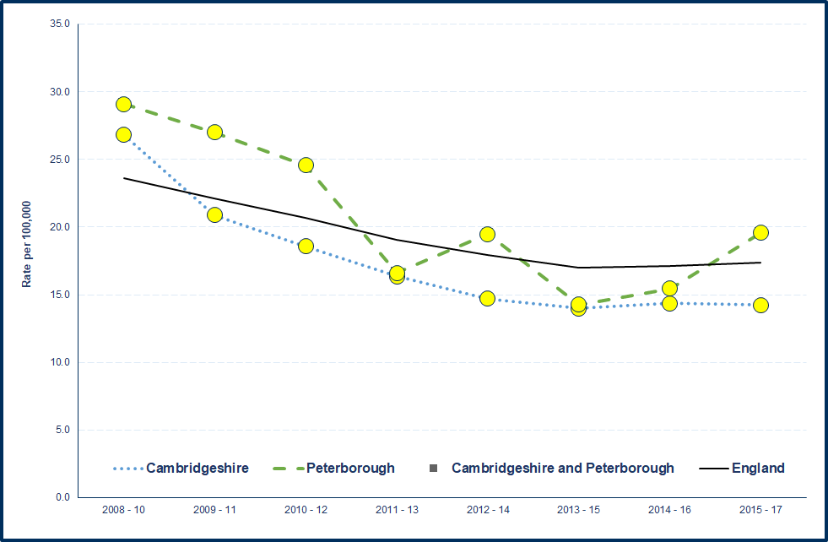

Source: Department for Transport (DfT), from PHE Child Health Profiles (<https://fingertips.phe.org.uk/>)

**Key points – children killed and seriously injured**

* Both Cambridgeshire and Peterborough have statistically similar rates of children killed and seriously injured (KSI) on England’s roads compared to the England average.
* Rates have increased in Peterborough since 2013/15.

1. **Health improvement**
   1. Low birth weight

Table 15: Low birth weight of term babies (under 2,500g) (%), 2017



Source: Office for National Statistics, from PHE Public Health Outcomes Framework (<https://fingertips.phe.org.uk/>)

Figure 10: Low birth weight of term babies (under 2,500g) (%)



Source: Office for National Statistics, from PHE Public Health Outcomes Framework (<https://fingertips.phe.org.uk/>)

**Key points – low birth weight of term babies**

* Cambridgeshire, Peterborough and all the districts have statistically similar percentages of low birth weight full term babies compared to the England average.
* The percentages fluctuate annually but trends have generally remained static over the last 10 years in all areas.
  1. Breastfeeding

Table 16: Breastfeeding initiation - % of all mothers who breastfed their babies in the first 48 hours after delivery, 2016/17



* Value not published for data quality reasons

Source: NHS England, from PHE Public Health Outcomes Framework (<https://fingertips.phe.org.uk/>)

Table 17: Breastfeeding - breastfeeding prevalence at 6-8 weeks after birth - % of all infants due a 6-8 week check that are totally or partially breastfed, 2017/18

Data are not available at District level

Source: Public Health England National Child and Maternal Health Intelligence Network, from PHE Public Health Outcomes Framework (<https://fingertips.phe.org.uk/>).

**Key points - breastfeeding**

* Breastfeeding initiation in Cambridge and Huntingdonshire is statistically significantly higher than the average for England.
* Breastfeeding initiation in Fenland and Peterborough is statistically significantly lower than the England average, with both areas experiencing decreasing trends in recent years.
* Cambridgeshire and Peterborough have statistically significantly high breastfeeding prevalence rates at 6-8 weeks compared to the average for England.
  1. Lifestyles
     1. Smoking

Nationally reported data on smoking status at the time of delivery are based on CCG returns and relate to CCG boundaries. Local authority data provided through the Public Health Outcomes Framework state the same figure for 2017/18 i.e. 11.5% compared to 10.8% for England. Local data are available from the CCG at Trust level for 2017/18, as reported below.

Table 18: smoking status at time of delivery - % of women who smoke at time of delivery, 2017/18





Source: Cambridgeshire and Peterborough CCG Smoking at the time of delivery returns

Table 19: Smoking prevalence at 15 years old - current smokers, regular smokers and occasional smokers, 2014/15



1. Regular smokers (>1 cigarette per week) and occasional smokers (smoke cigarettes sometimes)

2. Regular smokers (>1 cigarette per week)

3. Occasional smokers (<1 cigarette per week)

4. Have ever used/tried electronic cigarettes with the combination of currently, used to and tried e-cigarettes

5."Have you ever used/tried other tobacco products (i.e. shisha pipe, hookah, hubble-bubble, waterpipe etc.?") with the combination of currently, used to use and tried other tobacco products.

Source: What About YOUth (WAY) Survey, from PHE Public Health Outcomes Framework (<https://fingertips.phe.org.uk/>)

**Key points - Smoking**

* Smoking status at the time of delivery is notably higher in Peterborough and Stamford and the Queen Elizabeth Hospitals compared to the others local hospitals.
* Based on data from the What About YOUth Survey, the percentages of 15 year olds that are current smokers and regular smokers are statistically similar to the England average in both Cambridgeshire and Peterborough.
* Peterborough has a statistically significantly high proportion of 15 year olds that have used or tried e-cigarettes.
  + 1. Excess weight in children

Table 20: Overweight (including obese) children, 4-5 years (%), 2017/18



Source: National Child Measurement Programme, NHS Digital from PHE Public Health Outcomes Framework (<https://fingertips.phe.org.uk/>)

Figure 11: Overweight (including obese), 4-5 years (%), 2007/08 to 2017/18



Source: National Child Measurement Programme, NHS Digital from PHE Public Health Outcomes Framework (<https://fingertips.phe.org.uk/>)

Table 21: Overweight (including obese) children, 10-11 years (%), 2017/18



Source: National Child Measurement Programme, NHS Digital from PHE Public Health Outcomes Framework (<https://fingertips.phe.org.uk/>)

Figure 12: Overweight (including obese) children, 10-11 years (%), 2007/08 to 2017/18

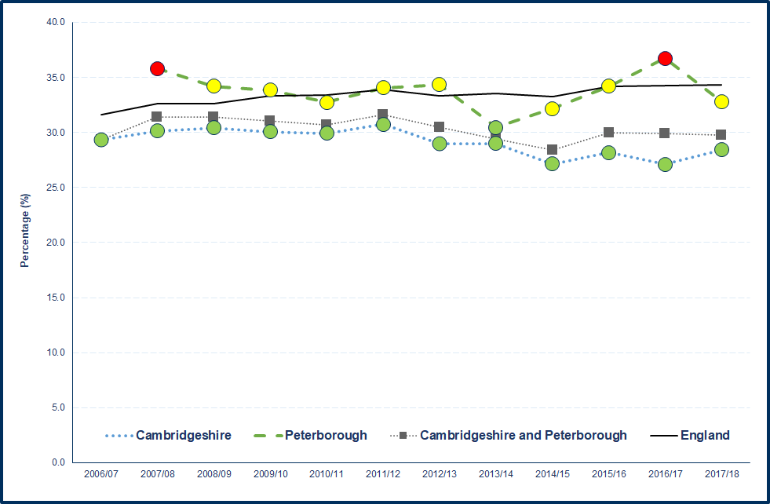

Source: National Child Measurement Programme, NHS Digital from PHE Public Health Outcomes Framework (<https://fingertips.phe.org.uk/>)

* + 1. Childhood obesity

Table 22: Obese children, 4-5 years (%), 2017/18



Source: National Child Measurement Programme, NHS Digital from PHE Public Health Outcomes Framework (<https://fingertips.phe.org.uk/>)

Figure 13: Obese children, 4-5 years (%), 2007/08 to 2017/18



Source: National Child Measurement Programme, NHS Digital from PHE Public Health Outcomes Framework (<https://fingertips.phe.org.uk/>)

Table 23: Obese children, 10-11 years (%), 2017/18



Source: National Child Measurement Programme, NHS Digital from PHE Public Health Outcomes Framework (<https://fingertips.phe.org.uk/>)

Figure 14: Obese children, 10-11 years (%), 2007/08 to 2017/18



Source: National Child Measurement Programme, NHS Digital from PHE Public Health Outcomes Framework (<https://fingertips.phe.org.uk/>)

**Key points – childhood excess weight**

**4-5 year olds - Excess weight**

* Cambridgeshire and all the districts, except Fenland, have statistically significantly low percentages compared to England.
* Fenland and Peterborough have statistically similar percentages to England.
* All areas are experiencing decreasing (positive) trends, with a notable decrease in Peterborough between 2016/17 and 2017/18.

**4-5 year olds - Obesity**

* Cambridgeshire and all the districts have statistically significantly low percentages compared to England.
* Peterborough has a statistically similar percentage to England.
* Cambridge, Fenland, Cambridgeshire and Peterborough are experiencing downward (positive) trends.
* Trends are assessed as being static in East Cambridgeshire, Huntingdonshire and South Cambridgeshire.
* Nationally there is an increasing trend in obesity in 4 to 5 year olds.

**10-11 year olds – Excess weight**

* Cambridgeshire and all the districts, except Fenland, have statistically significantly low percentages compared to England.
* Fenland and Peterborough have statistically similar percentages to England.
* The percentage in Peterborough moved from being statistically significantly higher than England in 2016/17 to being statistically similar in 2017/18.
* Trends are decreasing (positive) in Cambridge, East Cambridgeshire, South Cambridgeshire and Cambridgeshire.
* Trends have remained static in Fenland, Huntingdonshire and Peterborough.
* Nationally there is an increasing trend in excess weight in 10 to 11 year olds.

**10-11 year olds – Obesity**

* Cambridgeshire and all the districts, except Fenland, have statistically significantly low percentages compared to England.
* Fenland and Peterborough have statistically similar percentages compared to England.
* The percentage in Peterborough moved from being statistically significantly higher than England in 2016/17 to being statistically similar in 2017/18.
* Trends are decreasing in South Cambridgeshire and Cambridgeshire.
* Trends are static in Cambridge, East Cambridgeshire, Fenland and Huntingdonshire.
* Trends are increasing in Peterborough and England.
  + 1. Alcohol

Table 24: Admission episodes for alcohol-specific conditions - under 18s crude rate per 100,000, 2015/16 – 2017/18



Source: Calculated by Public Health England: Risk Factors Intelligence (RFI), from PHE Health Profiles (<https://fingertips.phe.org.uk/>)

Figure 15: Admission episodes for alcohol-specific conditions - Under 18s crude rate per 100,000 population, 2006/07 - 2008/09 to 2015/16 - 2017/18



Source: Calculated by Public Health England: Risk Factors Intelligence (RFI) team using data from NHS Digital - Hospital Episode Statistics (HES) and Office for National Statistics (ONS) - Mid Year Population Estimates.

**Key points – alcohol hospital admissions**

* Huntingdonshire has a statistically significantly high alcohol-specific hospital admission rate compared to England, with rates decreasing since 2013/16.
* In the previous time period (2014/17) Cambridge had a statistically significantly high rate compared to England, but this has moved to being statistically similar for the latest time period (2015/18).
* Rates have increased in each time period in South Cambridgeshire, with the latest rate higher, but not significantly higher, than the England rate.
* There was a noticeable reduction in the rate in Peterborough to the latest time period, leading to the area becoming statistically significantly better than England, where previously it had been statistically similar.
  + 1. Substance misuse

Table 25: Hospital admissions due to substance misuse, directly standardised rate per 100,000 population aged 15-24 years, 2015/16 – 2017/18

Data not available at District or Combined Authority level

Source: Hospital Episode Statistics (HES), from PHE Child Health Profiles (<https://fingertips.phe.org.uk/>)

Figure 16: Hospital admissions due to substance misuse, 15-24 years, directly standardised rate per 100,000 population aged 15-24 years, 2008/09 - 2010/11 to 2014/15 – 2017/18



Source: Hospital Episode Statistics (HES), from PHE Child Health Profiles (<https://fingertips.phe.org.uk/>)

**Key points – substance misuse**

* Peterborough has a statistically significantly high hospital admission rate compared to England, with a notable increasing trend.
* There is an overall increasing (worsening) trend in Cambridgeshire, but the latest rate moved from being statistically significantly similar to England in 2014/17 to being statistically significantly lower in 2015/18.
  + 1. Sexual health

Table 26: Chlamydia proportion aged 15-24 years screened (%), 2018



Source: CTAD Chlamydia Surveillance System, from PHE Sexual and Reproductive Health Profiles (https://fingertips.phe.org.uk/)

Table 27: Chlamydia detection rate, crude rate per 100,000 aged 15-24 years, 2018





Source: CTAD Chlamydia Surveillance System, from PHE Sexual and Reproductive Health Profiles (https://fingertips.phe.org.uk/)

**Key points – chlamydia screening and detection**

* Cambridgeshire and all the districts, except Cambridge, have statistically significantly low proportions of 15 to 24 year olds screened for chlamydia compared to England.
* Cambridge and Peterborough have statistically significantly high proportions of chlamydia screening compared to England.
* All areas are experiencing decreasing trends in the proportion of people aged 15 to 24 years screened for chlamydia.
* Cambridgeshire and all the districts have low chlamydia detection rates compared to the nationally set benchmark.
* Peterborough has a high chlamydia detection rate compared to the nationally set benchmark.
* Cambridgeshire, Cambridge and Huntingdonshire have experienced downward trends in chlamydia detection rates over the last 5 years.
* Detection rates have been static in East Cambridgeshire, Fenland, South Cambridgeshire and Peterborough over the last 5 years.

Table 28: Percentage of women aged under 25 choosing long acting reversible contraceptives (LARC) excluding injections as their main method of contraception at Sexual and Reproductive Health Services, 2017

 

Source: NHS Digital, from PHE Sexual and Reproductive Health Profiles and Office for National Statistics

**Key points – long acting reversible contraceptives (LARC)**

* Cambridge, South Cambridgeshire, Cambridgeshire and Peterborough have statistically significantly high percentages of women aged under 25 choosing long acting reversible contraceptives (excluding injections) as their main method of contraception compared to England, all with increasing trends, most notably in Cambridge.
* There was a noticeable decrease in uptake in East Cambridgeshire between 2016 and 2017.

Table 29: Repeat abortions, under 25 year olds (%), 2017

Data not available

at District level

Source: Department of Health, from Sexual and Reproductive Health Profiles (<https://fingertips.phe.org.uk>)

Table 30: Women aged under 25 years having an abortion who have previously had a birth, 2017



Data not available

at District level

Source: Department of Health, from Sexual and Reproductive Health Profiles (<https://fingertips.phe.org.uk>)

Figure 17:Abortion after a birth, under 25 year olds, 2014 to 2017



Source: Department of Health, from Sexual and Reproductive Health Profiles (<https://fingertips.phe.org.uk>)

**Key points – Abortions in under 25 year olds abortions**

* Cambridgeshire has a statistically significantly low percentage of repeat abortions in under 25 year olds compared to England, with a static trend.
* Cambridgeshire has a statistically significantly low percentage of abortions after a birth in under 25 year olds when compared to England.
* Peterborough has a statistically significantly high percentage of abortions after a birth in under 25 year olds when compared to England, with a notable decreasing trend.
  1. Teenage conceptions

Table 31: Under 18 conceptions crude rate per 1,000 females aged 15-17 years, 2017



Source: Office for National Statistics (ONS), from PHE Public Health Outcomes Framework (https://fingertips.phe.org.uk)

Figure 18: Under 18 conceptions crude rate per 1,000 females aged 15-17 years, 1998 to 2017



Source: Office for National Statistics (ONS), from PHE Public Health Outcomes Framework (<https://fingertips.phe.org.uk>)

Table 32: Under 18s conceptions leading to abortion (%), 2017



Source: Office for National Statistics (ONS), from PHE Sexual and Reproductive Health Profiles (<https://fingertips.phe.org.uk>)

Note: Fingertips reports that there are data quality issues for all areas except Huntingdonshire and Peterborough

Table 33: Under 16 conceptions crude rate per 1,000 females aged 13-15 years, 2017

Data not available at District level

*There is a data quality issue with this value.

Source: Office for National Statistics (ONS), from PHE Public Health Outcomes Framework (<https://fingertips.phe.org.uk>)

Note: Fingertips reports that there are data quality issues with Peterborough

Table 34: Teenage mothers, delivery episodes where the mother is aged under 18 years (%), 2017/18

Data not available at District level

Source: Hospital Episode Statistics (HES) Copyright © 2016 from PHE Sexual and Reproductive Health Profiles (<https://fingertips.phe.org.uk>)

Figure 19: Teenage mothers, delivery episodes where the mother is aged under 18 years (%), 2010/11 to 2017/18



Source: Hospital Episode Statistics (HES) Copyright © 2016 from PHE Sexual and Reproductive Health Profiles (<https://fingertips.phe.org.uk>)

**Key points – teenage conceptions, abortions and births**

**Teenage conceptions - under 18 year olds**

* Cambridgeshire and South Cambridgeshire have statistically significantly low teenage conception rates compared to England.
* Peterborough has moved from having a statistically significantly high teenage conception rate in 2016 to having a statistically similar rate in 2017 when compared to England.
* Cambridgeshire, Peterborough and all the districts have experienced downward trends in teenage conception rates over the last 6 years.

**Teenage conceptions - under 16 year olds**

* Cambridgeshire and Peterborough have statistically similar teenage conception rates in under 16 year olds compared to England, with both areas having experienced downward trends over the last 8 years.

**Teenage conceptions leading to abortion – under 18 year olds**

* Cambridgeshire and all the districts have statistically similar rates compared to England.
* Peterborough has a statistically significantly low rate compared to England, with an overall increasing trend.

**Teenage mothers – under 18 year olds**

* Peterborough has a statistically significantly high percentage of teenage mothers compared to England.
* Both Cambridgeshire and Peterborough have experienced overall decreasing trends in the proportion of teenage mothers. However, there was a notable increase in percentages between 2016/17 and 2017/18 in Peterborough, which led to the area becoming statistically significantly higher than England having previously been statistically similar.
  1. Decayed, missing or filled teeth

Table 35: Children with one or more decayed, missing or filled teeth, 5 year olds (%), 2016/17



Data not available

at Combined

Authority or District Level

Source: Dental Public Health Epidemiology Programme for England, from PHE Child and Maternal Health profile (<https://fingertips.phe.org.uk>)

Table 36: Proportion of 5 year olds free from dental decay (%), 2016/17



Source: National Dental Epidemiology Programme for England: oral health survey (based on sample data) of five-year-old children 2015, from PHE Public Health Outcomes Framework (<https://fingertips.phe.org.uk>)

**Key points – decayed, missing or filled teeth and 5 year olds free from dental decay**

* Peterborough has a statistically significantly high proportion of 5 year olds with one or more decayed, missing or filled teeth and a statistically significantly low proportion of 5 year olds free from dental decay compared to England.
* Cambridgeshire and all the districts, except Fenland, have statistically significantly high proportions of 5 year olds free from dental decay compared to England.
* Fenland has a statistically similar proportion compared to England.

1. **Health protection**
   1. Vaccinations and immunisations

Summary table of all childhood vaccinations

Table 37: Diptheria, pertussis, tetanus, Haemophilus influenza type b and polio (Dtap/IPV/Hib), 2017/18



Table 38: Haemophilus influenza type b and meningitis C (Hib/MenC), 2017/18

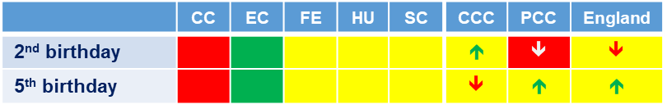

Table 39: Pneumococcal (PCV), 2017/18





Source: Public Health Outcomes Framework, Fingertips, Public Health England (PHE), 2017/18 – based on COVER statistics, NHS Digital. District level based on postcode of practice – PHI derived

Note: as presented in Best Start in Life data pack, based on the location of GP practice, Cambridgeshire County Council and Peterborough City Council

**Key points – vaccinations**

* Dtap/IPV/Hib coverage is generally good at district level, but uptake is decreasing in both age cohorts in Peterborough.
* Hib/MenC uptake is low in Cambridge in both 2 and 5 year olds, and low in 2 year olds in Peterborough, where coverage is decreasing.
* PCV uptake is generally good by first birthday but less so by second birthday, with coverage below 90% in both Cambridge and Peterborough. Trends are increasing in both age cohorts in Cambridgeshire and decreasing in Peterborough.
  + 1. MMR

Table 40: MMR vaccination - % of eligible children who have received one dose of MMR, 2 years old, 2017/18

Data not available

District level



Source: Cover of Vaccination Evaluated Rapidly (COVER) data, from Public Health Outcomes Framework (https://fingertips.phe.org.uk)

Figure 20: MMR vaccination - % of eligible children who have received one dose of MMR, 2 years old, 2010/11 to 2017/18





Source: Cover of Vaccination Evaluated Rapidly (COVER) data, from Public Health Outcomes Framework (https://fingertips.phe.org.uk)

Table 41: MMR vaccination - % of eligible children who have received two doses of MMR, 5 years old, 2017/18

Data not available

at District level



Source: Cover of Vaccination Evaluated Rapidly (COVER) data, from Public Health Outcomes Framework (<https://fingertips.phe.org.uk>)

Figure 21: MMR vaccination - % of eligible children who have received two doses of MMR, 5 years old, 2010/11 to 2017/18



Source: Cover of Vaccination Evaluated Rapidly (COVER) data, from Public Health Outcomes Framework (<https://fingertips.phe.org.uk>)

**Key points - MMR**

* The percentage of eligible children who have received one dose of MMR at 2 years old in Cambridgeshire and Peterborough are within the benchmark of 90% to 95%. Above 95% is the main target.
* There is a decreasing trend in MMR one dose coverage in 2 year olds in Peterborough.
* The percentage of eligible children who have received two doses of MMR at 5 years old in both Cambridgeshire and Peterborough are below 90%. The target is 95%.
* There is an upward trend in coverage in both Cambridgeshire and Peterborough for two doses of MMR at 5 years old.
  + 1. HPV

Table 42: Population vaccination coverage - HPV vaccination coverage for two doses, females aged 13-14 years old, 2017/18

Data not available

at District level



Source: Public Health England (PHE). Public Health England Immunisation, Hepatitis and Blood Safety Department

**Key points - HPV**

* Two dose HPV vaccination coverage in 13-14 years old females in Cambridgeshire and Peterborough are within the benchmark goal of 80% to 90%. The national target is over 90%.
* There was a notable decrease in Peterborough between 2015/16 and 2016/17, which remained static to 2017/18. Coverage in Cambridgeshire has decreased slightly.
  + 1. Children in care immunisations

Table 43: Children in care under 18 years - % of children in care for at least 12 months whose immunisations were up to date, 2018



Data not available at District level

Source: Department for Education (DfE) <https://www.gov.uk/government/collections/statistics-looked-after-children>, PHE Child and Maternal Health Profile, (https://fingertips.phe.org.uk)

Figure 22: Children in care under 18 years - % of children in care for at least 12 months whose immunisations were up to date, 2012 to 2018



Source: Department for Education (DfE) <https://www.gov.uk/government/collections/statistics-looked-after-children>

**Key Points**

**Key points – children in care immunisations**

* The percentage of children in care (for at least 12 months) whose immunisations are up to date in Peterborough is statistically significantly higher than England, with a relatively static trend over the last 6 years.
* The percentage of children in care (for at least 12 months) whose immunisations are up to date in Cambridgeshire is statistically significantly lower than England, with an overall static trend.

1. **Prevention of ill health**
   1. A&E attendances

Table 44: A&E attendances, 0-4 years - A&E attendance rate per 1,000 population aged 0-4 years, 2017/18

Data not available at District level

Source: Hospital Episode Statistics (HES) Copyright © 2018, from PHE Child Health Profiles (https://fingertips.phe.org.uk)

Figure 23: A&E attendances, 0-4 years - A&E attendance rate per 1,000 population aged 0-4 years, 2010/11 to 2017/18



Source: Hospital Episode Statistics (HES) Copyright © 2018, from PHE Child Health Profiles (https://fingertips.phe.org.uk)

**Key points – A&E attendances**

* The A&E attendance rate in children aged 0-4 years is statistically significantly higher in Peterborough than the national average.
* The A&E attendance rate in children aged 0-4 years is statistically significantly lower in Cambridgeshire than the national average.
* There has been a marked upward trend in Peterborough, but rates decreased in 2016/17 and stabilised to 2017/18.
  1. Hospital admissions – unintentional and deliberate injuries

Table 45: Hospital admissions caused by unintentional and deliberate injuries in children, 0-4 years - crude rate per 10,000 resident population aged 0-4 years, 2017/18



Source: Hospital Episode Statistics (HES) Copyright © 2018, from PHE Public Health Outcomes Framework (https://fingertips.phe.org.uk)

Figure 24: Hospital admissions caused by unintentional and deliberate injuries in children, 0-4 years - crude rate per 10,000 resident population aged 0-4 years, 2010/11 to 2017/18



Source: Hospital Episode Statistics (HES) Copyright © 2018, from PHE Public Health Outcomes Framework (https://fingertips.phe.org.uk)

Table 46: Hospital admissions caused by unintentional and deliberate injuries in children, 0-14 years - crude rate per 10,000 resident population aged 0-14 years, 2017/18



.

Source: Hospital Episode Statistics (HES) Copyright © 2018, from PHE Public Health Outcomes Framework (https://fingertips.phe.org.uk)

Figure 25: Hospital admissions caused by unintentional and deliberate injuries in children, 0-14 years - crude rate per 10,000 resident population aged 0-14 years, 2010/11 to 2017/18



Source: Hospital Episode Statistics (HES) Copyright © 2018, from PHE Public Health Outcomes Framework (https://fingertips.phe.org.uk)

**Key points – hospital admission caused by unintentional and deliberate injuries**

**0-4 year olds**

* Cambridgeshire and all the districts, except Huntingdonshire, have statistically significantly low hospital admissions rates for unintentional and deliberate injuries in 0 to 4 year olds compared to England.
* Peterborough and Huntingdonshire have statistically similar rates to England.
* All areas are experiencing downward trends.
* The rate in Fenland moved from being statistically similar to England in 2016/17 to being statistically significantly better in 2017/18.

**0-14 year olds**

* Cambridgeshire, Cambridge, East Cambridgeshire and South Cambridgeshire have statistically significantly low hospital admissions rates for unintentional and deliberate injuries in 0 to 14 year olds compared to England.
* Fenland, Huntingdonshire and Peterborough have statistically similar rates to England.
* All areas, with the exception of Fenland, are experiencing downward trends in admission rates.
* The trend in Fenland is static.
  1. Hospital admissions – asthma, diabetes and epilepsy

Table 47: Hospital admissions for asthma, under 19 years - crude rate per 100,000 population aged 0-18 years, 2017/18

Data not available

at district level

Source: Hospital Episode Statistics (HES) Copyright © 2016, from PHE Child Health Profiles (<https://fingertips.phe.org.uk>)

Figure 26: Hospital admissions for asthma, under 19 years - crude rate per 100,000 population aged 0-18 years, 2011/12 to 2017/18



Source: Hospital Episode Statistics (HES) Copyright © 2016, from PHE Child Health Profiles (<https://fingertips.phe.org.uk>)

Table 48: Unplanned hospitalisation for asthma, diabetes and epilepsy in under 19s (directly standardised rate) population aged 0-18 years, 2014/15

Data only available

at CCG level

Source: Hospital Episode Statistics (HES) Copyright © 2016, from PHE Child Health Profiles (<https://fingertips.phe.org.uk>)

**Key points – hospital admissions for asthma, diabetes and epilepsy**

**Asthma**

* Cambridgeshire has a statistically significantly low rate compared to England.
* Peterborough has a statistically significantly high rate compared to England.
* Both areas have been assessed as having static trends.

**Asthma, diabetes and epilepsy**

* The CCG admission rate for these three conditions combined is similar to the national average, with rates remaining relatively stable over previous 5 years (2010/11 to 2014/15).
  1. Hospital admissions – mental health conditions

Table 49: Hospital admissions for mental health conditions, under 18 year olds - crude rate per 100,000 population aged 0-17 years, 2017/18

Data not available at district level

Source: Hospital Episode Statistics (HES) Copyright © 2016, from PHE Child Health Profiles (<https://fingertips.phe.org.uk>)

Figure 27: Hospital admissions for mental health conditions, under 18 year olds - crude rate per 100,000 population aged 0-17 years, 2010/11 to 2017/18



Source: Hospital Episode Statistics (HES) Copyright © 2016, from PHE Child Health Profiles (<https://fingertips.phe.org.uk>)

**Key points – hospital admissions for mental health conditions**

* Both Cambridgeshire and Peterborough have statistically significantly low rates of hospital admissions for mental health conditions compared to England.
* The overall trend has remained static in both areas over the last 8 years.
  1. Hospital admissions – self-harm

Table 50: Hospital admissions as a result of self-harm, 10-24 years - directly standardised rate per 100,000 resident population aged 10-24 years, 2017/18

Data not available at district level

Source: Hospital Episode Statistics (HES) Copyright © 2016, from PHE Child Health Profiles (<https://fingertips.phe.org.uk>)

Figure 28: Hospital admissions as a result of self-harm, 10-24 years - directly standardised rate per 100,000 resident population aged 10-24 years, 2011/12 to 2017/18



Source: Hospital Episode Statistics (HES) Copyright © 2016, from PHE Child Health Profiles (<https://fingertips.phe.org.uk>)

**Key points – hospital admissions for self-harm**

* Both Cambridgeshire and Peterborough have statistically significantly high rates of hospital admissions as a result of self-harm (10-24 years) compared to the national average.
* Both areas show overall increasing trends.
* Local analysis on self-harm hospital admission rates for 2017/18 showed that Cambridge and East Cambridgeshire had statistically significantly high rates compared to England. Admission rates are highest in young people, especially 15 to 19 year olds, and are higher in females than males. Intentional self-poisoning is the most common reason for self-harm hospital admissions. A small number of patients account for notable frequent admissions.

1. **Premature mortality**
   1. Infant Mortality

Table 51: Infant mortality - rate of deaths in infants aged under 1 year per 1,000 live births, 2015-2017



Source: Office of National Statistics, from PHE Pubic Health Outcomes Framework (https://fingertips.phe.org.uk)

Figure 29: Infant mortality - rate of deaths in infants aged under 1 year per 1,000 live births, 2006-2008 to 2015-2017



Source: Office of National Statistics, from PHE Pubic Health Outcomes Framework (https://fingertips.phe.org.uk)

**Key points – infant mortality**

* Cambridgeshire, Peterborough and all the districts, except East Cambridgeshire, have statistically similar rates compared to England.
* East Cambridgeshire has a statistically significantly low rate compared to England.
* Numbers are relatively small and rates fluctuate but there has generally been an increasing trend in both Cambridge and South Cambridgeshire since 2011-13.
  1. Child Mortality

Table 52: Child mortality in persons aged 1-17 years - directly age-standardised rates (DASR) per 100,000 population, 2015-17

Data not available

at District level

Source: Office of National Statistics, from PHE Child Health Profiles (https://fingertips.phe.org.uk)

Figure 30: Child mortality in persons aged 1-17 years, 2010-12 to 2015-17



Source: Office of National Statistics, from PHE Child Health Profiles (https://fingertips.phe.org.uk)

**Key points – child mortality**

* Child mortality rates in both Cambridgeshire and Peterborough are statistically similar to the England rate.
* There was a notable increase in rates in Peterborough between 2013-15 and 2014-16.

Report prepared by:

Helen Whyman

Public Health Information Analyst

Public Health Intelligence, Cambridgeshire and Peterborough Councils

[phi-team@cambridgeshire.gov.uk](mailto:phi-team@cambridgeshire.gov.uk)

1. **Appendices**
   1. Child Health Profile – Cambridgeshire

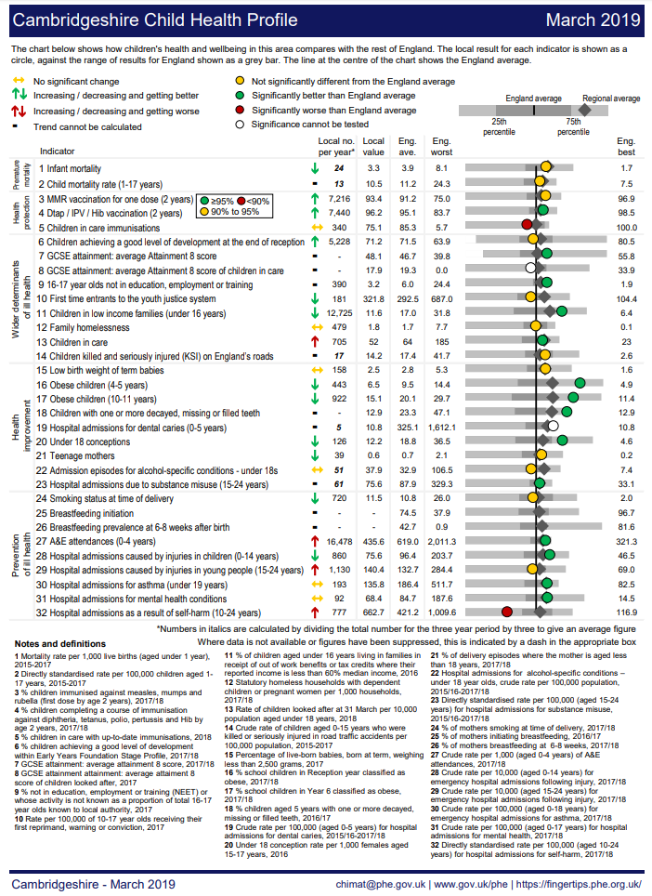

* 1. Child Health Profile – Peterborough

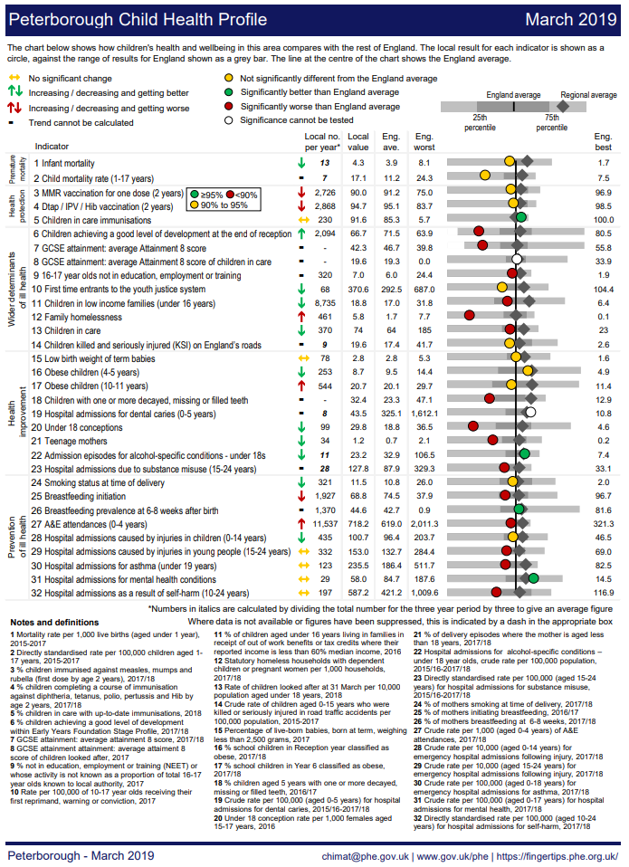

* 1. Cambridgeshire and Peterborough Children’s Outcomes Framework – latest monitoring (March 2019)







1. Child Health Profiles, Public Health England (https://fingertips.phe.org.uk/profile-group/child-health/profile/child-health-overview/area-search-results/E12000006?search_type=list-child-areas&place_name=East%20of%20England)
2. Mid 2015 based population forecasts, 2016 to 2026, Research Group, Cambridgeshire County Council
3. Public Health Outcomes Framework, Public Health England (<https://fingertips.phe.org.uk>) – as at July 2019