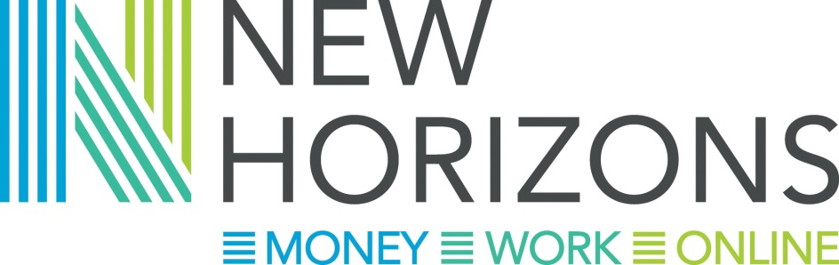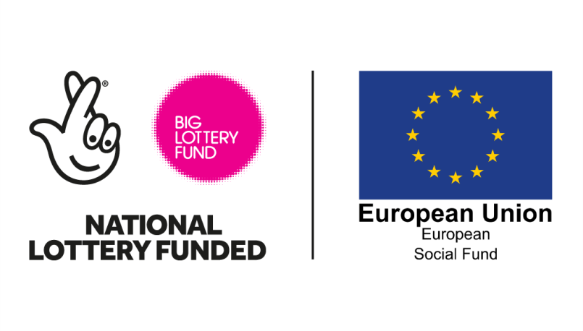

Who we are
We are a partnership of nine organisations across the Greater Cambridge Greater Peterborough Local Enterprise Partnership. We are funded by the Big Lottery and European Social Funding as part of the Building Better Opportunities programme from 2016-19.
The partnership consists of; Axiom Housing Association, Broadland Housing, Centre 33, CHS Group, Citizens Advice Rural Cambridgeshire, Cross Keys Homes, Norfolk Citizens Advice Bureau, Papworth Trust and Cambridge Centre for Housing and Planning Research who are providing action research.

Our aims
We want to help people move closer to the job market by helping them feel more confident and in control of their money, by helping them get on-line and by giving them the tools to be able to look for work. We aim to work with over 350 people across the area to help them:
- improve their work readiness
- move into job search if they are economically inactive
- access training
- have decreased risk of financial pressures and difficulties constraining work related activity
- become more confident and in control of day to day money
- increase their ability to plan ahead for money needs including securing and retaining employment
- have greater confidence and capability to access appropriate support and self- help using a range of channels, including digital.

Who we help
Our core hubs are in Kings Lynn, Wisbech, Cambridge and Peterborough with mobile outreach for disadvantaged groups, including into rural areas. We will aim to offer home visits where needed. Participants must have the right to live and work in the UK, and not be working including permitted work and zero hour contracts.
We will target our services on people who are furthest from the labour market and are at most risk of social exclusion and who:
• are struggling to make ends meet
• have accessed crisis support e.g. foodbanks
• have significant priority debt
• live in households in which no-one works
• will be affected by benefits changes and/or are likely to struggle when Universal Credit is introduced locally.

What we do:
Our New Horizons Coaches working across the partnership can provide:
- Up to 20 hours one to one coaching support on money, getting on-line and work
- Debt remedy services to participants on the project
- The loan of an internet device and free wifi access for a limited amount of time to eligible participants
In addition we are building on the successes of the Making Money Count project in Fenland and developing an expanded website at www.makingmoneycount.org.uk which will include user friendly information on money, work and digital inclusion. The website will also host an interactive ‘map’ outlining other services available in each geographical area around money, work and getting on-line. This will go live in March 2017.
How do I get further information or refer a client?
You can contact the New Horizons Project Manager Lynne McAulay on lynne.mcaulay@chsgroup.org.uk or phone 07590 861337.

EVERYDAY HELP WITH MONEY, GETTING ONLINE AND FINDING WORK

