Peterborough Joint Strategic Needs Assessment Core Dataset

August 2017

Contents

1. Introduction & Purpose 3
2. Executive Summary 4
3. Key Population & Health Statistics in Peterborough 6
4. Geography & Demography 7
5. Relative Deprivation & Wider Determinants of Health 14
6. Lifestyle, Risk Factors and Health and Wellbeing 18
6.1 Smoking 18
6.2 Alcohol 24
6.3 Drug Use 26
6.4 Sexual Health 27
6.5 Physical Activity 28
6.6 Transport and Health 30
6.7 Diet and Healthy Weight 32
7. Levels of Illness and Health and Social Care Services 33
7.1 Long Term Conditions Prevalence 33
7.2 Mental Health & Disability 34
7.3 NHS Hospital Services 37
7.4 Adult Social Care 40
8. Overall Population Health & Causes of Mortality 42
9. Peterborough Joint Strategic Needs Assessment (JSNA) Summary Topic Review 47
9.1 Pharmaceutical Needs Assessment 2015 47
9.2 Children & Young People JSNA 2015 48
9.3 Cardiovascular Disease JSNA 2015 48
9.4 Mental Health & Mental Illness in Adults of Working Age JSNA 2016 49
9.5 Diverse Ethnic Communities JSNA 2016 49
9.6 Older People’s Primary Prevention JSNA 2017 50
10. Sources of Further Information about the Health & Wellbeing of Peterborough’s Population 51

Introduction & Purpose

This document summarises data that comprises the Peterborough Joint Strategic Needs Assessment (JSNA) Core Dataset 2017, as undertaken by Public Health Intelligence at Peterborough City Council in conjunction with other key stakeholders across the local healthcare and adult social care systems.
JSNA is the means by which Local Authorities (LAs) and Clinical Commissioning Groups (CCGs) assess and describe the future health, care and wellbeing needs of the local population and identify the strategic direction of service delivery to meet those needs.
The aim of a JSNA is to:
- Provide analysis of data to show the health and wellbeing status of local communities
- Define where inequalities exist
- Provide information on local community views and evidence of effectiveness of existing interventions which will help to shape future plans for services
- Highlight key findings based on the information and evidence collected
JSNAs analyse the health needs of populations to inform and guide commissioning of health, well-being and social care services within local authority areas. The JSNA process, as outlined in the diagram below, helps identify current and future health and wellbeing needs, leading to agreed commissioning priorities to improve overall healthcare outcomes and reduce health inequalities.
Figure 1: The Joint Strategic Needs Assessment Process
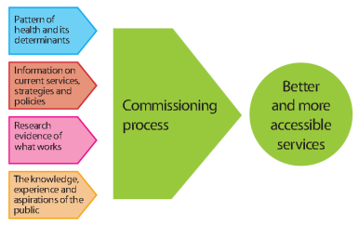
Source: Peterborough City Council Public Health
This JSNA core dataset summarises key information relating to the population of Peterborough and the healthcare service needs and outcomes of its residents, including data relating to demographics, wider socio-economic determinants of health, disease/illness prevalence and associated risk factors and health and social care utilisation. This document forms a companion piece to the 2017 Peterborough JSNA Summary document, which provides more detailed information on themed JSNAs commissioned by the Peterborough Health & Wellbeing Board since 2014, including:
- Pharmaceutical Needs Assessment 2015
- Children & Young People JSNA 2015
- Cardiovascular Disease JSNA 2015
- Mental Health & Mental Illness in Adults of Working Age JSNA 2016
- Diverse Ethnic Communities JSNA 2016
- Older People’s Primary Prevention JSNA 2017

A summary of key findings from the projects is contained within section 9 of this report, beginning on page 47.

Executive Summary

Demography
- Peterborough is one of the fastest growing cities in the UK, with an ethnically diverse, relatively young population. Peterborough is also one of the more deprived areas in the East of England and this contributes to a number of adverse healthcare outcomes in the area.
- Deprivation and healthcare outcomes vary substantially between different areas of Peterborough, with poor healthcare outcomes observed in Peterborough's urban, relatively deprived central areas and better outcomes seen in the rural, outer areas of the city.
- The population of Peterborough increased by 1.6%, from 193,530 to 196,640, between 2014 and 2015, an increase of 3,110 residents. By 2036, the population is estimated to increase to 240,830 residents, which would represent an increase of 24.4% from the 2014 population figure. Future population growth is expected to be highest in the new Great Haddon development and existing areas such as Hargate and Hempsted, Gunthorpe and Central
- The Black & Minority Ethnic (BME) population in Peterborough varies significantly between electoral wards, comprising 2.3% of the total population of Barnack but 58.2% of Central at the time of the 2011 census. Deprivation tends to be higher in areas of Peterborough with higher BME populations. Peterborough has experienced substantial migration from countries that joined the European Union as part of its 2004 enlargement, such as Estonia, Latvia, Lithuania & Poland - the 2015 school census shows that 35.1% of pupils in Peterborough speak a primary language other than English at home

Life Expectancy & Mortality

- Life expectancy at birth in Peterborough is 78.6 years for males and 82.4 years for females; both of these indicators are statistically significantly worse than the England averages of 80.3 years for males and 83.7 years for females. Healthy life expectancy is below that of England for both males (61.8 years compared to 63.4 years) and females (62.4 years compared to 65.5 years)
- Under 75 mortality rates in Peterborough are statistically significantly worse for both males and females. Circulatory diseases are estimated to contribute towards approximately 33.6% of the life expectancy gap between Peterborough and England for males and 53.9% for females. If Peterborough had the same mortality rates as England for circulatory diseases, local life expectancy would increase 0.45 years for males and 0.43 years for females
- Peterborough has statistically significantly higher rates of mortality for both all ages and under 75s only than neighbouring Cambridgeshire for all causes and a number of specific causes including circulatory diseases, cancer and respiratory diseases.

Mental Health

- Many of the recognised risk factors for poor mental health are found at a higher rate in Peterborough than in England, including higher rates of socio-economic deprivation, numbers of children in care, incidents of violent crime, the rate of homelessness and prevalence of substance abuse. Prevalence of conditions such as depression and anxiety as well as long-term mental health conditions have risen in recent years in Peterborough, in line with increases observed across England. However, suicide rates in Peterborough have fallen consistently over the most recent three year periods for which data is available, and are similar to the national average.
Lifestyle risk factors
- Smoking prevalence has fallen relatively consistently in Peterborough over the past few years and in 2016 is 17.6% compared to 15.5% in England, which is a statistically similar rate. However, Peterborough has statistically significantly high rates of smoking-attributable hospital admissions and it is estimated that between 2013 and 2015, over 4,000 years of life were lost among Peterborough residents as a result of mortality from smoking related illnesses
- Rates of alcohol-specific mortality in Peterborough are similar to those of England, but rates of admission to hospital as a result of alcohol-specific conditions are statistically significantly worse than England and among the worst among Peterborough's nearest socio-economic neighbours
- The percentage of children with an unhealthy weight has remained similar to the national average, but the percentage of adults with an unhealthy weight is significantly higher than the national average at 70.8% compared to 64.8%.

Utilisation of services

- The directly age-standardised rate of inpatient hospital admissions in Peterborough has fallen marginally in recent years and is now similar to that of neighbouring Cambridgeshire. However, emergency admission rates in Peterborough for all ages, under 75s only and over 75s only have been statistically significantly higher (worse) than Cambridgeshire for each of the five consecutive years 2011/12 - 2015/16. By contrast, elective admission rates in Peterborough for all ages, under 75s only and over 75s only are statistically significantly lower (better) than Cambridgeshire in 2015/16.
- Rates of A&E attendance have risen in each of the four consecutive years 2012/13 - 2015/16 and are statistically significantly higher (worse) than Cambridgeshire. Since the opening of Peterborough's Minor Illness & Injury Unit in 2013, attendances for minor injuries have increased substantially and Peterborough had a greater number of MIU attendances than Cambridgeshire in both 2014/15 and 2015/16 despite having a notably smaller overall population.
- Peterborough has a statistically significantly lower (better) rate of adults aged 18-64 and 65+ having their long-term support needs met by admission to residential and nursing care homes than the average of its CIPFA comparator group and England. The rate of delayed transfers of care attributable to adult social care is also statistically significantly better than Peterborough's CIPFA group and England. However, only 33.4% of Peterborough carers receive direct payments which is statistically significantly lower than Peterborough’s CIPFA group and England and has decreased from 2014/15

Key Population & Health Statistics in Peterborough

Figure 2: Key Population & Health Statistics in Peterborough
Indicator |  |  | Source | Peterborough |  | East of England |  | England |  | CIPFA ranking (1= Best, 16=Worst)
 |  |  |  | Number | % | Number | % | Number | %
Population | Population estimates | Children (under 16 years) | 1 | 44,400 | 23% | 1,174,000 | 19% | 10,529,100 | 19% | -
 |  | Working age (16-64 years) | 1 | 124,200 | 63% | 3,772,200 | 62% | 34,856,100 | 63% | -
 |  | Older people (age 65+) | 1 | 28,400 | 14% | 1,184,400 | 19% | 9,882,800 | 18% | -
 |  | Total | 1 | 197,100 | 100% | 6,130,500 | 100% | 55,268,100 | 100% | -
 | Population forecasts % change 2014 to 2021 | Children (under 16 years) | 2 | 49,200 | 10.8% | - | - | - | - | -
 |  | Working age (16-64 years | 2 | 139,100 | 12.0% | - | - | - | - | -
 |  | Older people (age 65+) | 2 | 31,200 | 9.9% | - | - | - | - | -
 |  | Total | 2 | 219,600 | 11.4% | - | - | - | - | -
LE | Life Expectancy | Male (years) | 3 | 78.6 | - | 80.3 | - | 79.5 | - | 6
 |  | Female (years) | 3 | 82.4 | - | 83.7 | - | 83.1 | - | 6
 | Healthy Life Expectancy | Male (years) | 3 | 61.8 | - | 64.8 | - | 63.4 | - | 7
 |  | Female (years) | 3 | 62.4 | - | 65.5 | - | 64.1 | - | 6
Lifestyles | Smoking | All (%) | 4 | - | 17.6 | - | 14.4 | - | 15.5 | 8
 |  | Routine and manual (%) | 4 | - | 27.9 | - | 26.6 | - | 26.5 | 10
 | Excess weight (% overweight and obese) | Children aged 4-5 years (%) | 5 | - | 22.8 | - | 20.9 | - | 22.1 | 13
 |  | Children 10-11 years (%) | 5 | - | 34.2 | - | 31.7 | - | 34.2 | 5
 |  | Adults (%) | 6 | - | 70.8 | - | 65.6 | - | 64.8 | 14
 | Physical Activity | Recommended level (%) | 7 | - | 54.7 | - | 57.8 | - | 57.0 | 10
 | Alcohol | Hospital admissions - male (directly age-standardised rate per 100,000) | 8 | 939 | - | 730 | - | 830 | - | 12
 |  | Hospital admissions -female (directly age-standardised rate per 100,000) | 8 | 491.0 | - | 483 | - | 483.0 | - | 9
 | Teenage conceptions | Under 18 years (crude rate per 1,000) | 9 | 28.3 | - | 18.8 | - | 20.8 | - | 14
Mortality | All age all cause mortality | Male (directly age-standardised rate per 100,000) | 10 | 1,190.3 | - | 1068.6 | - | 1,138.0 | - | -
 |  | Female (directly age-standardised rate per 100,000) | 10 | 890.8 | - | 797.5 | - | 838.1 | - | -
 | Premature mortality (under 75 years) | Male (directly age-standardised rate per 100,000) | 10 | 457.8 | - | 365.7 | - | 410.5 | - | -
 |  | Female (directly age-standardised rate per 100,000) | 10 | 293.0 | - | 245.7 | - | 267.7 | - | -

Sources:
Source Number | Source | Source Number | Source
1 | 2016 mid-year population estimates, ONS | 6 | Adult excess weight statistics, 2013-15, Public health Outcomes Framework
2 | 2013 mid-year population forecasts, Research & Performance Team, Cambridgeshire County Council | 7 | Adult physical activity statistics, 2015, Public Health Outcomes Framework
3 | Life expectancy indicators 2013-15, Public Health Outcomes Framework | 8 | Alcohol admissions statistics, 2015-16, Public Health Outcomes Framework
4 | Smoking statistics (APS) 2016, Public Health Outcomes Framework | 9 | Teenage conceptions statistics, 2015, Public Health Outcomes Framework
5 | Childhood excess weight statistics, 2015-16, Public Health Outcomes Framework | 10 | Mortality statistics, 2012-14, NHS Digital

Peterborough has a higher percentage of residents aged under 16 years (23%) than the East of England (19%) and England (19%) and conversely a lower percentage of residents aged 65+ (14% compared to 19% in the East of England and 18% in England). The total population of the area is forecast to increase 11.4% between 2014 and 2021, reaching 219,600.
Average life expectancy in Peterborough is statistically significantly low in comparison to England for both males and females. Healthy life expectancy - the average number of years a person would expect to live in good health is now statistically similar to both the East of England and England.
Smoking rates in Peterborough are statistically similar to, those of England. 70.8% of Peterborough residents have excess weight which is statistically significantly higher than the national average of 64.8%.
It is of note that Peterborough is statistically significantly worse than England for directly age-standardised rate of under 75 mortality (male and female), all age, all-cause mortality (females only), teenage conception rate and hospital admissions as a result of alcohol (males only); the East of England collectively is statistically significantly better than England for all of these indicators.

Geography & Demography

Figure 3: Peterborough Unitary Authority Electoral Ward Boundaries, 2016-Present
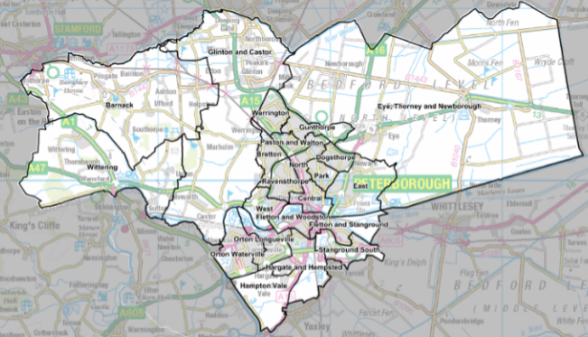
© Crown copyright and database rights, 2017, Ordnance Survey 1000023205
Peterborough is a Unitary Authority in the East of England which, as of 2016, is comprised of 22 electoral wards (previously 24), as shown within the map above. Peterborough has a densely populated urban centre and some rural areas towards its outer boundaries; general health and healthcare outcomes vary significantly between different areas of Peterborough.
Peterborough was ranked by the 2017 Centre for Cities report ‘Cities Outlook 2017’ as the fourth-fasted growing city in the UK, behind only Exeter, Coventry and Cambridge, and has been one of the fastest growing cities in the UK for a number of years.
Figure 4: Cambridgeshire Research Group Mid-year Population Estimates, Peterborough, 2011-2015

Source: Cambridgeshire Research Group
Cambridgeshire Research Group mid-year population estimates show a consistent year-on-year increase between 2011 and 2015, with an increase to 196,640 in 2015.
Figure 5: 2014-15 Estimated Population Growth, Peterborough & Cambridgeshire
Area | Population
 | 2014 | 2015 | % Change 14-15
Peterborough | 193,530 | 196,640 | 1.6%
Cambridge City | 130,250 | 132,130 | 1.4%
East Cambridgeshire | 85,740 | 86,300 | 0.7%
Fenland | 97,880 | 99,170 | 1.3%
Huntingdonshire | 174,540 | 176,050 | 0.9%
South Cambridgeshire | 152,350 | 154,660 | 1.5%
Cambridgeshire | 640,760 | 648,310 | 1.2%
Peterborough & Cambridgeshire | 834,290 | 844,950 | 1.3%
Source: Cambridgeshire Research Group
Data from the Cambridgeshire Research Group suggests that the population of Peterborough increased by 1.6%, from 193,530 to 196,640, between 2014 and 2015. The observed increase is 3,110 residents. This represents a higher increase in population in percentage terms than neighbouring Cambridgeshire, where growth is estimated to be 1.2%.

Figure 6: 2014-15 Estimated Population Growth, Peterborough Electoral Wards
Electoral Ward | Population
 | 2014 | 2015 | % Change 14-15 | Rank of % Change 14-15
Barnack | 3,020 | 3,090 | 2.3% | 5
Bretton | 9,780 | 9,830 | 0.5% | 21
Central | 11,010 | 11,300 | 2.6% | 3
Dogsthorpe | 10,000 | 10,060 | 0.6% | 20
East | 10,210 | 10,430 | 2.2% | 6
Eye, Thorney and Newborough | 8,810 | 8,870 | 0.7% | 18
Fletton and Stanground | 9,480 | 9,730 | 2.6% | 2
Fletton and Woodston | 10,450 | 10,620 | 1.6% | 12
Glinton and Castor | 6,490 | 6,530 | 0.6% | 19
Gunthorpe | 8,640 | 8,820 | 2.1% | 8
Hampton Vale | 6,360 | 6,510 | 2.4% | 4
Hargate and Hempsted | 6,130 | 6,260 | 2.1% | 7
North | 10,550 | 10,710 | 1.5% | 14
Orton Longueville | 11,190 | 11,350 | 1.4% | 16
Orton Waterville | 9,890 | 10,080 | 1.9% | 9
Park | 10,780 | 10,890 | 1.0% | 17
Paston and Walton | 10,920 | 11,110 | 1.7% | 10
Ravensthorpe | 11,080 | 11,270 | 1.7% | 11
Stanground South | 7,870 | 8,160 | 3.7% | 1
Werrington | 11,040 | 11,210 | 1.5% | 13
West | 6,080 | 6,170 | 1.5% | 15
Wittering | 3,770 | 3,660 | -2.9% | 22
Total | 193,530 | 196,640 | 1.6% | -
Source: Cambridgeshire Research Group
The table above shows estimated population growth between 2014 and 2015 for electoral wards within Peterborough. In percentage terms, population growth was highest in Stanground South, Fletton and Stanground and Central and lowest in Wittering, Bretton and Dogsthorpe, with Wittering the only area to see a reduction in observed population.
Figure 7: Cambridgeshire Research Group Population Growth Estimates, 2016 – 2036, Peterborough by Age Band
Local Authority | Year | 0-4 | 5-14 | 15-24 | 25-44 | 45-64 | 65-74 | 75-84 | Over 85 | Total | 16-64 | 18-64
Peterborough – Observed Population Growth 2016-36 | 2016 | 15,700 | 27,520 | 22,700 | 57,670 | 45,950 | 15,560 | 9,130 | 3,900 | 198,130 | 123,880 | 119,160
 | 2021 | 16,300 | 31,020 | 24,310 | 62,770 | 49,450 | 17,550 | 10,360 | 4,700 | 216,420 | 133,810 | 128,660
 | 2026 | 17,100 | 32,120 | 26,900 | 65,370 | 52,450 | 18,750 | 13,050 | 5,800 | 231,520 | 141,510 | 135,340
 | 2031 | 17,000 | 32,720 | 28,200 | 64,270 | 54,450 | 21,250 | 14,850 | 7,500 | 240,220 | 143,790 | 137,590
 | 2036 | 16,200 | 31,920 | 27,300 | 61,470 | 55,150 | 22,650 | 16,050 | 10,100 | 240,830 | 140,750 | 134,560
Peterborough - % Growth 2016-2036 | - | 3.2% | 16.0% | 20.3% | 6.6% | 20.0% | 45.6% | 75.8% | 159.0% | 21.6% | 13.6% | 12.9%
Source: Cambridgeshire Research Group
Cambridgeshire Research Group population growth estimates suggest overall growth in Peterborough between 2016 and 2036 will be 12.9%, from 198,130 to 240,830 residents. Growth is anticipated to be highest among older age groups, with predicted increases of 159.0% in over 85s, 75.8% in the 75-84 age group and 45.6% in residents 65-74.

Figure 8: Cambridgeshire Research Group Population Growth Estimates, 2016-36, Peterborough Electoral Wards
Electoral Ward | 2016 | 2021 | 2026 | 2031 | 2036 | Numerical Increase 2016-36 | % Increase 2016-36 | Rank of Numerical Increase 2016-36 | Rank of % Increase 2016-36
Barnack | 3,090 | 3,230 | 3,290 | 3,290 | 3,270 | 180 | 5.8% | 16 | 14
Bretton | 9,850 | 10,340 | 10,490 | 10,430 | 10,330 | 480 | 4.9% | 14 | 15
Central | 11,540 | 13,230 | 14,540 | 14,580 | 14,450 | 2,910 | 25.2% | 4 | 3
Dogsthorpe | 10,020 | 10,630 | 10,850 | 10,750 | 10,610 | 590 | 5.9% | 12 | 13
East | 10,570 | 11,660 | 11,930 | 12,170 | 12,740 | 2,170 | 20.5% | 5 | 7
Eye, Thorney and Newborough | 9,030 | 9,970 | 10,430 | 10,450 | 10,410 | 1,380 | 15.3% | 9 | 9
Fletton and Stanground | 9,980 | 10,740 | 11,360 | 11,440 | 11,480 | 1,500 | 15.0% | 8 | 10
Fletton and Woodston | 10,580 | 10,960 | 11,510 | 11,470 | 11,390 | 810 | 7.7% | 11 | 12
Glinton and Castor | 6,520 | 6,670 | 6,770 | 6,770 | 6,760 | 240 | 3.7% | 15 | 16
Gunthorpe | 9,010 | 10,430 | 13,310 | 16,200 | 16,160 | 7,150 | 79.4% | 3 | 2
Hampton Vale | 6,580 | 8,350 | 8,650 | 8,440 | 8,210 | 1,630 | 24.8% | 7 | 4
Great Haddon | 0 | 1,760 | 5,090 | 9,520 | 12,770 | 12,770 | - | 1 | -
Hargate and Hempsted | 6,580 | 11,000 | 13,990 | 16,330 | 15,800 | 9,220 | 140.1% | 2 | 1
North | 10,730 | 10,750 | 10,800 | 10,680 | 10,530 | -200 | -1.9% | 19 | 19
Orton Longueville | 11,300 | 11,200 | 11,090 | 10,940 | 10,760 | -540 | -4.8% | 23 | 23
Orton Waterville | 10,110 | 10,770 | 11,330 | 11,230 | 10,980 | 870 | 8.6% | 10 | 11
Park | 10,870 | 10,770 | 11,060 | 10,910 | 10,710 | -160 | -1.5% | 18 | 18
Paston and Walton | 11,060 | 10,970 | 10,890 | 10,720 | 10,540 | -520 | -4.7% | 22 | 22
Ravensthorpe | 11,210 | 11,130 | 11,760 | 11,720 | 11,320 | 110 | 1.0% | 17 | 17
Stanground South | 8,560 | 10,770 | 11,090 | 10,880 | 10,660 | 2,100 | 24.5% | 6 | 5
Werrington | 11,150 | 11,040 | 11,070 | 10,990 | 10,760 | -390 | -3.5% | 21 | 21
West | 6,140 | 6,100 | 6,070 | 6,020 | 5,940 | -200 | -3.3% | 19 | 20
Wittering | 3,640 | 3,960 | 4,180 | 4,330 | 4,230 | 590 | 16.2% | 12 | 8
Total | 198,120 | 216,430 | 231,550 | 240,260 | 240,810 | 42,690 | 21.5% | - | -
Source: Cambridgeshire Research Group
Population growth in Peterborough between 2016 and 2036 is expected to be highest in numerical terms in the Great Haddon development to the south of the area, which has yet to commence but is expected to have 12,770 residents by 2036. The population of Hargate and Hempsted is predicted to rise by 9,220 residents (140.1%) over this period and in Gunthorpe, the population is predicted to increase by 7,150 residents (79.4%). In percentage terms, excluding the Great Haddon development which is yet to commence, population increases are forecast to be highest in Hargate and Hempsted, Gunthorpe and Central.
The map below shows future planned major development sites within the newly-formed Cambridgeshire & Peterborough Combined Authority and illustrates the above-referenced significant rise in dwelling stock in Peterborough over coming years, particularly in the Great Haddon area. The draft Local Plan for Peterborough also includes a housing target of 27,625 by 2036 (an increase of 35.9%), an additional 22,024 jobs within the same period and an increase in Gross Value Added of £6,452.7 million by 2031, an increase of 35.3%.

Figure 9: Major Development Sites – Cambridgeshire & Peterborough Combined Authority
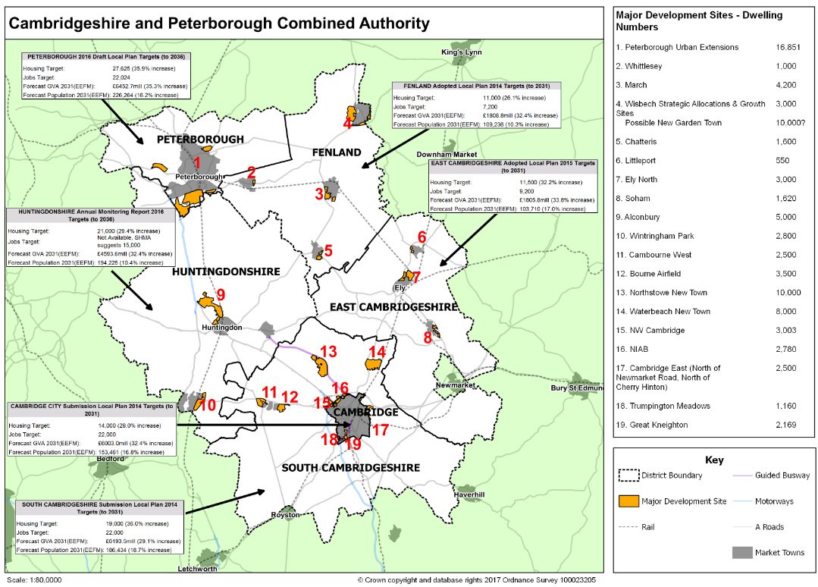
© Crown Copyright and database rights, 2017 Ordnance Survey 100023205
Figure 10: Components of Population Change in Peterborough, 2011-15
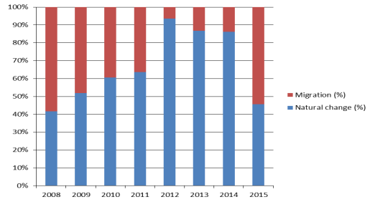
Source: Office for National Statistics mid-year components of change
Population change is driven by two main components: natural change (the balance of births and deaths) and net migration (the balance of the number of people leaving and arriving in an area). The figure above shows that natural change (a greater number of births than deaths) has been the primary component in population change in Peterborough for a number of years, although migration has increased substantially as a determinant in 2015, contributing at its highest level since around 2008.

Figure 11: Births & Deaths in Peterborough, 2009-2015

Births and deaths in Peterborough, 2009-2015 | 2009 | 2010 | 2011 | 2012 | 2013 | 2014 | 2015
Births | 2,950 | 3,080 | 3,130 | 3,270 | 3,210 | 3,130 | 3,170
Deaths | 1,430 | 1,380 | 1,420 | 1,480 | 1,450 | 1,350 | 1,560
Overall Natural Change | 1,520 | 1,700 | 1,710 | 1,790 | 1,760 | 1,780 | 1,610
Source: Office for National Statistics
Office for National Statistics (ONS) data show that the number of births in Peterborough has been higher than the number of deaths in each year between 2009 and 2015, although the ‘overall natural change’ value – the difference between the number of recorded births and deaths in the local authority – is lower in 2015, at 1,610, than it has been in any year since 2009, due to a relative decrease in births and increase in deaths.

Figure 12: Estimated Rate of non-UK Born Population, crude rate per 1,000 of Total Population, Peterborough, Cambridgeshire & Cambridgeshire Districts 2010-2014
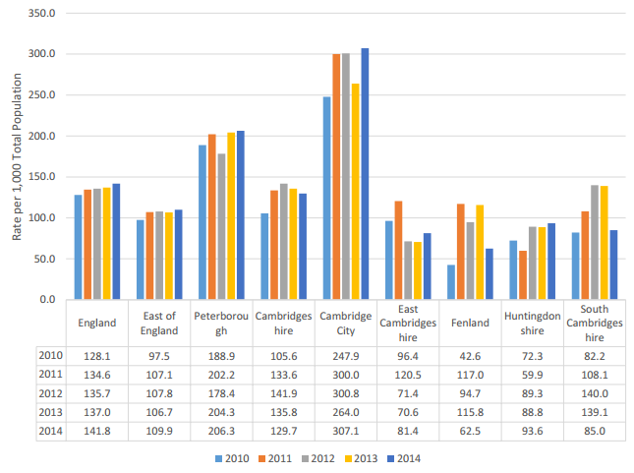
Source: Office for National Statistics

The estimated crude rate of non-UK born population in Peterborough is second only to Cambridge City among areas within the table above in each of the years 2010 – 2014. 206 of every 1,000 residents in Peterborough in 2014 were born outside of the UK, compared to an estimated 110/1,000 in the East of England and 142/1,000 in England.

Figure 13: Overseas National Insurance Number Registrations in Peterborough, 2010/11 – 2014/15 (rounded to nearest 10)
National Insurance Number registrations in Peterborough, 2010/11 - 2014/15 (Rounded to Nearest 10) | 2010/11 | 2011/12 | 2012/13 | 2013/14 | 2014/15 | Total
European Union EU15 Member States (Austria, Belgium, Denmark, Finland, France, Germany, Greece, Ireland, Italy, Luxembourg, Netherlands, Portugal, Spain, Sweden, (group also includes United Kingdom)) | 370 | 390 | 500 | 590 | 770 | 2,620
European Union Accession Member States (Czech Republic, Estonia, Hungary, Latvia, Lithuania, Poland, Slovakia, Slovenia) | 3,560 | 2,920 | 3,010 | 2,630 | 3,400 | 15,520
Other European | 40 | 20 | 30 | 30 | 30 | 150
Africa | 160 | 110 | 70 | 110 | 130 | 580
Asia & Middle East | 680 | 510 | 360 | 360 | 360 | 2,270
The Americas | 30 | 20 | 30 | 40 | 60 | 180
Australasia & Oceania | 20 | 20 | 20 | 10 | 20 | 90
Other | 10 | 10 | 0 | 10 | 10 | 40
Total | 4,860 | 4,000 | 4,020 | 3,790 | 4,780 | 21,450
Source: Department for Work & Pensions
The greatest number of national insurance registrations in Peterborough between 2010/11 – 2014/15 from overseas has been from ‘EU Accession Member States’ – primarily Eastern European countries that acceded to European Membership in 2004. Economic migration from these countries accounts for 15,520 or 21,450 overseas national insurance registrations over the period 2010/11 – 2014/15 – 72.4% of the total. Migration from EU15 member states and areas of Asia and the Middle East account for 4,890 NINO registrations, 22.8% of the total.
Peterborough has an ethnically diverse population which brings a richness of cultural experience and heritage to the area. The following table indicates the percentage of black and ethnic minority residents living in each area and shows some correlation between ethnicity and living in an area experiencing higher socio-economic deprivation.
Figure 14: Percentage of Black & Minority Ethnic (BME) Residents & 2015 Index of Multiple Deprivation Scores, Peterborough Electoral Wards
Electoral Ward (Pre-Boundary Change) | 2011 % BME (Census Data) | IMD 2015
Northborough | 2.3 | 10.1
Barnack | 2.7 | 9.8
Glinton and Wittering | 2.8 | 10.1
Newborough | 4.7 | 17.2
Werrington South | 4.9 | 10.6
Eye and Thorney | 5.0 | 20.8
Stanground Central | 6.9 | 24.0
Orton Waterville | 7.2 | 17.9
Werrington North | 7.4 | 17.4
Walton | 8.2 | 25.9
Stanground East | 8.3 | 25.4
Paston | 9.6 | 36.9
Orton Longueville | 10.1 | 40.5
Fletton and Woodston | 11.5 | 23.5
Bretton North | 12.4 | 39.0
Orton with Hampton | 14.0 | 14.5
Bretton South | 14.8 | 27.7
Dogsthorpe | 18.4 | 40.7
North | 23.0 | 42.4
East | 26.8 | 37.6
West | 29.5 | 15.3
Ravensthorpe | 30.8 | 42.2
Park | 35.8 | 26.0
Central | 58.2 | 45.8
Peterborough | 17.5 | 27.7
England | 14.6 | 21.8
Source: 2011 Census & 2015 Indices of Multiple Deprivation
Key:
Higher than Peterborough average
Lower than Peterborough average

Relative Deprivation & Wider Determinants of Health

Peterborough is one of the more socio-economically deprived areas in the East of England, with an Index of Multiple Deprivation (IMD) 2015 score of 27.7. The IMD assesses relative deprivation in relation to a number of ‘domains’, including income (including income deprivation specifically affecting children and older people), employment, educations, skills and training, health and disability, crime, housing and services and the living environment. Higher scores represent higher levels of relative deprivation and Peterborough’s score of 27.7 is the highest within the East of England.

Figure 15: Index of Multiple Deprivation (IMD) Scores 2015, Local Authorities within the East of England
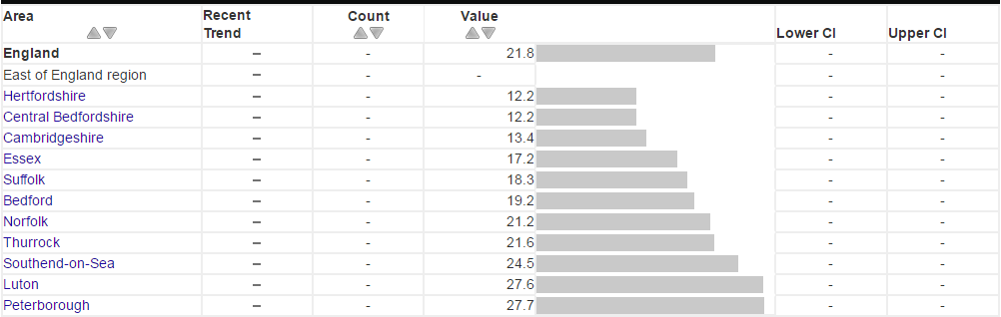
Source: Department of Communities and Local Government (DCLG) within Public Health Outcomes Framework

Figure 16: Peterborough Lower Super Output Areas (LSOAs) by IMD 2015 Score with Electoral Ward Boundaries
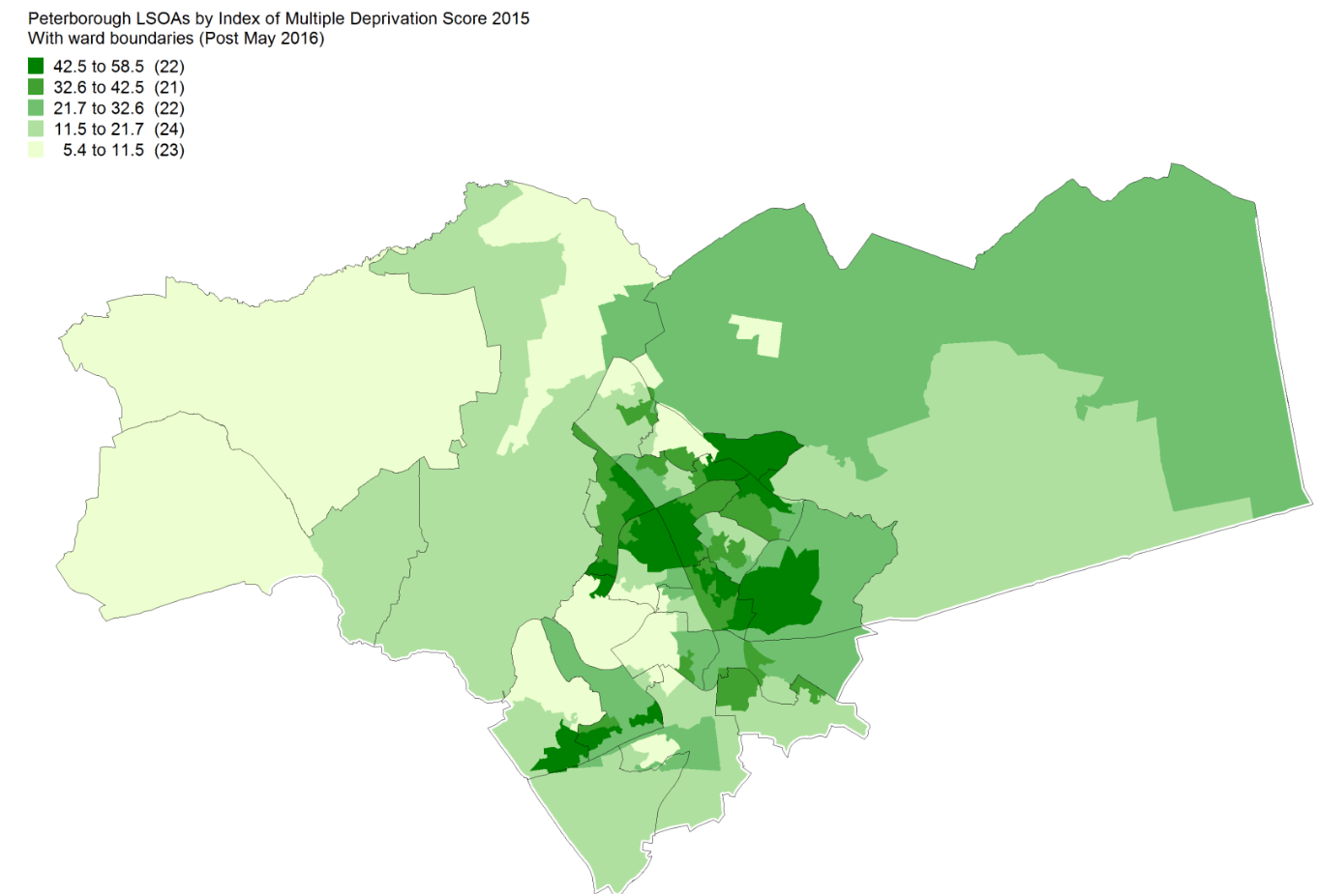
© Crown copyright and database rights 2017, Ordnance Survey 100023205
The map above shows IMD scores for all Lower Super Output Areas (LSOAs – small geographical populations of approximately 1,500 residents) in Peterborough and illustrates that deprivation varies substantially across the city. Areas towards the urban centre of Peterborough, primarily within electoral wards such as Central, North, Dogsthorpe and Ravensthorpe, are among the most deprived within the city, whereas rural, outer areas have less deprivation.
Figure 17: Proportion of Lower Super Output Areas (LSOAs) in Peterborough within National Deciles by Individual Index of Multiple Deprivation 2015 Sub-domains
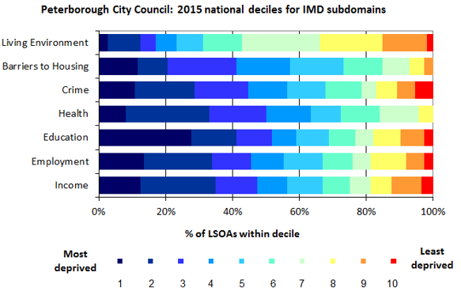
Source: Peterborough Public Health Intelligence/Index of Multiple Deprivation, Department for Communities & Local Government (DCLG)
Peterborough has high percentages of LSOAs within the most deprived national deciles for a number of Index of Multiple Deprivation subdomains.
Sir Michael Marmot’s 2010 report ‘Fair Society, Healthy Lives’ suggests that improving population health requires focus on reducing inequalities across a number of areas, including educational attainment and employment/income. The report estimated that the annual cost of health inequalities in the UK is between £36 billion and £40 billion through lost taxes, welfare payments and costs to the NHS. A number of ‘Marmot Indicators’ have subsequently been adopted by Public Health England as measures of wider determinants that affect healthcare outcomes. Peterborough’s status with regards to some of these key indicators is noted below.
Figure 18: Percentage of pupils achieving a ‘good level of development’ at end of Early Years Foundation Stage in Peterborough by LSOA with 2016 – Present Electoral Ward Boundaries, 2016
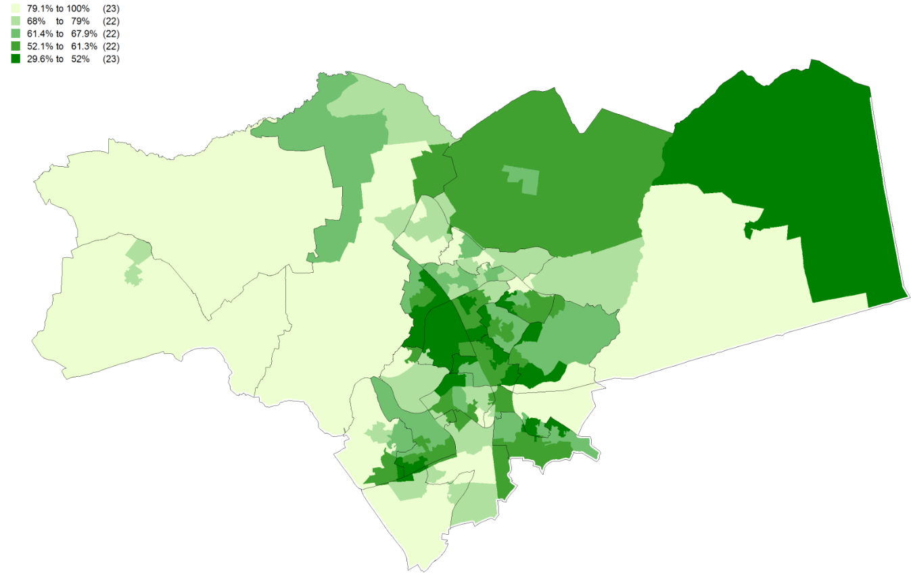
© Crown copyright and database rights 2017, Ordnance Survey 100023205
Within the map above, light shading represents LSOAs with high percentages of children achieving a ‘good level of development’ at the end of the Early Years Foundation Stage., considered a key measure of early years development across a wide range of developmental areas. Children from poorer backgrounds are more at risk of poorer development and evidence shows that differences by social background emerge early in life.
Attainment for this indicator is generally higher in the rural, more affluent areas of Peterborough such as Barnack, Wittering, Glinton and Castor and is lower towards the centre of Peterborough, particularly in relatively deprived areas such as Ravensthorpe, North and Bretton.
Figure 19: Percentage of pupils achieving 5+ A*-C GCSEs in Peterborough by LSOA with 2016 – Present Electoral Ward Boundaries, 2014/2015
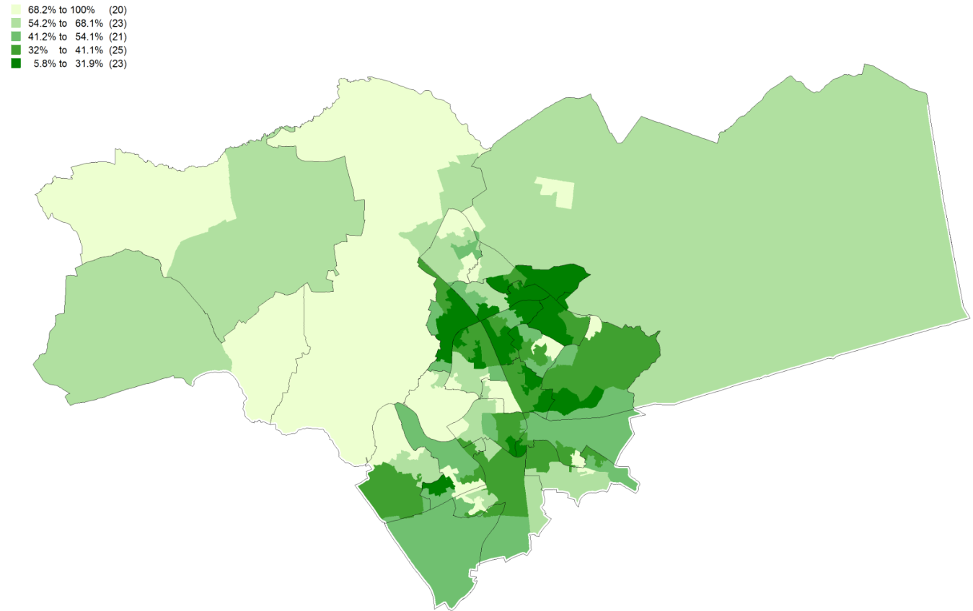
© Crown copyright and database rights 2017, Ordnance Survey 100023205
As with early good levels of development at Early Years Foundation Stage, percentages of pupils achieving 5+ A*-C GCSEs are highest in the rural, affluent areas of outer Peterborough, whereas GCSE attainment is lowest towards the centre of Peterborough.
Educational attainment is influenced by both the quality of education children receive and their family socio-economic circumstances and is a significant predictor of health, wellbeing and economic attainment in later life.
Figure 20: Peterborough LSOAs by Job Seeker’s Allowance Claimant Crude Rate per 10,000, November 2016
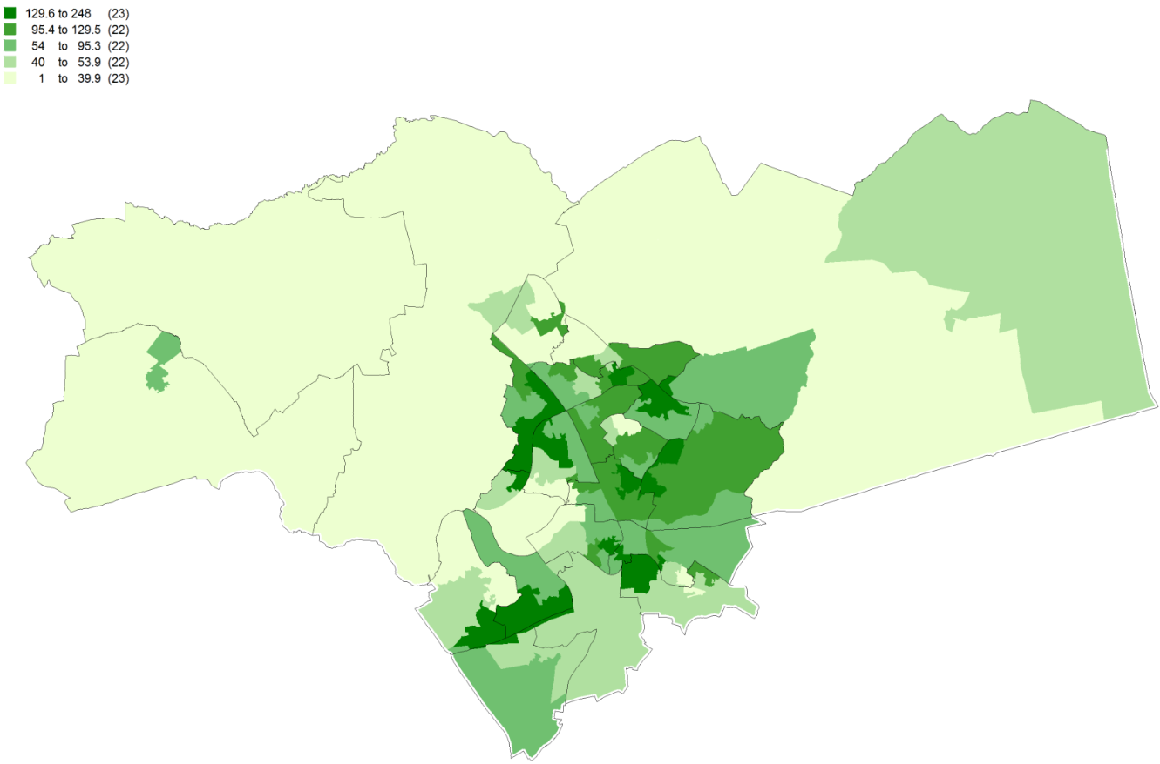© Crown copyright and database rights 2017, Ordnance Survey 100023205
Correlation is noteworthy between low rates of GCSE attainment and high rates of claimants of job seeker’s allowance in many electorate wards, as shown within the above map.
Figure 21: Peterborough Selected Wider Determinants of Health Indicators
Indicator | Time Period | Peterborough Value | England Value | Peterborough Status | Peterborough CIPFA Ranking (1=Best, 16=Worst)
Employment rate, 16-64 year olds, % | 2015/16 | 75.2 | 73.9 | Statistically similar to England | 4
Unemployment rate, 16+, % | 2015 | 5.3 | 5.1 | Statistically similar to England | 5
Economic inactivity rate, 16-64 year olds, % | 2015/16 | 20.9 | 22.0 | Statistically similar to England | 6
Children in low income families (all dependent children under 20), % | 2014 | 23.1 | 19.9 | Statistically significantly worse than England | 10
Children in low income families (under 16s), % | 2014 | 23.1 | 20.1 | Statistically significantly worse than England | 8
Violent crime: rate of hospital admissions for violence, directly age-standardised rate per 100,000 | 2013/14-2015/16 | 70.3 | 44.8 | Statistically significantly worse than England | 14
Violent crime: rate of violent offences, crude rate per 1,000 | 2015/16 | 21.2 | 17.2 | Higher than England (statistical significance not calculated) | 9
Violent crime: rate of sexual offences, crude rate per 1,000 | 2015/16 | 2.0 | 1.7 | Higher than England (statistical significance not calculated) | 10
First time offenders , crude rate per 100,000 | 2016 | 357.8 | 218.4 | Higher than England (statistical significance not calculated) | 16
First time entrants to the youth justice system, 10-17 years, crude rate per 100,000 | 2016 | 320.2 | 327.1 | Statistically similar to England | 9
Statutory homelessness: households in temporary accommodation, crude rate per 1,000 | 2015/16 | 2 | 3 | Statistically significantly better than England | 12
Statutory homelessness: eligible homeless people not in priority need, crude rate per 1,000 | 2015/16 | 2.4 | 0.9 | Statistically significantly worse than England | 13
Children providing unpaid care, 0-15 year olds, % | 2011 | 1.0 | 1.1 | Statistically significantly better than England | 2
Young people providing unpaid care, 16-24 year olds, % | 2011 | 5.2 | 4.8 | Statistically significantly worse than England | 10
Unpaid carers, % | 2011 | 2.4 | 2.4 | Statistically similar to England | 6
Social isolation: adult social care users who have as much social contact as they would like, % | 2015/16 | 41.8 | 45.4 | Statistically similar to England | 14
Source: Public Health England ‘Fingertips’
It is important to note that as with many nationally benchmarked indicators, the data can be quite out of date. For example the data on unpaid care is from the 2011 census, and data on children living in poverty is from 2014. Other indicators are from 2015/16 or 2016 due to the time taken to collect and quality assure data from all local authority areas and then benchmark variation between authorities for statistical significance. However the data help to give a general picture of Peterborough’s comparative position on the determinants of health.

Lifestyle, Risk Factors and Health and Wellbeing

A number of key lifestyle risk factors influence overall levels of health and healthcare outcomes. The analysis below focuses on smoking, alcohol, sexual health, physical activity and active travel, long term condition prevalence and mental health and disability within Peterborough.

6.1 Smoking

Figure 22: Smoking prevalence in adults – current smokers, Peterborough Trend, 2012 - 2016
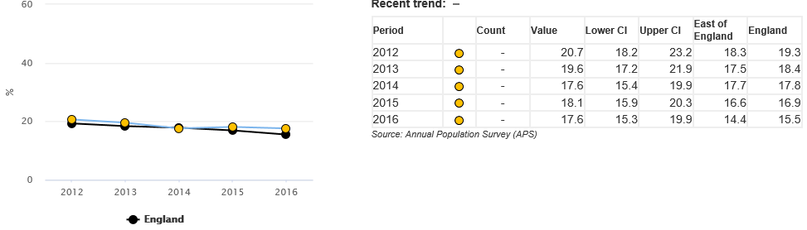
Source: Local tobacco control profiles, Public Health England
Smoking prevalence in adults has been falling relatively consistently both in Peterborough and nationally between 2012 and 2016 and Peterborough is currently statistically similar to England for numbers of adults who are current smokers. Applied to the estimated Peterborough population in 2016 of 198,120, this represents an estimated 34,869 smokers within the area. The population of Peterborough is anticipated to increase to 240,810 by 2036, which, without further reduction in smoking prevalence, would equate to 42,383 smokers – an increase of 7,514.

Figure 23: Smoking prevalence in adults – current smokers, Peterborough & Nearest Socio-Economic Neighbours- 2016
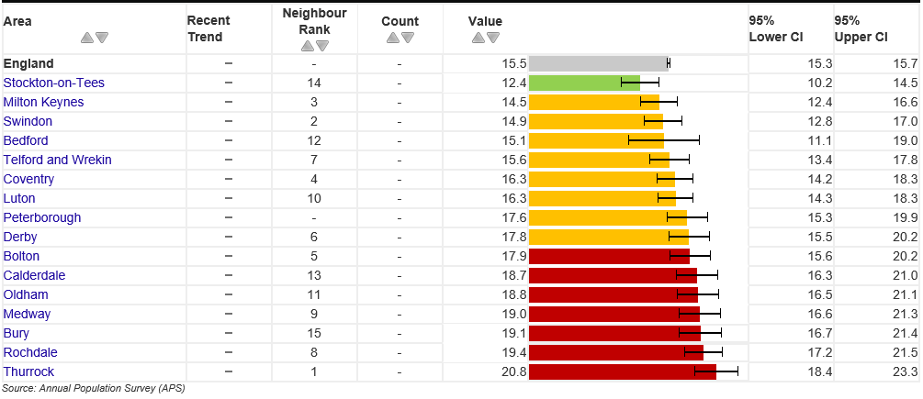 Source: Local tobacco control profiles, Public Health England
Peterborough has the 9th highest smoking prevalence within its Chartered Institute of Finance & Public Accountancy (CIPFA) group of nearest socio-economic neighbours (a total of sixteen local authorities including Peterborough) and is one of 8 local authorities within this group to have statistically similar prevalence to that of England.
Figure 24: Smoking prevalence in adults – current smokers who work in routine & manual occupations, Peterborough Trend, 2012 - 2016

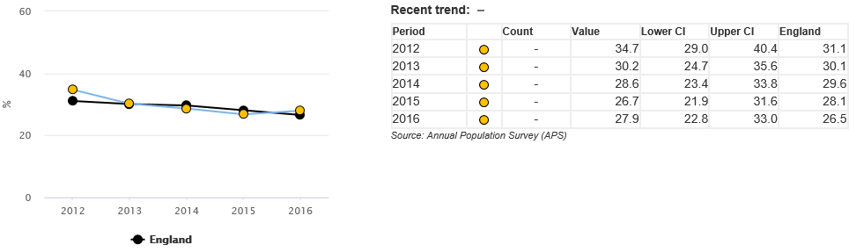
Source: Local tobacco control profiles, Public Health England
Smoking prevalence is higher among routine & manual workers than the overall population for both Peterborough and England. The Peterborough prevalence value of 27.9% for 2016 is statistically similar, to England.

Figure 25: Smoking prevalence in adults – current smokers who work in routine & manual occupations, Peterborough & Nearest Socio-Economic Neighbours 2016
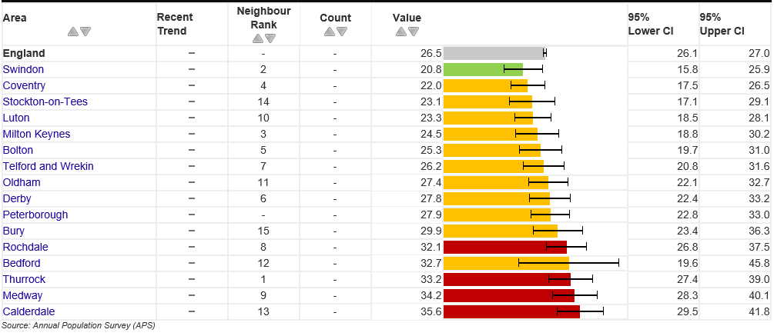
Source: Local tobacco control profiles, Public Health England
Peterborough is one of 11 local authorities within its group of nearest socio-economic neighbours to be statistically similar to England for smoking prevalence in routine and manual workers.
Figure 26: Smoking attributable hospital admissions, Peterborough trend 2009/10 – 2015/16, directly age-standardised rate per 100,000
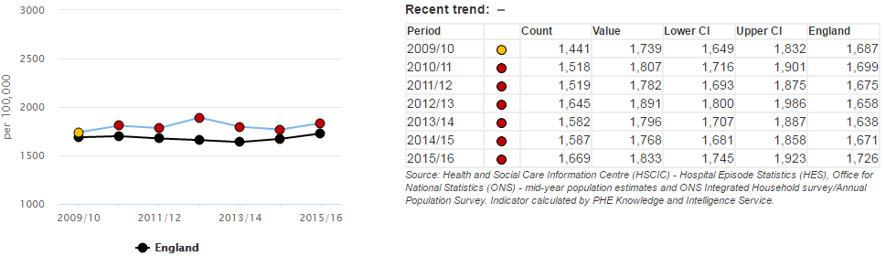
Source: Local Tobacco Control Profiles, Public Health England
The directly age-standardised rate of smoking attributable hospital admissions in Peterborough has been statistically significantly worse than England for six consecutive years. This is likely to reflect historical smoking rates in the area as well as current trends.

Figure 27: Potential years of life lost due to smoking related illness, Peterborough 2013-15, directly age-standardised rate per 100,000
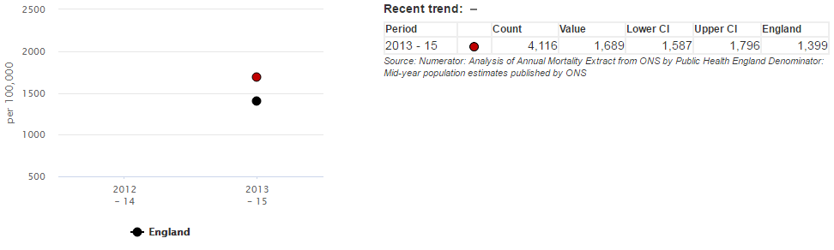
Source: Local Tobacco Control Profiles, Public Health England
Data show that the directly age-standardised rate of potential years of life lost due to smoking related illness in Peterborough for 2013-15 is 1,689 years, statistically significantly higher than the England rate of 1,399.
Figure 28: Hospital admissions for asthma, under 19 years, Peterborough trend 2011/12 – 2015/16, crude rate per 100,000
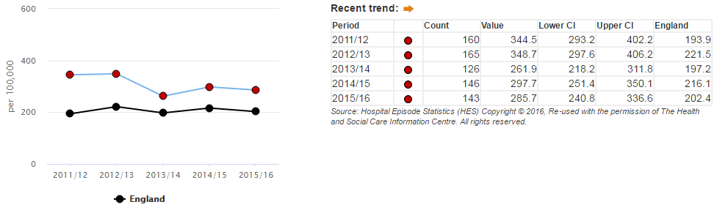
Source: Local Tobacco Control Profiles, Public Health England
It is well documented that tobacco smoke is a risk factor for developing asthma and exposure to second hand smoke can affect asthma sufferers. Peterborough has had statistically significantly higher crude rates of hospital admissions in under 19 year olds than England for asthma for each year within the above analysis, although this may reflect a number of factors in addition to smoking rates.

Figure 29: Emergency hospital admissions for Chronic Obstructive Pulmonary Disease, Peterborough trend 2010/11 – 2015/16, directly age-standardised rate per 100,000
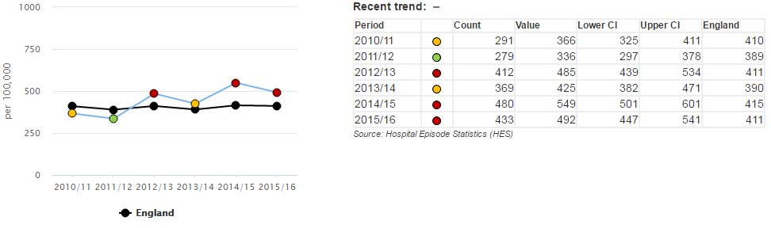
Source: Local Tobacco Control Profiles, Public Health England
The directly age-standardised rate of emergency hospital admissions for chronic obstructive pulmonary disease (COPD) in Peterborough has been statistically significantly worse than England for two consecutive years, having been statistically similar in 2013/14 and statistically significantly better in 2011/12. Smoking is a strong causative factor for COPD in the longer term, but other factors are likely to affect year on year variation in admission rates.
Figure 30: Smoking Prevalence (Residents Aged 15+), Greater Peterborough Local Commissioning Group General Practices, 2015/16
Practice Code | Practice Name | Recorded Smokers (15+) | Practice Population (15+) | Prevalence (%) | Lower CI (%) | Upper CI (%) | Greater Peterborough Quintile (5 = Least Deprived, 1 = Most Deprived)
K83023 | OUNDLE | 1,014 | 9,122 | 11.1 | 10.5 | 11.8 | 5
D81618 | AILSWORTH MEDICAL CENTRE | 241 | 1,994 | 12.1 | 10.7 | 13.6 | 5
K83017 | WANSFORD SURGERY | 769 | 6,176 | 12.5 | 11.7 | 13.3 | 5
D81616 | HODGSON MEDICAL CENTRE | 533 | 3,683 | 14.5 | 13.4 | 15.6 | 5
D81615 | THORPE ROAD SURGERY | 711 | 4,873 | 14.6 | 13.6 | 15.6 | 4
D81630 | HAMPTON HEALTH | 1,003 | 6,333 | 15.8 | 15.0 | 16.8 | 5
D81605 | HUNTLY GROVE PRACTICE | 261 | 1,636 | 16.0 | 14.3 | 17.8 | 2
D81031 | YAXLEY GROUP PRACTICE | 2,150 | 12,533 | 17.2 | 16.5 | 17.8 | 5
D81022 | THORNEY | 1,183 | 6,546 | 18.1 | 17.2 | 19.0 | 4
D81039 | JENNER HEALTH CENTRE | 1,205 | 6,599 | 18.3 | 17.3 | 19.2 | 4
D81046 | NEW QUEEN STREET SURGERY | 2,633 | 14,391 | 18.3 | 17.7 | 18.9 | 4
Y00486 | BOTOLPH BRIDGE COMMUNITY HEALTH | 1,033 | 5,335 | 19.4 | 18.3 | 20.4 | 4
D81007 | PARK MEDICAL CENTRE | 1,459 | 7,261 | 20.1 | 19.2 | 21.0 | 2
D81645 | THE GRANGE MEDICAL CENTRE | 448 | 2,227 | 20.1 | 18.5 | 21.8 | 3
D81024 | THOMAS WALKER | 1,233 | 5,884 | 21.0 | 19.9 | 22.0 | 3
D81019 | MINSTER MEDICAL PRACTICE | 761 | 3,472 | 21.9 | 20.6 | 23.3 | 2
D81026 | BOROUGHBURY | 4,674 | 21,256 | 22.0 | 21.4 | 22.6 | 3
D81065 | WELLAND MEDICAL PRACTICE | 695 | 3,133 | 22.2 | 20.8 | 23.7 | 1
D81029 | OLD FLETTON SURGERY | 2,290 | 9,872 | 23.2 | 22.4 | 24.0 | 4
D81020 | NENE VALLEY MEDICAL PRACTICE | 2,311 | 9,951 | 23.2 | 22.4 | 24.1 | 2
D81023 | PASTON HEALTH CENTRE | 2,669 | 10,844 | 24.6 | 23.8 | 25.4 | 3
D81629 | BUSHFIELD | 1,099 | 4,362 | 25.2 | 23.9 | 26.5 | 2
D81053 | BRETTON MEDICAL PRACTICE | 2,548 | 9,446 | 27.0 | 26.1 | 27.9 | 1
D81063 | WESTGATE | 2,725 | 9,649 | 28.2 | 27.4 | 29.1 | 2
D81624 | DOGSTHORPE MEDICAL CENTRE | 1,029 | 3,547 | 29.0 | 27.5 | 30.5 | 1
D81073 | WESTWOOD CLINIC | 1,181 | 4,024 | 29.3 | 28.0 | 30.8 | 1
D81620 | PARNWELL MEDICAL CENTRE | 433 | 1,412 | 30.7 | 28.3 | 33.1 | 3
D81631 | MILLFIELD MEDICAL CENTRE | 2,943 | 8,917 | 33.0 | 32.0 | 34.0 | 1
D81625 | THISTLEMOOR MEDICAL CENTRE | 5,918 | 14,928 | 39.6 | 38.9 | 40.4 | 1
- | PETERBOROUGH LCG | 47,152 | 209,406 | 22.5 | 22.3 | 22.7 | -
Source: Quality Outcomes Framework 2015/16
Overall smoking prevalence among patients registered with General Practices (GPs) within Peterborough Local Commissioning Group (LCG) is 22.5% in 2015/16. Of 29 GPs within the LCG, 15 have a statistically significantly low prevalence value in comparison to Peterborough LCG and 9 have statistically significantly high prevalence. There is relatively strong correlation between high levels of smoking prevalence and high levels of socio-economic deprivation.
Figure 31: Smoking Prevalence (Residents Aged 15+), Greater Peterborough Local Commissioning Group Deprivation Quintiles, 2015/16
LCG Deprivation Quintile | Recorded smokers within quintile (15+) | Sum of practice populations within quintile(15+) | Prevalence (%) | Lower CI (%) | Upper CI (%)
Quintile 5 (Least Deprived) | 5,710 | 39,841 | 14.3 | 14.0 | 14.7
Quintile 4 | 9,055 | 47,616 | 19.0 | 18.7 | 19.4
Quintile 3 | 9,457 | 41,623 | 22.7 | 22.3 | 23.1
Quintile 2 | 8,616 | 36,331 | 23.7 | 23.3 | 24.2
Quintile 1 (Most Deprived) | 14,314 | 43,995 | 32.5 | 32.1 | 33.0
Peterborough LCG | 47,152 | 209,406 | 22.5 | 22.3 | 22.7
Source: Quality Outcomes Framework 2015/16
Smoking prevalence in Peterborough varies substantially between deprivation quintiles. Prevalence is 14.3% in the least deprived quintile of Peterborough (comprising Oundle, Ailsworth Medical Centre, Wansford Surgery, Hodgson Medical Centre, Hampton Health and Yaxley Group Practice) and is 32.5% in the most deprived quintile (Welland Medical Practice, Bretton Medical Practice, Dogsthorpe Medical Centre, Westwood Clinic, Millfield Medical Centre and Thistlemoor Medical Centre).

6.2 Alcohol

Alcohol consumption is a contributing factor to hospital admissions and deaths from a wide range of conditions and data suggest that over 50% of violent crime involves alcohol. Alcohol use can also increase anxiety and stress as well as contributing to adverse mental health, such as depression.
Peterborough has some poor healthcare outcomes with regards to the consumption of and effects of alcohol in relation to healthcare. This is particularly noteworthy as Peterborough has a high percentage of adults who abstain from drinking alcohol (23.2%) compared to the East of England (11.2%) and England (15.5%); it is therefore a relatively smaller percentage of adults who do consume alcohol that contribute towards a number of indicators outlined below.
Figure 32: Percentage of adults who abstain from drinking alcohol, %, Peterborough, East of England & England, 2011-14
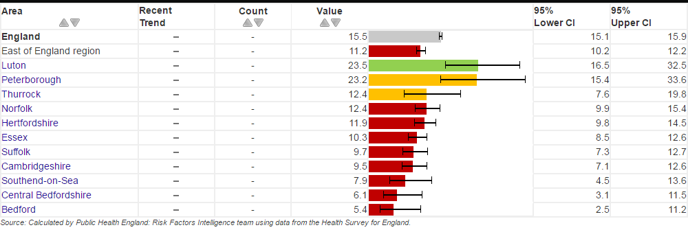
Source: Local Alcohol Profiles for England, Public Health England
Figure 33: Percentage of adults who abstain from drinking alcohol, %, National Deprivation Deciles, 2011-14
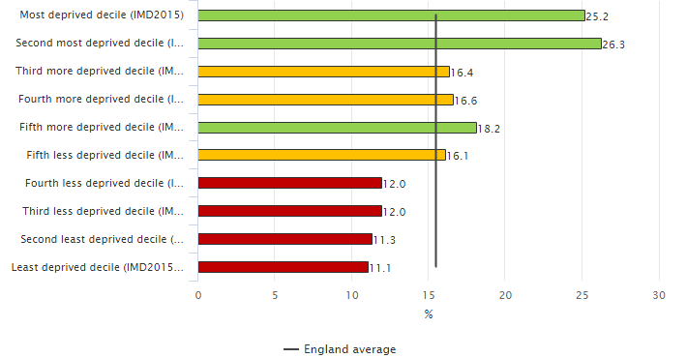
Source: Local Alcohol Profiles for England, Public Health England
Data show clear correlation between high levels of deprivation (such as those observed in the two areas of the East of England with the highest rates of alcohol abstention, Luton and Peterborough) and high percentages of adults who abstain from drinking alcohol. Percentages of adults who drink alcohol rises as deprivation falls, with the four least-deprived deciles in England all having statistically significantly lower percentages of adults who abstain from drinking alcohol.
Figure 34: Key Alcohol Indicators, Peterborough
Indicator | Time Period | Peterborough Value | England Value | Peterborough Status | Peterborough Trend | Peterborough CIPFA Ranking (1=Best, 11=Worst)
Alcohol-specific mortality, directly age-standardised rate per 100,000 | 2013-15 | 12.7 | 11.5 | Statistically similar to England | ❐ | 7
Alcohol-related mortality, directly age-standardised rate per 100,000 | 2015 | 53.7 | 46.1 | Statistically similar to England | ❐ | 9
Hospital admission episodes for alcohol-specific conditions, all ages, directly age-standardised rate per 100,000 | 2015-16 | 665 | 583 | Statistically significantly worse than England | ❑ | 9
Hospital admission episodes for alcohol-specific conditions, under 18s only, directly age-standardised rate per 100,000 | 2013/14-2015/16 | 45 | 37.4 | Statistically similar to England | ❑ | 13
Hospital admission episodes for alcohol-related conditions (narrow definition, all ages), directly age-standardised rate per 100,000 | 2015-16 | 708 | 647 | Statistically significantly worse than England | ❐ | 10
Hospital admission episodes for alcohol-related conditions (broad definition, all ages), directly age-standardised rate per 100,000 | 2015-16 | 2299 | 2179 | Statistically significantly worse than England | ❑ | 8
Source: Local Alcohol Profiles for England, Public Health England
Key:
Statistical significance | Trend
Statistically significantly better than England | Increasing - getting better | ❐
Statistically similar to England | Decreasing - getting better | ❑
Statistically significantly worse than England | Increasing - getting worse | ❐
No comparison available | Decreasing - getting worse | ❑

Although Peterborough has statistically similar directly age-standardised rates of mortality (alcohol-specific and alcohol-related), rates of hospital admissions for alcohol-specific conditions are statistically significantly worse than England and among the worst observed within Peterborough’s CIPFA group of nearest socio-economic comparators.

6.3 Drug Use

Figure 35: Drug Use - 15 Year Olds in Peterborough, What About YOUth Survey 2014/15
Indicator | Time Period | Peterborough Value | England Value | Peterborough Status | Peterborough Trend | Peterborough CSSNBT Ranking (1=Best, 11=Worst)
Percentage of 15 year olds who have ever tried cannabis | 2014-15 | 10.9% | 10.7% | Statistically similar to England | First data point, no trend available | 9
Percentage of 15 year olds who have taken cannabis in the last month | 2014-15 | 4.4% | 4.6% | Statistically similar to England | First data point, no trend available | 6
Percentage of 15 year olds who have taken drugs (excluding cannabis) in the last month | 2014-15 | 0.6% | 0.9% | Statistically similar to England | First data point, no trend available | 1
Source: Public Health Outcomes Framework
Data show that the percentage of 15 year olds in Peterborough who have ever tried cannabis, and had taken cannabis or any other drug within the last month at the time they were surveyed are statistically similar to national averages. It is, however, of note that the Peterborough value of 0.6% for 15 year olds who have taken drugs (excluding cannabis) in the last month is the lowest within Peterborough’s assigned group of nearest Children’s Service Statistical Neighbour Benchmarking (CSSNBT) socio-economic neighbours.
Figure 36: Drug Related Deaths, Peterborough, Cambridgeshire Districts, Cambridgeshire, East of England & England, 2013-15
Area | Number of Drug Related Deaths (2013-15) | Crude Rate per 100,000 population
Peterborough | 31 | 5.3
Cambridgeshire | 60 | 3.2
Cambridge City | 19 | 5.3
East Cambridgeshire | * | *
Fenland | 13 | 4.5
Huntingdonshire | 21 | 4.1
South Cambridgeshire | 5 | 1.1
East of England | 605 | 3.4
England | 6,232 | 3.9
Office for National Statistics Deaths related to drug poisoning in England and Wales 2001-2015
*Value redacted due to low numbers
The crude rate of drug related deaths in Peterborough for 2013-15 is 31, which equates to a crude rate of 5.3/100,000. This is higher than the average for Cambridgeshire (3.2/100,000), the East of England (3.4/100,000) and England (3.9/100,000).

6.4 Sexual Health

Figure 37: Key Sexual Health Indicators, Peterborough
Indicator | Time Period | Peterborough Value | England Value | Peterborough Status | Peterborough Trend | Peterborough CIPFA Ranking (1=Best, 11=Worst)
Chlamydia proportion aged 15-24 screened, % | 2016 | 25 | 20.7 | Statistically significantly better than England | ❐ | 2
Chlamydia detection rate, 15-24 year olds, crude rate per 100,000 | 2016 | 2,862 | 1,882 | Above national benchmark value of 2,300/100,000 | ❐ | 2
New STI diagnoses excluding chlamydia, <25 only, crude rate per 100,000 | 2016 | 1,105 | 795 | Statistically significantly worse than England | ❐ | 15
Late diagnosis of HIV, % | 2013-15 | 60.5 | 40.1 | Above national benchmark value of 50.0% | ❐ | 12
Under 18 conception rate, crude rate per 1,000 | 2015 | 28.3 | 20.8 | Statistically significantly worse than England | ❑ | 14
Under 25 repeat abortions, % | 2016 | 26.5 | 26.7 | Statistically similar to England | ❐ | 4
Source: Sexual & Reproductive Health Profiles
Key:
Statistical significance | Trend
Statistically significantly better than England | Increasing - getting better | ❐
Statistically similar to England | Decreasing - getting better | ❑
Statistically significantly worse than England | Increasing - getting worse | ❐
No comparison available | Decreasing - getting worse | ❑

25.0% of 15-24 year olds in Peterborough were screened for chlamydia in 2016, statistically significantly higher than the England value of 20.7%. Peterborough also has a crude chlamydia detection rate of 2,862/100,000, above the national benchmark goal of 2,300/100,000.
However, the crude rate of new STI diagnoses in Peterborough in 2016 was 1,105, statistically significantly higher than England (795/100,000). The percentage of HIV diagnoses defined as ‘late’ – with a CD4 count less than 350 cells per mm3 – is 60.5% in Peterborough, above the national benchmark value of 50.0%.
Peterborough’s under 18 conception rate has been statistically significantly worse than England for each year since 2012 as noted within the trend graph below and 26.5% of under 25 abortions in Peterborough involved a woman who had had a previous abortion in any year.

Figure 38: Under 18 conceptions rate, Peterborough, crude rate per 1,000, 1998-2015
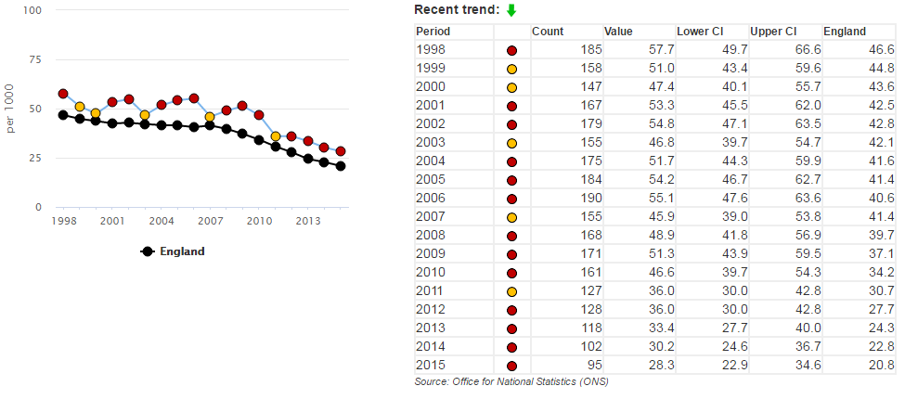
Source: Sexual & Reproductive Health Profiles, Public Health Outcomes Framework

6.5 Physical Activity

Figure 39: Peterborough Physical Activity Profile – Key Indicators

Indicator | Time Period | Peterborough Value | England Value | Peterborough Status | Peterborough Trend | Peterborough CIPFA Ranking (1=Best, 16=Worst)
Percentage of adults doing 150+ minutes of physical activity per week | 2015 | 54.7% | 57.0% | Statistically similar to England | ❐ | 10
Percentage of adults achieving less than 30 minutes of physical activity per week | 2015 | 34.3% | 28.7% | Statistically significantly worse than England | ❐ | 15
Percentage of adults doing 30-149 minutes physical activity per week | 2015 | 11.0% | 14.3% | Statistically significantly worse than England | ❑ | 16
Percentage of 15 year olds physically active for at least one hour per day, seven days per week | 2014-15 | 12.7% | 13.9% | Statistically similar to England | First data point, no trend available | 10
Percentage of 15 year olds with a mean sedentary time in the last week of over 7 hours per day | 2014-15 | 71.3% | 70.1% | Statistically similar to England | First data point, no trend available | 9
Percentage of adults who do any walking, at least five times per week | 2014-15 | 48.8% | 50.6% | Statistically similar to England | First data point, no trend available | 6
Percentage of adults who do any walking, at least once per week | 2014-15 | 77.7% | 80.6% | Statistically similar to England | First data point, no trend available | 6
Percentage of adults who do any cycling, at least three times per week | 2014-15 | 8.6% | 4.4% | Statistically significantly better than England | First data point, no trend available | 1
Percentage of adults who do any cycling, at least once per month | 2014-15 | 25.1% | 14.7% | Statistically significantly better than England | First data point, no trend available | 1
Utilisation of outdoor space for exercise/health reasons | Mar 15 -Feb 16 | 17.8% | 17.9% | Statistically similar to England | ❑ | 9
Source: Public Health Outcomes Framework Physical Activity Profiles
Key:
Statistical significance | Trend
Statistically significantly better than England | Increasing - getting better | ❐
Statistically similar to England | Decreasing - getting better | ❑
Statistically significantly worse than England | Increasing - getting worse | ❐
No comparison available | Decreasing - getting worse | ❑

Peterborough has the highest percentage of adults who do any cycling three times a week or at least once a month of any area within its group of nearest socio-economic neighbours as assigned by the Charted Institute of Public Finance Accountancy (CIPFA), with percentages for both indicators statistically significantly higher than England. However, there are a number of key physical activity indicators for which Peterborough performs relatively poorly in comparison to both England and its CIPFA comparator group. Percentages of adults achieving less than 30 minutes of physical activity per week and 30-149 minutes of physical activity per week are both statistically significantly worse than England. Peterborough is ranked 15th of 16 within its CIPFA group for adults achieving less than 30 minutes physical activity per week and 16th of 16 for adults doing 30-149 minutes of physical activity per week.
Raising physical activity levels is an important aspiration of Public Health, as physical inactivity is the fourth leading risk factor for death worldwide. Physical inactivity contributes to an increased risk of diabetes, cardiovascular disease and cancer..
Figure 40: Percentage of adults achieving less than 30 minutes of physical activity per week, Peterborough, 2012 - 2015
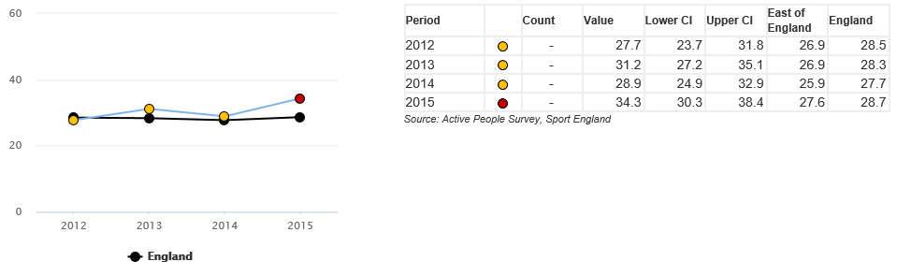
Source: Public Health Outcomes Framework Physical Activity Profiles
The percentage of adults achieving less than 30 minutes of physical activity per week in Peterborough rose from 28.9% to 34.3% between 2014 and 2015 and is now statistically significantly worse than England (28.7%) for the first time.

Figure 41: Percentage of adults achieving less than 30 minutes of physical activity per week, England, 2015, split by Ethnicity
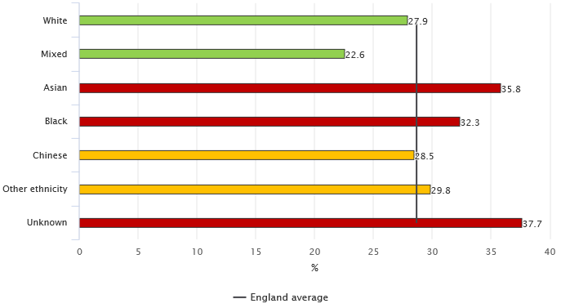
Source: Public Health Outcomes Framework Physical Activity Profiles
2015 data show that in England, percentages of adults undertaking less than 30 minutes of physical activity per week are higher in Black & Ethnic Minority (BME) groups than in the ‘white’ ethnicity group. 17.5% of the Peterborough population self-identified as being of BME ethnicity in the 2011 census, statistically significantly higher than the England percentage of 14.6%.

6.6 Transport and Health

Active transport or travel is any means of moving from one place to another that involves being physically active. Walking or cycling are the main forms of active travel, although using public transport can also contribute to levels of physical activity, as people who take public transport are likely to walk further than car users – for example, by walking to and from bus stops.
Active transport has an important role to play in improving health and wellbeing; there is a wealth of evidence that demonstrates that walking and cycling are effective ways of increasing and maintaining levels of physical activity as part of everyday life for the majority of the population, at little personal or environmental cost. Active travel is a viable alternative to the many short journeys that are still made by car. It is noted by the Department of Health that the easiest way for most people to stay physically active is by incorporating physical activity, such as walking or cycling, in to their daily lives, particularly as part of commuting for work.
As an overall environment, Peterborough has some challenges in relation active transport. Peterborough was ranked by the Campaign for Better Transport’s 2014 ‘Car Dependency Scorecard 2014’ (the most recent such analysis) as the most car-dependent city in the UK.
The crude rate of killed and seriously injured (KSI) casualties on roads and crude rate of children killed or seriously injured in road traffic accidents in Peterborough were both statistically similar to England in 2013/15 and decreasing as shown in the figure. In 2013/15 Peterborough ranked 15th of 16 among nearest CIPFA neighbours with regards to crude rate of KSI as shown below.

Figure 42: Killed and Seriously Injured (KSI) Casualties on Peterborough Roads, 2009-11 / 2013-15, Crude rate per 100,000
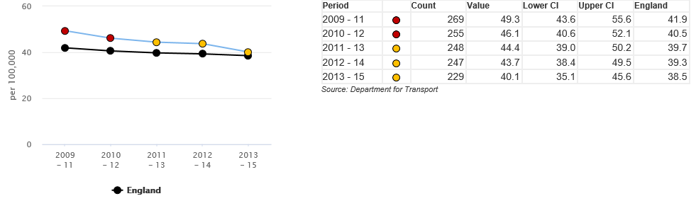
Source: Department for Transport

Figure 43: Killed and Seriously Injured (KSI) Casualties on England’s Roads, 2013-15, Crude rate per 100,000
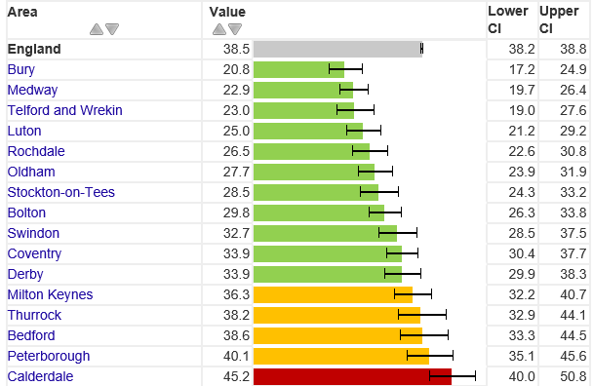
Source: Department for Transport
The Cambridgeshire & Peterborough Road Safety Partnership collates an annual statistical summary of road collision and casualty data to monitor performance against the three targets of the partnership group:
- To reduce the number of people killed or seriously injured (KSI) in collisions by at least 40% by 2020
- To reduce the number of children killed or seriously in collisions by at least 40% by 2020
- To reduce the number of cyclists and pedestrians killed or seriously injured in collisions by at least 40% by 2020.

Figure 44: Casualties per 100 million Vehicle Km Travelled, 2015, Peterborough, Cambridgeshire & Great Britain

Area | KSI | Slight | Total (may not sum due to rounding)
Peterborough | 3.6 | 39.0 | 42.5
Cambridgeshire | 3.7 | 20.4 | 24.1
Great Britain | 4.7 | 31.9 | 36.5
Source: Cambridgeshire & Peterborough Road Safety Partnership, Annual Statistics Summary 2015

Both Peterborough and Cambridgeshire have lower rates of KSI per 100 million vehicle Km travelled than Great Britain, although Peterborough has a markedly higher rate of ‘slight’ injuries than observed nationally which contributes towards a higher overall rate of 42.5/100 million Km travelled compared to 36.5/100 million Km travelled across all of Great Britain.
Figure 45: Observed Casualties by Local Authority, 2014, Observed Numbers & Crude Rates per 100,000
Local Authority | Fatal |  | Serious |  | Slight |  | Total
 | Number | Rate | Number | Rate | Number | Rate | Number | Rate
Peterborough | 4 | 2.1 | 68 | 35.1 | 587 | 303.0 | 659 | 340.1
Cambridgeshire | 19Plea;se | 3.0 | 236 | 36.9 | 1,462 | 228.5 | 1,717 | 268.4
Source: Cambridgeshire & Peterborough Road Safety Partnership, Annual Statistics Summary 2015 & ONS Mid-Year Population Projections

6.7 Diet and Healthy Weight

Figure 46: Peterborough Diet & Healthy weight profile
Indicator | Time Period | Peterborough Value | England Value | Peterborough Status | Peterborough Trend | Peterborough CIPFA Ranking (1=Best, 16=Worst)
Percentage of adults with excess weight | 2013-15 | 70.8% | 64.8% | Statistically significantly worse than England | ❐ | 14
Percentage of overweight/obese reception age children | 2015-16 | 22.8% | 22.1% | Statistically similar to England | ❐ | 13
Percentage of overweight/obese year 6 age children | 2015-16 | 34.2% | 34.2% | Statistically similar to England | ❐ | 5
Percentage of the population meeting the recommended '5 a day' on a 'usual day' (adults) | 2015 | 48.0% | 52.3% | Statistically significantly worse than England | ❐ | 10
Average number of portions of fruit consumed daily (adults) | 2015 | 2.4 | 2.5 | Statistically similar to England | ❐ | 7
Average number of portions of vegetables consumed daily (adults) | 2015 | 2.1 | 2.3 | Statistically significantly worse than England | ❑ | 10
Percentage of the population meeting the recommended '5 a day' on a 'usual day' (15 year olds) | 2014-15 | 50.1% | 52.4% | Statistically similar to England | First data point, no trend available | 7
Average number of portions of fruit consumed daily (15 year olds) | 2014-15 | 2.6 | 2.4 | Statistically significantly better than England | First data point, no trend available | 1
Average number of portions of vegetables consumed daily (15 year olds) | 2014-15 | 2.3 | 2.4 | Statistically significantly worse than England | First data point, no trend available | 8
Source: Public Health Outcomes Framework Physical Activity Profiles
Key:
Statistical significance | Trend
Statistically significantly better than England | Increasing - getting better | ❐
Statistically similar to England | Decreasing - getting better | ❑
Statistically significantly worse than England | Increasing - getting worse | ❐
No comparison available | Decreasing - getting worse | ❑

It is of note is that while rates of childhood overweight/obesity in Peterborough are similar to the national average, most recent data show increases in Peterborough in the percentage of 4/5 year olds and 10/11 year olds. For adults, the percentage with excess weight (include adults classified as obese) is statistically significantly worse than England at 70.8% compared to 64.8%, which is the 3rd highest of 16 local authorities within Peterborough's CIPFA comparator group.
Body mass index is a significant risk factor for a number of long term conditions – both those which lead to mortality such as diabetes, heart disease and cancer, and those which cause long term pain and disability such as musculoskeletal conditions.
In Peterborough, a statistically significantly low percentage of adults consume the recommended ‘5 portions of fruit and vegetables’ on an average day in comparison to England (48.0% compared to 52.3%).

Levels of Illness and Health and Social Care Services

7.1 Long Term Conditions Prevalence

Figure 47: Disease & Risk Factor Prevalence – Long Term Conditions, Peterborough
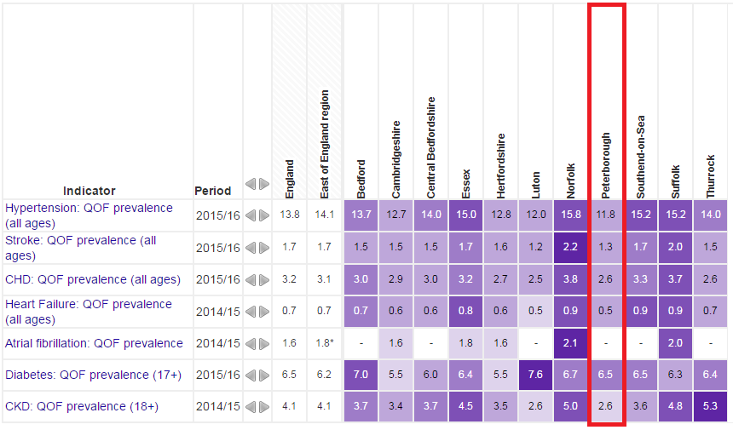
Source: Public Health England ‘Fingertips’
Compared with benchmark:
Peterborough has relatively low prevalence of a number of long term conditions, which is likely to be attributable to the relatively young population of the area, as prevalence figures are not adjusted for the age structure of the population Prevalence in Peterborough is below that of England for all conditions contained within the above analysis, but will likely increase with the predicted ageing of Peterborough’s population over coming years.

7.2 Mental Health & Disability

Figure 48: Depression & Anxiety Prevalence (GP Patient Survey), 18+, %, Peterborough Trend 2013/14 – 2015/16
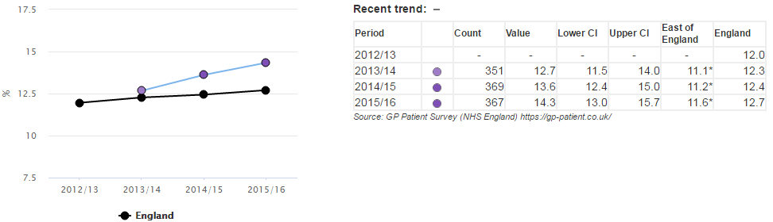
Source: Public Health England ‘Fingertips’
According to data from the GP patient survey, the prevalence of depression and anxiety in Peterborough is 14.3% for 2015/16, above that of England (12.7%) and rise more quickly than observed nationally.

Figure 49: Recorded Prevalence of Dementia, All Ages, %, Peterborough Trend 2009/10 – 2014/15
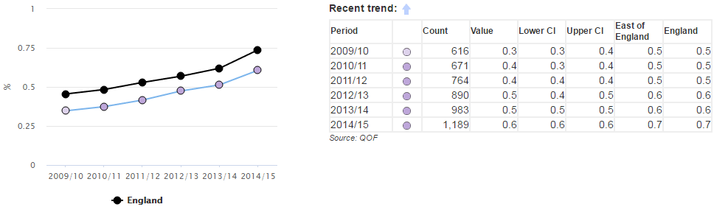
Source: Public Health England ‘Fingertips’
Dementia tends to occur in older people and therefore Peterborough, which has a younger population than England, has had lower prevalence of dementia in each of the years within the figure above. Dementia prevalence has risen in England between 2009/10 – 2014/15 from 0.5% to 0.7% and in Peterborough, from 0.3% to 0.6%. The QOF prevalence depends on the amount of recording by GPs as well as the actual prevalence of dementia.
Figure 50: Recorded Prevalence of a Learning Disability, All Ages, % Peterborough Trend 2009/10 – 2013/14
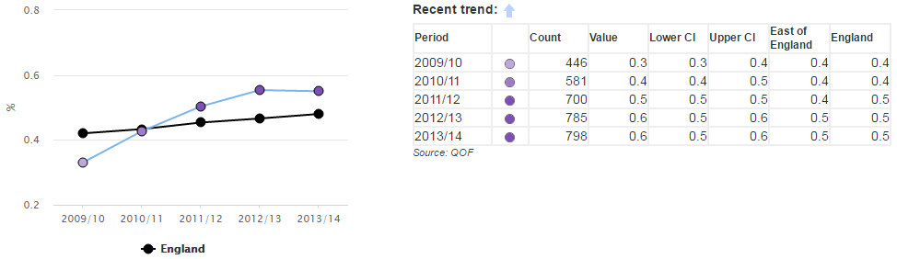
Source: Public Health England ‘Fingertips’
The prevalence of patients with learning disabilities recorded on Peterborough GP disease registers has increased between 2009/10 – 2013/14 from 0.3% to 0.6%, whereas nationally it has risen from 0.4% to 0.5% over the same period. The number of patients in Peterborough with a learning disability over this period has increased from 446 to 798, a rise of 79%. This is likely to reflect better recording by GPs rather than an actual increase of this magnitude.
Figure 51: Suicide Rate, Persons, Peterborough, 2001/03 – 2013-15, Directly Age-Standardised Rate per 100,000

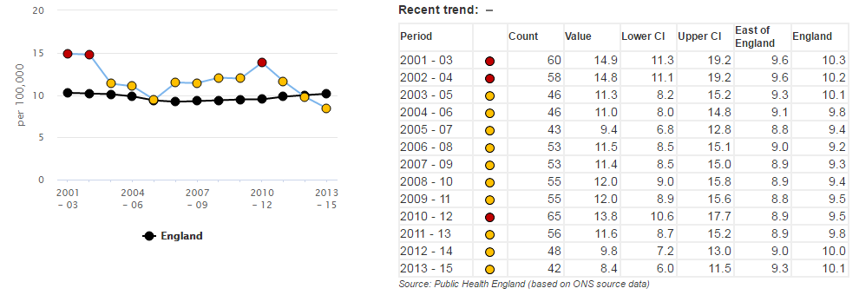
Source: Public Health Outcomes Framework
The directly age-standardised suicide rate in Peterborough is currently 8.4/100,000, which is statistically similar to England. There were 42 suicides in Peterborough in 2013-15. The rate has fallen in three consecutive periods, having been statistically significantly worse than England as recently as 2010-12.

Figure 52: Hospital Admissions as a Result of Self-Harm, Persons Aged 10-24, Peterborough, 20011/12 – 2015/16, Directly Age-Standardised Rate per 100,000
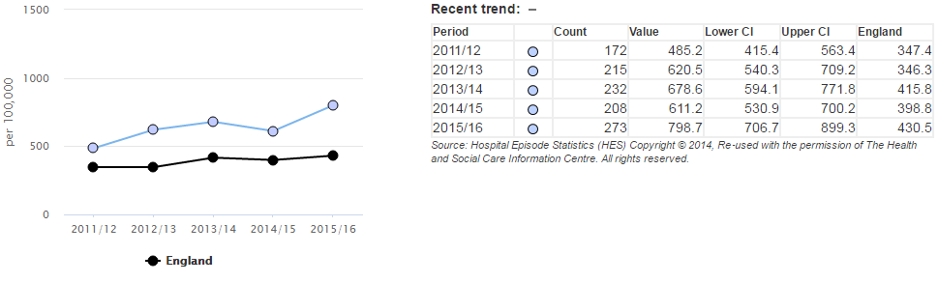
Source: Public Health Outcomes Framework
The directly age-standardised rate of hospital admissions as a result of self-harm in Peterborough among 10-24 year olds has been higher than the England average for five consecutive years and rose to 798.7/100,000 in 2015/16. Further analysis would be required to ascertain the extent to which this rate may be affected by differences in clinical coding between Peterborough and other areas of England. Peterborough’s rate for 2015/16 is the highest among its CIPFA group of nearest socio-economic neighbours as illustrated below.
Figure 53: Hospital Admissions as a Result of Self-Harm, Persons Aged 10-24, Peterborough & Nearest Socio-Economic Neighbours, 2015/16, Directly Age-Standardised Rate per 100,000
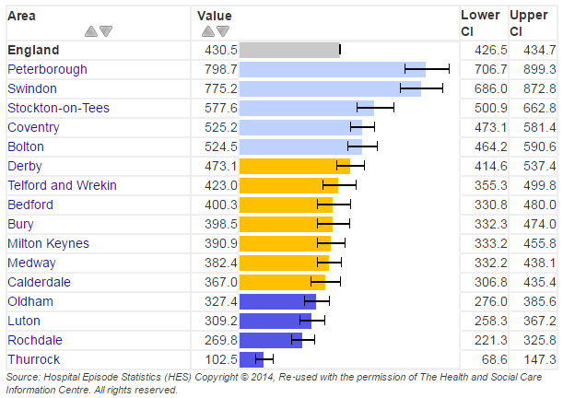
Source: Public Health Outcomes Framework

7.3 NHS Hospital Services

The below tables show directly age-standardised hospital admission rates for Peterborough and Cambridgeshire. Data include all elective, emergency, maternity and other admissions (including well babies receiving usual care).
Figure 54: Inpatient Hospital Admissions – All Admissions, 2011/12 - 2015/16, Directly Age-Standardised Admission Rates per 1,000, Peterborough & Cambridgeshire
Area | 11/12 |  | 12/13 |  | 13/14 |  | 14/15 |  | 15/16
 | Admission Episodes | DASR | Admission Episodes | DASR | Admission Episodes | DASR | Admission Episodes | DASR | Admission Episodes | DASR
Peterborough | 45,884 | 273.3 | 46,693 | 275.2 | 46,491 | 271.8 | 47,487 | 274.0 | 48,166 | 272.4
Cambridgeshire | 151,742 | 258.8 | 151,167 | 253.6 | 163,074 | 267.7 | 165,115 | 267.1 | 171,580 | 273.7
Peterborough & Cambridgeshire | 197,626 | 262.4 | 197,860 | 258.6 | 209,565 | 268.1 | 212,602 | 268.1 | 219,746 | 272.9
Source: Hospital Episode Statistics
The directly age-standardised rate of inpatient hospital admissions in Peterborough for all ages was statistically significantly higher (worse) than the Peterborough and Cambridgeshire average in 2011/12, 2012/13 and 2014/15. Within the table above, 2015/16 is the only year for which Peterborough has a lower directly age-standardised rate of inpatient hospital admissions than Cambridgeshire.
Figure 55: Inpatient Hospital Admissions – Under 75s Only, 2011/12 - 2015/16, Directly Age-Standardised Admission Rates per 1,000, Peterborough & Cambridgeshire
Area | 11/12 |  | 12/13 |  | 13/14 |  | 14/15 |  | 15/16
 | Admission Episodes | DASR | Admission Episodes | DASR | Admission Episodes | DASR | Admission Episodes | DASR | Admission Episodes | DASR
Peterborough | 37,607 | 234.0 | 38,041 | 233.6 | 37,812 | 230.2 | 38,249 | 229.9 | 38,635 | 227.0
Cambridgeshire | 118,287 | 215.3 | 117,285 | 210.4 | 127,722 | 224.5 | 127,685 | 221.9 | 132,869 | 227.8
Peterborough & Cambridgeshire | 155,894 | 219.9 | 155,326 | 215.8 | 165,534 | 225.2 | 165,934 | 223.1 | 171,504 | 227.1
Source: Hospital Episode Statistics
For under 75 inpatient hospital admissions, Peterborough has had a statistically significantly higher (worse) directly age-standardised rate than the average of Peterborough and Cambridgeshire for each year within the above table with the exception of 2015/16, for which the Peterborough rate is marginally below that of Cambridgeshire.
Figure 56: Inpatient Hospital Admissions – Over 75s Only, 2011/12 - 2015/16, Directly Age-Standardised Admission Rates per 1,000, Peterborough & Cambridgeshire
Area | 11/12 |  | 12/13 |  | 13/14 |  | 14/15 |  | 15/16
 | Admission Episodes | DASR | Admission Episodes | DASR | Admission Episodes | DASR | Admission Episodes | DASR | Admission Episodes | DASR
Peterborough | 8,277 | 671.0 | 8,652 | 696.0 | 8,679 | 692.5 | 9,238 | 719.6 | 9,531 | 730.9
Cambridgeshire | 33,455 | 698.6 | 33,882 | 691.0 | 35,352 | 704.0 | 37,430 | 724.9 | 38,711 | 737.6
Peterborough & Cambridgeshire | 41,732 | 692.7 | 42,534 | 691.6 | 44,031 | 701.4 | 46,668 | 723.7 | 48,242 | 736.1
Source: Hospital Episode Statistics
Peterborough’s directly age-standardised rate of inpatient hospital admissions among over 75s has been statistically similar to the average of Peterborough and Cambridgeshire in each year within the above analysis and is 730.9/1,000 in 2015/16.
Figure 57: Inpatient Hospital Admissions – All Admissions, Elective and Emergency, 2011/12 - 2015/16, Directly Age-Standardised Admission Rates per 1,000, Peterborough & Cambridgeshire
Area | 11/12 |  | 12/13 |  | 13/14 |  | 14/15 |  | 15/16
 | Admission Episodes | DASR | Admission Episodes | DASR | Admission Episodes | DASR | Admission Episodes | DASR | Admission Episodes | DASR
Peterborough Elective | 23,515 | 147.7 | 23,760 | 147.5 | 24,209 | 149.0 | 24,289 | 147.0 | 23,884 | 141.3
Peterborough Emergency | 18,042 | 105.2 | 18,664 | 107.6 | 18,323 | 104.4 | 19,250 | 108.6 | 20,271 | 112.5
Cambridgeshire Elective | 89,850 | 156.1 | 87,874 | 150.3 | 92,147 | 155.0 | 90,724 | 149.9 | 93,557 | 152.3
Cambridgeshire Emergency | 49,876 | 84.3 | 51,425 | 85.4 | 53,500 | 87.4 | 56,006 | 90.2 | 59,136 | 93.8
Peterborough & Cambridgeshire Elective | 113,365 | 154.6 | 111,634 | 149.8 | 116,356 | 153.8 | 115,013 | 149.4 | 117,441 | 150.2
Peterborough & Cambridgeshire Emergency | 67,918 | 89.0 | 70,089 | 90.3 | 71,823 | 91.2 | 75,256 | 94.3 | 79,407 | 97.9
Source: Hospital Episode Statistics
It is of note that the directly age-standardised rate of emergency inpatient hospital admissions in Peterborough is statistically significantly higher than the average of Peterborough and Cambridgeshire for each year within the above analysis and has risen to 112.5/100,000 in 2015/16. Conversely, the rate of elective admissions in Peterborough is statistically significantly lower than than the average of Peterborough and Cambridgeshire in 2011/12, 2013/14 and 2015/16. Higher rates of emergency admissions are often associated with socio-economic deprivation levels.
Figure 58: Inpatient Hospital Admissions – Under 75s Only, Elective and Emergency, 2011/12 - 2015/16, Directly Age-Standardised Admission Rates per 1,000, Peterborough & Cambridgeshire
Area | 11/12 |  | 12/13 |  | 13/14 |  | 14/15 |  | 15/16
 | Admission Episodes | DASR | Admission Episodes | DASR | Admission Episodes | DASR | Admission Episodes | DASR | Admission Episodes | DASR
Peterborough Elective | 19,532 | 130.6 | 19,692 | 129.9 | 20,091 | 131.1 | 19,962 | 127.8 | 19,674 | 123.1
Peterborough Emergency | 13,854 | 81.8 | 14,165 | 82.3 | 13,825 | 79.4 | 14,413 | 82.4 | 15,037 | 84.1
Cambridgeshire Elective | 71,711 | 133.7 | 70,295 | 129.1 | 73,551 | 133.1 | 71,805 | 127.9 | 73,877 | 129.6
Cambridgeshire Emergency | 35,219 | 62.7 | 35,721 | 62.7 | 37,120 | 64.4 | 38,160 | 65.6 | 40,730 | 69.0
Peterborough & Cambridgeshire Elective | 91,243 | 133.3 | 89,987 | 129.4 | 93,642 | 132.7 | 91,767 | 128.0 | 93,551 | 128.4
Peterborough & Cambridgeshire Emergency | 49,073 | 67.2 | 49,886 | 67.2 | 50,945 | 67.9 | 52,573 | 69.4 | 55,767 | 72.5
Source: Hospital Episode Statistics
Peterborough has a statistically significantly lower directly age-standardised rate of elective hospital admissions for under 75s in 2015/16 compared to the Peterborough and Cambridgeshire average. However, for emergency admissions, Peterborough has been statistically significantly higher for each year within the table above.
Figure 59: Inpatient Hospital Admissions – Over 75s Only, Elective and Emergency, 2011/12 - 2015/16, Directly Age-Standardised Admission Rates per 1,000, Peterborough & Cambridgeshire
Area | 11/12 |  | 12/13 |  | 13/14 |  | 14/15 |  | 15/16
 | Admission Episodes | DASR | Admission Episodes | DASR | Admission Episodes | DASR | Admission Episodes | DASR | Admission Episodes | DASR
Peterborough Elective | 3,983 | 321.1 | 4,068 | 325.7 | 4,118 | 330.8 | 4,327 | 340.2 | 4,210 | 325.1
Peterborough Emergency | 4,188 | 341.4 | 4,499 | 363.6 | 4,498 | 356.7 | 4,837 | 373.6 | 5,234 | 399.1
Cambridgeshire Elective | 18,139 | 382.6 | 17,579 | 364.1 | 18,596 | 376.1 | 18,919 | 373.1 | 19,680 | 381.4
Cambridgeshire Emergency | 14,657 | 302.4 | 15,704 | 314.9 | 16,380 | 320.4 | 17,846 | 339.0 | 18,406 | 344.3
Peterborough & Cambridgeshire Elective | 22,122 | 369.9 | 21,647 | 356.2 | 22,714 | 367.0 | 23,246 | 366.5 | 23,890 | 370.2
Peterborough & Cambridgeshire Emergency | 18,845 | 310.2 | 20,203 | 324.4 | 20,878 | 327.5 | 22,683 | 345.7 | 23,640 | 355.0
Source: Hospital Episode Statistics
For over 75s, Peterborough’s directly age-standardised rate of elective inpatient hospital admissions has been statistically significantly lower than the Peterborough and Cambridgeshire average for each of the five years between 2011/12 and 2015/16. Conversely, Peterborough has had a significantly higher rate of emergency admissions in the over 75 age group for each year within the same time period, 2011/12 – 2015/16.

Figure 60: A&E Hospital Attendances – All Attendances, 2011/12 - 2015/16, Directly Age-Standardised Admission Rates per 1,000, Peterborough & Cambridgeshire
Area | 11/12 |  | 12/13 |  | 13/14 |  | 14/15 |  | 15/16
 | Attendances | DASR | Attendances | DASR | Attendances | DASR | Attendances | DASR | Attendances | DASR
Peterborough | 51,502 | 277.0 | 52,339 | 280.4 | 72,544 | 375.8 | 93,018 | 474.8 | 96,026 | 481.1
Cambridgeshire | 160,122 | 256.4 | 162,352 | 257.4 | 166,881 | 262.6 | 183,545 | 285.3 | 190,214 | 292.2
Peterborough & Cambridgeshire | 211,624 | 260.8 | 214,691 | 262.2 | 239,425 | 288.8 | 276,563 | 329.3 | 286,240 | 336.2
Source: Hospital Episode Statistics
Peterborough has a relatively high level of A&E hospital attendances in comparison to Cambridgeshire, with statistically significantly higher directly age-standardised rates of attendance in each of the years within the table above. Peterborough’s rate has increased for four consecutive years and stands at 481.1/1,000 for 2015/16. Higher A&E attendances are often associated with areas of higher socio-economic deprivation.
Figure 61: A&E Hospital Attendances – 24 Hour A&E Attendances Only, 2011/12 - 2015/16, Directly Age-Standardised Admission Rates per 1,000, Peterborough & Cambridgeshire
Area | 11/12 |  | 12/13 |  | 13/14 |  | 14/15 |  | 15/16
 | Attendances | DASR | Attendances | DASR | Attendances | DASR | Attendances | DASR | Attendances | DASR
Peterborough | 49,896 | 268.4 | 50,708 | 271.9 | 52,120 | 274.4 | 52,120 | 274.4 | 55,992 | 288.8
Cambridgeshire | 130,396 | 209.2 | 126,576 | 201.0 | 144,630 | 225.2 | 144,630 | 225.2 | 151,077 | 232.3
Peterborough & Cambridgeshire | 180,292 | 222.6 | 177,284 | 216.9 | 196,750 | 236.1 | 196,750 | 236.1 | 207,069 | 244.9
Source: Hospital Episode Statistics
The rate of attendance at 24 hour A&E is statistically significantly high (worse) compared to the average for Peterborough and Cambridgeshire for each of the five years 2011/12 – 2015/16.
Figure 62: A&E Hospital Attendances – Minor Injuries Unit Attendances Only, 2011/12 - 2015/16, Directly Age-Standardised Admission Rates per 1,000, Peterborough & Cambridgeshire
Area | 11/12 |  | 12/13 |  | 13/14 |  | 14/15 |  | 15/16
 | Attendances | DASR | Attendances | DASR | Attendances | DASR | Attendances | DASR | Attendances | DASR
Peterborough | 1,421 | 7.6 | 1,396 | 7.4 | 21,684 | 106.4 | 40,697 | 199.3 | 39,805 | 191.2
Cambridgeshire | 28,931 | 45.9 | 29,345 | 46.1 | 30,614 | 47.8 | 38,391 | 59.4 | 38,551 | 59.0
Peterborough & Cambridgeshire | 30,352 | 37.1 | 30,741 | 37.2 | 52,298 | 61.8 | 79,088 | 92.4 | 78,356 | 90.4
Source: Hospital Episode Statistics
The Peterborough Minor Illness & Injury Unit opened in 2013, leading to a substantial rise in A&E attendances attributed as ‘minor injuries unit attendances’. Since the opening of this unit, a greater number of MIU attendances in Peterborough and Cambridgeshire have been in Peterborough, despite Cambridgeshire having a much higher overall population. The directly age-standardised rate of MIU attendances in Peterborough has been statistically significantly higher than Cambridgeshire for three consecutive years.

7.4 Adult Social Care

Peterborough has a statistically significantly better (lower) rate of adults aged 18-64 and 65+ having their long-term support needs met by admission to residential and nursing care homes than the average of its CIPFA comparator group and England.
The rate of delayed transfers of care attributable to adult social care is also statistically significantly better than Peterborough's CIPFA group and England. However, only 33.4% of Peterborough carers receive direct payments which is statistically significantly lower than Peterborough’s CIPFA group and England and has decreased from 2014/15.
The table below provides a summary of key Adult Social Care Outcomes Framework indicators for 2015-16.
Figure 63: Peterborough Key Adult Social Care Outcomes Framework Indicators
ASCOF INDICATORS 2015-16 |  | Peterborough | Comparator Group Averages |  |  | England | Comparison | Local trend
 |  |  | CIPFA | Unitary Authorities | Regional
1A | Social care-related quality of life score | 19.1 | 19.1 | 19.3 | 19 | 19.1 | In line England & CIPFA | Static
1B | The proportion of people who use services who have control over their daily life, percentage | 76.5% | 76.7% | 79.0% | 77.4% | 76.6% | In line England & CIPFA | ❑
1C(1A) | The proportion of people who use services who receive self-directed support, percentage | 98.6% | 91.0% | 89.5% | 85.1% | 86.9% | Above CIPFA & England | Static
1C(1B) | The proportion of carers who receive self-directed support, percentage | 100.0% | 85.2% | 77.1% | 89.2% | 77.7% | Above CIPFA & England | Static
1C(2A) | The proportion of people who use services who receive direct payments, percentage | 25.4% | 27.6% | 27.6% | 29.3% | 28.1% | Below CIPFA & England | Static
1C(2B) | The proportion of carers who receive direct payments, percentage | 33.4% | 76.7% | 59.9% | 83.1% | 67.4% | Significantly Below CIPFA & England | ❑
1E | The proportion of adults with a learning disability in paid employment, percentage | 10.0% | 6.0% | 7.0% | 7.1% | 5.8% | Above CIPFA & England | ❐
1F | The proportion of adults in contact with secondary mental health services in paid employment, percentage | 6.2% | 6.1% | 8.2% | 5.1% | 6.7% | In line England & CIPFA | Static
1G | The proportion of adults with a learning disability who live in their own home or with their family, percentage | 84.2% | 78.9% | 76.4% | 74.0% | 75.4% | Above CIPFA & England | ❐
1H | The proportion of adults in contact with secondary mental health services living independently, with or without support, percentage | 52.1% | 51.6% | 60.3% | 44.1% | 58.6% | Below England | ❐
1I(1) | The proportion of people who use services who reported that they had as much social contact as they would like, percentage | 41.8% | 46.3% | 47.0% | 44.8% | 45.4% | Below England & CIPFA | ❑
2A(1) | Long-term support needs of younger adults (aged 18-64) met by admission to residential and nursing care homes, per 100,000 population | 4.2 | 12.6 | 15.9 | 15.8 | 13.3 | Significantly better CIPFA & England | ❐
2A(2) | Long-term support needs of older adults (aged 65 and over) met by admission to residential and nursing care homes, per 100,000 population | 394.4 | 660 | 665 | 570 | 628.2 | Significantly better CIPFA & England | ❐
2B(1) | The proportion of older people (aged 65 and over) who were still at home 91 days after discharge from hospital into reablement/rehabilitation services, percentage | 83.3% | 81.7% | 83.9% | 82.6% | 82.7% | Above England & CIPFA | ❐
2B(2) | The proportion of older people (aged 65 and over) who received reablement/rehabilitation services after discharge from hospital, percentage | 2.1% | 2.5% | 2.9% | 2.6% | 2.9% | Below England & CIPFA | ❐
2C(1) | Delayed transfers of care from hospital, per 100,000 | 10.1 | 10.7 | 12.1 | 11.6 | 12.1 | Below England & CIPFA | ❑
2C(2) | Delayed transfers of care from hospital that are attributable to adult social care, per 100,000 population | 0.7 | 3.2 | 4.3 | 3.5 | 4.7 | Significantly better CIPFA & England | ❑
2D | The outcome of short-term services: sequel to service | 74.9 | 75.9 | 78.5 | 81.5 | 75.8 | Below England & CIPFA | ❐
3A | Overall satisfaction of people who use services with their care and support | 64.4 | 63.5 | 66.3 | 64.5 | 64.4 | In line England | ❐
3D(1) | The proportion of people who use services who find it easy to find information about support, percentage | 72.8% | 73.9% | 75.6% | 72.7% | 73.5% | Below England & CIPFA | ❑
4A | The proportion of people who use services who feel safe, percentage | 65.0% | 68.1% | 69.6% | 68.7% | 69.2% | Below England & CIPFA | ❐
4B | The proportion of people who use services who say that those services have made them feel safe and secure, percentage | 88.3% | 84.4% | 87.4% | 82.4% | 85.4% | Above England & CIPFA | ❑
Source: Peterborough City Council Adult Social Care/Performance Team Analysis
Key:
Statistical significance | Trend
Statistically significantly better than CIPFA & England | Increasing - getting better | ❐
Statistically similar to CIPFA & England | Decreasing - getting better | ❑
Statistically significantly worse than CIPFA & England | Increasing - getting worse | ❐
No comparison available | Decreasing - getting worse | ❑

Overall Population Health & Causes of Mortality

Figure 64: Major Causes of Death, Persons, 2012-14, Peterborough & England
Major Causes of Death, Persons, 2012-14
England | Peterborough
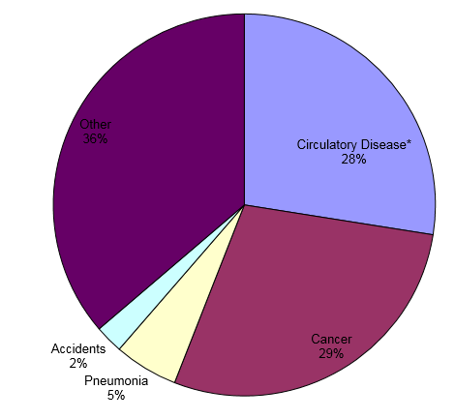 | 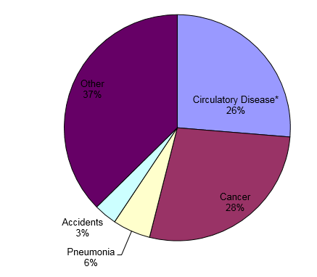
Source: NHS Digital Indicators
Peterborough has a larger percentage (37%) of deaths within the ‘other’ group – e.g. causes other than circulatory disease, cancer, pneumonia or accidents, than England (30%) and conversely slightly lower percentages of deaths from other main causes, with the exception of accidents (3% in Peterborough compared to 2% in England).
Figure 65: All-Cause Mortality, All Ages, Directly Age-Standardised Rates per 100,000, Peterborough & Cambridgeshire Trends, 2006-08 / 2014-16

Source: Office for National Statistics Mortality Data
The directly age-standardised rate of all-age, all-cause mortality in Peterborough has fallen between 2006-08 and 2014-16 from 1,173.0/100,000 to 1,031.3/100,000 but remains statistically significantly higher than that of neighbouring Cambridgeshire (904.5/100,000).
Figure 66: All-cause Mortality, Under 75s only, Directly Age-Standardised Rates per 100,000, Peterborough & Cambridgeshire Trends, 2006-08 / 2014-16

Source: Office for National Statistics Mortality Data
Under 75 all-cause mortality in Peterborough has fallen between 2006-08 and 2014-16 from 393.9/100,000 to 252.5/100,000. Over this same time period the Cambridgeshire rate fell from 340.5/100,000 to 235.8/100,000.
Figure 67: Cause-Specific Mortality, Directly Age-Standardised Rates per 100,000, Peterborough & Cambridgeshire, 2014-16
Area | All Ages |  |  |  |  | Under 75 Only
 | All Causes | Circulatory Diseases | CHD | Cancer | Respiratory Diseases | All Causes | Circulatory Diseases | CHD | Cancer | Respiratory Diseases
Peterborough | 1,031.3 | 252.5 | 127.8 | 281.5 | 152.0 | 378.5 | 80.6 | 45.6 | 147.3 | 41.6
Cambridgeshire | 872.5 | 231.4 | 95.2 | 252.1 | 108.5 | 283.7 | 62.7 | 31.0 | 120.8 | 24.2
Peterborough & Cambridgeshire | 904.5 | 235.8 | 99.5 | 258.2 | 117.1 | 303.4 | 66.3 | 33.9 | 126.4 | 27.6
Source: Office for National Statistics Mortality Data
Data show that Peterborough has statistically significantly higher rates than the Cambridgeshire and Peterborough average for all of the conditions listed within the table above, with the exception of all-age circulatory diseases. Deaths from circulatory disease under age 75 remain higher than the Cambridgeshire and Peterborough average.

Figure 68: Key Life Expectancy Indicators, Peterborough, 2013-15
Indicator | Time Period | Peterborough Value | England Value | Peterborough Status | Peterborough Trend | Peterborough CIPFA Ranking (1=Best, 16=Worst)
Healthy life expectancy at birth (Male), Years | 2013-15 | 61.8 | 63.4 | Statistically similar to England | ❐ | 10
Healthy life expectancy at birth (Feale), Years | 2013-15 | 62.4 | 64.1 | Statistically similar to England | ❐ | 6
Life expectancy at birth (Male), Years | 2013-15 | 78.6 | 79.5 | Statistically significantly worse than England | ❐ | 6
Life expectancy at birth (Female), Years | 2013-15 | 82.4 | 83.1 | Statistically significantly worse than England | ❐ | 6
Life expectancy at 65 (Male), Years | 2013-15 | 18.5 | 18.7 | Statistically similar to England | ❐ | 3
Life expectancy at 65 (Female), Years | 2013-15 | 20.9 | 21.1 | Statistically similar to England | ❐ | 4
Source: Public Health Outcomes Framework
Although healthy life expectancy, life expectancy at birth and life expectancy at age 65 have shown long term improvement since 2001-for both males and females, life expectancy at birth for males and females continues to be statistically significantly below national averages.

Figure 69: Life expectancy at birth, males, Peterborough, 2001-03 / 2013-15
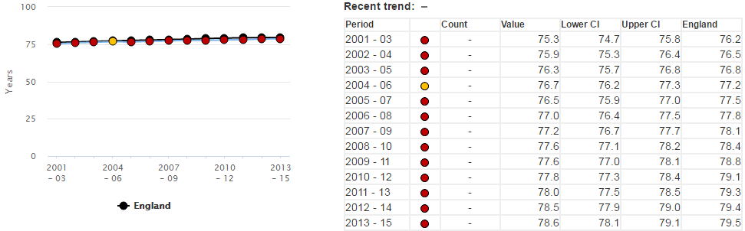
Source: Public Health Outcomes Framework
Male life expectancy at birth in Peterborough has been statistically significantly worse than England for each pooled period between 2005-07 and 2013-15.
Figure 70: Life expectancy at birth, females, Peterborough, 2001-03 / 2013-15
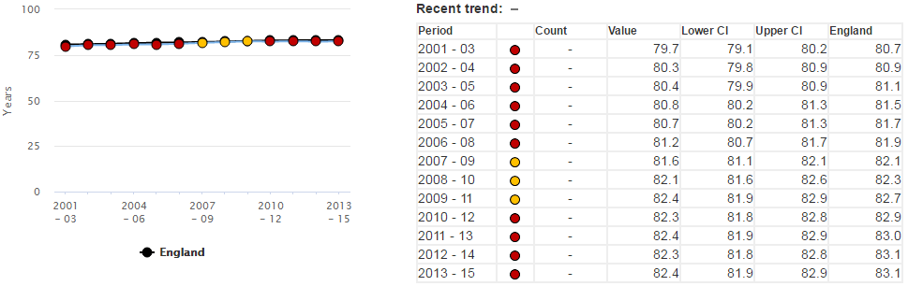
Source: Public Health Outcomes Framework
Female life expectancy at birth in Peterborough was statistically similar to that of England as recently as 2009-11 but has since ceased to increase at the same rate as that observed nationally. The current female life expectancy at birth in Peterborough is 82.4 years, the same value as 2009-11, whilst in England there has been an increase from 82.7 years to 83.1 years over the same time period.
Figure 71: Variation in Life Expectancy by National LSOA Deprivation Deciles, 2013-15
National Decile | Healthy Life Expectancy at birth |  | Life Expectancy at Birth
 | Males | Females | Males | Females
1 (Most deprived decile) | 51.9 | 52.2 | 74.0 | 78.9
2 | 56.1 | 56.1 | 76.1 | 80.4
3 | 59.3 | 59.5 | 77.4 | 81.7
4 | 61.4 | 62.3 | 78.7 | 82.5
5 | 63.8 | 64.7 | 79.6 | 83.1
6 | 65.2 | 66.5 | 80.4 | 83.6
7 | 66.9 | 67.0 | 81.0 | 84.2
8 | 67.5 | 68.7 | 81.4 | 84.5
9 | 68.4 | 68.8 | 82.1 | 85.1
10 (Least deprived decile) | 70.6 | 71.3 | 83.1 | 86.1
England | 63.4 | 64.1 | 79.5 | 83.1
Source: Public Health Outcomes Framework
Although data are not available at local super output area (LSOA) level locally, , the table above shows the contrasting values in healthy life expectancy at birth and life expectancy at birth between the most and least deprived LSOAs in England. The four most deprived deciles in England – which, as a relatively deprived area, contained many LSOAs within Peterborough - all have statistically significantly lower healthy life expectancy and life expectancy at birth for both males and females than the national average.
Figure 72: Directly age-standardised percentage of the population reporting good or very good health by gender, Peterborough, 2011
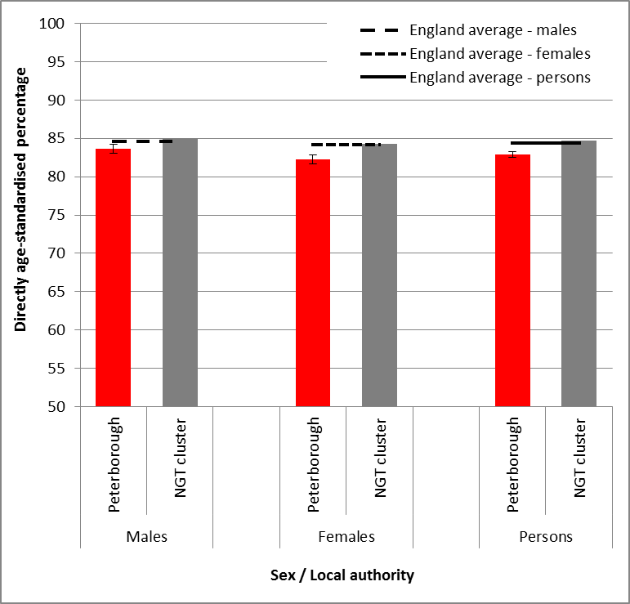
Source: Census 2011/Public Health Intelligence
For males, females and persons, a statistically significantly low percentage of people in Peterborough reported having ‘good’ or ‘very good’ health in the 2011 census compared to national averages.

Figure 73: Directly age-standardised percentage of the population with a long-term illness which affects day-to-day activities a lot health by gender, Peterborough, 2011
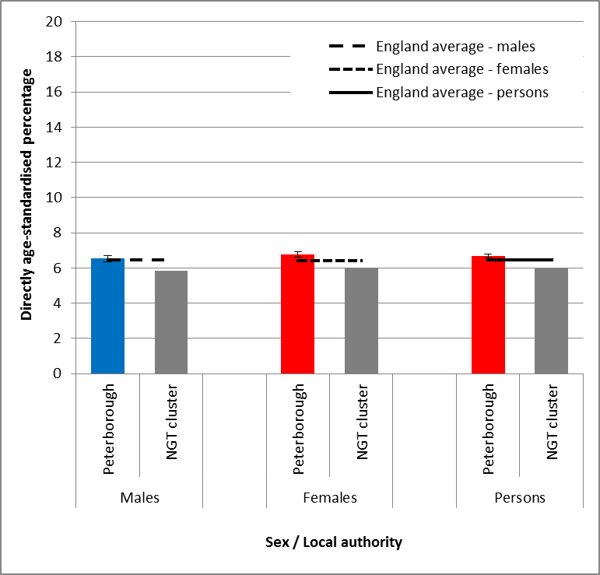
Source: Census 2011/Public Health Intelligence
Data show that the percentage of males reporting having a long term illness that affects their day-to-day activities a lot in Peterborough is similar to that of England, whereas for females and for all persons the percentage is statistically significantly high.

Peterborough Joint Strategic Needs Assessment (JSNA) Summary Topic Review

Since 2014, the below JSNA projects have been commissioned and completed by the Peterborough Health & Wellbeing Board:
- Pharmaceutical Needs Assessment 2015
- Children & Young People JSNA 2015
- Cardiovascular Disease JSNA 2015
- Mental Health & Mental Illness in Adults of Working Age JSNA 2016
- Diverse Ethnic Communities JSNA 2016
- Older People’s Primary Prevention JSNA 2017
Key findings from these projects are summarised below. It should be noted that the statistics quoted are from the time the themed JSNA was completed and therefore will generally not be the most recently available data.

9.1 Pharmaceutical Needs Assessment 2015

- Every Health & Wellbeing Board has a statutory duty to publish a statement of the need for local pharmaceutical services in its area at least once every three years. The first such assessment in Peterborough was published in 2015 and will be updated in 2018.
- At the time of the 2015 PNA, Peterborough had 43 community pharmacies, equivalent to 24 per 100,000 population – higher than both the national (22 per 100,000) and regional (20 per 100,000) averages. Pharmaceutical provision for both essential and advanced services was therefore considered sufficient.
- However, it was noted that locally commissioned services such as stop smoking appeared inadequate, evidenced by deteriorating quit rates, and relatively high smoking prevalence among both all adults and pregnant women specifically in comparison to national and regional averages. It was also noted also that no community pharmacies in Peterborough were commissioned to provide flu vaccination for over 65s and only 13 provided flu vaccination services for at risk groups and that no pharmacies provide sexual health services such as emergency hormonal contraception and chlamydia testing and treatment despite higher teenage pregnancy and low chlamydia detection rates compared to national and regional averages.
- Peterborough is one of the fastest-growing cities in the UK, with an ethnically diverse and relatively young population. As the population grows, community pharmacies have the potential to make a significant contribution to healthy ageing and the prevention, identification and management of diseases, through which demand on other healthcare services may be reduced. Due to the diversity of the local population, promotions may need to be targeted specifically to different groups to be of greatest benefit.
- A number of pharmacies are located in areas of Peterborough that have relatively low life expectancy and relatively high levels of deprivation. These pharmacies can help promote healthier living, including through direct health promotion campaigns in conjunction with Public Health, as well as providing appropriate minor ailment treatment services.

9.2 Children & Young People JSNA 2015

- Children and young people under the age of 20 made up 26.5% of the population of Peterborough in 2012, whereas the national average was 23.9%.
- In 2013, 40.8% of school children were from a minority ethnic background, significantly higher than the national average of 26.7%.
- The level of child poverty in Peterborough was worse than average, with 23.6% of children aged under 16 living in poverty compared to 20.6% in England.
- A lower percentage of students in Peterborough achieved 5 or more A*-C GCSEs and also more young people are not in education, employment or training than England.
- The rate of under 18 conceptions in Peterborough was, and remains, statistically significantly higher than England and the highest in the East of England.
- Rates of admission to hospital as a result of self-harm in young people were, and remain, statistically significantly worse in Peterborough compared to England.
- Of 20 indicators relating to the mental health of children and young people for which a national benchmark is available, Peterborough was below benchmark for 15 (75%).

9.3 Cardiovascular Disease JSNA 2015

- 2011-13 data showed Peterborough to have statistically significantly higher mortality rates than England for mortality from causes considered preventable, under 75 mortality from all cardiovascular diseases and under 75 mortality from all cardiovascular diseases considered preventable.
- Circulatory diseases are estimated to contribute towards 33.6% of the life expectancy gap between Peterborough and England for males and 53.9% for females. If Peterborough had the same mortality rates as England for circulatory diseases, local life expectancy would increase 0.45 years for males and 0.43 years for females.
- The number of people registered with a General Practice in Peterborough with cardiovascular disease is expected to rise 12.6%, from 21,467 to 27,306, between 2015 and 2031.
- Both the Borderline and Peterborough Local Commissioning Groups (now merged as Greater Peterborough Local Commissioning Group) had statistically significantly higher prevalence of diabetes and hypertension in 2013/14 compared to Cambridgeshire & Peterborough Clinical Commissioning Group, as well as higher percentages of adult smokers and obese adults.
- South Asian populations in the UK are known to have higher rates of premature coronary heart disease (CHD), therefore engagement with the substantial local South Asian populations in the area should be encouraged to improve related healthcare outcomes in Peterborough. Hospital admission and mortality data for circulatory diseases in Peterborough show a correlation between high rates of admission/mortality, relatively high levels of socio-economic deprivation and high percentages of Black & Minority Ethnic (BME) populations.
- Peterborough offers NHS Health Checks to a significantly higher percentage of residents aged 40-74 than England, however the ‘conversion rate’ i.e. the number of those invited who attend was relatively low at the time of this JNSA at 47.9%.

9.4 Mental Health & Mental Illness in Adults of Working Age JSNA 2016

- Many of the recognised risk factors for poor mental health are found at a higher rate in Peterborough than in England, including higher rates of socio-economic deprivation, numbers of children in care, incidents of violent crime, the rate of homelessness and prevalence of substance misuse.
- 28,000 adults in Peterborough were estimated to be living with a common mental health disorder (such as depression or anxiety disorders); this number is expected to rise 8.2%, to 30,296, by 2030.
- In 2014/15, over 11,000 referrals were made to secondary care (specialist) mental health services for adults within the Greater Peterborough Local Commissioning Group system
- Peterborough has lower levels of recorded depression than would be expected considering the aforementioned risk factors and prevalence data do not correlate with areas of deprivation. Further analysis would be required to ascertain whether this is as a result of under-recording and if therefore there is substantial unaddressed need within Peterborough.
- Hospital admission rates for adult self-harm in 2013/14 were the highest in the East of England, 40% above the national average rate.
- Suicide rates in Peterborough have fallen from being higher than England to now lower than England, although the difference is not statistically similar.

9.5 Diverse Ethnic Communities JSNA 2016

- Peterborough has a highly diverse population in comparison to England; at the time of the 2011 census, 29% of the Peterborough population self-identified with an ethnicity other than ‘White British’. Of these, ‘Asian or Asian British’ and ‘White Other’ were the most common responses, comprising 12% and 11% of the total respectively.
- The overall population of Peterborough increased by 17.7% between 2001 and 2011, with the greatest increases seen within the ‘White Other’ and ‘Black British or Black African’ category.
- Estimates of net international migration between 2009 and 2014 show Peterborough to have a higher rate of net migration than any other area of Cambridgeshire and Peterborough with the exception of Cambridge City. The non-UK born population in Peterborough is now estimated to be 206.3 residents per 1,000 total population.
- The Black & Minority Ethnic (BME) population varies significantly across Peterborough, comprising only 2.3% of the total population of the Barnack electoral ward but 58.2% of the total population of the Central electoral ward. Deprivation tends to be higher in areas of Peterborough with higher BME populations.
- Peterborough has the second-highest percentage of residents who cannot speak English well or at all in the East of England (4.9%). Luton is the highest in the East of England (5.4%) and both areas are statistically significantly higher than the England percentage of 1.7%. Inability to speak English is associated with relatively poor socio-economic outcomes and deprivation tends to be higher in electoral wards with high percentages of residents who cannot speak English well or at all.
- The 2015 School Census shows 35.1% of pupils in Peterborough speak a primary language other than English at home. GCSE attainment tends to be lower among pupils who do not primarily speak English at home.

9.6 Older People’s Primary Prevention JSNA 2017

- For the first time in history, the fastest growth in the UK’s population is among the older age groups. Although Peterborough’s older population is currently smaller as a percentage of the overall population than that of England, anticipated changes will see the proportion of older people soon aligning with projections nationally. This provides an opportunity to work with residents to enact positive change as they age to ensure better overall healthcare outcomes and thus lower demand on healthcare services in future years.
- The impact on healthcare outcomes in Peterborough of adverse behaviours remains significant even where progress is seen in relation to prevalence data – e.g. Peterborough’s smoking prevalence is statistically similar to that of England, however the rate of smoking-attributable hospital admissions in the area remains statistically significantly high. Hospital admissions for alcohol-related conditions (narrow definition, persons) also remain significantly higher than England.
- Specifically targeted interventions may be required across differing ethnic groups to improve overall healthcare outcomes in Peterborough. For example, data show that percentages of residents who do not achieve 30 minutes or more of moderate-intensity exercise per week are significantly higher among BME groups than ‘white’ ethnicity residents. World Health Organisation data also show that mortality rates from cardiovascular disease are significantly higher than England in countries from which relatively high levels of economic migrants have arrived in Peterborough in recent years, such as Poland, Lithuania and Estonia.
- Peterborough has been adjudged the most ‘car dependent city’ in the UK by the Campaign for Better Transport, due to the ease of travel by car within the area and relative lack of practical opportunities to walk/cycle. This presents a challenge from a public health perspective, as resultantly relatively few Peterborough residents are able to reach recommended levels of exercise through active travel as part of their ‘normal’ working day, thus putting additional emphasis on the need to improve active travel provision as well as other opportunities to exercise delivered via PCC and other stakeholders to maintain and improve population health.
- Only 11.9% of residents in Peterborough aged 55+ participate in sport/active recreation of at least moderate intensity for 30 minutes or more on a regular basis in Peterborough.
- A lower percentage of residents in Peterborough (48.0%) meet the recommended ‘5 a day’ fruit/vegetable consumption levels than in England (52.3%).

Sources of Further Information about the Health & Wellbeing of Peterborough’s Population

A wealth of additional reports and data relating to the health and wellbeing of residents of Peterborough and Cambridgeshire is available via the below sources:
Peterborough City Council
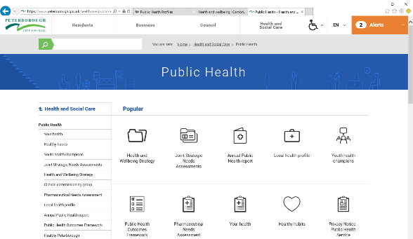
- Peterborough Public Health Directorate home and resources page.
- Peterborough local health profile.
- Peterborough public health outcomes framework (PHOF).
- Peterborough annual public health report.
- Peterborough joint strategic needs assessment (JSNA) page.
- Health advice for Peterborough (healthy Peterborough).
- Peterborough health and wellbeing strategy.

Cambridgeshire County Council
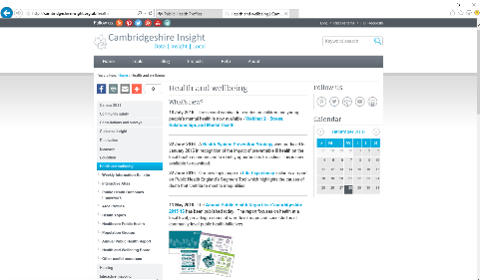
- Cambridgeshire Insight home page.
- Cambridgeshire Insight demography page.
- Cambridgeshire Insight health page.
- Cambridgeshire Insight area health profiles.
- Cambridgeshire Insight CCG/NHS healthcare page.
- Cambridgeshire Insight public health outcomes framework (PHOF).
- Cambridgeshire annual public health report.
- Cambridgeshire Insight joint strategic needs assessment (JSNA) page.
- Cambridgeshire County Council Public Health Directorate home page.
- Cambridgeshire health and wellbeing strategy.

Public Health England population health intelligence resources
Many of these cover local authority and CCG (NHS) data.
- Public Health England home page.
- Public Health England Fingertips topic and area based health profiles.
- Public health England subject-based data and knowledge gateway.
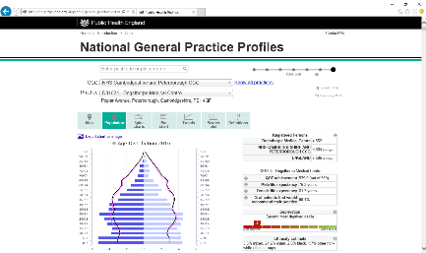
- Primary care data for England, CCGs and general practices.
- Topic based health intelligence networks (cancer; CVD; child and maternal health; mental health, dementia and neurology; end of life care).
- Public Health Outcomes Framework PHOF national site for national PHOF data and data for all local authorities.
- Small area population health data at Local Health.

CCG (NHS) specific intelligence resources
Please note that many of the resource links above include CCG and NHS data.

- NHS England resources for CCGs home page.
- NHS England commissioning intelligence model describes the steps in the commissioning cycle, provides example commissioning questions and potential data types and resources to answer them.
- NHS England CCG outcomes tools.
- NHS Right Care home page – Right Care looks at healthcare variation.
- NHS England Commissioning for Value suite of products and resources.
- NHS England primary care data web tool.
- National Institute for Health and Care Excellence (NICE): NICE home page, NICE pathways, NICE guidance; NICE standards and indicators and NICE evidence services.
- Cambridgeshire and Peterborough CCG home page.

Other analytical and population health intelligence resources
- NHS Digital home page – collected data and information resources from the umbrella body for information services in health and social care.
- Office for National Statistics home page - the national producer of official statistics and the recognised national statistical institute of the UK.
- The King Fund – data and policy briefings from the King's Fund independent charity who work to improve health and care in England.

http://www.centreforcities.org/wp-content/uploads/2017/01/Cities-Outlook-2017-Web.pdf
https://www.local.gov.uk/marmot-review-report-fair-society-healthy-lives
https://fingertips.phe.org.uk/profile/local-alcohol-profiles/data#page/6/gid/1938133118/pat/6/par/E12000006/ati/102/are/E06000031/iid/92774/age/168/sex/4
http://www.alcoholpolicy.net/2015/02/53-of-violent-incidents-alcohol-related-british-crime-survey-201314.html
https://www.drinkaware.co.uk/alcohol-facts/health-effects-of-alcohol/mental-health/alcohol-and-mental-health/
World Health Organisation, Global Recommendations for Physical Health. 2010. Available at http://www.who.int/dietphysicalactivity/factsheet_recommendations/en/
World Health Organisation, Global Health Risks. 2009. Available at http://www.who.int/healthinfo/global_burden_disease/global_health_risks/en/
‘Start active, stay active: a report on physical activity from the four home countries’, Chief Medical Officers (2011), Department of Health.

