Fenland community safety Partnership

Quarter 1 2018/19: Fenland Offending Profile

version 1.0
June 2018

‘Cambridgeshire Research Group’ (CRG) is the brand name for Cambridgeshire County Council’s Research & Performance Function. As well as supporting the County Council we take on a range of work commissioned by other public sector bodies both within Cambridgeshire and beyond.

All the output of the team and that of our partners is published on our dedicated website
www.cambridgeshireinsight.org.uk

For more information about the team phone 01223 715300
Document Details
Title: | Fenland Community Safety Partnership Q1 Strategic Assessment 2018/2019
Date Created: | May 2018
Description: | The purpose of this document is to provide the Fenland Community Safety Partnership with an understanding of key community safety issues affecting the district.
Produced by: | Jamie Leeman  Senior Research Analyst, Cambridgeshire County Council
Additional Contributions: | Alan Boughen, Aarron Locks  Fenland District Council
On behalf of: | The document has been produced by the CRG, on behalf of Fenland Community Safety Partnership and is available to download from Cambridgeshire Insight
Geographic Coverage: | Fenland district and Cambridgeshire County where relevant
Time Period: | 2018/19, plus historical data where relevant
Format: | word
Status: | Draft 0.1
Usage Statement: | This product is the property of the Research Group, Cambridgeshire County Council. If you wish to reproduce this document either in whole, or in part, please acknowledge the source and the author(s).
Disclaimer: | Cambridgeshire County Council, while believing the information in this publication to be correct, does not guarantee its accuracy nor does the County Council accept any liability for any direct or indirect loss or damage or other consequences, however arising from the use of such information supplied.

Contents

Contents
Contents 3
Section 1: Executive Summary 4
Key Findings 4
Recommendations 5
Section 2: Introduction 7
Understanding Offending in Fenland 7
Offender Needs 16
Accommodation as an Offender Need 18
Accommodation as an Offender Need in Fenland 23
Shoplifting 28
Dwelling Burglary 30
Fenland Community Survey 31
Appendix A 32
Appendix B 33

Section 1: Executive Summary

Key Findings
Offending and Offenders

Between April 2017 and March 2018, there were 878 offenders that were charged by the police with an offence in Fenland. These 878 individuals were associated with 1,352 recorded offences. This means some offenders committed more than one offence, although the majority of offenders (73%) committed just one offence.

In Fenland, most offences occur in urban areas (March, Chatteris and Whittlesey and Wisbech) and most offenders reside in these areas.

The data for 2017/18 shows an increase in the rate of offenders for Fenland after a period of decline. Fenland had recorded the fastest rate of decline (40%) in the volume of offenders known to the police, it is unclear from the data what has caused either the large decline or the recent slight increase. Similar recent increases have also been seen in the Youth Offending Service (YOS) cohort too. Through 2017/18 Fenland had 43 youth offenders registered with YOS.
- 2017/18: 8.9 offenders per 1000 population (878 offenders)
- 2016: 7.8 offenders per 1000 population (767 offenders)
- 2012: 13.2 offenders per 1000 population (1,267 offenders)
Analysis of known offenders to the police in Fenland showed that 74% were male and 26% female. This proportion of females is a higher than the rest of Cambridgeshire (20%). Similarly, 57% of offenders were White British but 18% were White Other, higher than the Cambridgeshire average (14%). The most common first offence category recorded by Fenland offenders was violence against the person (36%), followed by theft and handling, (25%).
Offender Needs
The individual needs of offenders can be overlapping and complex, with offending behaviour entrenched and therefore, this multi-faceted picture can require intensive support in order for reduction in recidivism to be achieved.
Of those assessed in Fenland, the most common need pathway to offending was ‘Thinking and Behaviour’ which assesses the offender’s application of reasoning, especially to social problems. Fenland also saw a high proportion of assessed offenders having negative attitudes towards offending. This pathway considers the offender’s attitude towards their offending and towards supervision.
In Fenland, the level of need among offenders (as assessed by CRC) is less complex and the prevalence of need is generally lower or in line with other districts in the county. Accommodation was an assessed need linked to offending for 13% of assessed offenders in Fenland, which was the second lowest of all districts in Cambridgeshire.

Accommodation
Accommodation need is a common amongst offenders leaving prison and is often seen as a root cause of reoffending. This is shown in both national and local research. The 2017 Cambridgeshire and Peterborough Offender needs assessment showed accommodation to be a common need across the different cohorts of offenders. On top of this, a report by Peterborough prison also highlighted high levels of accommodation need amongst those leaving prison.
There is currently no, or limited, provision for those who:
- Are near to their release date and have a change in housing circumstances which leaves insufficient time to arrange suitable alternative accommodation.
- Have no specific criteria or restrictions placed on them although have a previous history of housing debts, ASB or damage to property
- A history of poor coping mechanisms when all restrictions of custody are removed and have no statutory supervision arrangements
- Have no family or housing support network (including family or relationship breakdown)
- Require immediate access to housing when released directly from court following the case being dismissed, released on court bail or sentence is deemed served whilst on remand.
- Have exceeded all housing options in local area and have no local connection elsewhere in the country
Despite Fenland having the second lowest level of assessed accommodation need linked to offending in Cambridgeshire, it is recognised both locally and nationally that gaps in current accommodation provision for offenders is impacting on re-offending rates.
Shoplifting and Acquisitive Crime
Despite Fenland CSP making shoplifting as a focus priority in 2017/18, police recorded shoplifting across the district continues to increase.
The partnership has previous acknowledged a need for intervention here and some activity was placed in the 2017/18 action plan to tackle this.
A high proportion of those individuals in Fenland linked to the Integrated Offender Management (IOM) scheme are linked to serious acquisitive crime. IOM has limited effectiveness with shoplifting offenders and so tends not to receive as many referrals for this crime type.
There have also been short term increases in dwelling burglary in the district. The increases are mirrored across the force-wide area.

Recommendations
Whilst there are number of recommendations for possible activity by Fenland community safety partnership (FCSP) to tackle different aspects of offending, the two major recommendations to the partnership are:
- Through FCSP representation at the County Reducing Re-offending Group, the partnership should determine how best CSP members can help identify and refer to the IOM scheme those individuals identified as low level offenders or those on the brink of offending.
- Support the County IOM scheme in the development and introduction of a Rent Deposit Scheme to reduce re-offending.
Tackling Offending
The Cambridgeshire Criminal Justice Board (CCJB) are currently in the process of putting together a local action plan for delivery in tackling offending across the county. It is recommended that the CSP await for this action plan to be released and then identify how they can support with any local activity. Fenland Community Safety Partnership have representation on the county-wide reducing reoffending group and it should ensure that any local activity is shared or in line with county wide activity.
The CSP should continue to maintain a strong relationship with the Integrated Offender Management (IOM) scheme to help identify low level offenders or those on the brink of offending locally.
The county wide offender needs assessment highlighted that the risk factors for youth offending have a considerable overlap with the risk factors for other negative outcomes in adolescence including substance misuse, mental ill-health, low educational attainment and young parenthood. These are areas that members of the partnership are engaged in and could support here.
Tackling Accommodation Need
Whilst accommodation wasn’t the highest need, it is timely to focus on this to make the most of the current county level work on accommodation.
Access to housing cannot be resolved by the criminal justice system alone and will need collaboration across many authorities and partners whilst a clearer picture of the available housing in each area is needed, highlighting system gaps and policies. The recommendation here is that the CSP discuss the local challenges of supporting offenders and discuss ways that this can be improved in the district. The partnership should maintain existing links with the sub-regional housing board to share the outcomes of this.
Fenland District Council has provisionally agreed to support a rent deposit scheme that would help secure 20 rooms for those individuals linked to the Integrated Offender Management (IOM scheme) across Cambridgeshire and Peterborough, on a pilot basis of one year. The scheme will be supported by NACRO and landlords with maintaining the property. This ‘in principal’ agreement has so far been mirrored across Huntingdonshire and Peterborough. Should this scheme proceed, the CSP can support this by helping to identify those individuals that would benefit from IOM intervention and potentially benefit from this accommodation support.
The Cambridgeshire and Peterborough Trailblazer scheme works to support services to help reduce homelessness. Officers work to help organisations to identify the early warning signs of homelessness. Each individual partner within the Fenland CSP has the potential to play a key role in identifying individuals that could be on the verge of prevention. It is recommended that the CSP ensure that any relevant partners engage with the trailblazing project and look for ways in which that they can support the early identification of those on the verge of homelessness.
Additional information and advice on securing housing for ex-offenders can be found on Shelter’s website. NACROM is also national charity for ex-offenders and can provide advice in many areas, including housing. The partnership should work to help ensure that any individuals that may be on the brink of homelessness are receiving appropriate advice and guidance.
Shoplifting
The partnership should continue to prioritise Shoplifting as a focus area. This was a focus in 2017/18 and there have been further increases in shoplifting offences. The partnership have explored the opportunity of developing a scheme similar to Sue’s Essentials in East Cambridgeshire which aims to aims to reduce crime – theft in particular – through the distribution of free toiletries, sanitary items and underwear. The partnership should look to implement a similar, appropriate scheme in Fenland through 2018/19.

2: Introduction
The 2017/18 annual strategic review delivered to the Fenland Community Safety Partnership (FCSP), recommended that the partnership review the underlying causes of offending across the district. The main reason for this focus is that the district has seen increases in specific crime types but also, it is important that the partners looks to support some of the findings of the 2017 Cambridgeshire and Peterborough Offender Needs Assessment and further local analysis.
The purpose of this strategic assessment is to understand levels of offending in Fenland specifically and contributing factors to offending across the district, particularly accommodation. The ultimate aim is to provide recommendations for ways in which the CSP can help to tackle these contributory factors, locally, across the district.
It is a priority of the Fenland CSP to tackle offenders but this is also a priority across the force-wide area and across other CSP areas. The Cambridgeshire and Peterborough Police and Crime Commissioner’s Police and Crime Plan has tackling offenders as a key priority. This force wide approach is supported by the Cambridgeshire and Peterborough reducing reoffending group which includes representation from each of the community safety partnerships across the force-wide area.
Accommodation was identified as a specific offender need in the county wide assessment, alongside other local analysis, so it has been agreed that this would be a focus of this report. This will give the partnership the opportunity to understand this issue and discuss what can be done locally to support this specific need.
It is important to stress that the focus of this report will also be on those areas that the CSP can influence through future activity. Tackling accommodation need will cross over into other areas or partnerships, such as the Cambridge sub-regional housing board. It is therefore important to note that any recommendations within this report will be aimed directly at the CSP.

Understanding Offending in Fenland
In order to understand the scale of offending and type of offending need in Fenland, it is firstly important to study the level of known offending across the district and in particular, the number of known offenders. A number of data sources have been analysed to improve the understanding of offenders including offenders know to police, the Community Rehabilitation Companies (CRC) cohort, National Probation Service (NPS) data and those known to the Youth Offending Service (YOS).
By understanding the scale of offending and specific offending habits across the district, the assessment will then start to identify specific offender needs in the district.

Numbers in contact with criminal justice system (CJS)
According to the latest figures obtained from Cambridgeshire police, there were 878 unique offenders within Fenland from April 2017 to March 2018. This does not include those individuals who are defined as suspects. Other individuals known to be in contact with the CJS are those individuals managed by probation services.
In total, as of May 2018 Community Rehabilitation Companies (CRCs) manage 272 individuals in Fenland. The National Probation Service (NPS) manages a further 69 individuals in Fenland (February 2017) . Youth services also manage individuals that have offended and in 2017/18. Fenland had 43 young offenders registered with Youth Services in 2017/18.
The diagram below is designed to demonstrate the scale of the different offender cohorts in Fenland.
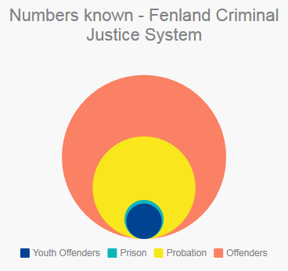
Figure 1: Diagram of numbers known to the Criminal Justice System (Fenland)

Understanding the current demand for services can lead to improvements in the future. However, it should be noted that any policy changes introduced (e.g. community sentences or restorative practices) will affect ‘where’ within the system offenders show up.
The table below shows the rate of offenders across Cambridgeshire and Peterborough over the last five years. For the purpose of this report, a 2017/18 update has been included for Fenland. For the past 5 years, Fenland has had a higher rate of offenders per 1,000 population than the force-wide total.
Fenland had recorded the fastest rate of decline in offenders from 1,267 in 2012 to 767 in 2016 (40% decrease). South Cambridgeshire had the slowest from 917 to 671 (27% decrease). The most recent rate for Fenland though shows an upturn in the rate in 2017/18. Despite this increase, the number of offenders in the district is in long term decline.
Table 1: Rate of known offenders to the police per 1000 population by district of residence
Year | Constabulary | Cambridge City | East Cambs | Fenland | Huntingdonshire | Peterborough | South Cambridgeshire
2012 | 10.8 | 11.5 | 7.3 | 13.2 | 8.3 | 16.7 | 6.1
2013 | 9.9 | 11.6 | 6.2 | 11.2 | 7.3 | 15.4 | 5.7
2014 | 8.8 | 10.0 | 5.6 | 11.2 | 6.3 | 13.7 | 5.1
2015 | 6.9 | 7.1 | 4.2 | 8.8 | 5.8 | 10.6 | 4.0
2016 | 7.1 | 7.1 | 5.1 | 7.8 | 5.2 | 11.4 | 4.4
2017/18 | N/A | N/A | N/A | 8.9 | N/A | N/A | N/A
Source: Cambridgeshire Police

Offenders Known to the Police in Fenland
Between April 2017 and March 2018 there were 878 offenders in total that were charged with an offence (meaning an individual was charged in relation to an offence by Police, does not indicate the disposal) in Fenland. Between these 878 individuals, 1,352 offences were committed. This means that some offenders committed more than one offence although the majority of offenders committed just one offence.
Table 2 below breaks down the total number of offenders by the number of crimes that they committed between April 2017 and March 2018. This shows that just 27% of all offenders committed 52% of all offences. In total, around 73% of offenders committed one crime only during the 12 month period.
Table 2: Offenders and Offences known to Cambridgeshire Police in Fenland, April 2017- March 2018
Number of Offences Committed | Number of Offenders | Total Offences | Percentage of offences | Percentage of offenders
1 | 644 | 644 | 48% | 73%
2 | 134 | 268 | 20% | 31%
3 | 50 | 150 | 11% | 17%
4 | 21 | 84 | 6% | 10%
5 | 7 | 35 | 3% | 4%
6 | 5 | 30 | 2% | 3%
7 | 7 | 49 | 4% | 6%
8 | <5 | 32 | - | -
9 | <5 | 36 | - | -
10 | <5 | 10 | - | -
14 | <5 | 14 | - | -
Profile of known offenders to police in Fenland
An offender profile can be seen on the following page which highlights the key demographics of the offenders within Fenland. The key points are as follows:
- Gender: 74% male / 26% female (large percentage of females compared to county-wide average of 20%).
- Ethnicity: 57% White British with a significant percentage of White Other (18%)
- Type of offences: The most common first offence category recorded by Fenland offenders was Violence against the person (36%) followed by Theft and Handling (25%)
- Age: The single largest age group were aged 14 years with a significant amount under 18. Otherwise there is a consistent pattern of offending from 13 to 37 years age.
Figure 2: A profile of offenders known to Cambridgeshire Police in Fenland, 2017/18
Offender Profile: |  | Number of Offenders | Percentage
 |  | 878
Gender | Male | 654 | 74%
 | Female | 224 | 26%
Age Group | Under 18 | 164 | 19%
 | 18-21 | 85 | 10%
 | 22-25 | 90 | 10%
 | 26-30 | 121 | 14%
 | 31-35 | 113 | 13%
 | 36-40 | 90 | 10%
 | 41-50 | 137 | 16%
 | 51-60 | 54 | 6%
 | 61+ | 19 | 2%
Ethnicity | White British | 503 | 57%
 | White: Other inc Irish | 154 | 18%
 | Black or Black British | 9 | 1%
 | Mixed | 14 | 2%
 | Asian or Asian British | 3 | 0%
 | Other inc Gypsy or Irish traveller | 8 | 1%
 | Refusal and Unknown | 187 | 21%
Offence category | Arson and Criminal Damage | 89 | 10%
 | Burglary | 31 | 4%
 | Drug Offences | 84 | 10%
 | Misc Crimes Against Society | 20 | 2%
 | Non-Crime | 13 | 1%
 | Possession of Weapons | 28 | 3%
 | Public Order Offences | 46 | 5%
 | Robbery | 7 | 1%
 | Sexual Offences | 14 | 2%
 | Theft and Handling | 219 | 25%
 | Vehicle Offences | 15 | 2%
 | Violence Against the Person | 312 | 36%

Youth Offenders
This section draws upon data from Cambridgeshire Youth Offending Service and aims to pull together the scale of the numbers of young people in contact with the criminal justice system in Fenland. The data in Figure 3 is as of 2016 as this was the most recent data available for the whole county, although more recent data has been made available for Fenland. Figure 3 breaks down the number of juvenile offenders by each district in Cambridgeshire. Of the five districts, Fenland had the third highest volume (41) in 2016.
Figure 3: Total Count of Juvenile Youth Offenders by district, 2016.

The county wide offender needs assessment highlighted that the risk factors for youth offending have a considerable overlap with the risk factors for other negative outcomes in adolescence including substance misuse, mental ill-health, low educational attainment and young parenthood. So generally, those interventions that are most effective with young people happen early on in their lives and address a broad range of behaviours not just offending. These schemes also produce a range of other benefits for the young person; not just to prevent re-offending and this is an area that the community safety partnership can add value.
The overview shown below shows that over the last three years the number of first time entrants (FTE) into YOS has increased. The national long term trend shows declining rates of young offenders despite these short term increases locally. Measured nationally in 2015/16 there has been an 83% reduction in First Time Entrants (FTEs) since 2006. In terms of future demand currently the population is forecast to increase (18.8%) across the district between 2016 and 2026 in the 10-19 year old age group. It is uncertain at this time how that will affect the volume of first time entrants.
Figure 4 below highlights the recent short term increases in the number of unique First Time Entrants into the Youth Offending Service by year. These short term increases mirror local increases in overall offending. A number of these FTE are linked to numerous offences but looking at each individual’s first offence, the most common offence in 2017/18 was common assault followed by destroy/damage to property.
Figure 4: The total number of unique First Time Entrants (FTE) to Youth Offending Service by year
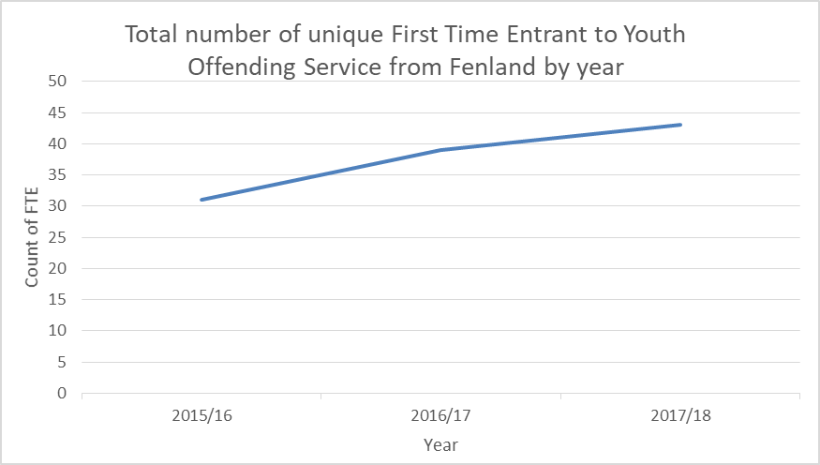

Fenland Community Rehabilitation Company Cohort
Whilst there are no ‘typical offenders’ it is possible to identify some key groups within the offending population. This section of the needs assessment considers adult offenders in Fenland managed by the Bedfordshire, Northamptonshire and Cambridgeshire (BeNCH) CRC which is run by Sodexo.
Offenders are managed for a number of reasons:
- They have been convicted of a crime and the court has given them a community sentence. A community sentence is a punishment that is carried out within the community and can include the offender having to do unpaid work, take a training course to address an aspect of their behaviour or perhaps have some restrictions on them such as a curfew.
- An offender has been released from prison ‘on licence’. Being on licence means that they are serving part of their sentence in the community and are subject to certain terms and conditions which if breached would mean that they would have to return to prison.
The information in the following section is based on data from the Offender Assessment System (OASys) database and is based upon the details of clients who were on the caseload of the CRC in May 2017, a total of 278 people.
Each offender supervised by the CRC is subject to an assessment of the risk they pose to others and themselves, this also includes contributing factors to their offending. The Offender Assessment System (OASys) provides an assessment against eight criminogenic need factors and an additional two contributing factors to offending. The criminogenic needs are identified where the offender manager states that the need is directly linked to offending behaviour. These are featured in the analysis.
Note on Key findings:
Any comparisons with the previous analysis on offenders published by the Research Group must take into consideration that an ‘additional’ group – i.e. those sentenced to less than 12 months were not within the previous cohort and any differences might be explained purely by that difference. In the absence of a complete explanation of changes over time caution should be taken with any comparison.
Whilst a demographic profile of the CRC cohort was included as part of the 2017 offender needs assessment, an update as of May 2018 has been included within this report for Fenland. Analysis of the data showed that of the 272 CRC service users registered in Fenland:
- 17% were female (46), 83% male.
- 27 individuals (10.1%) were in transient or temporary accommodation
- 4 individuals registered homeless and 1 with no fixed abode
- 33% (89) have a disability of some description (predominantly mental health issues)
- 4.5% have had issues with suicide / self-harm.
- 7.5% are under age of 21 (20 individuals)
- Largest age group are 31-35 (56 individuals)
- Rural tenants make up the single largest grouping with 19% (51) as measured against the ONS’s pen portraits groupings.
- White British make up 67% of all CRC service users, with White Other making up 24%
- Very few Asian, Black or Mixed ethnicity service users.
- A large proportion of service users committed violent offences (33%).
- Even split between service users on probation due to acquisitive offences and motoring offences (23%)

National Probabtion Service (NPS) Cohort
Analysis of National Probation Service (NPS) clients in Cambridgeshire and Peterborough.
This section of the strategic assessment focuses on adult offenders that are managed by the National Probation Service (NPS). The NPS is a statutory criminal justice service that supervises high risk offenders released into the community. The NPS was set up in conjunction with the creation of CRC’s in 2014 before coming operational in 2015.

The information in the following section is based on data from the Offender Assessment System (OASys) database and is based upon the details of clients who were on the caseload of the CRC in February 2017, a total of 90 people.
The NPS has a variety of responsibilities that include;
- preparing pre-sentence reports for courts, to help them select the most appropriate sentence
- managing approved premises for offenders with a residence requirement on their sentence
- assessing offenders in prison to prepare them for release on licence to the community, when they will come under our supervision
- helping all offenders serving sentences in the community to meet the requirements ordered by the courts
- communicating with and prioritising the wellbeing of victims of serious sexual and violent offences, when the offender has received a prison sentence of 12 months or more, or is detained as a mental health patient
This section analyses OASys data as with the CRC Cohort. The data provided details the clients supervised by the NPS in Fenland / Cambridgeshire as of February 2017. As with the CRC Cohort NPS Clients are assessed using the OASys tool. The Offender Assessment System (OASys) provides an assessment against eight criminogenic need factors and an additional two contributing factors to offending.
General demography
- 97% of Fenland NPS Clients are male
- 76% are White British with 16% White Other (highest in the county)
- Largest age groups is 51-60 with 20% of NPS Service Users
Significant variations between Fenland and other districts are outlined below, however differences between districts will be impacted by the local demographic profile:
- Fenland has the highest level of White Other NPS Clients of all the local districts reflecting the demographic makeup.
Figure 5: Profile summary of NPS Cohort (Feb 2017)
 |  | Constabulary | Cambridge | East Cambs | Fenland | Huntingdonshire | South Cambs | Peterborough | Out of County | No Geographic Data
Number of  Offenders Per District | Number of Offenders | 1448 | 85 | 39 | 90 | 140 | 60 | 331 | 372 | 283
Gender | Male | 96% | 99% | 95% | 97% | 96% | 97% | 95% | 98% | 94%
 | Female | 4% | 1% | 5% | 3% | 4% | 3% | 5% | 2% | 6%
Age Group | 21 and under | 7% | 8% | 8% | 1% | 7% | 8% | 8% | 7% | 6%
 | 22-25 | 14% | 16% | 8% | 18% | 12% | 13% | 14% | 11% | 15%
 | 26-30 | 15% | 18% | 18% | 17% | 14% | 18% | 13% | 14% | 13%
 | 31-35 | 17% | 15% | 18% | 16% | 19% | 25% | 16% | 15% | 18%
 | 36-40 | 10% | 7% | 10% | 8% | 10% | 3% | 14% | 10% | 10%
 | 41-50 | 17% | 14% | 15% | 16% | 18% | 17% | 16% | 18% | 17%
 | 51-60 | 15% | 16% | 10% | 20% | 11% | 13% | 15% | 15% | 12%
 | 61 or older | 7% | 5% | 13% | 6% | 9% | 2% | 5% | 10% | 5%
 | Not known | 0% | 0% | 0% | 0% | 0% | 0% | 0% | 0% | 4%
Ethnicity | White British | 75% | 77% | 90% | 76% | 87% | 75% | 71% | 80% | 73%
 | White: Other inc Irish | 10% | 7% | 5% | 16% | 4% | 10% | 9% | 8% | 13%
 | Black or Black British | 4% | 6% | 0% | 2% | 3% | 5% | 6% | 4% | 4%
 | Mixed | 1% | 2% | 0% | 0% | 1% | 3% | 2% | 1% | 2%
 | Asian or Asian British | 4% | 5% | 0% | 0% | 2% | 0% | 8% | 4% | 2%
 | Other, Gypsy or Irish traveller | 2% | 0% | 3% | 7% | 1% | 5% | 4% | 3% | 2%
 | Refusal and Unknown | 0% | 2% | 3% | 0% | 1% | 2% | 0% | 1% | 2%
Order Category | Community Order | 20% | 31% | 44% | 28% | 20% | 40% | 24% | 11% | 13%
 | Post release | 28% | 47% | 21% | 41% | 36% | 37% | 37% | 19% | 17%
 | Pre-release | 53% | 22% | 36% | 31% | 44% | 23% | 38% | 70% | 71%
 | Terminated | 0% | 0% | 0% | 0% | 0% | 0% | 0% | 0% | 0%
OGSR 3 | Low <25 | 27% | 35% | 41% | 43% | 46% | 37% | 30% | 48% | 27%
 | Medium 25-40 | 11% | 8% | 21% | 14% | 15% | 13% | 14% | 14% | 10%
 | High 41-79 | 32% | 38% | 18% | 30% | 31% | 35% | 42% | 30% | 37%
 | Very High 80+ | 11% | 19% | 21% | 6% | 6% | 15% | 10% | 7% | 15%
 | Blank | 18% | 0% | 13% | 0% | 0% | 0% | 0% | 0% | 0%
Offence category | Acquisitive | 6% | 8% | 13% | 8% | 1% | 3% | 7% | 3% | 8%
 | Drugs | 2% | 7% | 3% | 1% | 0% | 3% | 2% | 1% | 1%
 | Motoring | 3% | 2% | 8% | 7% | 3% | 3% | 2% | 2% | 1%
 | Other | 10% | 8% | 15% | 6% | 4% | 7% | 15% | 7% | 11%
 | Robbery | 8% | 12% | 3% | 7% | 4% | 7% | 8% | 5% | 12%
 | Sexual | 30% | 34% | 26% | 32% | 49% | 30% | 23% | 35% | 31%
 | Violence | 41% | 28% | 33% | 40% | 39% | 47% | 43% | 46% | 35%
 | Blank | 0% | 0% | 0% | 0% | 0% | 0% | 0% | 0% | 0%
Pathways | Accommodation | 38% | 39% | 33% | 17% | 29% | 26% | 42% | 36% | 46%
 | ETE | 24% | 27% | 19% | 23% | 20% | 22% | 23% | 21% | 31%
 | Finance | 36% | 37% | 22% | 35% | 20% | 30% | 33% | 32% | 51%
 | Relationships | 69% | 79% | 56% | 64% | 72% | 57% | 69% | 71% | 69%
 | Lifestyles | 79% | 79% | 70% | 70% | 78% | 52% | 81% | 79% | 86%
 | Drugs | 56% | 56% | 63% | 54% | 54% | 76% | 36% | 54% | 42%
 | Alcohol | 50% | 56% | 44% | 36% | 51% | 50% | 48% | 51% | 53%
 | Emotional | 47% | 49% | 41% | 42% | 44% | 59% | 44% | 50% | 48%
 | Thinking and Behaviour | 97% | 94% | 100% | 97% | 93% | 94% | 97% | 96% | 99%
 | Attitudes to offending | 71% | 71% | 37% | 65% | 64% | 63% | 75% | 68% | 78%
Disability | Yes | 31% | 41% | 41% | 31% | 30% | 33% | 36% | 27% | 27%
 | No | 68% | 56% | 56% | 69% | 70% | 65% | 64% | 73% | 70%
 | Unknown | 1% | 2% | 3% | 0% | 0% | 2% | 0% | 1% | 2%
Mental Health | Yes | 15% | 18% | 13% | 14% | 13% | 10% | 20% | 12% | 15%

Offender Needs
This assessment has already identified how many offenders there are in the district and the demographic profiles of the different cohorts of known offenders. The assessment will now look at the specific needs of those that offend in the district and the potential contributory to offending habits across the district. The pathways section of the NPS profile table in Figure 5, above, begins to give insight here. Whilst accommodation wasn’t the highest need, it is timely to focus on this to make the most of the current county level work on accommodation.
The data in this section is from the Offender Assessment System (OASYs) that identifies and classifies offending related needs (i.e. issues that are assessed as directly related to offending behaviour), such as accommodation and poor literacy. These were carried out by CRC and NPS up until 2017 but they now have a new form of assessment. Tackling these specific needs can reduce the probability of re‐offending. There are ten ‘pathways’ assessed within OASys which help to identify these specific offending related factors.
Table 3 below offers a breakdown of all completed assessments with OASys and the pathway to offending by district. Of those assessed in Fenland, the most common pathway to offending was ‘Thinking and Behaviour’ which assesses the offender’s application of reasoning, especially to social problems. Research indicates that offenders tend not to think things through, plan or consider consequences of their behaviour and do not see things from other people’s perspectives. Those with a number of such ‘cognitive deficits’ will be more likely to re‐offend.

Table 3: Breakdown of completed assessments OASys and the pathway of individuals to offending by district

*A full definition of each pathway can be found in the appendix of this document
 |  |  | Cambridge | East Cambs | Fenland | Hunts | South Cambs | Peterborough | No Geographic Data
 |  | Total OASys assessments completed | 204 | 78 | 188 | 198 | 122 | 503 | 289
Pathways |  | Accommodation | 40 | 7 | 25 | 31 | 20 | 92 | 108
 |  | Education Training and Employment | 42 | 15 | 47 | 31 | 24 | 138 | 94
 |  | Relationships | 88 | 33 | 72 | 82 | 53 | 220 | 175
 |  | Lifestyles | 76 | 25 | 52 | 60 | 36 | 181 | 172
 |  | Drugs | 59 | 13 | 30 | 41 | 26 | 117 | 136
 |  | Alcohol | 58 | 22 | 55 | 58 | 34 | 148 | 120
 |  | Thinking and Behaviour | 171 | 72 | 172 | 173 | 104 | 451 | 262
 |  | Attitudes to offending | 126 | 49 | 132 | 107 | 75 | 335 | 182
 |  | Finance | 60 | 13 | 31 | 43 | 26 | 129 | 134
 |  | Emotional | 71 | 21 | 50 | 52 | 37 | 130 | 108

Fenland also saw a high proportion of assessed offenders having negative attitudes towards offending. This pathway considers the offender’s attitude towards their offending and towards supervision. A growing body of research demonstrates that pro‐criminal attitudes are predictive of reconviction. Addressing attitudes can reduce the likelihood of reconviction.
At a force-wide level, the pathways of offending were also studied across different demographic sub-groups within the offender needs assessment. Each of the pathways require a multi-agency approach. Cambridgeshire Constabulary are looking to tackle underlying reasons of offending through the use of Conditional Cautioning via the Offender Hub. With a Conditional Caution, the offender’s issues are identified and appropriate conditions are set as well as the timeframe in which it needs to be completed by. Once the condition or conditions are met, the case is finalised and there is no prosecution.
There are a range of agencies involved in the Conditional Cautioning partnership including Drug and Alcohol teams and Outside Links which offer a range of support including housing, finance, benefit and debt support, employment training and education. They can also assist individuals with accessing support agencies such as food banks and help with form filling. The work here is reactionary to offender needs and there is a role within the CSP to take a preventative stance of offending through promotion of relevant services.

Complexity of need
The table below summarises the number of assessed needs by the number of offenders, as captured within OASys. Whilst the highest grouping had no assessed needs, there were more individuals with at least 1 assessed need than none. It is important that the partnership acknowledges that the needs of a certain subset of offenders are particularly complex with a number of contributory factors.
Table 4: Breakdown of offenders by the number of assessed needs, OASys Database, February 2017
Number of assessed need | Count of offenders
0 | 92
1 | 15
2 | 45
3 | 39
4 | 32
5 | 23
6 | 13
7 | 8
8 | 5
9 | 3
The 2017 Cambridgeshire and Peterborough Offender needs assessment showed accommodation to be a common need across the different cohorts of offenders. On top of this, a report by Peterborough prison also highlighted that between January and June 2017, 333 sentenced residents were released from HMP Peterborough and of this cohort 59% were released with no accommodation. Similarly, between July and December 2017, 313 residents were released from HMP Peterborough with 33% having no accommodation.
It was agreed on the back of these two key sources of analysis that the CSP should look to focus their understanding of accommodation as a specific offender need and it is recommended that the partnership should understand this area and have a focussed conversation to ways that they can support this. Whilst Fenland had the lowest rate of assessed accommodation need (17%, Figure 5) of all districts in the NPS cohort, it has been recognised as an underlying cause of offending both locally and nationally.

Accommodation as an Offender Need

Introduction
Research carried out by the Centre of Housing Policy at York University on behalf of the Joseph Rowntree Foundation in 1996 concluded that ex-prisoners were more likely to re-offend if they did not find satisfactory accommodation on release. Evidence at that time suggested that the general level of housing assistance prisoners received was ‘inadequate’
It is not just a lack of accommodation that can have an effect on the behaviour of individuals. The type, quality and locations are also important. This variety of factors within an accommodation context can affect the behaviour of potential offenders. There can be anti-social risks with certain accommodation that could affect the individual’s relationships with friends, family, cohabitees, neighbours or visitors for example. There can be anti-social risks associated with specific locations, for example if there are offending opportunities nearby.
Some crimes can be directly linked to accommodation such as vagrancy, illegal occupation of premises, travelling, begging and consumption of alcohol (if the individual has no accommodation and consumes alcohol in a public place). There are also indirectly related crimes; an individual may live in an area of high crime and by association become involved in crime such as drug dealing or theft.
A majority of analysis within the 2017 Cambridgeshire and Peterborough review of the housing need of offenders is derived from OASys data. In OASys, accommodation needs include ‘no fixed abode’, ‘transient’ or ‘unsuitable’ accommodation, lack of ‘permanent’ accommodation and ‘unsuitable location’ (meaning close to criminal associates or potential victims). This is a range of quite different situations that offenders may face.
Over a third (38%) of the assessed NPS Cohort have been identified as having issues related to accommodation that can be linked to their criminal behaviour. NPS individuals by default have committed more serious offences which may mean they lead more chaotic lifestyles prior to their latest offence. Similarly to repeat CRC offenders the more prolific and more serious offenders are less likely to have stable housing to return to.

Among the local prison population which includes Bedford prison and the higher security prisons of Whitemoor and Littlehey there is a far higher prevalence of accommodation need with an average of 53% of offenders identified as having an accommodation need. More specifically for Cambridgeshire, 57% of male and 63% of women prisoners at Peterborough prison have been identified as having an accommodation pathway need.

The highest accommodation need identified among the sub groups of offenders is prisoners at HMP Peterborough with 60% (335) of the 559 assessed prisoners showing an accommodation need. The reason for this might be that prisoners are by default serving a custodial sentence (unless on remand) and so potentially have no home to go back to or have committed their offences because of a lack of stability with regard to housing. Offenders generally tend to lead more complicated and unorganised lives than the general population. Not having a consistent home can causes issues with health, employment and relationships.

Cambridgeshire and Peterborough Offender Needs Assessment, 2017
Figure 6, taken from the county wide offender needs assessment, breaks down the level of assessed accommodation need from OASys and YOS assessments.
Some reports have suggested that two-thirds of prisoners need help to find accommodation when approaching a release date, or probation. As such, ex-offenders may find themselves homeless, or in temporary and unstable homes.
Figure 6: Breakdown of assessed accommodation need by cohort, OASys and YOS Assessments
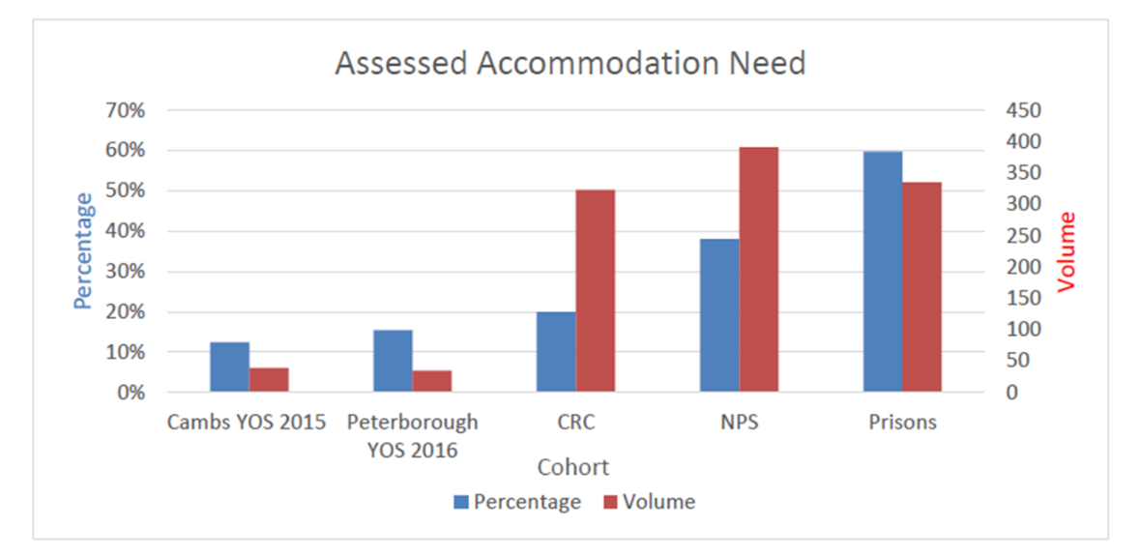
Figures 7 and 8 though offer a breakdown of the number of offenders that are released from Peterborough prison either with accommodation or no fixed abode. Clearly, there are a number of offenders (both male and female) leaving Peterborough prison, some of which will be Fenland residents, with no permanent accommodation. As shown in figure 7, between January and June 2017, 63 males were released from Peterborough prison with no fixed abode (NFA) in Cambridgeshire.
Currently, if an individual is homeless on release a local authority may have a statutory duty to assist but they must only secure accommodation if the ex-offender is a priority need. Even if the offender is not entitled to assistance, the authority must provide advice.

Figure 7: Assessed Accommodation need amongst males released from Peterborough Prison, Jan-Jun 2017
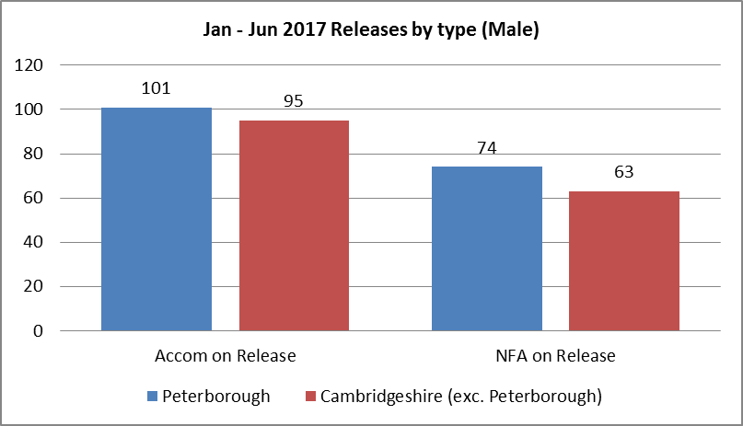
Similarly, figure 8 shows that between January and June 2017, there were 22 females in total released from Peterborough prison with no fixed abode (NFA), 7 of which were released into Cambridgeshire.
Figure 8: Assessed Accommodation need amongst females released from Peterborough Prison, Jan-Jun 2017
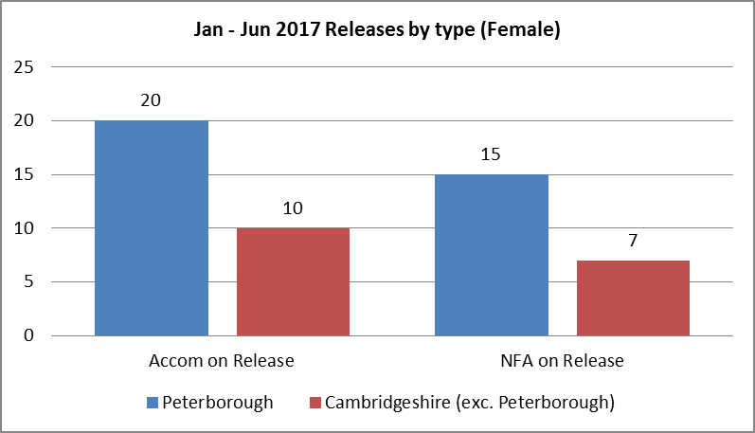
The OASys assessments and the above evidence provided by Peterborough prison highlights that accommodation is a common offender need and the next section of this assessment will look at the specific importance and implications of this.

ACCOMMODATION
Housing or shelter makes up one of our key needs along with air, food, water, clothing and warmth according to Maslow’s hierarchy of needs. Without housing we are reduced to a struggle to survive, without an address access to jobs and services can be extremely limited. Whilst appropriate housing may be an issue for a large number of offenders it is known that for some it can actually lead to criminal behaviour. Housing issues can result in criminal behaviour but conversely entering the criminal justice system can be the cause of housing issues. Suitable accommodation is potentially crucial to providing an individual with a stable and reliable lifestyle. Time in prison however can cause a person to lose their home and homelessness can lead to re-offending. A pattern of offending can contribute to problems finding suitable accommodation.
A recent report released by the Justice Commons Select Committee found the following:
A Ministry and Justice research assessment highlighted that homeless offenders entering prison have a much higher reconviction rate in a year (79% vs 47%) and research also shows that reoffenders have a much higher accommodation need. National research suggests that around 15% of prisons within a sample of research reported being homeless before custody suggesting a need to tackle homelessness as an intervention against offending. Similarly, several studies and surveys have found a high proportion of those rough sleeping or the ‘hidden homeless’ has spent time in jail. In 2011 Crisis reported that, of the hidden homeless they had talked to, 33% had spent time in prison.
“There are strong links between homelessness and reoffending, therefore we find that it is unacceptable that any local council has been able to deem an individual who has served a custodial sentence as making themselves intentionally homeless. We call on the Government to amend its guidance for Local Authorities to make it explicit that an individual who is homeless because of having served a custodial sentence should be deemed vulnerable for the purposes of the Homelessness Reduction Act 2017.
…Currently offenders cannot apply for Universal Credit until they are released from custody. For many this can mean that they have the £46 discharge grant to live on for a number of weeks. We call on the Ministry of Justice and the Department for Work and Pensions to enable offenders serving custodial sentences to apply for Universal Credit (UC) prior to their release from custody so that they receive UC on the day of release. In the interim we recommend that the Ministry of Justice set up a transitional credit fund for those offenders who have insufficient funds to provide for the basics.”

Figure 9 below summarises one key cycle of reoffending and the role that accommodation need plays in this. The evidence supplied by Peterborough prison shows that it is not uncommon for offenders to leave prison with no fixed abode or accommodation need and this can lead to homelessness with in turn leads to reoffending.
Figure 9: Diagram representing the potential cycle of offending where accommodation is a need

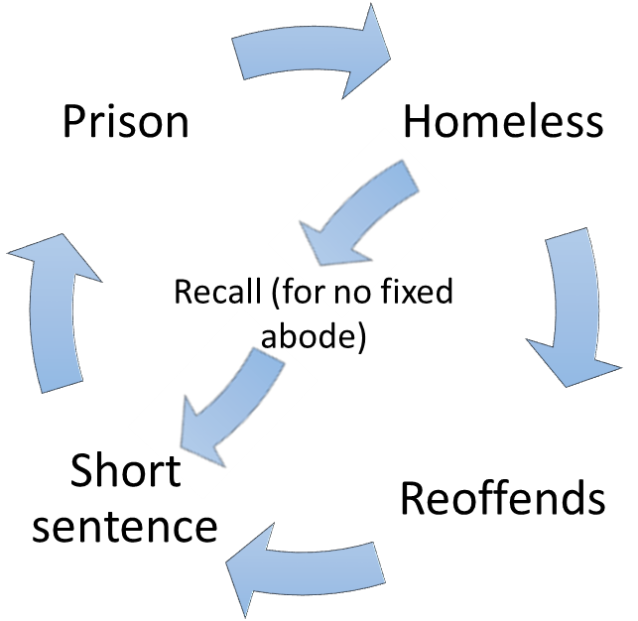

Accommodation as an Offender Need in Fenland
Whilst evidence shows that accommodation is a common need amongst offenders, including those leaving Peterborough prison, it is important to understand accommodation as a specific offender need in Fenland. Analysis of a snapshot of probation data from February 2017 showed that in Fenland there was 365 individuals in probation and at least 37 of these had accommodation needs linked to their offending. Of those in probation over half are lower risk, though still likely have complex needs.
These numbers will be an under-estimate of housing need in those with an offending history as:
- It only includes those where accommodation need is deemed to contribute to offending behaviour
- There is no geographic data on 21% of those in probation, and 24% had not completed a needs assessment
- This does not include young offenders, those in prison on remand (who do not receive a sentence) or those in contact with the police (e.g. receive a caution)

Addressing Accommodation Need
In Cambridgeshire and Peterborough, the 5 district councils of South Cambridgeshire, Cambridge City, East Cambridgeshire, Huntingdonshire, Fenland and the Unitary Authority of Peterborough are responsible for their individual housing strategies. South Cambridgeshire and Cambridge City are the only remaining districts with their own social housing stock. However, there are still housing associations working in these 2 districts. Huntingdonshire, Fenland, East Cambridgeshire and Peterborough have passed their social housing stock to housing association partners known as the stock landlords. This means that the majority (but not all) of social rented housing is managed by the relevant stock transfer landlord.
To understand accommodation needs i.e. people waiting to move into social rented housing, the majority of this work is undertaken by Home-Link which is a sub-regional housing lettings system. Unfortunately, Home-Link data was not able to be provided for this report. Home-Link offer accommodation support to individuals based in their circumstances and on a prioritisation basis. The criteria for each level of prioritisation can be found in Appendix B of this document.
Table 5 breaks down the existing provision of total social dwelling across Cambridgeshire and Peterborough.
Table 5: Current provision of total social dwellings in Cambridgeshire and Peterborough
 | Local Authority (incl. owned by other LAs) | Private Registered Provider | Other public sector | Total | Population | Rate per 1000
Cambridge | 6,920 | 4,890 | 100 | 11,910 | 136,240.00 | 87.4
East Cambs | 10 | 5,200 | 120 | 5,330 | 87,170 | 61.1
Fenland | 0 | 5,560 | 10 | 5,570 | 98,340 | 56.6
Huntingdonshire | 0 | 9,600 | 120 | 9,720 | 177,770 | 54.7
South Cambs | 5,250 | 3,480 | 150 | 8,880 | 153,890 | 57.7
Peterborough | 10 | 15,740 | 520 | 16,270 | 198,130 | 82.1
Total | 12,190 | 44,470 | 1,020 | 57,680 | 851,540

Fenland has the second lowest rate of social dwellings per 1,000 population of the 6 local authorities across Cambridgeshire and Peterborough. This means an offender could be made to wait for suitable accommodation. The impact of this can mean an offender is provided emergency accommodation in a hostel if available. Alternatively they may choose to stay with friends or family or even sleep rough. This can be a particular issue for those on short sentences or those returning to prison within a short period after their release.

Current Provision
The below section outlines the current provisions in place to support offenders with accommodation need.
Ex-Offender Project – Luminus (Wisbech)
In total, there are 12 places for clients that are engaged with Inclusion substance misuse treatment service and those who have an offending history with support provided. Of these 12 places, 10 places in Huntingdon (Huntingdonshire) and 2 places in Wisbech (Fenland). Clients are referred for nomination to the local authority with a recommendation for a band A priority with Homelink following a successful tenancy.

Luminus - The Ferry Project (Wisbech)
Here, supported accommodation is available. Clients are referred for nomination to the local authority with a recommendation for a band A priority with Home link following a successful tenancy.

Genesis Housing (Wisbech and March)
Single homeless people with support needs. Referrals are accepted from local housing authority, other housing providers, probation, youth offender’s scheme, mental health teams, young people's service, drugs and alcohol services, adult social care. There are 9 Places in both March and Wisbech.

Wisbech Foyer
Run by Axiom housing for up to 17 young people between the ages of 16 and 25 yrs. There are also two ‘move on’ flats for those residents who are ready to make the next step towards independence.
All referrals are via the Fenland Joint Allocation Panel (JAP) and can be made by the applicant or via any a relevant agency.

What are the Gaps?
As mentioned, there is local and county-wide provision for those individuals with specific housing needs based on their circumstances. There are gaps in this provision though and accommodation can be difficult to secure for those individuals who:
- Are near to their release date and have a change in housing circumstances which leaves insufficient time to arrange suitable alternative accommodation
- Have no specific criteria or restrictions placed on them although have a previous history of housing debts, ASB or damage to property
- A history of poor coping when all restrictions of custody are removed and have no statutory supervision arrangements
- Have no family or housing support network (including family or relationship breakdown)
- Require immediate access to housing when released directly from court following the case being dismissed, released on court bail or sentence is deemed served whilst on remand
- Have exceeded all housing options in local area and have no local connection elsewhere in the country
These are all gaps in provision that is difficult for the CSP to resolve and is based largely on local housing policy and is a sub-regional housing issue. The Cambridgeshire and Peterborough offender needs assessment highlighted that access to housing cannot be resolved by the criminal justice system and will need collaboration across many authorities and partners. A clearer picture of the available housing in each area is needed, highlighting system gaps and policies. The CSP can help here be identifying and magnifying the focus on those areas where there may be current gaps locally.

Cambridgeshire and Peterborough Trailblazer Partnership
As identified, tackling homelessness is an intervention that can help to tackle offending or re-offending. The Cambridgeshire and Peterborough Trailblazer scheme works to support services to help reduce homelessness. Officers work to help organisations to identify the early warning signs of homelessness and identify ways to prevent it. The Trailblazing partnership works to:
- Educate organisations to recognise the early warning signs of homelessness and ways to prevent it
- Help people as early as possible when threatened with homelessness
- Promote housing health checks and budgeting tools
- Support agencies to make action plans for those at risk of homelessness
- Ensure customers are engaging with help given to prevent homelessness
- Work closely with housing options teams to see what has been successful and what has not and utilise feedback to further develop the project
- Run a homeless prevention hub and private rent and landlord solution service.
The partners linked to the trailblazer project include:
- Cambridge sub-regional housing board (CRHB)
- Cambridgeshire and Peterborough Clinical Commissioning Group
- Cambridgeshire and Peterborough NHS Foundation Trust
- Cambridgeshire and Peterborough Public Services Board
- Cambridgeshire County Council teams including Adult Drug Treatment and Criminal Justice, Children, Adults and Families, Adult Social Care, Chronically Excluded Adults, Drug and Alcohol Team and Mental Health Commissioning
- Public Health
- Together for Families
- Cambridgeshire Insight partnership
- CHS Group including Building Better Opportunities and Circle-Roddons including Making Money Count
- Department of Work & Pensions
- Police & Crime Commissioner
- Police Integrated Offender Management
- Probation
- Local Registered Social Landlords via the Neighbourhood and Community Forum
- District housing authorities: Cambridge, East Cambridgeshire, Fenland, Huntingdonshire, South Cambridgeshire and Peterborough
A number of the above organisations are members of the community safety partnership and have the ability to work both locally in Fenland but also to offer housing, and wider, support across Cambridgeshire through the Trailblazer scheme Each individual partner within the Fenland CSP has the potential to play a key role in identifying individuals that could be on the verge of prevention. It is recommended that the CSP ensure that any relevant partners engage with the trailblazing project and look for ways in which that they can support the early identification of those on the verge of homelessness.

Example of Best Practice
The case study below outlines an example of best practice highlighted by the Local Government Association in a guide for police and crime commissioners. The case study identifies multi-agencies working in addressing offender need around accommodation and drug and alcohol misuse.
IMPACT is Safer Bristol’s multi-agency team made up of drug workers, police, probation and release officers working together to cut crime. The team identify and manage offenders who commit most of the robberies, burglaries and thefts in the area, reducing the risk of further offending by supporting them to address the issues that are causing them to commit crime and giving them the options to become a productive member of society.

IMPACT clients are prioritised by all substance misuse treatment services commissioned by the local authority so that they are fast tracked into treatment. Safer Bristol also commission accommodation and floating support that is accessed via the housing support register for clients with drug and alcohol problems. In addition, there are two dedicated posts within the council’s housing options team that support clients with other housing issues including referral onto the housing support register for access to supported accommodation and housing support.

To date IMPACT has had numerous successes. Frequency of re-offending by the cohort has shown a continuous downward trend since the scheme was introduced.

Integrated Offender Management (IOM)
Integrated offender management is a scheme that aims to reduce re-offending in the most prolific of offenders. It is made up of partnership agencies that come together to manage individuals and support them in an attempt to stabilize their often chaotic lifestyles in order to reduce their offending habits.
Integrated Offender Manager (IOM) brings different agencies together to manage those offenders who cause the most harm and offers interventions which help them to address the issues that influence their offending behaviour. Around 175 Offenders are managed by multi-agency teams in Peterborough and Cambridgeshire. Currently there are 8 individuals being managed by IOM that reside in Fenland. IOM will manage any individual that meets the criteria and can be referred individuals by various agencies. Most of the current cohort in Fenland have committed serious acquisitive offences.
Housing shortage in Cambridgeshire continues to be a problem for the IOM cohort. Most of the persons on the scheme are not classed as a priority needs at this present time for council housing department, as they are single with no dependants or no contributing physical or mental health needs that determine them to be a priority need. There is a continuing demand on housing in the county.
Vulnerable persons with substance misuse and mental health issues are unable to break the cycle of crime, in part due to the contributing factor that they are homeless. IOM has limited effectiveness with shoplifting offenders and so tends not to receive as many referrals for this crime type.

Supporting the IOM Cohort: Rent Deposit Scheme
Fenland District Council have agreed, in principle, to support a rent deposit scheme that would help secure 20 rooms for those individuals linked to the Integrated Offender Management (IOM scheme) across Cambridgeshire and Peterborough, on a pilot basis of one year. The scheme will be supported by Nacro and landlords with maintaining the property. This in principal agreement has so far been mirrored across Huntingdonshire and Peterborough. The scheme is currently awaiting for a response from the other CSPs in the county.
The pilot is not just about providing deposit, it is more about the support element that surrounds an individual once a private rented property is found.
The main aims of the project are to:
- Increase the number of vulnerable individuals accessing accommodation within the Private Rented Sector
- Increase the number of high risk offenders accessing accommodation within the Private Rented sector
- Recycle at least 15% of the rent deposit scheme
The scheme has recognised some of the existing gaps in provision, particularly to those low-level offenders or those individuals on the verge of offending. Here, the CSP has the opportunity of working with the IOM scheme to identify individuals that would benefit from IOM support and should the scheme proceed, there is a potential for those offenders with specific housing need to receive support.

Shoplifting
The partnership identified Shoplifting as a priority topic for a strategic assessment in 2017/18 and received a number of specific recommendations on how to tackle Shoplifting. Despite this focus, Shoplifting continued to increase across the district, as highlighted in the 2017/18 end of year review.
Figure 10: A breakdown of shoplifting offences in Fenland by month, January 2013 to December 2017
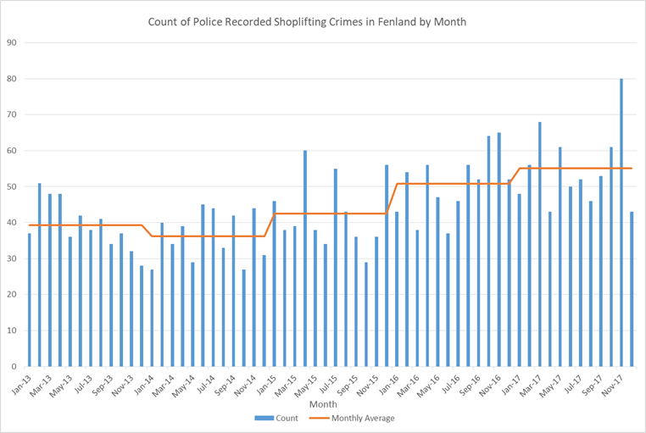
The quarter one assessment did highlight that locally there were increases in the theft of toiletries. The constabulary identified increases in the number of children and teenagers from deprived families shoplifting the items due to poverty. Whilst increases in shoplifting cannot be completed attributed to destitution, it may be linked to some thefts.
The table below takes our understanding here a step further by breaking down the offender need pathways for those offenders committing acquisitive offences across Cambridgeshire and Peterborough.
Anecdotal evidence from the Integrated Offender Management (IOM) team suggests that a high proportion of those individuals linked to the scheme in Fenland have been linked to serious acquisitive crime.
Table 6: Need Pathways for Offenders committing acquisitive offences
 | Total |  | Men |  | Women
Total OASys assessments completed | 392 |  | 302 |  | 90
Accommodation | 81 | 21% | 70 | 23% | 11 | 12%
Education Training and Employment | 186 | 47% | 143 | 47% | 43 | 48%
Relationships | 230 | 59% | 172 | 57% | 58 | 64%
Lifestyles | 204 | 52% | 165 | 55% | 39 | 43%
Drugs | 151 | 39% | 123 | 41% | 28 | 31%
Alcohol | 81 | 21% | 71 | 24% | 10 | 11%
Thinking and Behaviour | 343 | 88% | 261 | 86% | 82 | 91%
Attitudes to offending | 273 | 70% | 219 | 73% | 54 | 60%
Finance | 230 | 59% | 172 | 57% | 58 | 64%
Emotional | 97 | 25% | 65 | 22% | 32 | 36%

In 2017/18 local work to reduce recorded shoplifting considered how local support services, including voluntary bodies, could support an identified offender cohort. There was a focus on Foodbank provision and following engagement with those facilities the support they could provide was very limited if available at all. This included looking at opportunities for offenders to access 'Sue’s Essentials'. This strand of work continues to determine the most appropriate means by which Sue’s Essentials can be made available. ‘Sue’s Essentials’ is an initiative which began in East Cambs that aims to reduce crime – theft in particular – through the distribution of free toiletries, sanitary items and underwear.
It is recommended that the partnership continue to explore this scheme, or an equivalent intervention through 2018/19.

Dwelling Burglary
As well as increases in Shoplifting, the 2017/18 end of year strategic assessment also highlighted increases in Dwelling Burglary across the district to the highest volume of the past five years. It is recommended that the partnership acknowledges these increases in the backdrop of the underlying causes of offending in the district as outlined in this report.
Figure 11: Breakdown of police recorded dwelling burglary in Fenland, 2013- 2017
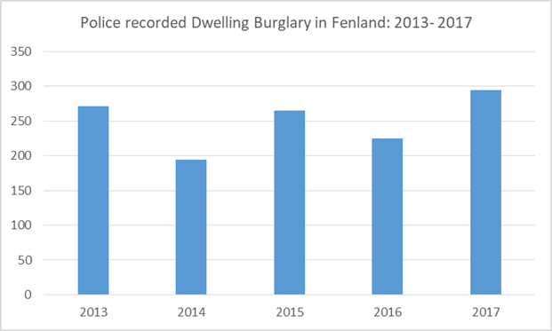
It should be noted that burglary dwelling is up across the constabulary as a whole and across all individual districts highlighting it is a wider problem than in Fenland alone. The partnership should note these increases though and continue monitor local trends for further increases.

Fenland Community Survey
Each quarterly strategic assessment will contain a short summary of the key findings of the Fenland Community Safety survey. Surveys have been completed as part of the community engagement process and they are also available to complete through the internet via http://www.fenland.gov.uk/CSPsurvey . As is common for a community survey, responses mostly reflect low level but visible issues for community members, rather than the highest risk or harm issues. It is the role of the detailed strategic assessments to identify those crimes that can be hidden from the community or highest risk.
Figures in brackets are from the previous survey January to March 2018.
Over the period April to June 2018, 490 responses were received. This was a 107% increase on the previous three months (237). Responses can be broken down by geographical areas as: Chatteris 126, March 113, Whittlesey 128 and Wisbech 123. A high percentage of those surveyed were between the ages of 36 and 65. The volume of responses is low in terms of statistical reliance for the whole of the Fenland district. But it can be used as an indicator for emerging issues.
When asked if respondents had been directly affected by ASB/Crime in the past three months, speeding/anti-social driving and dog fouling were the highest profile issues across the district. parking was in the top 4 for each area. Fly tipping/Litter was also highlighted as an issue in Wisbech, equal second with dog fouling. March, Chatteris and Whittlesey returned the highest ‘no issues’ at 22%(37), 24%(26) and 21%(31) respectively with Wisbech at 10% (7).
Of those surveyed the vast majority felt neither they nor their family had been adversely affected by ASB/crime. Across the whole district of Fenland the problems most experienced related to speed/anti-social driving, dog fouling and parking.
Tables 7 and 8 provide a snap shot of how safe people feel and their perception of crime/ASB in their locality.
Table 7: How safe do you feel where you live?, Fenland Community Survey (April to June 2018)
How safe do you feel where you live?
 | Very Safe | Safe | Unsafe | Very Unsafe
Chatteris | 12%(12) | 71%(62) | 15%(26) | 2%(0)
March | 14%(23) | 71%(73) | 12%(5) | 3%(0)
Whittlesey | 5%(10) | 66%(74) | 28%(15) | 1%(2)
Wisbech | 8%(9) | 62%(67) | 27%(19) | 2%(5)

There was a reduction in the percentage of respondents that said that they felt very safe where they live in March, Whittlesey and Wisbech. Similarly, there was a reduction in the number of respondents that said that there was no problem at all with crime and ASB where they live, across all for geographical areas in the county.

Table 8: Is there a problem with Crime and ASB where you live?, Fenland Community Survey (April to June 2018)
Is there a problem with Crime & ASB where you live?
 | Not at all | Not much | Quite a problem | Big problem
Chatteris | 23%(36) | 51%(38) | 23%(24) | 4%(2)
March | 22%(40) | 56%(52) | 20%(8) | 2%(0)
Whittlesey | 22%(37) | 37%(48) | 30%(13) | 10%(2)
Wisbech | 14%(18) | 55%(54) | 19%(21) | 12%(7)
Please note: Figures do not add to 100% as some respondents skipped the questions
What should the CSP focus on?
Across the district, the issue the community felt the partnership should focus on was speeding/anti-social driving. This was the highest return for each area with an average of 39.15% (39.25) respondents across the four geographical areas. The partnership received a detailed strategic assessment on anti-social driving during 2017/18 and took specific recommendations to forward into the partnership’s action plan.
Chatteris, March and Whittlesey indicated burglary/theft as their second priority with street drinking the second priority for Wisbech. The findings of this strategic assessment show how there have been recent increases in police recorded dwelling burglary in Fenland and it has been recommended that the partnership discuss ways to tackle this. The partnership are due to receive a strategic assessment in quarter 3 this year on on alcohol and substance misuse, based on the findings of the 2017/18 end of year assessment and this will also offer a review of street drinking in the district.

Appendix A

Cambridgeshire Insight, Cambridgeshire Housing Providers;
http://cambridgeshireinsight.org.uk/housing/housing-providers
Centre for Crime and Statistics;
https://www.crimeandjustice.org.uk/sites/crimeandjustice.org.uk/files/Accommodation_and_offending.pdf, 2002
Crisis, The hidden truth about homelessness;
https://www.crisis.org.uk/media/236816/the_hidden_truth_about_homelessness_es.pdf
Ministry of Justice, MOJ Research Assessment 3/12: Accommodation, homelessness and reoffending of prisoners: Results from the Surveying Prisoner Crime Reduction (SPCR) survey. Kim Williams, Jennifer Poyser, and Kathryn Hopkins
Youth Justice Service, YJS. (2016). Youth Justice Statistics. Available; https://www.gov.uk/government/uploads/system/uploads/attachment_data/file/585897/youth-justice-statistics-2015-2016.pdf
National Probation Service, About Us;
https://www.gov.uk/government/organisations/national-probation-service/about
Wilson, W, Housing Support for ex- offenders, 2017;
http://researchbriefings.files.parliament.uk/documents/SN02989/SN02989.pdf

Appendix B
Home Link Prioritisation Bands:
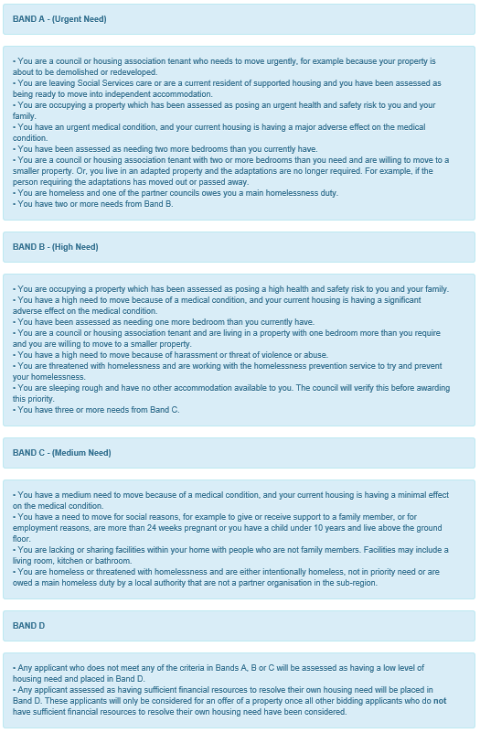

Appendix C: Description of Offender Pathways

Offending Pathways
• Thinking and Behaviour: This pathway assesses the offender’s application of reasoning, especially to social problems. Research indicates that offenders tend not to think things through, plan or consider consequences of their behaviour and do not see things from other people’s perspectives. Those with a number of such ‘cognitive deficits’ will be more likely to re-offend.
• Attitudes (64 %): This pathway considers the offender’s attitude towards their offending and towards supervision. A growing body of research demonstrates that pro-criminal attitudes are predictive of reconviction. Addressing attitudes can reduce the likelihood of reconviction.
• Relationships (46 %): - This pathway assesses whether the offender’s satisfaction with their relationships and their stability relate to their offending behaviour.
• Lifestyle and Associates (38 %): - This pathway examines aspects of the offender’s current lifestyle. A clear link exists between how offenders spend their time, with whom they mix and likelihood of reconviction.
• Alcohol Misuse (31 %): This pathway considers whether alcohol misuse is a significant factor in previous or current offending. This is often linked with risk of harm.
• Emotional Wellbeing (30 %): This pathway examines the extent to which emotional problems interfere with the offender’s functioning or create risk of harm to themselves or others. Mental health problems such as anxiety and depression relate to offending for certain groups.
• Financial Management and Income (28 %): This pathway deals with income, which directly relates to reoffending. It looks at how income is managed and the general ability to cope.
• Drug Misuse (27 %): This pathway identifies the extent and type of drug misuse and its effects on an offender’s life. Research consistently links misuse of drugs with re-offending.
• Education, Training and Employability (25 %): research demonstrates that offenders are generally less well educated and trained than other groups in society. They are more likely to be unemployed, have a poor history of employment and express a dislike to the work ethic.
• Accommodation (20 %): This pathway looks at whether accommodation is available, the quality of
accommodation and whether the location encourages reoffending or creates a risk of harm.

. It has not been possible at this time to obtain the latest information for all of these services so we will refer to figures obtained in the recent County Wide Offender Needs assessment of 2017.
* The latest rate of offenders per 1000 people is higher than the previous rates but it should be noted that the methodology has deferred in that the population count has remained a 2016 estimate and the count of offenders most recently was over a financial year not a calendar year as in the previous rates shown.
YJS. (2016). Youth Justice Statistics. Available: https://www.gov.uk/government/uploads/system/uploads/attachment_data/file/585897/youth-justice-statistics-2015-2016.pdf
https://www.gov.uk/government/organisations/national-probation-service/about
http://researchbriefings.files.parliament.uk/documents/SN02989/SN02989.pdf
https://www.crimeandjustice.org.uk/sites/crimeandjustice.org.uk/files/Accommodation_and_offending.pdf
http://researchbriefings.files.parliament.uk/documents/SN02989/SN02989.pdf
http://researchbriefings.files.parliament.uk/documents/SN02989/SN02989.pdf
MOJ Research Assessment 3/12: Accommodation, homelessness and reoffending of prisoners: Results from the Surveying Prisoner Crime Reduction (SPCR) survey. Kim Williams, Jennifer Poyser, and Kathryn Hopkins
http://researchbriefings.files.parliament.uk/documents/SN02989/SN02989.pdf
https://www.crisis.org.uk/media/236816/the_hidden_truth_about_homelessness_es.pdf
http://cambridgeshireinsight.org.uk/housing/housing-providers

