

**Cambridgeshire & Peterborough Children and Young People’s Health and Wellbeing**

District Outcomes Profile

July 2018

**Contents**

**1.** **Introduction** 4

**2.** **Summary** 5

2.1 Cambridgeshire 5

2.2 Peterborough 7

2.3 Districts 10

2.3.1 Cambridge 10

2.3.2 East Cambridgeshire 11

2.3.3 Fenland 12

2.3.4 Huntingdonshire 13

2.3.5 South Cambridgeshire 14

**3.** **Wider determinants of health** 15

3.1 Child poverty 15

3.2 Family homelessness 16

3.3 Education 17

3.3.1 Good level of development in Reception 17

3.3.2 Phonics screening check in Year 1 17

3.3.3 GCSE’s 18

3.3.4 Pupil absence 19

3.3.5 Not in education, employment or training (NEET) 19

3.4 Children in care 20

3.5 First time entrants to the youth justice system 20

3.6 Children killed and seriously injured 21

**4.** **Health improvement** 22

4.1 Low birth weight 22

4.2 Breastfeeding 22

4.3 Lifestyles 23

4.3.1 Smoking 23

4.3.2 Excess weight in children 24

4.3.3 Childhood obesity 25

4.3.4 Alcohol 28

4.3.5 Substance misuse 29

4.3.6 Sexual health 30

4.4 Teenage conceptions 32

4.5 Decayed, missing or filled teeth 34

**5.** **Health protection** 36

5.1 Vaccinations and immunisations 36

5.1.1 Summary table of all childhood vaccinations 36

5.1.2 MMR 36

5.1.3 HPV 38

5.1.4 Children in care immunisations 39

**6.** **Prevention of ill health** 40

6.1 A&E attendances 40

6.2 Hospital admissions – unintentional and deliberate injuries 41

6.3 Hospital admissions – asthma, diabetes and epilepsy 43

6.4 Hospital admissions – mental health conditions 44

6.5 Hospital admissions – self-harm 45

**7.** **Premature mortality** 47

7.1 Infant Mortality 47

7.2 Child Mortality 48

**8.** **Appendices** 49

8.1 Child Health Profile – Cambridgeshire 49

8.2 Child Health Profile – Peterborough 50

8.3 Cambridgeshire and Peterborough Children’s Outcomes Framework - baseline 51

1. **Introduction**

The annual national Child Health Profiles [1] are published at upper tier Council level only. These profiles present data on factors related to the health and wellbeing of pregnant women, children and young people, with the indicators designed to help local authorities and health services improve the health and wellbeing of children and tackle health inequalities.

This report presents data at district level, where available, to help identify the local needs of children and young people at, and between, lower geographical levels. Data for Cambridgeshire and Peterborough are presented where district level data are not available, to enable benchmarking against the national position. The indicators used are those from the Child Health Profiles (Appendix 1) and those from the locally defined and agreed Children’s Outcome Framework (Appendix 2).

Local authority summaries are included and highlight the areas where the districts are statistically significantly worse than England, where there could be possible future areas of concern and where improvements have already been seen. It should be noted that some measures may still be important even if they are not shown to be locally or nationally adverse, for example, if significant numbers of children and young people are involved, they are good overall measures of population health status or trends are adverse. Similarly, some issues may be masked at a higher level of geography and smaller area analysis may highlight particular pockets of deprivation where there are relatively worse health determinants and outcomes.

For the purpose of this report the districts, Cambridgeshire and Peterborough have been benchmarked against England, using the following key:

**Tables Charts**



1. **Summary**
   1. Cambridgeshire

There are almost **151,000** children and young people aged under 20 years living in Cambridgeshire, **23%** of the total population. The population is forecast to increase by almost 25,000 children and young people (16.4%) over the next 10 years, with the largest actual and proportional increases expected in 10 to 14 year olds and 15 to 19 year olds. [2]

The health and wellbeing of children and young people in Cambridgeshire is relatively positive in comparison to the experience of children in England with child poverty, breastfeeding prevalence at 6-8 weeks, teenage conceptions, excess weight, children in care, dental health, 16-17 year olds not in education, employment and training (NEET), pupil absence, A&E attendances and hospital admissions for asthma, mental health conditions and unintentional and deliberate injuries all statistically significantly better than the England averages.[3] However, there are several measures where Cambridgeshire fares worse than England.

**Potential priority areas \***

* **Hospital admissions as a result of self-harm (10-24 years):** In 2016/17 there was a reduction in the rate of hospital admissions for self-harm, but the County rate remained notably, and statistically significantly, higher than the England rate.
* **Chlamydia screening and detection (15-24 years)**: In 2016/17, as in previous years, Cambridgeshire had a statistically significantly low proportion of 15 to 24 year olds screened for chlamydia, with a detection rate that was below the nationally set benchmark.
* **School readiness – Reception:** In 2016/17 the percentage of Reception aged children achieving a good level of development at the end of the school year was statistically similar to England, but for those with free school meal status the level of development was statistically significantly worse than experienced nationally. The gap between the Cambridgeshire and England rate increased in 2016/17. The proportion of pupils that achieved a good level of development at the end of Reception increased in Cambridgeshire (from 69.7% in 2015/16 to 70.7% in 2016/17) but the proportion of those with such good development in pupils with free school meal status decreased (from 49.3% in 2015/16 to 47.9% in 2016/17).
* **School readiness – Year 1:** In 2016/17 the proportion of Year 1 pupils achieving the expected level in the phonics screening check was statistically significantly worse than England in all pupils and those with free school meal status, but there were increases in achievement between 2015/16 and 2016/17 (from 78.2% to 79.8% in all pupils and from 58.2% to 60.9% in those with free school meal status). There have been improvements in rates since 2014/15, with the most marked increase in achievement in those with free school meal status.
* **Vaccinations in 5 year olds:** the one booster dose of Hib/Men C vaccine by 5th birthday was below the target of 95% in 2016/17 at 89.4%. Two doses of MMR vaccinations was below the target of 95% in 2016/17 at 85.1%.

**Areas that could be of future possible concern \*\***

* **Low birth weight of term babies**: in 2016 an increase in the proportion of term babies born with a low birth weight (under 2,500g) moved Cambridgeshire from being statistically significantly better than England to being statistically similar.

* **Vaccinations**: the following vaccinations were below the target of 95% but above 90% in 2016/17: Dtap/IPV/Hib (1 year olds); PCV (1 year olds); Hib/MenC booster (2 year olds); PCV booster (2 years old), MMR for one dose (2 year olds) and MMR for one dose (5 year olds) HPV coverage has declined over the last four years with coverage in 2016/17 statistically similar to England at 86%.
* **Conceptions, under 16 year olds:** a slight increase in the rate in 2016, against a nationally continued decrease in rates, has led to Cambridgeshire becoming statistically similar to England, from being statistically better in 2015.
* **Teenage mothers:** the proportion of teenage mothers has stabilised in Cambridgeshire (2013/14 to 2016/17), but there has been a downward trend nationally, which has led to Cambridgeshire becoming statistically similar to the England rate since 2015/16.
* **Persons under 18 admitted to hospital for alcohol-specific conditions**: there has been an upward trend in rates since 2011/12-2016/17, against a notable downward trend seen nationally. This has led to Cambridgeshire having a rate that is higher, but statistically similar, to England.
* **First time entrants to the youth justice system:** an increase in the rate in 2016 led to Cambridgeshire moving from being statistically significantly better than England (between 2013 and 2015) to being statistically similar.

**Areas of improvement \*\*\***

* **Dtap/IPV/Hib vaccinations for 2 year olds:** a notable increase in the coverage in 2016/17 has led to Cambridgeshire becoming statistically significantly better than the average for England.
* **Pupil absence:** there was a reduction in the rate in 2015/16 which led to Cambridgeshire becoming statistically significantly better than England, where it had previously been statistically similar.
* **Hospital admissions caused by injuries in young people (15-24 years):** a decrease in the rate in 2016/17 led to Cambridgeshire becoming statistically similar to England, where previously it had been statistically significantly worse. There have also been improvements in the rates for 0-4 year olds and under 15 year olds, which have been, and remain, statistically significantly better than England.
* **Long acting contraceptive use (excluding injections in Sexual Reproductive Health Services), under 25 year olds:** an increase in 2016 has led to Cambridgeshire having statistically significantly high LARC uptake compared to the England average.

**Notes**

|  |  |
| --- | --- |
| * | Statistically significantly worse than England. |
| ** | Statistically similar and below the England average; moved from being statistically significantly better than England to being statistically similar; a negative trend regardless of statistical significance. |
| *** | Statistically significantly better than England where had previously been statistically similar; statistically similar to England where had been statistically significantly worse. |

* 1. Peterborough

Peterborough has a younger population than the national average. There are over **54,000** children and young people aged under 20 years living in Peterborough, **27%** of the total population. The population is forecast to increase by almost 9,500 children and young people (17.3%) over the next 10 years, with the largest actual and proportional increases expected in 10 to 14 year olds and 15 to 19 year olds. 2

The health and wellbeing of children and young people in Peterborough is overall poorer in comparison to the experience of children in England as a whole, with around 1 in 5 children aged under 16 years living in poverty. Measures relating to pregnancy and birth are similar to the national average with low birth weight babies, stillbirths and infant mortality around the England rates. However, teenage conceptions, breastfeeding initiation and smoking at the time of delivery are significantly worse than England. As children move into early years there are more areas that are statistically significantly worse than England such as excess weight, dental health problems and attendances at A&E. Educational attainment generally fares worse in Peterborough when compared to England with poorer levels of development at the end of reception, phonics achievement in Year 1 and attainment at GCSE’s. Hospital admissions for self-harm, unintentional and deliberate injuries in older teenagers and asthma are high. However, there are several indicators where notable improvements are being made including the prevalence of breastfeeding at 6-8 weeks, the proportion of teenage mothers, first time entrants to the youth justice system and hospital admissions due to unintentional and deliberate injuries in younger children. 3

**Potential priority areas \***

* **Children in low income families (under 16 years):** In 2015 18.7% of children were living in poverty, which was statistically significantly worse than the national average of 16.8%. The gap between Peterborough and England narrowed in 2015.
* **Breastfeeding initiation:** the rates dropped to being statistically significantly worse than England in 2015/16 and 2016/17, having been statistically similar to England in the previous 4 years.
* **Smoking status at the time of delivery:** The data reported in the Public Health Outcomes Framework relate to a CCG figure, which is not representative of the variation across Cambridgeshire and Peterborough. Local hospital data for 2017/18 shows that smoking at the time of delivery was 6.7% at Cambridge University Hospital Foundation Trust, 10.3% at Hinchingbrooke, 14.4% at Peterborough and Stamford Hospitals and 21.9% at the Queen Elizabeth Hospitals, with the prevalence in the latter two hospital being statistically significantly higher than the average for Cambridgeshire and Peterborough. These hospitals predominantly cover the populations of Peterborough and north Fenland.
* **A&E attendances, 0-4 years:** there was a reduction in attendance rates in 2016/17 but they remained notably, and statistically significantly, higher than the England rate.
* **Vaccinations in 5 year olds:** the one booster dose of Hib/Men C vaccine by 5th birthday was below the target of 95% in 2016/17 at 89.6%. Two doses of MMR vaccinations was below the target of 95% in 2016/17 at 89.6%. One dose of MMR at 5 year olds was above target at 95.6%. The national target for all vaccinations is 95%.
* **Children with one or more decayed, missing or filled teeth, 5 year olds:** in 2016/17 Peterborough had a statistically significantly high number of children with one or more decayed, missing or filled teeth compared to England.
* **Children achieving a good level of development at the end of reception:** There was a slight increase in achievement in 2016/17, but due to a greater increase experienced nationally, the gap in achievement between Peterborough and England has widened. However, the achievement of those pupils with free school meal status is slightly better and statistically similar to England.
* **Children achieving expected level in the phonics screening check, Year 1:** there was a decrease in expected achievement in 2016/17 whilst there was an increase in the national average, leading to a widening of the gap in achievement between Peterborough and England. There was also a reduction in the achievement in pupils with free school meals, which led to Peterborough becoming statistically significantly worse than England in 2016/17, where it had been statistically similar to England in 2015/16.
* **Excess weight, 10-11 years:** there have been annual increases in the percentage of pupils aged 10-11 years with excess weight, which that has led to Peterborough becoming statistically significantly worse than England in 2016/17. The proportion of obese children in Peterborough was also statistically significantly worse than England in 2016/17.
* **GCSEs achieved (5A*-C including English and Maths):** there was a slight decrease in attainment in 2015/16, against an increasing national trend in attainment, which widened the gap between Peterborough and England.
* **Conceptions, under 16 years:**  there was a notable increase in rates in 2016 that led to Peterborough becoming statistically significantly worse than the England average, whereas it had previously been statistically similar. The numbers are small and fluctuate annually.
* **Conceptions, under 18 years:**  the rates have been statistically significantly worse than England since 2012 and, due to an increase in the rate in 2016 against a decreasing national trend, the gap between Peterborough and England is widening.
* **Hospital admissions as a result of self-harm, 10-24 years:** there was a notable decrease in rates in 2016/17, following an annual increasing trend. However, the rate remains statistically significantly higher than the England rate.
* **Hospital admissions due to substance misuse, 15-24 years:** there is an upward trend in admission rates in Peterborough and, whilst rates until recently were also increasing nationally they have decreased in the latest time period (2014/15-2016/17), leading to the rates being substantially higher in Peterborough than the national average.
* **Hospital admissions caused by injuries in young people, 15-24 years:**  there is an overall downward trend in admission rates in Peterborough, but in 2016/17 they remained notably, and statistically significantly, higher than the England rate.
* **Hospital admissions for asthma, under 19 years:** rates have been increasing since 2013/14, with the rate in 2016/17 being notably, and statistically significantly, higher than the England rate.
* **Family homelessness:** there is a notable increasing trend in the rate of family homelessness in Peterborough, against a static national trend. In 2016/17 the rate was over three times higher in Peterborough than England.
* **Children in care:** Peterborough has historically had statistically significantly high rates of children in care compared to the England average but, due to a reduction in the Peterborough rate in 2016/17 and a slight increase in England’s rate, the gap between Peterborough and England appears to be narrowing.

**Areas that could be of future possible concern \*\***

* **Low birth weight of term babies:** there was an increase in the proportion of full term babies born with a low birth weight (under 2,500g) in 2016 and, whilst this remains statistically similar to England, there has been a general increase in the proportion since 2010.
* **Excess weight, 4-5 year olds**: whilst Peterborough is statistically similar to England there have been annual increases in the proportion of 4-5 year olds with excess weight since 2014/15, as also experienced nationally. However, the proportion of children that were identified as obese has declined annually from 2013/14.
* **Vaccinations**: the following vaccinations were below the target of 95% but above 90% in 2016/17: Dtap/IPV/Hib (1 year olds); PCV (1 year olds); Hib/MenC booster (2 year olds); PCV booster (2 year olds) and MMR for one dose (2 year olds). HPV coverage has declined over the last three years with coverage in 2016/17 being statistically similar to England, at 86%.
* **Child mortality rate, 1-17 years:** there was a notable increase in rates in 2014-16 which were higher, but statistically similar, to the England rate.
* **Long acting contraceptive use (excluding injections in Sexual Reproductive Health Services), under 25 year olds:** a decrease in LARC uptake in 2016 has led to Peterborough becoming statistically similar to England, from previously being statistically significantly better.

**Areas of improvement \*\*\***

* **First time entrants to the youth justice system**: there was a notable decrease in rates between 2015 and 2016 that led to Peterborough becoming statistically similar to England, whereas it had previously been statistically significantly worse.
* **Breastfeeding prevalence at 6-8 weeks after birth:** an increase in prevalence in 2016/17 has led to a statistically significantly better rate in Peterborough than experienced nationally.
* **Hospital admissions caused by unintentional and deliberate injuries:** there were notable decreases in the rates for children aged under 5 years and under 15 years in 2016/17 and, whilst Peterborough remains statistically similar to England, the rates are now lower than the national average.
* **Teenage mothers:** a reduction in the proportion of teenage mothers in 2016/17 has led to Peterborough becoming statistically similar to England, whereas previously it had been statistically significantly worse. The rate in Peterborough was the same as England in 2016/17.

**Notes**

|  |  |
| --- | --- |
| * | Statistically significantly worse than England. |
| ** | Statistically similar and below the England average; moved from being statistically significantly better than England to being statistically similar; a negative trend regardless of statistical significance. |
| *** | Statistically significantly better than England where had previously been statistically similar; statistically similar to England where had been statistically significantly worse. |

* 1. Districts
     1. Cambridge

There are approximately **30,000** children and young people aged under 20 years living in Cambridge, **22%** of the total population, with a notably high proportion of 15 to 19 year olds due to the university student population. The population is forecast to increase by almost 5,500 children and young people (18.0%) over the next 10 years, with the largest actual and proportional increase expected in 10 to 14 year olds.2

The health and wellbeing of children and young people in Cambridge is relatively positive in comparison to the experience of children in England with children living in poverty, breastfeeding initiation, teenage conceptions, excess weight, dental health and hospital admissions caused by unintentional and deliberate injuries all statistically significantly better than the average for England. However, as explored below, there are several measures where the Cambridge fares worse than the England averages. 3 Also, whilst child poverty is statistically significantly better than the England average it is statistically significantly worse than the Cambridgeshire average.

**Potential priority areas \***

* **Pupil absence**: the proportion of absent pupils increased in 2015/16 and became statistically significantly worse than the England average.
* **Hospital admissions for self-harm, 10-24 years**: this currently isn’t produced nationally for districts, but local analysis shows that admission rates in 2016/17 were statistically significantly high in Cambridge compared to the England rate.
* **Chlamydia detection rates, 15-24 years:** the detection rate in 2017 was lower than the nationally set benchmark, with rates declining since 2012.
* **Hospital admissions for alcohol-specific conditions, under 18 year olds**: rates have been increasing since 2013/14-2015/16 and were statistically significantly worse than England for the first time in 2014/15-2016/17. Nationally there is a downward trend in these admissions.

**Areas that could be of future possible concern \*\***

* **Infant mortality**: rates are statistically similar to England but have been increasing since 2011-13 and are now higher, but not significantly higher, than England.
* **Low birth weight of term babies**: the proportion is statistically similar to the England average but has remained relatively stable over the last 10 years, as it has nationally.
* **Childhood excess weight, 10-11 year olds**: there was a notable increase in the proportion of Year 6 pupils with excess weight in 2016/17 and, although the rates remain statistically significantly better than England average, the gap has narrowed between Cambridge and England.

**Areas of improvement \*\*\***

* **Conceptions, under 18 years**: In 2016 the rates, for the first time since 2012, were statistically significantly better than the England average.
* **Chlamydia screening, 15-24 year olds**: an increase in the proportion of people screened in 2017 has led to Cambridge becoming statistically similar to the average for England, where it had been statistically significantly worse in the previous two years.

**Notes**

|  |  |
| --- | --- |
| * | Statistically significantly worse than England. |
| ** | Statistically similar and below the England average; moved from being statistically significantly better than England to being statistically similar; a negative trend regardless of statistical significance. |
| *** | Statistically significantly better than England where had previously been statistically similar; statistically similar to England where had been statistically significantly worse. |

* + 1. East Cambridgeshire

There are approximately **21,000** children and young people aged under 20 years living in East Cambridgeshire, **24%** of the total population.The population is forecast to increase by over 4,000 children and young people (19.5%) over the next 10 years, with the largest actual and proportional increases expected in under 5 year olds and 10 to 19 year olds, with a relatively small increase in 5 to 9 year olds. 2

The health and wellbeing of children and young people in East Cambridgeshire is relatively positive in comparison to the experience of children in England with child poverty, infant mortality, teenage conceptions, excess weight, pupils absence, hospital admissions caused by unintentional and deliberate injuries and dental health all being significantly better than England. 3

**Potential priority areas \***

* **Hospital admissions for self-harm, 10-24 years**: this currently isn’t produced nationally but local analysis shows that admissions rates in 2016/17 were statistically significantly high in East Cambridgeshire compared to the England rate.
* **Chlamydia detection rates, 15-24 year olds**: there is a downward trend in detection rates, with less people also being screened.

**Areas that could be of future possible concern \*\***

* None found

**Areas of improvement \*\*\***

* **Child poverty, under 16 year olds**: there was a notable decrease in the percentage of children living in poverty between 2014 and 2015, with an overall downward trend since 2006. East Cambridgeshire has always had a statistically significantly low proportion of children living in poverty compared to the national averages.
* **Child excess weight, 4-5 year olds**: a decrease in rates in 2016/17 has led to East Cambridgeshire becoming statistically significantly better than England, from being statistically similar in 2015/16.
* **Pupil absence:** an improvement in rates in 2015/16 resulted in East Cambridgeshire becoming statistically significantly better than England.

**Notes**

|  |  |
| --- | --- |
| * | Statistically significantly worse than England. |
| ** | Statistically similar and below the England average; moved from being statistically significantly better than England to being statistically similar; a negative trend regardless of statistical significance. |
| *** | Statistically significantly better than England where had previously been statistically similar; statistically similar to England where had been statistically significantly worse. |

* + 1. Fenland

There are approximately **22,000** children and young people aged under 20 years living in Fenland, **22%** of the total population. The population is forecast to increase by almost 3,000 children and young people (13.0%) over the next 10 years, with the largest actual and proportional increases expected in 10 to 14 year olds.2

The health and wellbeing of children and young people in Fenland is generally similar to the experience of children in England, but fares poorer in comparison to those in Cambridgeshire as a whole. There are a few areas where the district fares worse than the national averages (as detailed below) but there are further areas where the rates in Fenland are statistically significantly worse than those for Cambridgeshire as a whole. These include child poverty, teenage conceptions, excess weight in 10-11 year olds, hospital admissions caused by unintentional and deliberate injuries and dental health. 3

**Potential priority areas \***

* **Child living in poverty, aged under 16 years:** historically Fenland has had statistically significantly higher proportions of children living in poverty than England. There was a decrease in the proportion in 2015 (latest time period available), which reflected a reduction in the national rates.
* **Breastfeeding initiation:** there appears to be a decreasing trend in Fenland, against a fairly static national trend.
* **Chlamydia detection rates**: this is lower than the nationally set benchmark, and has been decreasing annually since 2013.

**Areas that could be of future possible concern \*\***

* **Infant mortality:** there has been an overall upward trend in infant mortality rates since 2009-11 with the rate, although remaining statistically similar to England, notably higher than the national rate in 2014-16.
* **Low birth weight of term babies**: this was statistically similar to England in 2016, as it has been since 2006, but there was notable increase in the proportion in 2016.

**Areas of improvement \*\*\***

* **Child excess weight, 4-5 year olds**: there has been an overall decreasing trend in the proportion of children aged 4-5 years old with excess weight, with rates now statistically similar to England, where they had previously been statistically significantly high in comparison.
* **Pupil absence:** there is a notable downward trend in pupil absence in Fenland, with the rate in 2015/16 statistically similar to England.

**Notes**

|  |  |
| --- | --- |
| * | Statistically significantly worse than England. |
| ** | Statistically similar and below the England average; moved from being statistically significantly better than England to being statistically similar; a negative trend regardless of statistical significance. |
| *** | Statistically significantly better than England where had previously been statistically similar; statistically similar to England where had been statistically significantly worse. |

* + 1. Huntingdonshire

There are approximately **41,000** children and young people aged under 20 years living in Huntingdonshire, **23%** of the total population. The population is forecast to increase by over 5,600 children and young people (13.8%) over the next 10 years, with the largest actual and proportional increases expected in 10 to 14 year olds. 2

The health and wellbeing of children and young people in Huntingdonshire is generally more positive in comparison to the experience of children in England as a whole with children living in poverty, breastfeeding initiation, excess weight, infant mortality and dental health all statistically significantly better than the national averages. However, in comparison to Cambridgeshire the area has statistically significantly high teenage conception rates and hospital admissions for unintentional and deliberate injuries. 3

**Potential priority areas \***

* **Chlamydia detection rates, 15-24 year olds**: the detection rate in 2017 was lower than the nationally set benchmark, with rates declining since 2014. The proportion of 15 to 24 year olds screened is also decreasing annually.
* **Persons under 18 admitted to hospital for alcohol-specific conditions**: there has been an increasing trend since 2010/11-2012/13, with the rate in 2014/15-2016/17 being statistically significantly higher than the national rate.

**Areas that could be of future possible concern \*\***

* **Low birth weight of term babies**: in 2016 there was an increase in the proportion of low birth weight term babies that has led to the proportion becoming statistically similar to England, where it had previously (in 2015) been statistically significantly better.
* **Conceptions, under 18 year olds:** since 1998 rates have been statistically significantly better than England. However, an increase in the rate in 2016 has led to the area becoming statistically similar to the national average, with the rate just below the England rate.

**Areas of improvement \*\*\***

* **Infant mortality:** a reduction in rates in 2014-16 has led to the area becoming statistically significantly better than England.

* **Hospital admissions caused by unintentional and deliberate injuries in children, 0-14 year olds:** a decrease in rates in 2016/17 has led to the area becoming statistically significantly better than England, but it remains statistically significantly worse than the Cambridgeshire average. There has also been a decrease in the rates of admissions in 0-4 year olds.

**Notes**

|  |  |
| --- | --- |
| * | Statistically significantly worse than England. |
| ** | Statistically similar and below the England average; moved from being statistically significantly better than England to being statistically similar; a negative trend regardless of statistical significance. |
| *** | Statistically significantly better than England where had previously been statistically similar; statistically similar to England where had been statistically significantly worse. |

* + 1. South Cambridgeshire

There are approximately **38,000** children and young people aged under 20 years living in South Cambridgeshire, **24%** of the total population. The population is forecast to increase by almost 7,000 children and young people (18.4%) over the next 10 years, with the largest actual and proportional increases expected in 15 to 19 year olds. 2

The health and wellbeing of children and young people in South Cambridgeshire is relatively positive in comparison to the experience of children in England with child poverty, teenage conceptions, excess weight, pupil absence, hospital admissions caused by unintentional and deliberate injuries and dental health all being significantly better than England. 3

**Potential priority areas \***

* **Chlamydia detection rates**: the detection rate in 2017 was lower than the nationally set benchmark, with relatively stable rates over the last 5 years. There was a slight increase in the proportion screened in 2017, but the screening rate remained statistically significantly worse than the England average.

**Areas that could be of future possible concern \*\***

* **Infant mortality**: rates are statistically similar to the England average, but have been increasing since 2011-13 and are now (2014-16) around the national average.
* **Low birth weight of term babies**: an increase in this proportion in 2016 has led to the area becoming statistically similar to the England average, whereas previously it had been statistically significantly better.

**Areas of improvement \*\*\***

* **Pupil absence**: a decrease in the rates in 2015/16 has resulted in South Cambridgeshire becoming statistically significantly better than the England average, whereas it had previously been statistically similar.

**Notes**

|  |  |
| --- | --- |
| * | Statistically significantly worse than England. |
| ** | Statistically similar and below the England average; moved from being statistically significantly better than England to being statistically similar; a negative trend regardless of statistical significance. |
| *** | Statistically significantly better than England where had previously been statistically similar; statistically similar to England where had been statistically significantly worse. |

1. **Wider determinants of health**
   1. Child poverty

Table 1: Children in low income families, under 16 year olds (%), 2015



Source: HM Revenue and Customs, from PHE Public Health Outcomes Framework (<https://fingertips.phe.org.uk/>)

Figure 1: Children in low income families, under 16 year olds (%), Fenland, Cambridgeshire and Peterborough, 2006 to 2015

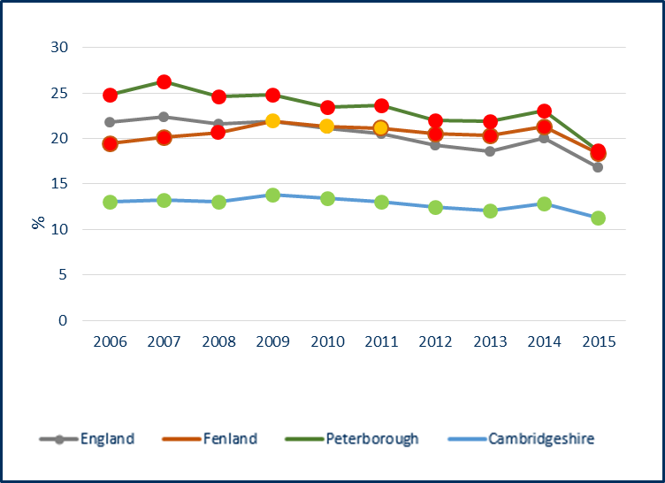

Source: HM Revenue and Customs, from PHE Public Health Outcomes Framework (<https://fingertips.phe.org.uk/>)

**Key points – child poverty**

* Fenland and Peterborough have statistically significantly worse child poverty rates than the average for England. All other districts are statistically significantly better than England.
* There is a decreasing trend in child poverty in Cambridgeshire and Peterborough. Overall there has been a slight increasing trend in Fenland, but there was a notable decrease in the latest in 2015 (21.3% in 2014 to 18.4% in 2015).
  1. Family homelessness

Table 2: Family homelessness, crude rate per 1,000 households, 2016/17

Data not available at District level

*Aggregated from all

known lower geography

values

Source: P1E quarterly returns, Department for Communities and Local Government from PHE Child Health Profiles (<https://fingertips.phe.org.uk/>)

Figure 2: Family homelessness, crude rate per 1,000 households for Cambridgeshire and Peterborough, 2011/12 to 2016/17

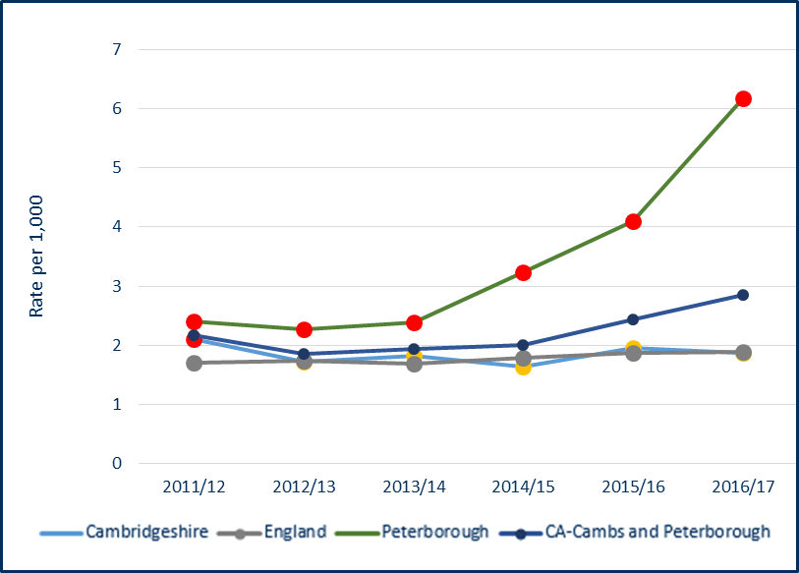

Source: P1E quarterly returns, Department for Communities and Local Government from PHE Child Health Profiles (<https://fingertips.phe.org.uk/>)

**Key points – family homelessness**

* Peterborough has a statistically significantly high rate of family homelessness compared to the England average, with a marked increasing trend.
  1. Education
     1. Good level of development in Reception

Table 3: Children achieving a good level of development at the end of reception (%), 2016/17

Data not available

at District level

**Source:** Department for Education, from PHE Public Health Outcomes Framework (<https://fingertips.phe.org.uk/>)

Table 4: Children with free school meal status achieving a good of level of development at the endof reception (%), 2016/17



Data not available

at District level

Source: Department for Education, from PHE Public Health Outcomes Framework (<https://fingertips.phe.org.uk/>)

**Key points - good level of development at reception**

* The percentage of children achieving a good level of development at the end of reception is statistically significantly lower in Peterborough than England.
* The percentage of children with free school meal status achieving a good level of development at the end of reception is statistically significantly lower in Cambridgeshire than England.
* Both Cambridgeshire and Peterborough have experienced increases in the development of all reception aged children and those with free school meal status over the last 5 years.
  + 1. Phonics screening check in Year 1

Table 5: School Readiness: the percentage of Year 1 pupils achieving the expected level in the phonics screening check, 2016/17

Data not available

at District level

Source: Department for Education, from PHE Public Health Outcomes Framework (<https://fingertips.phe.org.uk/>)

Table 6: School Readiness: the percentage of Year 1 pupils with free school meal status achieving the expected level in the phonics screening check, 2016/17

Data not available

at District level

Source: Department for Education, from PHE Public Health Outcomes Framework (<https://fingertips.phe.org.uk/>)

**Key points – achievement of expected level in the phonics screening check in Year 1**

* The percentage of pupils achieving the expected level in the phonics screening check is statistically significantly lower in both Cambridgeshire and Peterborough than England, for all Year 1 pupils and those that have free school meal status.
* Cambridgeshire is experiencing an upward trend in the percentage of pupils meeting the expected level in phonics screening, with the gap between those with free meal status and the national average narrowing.
* Peterborough experienced a decrease in the attainment of those with free school meal status in 2016/17 but overall there has been an increase in the last 5 years.
  + 1. GCSE’s

Table 7: GCSEs achieved - % of pupils achieving 5A*-C including English & Maths, 2015/16



*Aggregated from all

known lower geography

values

Source: Department for Education, from PHE Health Profiles (<https://fingertips.phe.org.uk/>)

Table 8: GCSE achieved 5A*-C including English & Maths with free school meal status, 2014/15



Data not available at District level

*Aggregated from all

known lower geography

values

Source: Department for Education, from PHE Wider Determinant of Health (<https://fingertips.phe.org.uk/>)

**Key points – GCSE attainment**

* Cambridge, South Cambridgeshire and Cambridgeshire have GCSE attainment rates that are significantly better than the England average.
* Fenland and Peterborough have a GCSE attainment rates that are statistically significantly worse than the England average.
* Both Cambridgeshire and Peterborough have statistically significantly worse GCSE attainment for pupils with free school meal status when compared to the England average.
  + 1. Pupil absence

Table 9: Pupil absence - % of half days missed by pupils due to overall absence (including authorised and unauthorised absence), 2015/16



Source: Department for Education, from PHE Public Health Outcomes Framework (<https://fingertips.phe.org.uk/>)

**Key points – pupil absence**

* Cambridge has a statistically significantly high percentage of pupil absence compared to the England average.
* East Cambridgeshire, South Cambridgeshire and Cambridgeshire have statistically significantly low percentages compared to the England average.
* All areas have seen decreasing (positive) trends in the percentage of absent pupils.
  + 1. Not in education, employment or training (NEET)

Table 10: 16-17 year olds not in education, employment or training (NEET) or whose activity is not known (%) - current method, 2016



Data not available

at District level

Source: Department for Education, from PHE Public Health Outcomes Framework (<https://fingertips.phe.org.uk/>)

**Key points – not in education, employment or training (NEET)**

* Cambridgeshire has a percentage that is statistically significantly better than the England average.
* Peterborough’s percentage is statistically similar to England’s, and is statistically significantly higher than the average for Cambridgeshire.
  1. Children in care

Table 11: Children in care, rate per 10,000 population aged under 18 years, 2017

Data not available at District level

*Aggregated from all

known lower geography

values

Source: Department for Education, from PHE Child Health Profiles (<https://fingertips.phe.org.uk/>)

**Key points – children in care**

* Peterborough has a statistically significantly higher rate of children in care than England, with an overall decreasing trend.
* Cambridgeshire has a statistically significantly lower rate of children in care than England, with an overall increasing trend.
  1. First time entrants to the youth justice system

Table 12: First time entrants to the youth justice system - rate of 10-17 year olds receiving their first reprimand, warning or conviction per 100,000 population, 2016



Data not available at District level

Source: Police National Computer, from PHE Public Health Outcomes Framework (<https://fingertips.phe.org.uk/>)

Figure 3: First time entrants to the youth justice system - rate of 10-17 year olds receiving their first reprimand, warning or conviction per 100,000 population for Cambridgeshire and Peterborough, 2010 to 2016

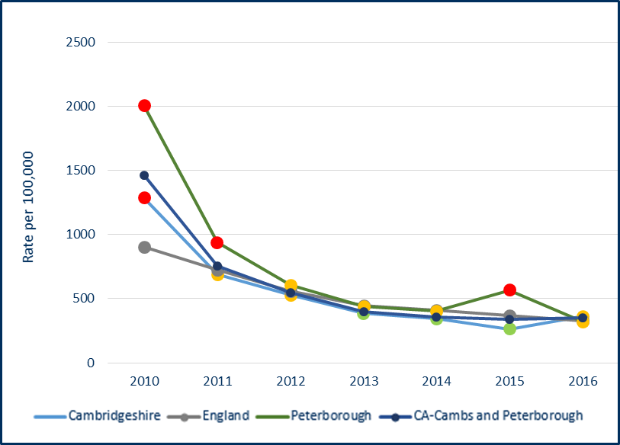

Source: Police National Computer, from PHE Public Health Outcomes Framework (<https://fingertips.phe.org.uk/>)

**Key points – first time entrants to the youth justice system**

* Rates are around the national average in both Cambridgeshire and Peterborough.
* All areas have seen a notable decrease in rates over the last 6 years, but there was a peak in Peterborough in 2015.

* 1. Children killed and seriously injured

Table 13: Children killed and seriously injured (KSI) on England's roads, crude rate of children aged 0-15 years per 100,000 population, 2014/2016



Data not available at District level

*Aggregated from all

known lower geography

values

Source: Department for Transport (DfT), from PHE Child Health Profiles (<https://fingertips.phe.org.uk/>)

**Key points – children killed and seriously injured**

* Both Cambridgeshire and Peterborough have statistically similar rates of children killed and seriously injured (KSI) to the England average.

1. **Health improvement**
   1. Low birth weight

Table 14: Low birth weight of term babies, % of all live births at term with low birth weight (under 2,500g), 2016



Source: Office for National Statistics, from PHE Public Health Outcomes Framework (<https://fingertips.phe.org.uk/>)

**Key points – low birth weight of term babies**

* All districts in Cambridgeshire have statistically similar percentages to the England average, as do Cambridgeshire and Peterborough.
* The percentages fluctuate annually but there has generally been a static trend in all areas across Cambridgeshire and Peterborough over the last 10 years.
  1. Breastfeeding

Table 15: Breastfeeding initiation - % of all mothers who breastfed their babies in the first 48 hours after delivery, 2016/17



*Aggregated from all

known lower geography

values

- Value not published for data quality reasons

Source: NHS England, from PHE Public Health Outcomes Framework (<https://fingertips.phe.org.uk/>)

Table 16: Breastfeeding - breastfeeding prevalence at 6-8 weeks after birth - current method - % of all infants due a 6-8 week check that are totally or partially breastfed, 2016/17



Data not available

at District level

*Aggregated from all

known lower geography

values

1Annual figure includes constituent area(s) with annual figure scaled up data from three quarters' data

Source: Public Health England National Child and Maternal Health Intelligence Network, from PHE Public Health Outcomes Framework (<https://fingertips.phe.org.uk/>)

**Key points - breastfeeding**

* Breastfeeding initiation in Cambridge and Huntingdonshire is statistically significantly higher than the average for England.
* Breastfeeding initiation in Fenland and Peterborough is statistically significantly lower than the England average, with both areas experiencing decreasing trends in recent years.
* Cambridgeshire and Peterborough have statistically significantly high breastfeeding prevalence rates at 6-8 weeks compared to the England average, with both areas, most notably Peterborough, experiencing increases in rates between 2015/16 and 2016/17.
  1. Lifestyles
     1. Smoking

Nationally reported data on smoking status at the time of delivery are based on CCG returns and relate to CCG boundaries, so all local authority data provided through the Public Health Outcomes Framework state the same figure for 2016/17 i.e. 11.6% compared to 10.7% for England. Local data are available from the CCG at Trust level for 2017/18, as reported below.

Table 17: smoking status at time of delivery - % of women who smoke at time of delivery, 2017/18

 

Source: Cambridgeshire and Peterborough CCG Smoking at the time of delivery returns

Table 18: Smoking prevalence at 15 years old - current smokers, regular smokers and occasional smokers, Cambridgeshire and Peterborough, 2014/15



1. Regular smokers (>1 cigarette per week) and occasional smokers (smoke cigarettes sometimes)

2. Regular smokers (>1 cigarette per week)

3. Occasional smokers (<1 cigarette per week)

4. Have ever used/tried electronic cigarettes with the combination of currently, used to and tried e-cigarettes

5."Have you ever used/tried other tobacco products (i.e. shisha pipe, hookah, hubble-bubble, waterpipe etc.?") with the combination of currently, used to use and tried other tobacco products.

Source: What About YOUth (WAY) Survey, from PHE Public Health Outcomes Framework (<https://fingertips.phe.org.uk/>)

**Key points - Smoking**

* Smoking status at the time of delivery is notably higher in Peterborough and Stamford and the Queen Elizabeth Hospitals compared to the others local hospitals.
* Based on data from the What About YOUth Survey, the percentages of 15 year olds that are current smokers and regular smokers are statistically similar to the England average in both Cambridgeshire and Peterborough.
* Peterborough has a statistically significantly high proportion of 15 year olds that have used or tried e-cigarettes.
  + 1. Excess weight in children

Table 19: Overweight (including obese) children, 4-5 years (%), 2016/17



Source: National Child Measurement Programme, NHS Digital from PHE Public Health Outcomes Framework (<https://fingertips.phe.org.uk/>)

Figure 4: Overweight (including obese), 4-5 years (%) for Cambridgeshire and Peterborough, 2007/08 to 2016/17

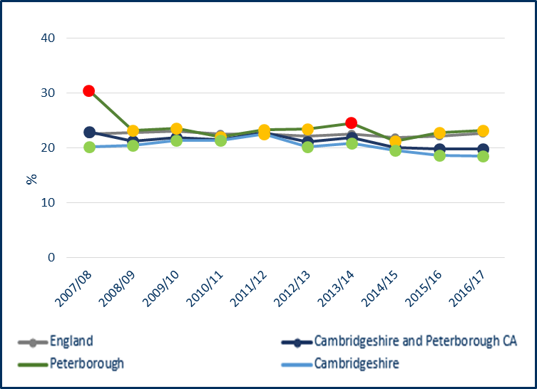

Source: National Child Measurement Programme, NHS Digital from PHE Public Health Outcomes Framework (<https://fingertips.phe.org.uk/>)

Table 20: Overweight (including obese) children, 10-11 years (%), 2016/17



Source: National Child Measurement Programme, NHS Digital from PHE Public Health Outcomes Framework (<https://fingertips.phe.org.uk/>)

Figure 5: Overweight (including obese) children, 10-11 years (%) for Cambridgeshire and Peterborough, 2007/08 to 2016/17

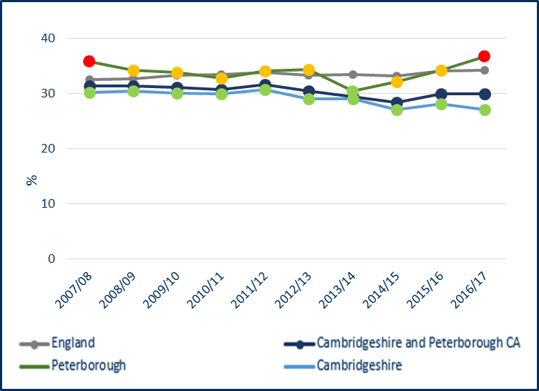

Source: National Child Measurement Programme, NHS Digital from PHE Public Health Outcomes Framework (<https://fingertips.phe.org.uk/>)

* + 1. Childhood obesity

Table 21: Obese children, 4-5 years (%), 2016/17



Source: National Child Measurement Programme, NHS Digital from PHE Public Health Outcomes Framework (<https://fingertips.phe.org.uk/>)

Figure 6: Obese children (4-5 years) % for Cambridgeshire and Peterborough, 2007/08 to 2016/17

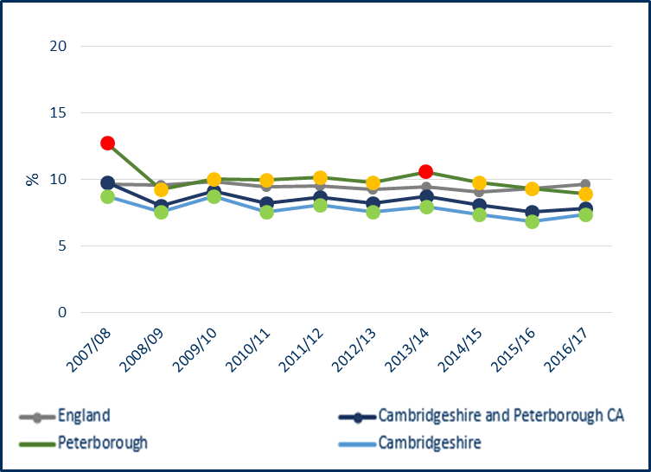

Source: National Child Measurement Programme, NHS Digital from PHE Public Health Outcomes Framework (<https://fingertips.phe.org.uk/>)

Table 22: Obese children, 10-11 years (%), 2016/17



Source: National Child Measurement Programme, NHS Digital from PHE Public Health Outcomes Framework (<https://fingertips.phe.org.uk/>)

Figure 7: Obese children (10-11 years) % for Cambridgeshire and Peterborough, 2007/08 to 2016/17

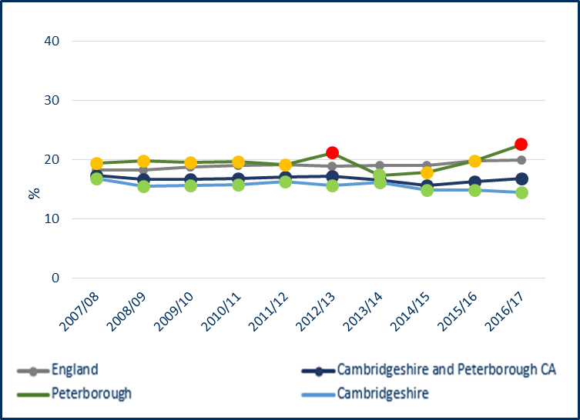

Source: National Child Measurement Programme, NHS Digital from PHE Public Health Outcomes Framework (<https://fingertips.phe.org.uk/>)

**Key points – childhood excess weight**

**4-5 year olds - Excess weight**

* All districts in Cambridgeshire, except Fenland, have statistically significantly lower percentages compared to England.
* Fenland and Peterborough have statistically similar percentages compared to England.
* Cambridgeshire has a statistically significantly lower percentages compared to England.
* There is a decreasing trend in Cambridgeshire, Cambridge and Fenland.
* There have been slight annual increases in Peterborough over the last three years.

**4-5 year olds - Obesity**

* All districts in Cambridgeshire, except Fenland, have statistically significantly lower percentages than England.
* Fenland and Peterborough have statistically similar percentages compared to England.
* There is a decreasing trend in the proportions in Cambridgeshire.
* There is no significant change in recent trend in Peterborough.
* Cambridge and Fenland have been experiencing downward trends, with all other Cambridgeshire districts showing a relatively static trend over the last 10 years.

**10-11 year olds – Excess weight**

* All districts in Cambridgeshire, except Fenland, have statistically significantly lower percentages compared to England. Fenland has a statistically similar percentage.
* Cambridgeshire has a statistically significantly lower percentages compared to England.
* Peterborough has a statistically significantly high percentage compared to England.
* The trend in Cambridgeshire is decreasing, as it is in Cambridge, East Cambridgeshire and South Cambridgeshire.
* The trend in Peterborough has been notably increasing since 2013/14.

**10-11 year olds – Obesity**

* All districts in Cambridgeshire, except Fenland, have statistically significantly lower percentages compared to England. Fenland has a statistically similar percentage.
* Peterborough has a statistically significantly high proportion compared to England.
* Cambridgeshire has a decreasing trend.
* Peterborough has been experiencing an upward trend in recent years (2013/14 to 2016/17).
* All Cambridgeshire districts have static trends, with the exception of South Cambridgeshire which has been assessed as experiencing a downward trend.
  + 1. Alcohol

Table 23: Admission episodes for alcohol-specific conditions - Under 18s crude rate per 100,000, 2014/15 - 2016/17



*Aggregated from all

known lower geography

values

Source: Calculated by Public Health England: Risk Factors Intelligence (RFI), from PHE Health Profiles (<https://fingertips.phe.org.uk/>)

Figure 8: Admission episodes for alcohol-specific conditions - Under 18s crude rate per 100,000 for, Huntingdonshire and Cambridge 2006/07 - 2008/09 to 2014/15 - 2016/17

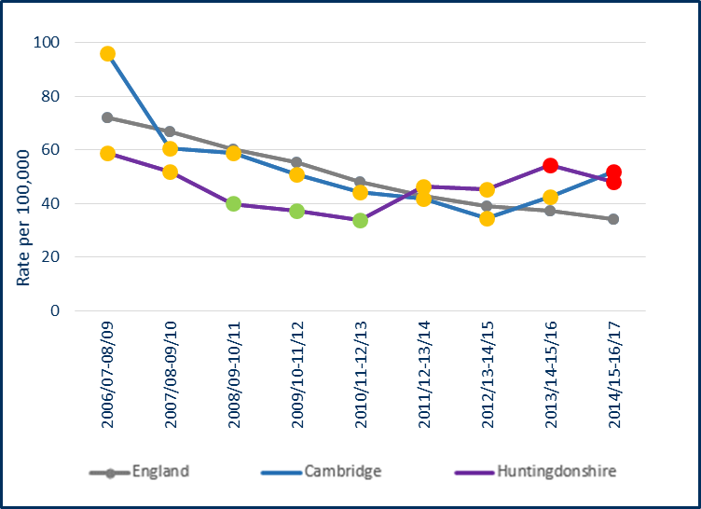

Source: Calculated by Public Health England: Risk Factors Intelligence (RFI) team using data from NHS Digital - Hospital Episode Statistics (HES) and Office for National Statistics (ONS) - Mid Year Population Estimates.

**Key points – alcohol admissions**

* Cambridge and Huntingdonshire have statistically significantly higher rates compared to England, with both areas experiencing increasing trends in recent years.
* There has been an increasing trend in South Cambridgeshire, with the latest rate now being statistically similar to England, whereas historically it had been statistically significantly better than England.
* The rate in Peterborough has remained fairly stable in recent years.
  + 1. Substance misuse

Table 24: Hospital admissions due to substance misuse, directly standardised rate per 100,000 population aged 15-24 years, 2014/15 - 2016/17

Data not available at District or Combined Authority level

Source: Hospital Episode Statistics (HES), from PHE Child Health Profiles (<https://fingertips.phe.org.uk/>)

Figure 9: Hospital admissions due to substance misuse, 15-24 years, directly standardised rate per 100,000 population aged 15-24 years for Cambridgeshire and Peterborough, 2008/09 - 2010/11 to 2014/15 - 2016/17

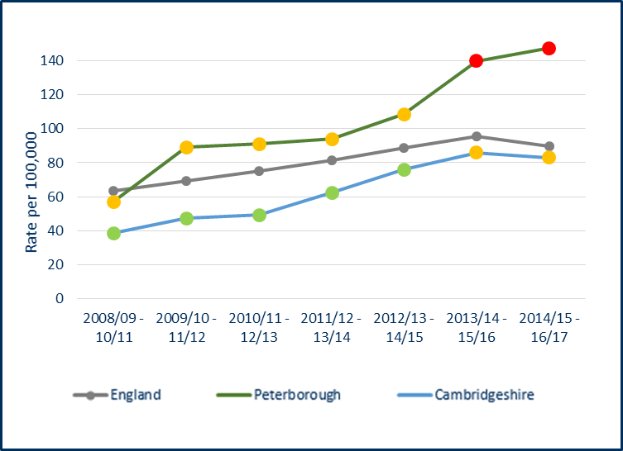

Source: Hospital Episode Statistics (HES), from PHE Child Health Profiles (<https://fingertips.phe.org.uk/>)

**Key points – substance misuse**

* Peterborough has a statistically significantly higher rate compared to England, with a notable increasing trend.
* There is an increasing trend in Cambridgeshire with the latest rates being statistically similar to England, compared to historically being statistically significantly better.
  + 1. Sexual health

Table 25: Chlamydia proportion aged 15-24 years screened (%), 2017



Source: CTAD Chlamydia Surveillance System, from PHE Sexual and Reproductive Health Profiles (https://fingertips.phe.org.uk/)

Table 26: Chlamydia detection rate, crude rate per 100,000 aged 15-24 years, 2017





Source: CTAD Chlamydia Surveillance System, from PHE Sexual and Reproductive Health Profiles (https://fingertips.phe.org.uk/)

**Key points – chlamydia screening and detection**

* All Cambridgeshire districts, except Cambridge, have statistically significantly low proportions of 15-24 year olds screened for chlamydia compared to England. Cambridge has a statistically similar proportion.
* Peterborough has a statistically significantly high proportion of chlamydia screening than England.
* Cambridgeshire has a statistically significantly low screening proportion compared to England.
* Cambridgeshire and all the districts have low chlamydia detection rates compared to the nationally set benchmark.
* Peterborough has a high chlamydia detection rate compared to the nationally set benchmark.
* Cambridgeshire, Cambridge, East Cambridgeshire, Fenland and Huntingdonshire have experienced downward trends in detection rates for the last 5 years.

Table 27: Percentage of women aged under 25 choosing long acting reversible contraceptives (LARC) excluding injections as their main method of contraception at Sexual and Reproductive Health Services for Cambridgeshire and Peterborough, 2016

Source: NHS Digital, from PHE Sexual and Reproductive Health Profiles and Office for National Statistics

**Key points – LARC**

* East Cambridgeshire has a statistically significantly high percentage of women aged under 25 choosing long acting reversible contraceptives (excluding injections) as their main method of contraception compared to England.
* Cambridgeshire has a statistically significantly high percentage of women aged under 25 choosing long acting reversible contraceptives (excluding injections) as their main method of contraception compared to England.

Table 28: Repeat abortions, under 25 year olds (%), 2016

Data not available

at District level

Source: Department of Health, from Sexual and Reproductive Health Profiles (<https://fingertips.phe.org.uk>)

Table 29: Abortion after a birth, under 25 year olds, 2016



Data not available

at District level

Source: Department of Health, from Sexual and Reproductive Health Profiles (<https://fingertips.phe.org.uk>)

Figure 10:Abortion after a birth, under 25 year olds, 2014 to 2016

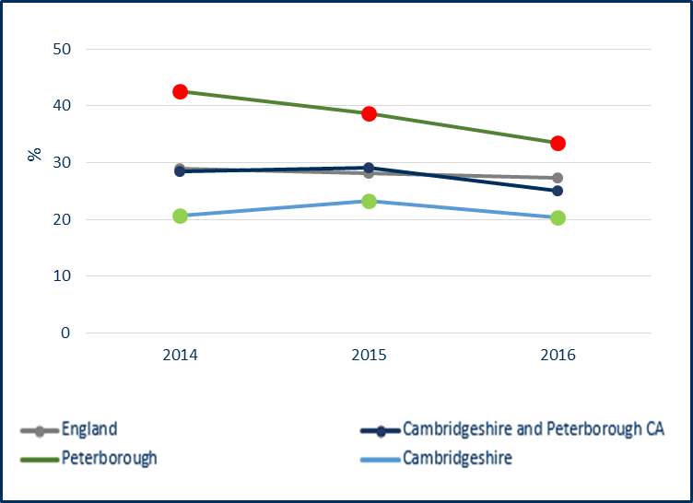

Source: Department of Health, from Sexual and Reproductive Health Profiles (<https://fingertips.phe.org.uk>)

**Key points – Abortions in under 25 year olds abortions**

* Cambridgeshire has a statistically significantly low percentage of repeat abortions in under 25 year olds compared to England.
* Cambridgeshire has a statistically significantly low percentage of abortions after a birth in under 25 year olds when compared to England.
* Peterborough has a statistically significantly high percentage of abortions after a birth in under 25 year olds when compared to England.
* The Peterborough percentage has been statistically significantly higher than England for the last 3 years, but is decreasing.
  1. Teenage conceptions

Table 30: Under 18 conceptions crude rate per 1,000 females aged 15-17 years, 2016



Source: Office for National Statistics (ONS), from PHE Public Health Outcomes Framework (https://fingertips.phe.org.uk)

Figure 11: Under 18 conceptions crude rate per 1,000 females aged 15-17 years for Cambridgeshire and Peterborough, 1998 to 2016

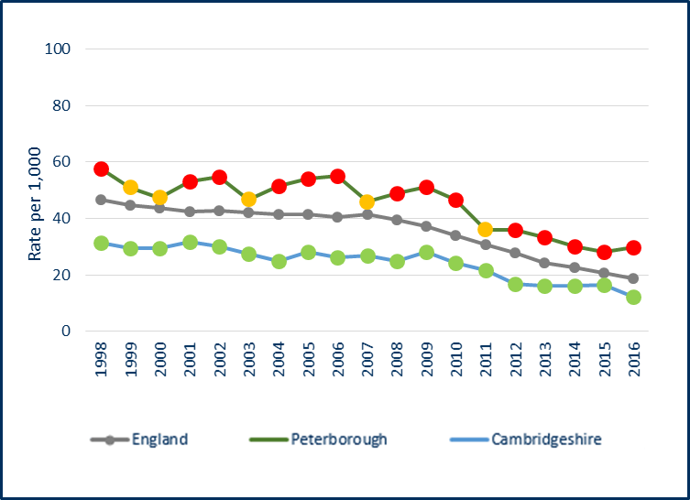

Source: Office for National Statistics (ONS), from PHE Public Health Outcomes Framework (<https://fingertips.phe.org.uk>)

Table 31: Under 18s conceptions leading to abortion %, 2016



‘-‘ denotes fewer than 6 conceptions

Source: Office for National Statistics (ONS), from PHE Sexual and Reproductive Health Profiles (<https://fingertips.phe.org.uk>)

Table 32: Under 16 conceptions crude rate per 1,000 females aged 13-15 years, 2016

Data not available at District level

*There is a data quality issue with this value.

Source: Office for National Statistics (ONS), from PHE Public Health Outcomes Framework (https://fingertips.phe.org.uk)

Table 33: Teenage mothers, % of delivery episodes where the mother is aged under 18 years, 2016/17



Data not available at District level

*Aggregated from all

known lower geography

values

Source: Hospital Episode Statistics (HES) Copyright © 2016 from PHE Sexual and Reproductive Health Profiles (<https://fingertips.phe.org.uk>)

**Key points – teenage conceptions, abortions and births**

**Teenage conceptions**

* Cambridgeshire, Cambridge and South Cambridgeshire have statistically significantly low teenage conception rates compared to England
* Peterborough has a statistically significantly high teenage conception rate compared to England.
* Cambridgeshire, Peterborough and all the districts have experienced downward trends in rates over the last 10 years. However, rates in Huntingdonshire have increased annually since 2012, with the latest rate (2016) statistically similar to England, whereas historically is had been statistically significantly better.
* Peterborough appears to have a statistically significantly high proportion of conceptions in under 16 year olds compared to the England average, but there is a data quality issues with the figure.

**Teenage conceptions leading to abortion**

* Cambridgeshire, Peterborough and all the districts have statistically similar rates compared to England, with the exception of Huntingdonshire which has a statistically significantly high percentage.
* There was a noticeable increase from 23.3% in 2015 to 50.0% in 2016 in Fenland.
* The Huntingdonshire percentage has been increasing year on year, and is now statistically significantly higher than England.

**Teenage mothers**

* Cambridgeshire and Peterborough both have statistically similar percentages of teenage mothers to England.
* There was a notable decrease in teenage mothers in Peterborough between 2015/16 and 2016/17 (1.3% in 2015/16 to 0.8% in 2016/17).
  1. Decayed, missing or filled teeth

Table 34: DMFT (decayed, missing or filled teeth), 5 year olds, average number, 2016/17



Source: Dental Public Health Epidemiology Programme for England, from PHE Oral Health Profile (<https://fingertips.phe.org.uk>)

Table 35: Children (5 year olds) with one or more decayed, missing or filled teeth, %, 2016/17



Data not available

at Combined

Authority or District Level

Source: Dental Public Health Epidemiology Programme for England, from PHE Oral Health Profile (<https://fingertips.phe.org.uk>)

Table 36: Proportion (%) of 5 year olds free from dental decay, 2014/15



*Aggregated from all

known lower geography

values

Source: National Dental Epidemiology Programme for England: oral health survey of five-year-old children 2015, from PHE Oral Health Profile (<https://fingertips.phe.org.uk>)

**Key points – decayed, missing or filled teeth and 5 year olds free from dental decay**

* All districts in Cambridgeshire, except Fenland, have a statistically significantly low average number of decayed, missing or filled teeth in 5 year olds compared to England. Fenland is statistically similar.
* Cambridgeshire has a statistically significantly low average number of decayed, missing or filled teeth in 5 year olds compared to England.
* Peterborough has a statistically significantly similar average number of decayed, missing or filled teeth in 5 year olds compared to England. Fenland is statistically similar.
* All districts except Fenland have statistically significantly high proportions of 5 year olds free from decay compared to England. Fenland is statistically similar.
* Cambridgeshire has a statistically significantly high proportion of 5 year olds free from decay compared to England.

1. **Health protection**
   1. Vaccinations and immunisations
      1. Summary table of all childhood vaccinations



Note:1 - Vaccination - Dtap / IPV / Hib (1 year old) = diphtheria, hepatitis B, Hib (Haemophilus influenzae type b), polio, tetanus, whooping cough (pertussis).

Note:2 - benchmarked against threshold based goals - see http://www.phoutcomes.info/

Note:3 - DQ = value not published for data quality reasons

Note:4 - Hib = Haemophilus influenzae type b; MenC = meningitis C

Note:5 - MMR = measles, mumps and rubella

Note 6 - PCV= pneumococcal infections that can cause pneumonia, septicaemia or meningitis

Note:7 - HPV = Human papilloma virus

^ Aggregated from all known lower geography values

- Data not available

~ Value estimated from former primary care organisations covered by the local authority

The number next to the trend arrow indicates the number of year that the trend relates to.

Source: Public Health Outcomes Framework, PHE (<https://fingertips.phe.org.uk/>)

**Key points – vaccinations**

* Vaccinations in 5 year olds are in the lowest nationally prescribed threshold in both Cambridgeshire and Peterborough, at under 90% coverage. This includes Hib/MenC boosters and two doses of MMR. The majority of other vaccinations are between 90-95% coverage. The national target is 95%.
* Flu uptake in 2-4 year olds is below the minimum threshold in Peterborough.
  + 1. MMR

Table 37: MMR vaccination - % of eligible children who have received one dose of MMR, 2 years old, 2016/17

Data not available

at District level

*Aggregated from all

known lower geography

values



Source: Cover of Vaccination Evaluated Rapidly (COVER) data, from Public Health Outcomes Framework (https://fingertips.phe.org.uk)

Figure 12: MMR vaccination - % of eligible children who have received one dose of MMR, 2 years old, for Cambridgeshire and Peterborough, trend 2010/11 to 2016/17

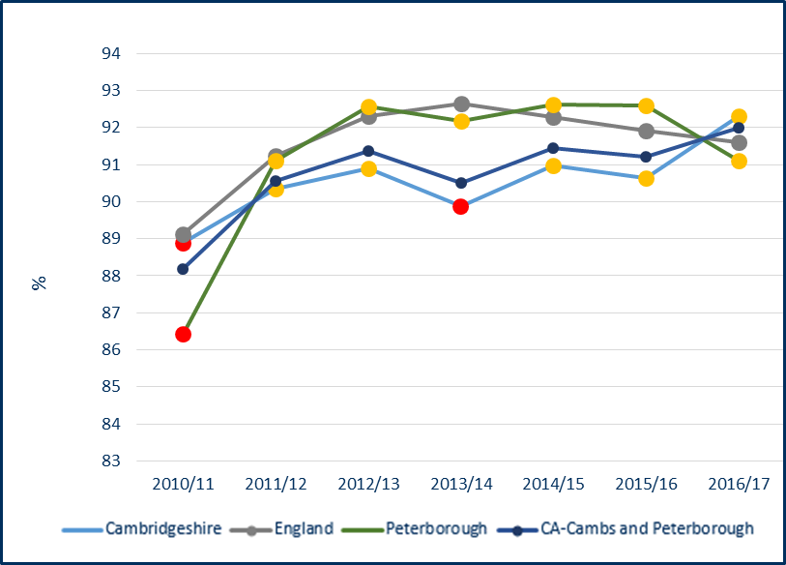



Source: Cover of Vaccination Evaluated Rapidly (COVER) data, from Public Health Outcomes Framework (https://fingertips.phe.org.uk)

Table 38: MMR vaccination - % of eligible children who have received two doses of MMR, 5 years old, 2016/17

Data not available

at District level

*Aggregated from all

known lower geography

values



Source: Cover of Vaccination Evaluated Rapidly (COVER) data, from Public Health Outcomes Framework (https://fingertips.phe.org.uk)

Figure 13: MMR vaccination - % of eligible children who have received two doses of MMR, 5 years old, for Cambridgeshire and Peterborough, trend 2010/11 to 2016/17





Source: Cover of Vaccination Evaluated Rapidly (COVER) data, from Public Health Outcomes Framework (https://fingertips.phe.org.uk)

**Key points - MMR**

* The percentage of eligible children who have received one dose of MMR at 2 years old in Cambridgeshire and Peterborough are within the benchmark of 90% to 95%. Above 95% is the main target.
* There is an increasing trend in both Cambridgeshire and Peterborough for MMR coverage in 2 year olds, although there was a reduction in Peterborough in 2016/17.
* The percentages of eligible children who have received two doses of MMR at 5 years in Cambridgeshire and Peterborough are below 90%. The target is 95%.
* There is an increasing trend in Peterborough and a decreasing trend in Cambridgeshire for MMR coverage at 5 years old.
  + 1. HPV

Table 39: Population vaccination coverage - HPV vaccination coverage for two doses, females aged 13-14 years old, 2016/17

Data not available

at District level

*Aggregated from all

known lower geography

values



Source: Public Health England (PHE). <https://www.gov.uk/government/statistics/annual-hpv-vaccine-coverage-2015-to-2016-by-local-authority-and-area-team>

**Key points - HPV**

* Two dose HPV vaccination coverage in females aged 13-14 years old in Cambridgeshire and Peterborough are within the benchmark goal of 80% to 90%. The national target is over 90%.
* There has been a notable decrease in coverage in Peterborough.
  + 1. Children in care immunisations

Table 40: Children in care under 18 years - % of children in care for at least 12 months whose immunisations were up to date, 2017

Data not available at District level 

*Aggregated from all known lower geography values.

Source: Department for Education (DfE) <https://www.gov.uk/government/collections/statistics-looked-after-children>

Figure 14: Children in care under 18 years - % of children in care for at least 12 months whose immunisations were up to date, trend 2012 to 2017

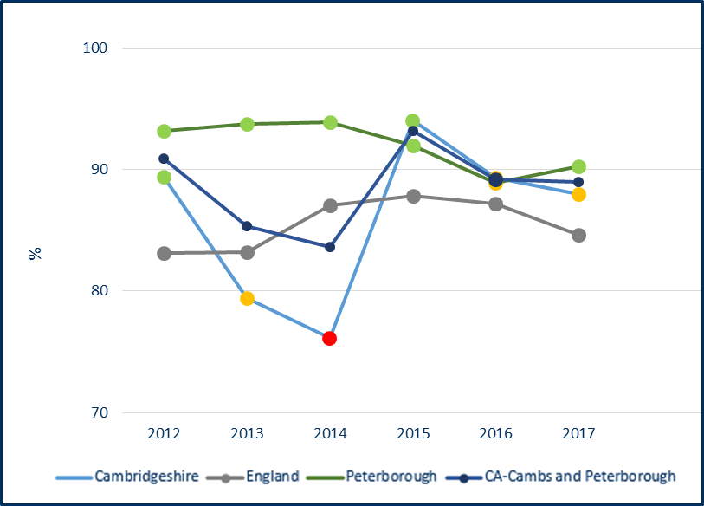

Source: Department for Education (DfE) <https://www.gov.uk/government/collections/statistics-looked-after-children>

**Key Points**

**Key points – children in care immunisations**

* The percentage of children in care (for at least 12 months) whose immunisations are up to date in Peterborough is statistically significantly higher than England, with a relatively static trend over the last 6 years.
* The percentage of children in care (for at least 12 months) whose immunisations are up to date in Cambridgeshire is statistically similar to England, with a decreasing trend since 2015.

1. **Prevention of ill health**
   1. A&E attendances

Table 41: A&E attendances, 0-4 years - A&E attendance rate per 1,000 population aged 0-4 years, 2016/17

Data not available at District level

*Aggregated from all known lower geography values.

Source: Hospital Episode Statistics (HES) Copyright © 2018, from PHE Child Health Profiles (https://fingertips.phe.org.uk)

Figure 15: A&E attendances, 0-4 years - A&E attendance rate per 1,000 population aged 0-4 years for Cambridgeshire and Peterborough, 2011 to 2017

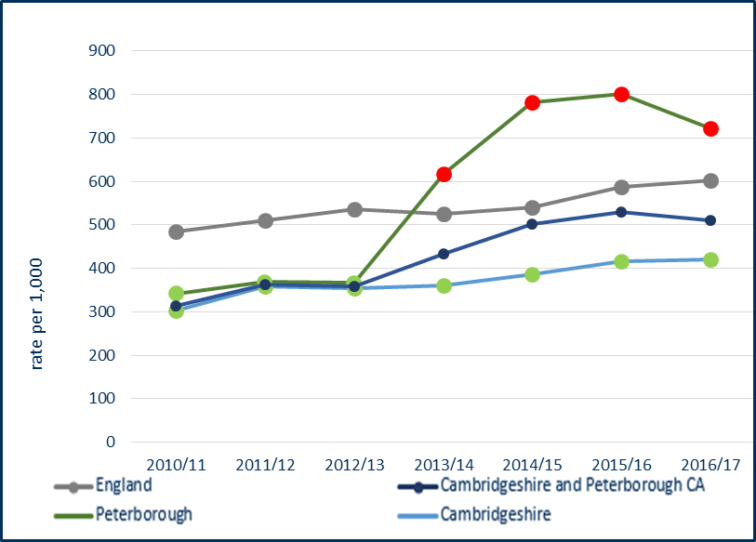

Source: Hospital Episode Statistics (HES) Copyright © 2018, from PHE Child Health Profiles (https://fingertips.phe.org.uk)

**Key points – A&E attendances**

* The A&E attendance rate in children aged 0-4 years is statistically significantly higher in Peterborough than the national average.
* The A&E attendance rate in children aged 0-4 years is statistically significantly lower in Cambridgeshire than the national average.
* Similar to the national trend, there appears to be an increasing trend in Cambridgeshire and, most notably, in Peterborough.
  1. Hospital admissions – unintentional and deliberate injuries

Table 42: Hospital admissions caused by unintentional and deliberate injuries in children, 0-14 years - crude rate per 10,000 resident population aged 0-14 years, 2016/17

*Aggregated from all known lower geography values.

Source: Hospital Episode Statistics (HES) Copyright © 2018, from PHE Public Health Outcomes Framework (https://fingertips.phe.org.uk)

Figure 16: Hospital admissions caused by unintentional and deliberate injuries in children, 0-14 years - crude rate per 10,000 resident population aged 0-14 years for Cambridgeshire, Peterborough and Fenland, 2010/11 to 2016/17

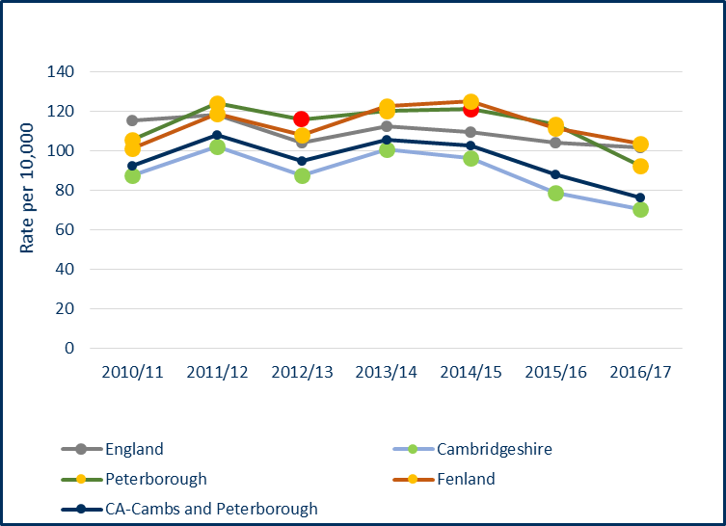

Source: Hospital Episode Statistics (HES) Copyright © 2018, from PHE Public Health Outcomes Framework (https://fingertips.phe.org.uk)

**Key points – hospital admission caused by unintentional and deliberate injuries, 0-14 year olds**

* The rate of hospital admissions caused by injuries in children (0-14 years) is statistically significantly lower in all districts compared to the national average, with the exception of Fenland which is statistically similar.
* In Cambridgeshire the rate is statistically significantly lower than the national average.
* In Peterborough the rate is statistically similar to the national average.
* The trend in both Cambridgeshire and Peterborough is improving.
* There has been no significant change in the trend in Fenland.

Table 43: Hospital admissions caused by unintentional and deliberate injuries in young people, 15-24 years - crude rate per 10,000 population aged 15-24 years, 2016/17

*Aggregated from all known lower geography values.

Source: Hospital Episode Statistics (HES) Copyright © 2018, from PHE Public Health Outcomes Framework (<https://fingertips.phe.org.uk>)

Figure 17: Hospital admissions caused by unintentional and deliberate injuries in young people, 15-24 years - crude rate per 10,000 population aged 15-24 years for Cambridgeshire and Peterborough, 2010/11 to 2016/17

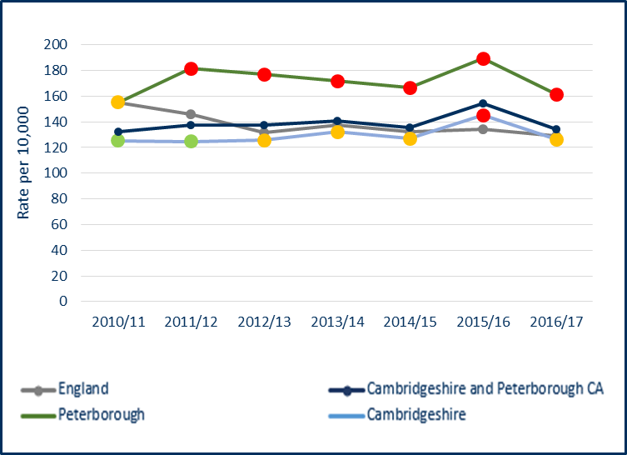

Source: Hospital Episode Statistics (HES) Copyright © 2018, from PHE Public Health Outcomes Framework (<https://fingertips.phe.org.uk>)

**Key points – hospital admission caused by unintentional and deliberate injuries**, **15-24 year olds**

* Peterborough has a statistically significantly higher rate than the national average.
* Cambridgeshire and Peterboroughhave both seen no significant change in the trend over the last 7 years. However, in 2016/17 Cambridgeshire moved from being statistically significantly worse than the national average to being statistically similar.
  1. Hospital admissions – asthma, diabetes and epilepsy

Table 44: Hospital admissions for asthma, under 19 years - crude rate per 100,000 population aged 0-18 years, 2016/17

Data not available at district level

*Aggregated from all known lower geography values.

Source: Hospital Episode Statistics (HES) Copyright © 2016, from PHE Child Health Profiles (<https://fingertips.phe.org.uk>)

Figure 18: Hospital admissions for asthma, under 19 years - crude rate per 100,000 population aged 0-18 years for Cambridgeshire and Peterborough, 2011/12 to 2016/17

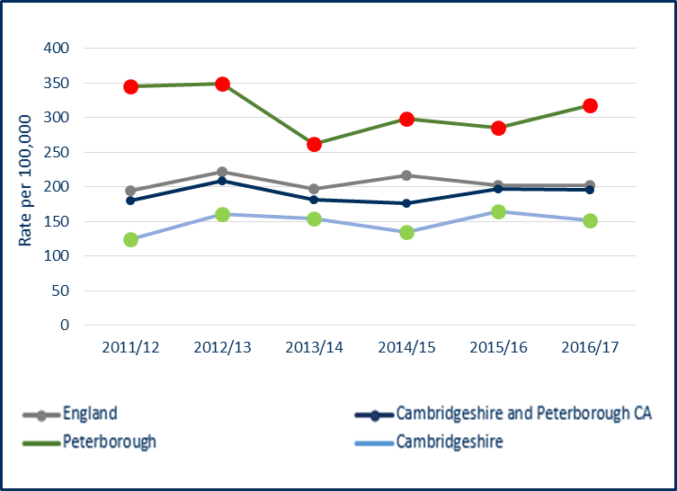

Source: Hospital Episode Statistics (HES) Copyright © 2016, from PHE Child Health Profiles (<https://fingertips.phe.org.uk>)

Table 45: Unplanned hospitalisation for asthma, diabetes and epilepsy in under 19s (directly standardised rate) population aged 0-18 years, 2014/15

Data only available at CCG level

Source: Hospital Episode Statistics (HES) Copyright © 2016, from PHE Child Health Profiles (<https://fingertips.phe.org.uk>)

Figure 19: Unplanned hospitalisation for asthma, diabetes and epilepsy in under 19s (directly standardised rate) population aged 0-18 years, 2010/11 to 2014/15

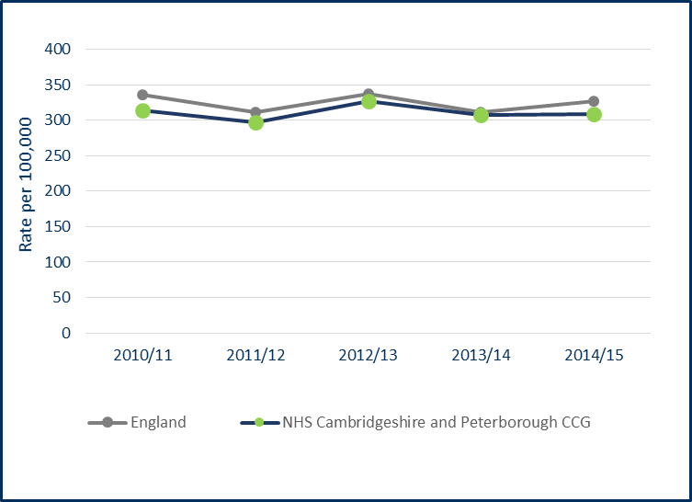

Source: Hospital Episode Statistics (HES) Copyright © 2016, from PHE Child Health Profiles

**Key points – hospital admissions for asthma, diabetes and epilepsy**

**Asthma**

* Cambridgeshire has a statistically significantly low rate compared to the national average.
* Peterborough has a statistically significantly high rate compared to the national average.
* Peterborough has been experiencing an upward trend in rates since 2013/14.

**Asthma, diabetes and epilepsy**

* The CCG admission rate for these three conditions combined is similar to the national average, with rates remaining relatively stable over the last 5 years.
  1. Hospital admissions – mental health conditions

Table 46: Hospital admissions for mental health conditions, under 18 year olds - crude rate per 100,000 population aged 0-17 years, 2016/17

Data not available at district level

*Aggregated from all known lower geography values.

Source: Hospital Episode Statistics (HES) Copyright © 2016, from PHE Child Health Profiles (<https://fingertips.phe.org.uk>)

Figure 20: Hospital admissions for mental health conditions, under 18 year olds - crude rate per 100,000 population aged 0-17 years for Cambridgeshire and Peterborough, 2010/11 to 2016/17

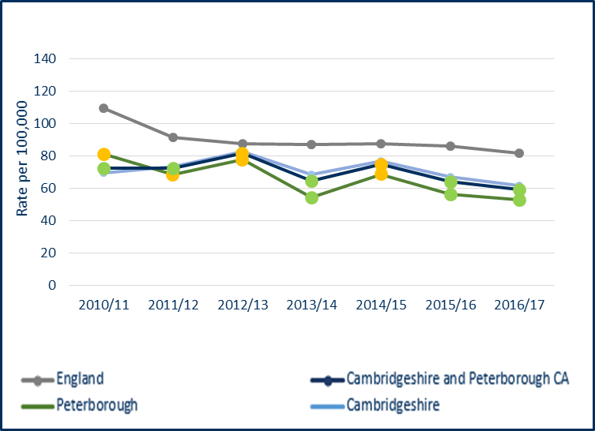

Source: Hospital Episode Statistics (HES) Copyright © 2016, from PHE Child Health Profiles (<https://fingertips.phe.org.uk>)

**Key points – hospital admissions for mental health conditions**

* Both Cambridgeshire and Peterborough have statistically significantly lower rates of hospital admissions for mental health conditions than the national average.
* The trend in Cambridgeshire has been relatively stable over the last 7 years.
* There has been an overall downward trend in Peterborough over the last 7 years.
  1. Hospital admissions – self-harm

Table 47: Hospital admissions as a result of self-harm, 10-24 years - directly standardised rate per 100,000 resident population aged 10-24 years, 2016/17

Data not available at district level

Source: Hospital Episode Statistics (HES) Copyright © 2016, from PHE Child Health Profiles (<https://fingertips.phe.org.uk>)

Figure 21: Hospital admissions as a result of self-harm, 10-24 years - directly standardised rate per 100,000 resident population aged 10-24 years for Cambridgeshire and Peterborough, 2011/12 to 2016/17

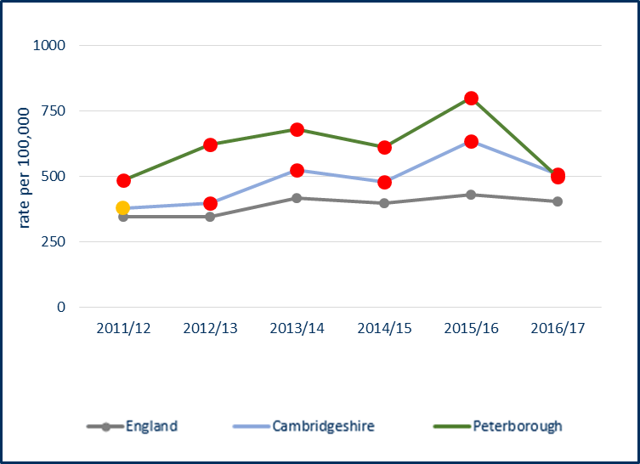

Source: Hospital Episode Statistics (HES) Copyright © 2016, from PHE Child Health Profiles (<https://fingertips.phe.org.uk>)

**Key points – hospital admissions for self-harm**

* Both Cambridgeshire and Peterborough have statistically significantly higher rates of hospital admissions as a result of self-harm (10-24 years) compared to the national average.
* The Cambridgeshire rate has been statistically significantly higher than England since 2012/13.
* The Peterborough rate has been statistically significantly higher than England since 2011/12.
* Local analysis on self-harm hospital admission rates has shown that Cambridge City and East Cambridgeshire had the highest rates in Cambridgeshire in 2016/17, with rates that are statistically significantly higher than the England rate. Admission rates are highest in young people, especially 15 to 19 year olds and are higher in females than males. Intentional self-poisoning is the most common reason for self-harm hospital admissions. A small number of patients account for notable frequent admissions.

1. **Premature mortality**
   1. Infant Mortality

Table 48: Infant mortality - rate of deaths in infants aged under 1 year per 1,000 live births, 2014-16



Source: Office of National Statistics, from PHE Pubic Health Outcomes Framework (https://fingertips.phe.org.uk)

Figure 22: Infant mortality - rate of deaths in infants aged under 1 year per 1,000 live births for Cambridgeshire and Peterborough trend 2007-2009 to 2014-2016

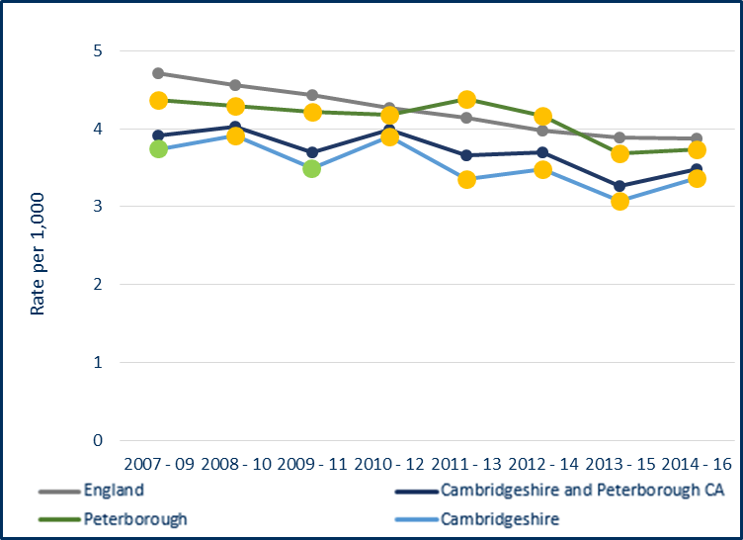

Source: Office of National Statistics, from PHE Pubic Health Outcomes Framework (https://fingertips.phe.org.uk)

**Key points – infant mortality**

* East Cambridgeshire and Huntingdonshire have statistically significantly lower rates compared to England. A decrease in rates in Huntingdonshire in 2014-16 led to the area becoming statistically significantly better than the national average, having been statistically similar since 2001-03.
* The rates of infant mortality in Cambridgeshire and Peterborough remain statistically similar to the England average.
* Numbers are relatively small and rates fluctuate but there has generally been an increasing trend in Cambridge City since 2011-13, in Fenland since 2009-11 and in South Cambridgeshire since 2011-13.
  1. Child Mortality

Table 49: Child mortality in persons aged 1-17 years - directly age-standardised rates (DASR) per 100,000 population, 2014-16

Data not available

at District level

Source: Office of National Statistics, from PHE Child Health Profiles (https://fingertips.phe.org.uk)

Figure 23: Child mortality in persons aged 1-17 years, Cambridgeshire and Peterborough, trend 2010-12 to 2014-16

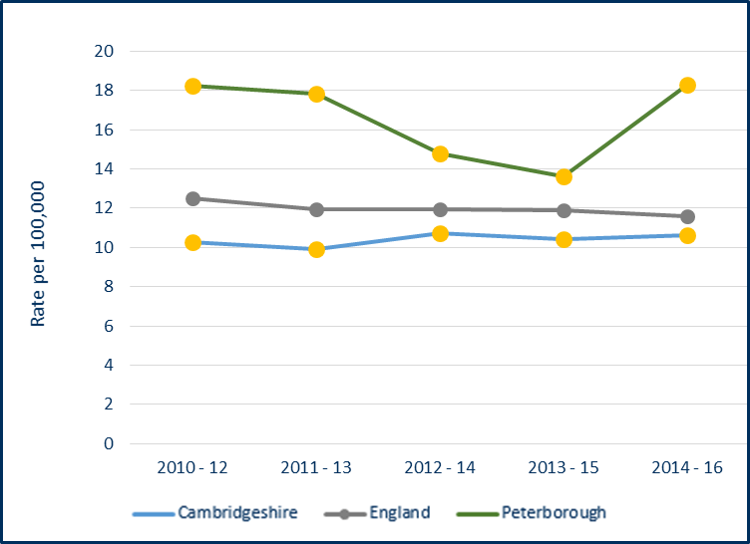

Source: Office of National Statistics, from PHE Child Health Profiles (https://fingertips.phe.org.uk)

**Key points – child mortality**

* The rates of child mortality in both Cambridgeshire and Peterborough are statistically similar to the England rate and have been since 2010-12.
* There was a notable increase in rates in Peterborough between 2013-15 and 2014-16.

Report prepared by:

Gen Fitzjohn and Helen Whyman

Public Health Information Analysts

Public Health Intelligence, Cambridgeshire and Peterborough Councils

[phi-team@peterborough.gov.uk](mailto:ryan.o'neill@peterborough.gov.uk)

1. **Appendices**
   1. Child Health Profile – Cambridgeshire

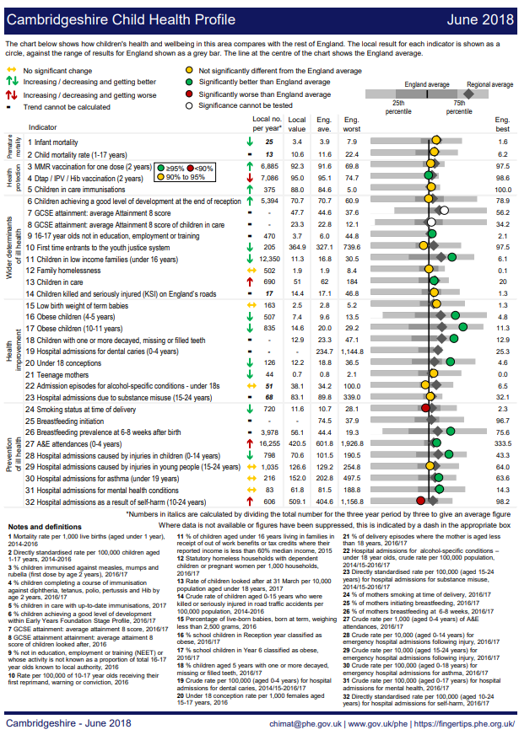

* 1. Child Health Profile – Peterborough

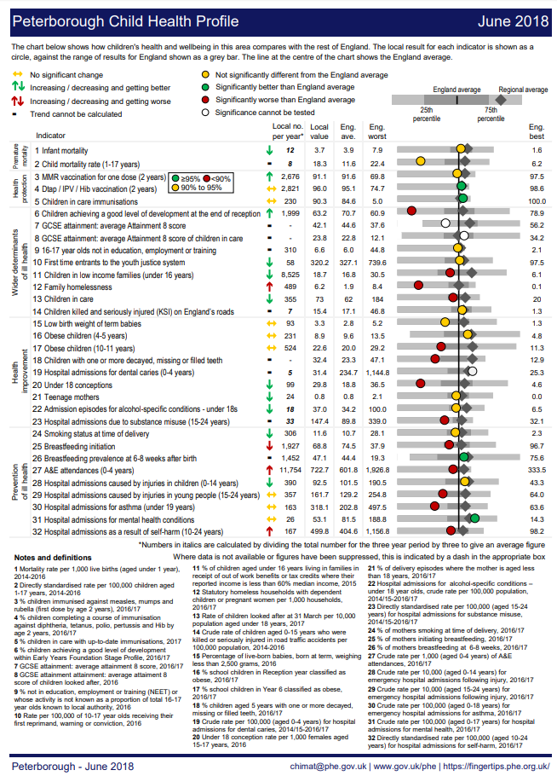

* 1. Cambridgeshire and Peterborough Children’s Outcomes Framework - baseline







1. Child Health Profiles, Public Health England (https://fingertips.phe.org.uk/profile-group/child-health/profile/child-health-overview/area-search-results/E12000006?search_type=list-child-areas&place_name=East%20of%20England)
2. Mid 2015 based population forecasts, 2016 to 2026, Research Group, Cambridgeshire County Council
3. Public Health Outcomes Framework, Public Health England (<https://fingertips.phe.org.uk>) – as at June 2018