2017 JSNA core dataset:

South Cambridgeshire Summary, July 2018

**Joint Strategic Needs Assessment**

cambridgeshire.gov.uk

Contents

Population estimates and forecasts 4

Population density 5

Fertility, migration and ethnicity 6

Deprivation 8

Wider determinants of health and wellbeing 9

Lifestyles and risk factors for health 11

Falls 12

Screening and vaccination 12

Disease prevalence – the amount of illness recorded in the population 13

Self-harm and suicide 13

Use of NHS hospital services 14

Life expectancy and mortality 14

Further information 16

Tables

Table 1: South Cambridgeshire – absolute long-term (20-year) population change, 2016 to 2036 (all ages)………………………………………………………………………………………………………………………………………………….4

Table 2: South Cambridgeshire – absolute short-term (5- and 10-year) population change, 2016 to 2026 by age group 4

Table 3: Population density for South Cambridgeshire, Cambridgeshire, East of England and England, mid-2016 5

Table 4: ONS mid-2015 to ONS mid-2016 population estimates – proportional contribution of each component of population change 7

Table 5: Indices of deprivation – 2015, overall score, children’s and older people’s indices and the percentage locally living in the national 20% most deprived area group by local authority, county and England 8

Table 6: Wider determinants of health and wellbeing: summary of key indicators from Public Health England’s Wider Determinants Atlas 10

Table 7: Lifestyles and risk factors – summary of key indicators for South Cambridgeshire, Cambridgeshire and England 11

Table 8: Falls in people aged 65 and over – emergency hospital admissions South Cambridgeshire, Cambridgeshire and England, 2015/16 12

Table 9: Screening and vaccination – coverage (%) for South Cambridgeshire, Cambridgeshire and England 12

Table 10: GP-recorded disease prevalence by district of general practice location, South Cambridgeshire, Cambridgeshire and England, 2015/16 13

Table 11: Self-harm and suicide indicators for South Cambridgeshire, Cambridgeshire and England 13

Table 12: Hospital-related admissions and attendances by admission type for South Cambridgeshire and Cambridgeshire 14

Table 13: Life expectancy and healthy life expectancy for South Cambridgeshire, Cambridgeshire and England 14

Table 14: Directly age-standardised rates for major causes of death in South Cambridgeshire and Cambridgeshire, 2014-16 15

Figures

Figure 1: South Cambridgeshire – absolute long-term (20-year) population change, 2016 to 2036 (all ages) (comparing CCC RG data with ONS projections) 4

Figure 2: South Cambridgeshire – absolute short-term (5- and 10-year) population change, 2016 to 2026 by age group (comparing CCC RG data with ONS projections) 5

Figure 3: Year– on-year percentage change in population density for South Cambridgeshire, Cambridgeshire, East of England and England, 2007/08 – 2015/16 6

Figure 4: General fertility rate (live birth rate per 1,000 women aged 15-44 years) by local authority of mother’s residence, Cambridgeshire, 2013-15 6

Figure 5: ONS mid-2015 to mid-2016 population estimates – absolute and proportional contribution of components of population change in South Cambridgeshire, Cambridgeshire, East of England and England 7

Figure 6: Percentage of national insurance registration applications (NINo) to adult overseas nationals entering South Cambridgeshire, (registration year to March 2017) 8

Figure 7: Percentage of population by broad ethnic group, South Cambridgeshire, 2011 8

Figure 8: Percentage of wards within South Cambridgeshire by deprivation quintile compared against all wards within Cambridgeshire County 9

Figure 9: Major causes of death in South Cambridgeshire, 2014-16 15

Statistical Significance

Throughout this JSNA district summary, comparisons between district/county and England have been made through the assessment of ‘statistical significance’. For each indicator value, 95% confidence intervals are calculated which provide a measure of uncertainty around the calculated value. If the confidence interval for the district/county value excludes the value for the benchmark (which is typically England), the difference between the district/county value and the benchmark is said to be ‘statistically significant’. When values are statistically significant they are represented via the colour scheme below:



All tables/figures that provide statistical measures are compared to England unless otherwise started. Occasionally, comparisons have been made that are not compared to England; in this situation the key is provided below the table/figure.

# Population estimates and forecasts

Table 1: South Cambridgeshire – absolute long-term (20-year) population change, 2016 to 2036 (all ages)

 Source: Office for National Statistics (ONS) 2014-based subnational population projections and Cambridgeshire County Council Research Group (CCC RG) mid-2015-based population forecasts

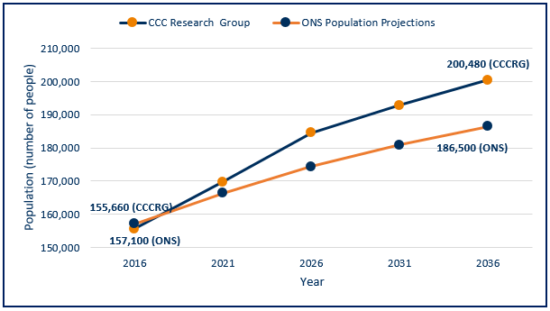Figure 1: South Cambridgeshire – absolute long-term (20-year) population change, 2016 to 2036 (all ages) (comparing CCC RG data with ONS projections)

Source: Office for National Statistics (ONS) 2014-based subnational population projections and Cambridgeshire County Council Research Group (CCC RG) mid-2015 based population forecasts

* Cambridgeshire County Council Research Group (CCC RG) predicts greater levels of population change by 2036 than ONS, whether absolutely or proportionally.
* The CCC RG forecast takes into account changes to housing development, the impacts of which are clear with the CCC RG data forecasts for South Cambridgeshire indicating a higher population than the ONS population projections for all forecast years.

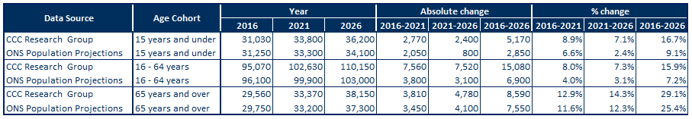Table 2: South Cambridgeshire – absolute short-term (5- and 10-year) population change, 2016 to 2026 by age group

Source: Office for National Statistics (ONS) 2014-based Subnational population projections and CCC RG mid-2015 based population forecasts

Figure 2: South Cambridgeshire – absolute short-term (5- and 10-year) population change, 2016 to 2026 by age group (comparing CCC RG data with ONS projections)

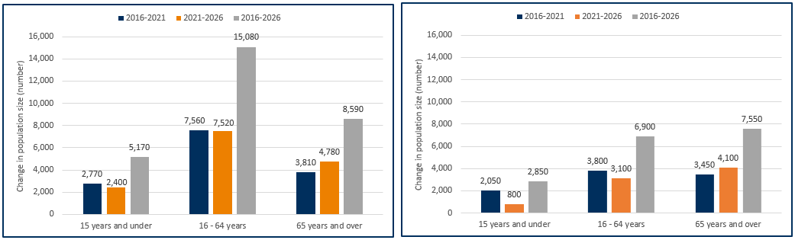CCC RG 2015-based population forecasts ONS 2014-based population projections

Source: CCC RG mid-2015-based population forecasts

Note: Y-axes for these charts do not start at zero

Source: Office for National Statistics (ONS) 2014-based subnational population projections

* Population data for 2016 in South Cambridgeshire are similar whether based on CCC RG or ONS models.
* Both CCC RG and ONS data suggest future population increases in South Cambridgeshire.
* Differences in predicted population growth between CCCRG and ONS are much greater for children and working age groups than for older people, reflecting the significant influence of future housing development in the CCC RG forecasts.

# Population density

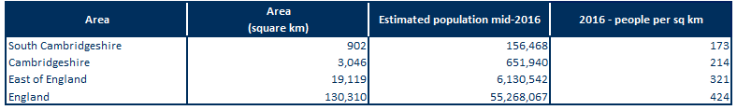Table 3: Population density for South Cambridgeshire, Cambridgeshire, East of England and England, mid-2016

Source: Office for National Statistics (ONS table MYE5)

* Overall, Cambridgeshire is a relatively rural area, with lower population density than that seen in England and the East of England.
* South Cambridgeshire is the second least densely populated district in Cambridgeshire behind East Cambridge (data not shown).
* South Cambridgeshire has a population density over 1.8 times lower than the East of England and under 2.5 times lower than the England average.

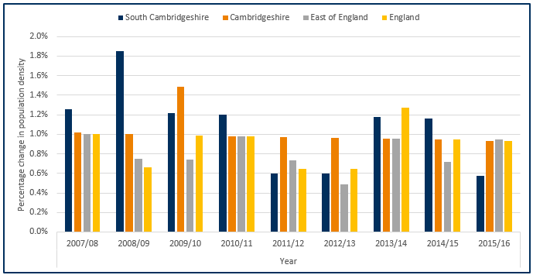Figure 3: Year– on-year percentage change in population density for South Cambridgeshire, Cambridgeshire, East of England and England, 2007/08 – 2015/16

Source: Office for National Statistics (ONS)

* Population changes within South Cambridgeshire has varied year to year roughly in line with national and regional increases with the exception of 2008/09 where a population growth of 1.8% was seen.
* South Cambridgeshire’s population growth has varied with a higher growth than England seen in the years 2007/08, 2008/09, 2009/10,2010/11, and later in 2014/15.
* South Cambridgeshire’s growth rate of 10.2% between 2007/08 and 2015/16 is the second highest growth rate of all the Cambridgeshire districts with a county average of 9.7%, (data not shown – please review the Peterborough and Cambridgeshire JSNA core dataset for further details).

# Fertility, migration and ethnicity

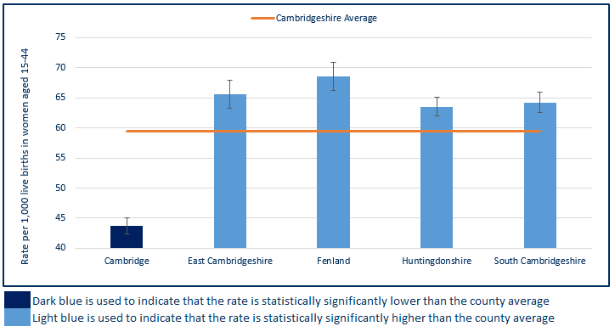Figure 4: General fertility rate (live birth rate per 1,000 women aged 15-44 years) by local authority of mother’s residence, Cambridgeshire, 2013-15

Source: ONS births registrations, ONS mid-year population estimates

Note: Y-axis for this chart does not begin at zero

* Excluding Cambridge, South Cambridgeshire has a similar fertility rate to the other districts in Cambridgeshire.
* This rate is statistically significantly higher than the county average which is influenced by Cambridge’s lower fertility rate.

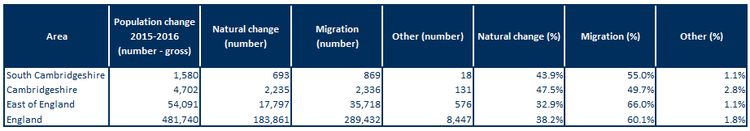Table 4: ONS mid-2015 to ONS mid-2016 population estimates – proportional contribution of each component of population change

Source: ONS population estimates mid-2016

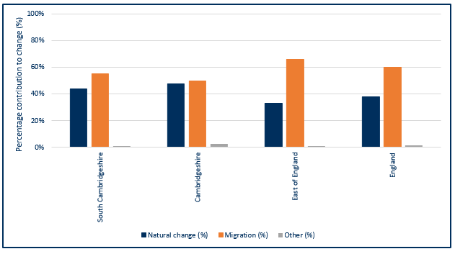Figure 5: ONS mid-2015 to mid-2016 population estimates –proportional contribution of components of population change in South Cambridgeshire, Cambridgeshire, East of England and England

Source: ONS population estimates mid-2016

* Natural change (births and deaths) and internal and international migration contribute to the majority of population change.
* In South Cambridgeshire, migration (55%) accounted for a larger proportion of population change than natural change (44%). Similarly, nationally and regionally, migration made a larger contribution to population change than natural change.
* Natural change and migration made an approximately equal contribution to population change in Cambridgeshire between 2015 and 2016.

Figure 6: Percentage of national insurance registration applications (NINo) to adult overseas nationals entering South Cambridgeshire, (registration year to March 2017)

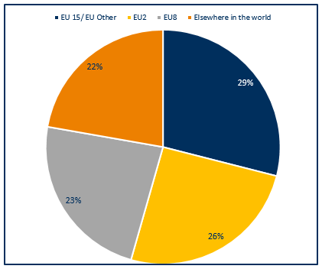

Note: EU15 member countries = EU members prior to the accession of 10 candidate countries on 1/5/2004; EU8 = the 10 accession countries; EU2 = those countries joining from 2007 (Bulgaria and Romania).

* In South Cambridgeshire European Union (EU) countries make up 78% of all registrations, with the E15/EU other countries making the largest single contribution of the three groups.

Source: Department for Work and Pensions (DWP)

Figure 7: Percentage of population by broad ethnic group, South Cambridgeshire, 2011

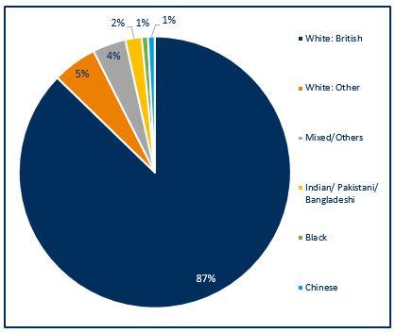

* South Cambridgeshire has a high proportion of people of White British ethnicity which is similar to Cambridgeshire which has a proportion of around 90% White British (data not shown).
* South Cambridgeshire has a small proportion of people from Chinese, Indian/Pakistani/Bangladeshi and Black ethnicities with only 4% of the population identifying as these ethnicities.
* Compared with England, Cambridgeshire has relatively small proportions of people from non-white ethnic groups (20.2% v. 15.5% respectively) (data not shown).

Source: Office for National Statistics, Census 2011, Table QS211EW

# Deprivation

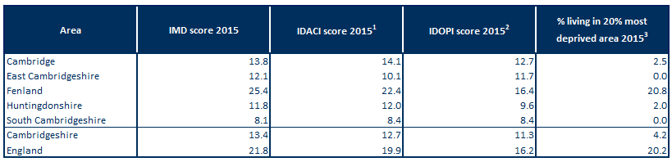Table 5: Indices of deprivation – 2015, overall score, children’s and older people’s indices and the percentage locally living in the national 20% most deprived area group by local authority, county and England

Source: DCLG from PHE Mental Health and Wellbeing JSNA

Note1: Income Deprivation Affecting Children Index (IDACI): Proportion of children aged 0-15 years living in income-deprived households as a proportion of all children aged 0-15 years.

Note2: Income Deprivation Affecting Older People Index (IDAOPI): Adults aged 60 or over living in income-deprived households as a percentage of all adults aged 60 or over.

Note3: Indices of Multiple Deprivation (IMD) 2015: % of people in an area living in the 20% most deprived areas in England.

* South Cambridgeshire has the lowest level of relative overall deprivation out of all the Cambridgeshire districts.
* Compared to England, South Cambridgeshire has low levels of relative deprivation for overall deprivation and income deprivation affecting children or older people.
* South Cambridgeshire also has lower levels of deprivation affecting children and older people than the county average, but both are below the national rates.
* All Cambridgeshire districts, excluding Fenland, have children and older people poverty rates that are lower than England.

Figure 8: Percentage of wards within South Cambridgeshire by deprivation quintile compared against all wards within Cambridgeshire County

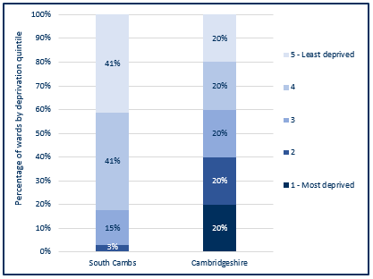

* South Cambridgeshire has no wards within the most deprived wards of Cambridgeshire.
* The majority of South Cambridgeshire wards are within the 5th and 4th deprivation quintile, and 100% of wards (34 wards) fall within the least deprived 80% of wards within Cambridgeshire.

Source: Index of Multiple Deprivation 2015, Department for Communities & Local Government (DCLG)

# Wider determinants of health and wellbeing

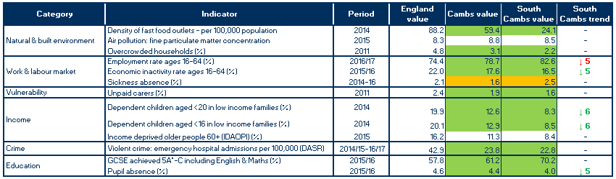Table 6: Wider determinants of health and wellbeing: summary of key indicators from Public Health England’s Wider Determinants Atlas

Source: Public Health England (PHE) wider determinants atlas

Note1: Full indicator descriptions and definitions are available at <https://fingertips.phe.org.uk/profile/wider-determinants>

Note2: the number following the trend arrow icon indicates the number of years this trend is based on, colour and direction represent increased or decreased levels with green representing an improvement and red a worsening.

* The density of fast food outlets is statistically significantly better than the England rate for South Cambridgeshire.
* South Cambridgeshire has a statistically significantly lower level of household overcrowding than found on average in England and a lower level compared with Cambridgeshire.
* Compared with England's average, South Cambridgeshire has a statistically significantly higher rate of people in employment, this rate is also higher than the county average.
* Sickness absence rates in South Cambridgeshire are statistically similar compared to the national average.
* South Cambridgeshire has lower rates of unpaid carers than England.
* The rates for dependent children aged <16 and <20 years in low income families are statistically significantly lower than the England average in South Cambridgeshire.
* Emergency hospital admissions due to violent crime in South Cambridgeshire are statistically better than the national rate, these rates are similar to Cambridgeshire.
* South Cambridgeshire and Cambridgeshire have statistically significantly lower rates compared to England for GCSE achievement (5A*-C including English & Maths).
* The rate of pupil absence in South Cambridgeshire is statistically significantly lower than the national average.

# Lifestyles and risk factors for health

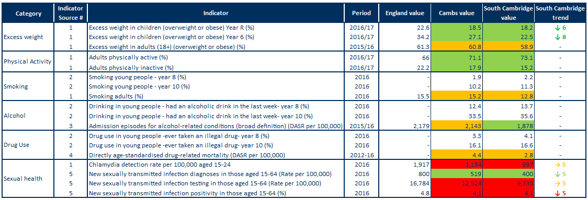Table 7: Lifestyles and risk factors – summary of key indicators for South Cambridgeshire, Cambridgeshire and England

Note1: Indicator names have been abbreviated

Note2: Alcohol-related conditions as primary or subsidiary cause of admission. Broad measures are considered the best reflection of the burden of alcohol on the community and services.

Note3: DASR = directly age-standardised rate.

Indicator sources:

1 Source: PHE Public Health Outcomes Framework

2 Source: Health Related Behaviour Survey, School Health Education Unit

3 Source: PHE Local Alcohol Profile for England

4 Source: NHS Digital Primary Care Mortality Database (ONS death registrations), mid-year population estimates

5 Source: PHE Sexual and Reproductive Health Profiles

* Rates of excess weight in children are statistically significantly lower than England in both South Cambridgeshire and Cambridgeshire for reception year and year 6.
* The rate of excess weight in adults (18+) is statistically similar to the England average for both South Cambridgeshire and Cambridgeshire.
* The rate for both physical activity and inactivity in adults (19+) is statistically significantly lower than England for South Cambridgeshire and Cambridgeshire.
* Data from the Health Related Behaviour Survey for South Cambridgeshire indicate an increase between Year 8 and 10 in levels of smoking, drinking and drug use.
* Smoking prevalence in adults 18+ is statistically similar to the England average for both South Cambridgeshire and Cambridgeshire.
* The rate of hospital admission episodes for alcohol-related conditions is statistically significantly lower in South Cambridgeshire compared to the England average, however it is statistically similar to the England average in Cambridgeshire.
* Drug related death rates in South Cambridgeshire and Cambridgeshire are both at statistically similar levels to England, with 15% of the deaths in Cambridgeshire within South Cambridgeshire (% data not shown – please review the Peterborough and Cambridgeshire JSNA core dataset for further details).
* The chlamydia detection rate is lower than the national target in South Cambridgeshire, as it is for the county as a whole.
* The STI diagnosis rate in South Cambridgeshire is statistically significantly better than the England average and has decreased over the last 5 years, as it has nationally (trend data not shown – please review the Public Health England Public Health Outcomes Framework for further details).
* Testing rates have increased over the last 5 years but positivity rates have declined, which may indicate inappropriate targeting or a general decrease in prevalence of infection in the population. Similar trends are observed for England as a whole (trend data not shown – please review the Public Health England Public Health Outcomes Framework for further details).

# Falls

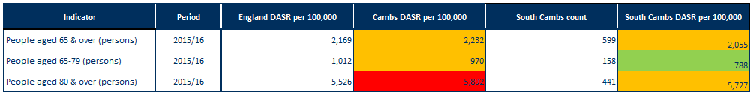Table 8: Falls in people aged 65 and over – emergency hospital admissions South Cambridgeshire, Cambridgeshire and England, 2015/16

Note: DASR = directly age-standardised rate per 100,000 population

Source: PHE, Public Health Outcomes Framework, <https://fingertips.phe.org.uk/profile/public-health-outcomes-framework>

* Falls in people aged 65 years and over and falls in people aged 80 years and over in South Cambridgeshire are statistically similar compared to England.
* Compared to England falls in people aged 65-79 years in South Cambridgeshire are statistically significantly lower.
* Rates for falls within Cambridgeshire are statistically similar to England for over 65’s and 65-79’s however for over 80’s the rate is statistically significantly worse.

# Screening and vaccination

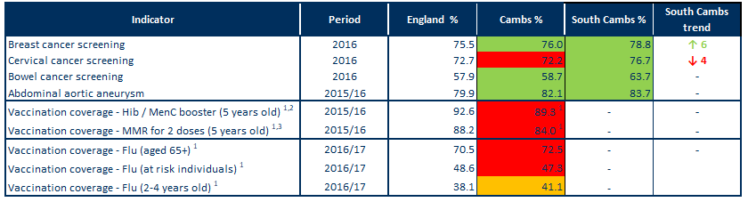Table 9: Screening and vaccination – coverage (%) for South Cambridgeshire, Cambridgeshire and England

Source: PHE, Public Health Outcomes Framework, <http://www.phoutcomes.info/>

Note1: benchmarked against threshold based goals

Note2: Hib = Haemophilus influenza type b; MenC = meningitis C

Note3: MMR = measles, mumps and rubella

* South Cambridgeshire rates for breast, cervical and bowel cancer screening are statistically significantly better than the England.
* The rate for abdominal aortic aneurysm screening is statistically significantly better than the England average in South Cambridgeshire.
* In Cambridgeshire, vaccination coverage for Hib, MenC, MMR and flu are poor when compared to national benchmarks excluding flu vaccination for 2-4 year olds which is achieving above the 40% required to achieve amber (data are not available for South Cambridgeshire).

# Disease prevalence – the amount of illness recorded in the population

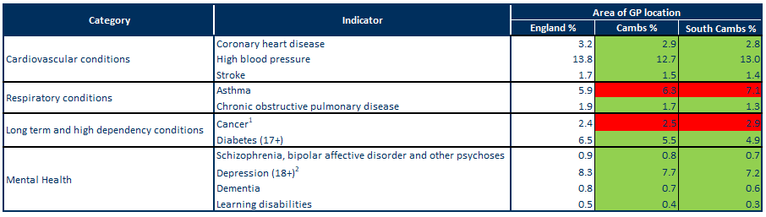Table 10: GP-recorded disease prevalence by district of general practice location, South Cambridgeshire, Cambridgeshire and England, 2015/16

Note1: Patients diagnosed with cancer (excluding non-melanotic skin cancer) on or after 01/04/2003

Note2: Patients with a record of unresolved depression since April 2006

Sources: NHS Digital, Quality and Outcomes Framework, Cambridgeshire County Council Public Health Intelligence

* In South Cambridgeshire and Cambridgeshire the recorded prevalence rates of coronary heart disease, high blood pressure and stroke are statistically significantly lower when compared to England.
* The recorded prevalence rate of asthma is statistically significantly higher in South Cambridgeshire and in Cambridgeshire when compared to the England average.
* Compared to England the recorded prevalence rate of chronic obstructive pulmonary disease (COPD) is statistically significantly lower in South Cambridgeshire and Cambridgeshire.
* The recorded prevalence rate of cancer is statistically significantly higher in South Cambridgeshire and Cambridgeshire when compared to England.
* In South Cambridgeshire and Cambridgeshire the prevalence rate of diabetes is statistically significantly lower when compared to the national average
* The recorded prevalence rate of all mental health indicators in South Cambridgeshire and Cambridgeshire are statistically significantly lower when compared to the England average.

# Self-harm and suicide

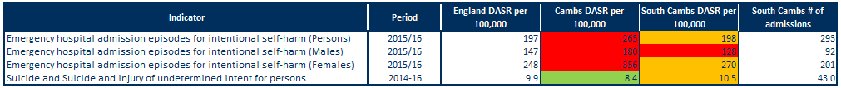Table 11: Self-harm and suicide indicators for South Cambridgeshire, Cambridgeshire and England

Source: Public Health England Public Health Outcomes Framework indicator

Note: DASR = directly age-standardised rate

* For persons and females rates of emergency admissions to hospital for self-harm are statistically similar to the national average for South Cambridgeshire.
* For females rates of emergency admissions to hospital for self-harm are statistically significantly higher when compared to England for South Cambridgeshire and Cambridgeshire.
* Rates for self-harm are higher in females, accounting for around 69% of hospital admissions in South Cambridgeshire.
* South Cambridgeshire has a statistically similar suicide rate when compared to the national average.

# Use of NHS hospital services

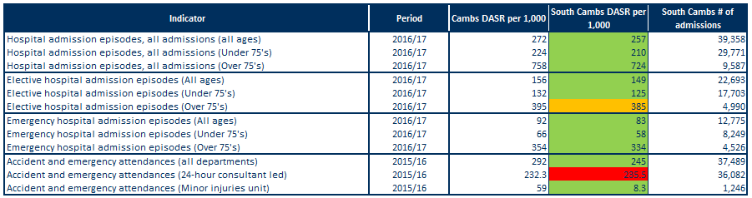 Table 12: Hospital-related admissions and attendances by admission type for South Cambridgeshire and Cambridgeshire

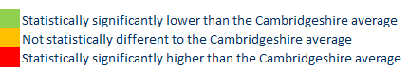Note: DASR = directly age-standardised rate

Sources: NHS Digital Hospital Episode Statistics, Office for National Statistics mid-year population estimates

* Rates for all hospital admissions, elective (planned) admissions and emergency admissions for all ages (excluding elective admissions for over 75’s) in South Cambridgeshire are statistically significantly lower than the Cambridgeshire average.
* The rate for elective hospital admissions for over 75’s is statistically similar to Cambridgeshire.
* Rates within South Cambridgeshire for all admissions are just under three and half times higher in people aged 75 and over than those under 75.
* All departments and minor injury unit based A&E attendances for South Cambridgeshire are statistically significantly lower than the Cambridgeshire average. The rate for 24-hour consultant led departments, however are statistically significantly higher than the Cambridgeshire average – this is highly influenced by the type of service that is based most locally at Addenbrookes Hospital.

# Life expectancy and mortality

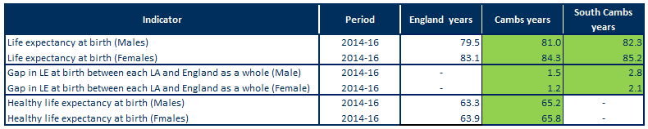Table 13: Life expectancy and healthy life expectancy for South Cambridgeshire, Cambridgeshire and England

Source: PHE, Public Health Outcomes Framework, <http://www.phoutcomes.info/>

* Life expectancy at birth is statistically significantly higher than the England average in males and females in South Cambridge and Cambridgeshire.
* Life expectancy in South Cambridge is statistically significantly higher than England for males, with a gap of 2.8 years (82.3 years compared to 79.5 years).
* Life expectancy in South Cambridge is statistically significantly higher than England for females, with a gap of 2.1 years (85.2 years compared to 83.1 years).
* Healthy life expectancy in Cambridgeshire is statistically significantly higher than the England average for males and females with a year gap of 1.9 for both sexes.

Figure 9: Major causes of death in South Cambridgeshire, 2014-16

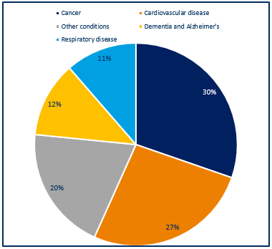

* Around 1,180 deaths occurred each year in South Cambridgeshire residents during 2014-16.
* The largest percentage of deaths were due to cancer (30%) and cardiovascular disease (27%), followed by dementia and Alzheimer’s (12%) and respiratory disease at (11%); other causes contributed 20%.
* The major causes of death in South Cambridgeshire are similar to those seen nationally.

Source: NHS Digital Primary Care Mortality Database (Cambridgeshire County Council Public Health Intelligence)

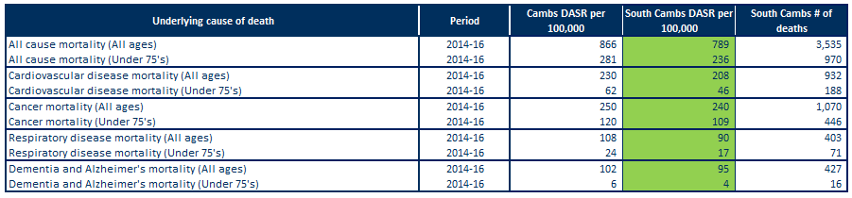Table 14: Directly age-standardised rates for major causes of death in South Cambridgeshire and Cambridgeshire, 2014-16

Note: DASR = directly age-standardised rate

Sources: Cambridgeshire County Council Public Health Intelligence (NHS Digital Primary Care Mortality Database, Office for National Statistics mid-year population estimates)

* In South Cambridgeshire, the rates for all-age and under 75’s all-cause mortality is statistically significantly lower than the Cambridgeshire average rates.
* In South Cambridgeshire, the rates for all-age and under 75’s cardiovascular disease mortality is statistically significantly lower than the Cambridgeshire average rates.
* Around 310 South Cambridgeshire residents died from cardiovascular disease each year between 2014 and 2016.
* The rates for all-age and under 75’s cancer mortality is statistically significantly lower than the England averages in South Cambridgeshire.
* Just over 350 South Cambridgeshire residents died from cancer each year between 2014 and 2016.
* In South Cambridgeshire, the rates for all-age and under 75’s respiratory disease mortality is statistically significantly lower than the Cambridgeshire average rates.
* Around 130 South Cambridgeshire residents died each year from respiratory disease between 2014 and 2016.
* The rates for all-age and under 75’s dementia and Alzheimer’s mortality is statistically significantly lower than the England averages in South Cambridgeshire.
* Just over 140 South Cambridgeshire residents died each year from dementia and Alzheimer’s disease between 2014 and 2016.

# Further information

The full Cambridgeshire and Cambridgeshire and Peterborough JSNA core datasets can be found on the Cambridgeshire County Council Insight website at: <https://cambridgeshireinsight.org.uk/jsna/published-joint-strategic-needs-assessments/>

And on the Peterborough City Council website at:

<https://www.peterborough.gov.uk/healthcare/public-health/JSNA/>

Author:

Elizabeth Wakefield, Public Health Analyst, Cambridgeshire and Peterborough PHI.

Date: 11/07/18