2017 JSNA core dataset:

Huntingdonshire Summary,

July 2018

**Joint Strategic Needs Assessment**

cambridgeshire.gov.uk

Contents

Population estimates and forecasts 4

Population density 5

Fertility, migration and ethnicity 6

Deprivation 9

Wider determinants of health and wellbeing 10

Lifestyles and risk factors for health 11

Falls 12

Screening and vaccination 12

Disease prevalence – the amount of illness recorded in the population 13

Self-harm and suicide 14

Use of NHS hospital services 14

Life expectancy and mortality 15

Further information 16

Tables

Table 1: Huntingdonshire – absolute long-term (20-year) population change, 2016 to 2036 (all ages) 4

Table 2: Huntingdonshire – absolute short-term (5- and 10-year) population change, 2016 to 2026 by age group 4

Table 3: Population density for Huntingdonshire, Cambridgeshire, East of England and England, mid-2016 5

Table 4: ONS mid-2015 to ONS mid-2016 population estimates – absolute and proportional contribution of each component of population change 7

Table 5: Indices of deprivation – 2015, overall score, children’s and older people’s indices and the percentage locally living in the national 20% most deprived area group by local authority, county and England 9

Table 6: Wider determinants of health and wellbeing: summary of key indicators from Public Health England’s Wider Determinants Atlas 10

Table 7: Lifestyles and risk factors – summary of key indicators for Huntingdonshire, Cambridgeshire and England 11

Table 8: Falls in people aged 65 and over – emergency hospital admissions Huntingdonshire, Cambridgeshire and England, 2016/17 12

Table 9: Screening and vaccination – coverage (%) for Huntingdonshire, Cambridgeshire and England 12

Table 10: GP-recorded disease prevalence by district of general practice location, Huntingdonshire, Cambridgeshire and England, 2015/16 13

Table 11: Self-harm and suicide indicators for Huntingdonshire, Cambridgeshire and England 14

Table 12: Hospital-related admissions and attendances by admission type for Huntingdonshire and Cambridgeshire 14

Table 13: Life expectancy and healthy life expectancy for Huntingdonshire, Cambridgeshire and England 15

Table 14: Directly age-standardised rates for major causes of death in Huntingdonshire and Cambridgeshire, 2014-16 16

Figures

Figure 1: Huntingdonshire – absolute long-term (20-year) population change, 2016 to 2036 (all ages) (comparing CCC RG data with ONS projections) 4

Figure 2: Huntingdonshire – absolute short-term (5- and 10-year) population change, 2016 to 2026 by age group (comparing CCC RG data with ONS projections) 5

Figure 3: Year– on-year percentage change in population density for Huntingdonshire, Cambridgeshire, East of England and England, 2007/08 – 2015/16 6

Figure 4: General fertility rate (live birth rate per 1,000 women aged 15-44 years) by local authority of mother’s residence, Cambridgeshire, 2013-15 6

Figure 5: ONS mid-2015 to mid-2016 population estimates – proportional contribution of components of population change in Huntingdonshire, Cambridgeshire, East of England and England 7

Figure 6: Percentage of national insurance registration applications (NINo) to adult overseas nationals entering Huntingdonshire, (registration year to March 2017) 8

Figure 7: Percentage of population by broad ethnic group, Huntingdonshire, 2011 8

Figure 8: Percentage of wards within Huntingdonshire by deprivation quintile compared against all wards within Cambridgeshire County 9

Figure 9: Major causes of death in Huntingdonshire, 2014-16 15

Statistical Significance

Throughout this JSNA district summary, comparisons between district/county and England have been made through the assessment of ‘statistical significance’. For each indicator value, 95% confidence intervals are calculated which provide a measure of uncertainty around the calculated value. If the confidence interval for the district/county value excludes the value for the benchmark (which is typically England), the difference between the district/county value and the benchmark is said to be ‘statistically significant’. When values are statistically significant they are represented via the colour scheme below:



All tables/figures that provide statistical measures are compared to England unless otherwise started. Occasionally, comparisons have been made that are not compared to England; in this situation the key is provided below the table/figure.

# Population estimates and forecasts



Table 1: Huntingdonshire – absolute long-term (20-year) population change, 2016 to 2036 (all ages)

Source: Office for National Statistics (ONS) 2014-based subnational population projections and Cambridgeshire County Council Research Group (CCC RG) mid-2015-based population forecasts

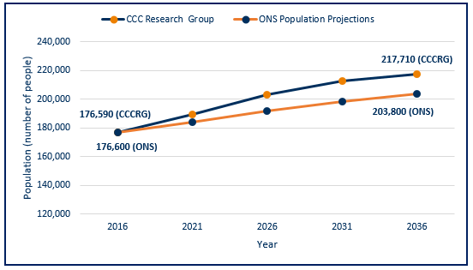Figure 1: Huntingdonshire – absolute long-term (20-year) population change, 2016 to 2036 (all ages) (comparing CCC RG data with ONS projections)

Source: Office for National Statistics (ONS) 2014-based subnational population projections and Cambridgeshire County Council Research Group (CCC RG) mid-2015 based population forecasts

* Cambridgeshire County Council Research Group (CCC RG) predicts greater levels of population change by 2036 than ONS, whether absolutely or proportionally.
* The CCC RG forecast takes into account changes to housing development, the impacts of which are clear with the CCC RG data forecasts for Huntingdonshire indicating a higher population than the ONS population projections for all forecast years.

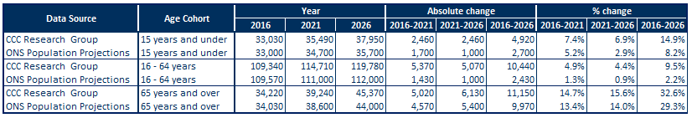Table 2: Huntingdonshire – absolute short-term (5- and 10-year) population change, 2016 to 2026 by age group

Source: Office for National Statistics (ONS) 2014-based Subnational population projections and CCC RG mid-2015 based population forecasts

Figure 2: Huntingdonshire – absolute short-term (5- and 10-year) population change, 2016 to 2026 by age group (comparing CCC RG data with ONS projections)

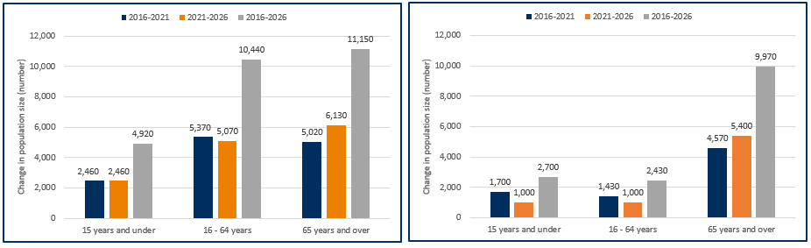CCC RG 2015-based population forecast ONS 2014-based population projections

Source: Office for National Statistics (ONS) 2014-based subnational population projections

Source: CCC RG mid-2015-based population forecasts

Note: Y-axes for these charts do not start at zero

* Population data for 2016 in Huntingdonshire are similar whether based on CCC RG or ONS models.
* Both CCC RG and ONS data suggest future population increases in Huntingdonshire.
* Variation in predicted population growth between CCCRG and ONS is much greater for children (4,920 v. 2,700) and working age groups (10,440 v. 2,430) than for older people (11,150 v. 9,970), reflecting the significant influence of future housing development reflected in the CCC RG forecasts.

# Population density

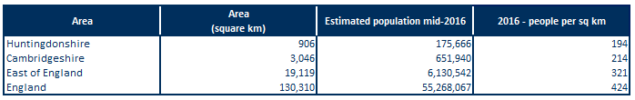Table 3: Population density for Huntingdonshire, Cambridgeshire, East of England and England, mid-2016

Source: Office for National Statistics (ONS table MYE5)

* Overall, Cambridgeshire is a relatively rural area, with lower population density than that seen in England and the East of England.
* Huntingdonshire is the second most densely populated district in Cambridgeshire behind Cambridge (data not shown).
* Huntingdonshire has a population density over 1.5 times lower than the East of England and over 2 times lower than the England average.

Figure 3: Year– on-year percentage change in population density for Huntingdonshire, Cambridgeshire, 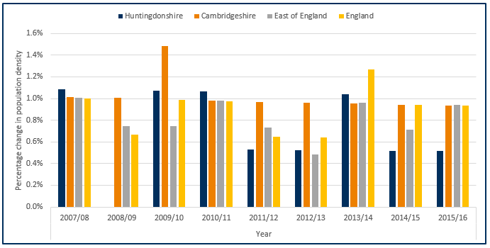East of England and England, 2007/08 – 2015/16

Source: Office for National Statistics (ONS)

Note: No population increase was seen for Huntingdonshire in the year 2008/09

* Population changes within Huntingdonshire has varied year to year but not drastically with the exception of 2008/09 where no population growth was seen.
* Huntingdonshire has had a higher growth density than England seen in the years 2007/08, 2009/10 and 2010/11.
* Huntingdonshire’s growth rate of 6.6% between 2007/08 and 2015/16 is the lowest of all the Cambridgeshire districts with a county average grow rate of 9.7%, (data not shown – please review the Peterborough and Cambridgeshire JSNA core dataset for further details).

# Fertility, migration and ethnicity

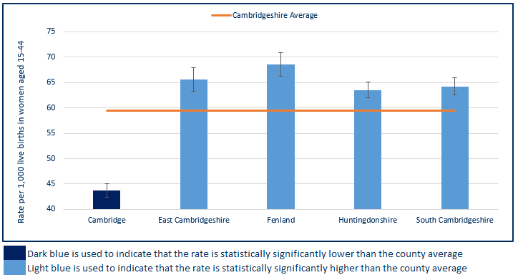Figure 4: General fertility rate (live birth rate per 1,000 women aged 15-44 years) by local authority of mother’s residence, Cambridgeshire, 2013-15

Source: ONS births registrations, ONS mid-year population estimates

Note: Y-axis for this chart does not begin at zero

* Excluding Cambridge, Huntingdonshire has a similar fertility rate to the other districts in Cambridgeshire.
* This rate is statistically significantly higher than the county average which is influenced by Cambridge’s lower fertility rate.

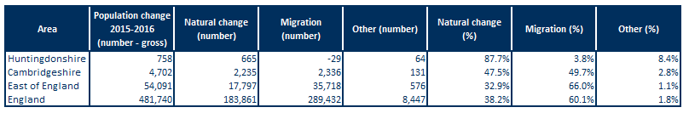Table 4: ONS mid-2015 to ONS mid-2016 population estimates – absolute and proportional contribution of each component of population change

Source: ONS population estimates mid-2016

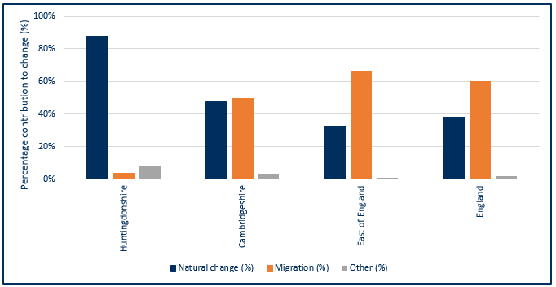Figure 5: ONS mid-2015 to mid-2016 population estimates – proportional contribution of components of population change in Huntingdonshire, Cambridgeshire, East of England and England

Source: ONS population estimates mid-2016

* Natural change (births and deaths) and internal and international migration contribute to the majority of population change.
* In Huntingdonshire, natural change accounted for the majority of the population change (88%). Conversely, nationally and regionally, migration made a larger contribution to population change than natural change.
* Natural change and migration made an approximately equal contribution to population change in Cambridgeshire between 2015 and 2016.

Figure 6: Percentage of national insurance registration applications (NINo) to adult overseas nationals entering Huntingdonshire, (registration year to March 2017)

Source: Department for Work and Pensions (DWP)

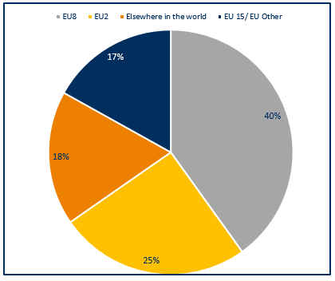

Note: EU15 member countries = EU members prior to the accession of 10 candidate countries on 1/5/2004; EU8 = the 10 accession countries; EU2 = those countries joining from 2007 (Bulgaria and Romania).

* In Huntingdonshire European Union (EU) countries make up 83% of all registrations, with the EU8 countries making the largest single contribution of the three groups.

Figure 7: Percentage of population by broad ethnic group, Huntingdonshire, 2011

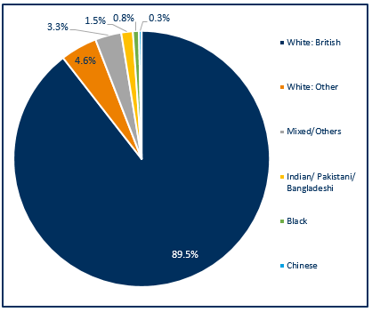

* Huntingdonshire has a high proportion of people of White British ethnicity which is similar to Cambridgeshire which has a proportion of around 90% White British (data not shown).
* Huntingdonshire has a small proportion of people from Chinese, Indian/Pakistani/Bangladesh, mixed/other and Black ethnicities with only 2.6% of the population identifying as these ethnicities.
* Compared with England, Cambridgeshire County has relatively small proportions of people from non-white ethnic groups (20.2% v. 15.5% respectively) (data not shown).

Source: Office for National Statistics, Census 2011, Table QS211EW

# Deprivation

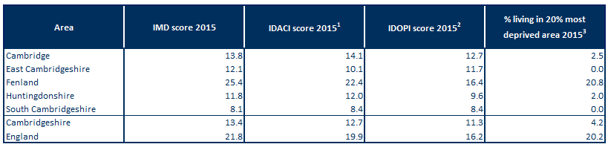Table 5: Indices of deprivation – 2015, overall score, children’s and older people’s indices and the percentage locally living in the national 20% most deprived area group by local authority, county and England

Source: DCLG from PHE Mental Health and Wellbeing JSNA

Note1: Income Deprivation Affecting Children Index (IDACI): Proportion of children aged 0-15 years living in income-deprived households as a proportion of all children aged 0-15 years.

Note2: Income Deprivation Affecting Older People Index (IDAOPI): Adults aged 60 or over living in income-deprived households as a percentage of all adults aged 60 or over.

Note3: IMD 2015: % of people in an area living in the 20% most deprived areas in England.

* Huntingdonshire has a slightly lower level of relative overall deprivation than the Cambridgeshire average.
* Huntingdonshire has low levels of relative deprivation, compared with England, for overall deprivation and income deprivation affecting children or older people.
* Huntingdonshire also has slightly lower levels of deprivation affecting children and older people than the county average, but both are below the national rates.
* All Cambridgeshire districts, excluding Fenland, have child and older people poverty rates that are lower than England.

Figure 8: Percentage of wards within Huntingdonshire by deprivation quintile compared against all wards within Cambridgeshire County

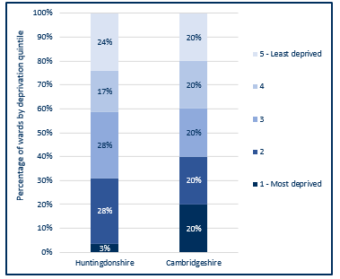

* Huntingdonshire has 3% of its wards (1 ward) within the most deprived wards of Cambridgeshire, this ward is Huntingdon North.
* The majority of Huntingdonshire wards are within the 3rd and 2nd deprivation quintile, and 97% of wards (28 wards) fall within the least deprived 80% of wards within Cambridgeshire.

Source: Index of Multiple Deprivation 2015, Department for Communities & Local Government (DCLG)

# Wider determinants of health and wellbeing

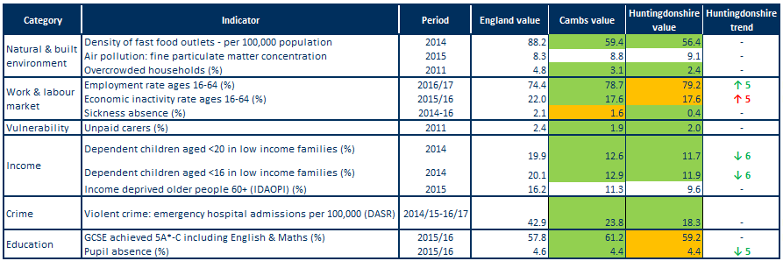Table 6: Wider determinants of health and wellbeing: summary of key indicators from Public Health England’s Wider Determinants Atlas

Source: Public Health England (PHE) wider determinants atlas

Note1: Full indicator descriptions and definitions are available at <https://fingertips.phe.org.uk/profile/wider-determinants>

Note2: the number following the trend arrow icon indicates the number of years this trend is based on, colour and direction represent increased or decreased levels with green representing an improvement and red a worsening.

* Huntingdonshire’s density of fast food outlets is statistically significantly better than the England rate.
* Huntingdonshire has a statistically significantly lower level of household overcrowding than found on average in England and a lower level compared with Cambridgeshire.
* Compared with England's average, Huntingdonshire has a statistically similar rate of people in employment, this rate is also higher than the county average.
* All districts excluding Fenland have significantly lower rates of unpaid carers than England. The rate in Huntingdonshire is similar to the Cambridgeshire rate.
* Huntingdonshire’s rates for dependent children aged <16 and <20 years in low income families are statistically significantly lower than the England average.
* Emergency hospital admissions due to violent crime in Huntingdonshire are statistically better than the national rate, and similar when compared to Cambridgeshire.
* Huntingdonshire is statistically similar when compared to national rates for GCSE achievement (5A*-C including English & Maths), Cambridgeshire rates are statistically significantly better than England.
* The rate for pupil absence in Huntingdonshire is statistically similar to the national average.

# Lifestyles and risk factors for health

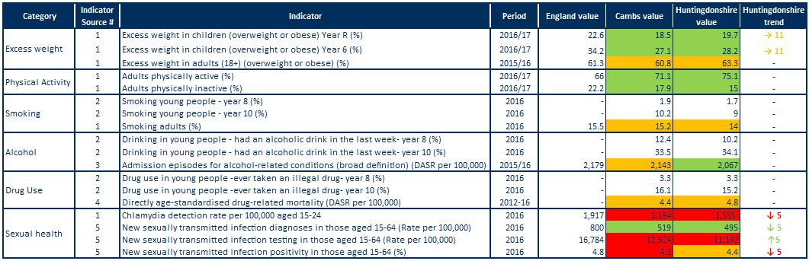Table 7: Lifestyles and risk factors – summary of key indicators for Huntingdonshire, Cambridgeshire and England

Note1: Indicator names have been abbreviated

Note2: Alcohol-related conditions as primary or subsidiary cause of admission. Broad measures are considered the best reflection of the burden of alcohol on the community and services.

Note3: DASR = directly age-standardised rate.

Indicator sources:

1 Source: PHE Public Health Outcomes Framework

2 Source: Health Related Behaviour Survey, School Health Education Unit

3 Source: PHE Local Alcohol Profile for England

4 Source: NHS Digital Primary Care Mortality Database (ONS death registrations), mid-year population estimates

5 Source: PHE Sexual and Reproductive Health Profiles

* Rates of excess weight in children are statistically significantly lower than England in both Huntingdonshire and Cambridgeshire for reception year and year 6.
* The rate of excess weight in adults (18+) is statistically similar to the England average for both Huntingdonshire and Cambridgeshire.
* The rate for both physical activity and inactivity in adults (19+) is statistically significantly better then England for Huntingdonshire and Cambridgeshire.
* Data from the Health Related Behaviour Survey for Huntingdonshire indicate steep increases between Year 8 and 10 in levels of smoking, drinking and drug use.
* Smoking prevalence in adults 18+ is statistically similar to the England average for both Huntingdonshire and Cambridgeshire.
* The rate of hospital admission episodes for alcohol-related conditions is statistically significantly lower in Huntingdonshire compared to the England average, however it is statistically similar to the England average in Cambridgeshire.
* Drug related death rates in Huntingdonshire and Cambridgeshire are both at statistically similar levels to England, with 30% of the deaths in Cambridgeshire within Huntingdonshire (% data not shown – please review the Peterborough and Cambridgeshire JSNA core dataset for further details).
* The chlamydia detection rate is lower than the national target in Huntingdonshire, as it is for the county as a whole.
* The STI diagnosis rate in Huntingdonshire is statistically significantly better than the England average and has decreased over the last 5 years, as it has nationally (trend data not shown – please review the Public Health England Public Health Outcomes Framework for further details).
* Testing rates have increased over the last 5 years but positivity rates have declined, which may indicate inappropriate targeting or a general decrease in prevalence of infection in the population. Similar trends are observed for England as a whole (trend data not shown – please review the Public Health England Public Health Outcomes Framework for further details).

# Falls

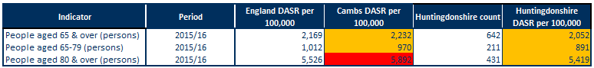Table 8: Falls in people aged 65 and over – emergency hospital admissions Huntingdonshire, Cambridgeshire and England, 2016/17

Note: DASR = directly age-standardised rate per 100,000 population

Source: PHE, Public Health Outcomes Framework, <https://fingertips.phe.org.uk/profile/public-health-outcomes-framework>

* Falls in people aged 65 years and over in Huntingdonshire are statistically similar compared to England.
* Rates for falls within Cambridgeshire are statistically similar to England for over 65’s and 65-79’s however for over 80’s the rate is statistically significantly worse.

# Screening and vaccination

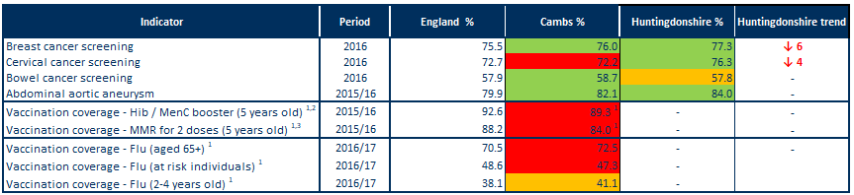Table 9: Screening and vaccination – coverage (%) for Huntingdonshire, Cambridgeshire and England

Source: PHE, Public Health Outcomes Framework, <http://www.phoutcomes.info/>

Note1: benchmarked against threshold based goals

Note2: Hib = Haemophilus influenza type b; MenC = meningitis C

Note3: MMR = measles, mumps and rubella

* Huntingdonshire rates for breast and cervical cancer screening are statistically significantly better than England.
* Bowel cancer screening rates within Huntingdonshire are statistically similar to England.
* Rates of abdominal aortic aneurysm screening in Huntingdonshire are statistically significantly better than the national average.
* Cambridgeshire rates for cancer screening and abdominal aortic aneurysm screening are statistically significantly better than the England average barring cervical cancer screening which is statistically significantly worse.
* In Cambridgeshire, vaccination coverage for Hib, MenC, MMR and flu are poor when compared to national benchmarks excluding flu vaccination for 2-4 year olds which is achieving above the 40% required to achieve amber (data are not available for Huntingdonshire).

# Disease prevalence – the amount of illness recorded in the population

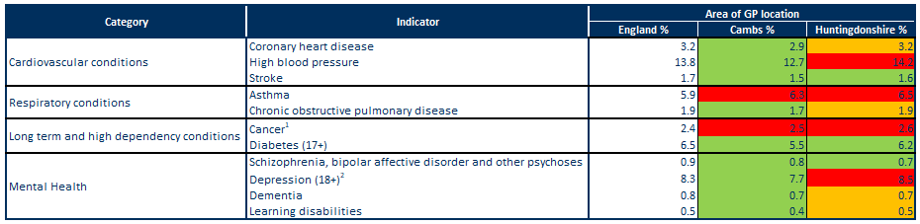Table 10: GP-recorded disease prevalence by district of general practice location, Huntingdonshire, Cambridgeshire and England, 2015/16

Note1: Patients diagnosed with cancer (excluding non-melanotic skin cancer) on or after 01/04/2003

Note2: Patients with a record of unresolved depression since April 2006

Sources: NHS Digital, Quality and Outcomes Framework, Cambridgeshire County Council Public Health Intelligence

* The recorded prevalence rate of coronary heart disease is statistically similar in Huntingdonshire when compared to the England average.
* In Huntingdonshire the recorded prevalence rate of high blood pressure is statistically significantly higher when compared to England.
* The recorded prevalence rate of stroke is statistically significantly lower in Huntingdonshire and in Cambridgeshire when compared to the national average.
* In Huntingdonshire and Cambridgeshire the recorded prevalence rate of asthma is statistically significantly higher when compared to the England average.
* The recorded prevalence rate of chronic obstructive pulmonary disease (COPD) is statistically similar when compared to England in Huntingdonshire however it is statistically significantly lower in Cambridgeshire.
* The recorded prevalence rate of cancer is statistically significantly higher in Huntingdonshire and Cambridgeshire when compared to national rates.
* In Huntingdonshire and Cambridgeshire the prevalence rate of diabetes is statistically significantly lower when compared to the England average
* In Huntingdonshire the recorded prevalence rates of schizophrenia, bipolar affective disorder and other psychoses is statistically significantly lower when compared to the England average
* The recorded prevalence rate of depression is statistically significantly higher in Huntingdonshire when compared to England.
* The recorded prevalence rate for dementia and learning difficulties in Huntingdonshire is statistically similar when compared to England, however it is statistically significantly lower when compared to England in Cambridgeshire.

# Self-harm and suicide

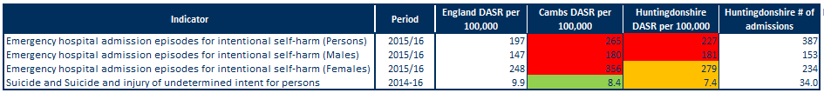

Table 11: Self-harm and suicide indicators for Huntingdonshire, Cambridgeshire and England

Source: Public Health England Public Health Outcomes Framework indicator

Note: DASR = directly age-standardised rate

* For persons and males rates of emergency admissions to hospital for self-harm are statistically significantly higher than the national average for Huntingdonshire and Cambridgeshire.
* For females rates of emergency admissions to hospital for self-harm are statistically similar compared to England for Huntingdonshire, this rate is statistically significantly higher when compared to England for Cambridgeshire.
* Rates for self-harm are higher in females, accounting for around 60% of hospital admissions in Huntingdonshire.
* Huntingdonshire has a statistically similar suicide rate when compared to the national average, however Cambridgeshire has a statistically significantly lower rate than the national average.

# Use of NHS hospital services

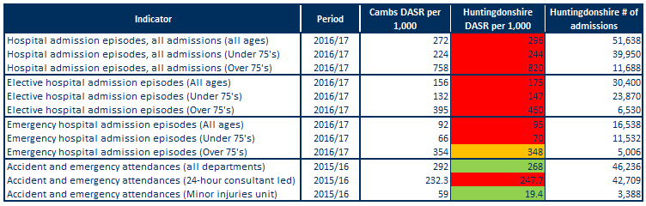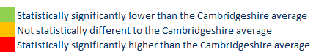 Table 12: Hospital-related admissions and attendances by admission type for Huntingdonshire and Cambridgeshire

Note: DASR = directly age-standardised rate

Sources: NHS Digital Hospital Episode Statistics, Office for National Statistics mid-year population estimates

* Rates for all hospital admissions, elective (planned) admissions and emergency admissions for all ages (excluding emergency admissions for over 75’s) in Huntingdonshire are statistically significantly higher than the Cambridgeshire averages.
* The rate for emergency hospital admissions for over 75’s is statistically similar to Cambridgeshire.
* Rates within Huntingdonshire for all admissions are over three times higher in people aged 75 and over than those under 75.
* All departments and minor injury unit based A&E attendances for Huntingdonshire are statistically significantly lower than the Cambridgeshire average. The rate for 24-hour consultant led departments, however are statistically significantly higher than the Cambridgeshire average – this is highly influenced by the type of service that is based most locally at Hinchingbrooke Hospital.

# Life expectancy and mortality

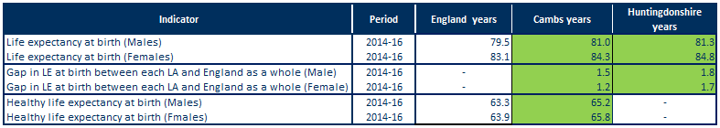Table 13: Life expectancy and healthy life expectancy for Huntingdonshire, Cambridgeshire and England

Source: PHE, Public Health Outcomes Framework, <http://www.phoutcomes.info/>

* Life expectancy at birth is statistically significantly higher than the England average in males and females in Huntingdonshire and Cambridgeshire.
* Life expectancy in Huntingdonshire is statistically significantly higher than England for males, with a gap of 1.8 years (81.3 years compared to 79.5 years).
* Life expectancy in Huntingdonshire is statistically significantly higher than England for females, with a gap of 1.7 year (84.8 years compared to 83.1 years).
* Healthy life expectancy in Cambridgeshire is statistically significantly higher than the England average for males and females with a year gap of 1.9 for both sexes.

Figure 9: Major causes of death in Huntingdonshire, 2014-16

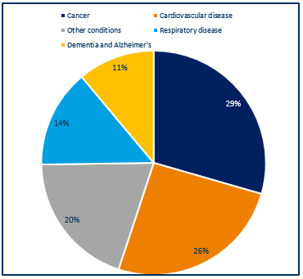

* Around 1,370 deaths occurred each year in Huntingdonshire residents during 2014-16.
* The largest percentage of deaths were due to cancer (29%) and cardiovascular disease (26%), followed by respiratory disease (14%) and dementia and Alzheimer’s at (11%); other causes contributed 20%.
* The major causes of death in Huntingdonshire are similar to those seen nationally.

Source: NHS Digital Primary Care Mortality Database (Cambridgeshire County Council Public Health Intelligence)

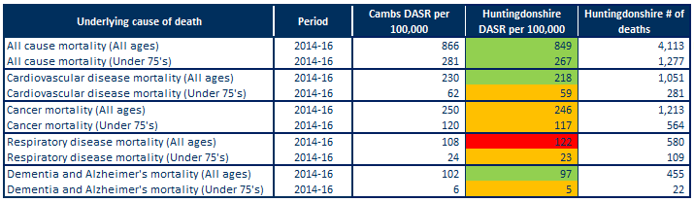Table 14: Directly age-standardised rates for major causes of death in Huntingdonshire and Cambridgeshire, 2014-16

Note: DASR = directly age-standardised rate

Sources: Cambridgeshire County Council Public Health Intelligence (NHS Digital Primary Care Mortality Database, Office for National Statistics mid-year population estimates)

* In Huntingdonshire, the rates for all-age and under 75’s all-cause mortality is statistically significantly lower than the Cambridgeshire average rates.
* The rate of all-age cardiovascular disease mortality is statistically significantly lower than the Cambridgeshire average rate.
* Just under 350 Huntingdonshire residents died from cardiovascular disease each year between 2014 and 2016.
* The rates for under 75’s cardiovascular disease mortality and all age and under 75’s cancer mortality are statistically similar for Huntingdonshire when compared to the Cambridgeshire averages.
* Just over 400 Huntingdonshire residents died from cancer each year between 2014 and 2016.
* The rates in Huntingdonshire for all-age mortality from respiratory disease are statistically significantly higher than the Cambridgeshire average rates.
* Just over 190 Huntingdonshire residents died each year from respiratory disease between 2014 and 2016.
* The rates for under 75’s respiratory disease and under 75’s dementia and Alzheimer’s mortality are statistically similar for Huntingdonshire when compared to the Cambridgeshire averages.
* The rates for all-age dementia and Alzheimer’s mortality is statistically significantly lower than the Cambridgeshire average rates.
* Around 150 Huntingdonshire residents died each year from dementia and Alzheimer’s disease between 2014 and 2016.

# Further information

The full Cambridgeshire and Cambridgeshire and Peterborough JSNA core datasets can be found on the Cambridgeshire County Council Insight website at: <https://cambridgeshireinsight.org.uk/jsna/published-joint-strategic-needs-assessments/>

And on the Peterborough City Council website at:

<https://www.peterborough.gov.uk/healthcare/public-health/JSNA/>

Author:

Elizabeth Wakefield, Public Health Analyst, Cambridgeshire and Peterborough PHI.

Date: 11/07/18