2017 JSNA core dataset:

Fenland Summary,

July 2018

**Joint Strategic Needs Assessment**

cambridgeshire.gov.uk

Contents

Population estimates and forecasts 4

Population density 5

Fertility, migration and ethnicity 6

Deprivation 9

Wider determinants of health and wellbeing 10

Lifestyles and risk factors for health 11

Falls 12

Screening and vaccination 12

Disease prevalence – the amount of illness recorded in the population 13

Self-harm and suicide 13

Use of NHS hospital services 14

Life expectancy and mortality 14

Further information 16

Tables

Table 1: Fenland – absolute long-term (20-year) population change, 2016 to 2036 (all ages) 4

Table 2: Fenland – absolute short-term (5- and 10-year) population change, 2016 to 2026 by age group 4

Table 3: Population density for Fenland, Cambridgeshire, East of England and England, mid-2016 5

Table 4: ONS mid-2015 to ONS mid-2016 population estimates – absolute and proportional contribution of each component of population change 7

Table 5: Indices of deprivation – 2015, overall score, children’s and older people’s indices and the percentage locally living in the national 20% most deprived area group by local authority, county and England 9

Table 6: Wider determinants of health and wellbeing: summary of key indicators from Public Health England’s Wider Determinants Atlas 10

Table 7: Lifestyles and risk factors – summary of key indicators for Fenland, Cambridgeshire and England 11

Table 8: Falls in people aged 65 and over – emergency hospital admissions Fenland, Cambridgeshire and England, 2015/16. 12

Table 9: Screening and vaccination – coverage (%) for Fenland, Cambridgeshire and England 12

Table 10: GP-recorded disease prevalence by district of general practice location, Fenland, Cambridgeshire and England, 2015/16 13

Table 11: Self-harm and suicide indicators for Fenland, Cambridgeshire and England 13

Table 12: Hospital-related admissions and attendances by admission type for Fenland and Cambridgeshire 14

Table 13: Life expectancy and healthy life expectancy for Fenland, Cambridgeshire and England 14

Table 14: Directly age-standardised rates for major causes of death in Fenland and Cambridgeshire, 2014-16 15

Figures

Figure 1: Fenland – absolute long-term (20-year) population change, 2016 to 2036 (all ages) (comparing CCC RG data with ONS projections) 4

Figure 2: Fenland – absolute short-term (5- and 10-year) population change, 2016 to 2026 by age group (comparing CCC RG data with ONS projections) 5

Figure 3: Year– on-year percentage change in population density for Fenland, Cambridgeshire, East of England and England, 2007/08 – 2015/16 6

Figure 4: General fertility rate (live birth rate per 1,000 women aged 15-44 years) by local authority of mother’s residence, Cambridgeshire, 2013-15 6

Figure 5: ONS mid-2015 to mid-2016 population estimates – proportional contribution of components of population change in Fenland, Cambridgeshire, East of England and England 7

Figure 6: Percentage of national insurance registration applications (NINo) to adult overseas nationals entering Fenland, (registration year to March 2017) 8

Figure 7: Percentage of population by broad ethnic group, Fenland, 2011 8

Figure 8: Percentage of wards within Fenland by deprivation quintile compared against all wards within Cambridgeshire County 9

Figure 9: Major causes of death in Fenland, 2014-16 15

Statistical Significance

Throughout this JSNA district summary, comparisons between district/county and England have been made through the assessment of ‘statistical significance’. For each indicator value, 95% confidence intervals are calculated which provide a measure of uncertainty around the calculated value. If the confidence interval for the district/county value excludes the value for the benchmark (which is typically England), the difference between the district/county value and the benchmark is said to be ‘statistically significant’. When values are statistically significant they are represented via the colour scheme below:



All tables/figures that provide statistical measures are compared to England unless otherwise started. Occasionally, comparisons have been made that are not compared to England; in this situation the key is provided below the table/figure.

# Population estimates and forecasts

Table : Fenland – absolute long-term (20-year) population change, 2016 to 2036 (all ages)

Source: Office for National Statistics (ONS) 2014-based subnational population projections and Cambridgeshire County Council Research Group (CCC RG) mid-2015-based population forecasts

Figure : Fenland – absolute long-term (20-year) population change, 2016 to 2036 (all ages) (comparing CCC RG data with ONS projections)

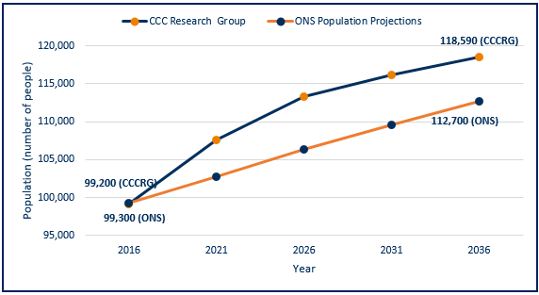

Source: Office for National Statistics (ONS) 2014-based subnational population projections and Cambridgeshire County Council Research Group (CCC RG) mid-2015 based population forecasts

* Cambridgeshire County Council Research Group (CCC RG) predicts greater levels of population change by 2036 than ONS, whether absolutely or proportionally.
* The CCC RG forecast takes into account changes to housing development, the impacts of which are clear with the CCC RG data forecasts for Fenland indicating a higher population than the ONS population projections for all forecast years.

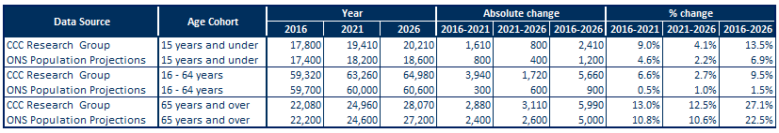Table : Fenland – absolute short-term (5- and 10-year) population change, 2016 to 2026 by age group

Source: Office for National Statistics (ONS) 2014-based Subnational population projections and CCC RG mid-2015 based population forecasts

Figure : Fenland – absolute short-term (5- and 10-year) population change, 2016 to 2026 by age group (comparing CCC RG data with ONS projections)

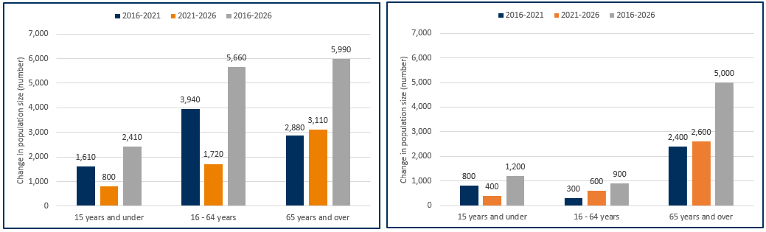CCC RG 2015-based population forecasts ONS 2014-based population projections

Source: CCC RG mid-2015-based population forecasts

Note: Y-axes for these charts do not start at zero

Source: Office for National Statistics (ONS) 2014-based subnational population projections

* Population data for 2016 in Fenland are similar whether based on CCC RG or ONS models.
* Both CCC RG and ONS data suggest future population increases in Fenland.
* Differences in predicted population growth between CCCRG and ONS are much greater for children and working age groups than for older people, reflecting the significant influence of future housing development in the CCC RG forecasts.

# Population density

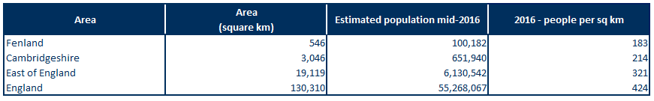Table : Population density for Fenland, Cambridgeshire, East of England and England, mid-2016

Source: Office for National Statistics (ONS table MYE5)

* Overall, Cambridgeshire is a relatively rural area, with lower population density than that seen in England and the East of England.
* Fenland has a population density similar to the Cambridgeshire average, almost 1.8 times lower than the East of England and over 2.3 times lower than the England average.

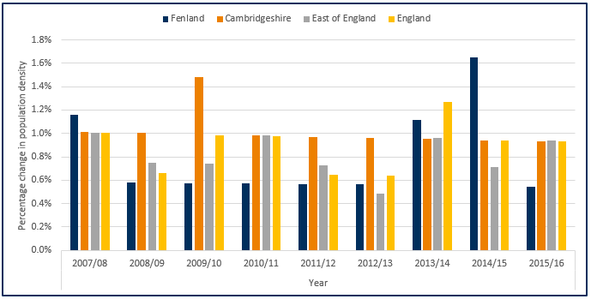Figure : Year-on-year percentage change in population density for Fenland, Cambridgeshire, East of England and England, 2007/08 – 2015/16

Source: Office for National Statistics (ONS)

* Overall, changes in population have been relatively stable with the exception of the population increase for Fenland in 2014/15.
* Typically Fenland’s population density growth rate has been lower the Cambridgeshire County average however for 2007/08, 2012/13 and 2014/15 Fenland has had a growth rate higher than Cambridgeshire and the East of England.
* Fenland has the second smallest growth rate within the Cambridgeshire districts with a growth rate of 7.6% between 2007/08 and 2015/16, (data not shown – please review the Peterborough and Cambridgeshire JSNA core dataset for further details).

# Fertility, migration and ethnicity

Figure : General fertility rate (live birth rate per 1,000 women aged 15-44 years) by local authority of mother’s residence, Cambridgeshire, 2013-15

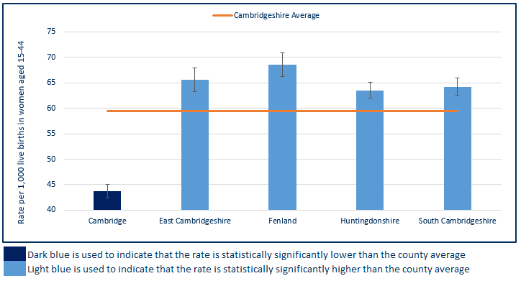

Source: ONS births registrations, ONS mid-year population estimates

Note: Y-axis for this chart does not begin at zero

* Excluding Cambridge, Fenland has a similar fertility rate to the other districts in Cambridgeshire.
* This rate is statistically significantly higher than the county average which is influenced by Cambridge’s lower fertility rate.

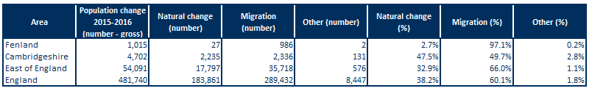Table : ONS mid-2015 to ONS mid-2016 population estimates – absolute and proportional contribution of each component of population change

Source: ONS population estimates mid-2016

Figure : ONS mid-2015 to mid-2016 population estimates – proportional contribution of components of population change in Fenland, Cambridgeshire, East of England and England

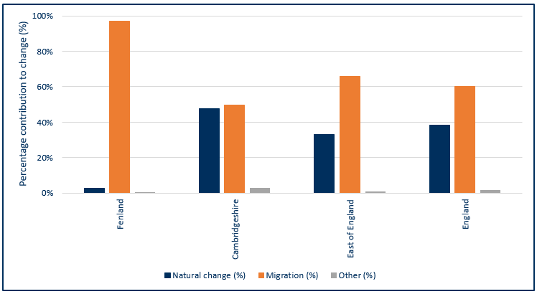Source: ONS population estimates mid-2016

* Natural change (births and deaths) and internal and international migration contribute to the majority of population change.
* Almost all of Fenland’s population changes are a result of migration with only 3% of change due to natural change. Similarly, nationally and regionally, migration made a larger contribution to population change than natural change.
* Natural change and migration made an approximately equal contribution to population change in Cambridgeshire between 2015 and 2016.

Figure : Percentage of national insurance registration applications (NINo) to adult overseas nationals entering Fenland, (registration year to March 2017)

Source: Department for Work and Pensions (DWP)

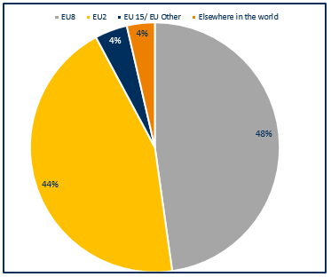

Note: EU15 member countries = EU members prior to the accession of 10 candidate countries on 1/5/2004; EU8 = the 10 accession countries; EU2 = those countries joining from 2007 (Bulgaria and Romania).

* In Fenland European Union (EU) countries make up 96% of all registrations, with the EU8 countries making the largest single contribution of the three groups closely followed by EU2 countries.

Figure : Percentage of population by broad ethnic group, Fenland, 2011

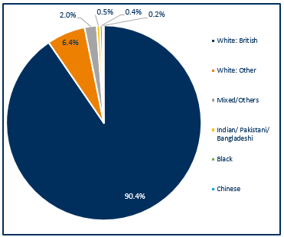

* Fenland has a high proportion of people of White British ethnicity, similar to Cambridgeshire which has a proportion of around 90% White British (data not shown).
* Fenland has a small proportion of people from Chinese, Mixed/Other, Indian/Pakistani/Bangladeshi and Black ethnicities with only 3.1% of the population identifying as these ethnicities.
* Compared with England, Cambridgeshire has relatively small proportions of people from non-white ethnic groups (20.2% v. 15.5% respectively) (data not shown).

Source: Office for National Statistics, Census 2011, Table QS211EW

# Deprivation

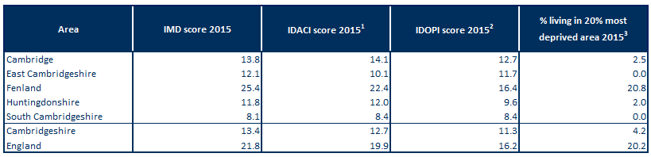Table : Indices of deprivation – 2015, overall score, children’s and older people’s indices and the percentage locally living in the national 20% most deprived area group by local authority, county and England

Source: DCLG from PHE Mental Health and Wellbeing JSNA

Note1: Income Deprivation Affecting Children Index (IDACI): Proportion of children aged 0-15 years living in income-deprived households as a proportion of all children aged 0-15 years.

Note2: Income Deprivation Affecting Older People Index (IDAOPI): Adults aged 60 or over living in income-deprived households as a percentage of all adults aged 60 or over.

Note3: IMD 2015: % of people in an area living in the 20% most deprived areas in England.

* Fenland has a high levels of deprivation compared to the Cambridgeshire average.
* Fenland has higher levels of relative deprivation, compared with England, for overall deprivation and income deprivation affecting children or older people.
* All other Cambridgeshire districts have child and older people’s poverty rates that are lower than England.

Figure : Percentage of wards within Fenland by deprivation quintile compared against all wards within Cambridgeshire County

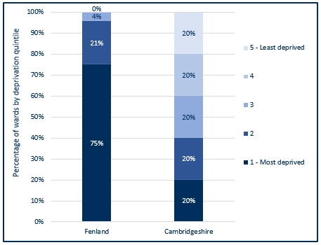

* 75% of Fenland wards (18 wards) are within the most deprived wards of Cambridgeshire, these wards are; Bassenhally, Benwick, Coates & Eastrea, Birch, Clarkson, Elm & Christchurch, Kirkgate, Lattersey, March East, March North, March West, Medworth, Octavia Hill, Parson Drove & Wisbech St Mary, Peckover, Roman Bank, Slade Lode, Staithe and Waterlees Village.
* The majority of Fenland wards are within the 1st deprivation quintile, and 25% of wards (6 wards) fall within the least deprived 80% of wards within Cambridgeshire.

Source: Index of Multiple Deprivation 2015, Department for Communities & Local Government (DCLG)

# Wider determinants of health and wellbeing

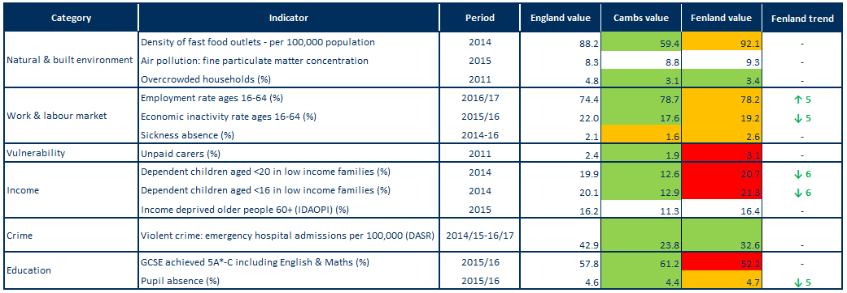Table : Wider determinants of health and wellbeing: summary of key indicators from Public Health England’s Wider Determinants Atlas

Source: Public Health England (PHE) wider determinants atlas

Note1: Full indicator descriptions and definitions are available at <https://fingertips.phe.org.uk/profile/wider-determinants>

Note2: the number following the trend arrow icon indicates the number of years this trend is based on, colour and direction represent increased or decreased levels with green representing an improvement and red a worsening.

* The density of fast food outlets within Fenland is statistically similar to the England rate.
* Fenland has a statistically lower level of household overcrowding than found on average in England with a similar level to Cambridgeshire.
* Compared with England's average, Cambridgeshire has a statistically significantly better rate of people in employment. Employment rates in Fenland are statistically similar to the national average.
* Fenland has statistically significantly higher rates of unpaid carers compared to England, all other districts within Cambridgeshire have statistically significantly lower levels of unpaid carers.
* Fenland’s rates for dependent children aged <16 and <20 years in low income families are statistically significantly higher than the England average.
* Emergency hospital admissions due to violent crime in Fenland are statistically significantly lower than the national average for the first time in six years, Cambridgeshire is also statistically significantly lower than England.
* Fenland is statistically significantly lower (worse) when compared to national rates for GCSE achievement (5A*-C including English & Maths), Cambridgeshire rates are statistically significantly better than England.
* The rate of pupil absence in Fenland is statistically similar to the national average. This rate is statistically significantly better than England in Cambridgeshire.

# Lifestyles and risk factors for health

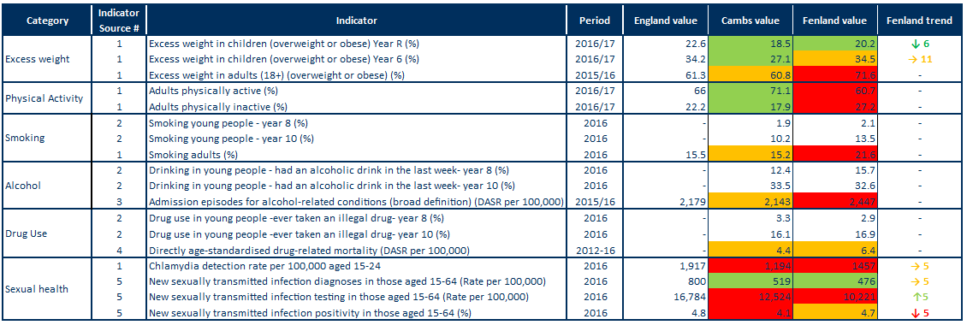Table : Lifestyles and risk factors – summary of key indicators for Fenland, Cambridgeshire and England

Note1: Indicator names have been abbreviated

Note2: Alcohol-related conditions as primary or subsidiary cause of admission. Broad measures are considered the best reflection of the burden of alcohol on the community and services.

Note3: DASR = directly age-standardised rate.

Indicator sources:

1 Source: PHE Public Health Outcomes Framework

2 Source: Health Related Behaviour Survey, School Health Education Unit

3 Source: PHE Local Alcohol Profile for England

4 Source: NHS Digital Primary Care Mortality Database (ONS death registrations), mid-year population estimates

5 Source: PHE Sexual and Reproductive Health Profiles

* Rates of excess weight in children are statistically significantly lower than England in both Cambridgeshire and Fenland for reception year.
* In Fenland rates of excess weight in children in year 6 are statistically similar to England.
* The rate of excess weight in adults (18+) is statistically similar to the England average for Cambridgeshire, while for Fenland the rate is statistically significantly worse than England.
* The rate for both physical activity and inactivity in adults (19+) is statistically significantly better than the England average for Cambridgeshire however for Fenland the rate is statistically significantly worse when compared to England.
* Data from the Health Related Behaviour Survey for Fenland indicate steep increases between Years 8 and 10 in levels of smoking, drinking and drug use.
* Smoking prevalence in adults 18+ is statistically similar to the England average for Cambridgeshire and statistically significantly higher for Fenland.
* The rate of hospital admission episodes for alcohol-related conditions is statistically significantly similar to England average in Cambridgeshire, however it is statistically significantly higher in Fenland.
* Drug related death rates in Cambridgeshire and Fenland are both at statistically similar levels to England, with 22% of the deaths in Cambridgeshire within Fenland (% data not shown – please review the Peterborough and Cambridgeshire JSNA core dataset for further details).
* The chlamydia detection rate is lower than the national target in Fenland, as it is for the county as a whole.
* The STI diagnosis rate in Fenland is statistically significantly better than the England average.
* Testing rates have increased over the last 5 years but positivity rates have declined, which may indicate inappropriate targeting or a general decrease in prevalence of infection in the population. Similar trends are observed for England as a whole (trend data not shown – please review the Public Health England Public Health Outcomes Framework for further details).

# Falls

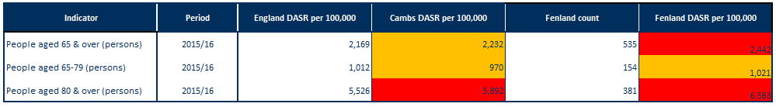Table : Falls in people aged 65 and over – emergency hospital admissions Fenland, Cambridgeshire and England, 2015/16.

Note: DASR = directly age-standardised rate per 100,000 population

Source: PHE, Public Health Outcomes Framework, <https://fingertips.phe.org.uk/profile/public-health-outcomes-framework>

* Rates of falls for people aged 65 years and over and for people aged 80 and over in Fenland are statistically significantly worse compared to England.
* Fenland has statistically similar rates of falls in people aged 65-79 years compared to England.
* Rates for falls within Cambridgeshire are statistically similar to England for over 65’s and 65-79’s however for over 80’s the rate is statistically significantly worse.

# Screening and vaccination

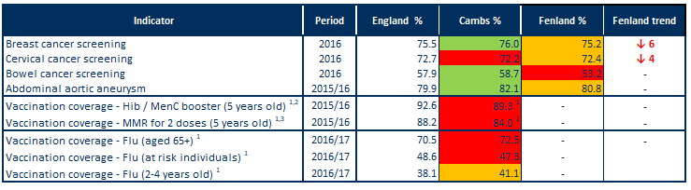Table : Screening and vaccination – coverage (%) for Fenland, Cambridgeshire and England

Source: PHE, Public Health Outcomes Framework, <http://www.phoutcomes.info/>

Note1: benchmarked against threshold based goals

Note2: Hib = Haemophilus influenza type b; MenC = meningitis C

Note3: MMR = measles, mumps and rubella

* Fenland rates for breast and cervical cancer screening are statistically similar to England.
* Rates for bowel cancer are statistically significantly worse for Fenland compared to national rates.
* Fenland rates for abdominal aortic aneurysm screening are statistically similar to England.
* In Cambridgeshire, vaccination coverage for Hib, MenC, MMR and flu are poor when compared to national benchmarks excluding flu vaccination for 2-4 year olds which is achieving above the 40% required to achieve amber (data are not available for Fenland).

# Disease prevalence – the amount of illness recorded in the population

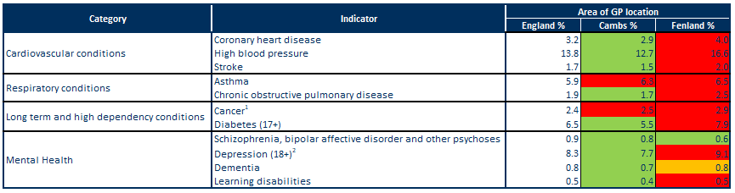Table : GP-recorded disease prevalence by district of general practice location, Fenland, Cambridgeshire and England, 2015/16

Note1: Patients diagnosed with cancer (excluding non-melanotic skin cancer) on or after 01/04/2003

Note2: Patients with a record of unresolved depression since April 2006

Sources: NHS Digital, Quality and Outcomes Framework, Cambridgeshire County Council Public Health Intelligence

* The recorded prevalence rates of coronary heart disease, high blood pressure and stroke are all statistically significantly higher in Fenland when compared to the England average.
* In Fenland, the recorded prevalence rates of asthma and chronic obstructive pulmonary disease (COPD) are statistically significantly higher when compared to national rates.
* The recorded prevalence rates of cancer and diabetes are statistically significantly higher in Fenland when compared to the England average.
* In Fenland, the recorded prevalence rate of schizophrenia is statistically significantly lower when compared to England.
* In Fenland, the recorded prevalence rate of depression and learning difficulties are statistically significantly higher when compared to national average.
* The recorded prevalence rate of dementia in Fenland is statistically similar when compared to England.

# Self-harm and suicide

Table : Self-harm and suicide indicators for Fenland, Cambridgeshire and England

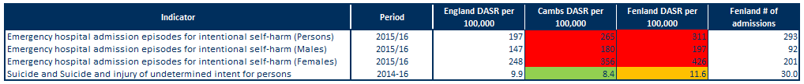Source: Public Health England Public Health Outcomes Framework indicator

Note: DASR = directly age-standardised rate

* All rates of emergency admissions to hospital for self-harm are statistically significantly higher than the national average for Fenland and Cambridgeshire.
* Rates for self-harm are higher in females, accounting for around 69% of hospital admissions in Fenland.
* Fenland has statistically similar suicide rate when compared to the national rate.
* Cambridgeshire has statistically significantly lower suicide rate when compared to the national rate.

# Use of NHS hospital services

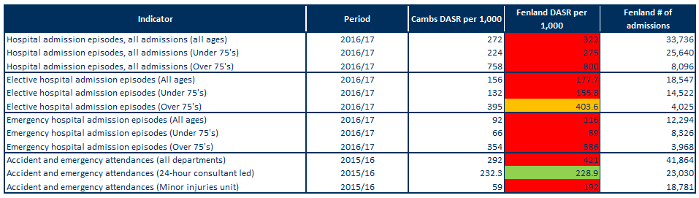 Table : Hospital-related admissions and attendances by admission type for Fenland and Cambridgeshire

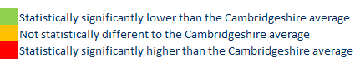Note: DASR = directly age-standardised rate

Sources: NHS Digital Hospital Episode Statistics, Office for National Statistics mid-year population estimates

* Rates for all hospital admissions, elective (planned) admissions and emergency admissions for all ages (excluding elective admissions for over 75’s) in Fenland are statistically significantly higher than Cambridgeshire averages.
* In Fenland the rate for elective hospital admissions for over 75’s is statistically similar to Cambridgeshire County.
* Rates within Fenland for all admissions are almost three times higher in people aged 75 and over than those under 75.
* All departments and minor injury unit based A&E attendances for Fenland are statistically significantly higher than the Cambridgeshire average. The rate for 24-hour consultant led departments, however are statistically significantly lower than the Cambridgeshire average – this is highly influenced by the type of service that is based most locally at Doddington and Hinchingbrooke Hospital’s

# Life expectancy and mortality

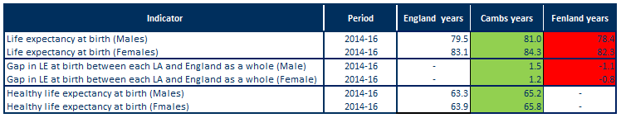Table : Life expectancy and healthy life expectancy for Fenland, Cambridgeshire and England

Source: PHE, Public Health Outcomes Framework, <http://www.phoutcomes.info/>

* Life expectancy at birth is statistically significantly lower than the England average in males and females in Fenland.
* Life expectancy in Fenland is statistically significantly lower than England for males, with a gap of -1.1 years (78.4 years compared to 79.5 years).
* Life expectancy in Fenland is statistically significantly lower than England for females, with a gap of -0.8 year (82.3 years compared to 83.1 years).
* Healthy life expectancy in Cambridgeshire is statistically significantly higher than the England average for males and females with a year gap of 1.9 for both sexes.

Figure : Major causes of death in Fenland, 2014-16

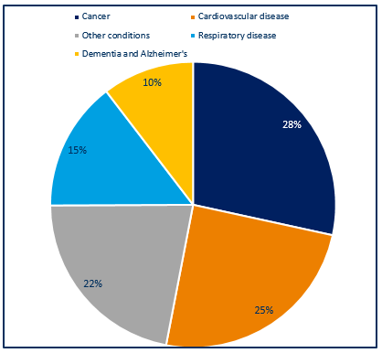

* Around 1,100 deaths occurred each year in Fenland residents during 2014-16.
* The majority of deaths were due to cancer (28%) and cardiovascular disease (25%), followed by respiratory disease at (15%) and dementia and Alzheimer’s at (10%); other causes contributed 22%.
* The major causes of death in Fenland are similar to those seen nationally.

Source: NHS Digital Primary Care Mortality Database (Cambridgeshire County Council Public Health Intelligence)

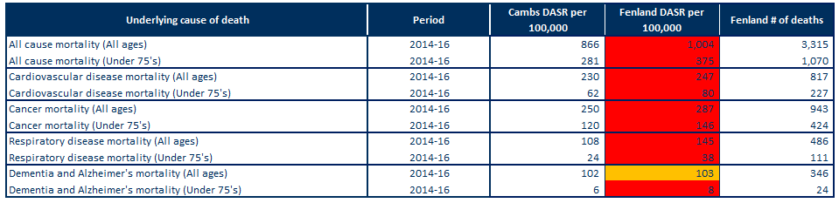Table 14: Directly age-standardised rates for major causes of death in Fenland and Cambridgeshire, 2014-16

Note: DASR = directly age-standardised rate

Sources: Cambridgeshire County Council Public Health Intelligence (NHS Digital Primary Care

Mortality Database, Office for National Statistics mid-year population estimates)

* In Fenland, the rate for all-age all-cause mortality is statistically significantly higher than the Cambridgeshire average rate.
* The rates for all-age and under 75’s cardiovascular disease in Fenland is statistically significantly higher than the Cambridgeshire average rates.
* Around 270 Fenland residents died from cardiovascular disease each year between 2014 and 2016.
* In Fenland, the rate for all-age and under 75’s cancer mortality is statistically significantly higher than the Cambridgeshire average rate.
* Just under 315 Fenland residents died from cancer each year between 2014 and 2016.
* In Fenland, the rate for all-age and under 75’s respiratory mortality is statistically significantly higher than the Cambridgeshire average rate.
* Just over 160 Fenland residents died from respiratory each year between 2014 and 2016.
* The rates for all-age dementia and Alzheimer’s disease mortality in Fenland is statistically similar to the Cambridgeshire average rates.
* In Fenland, the rates for under 75’s dementia and Alzheimer’s disease mortality are statistically significantly higher than the Cambridgeshire average rates.
* Around 115 Fenland residents died each year from dementia and Alzheimer’s disease between 2014 and 2016.

# Further information

The full Cambridgeshire and Cambridgeshire and Peterborough JSNA core datasets can be found on the Cambridgeshire County Council Insight website at: <https://cambridgeshireinsight.org.uk/jsna/published-joint-strategic-needs-assessments/>

And on the Peterborough City Council website at:

<https://www.peterborough.gov.uk/healthcare/public-health/JSNA/>

Author:

Elizabeth Wakefield, Public Health Analyst, Cambridgeshire and Peterborough PHI.

Date: 11/07/18