2017 JSNA core dataset:

Cambridge City Summary, July 2018

**Joint Strategic Needs Assessment**

cambridgeshire.gov.uk

Contents

Population estimates and forecasts 4

Population density 5

Fertility, migration and ethnicity 6

Deprivation 9

Wider determinants of health and wellbeing 10

Lifestyles and risk factors for health 11

Falls 12

Screening and vaccination 12

Disease prevalence – the amount of illness recorded in the population 13

Self-harm and suicide 13

Use of NHS hospital services 14

Life expectancy and mortality 14

Further information 16

Tables

Table 1: Cambridge – absolute long-term (20 year) population change, 2016 to 2036 (all ages) 4

Table 2: Cambridge – absolute short-term (5- and 10-year) population change, 2016 to 2026 by age group 4

Table 3: Population density for Cambridge, Cambridgeshire, East of England and England, mid-2016 5

Table 4: ONS mid-2015 to ONS mid-2016 population estimates – absolute and proportional contribution of each component of population change 7

Table 5: Indices of deprivation – 2015, overall score, children’s and older people’s indices and the percentage locally living in the national 20% most deprived area group by local authority, county and England 9

Table 6: Wider determinants of health and wellbeing: summary of key indicators from Public Health England’s Wider Determinants Atlas 10

Table 7: Lifestyles and risk factors – summary of key indicators for Cambridge, Cambridgeshire and England 11

Table 8: Falls in people aged 65 and over – emergency hospital admissions, Cambridge, Cambridgeshire and England 12

Table 9: Screening and vaccination – coverage (%) for Cambridge, Cambridgeshire and England 12

Table 10: GP-recorded disease prevalence by district of general practice location, Cambridge, Cambridgeshire and England, 2015/16 13

Table 11: Self-harm and suicide indicators for Cambridge, Cambridgeshire and England 13

Table 12: Hospital-related admissions and attendances by admission type for Cambridge and Cambridgeshire 14

Table 13: Life expectancy and healthy life expectancy for Cambridge, Cambridgeshire and England, 2014-16 14

Table 14: Directly age-standardised rates for major causes of death in Cambridge and Cambridgeshire, 2014-16 15

Figures

Figure 1: Cambridge – absolute long-term (20-year) population change, 2016 to 2036 (all ages) (comparing CCC RG data with ONS projections) 4

Figure 2: Cambridge – absolute short-term (5- and 10-year) population change, 2016 to 2026 by age group (comparing CCC RG data with ONS projections) 5

Figure 3: Year–on-year percentage change in population density for Cambridge, Cambridgeshire, East of England and England, 2007/08 - 2015/16 6

Figure 4: General fertility rate (live birth rate per 1,000 women aged 15-44 years) by local authority of mother’s residence, Cambridgeshire, 2013-15 6

Figure 5: ONS mid-2015 to mid-2016 population estimates – proportional contribution of components of population change in Cambridge, Cambridgeshire, East of England and England 7

Figure 6: Percentage of national insurance registration applications (NINo) to adult overseas nationals entering Cambridge, (registration year to March 2017) 8

Figure 7: Percentage of population by broad ethnic group, Cambridge, 2011 8

Figure 8: Percentage of wards within Cambridge by deprivation quintile compared against all wards within Cambridgeshire 9

Figure 9: Major causes of death in Cambridge, 2014-16 15

Statistical Significance

Throughout this JSNA district summary, comparisons between district/county and England have been made through the assessment of ‘statistical significance’. For each indicator value, 95% confidence intervals are calculated which provide a measure of uncertainty around the calculated value. If the confidence interval for the district/county value excludes the value for the benchmark (which is typically England), the difference between the district/county value and the benchmark is said to be ‘statistically significant’. When values are statistically significant they are represented via the colour scheme below:



All tables/figures that provide statistical measures are compared to England unless otherwise stated. Occasionally, comparisons have been made that are not compared to England; in this situation the key is provided below the table/figure.

# Population estimates and forecasts

Table : Cambridge – absolute long-term (20-year) population change, 2016 to 2036 (all ages)

Source: Office for National Statistics (ONS) 2014-based subnational population projections and Cambridgeshire County Council Research Group (CCC RG) mid-2015-based population forecasts

Figure : Cambridge – absolute long-term (20-year) population change, 2016 to 2036 (all ages) (comparing CCC RG data with ONS projections)

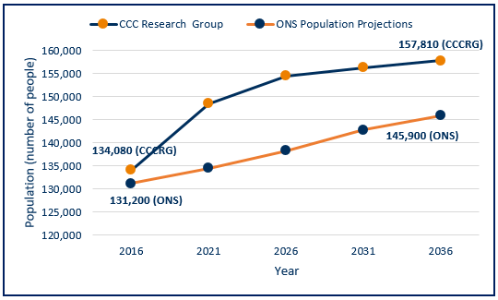

Source: Office for National Statistics (ONS) 2014-based subnational population projections and Cambridgeshire County Council Research Group (CCC RG) mid-2015-based population forecasts

* Cambridgeshire County Council Research Group (CCC RG) predicts greater levels of population change by 2036 than ONS, whether absolutely or proportionally.
* The CCC RG forecast takes into account changes to housing development, the impacts of which are clear with the CCC RG data forecasts for Cambridge indicating a higher population than the ONS population projections for all forecast years.

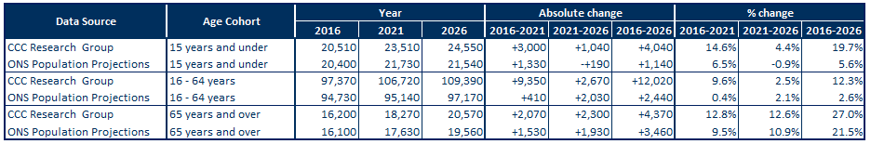Table : Cambridge – absolute short-term (5- and 10-year) population change, 2016 to 2026 by age group

Source: Office for National Statistics (ONS) 2014-based Subnational population projections and CCC RG mid-2015 based population forecasts

Figure : Cambridge – absolute short-term (5- and 10-year) population change, 2016 to 2026 by age group (comparing CCC RG data with ONS projections)

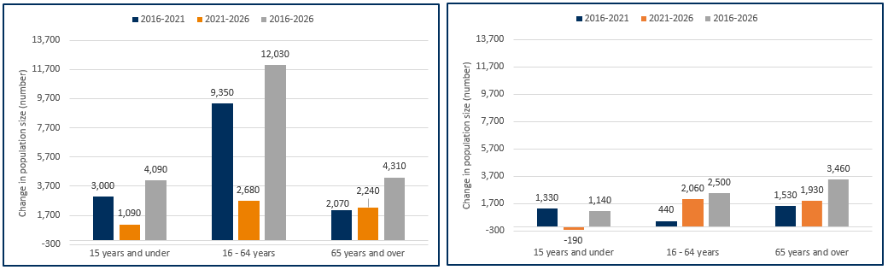CCC RG 2015-based population forecasts ONS 2014-based population projections

Source: CCC RG mid-2015-based population forecasts

Note: Y-axes for these charts do not start at zero

Source: Office for National Statistics (ONS) 2014-based subnational population projections

* Population data for 2016 in Cambridge are similar whether based on CCC RG or ONS models.
* Both CCC RG and ONS data suggest future population increases in Cambridge.
* Between 2021 and 2026, ONS forecasts a slight decrease in the number of children under 16.
* Differences in predicted population growth between CCC RG and ONS are much greater for children and working age groups than for older people, particularly in the 2016-21 period, reflecting the significant influence of future housing development in the CCC RG forecasts.

# Population density

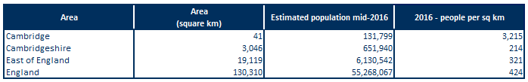Table : Population density for Cambridge, Cambridgeshire, East of England and England, mid-2016

Source: Office for National Statistics (ONS table MYE5)

* Overall, Cambridgeshire is a relatively rural area, with lower population density than that seen in England and the East of England.
* Cambridge is by far the most densely populated district in Cambridgeshire (data not shown).
* Cambridge has a population density far exceeding that of Cambridgeshire, East of England and England.

Figure 3: Year-on-year percentage change in population density for Cambridge, Cambridgeshire, East of England and England, 2007/08 - 2015/16

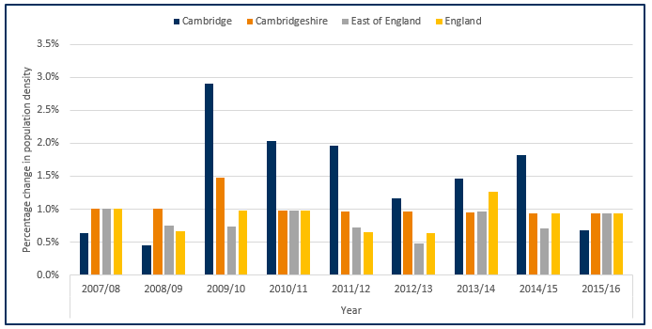

Source: Office for National Statistics (ONS)

* Excluding Cambridge, changes in the other population areas shown have been relatively stable.
* Population density for Cambridge rapidly increased in 2009/10 and has remained higher than Cambridgeshire, East of England and England for the subsequent five years.
* Cambridge has seen the largest population increase of all the districts between 2007/08 and 2015/16 with an increase of 14.2% (4.5 percentage points above Cambridgeshire with an increase of 9.7%) (data not shown – please review the Peterborough and Cambridgeshire JSNA core dataset for further details).
* In 2015/16, Cambridge had a lower growth rate then Cambridgeshire, East of England and England; this is the first time since 2008/09 that this has occurred.

# Fertility, migration and ethnicity

Figure : General fertility rate (live birth rate per 1,000 women aged 15-44 years) by local authority of mother’s residence, Cambridgeshire, 2013-15

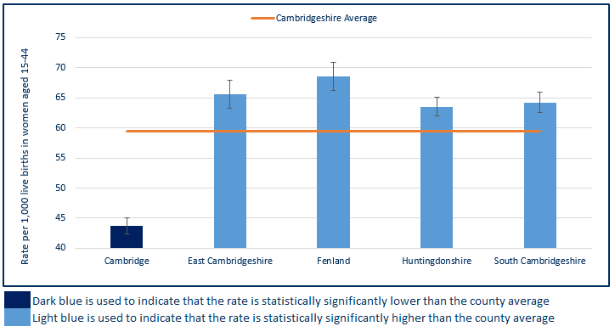

Source: ONS births registrations, ONS mid-year population estimates

Note: Y-axis for this chart does not begin at zero

* Cambridge has a low birth rate compared with other districts in Cambridgeshire. This rate is statistically significantly lower than the county average.
* All other districts have significantly higher rates when compared to the county average, which is influenced by the low Cambridge rate.

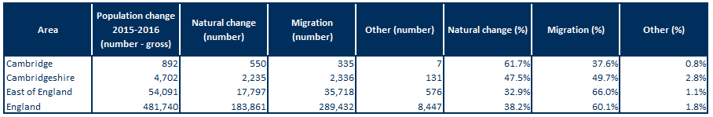Table : ONS mid-2015 to ONS mid-2016 population estimates – absolute and proportional contribution of each component of population change

Source: ONS population estimates mid-2016

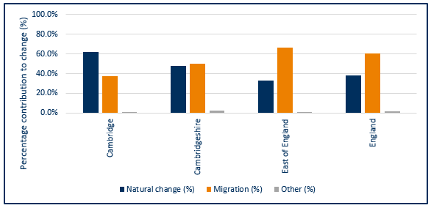Figure : ONS mid-2015 to mid-2016 population estimates – proportional contribution of components of population change in Cambridge, Cambridgeshire, East of England and England

Source: ONS population estimates mid-2016

* Natural change (births and deaths) and internal and international migration contribute to the majority of population change.
* In Cambridge, natural change accounted for a larger proportion of the population change than migration. Conversely, nationally and regionally, migration made a larger contribution to population change than natural change.
* Natural change and migration made an approximately equal contribution to population change in Cambridgeshire between 2015 and 2016.

Figure : Percentage of national insurance registration applications (NINo) to adult overseas nationals entering Cambridge, (registration year to March 2017)

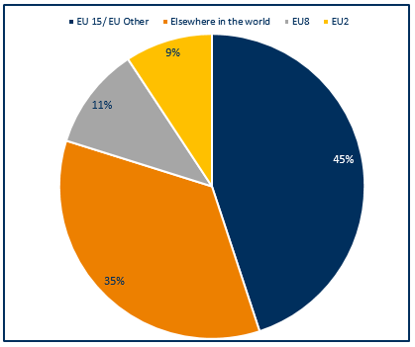

Note: EU15 member countries = EU members prior to the accession of 10 candidate countries on 1/5/2004; EU8 = the 10 accession countries; EU2 = those countries joining from 2007 (Bulgaria and Romania).

* In Cambridge, European Union (EU) countries make up 65% of all registrations, with the EU15 countries making the largest single contribution of the three groups.

Source: Department for Work and Pensions (DWP)

Figure : Percentage of population by broad ethnic group, Cambridge, 2011

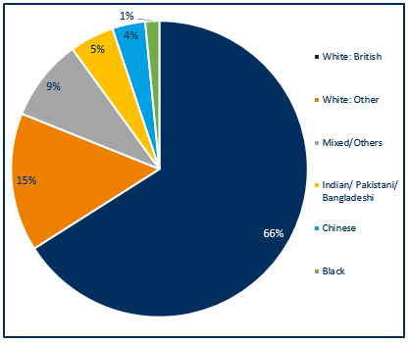

* Cambridge has a higher proportion of people of Chinese ethnicity than England (3.6% v. 0.7% respectively) and a fairly similar proportion of people from the Indian/Pakistani/Bangladeshi group (4.8% v. 5.6% respectively) (data not shown).
* In other Cambridgeshire districts, the White British group comprises around 90% of the population. In Cambridge, this is around 66% with a larger proportional contribution made by the White Other group and the Mixed/Others group.
* Compared with England, Cambridgeshire has relatively small proportions of people from non-white ethnic groups (20.2% v. 15.5 respectively) (data not shown).

Source: Office for National Statistics, Census 2011, Table QS211EW

# Deprivation

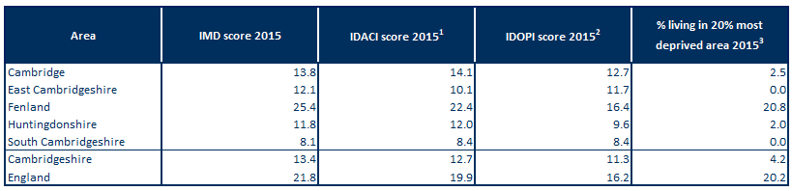Table : Indices of deprivation – 2015, overall score, children’s and older people’s indices and the percentage locally living in the national 20% most deprived area group by local authority, county and England

Source: DCLG from PHE Mental Health and Wellbeing JSNA

Note1: Income Deprivation Affecting Children Index (IDACI): Proportion of children aged 0-15 years living in income-deprived households as a proportion of all children aged 0-15 years.

Note2: Income Deprivation Affecting Older People Index (IDAOPI): Adults aged 60 or over living in income-deprived households as a percentage of all adults aged 60 or over.

Note3: IMD 2015: % of people in an area living in the 20% most deprived areas in England.

* Cambridge has a similar level of relative overall deprivation to the Cambridgeshire average.
* Cambridge has low levels of relative deprivation, compared with England, for overall deprivation and income deprivation affecting children or older people.
* Cambridge has slightly higher levels of deprivation affecting children and older people than the county average, but both are below the national rates.
* All Cambridgeshire districts, excluding Fenland, have child poverty rates that are lower than England. As in England, all these districts have decreasing recent trends (trend data not shown – please review the Peterborough and Cambridgeshire JSNA core dataset for further details).
* Compared to the Cambridgeshire average Cambridge has a higher child poverty rate. With the exception of Fenland the remaining districts have lower rates than Cambridgeshire.
* Similar to England, the older people’s deprivation percentage in Cambridge has decreased over the last few years (trend data not shown). – please review the Peterborough and Cambridgeshire JSNA core dataset for further details).

Figure : Percentage of wards within Cambridge by deprivation quintile compared against all wards within Cambridgeshire

* 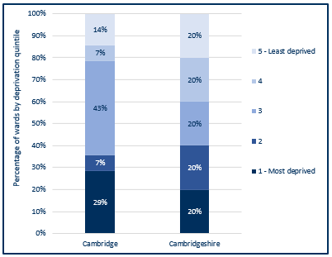Cambridge has 29% of its wards (4 wards) within the most deprived wards of Cambridgeshire, these ward are Abbey, Arbury, East Chesterton and King’s Hedges.
* The most common quintile for Cambridge wards is quintile 3 (43%), and 71% of wards (10 wards) fall within the least deprived 80% of wards within Cambridgeshire.

Source: Index of Multiple Deprivation 2015, Department for Communities & Local Government (DCLG)

# Wider determinants of health and wellbeing

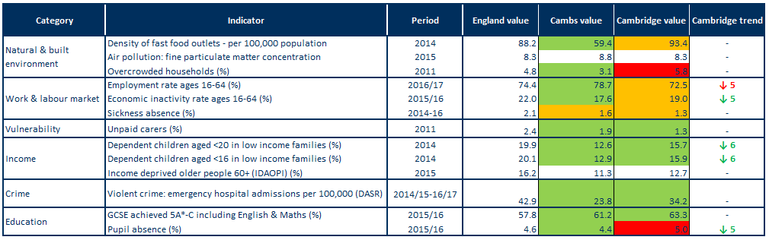Table : Wider determinants of health and wellbeing: summary of key indicators from Public Health England’s Wider Determinants Atlas

Source: Public Health England (PHE) wider determinants atlas

Note1: Full indicator descriptions and definitions are available at <https://fingertips.phe.org.uk/profile/wider-determinants>.

Note2: the number following the trend arrow icon indicates the number of years this trend is based on, colour and direction represent increased or decreased levels with green representing an improvement and red a worsening.

* Cambridge’s density of fast food outlets is statistically similar to the England rate, but worse than the Cambridgeshire average.
* Cambridge has a statistically higher (worse) level of household overcrowding than found on average in England and a higher level when compared with Cambridgeshire.
* Compared with England's average, Cambridgeshire has a statistically significantly better rate of people in employment. Employment rates in Cambridge are statistically similar to the national average.
* Cambridge has a statistically significantly lower rate of unpaid carers than England.
* Cambridge’s rates for dependent children aged <16 and <20 years in low income families are statistically significantly lower than the England average.
* Emergency hospital admissions due to violent crime in Cambridge are statistically better than the national rate, however these rates are higher than the Cambridgeshire average.
* Cambridge is statistically significantly better when compared to national rates for GCSE achievement (5A*-C including English & Maths), and similar to Cambridgeshire.
* The rate of pupil absence in Cambridge is statistically significantly worse than the national average and higher than the Cambridgeshire average.

# Lifestyles and risk factors for health

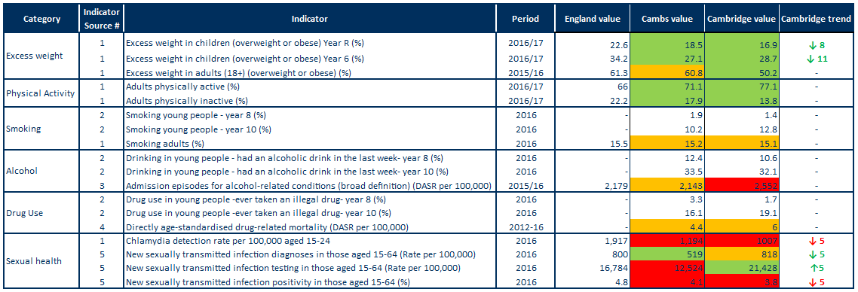Table : Lifestyles and risk factors – summary of key indicators for Cambridge, Cambridgeshire and England

Note1: Indicator names have been abbreviated

Note2: Alcohol-related conditions as primary or subsidiary cause of admission. Broad measures are considered the best reflection of the burden of alcohol on the community and services.

Note3: DASR = directly age-standardised rate.

Indicator sources:

1 Source: PHE Public Health Outcomes Framework

2 Source: Health Related Behaviour Survey, School Health Education Unit

3 Source: PHE Local Alcohol Profile for England

4 Source: NHS Digital Primary Care Mortality Database (ONS death registrations), mid-year population estimates

5 Source: PHE Sexual and Reproductive Health Profiles

* Rates of excess weight in children are statistically significantly lower than England in both Cambridgeshire and Cambridge for reception year and year 6.
* The rate of excess weight in adults (18+) is statistically similar to the England average for Cambridgeshire, while for Cambridge the rate is statistically better than England.
* The rate for both physical activity and inactivity in adults (19+) is statistically significantly better than the England average for both Cambridgeshire and Cambridge.
* Data from the Health Related Behaviour Survey for Cambridge indicate steep increases between Years 8 and 10 in levels of smoking, drinking and drug use.
* Smoking prevalence in adults 18+ is statistically similar to the England average for Cambridgeshire and Cambridge.
* The rate of hospital admission episodes for alcohol-related conditions is statistically significantly similar to England average in Cambridgeshire, however it is statistically significantly higher in Cambridge.
* Drug-related death rates in Cambridgeshire and Cambridge are both at statistically similar levels to England, with 26% of the deaths in Cambridgeshire within Cambridge (% data not shown – please review the Peterborough and Cambridgeshire JSNA core dataset for further details).
* The chlamydia detection rate is statistically significantly lower than the national target in Cambridge, as it is for the county as a whole.
* The STI diagnosis rate in Cambridge is statistically significantly similar to the England average and has decreased over the last 5 years, as it has nationally (trend data not shown – please review the Public Health England Public Health Outcomes Framework for further details).
* Testing rates have increased over the last 5 years but positivity rates have declined, which may indicate inappropriate targeting or a general decrease in prevalence of infection in the population. Similar trends are observed for England as a whole (trend data not shown – please review the Public Health England Public Health Outcomes Framework for further details).

# Falls

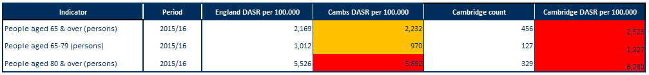Table : Falls in people aged 65 and over – emergency hospital admissions, Cambridge, Cambridgeshire and England

Note: DASR = directly age-standardised rate per 100,000 population

Source: PHE Public Health Outcomes Framework, <https://fingertips.phe.org.uk/profile/public-health-outcomes-framework>

* Falls in people aged 65 years and over in Cambridge are statistically significantly higher compared to England.
* Rates for falls within Cambridgeshire are statistically similar to England for over 65’s and 65-79’s however for over 80’s the rate is statistically significantly worse.

# Screening and vaccination

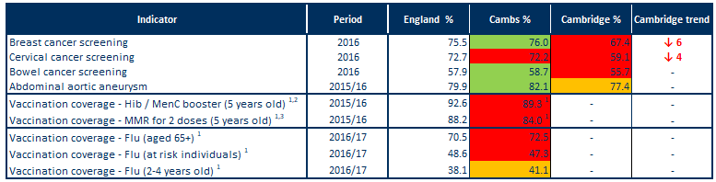Table : Screening and vaccination – coverage (%) for Cambridge, Cambridgeshire and England

Source: PHE Public Health Outcomes Framework, <http://www.phoutcomes.info/>

Note1: benchmarked against threshold based goals

Note2: Hib = Haemophilus influenza type b; MenC = meningitis C

Note3: MMR = measles, mumps and rubella

* Cambridge rates for breast, cervical and bowel cancer screening are statistically significantly worse than the England average.
* Cambridge rates for abdominal aortic aneurysm screening are statistically similar to England.
* In Cambridgeshire, vaccination coverage for Hib, MenC, MMR and flu are poor when compared to national benchmarks excluding flu vaccination for 2-4 year olds which is achieving above the 40% required to achieve amber (data are not available for Cambridge).

# Disease prevalence – the amount of illness recorded in the population

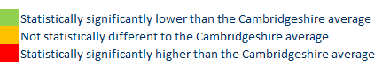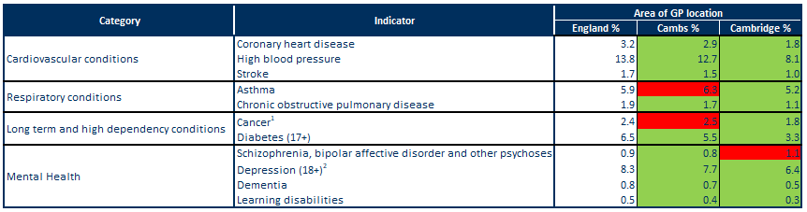Table : GP-recorded disease prevalence by district of general practice location, Cambridge, Cambridgeshire and England, 2015/16

Note1: Patients diagnosed with cancer (excluding non-melanotic skin cancer) on or after 01/04/2003

Note2: Patients with a record of unresolved depression since April 2006

Sources: NHS Digital, Quality and Outcomes Framework, Cambridgeshire County Council Public Health Intelligence

* The recorded prevalence rates of coronary heart disease, high blood pressure and stroke are statistically significantly lower in Cambridge and in Cambridgeshire as a whole when compared to the England average.
* The recorded prevalence rates of asthma and chronic obstructive pulmonary disease (COPD) are statistically significantly lower in Cambridge when compared to the England average, however Cambridgeshire is statistically significantly higher for asthma compared to the England average.
* The recorded prevalence rates of cancer and diabetes are statistically significantly lower in Cambridge when compared to the England average, however Cambridgeshire is statistically significantly higher for cancer compared to the England average.
* The recorded prevalence of schizophrenia, bipolar affective disorder and other psychoses is statistically significantly higher than the England average in Cambridge. All other indicators of mental health are statistically significantly lower in Cambridge and Cambridgeshire collectively when compared to the England average.

# Self-harm and suicide

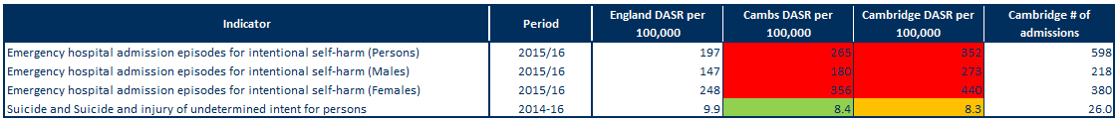Table : Self-harm and suicide indicators for Cambridge, Cambridgeshire and England

Source: Public Health England Public Health Outcomes Framework indicator

Note: DASR = directly age-standardised rate

* For persons, males and females, rates of emergency admissions to hospital for self-harm are statistically significantly higher than the national average for Cambridge and Cambridgeshire.
* Rates for self-harm are higher in females, accounting for around 60% of hospital admissions in Cambridge.
* Cambridge’s suicide rate does not differ significantly from the rate for England.
* Cambridgeshire’s suicide rate is statistically significantly lower than the national rate.

# Use of NHS hospital services

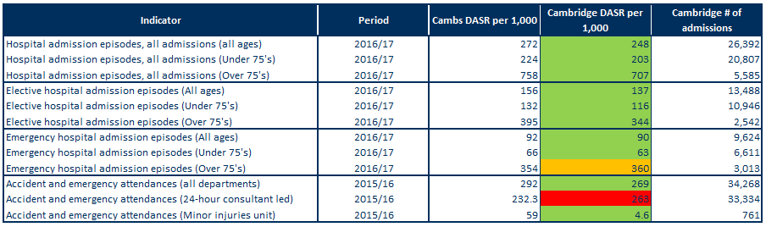Table : Hospital-related admissions and attendances by admission type for Cambridge and Cambridgeshire



Note: DASR = directly age-standardised rate

Sources: NHS Digital Hospital Episode Statistics, Office for National Statistics mid-year population estimates

* Rates for all hospital admissions, elective (planned) admissions and emergency admissions for all ages in Cambridge are statistically significantly lower than the Cambridgeshire averages.
* Rates within Cambridge for all admissions are more than three and a half times higher in people aged 75 and over compared to those under 75.
* All admission and elective admission rates for under 75’s and over 75’s in Cambridge are statistically significantly lower than the Cambridgeshire average, however the over 75’s rate for emergency hospital admissions is statistically similar to Cambridgeshire.
* All departments and minor injury unit based A&E attendances for Cambridge are statistically significantly lower than the Cambridgeshire average. The rate for 24-hour consultant led departments, however, is statistically significantly higher than the Cambridgeshire average – this is highly influenced by the type of service that is based most locally at Addenbrookes Hospital.

# Life expectancy and mortality

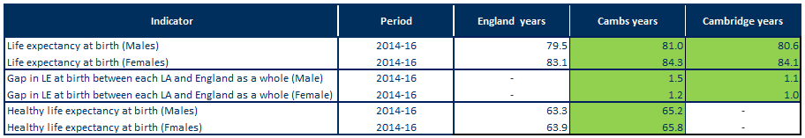Table : Life expectancy and healthy life expectancy for Cambridge, Cambridgeshire and England, 2014-16

Source: PHE Public Health Outcomes Framework, <http://www.phoutcomes.info/>

* Life expectancy at birth is statistically significantly higher than the England average in males and females in Cambridge and Cambridgeshire.
* Life expectancy in Cambridge is statistically significantly higher than England for males, with a gap of 1.1 years (80.6 years compared to 79.5 years).
* Life expectancy in Cambridge is statistically significantly higher than England for females, with a gap of 1 year (84.1 years compared to 83.1 years).
* Healthy life expectancy in Cambridgeshire is statistically significantly higher than the England average for males and females with a year gap of 1.9 for both sexes.

Figure : Major causes of death in Cambridge, 2014-16

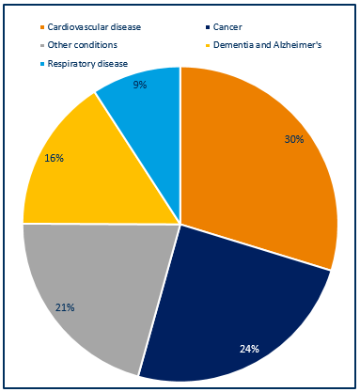

* Around 850 deaths occurred each year in Cambridge residents during 2014-16.
* The majority of deaths were due to cardiovascular disease (30%) and cancer (24%), followed by dementia and Alzheimer’s at (16%) and respiratory disease at (9%); other causes contributed 21%.
* The major causes of death in Cambridge are similar to those seen nationally.

Source: NHS Digital Primary Care Mortality Database (Cambridgeshire County Council Public Health Intelligence)

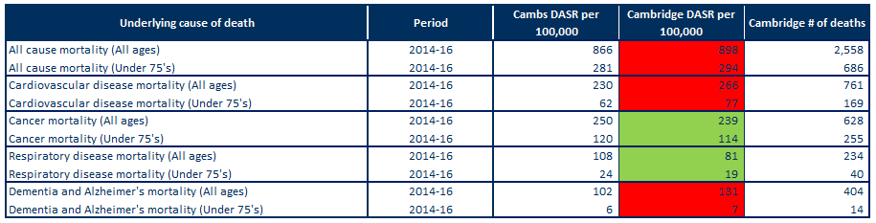Table 14: Directly age-standardised rates for major causes of death in Cambridge and Cambridgeshire, 2014-16

Note: DASR = directly age-standardised rate

Sources: Cambridgeshire County Council Public Health Intelligence (NHS Digital Primary Care Mortality Database, Office for National Statistics mid-year population estimates)

* In Cambridge, the rates of all-age and under 75 all-cause mortality are statistically significantly higher than the Cambridgeshire average rates.
* The rates of all-age and under 75 mortality from cardiovascular disease are statistically significantly higher than the Cambridgeshire averages in Cambridge.
* Just over 250 Cambridge residents died from cardiovascular disease each year between 2014 and 2016.
* In Cambridge, the rates of all-age and under 75 mortality from cancer are statistically significantly lower than the Cambridgeshire averages.
* Around 210 Cambridge residents died each year from cancer between 2014 and 2016.
* The rates of all-age and under 75 mortality from respiratory disease are statistically significantly lower than the Cambridgeshire averages in Cambridge.
* Just under 80 Cambridge residents died each year from respiratory disease between 2014 and 2016.
* The rates of all-age and under 75 mortality from dementia and Alzheimer’s are statistically significantly higher than the Cambridgeshire averages in Cambridge.
* Around 135 Cambridge residents died from dementia and Alzheimer’s each year between 2014 and 2016.

# Further information

The full Cambridgeshire and Cambridgeshire and Peterborough JSNA core datasets can be found on the Cambridgeshire County Council Insight website at: <https://cambridgeshireinsight.org.uk/jsna/published-joint-strategic-needs-assessments/>

And on the Peterborough City Council website at:

<https://www.peterborough.gov.uk/healthcare/public-health/JSNA/>

Author:

Elizabeth Wakefield, Public Health Analyst, Cambridgeshire and Peterborough PHI.

Date: 11/07/18