community safety Strategic assessment: Identifying and responding to vulnerable locations

version 1.0
july 2018

‘Cambridgeshire Research Group’ (CRG) is the brand name for Cambridgeshire County Council’s Research & Performance Function. As well as supporting the County Council we take on a range of work commissioned by other public sector bodies both within Cambridgeshire and beyond.

All the output of the team and that of our partners is published on our dedicated website
www.cambridgeshireinsight.org.uk

For more information about the team phone 01223 715300

Document Details
Title: | Community Safety Strategic Assessment: Identifying and responding to vulnerable locations
Date Created: | July 2018
Description: | The purpose of this document is to provide the Cambridge City Community Safety Partnership with an understanding of key community safety issues affecting the district.
Produced by: | Leigh Robert – Cambridgeshire Research Group
Additional Contributions: | David Attmore – Cambridgeshire Research Group  Ross Lewis, Streets and Open Spaces, Cambridge City Council
On behalf of: | The document has been produced by the CRG, on behalf of Cambridge City Community Safety Partnership and is available to download from http://www.cambridgeshireinsight.org.uk/community-safety/CSP/cambscity
Geographic Coverage: | Cambridge City and County where relevant
Time Period: | April 2017 to March 2018
Format: | Word
Status: | 1.0
Usage Statement: | This product is the property of the Research Group, Cambridgeshire County Council. If you wish to reproduce this document either in whole, or in part, please acknowledge the source and the author(s).
Disclaimer: | Cambridgeshire County Council, while believing the information in this publication to be correct, does not guarantee its accuracy nor does the County Council accept any liability for any direct or indirect loss or damage or other consequences, however arising from the use of such information supplied.

Contents

Contents 3
Introduction 4
Additional information 4
Executive Summary 5
Section 1: What is meant by ‘City Centre’? 6
Section 2: Information pack of crimes during past 12 months 8
Historic Centre 8
Geographical Area 8
Key Points 8
Crime Maps 9
Grafton Centre 10
Geographic Area 10
Key Points 10
Crime Maps 11
Rail Station 12
Geographic Area 12
Key Points 12
Crime Maps 13
Mill Road 14
Geographic Area 14
Key Points 14
Crime Maps 15
Summary of Crimes in Four Areas 16
Section 3: Next Steps 17
Appendix A. Maps 18

Introduction
The purpose of this strategic assessment is to provide the Cambridge City Community Safety Partnership (The Partnership) with an understanding of the crime, anti-social behaviour, and substance misuse issues affecting the city centre. The report does not make comparisons with national data or other urban areas. The specific focus of this document does not include a list of all the work currently being undertaken in this City. The document has been commissioned to help with the following;
- Provide a discussion of what is meant by the ‘city centre’ for the purposes of the action plan for The Partnership.
- Provide an information pack of available data of crimes and anti-social behaviour taking place in Cambridge, including when, where and what crimes etc. are most prevalent, in order for appropriate task groups to identify need.
- Agree what further information and data is needed to support The Partnership in identifying need and priority areas.

Additional information

The following links provide further data and information available to the Partnership and the public:
- District and Ward reports on crime are available here and are updated monthly;
https://cambridgeshireinsight.org.uk/communitysafety/report/view/5e4d37084a6d4fa38cfa3807ccb7a432/E07000008
- The interactive community safety atlas provides some of the main crime and disorder issues at ward level. The atlas allows the user to review the data directly on the map or in a chart. It can be accessed here;
https://cambridgeshireinsight.org.uk/communitysafety/map/
- The victim offender interactive profile that is presented at a district level can be accessed here;
https://cambridgeshireinsight.org.uk/communitysafety/topics/offenders/vona-gender-and-age-pyramid/

Executive Summary
Given that the Partnership has already agreed that the City Centre is a priority area for the current year this document is intended to help focus future activity. The partnership needs to consider where there are gaps and where it can add value to existing work.
Needs:
- Increase in police recorded violence
- Increase in anecdotal feedback about lone vulnerable individuals in the centre of the city during the night
- Increase in the number of knife injuries seen in Addenbrooke’s A&E Hospital
- Increase in shoplifting
Gaps:
- Agreed focus on priority outcome
- Feedback from Street Pastors on numbers and types of people assisted
- Ambulance assault data that includes specific location information
- Licencing complaints – specific concerns
- Profile of repeat offenders of shop theft
- Data sharing and multi-agency approach to night-time economy – The creation of the Market Ward Working Group is going someway to achieving this
Added Value:
- The Partnership could oversee and hold to account the Market Ward Working Group to ensure it is on track to tackle agreed goals
- Support the sharing of relevant information for the working group and partners

Section 1: What is meant by ‘City Centre’?
The term city centre conjures different images for different people. The same is true for the range of organisations and partnership within Cambridge. There is a need for this partnership to have a shared understanding of where activity as well as what activity takes place. In order for the right interventions to be delivered there needs to be clear agreement of what the shared outcomes are being aimed for.
Leading up to this report being produced a number of discussions have taken place at board and officer level as to ‘where’ to focus the priority. As yet, agreement has not been reached. A Market Ward Working Group has been set up and two initial meetings have taken place to agree some objectives, representation and key activity. This group is chaired by Sergeant Kevin Misik and currently the work is broadly falling into two categories:
- Retail issues (shop theft, daytime ASB including begging)
- Night-time economy issues (vulnerable people, licencing issues, and violence)
These broad categories were also the direction the Officer Support Group was considering.
There are many ways in which to examine a geographic area. For example, other areas (including Birmingham) have examined the ‘use’ of their areas with their City’s and used a variety of methods to designate them rather than using a catch all of ‘the city centre’. This allows for a more nuanced set of interventions to be designed into how spaces are being used.
For the purposes of our analysis we have looked at four key areas of the ‘City Centre’. However these are not exhaustive and The Partnership needs to agree a working definition of the area or areas that are the highest priority in relation to tackling crime and disorder. For the purposes of this report the Research Group have grouped four geographic areas based on previous analysis and areas of interest to the partnership. These could be refreshed and adapted to suit the needs of The Partnership.
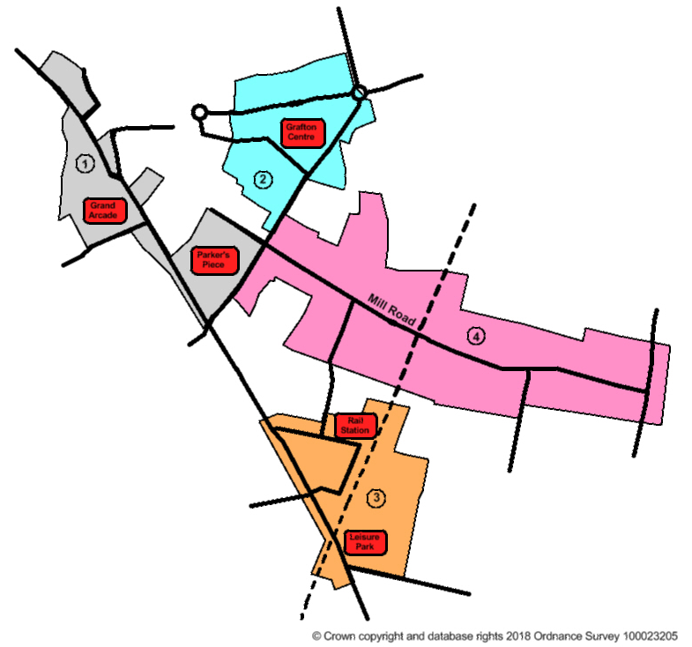
Figure 1: Research Group areas for which analysis was carried out
Key:
- ‘Historic Centre Area’ = Market Square, Grand Arcade & Parker’s Piece
- ‘Grafton Centre Area’ = Grafton Centre & surrounding area
- ‘Rail Station Area’ = Rail station & Cambridge Leisure Park
- ‘Mill Road Area’ = Mill Road & surrounding area (including Kelsey Kerridge)

Cambridge City is a vibrant city which serves it residents (including two universities) and workers with a range of retail, entertainment and tourist functions. These are not mutually exclusive and the overlap both in terms of people and places.
There are of course other geographies that organisations are working to including the ward boundaries, the BID area, pubwatch, CAMBAC (Cambridge Businesses against Crimes) and Lower Super Output Areas (LSOAs). These different geographies are shown in Appendix A. On top of that the retail footprint and night-time economy, or more broadly the entertainment footprint, overlap with each other in certain parts of the city or are not entirely connected (see figure 1).

Section 2: Information pack of crimes during past 12 months
This section is to provide an information pack of some of the available data of crimes and anti-social behaviour taking place in Cambridge. It is broken down by the four areas of the city centre, as well as the time of day that the crimes took place, in order for appropriate task groups to identify need.

Historic Centre

Geographical Area
For the purposes of our analysis, we have stated the Historic Centre Area to be the following.
This area is one of the busiest parts of the city and includes areas of retail, such as the Grand Arcade, Lion Yard and Petty Cury, as well as entertainment venues, such as The Regal and Lola Lo. Therefore, the area is likely to create a number of possible vulnerable locations for crime.

Key Points
Figure 1: Historic Centre Area
- Total of 2,647 police recorded crimes occurred in the past 12 months (April 2017 – March 2018)
- Total of 605 police recorded ASB incidents occurred in the past 12 months
- Over one-quarter (25.8%) of the crimes were bicycle thefts
- Over half (56.0%) of the crimes recorded were either bicycle theft, shoplifting or other theft
- June had the highest number of crimes – 9.7% of total recorded crimes – equivalent to 8.6 crimes per day
- September had the fewest crimes recorded – only 6.6% of crimes – significantly lower than the next fewest (August, 7.7%)
- 90.9% of the ASB incidents were Nuisance ASB
- 345 of the ASB incidents (57.0% of all the ASB incidents) included any of the following keywords; homeless, abusive language, drunk, begging and alcohol
- April saw the highest number of recorded incidents (11.4% of the total) – equivalent to 2.3 per day – more than double the number of incidents recorded in July (5.5% of total, or 1.1 per day)
- The area contains a number of the main crime hotspots in the whole of the city – in particular; Grand Arcade, Regent Street & Market Square – plus it is also a hotspot for needle finds in the city.
Figure 2: Time Clock showing when all crimes occurred in Historic Centre
- Large number of the police recorded crimes occur between the hours of 01:00-03:00 – with the peak time range being Friday and Saturday nights
- Theft (theft from person = 26.9%, other theft = 16.0%) and Violence (with injury = 19.9%, without injury = 17.6%) account for the large majority of the crimes occurring in the early hours of the morning

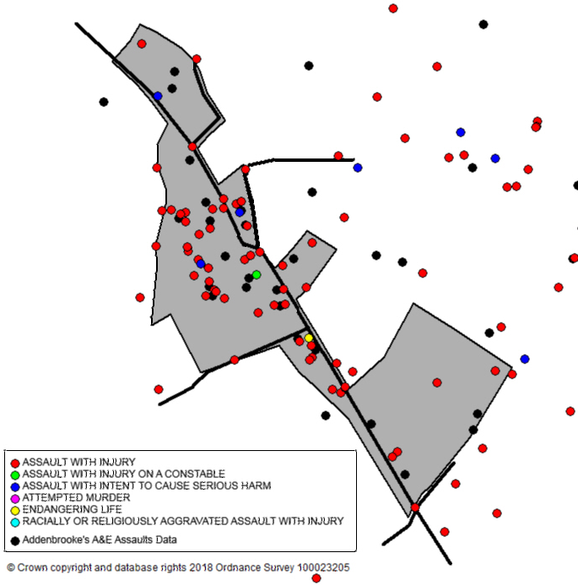
Crime Maps
Figure 3: Historic Centre Area and Shoplifting offences
Figure 4: Historic Centre Area, Violence with Injury offences and A&E Assault locations

Grafton Centre

Geographic Area
For the purposes of our analysis, we have stated the Grafton area to be the following.
This area is another of the main retail areas of the city, with a large amount of footfall in and around the Grafton Centre. There are plans for redevelopment of Fitzroy/Burleigh Street/Grafton primary shopping area in the future, with the location set for expansion for retail and leisure use, as well as residential and student accommodation. This is likely to further increase footfall in the area, as well as leading to a potentially more vulnerable location for crime.

Key Points
Figure 5: Grafton Centre Area
- Total of 605 police recorded crimes occurred in the past 12 months
- Further 241 police recorded ASB incidents occurred in the past 12 months
- Of the 605 crimes, over one-fifth (22.8%) of those were bicycle theft
- Over half (52.7%) of the crimes recorded were either bicycle theft, shoplifting or violence without injury
- June had the highest number of recorded crimes (11.7% of total) – equivalent to 2.4 crimes per day
- Whereas, July had the second lowest number of recorded crimes (6.4% of total) – equivalent to just 1.3 crimes per day
- Of the 241 ASB incidents, the majority (84%) were Nuisance ASB
- 102 of the ASB incidents (42.3% of all the ASB incidents) included any of the following keywords; homeless, abusive language, drunk, begging and alcohol
- September had the highest number of recorded ASB incidents (26), which was double August which had the fewest number of recorded incidents (13)
- This area is a hotspot for crime, particularly during the hours of 08:00-11:00, 11:00-14:00, 14:00-17:00 & 17:00-20:00
- The area is also a hotspot in relation to Violence with injury, Public Order Offences and Criminal Damage – as well as for needle finds in the city
Figure 6: Time Clock showing when all crimes occurred in Grafton Centre Area
- The most common time of crimes occurring were in the afternoon between 13:00-17:00
- The peak time range was this period at the weekends – with Monday and Tuesday having slightly fewer recorded crimes
- Shoplifting and bicycle theft account for nearly half (46.2%) of all the crimes that occurred during these hours – however public order was also high (13.0% of all crimes during these hours)

Crime Maps
Figure 7: Grafton Area and Shoplifting offences
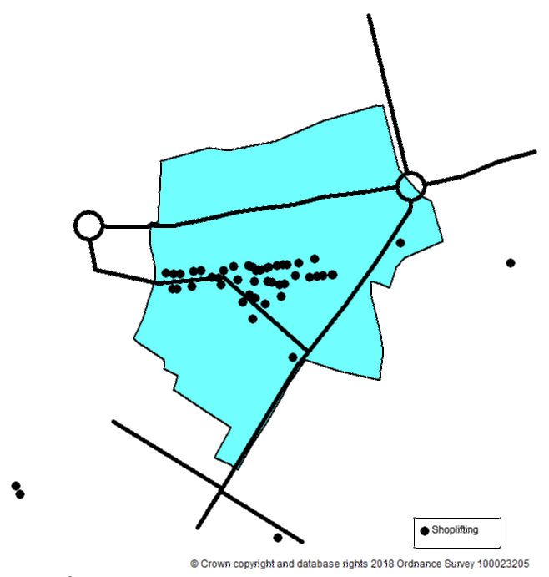
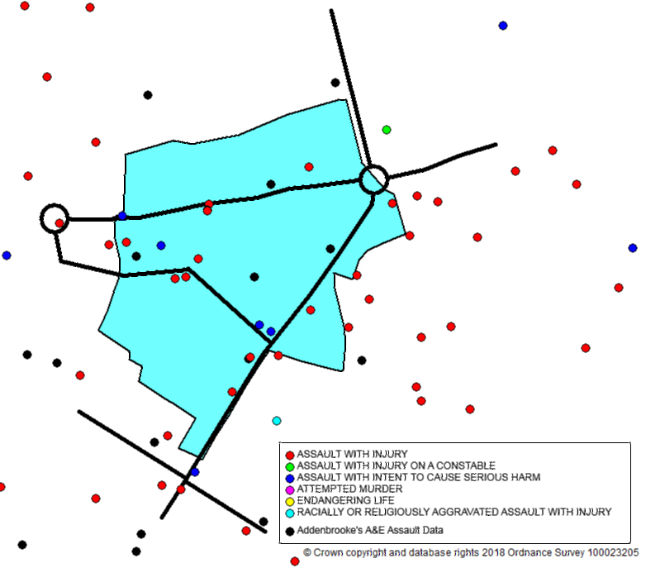
Figure 8: Grafton Area, Violence with Injury offences and A&E Assault locations

Rail Station

Geographic Area
For the purposes of our analysis, we have stated the Rail Station area to be the following.
This area has a significantly high footfall, due to the use of the rail station, but also has an area that is used as both a retail area and an entertainment area (Cambridge Leisure Park). Clifton Road Industrial Estate also features a large number of businesses, which proposes a slightly different dynamic in terms of the area being a vulnerable location for crime. The area is also undergoing a significant amount of change, which could increase the footfall in the area even more, also affecting the potential for crime.

Key Points
Figure 9: Rail Station Area
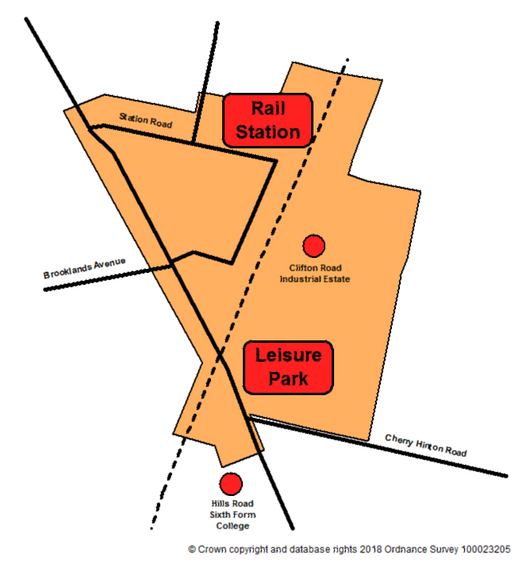
- Total of 579 police recorded crimes occurred in the past 12 months
- Further 190 police recorded ASB incidents occurred in the past 12 months
- Of the 579 crimes, nearly half (44.2%) of those were bicycle theft – the rail station is a particular hotspot for this type of crime
- A further 13.1% of the crimes were Other Theft – although this area is not a particularly large hotspot in relation to the whole city
- November had the highest number of recorded crimes (13.5% of total) – equivalent to an average of 2.6 crimes per day
- Whereas, April had fewer than half the number of recorded crimes as November (5.2% of total) – equivalent to 1.0 per day
- Of the 190 ASB incidents, 87.9% were Nuisance ASB – with the area being a hotspot in the City for these types of incidents
- 81 of the ASB incidents (42.6% of all the ASB incidents) included any of the following keywords; homeless, abusive language, drunk, begging and alcohol
- March saw the highest number of recorded incidents (15.8% of the total) – equivalent to 1.0 per day, which was more than three times the number of recorded incidents in September (4.7% of total)
- The Rail Station is a hotspot for crime, in particular between the hours of 05:00-08:00, 08:00-11:00 and 17:00-20:00
Figure 10: Time Clock showing when all crimes occurred in Rail Station Area
- The most common time of crimes occurring were between 16:00-20:00
- Friday and Saturday late afternoon was the peak time range for crimes occurring – in particular Saturdays, 15:00-20:00
- Bicycle Theft and Shoplifting accounted for over half (56.3%) of all the crimes that occurred during these peak hours

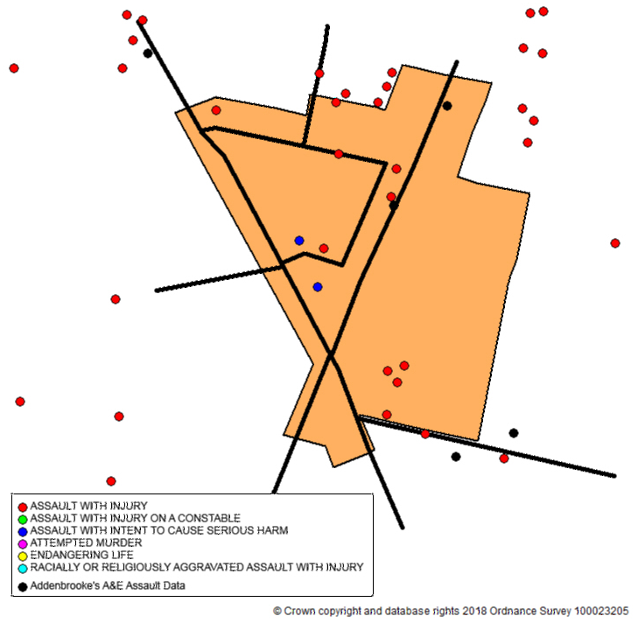
Crime Maps
Figure 11: Rail Station Area and Shoplifting offences
Figure 12: Rail Station Area, Violence with Injury offences and A&E assault locations

Mill Road

Geographic Area
For the purposes of our analysis, we have stated the Mill Road area to be the following.
Mill Road is an area of Cambridge that is slightly different to the others looked at in the report, due to its diverse range of shops and sense of community. There are two main centres along Mill Road, either side of the railway bridge, with both providing a range of shops. The surrounding streets contain large numbers of terraced housing, some of which have a high population of students and shared housing. These two factors can lead to the area being potentially vulnerable to crime.

Key Points
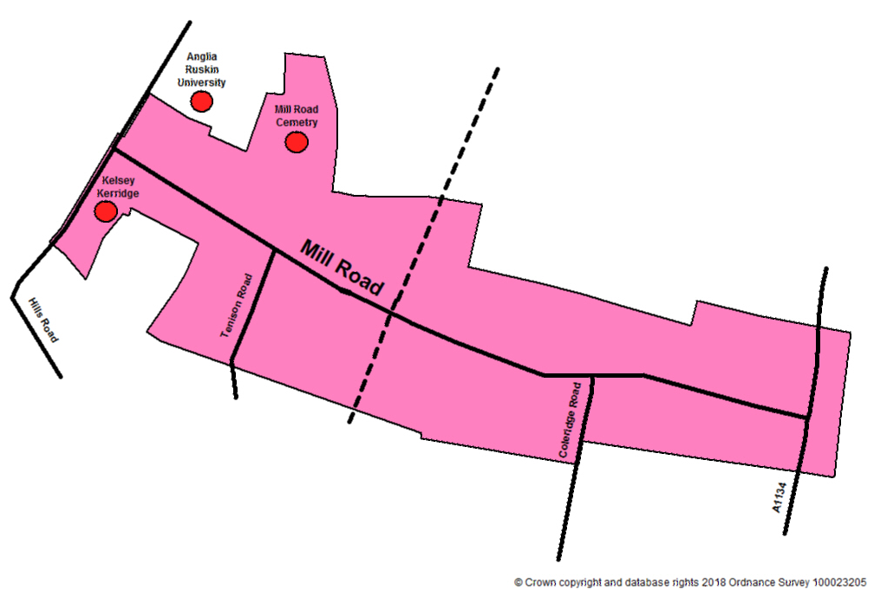
Figure 13: Mill Road Area
- Total of 694 police recorded crimes occurred in the past 12 months
- Further 317 police recorded ASB incidents occurred in the past 12 months
- Of the 694 crimes, nearly one-quarter (24.1%) were bicycle theft, with Violence without Injury accounting for a further 14.7% of the crimes
- Sexual Offences was also higher in this area, accounting for 4.6% of the total crimes that occurred
- July & June had the highest number of recorded crimes (10.5% and 9.7% of the total respectively) – which was equivalent to 2.4 and 2.2 crimes per day
- Whereas, the winter months of November – January accounted for the three months with the lowest recorded number of crimes
- Of the 317 ASB incidents, 81.1% were Nuisance ASB – although the area is not a particular hotspot in the city for this type of ASB
- 112 of the ASB incidents (35.3% of all the ASB incidents) included any of the following keywords; homeless, abusive language, drunk, begging and alcohol
- July also saw the highest number of ASB incidents (11.7% of the total) – equivalent to 1.2 per day
- The area is a hotspot for crime between the hours of 17:00-20:00 and 20:00-23:00
Figure 14: Time Clock showing when crimes occurred in Mill Road Area
- There was a large time frame for when crimes occurred in the Mill Road area, from 12:00-23:00
- Thursday between 17:00-20:00 was the peak time range for the occurrence of crimes
- Bicycle theft accounted for over one-quarter (26.2%) of the crimes that occurred in this time frame
- Criminal damage (8.5%) and vehicle offences (7.5%) accounted for a relatively high proportion of the total recorded crimes during this time frame – whereas theft and shoplifting was relatively low

Crime Maps
Figure 16: Mill Road Area and Shoplifting offences
Figure 15: Mill Road Area, Violence with Injury offences and A&E assault locations
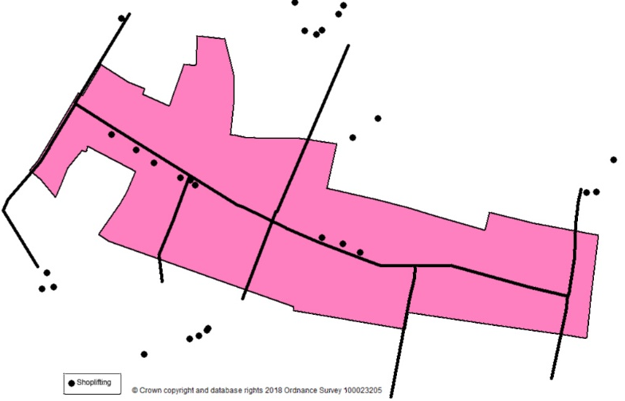
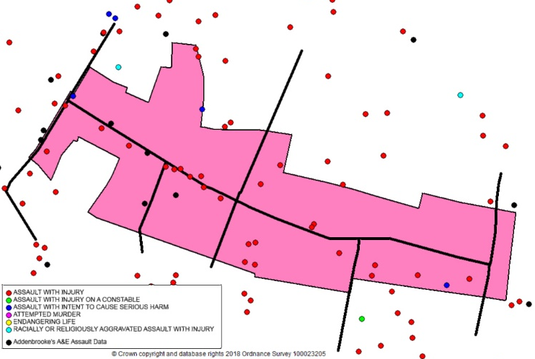

Summary of Crimes in Four Areas
The table breaks down the number of crimes/incidents that occurred in each of the four areas during the past 12 months (April 2017 – March 2018).
Table 1: Breakdown of the crimes that occurred in each of the four areas
 | Historic Centre | Grafton  Centre | Rail Station | Mill Road
Crime Type
Arson | 1 | 1 | 0 | 0
Bicycle Theft | 684 | 138 | 256 | 167
Burglary Business and Community | 42 | 14 | 3 | 14
Burglary Residential | 3 | 16 | 14 | 26
Criminal Damage | 89 | 41 | 27 | 54
Misc Crimes Against Society | 20 | 2 | 7 | 8
Sexual Offences | 32 | 8 | 9 | 32
Other Theft | 310 | 58 | 76 | 67
Possession of Drugs | 28 | 8 | 3 | 12
Possession of Weapons | 19 | 4 | 3 | 4
Public Order | 156 | 54 | 25 | 64
Robbery | 21 | 8 | 4 | 17
Shoplifting | 487 | 106 | 59 | 26
Theft from Person | 285 | 18 | 10 | 9
Trafficking of Drugs | 7 | 3 | 3 | 8
Vehicle Offences | 13 | 21 | 14 | 42
Violence with Injury | 176 | 30 | 14 | 42
Violence without Injury | 274 | 75 | 52 | 102
Subtotal | 2647 | 605 | 579 | 694
ASB Type
NUISANCE | 550 | 203 | 167 | 257
ENVIRONMENTAL | 38 | 20 | 17 | 39
PERSONAL - All categories | 16 | 17 | 5 | 19
Other | 1 | 1 | 1 | 2
Subtotal | 605 | 241 | 190 | 317
Total | 3252 | 846 | 769 | 1011

Section 3: Next Steps

When considering what is currently missing from the information pack that will enable more detailed analysis there was also consideration as to what the purpose of any further analysis.
The major stumbling block in agreeing what activity needs to take place is a clear and focused set of objectives. This first step needs to be completed, the range of data provided to date shows how many different issues could be tackled but to tackle all crime, disorder and nuisance would stretch the Partnership too thin.
Further data that would provide a greater understanding are;
- Feedback from Street Pastors on numbers and types of people assisted
- Ambulance assault data that includes specific location information
- Licencing complaints – specific concerns
- Profile of repeat offenders of shop theft
- More information on street life in these areas – in particular ASB linked to drinking, begging or homelessness

Appendix A. Maps
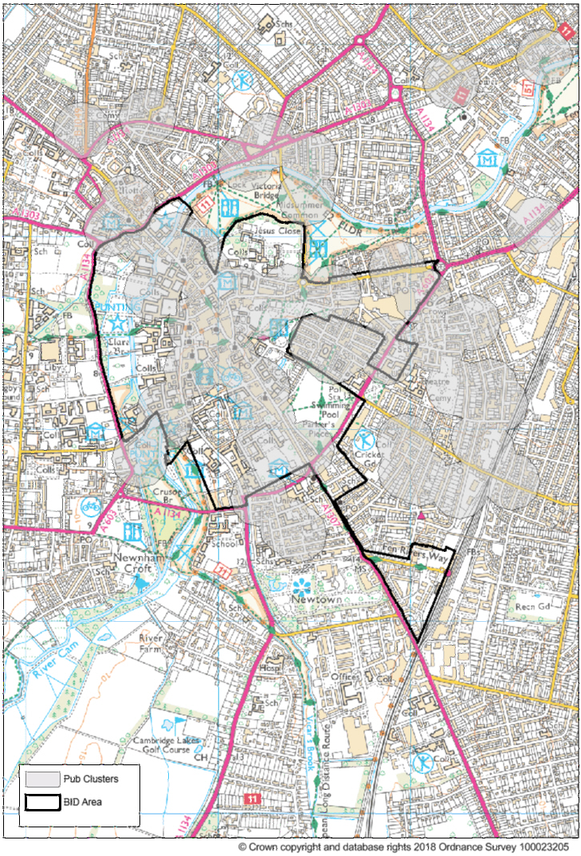

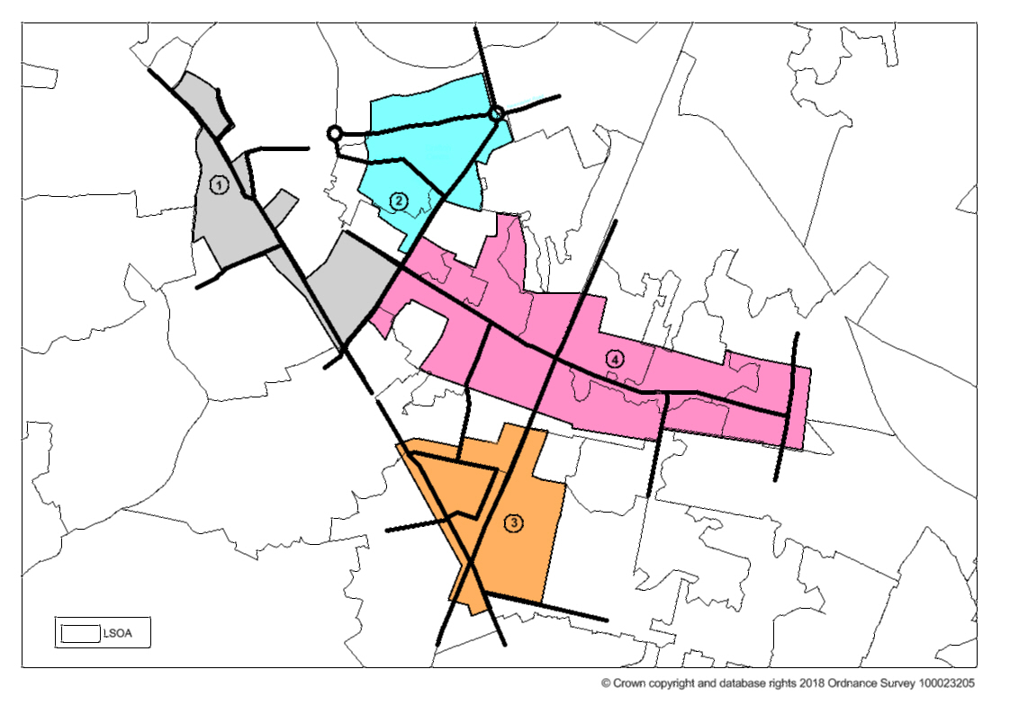

12% increase 2016/17 to 2017/18 Citywide (total violence against the person) – increases also seen countywide
21% increase 2016/17 to 2017/18 Citywide – also seen countywide
https://www.birmingham.gov.uk/download/downloads/id/.../big_city_plan_part_1.pdf
https://www.cambridge.gov.uk/public/ldf/draft_submission/Full%20Plan/Full%20Draft%20Plan%20with%20title%20pages%20reduced%20size.pdf
Keyword ASB

