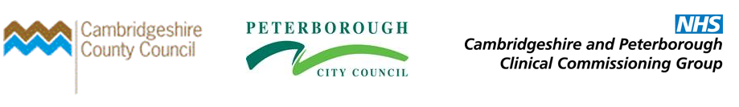

Supplementary Analysis of National Diabetes Audit 2013-14 & 2014-15, Cambridgeshire & Peterborough Clinical Commissioning Group

Contents

Section Number | Section | Page Number
1 | Introduction | 2
2 | Executive Summary | 4
3 | General Practices in Worst-Ranked NDA Attainment Quintile | 6
4 | Type 1 Diabetes, All 8 Care Processes 2013-14 | 8
5 | Type 2 Diabetes, All 8 Care Processes 2013-14 | 10
6 | Type 1 Diabetes, All 3 Treatment Targets 2013-14 | 13
7 | Type 2 Diabetes, All 3 Treatment Targets 2013-14 | 15
8 | Type 1 Diabetes, All 8 Care Processes 2014-15 | 18
9 | Type 2 Diabetes, All 8 Care Processes 2014-15 | 20
10 | Type 1 Diabetes, All 3 Treatment Targets 2014-15 | 23
11 | Type 2 Diabetes, All 3 Treatment Targets 2014-15 | 25

Introduction

The National Diabetes Audit (NDA) is the largest annual clinical audit in the world, integrating data from both primary and secondary care sources. The results of the 2013-14 and 2014-15 collections were published on 28th January 2016. An overview of the NDA is available on the Health & Social Care Information Centre (HSCIC) website at URL: http://www.hscic.gov.uk/nda and full data released by HSCIC in relation to the NDA, including results for individual General Practices, are available at URL: http://www.hscic.gov.uk/searchcatalogue?productid=20155&q=%22National+diabetes+audit%22&sort=Relevance&size=10&page=1#top
The NDA aims to answer four key questions based on the diabetes National Service Framework:
- Is everyone with diabetes diagnosed and recorded on a practice diabetes register?

- What percentage of people registered with diabetes received the nine NICE key processes of diabetes care?

- What percentage of people registered with diabetes achieved NICE defined treatment targets for glucose control, blood pressure and blood cholesterol?

- For people with registered diabetes, what are the rates of acute and long term complications (disease outcomes)?
The NDA aims to improve the quality of patient care by enabling NHS organisations to:
- Compare their outcomes of care with similar NHS organisations
- Identify and share best practice
- Identify gaps or shortfalls in commissioning services
- Assess local practice against the diabetes National Service Framework and NICE guidelines and drive service improvement
- Provide a more comprehensive picture of diabetes care and outcomes in England and Wales
Through participation in the audit, local services are able to benchmark their performance and identify where they are performing well and improve the quality of treatment and care they provide. On a national level, wide participation in the audit also provides an overview of the quality of care being provided in England and Wales.
This report is a supplementary addition to previously conducted analysis published in March 2016 that summarised findings from the NDA 2013-14 and 2014-15 for Cambridgeshire & Peterborough Clinical Commissioning Group (C&P CCG), including analysis of overall participation rates, the demographic composition of patients registered via general practices as part of the audit, care process completion for patients with type 1 diabetes and type 2 or other diabetes, percentages of patients newly diagnosed with diabetes offered/attending a structured education programme and treatment target achievement across the CCG.
This paper provides a deeper level of analysis than that published previously, including:
- A summary of General Practices within C&P CCG that may be most appropriate to be considered for practice-level intervention to improve outcomes as measured by the NDA, due to relatively consistent rankings among the worst performers within the CCG across available indicators.

- An overview of the distribution of attainment across all participating GPs within the CCG, any statistically significant general practices and LCG-level summaries for each of the below:

    - Type 1 Diabetes, All 8 Care Processes Attainment, 2013-14
    - Type 2 Diabetes, All 8 Care Processes Attainment, 2013-14
    - Type 1 Diabetes, All 3 Treatment Targets Attainment, 2013-14
    - Type 2 Diabetes, All 3 Treatment Targets Attainment, 2013-14
    - Type 1 Diabetes, All 8 Care Processes Attainment, 2014-15
    - Type 2 Diabetes, All 8 Care Processes Attainment, 2014-15
    - Type 1 Diabetes, All 3 Treatment Targets Attainment, 2014-15
    - Type 2 Diabetes, All 3 Treatment Targets Attainment, 2014-15

Executive Summary

- Of the 10 general practices with an average indicator ranking of 4.0 or worse (with 5 meaning the practice is in the worst-performing quintile of CCG GPs and 1 being within the best-performing quintile) based on available data from the 2013/14 and 2014/15 National Diabetes Audit, 3 are within the Peterborough LCG, 2 within Hunts Care Partners LCG and 1 each within the Borderline, Cam Health, CATCH, Hunts Health and Wisbech LCGs.

- Due to larger numbers of patients registered with type 2 diabetes rather than type 1 diabetes, there is less statistical uncertainty around type 2 diabetes data and therefore a greater number of practices are statistically significantly 'better' or 'worse' than the CCG as per 95% confidence interval calculations for type 2 indicators in comparison to type 1 indicators.

- In 2013/14, of 74 GPs that participated in the NDA, 21 are within CATCH LCG (28% of the total) and 17 within Peterborough LCG (23% of the total); resultantly these LCGs have a relatively high proportion of practices in both the 'worst' and 'best' performing quintiles for measured NDA indicators. In 2014/15, 77 practices participated and again CATCH LCG (21 practices, 27% of total) and Peterborough LCG (16 practices, 21% of total) had the highest numbers of participating practices and consequently relatively high numbers of practices in both the 'worst' and 'best' performing quintiles.

- In 2013/14, type 1 attainment for all 8 care processes is highest, on average, in Hunts Health LCG (52.5%) and lowest in Cam Health LCG (39.8%), with the CCG average being 47.1%. 7 GPs are statistically significantly worse than the CCG (including 2 within the Isle of Ely LCG) and 4 are significantly better than the CCG. For type 2 diabetes, attainment is highest in Cam Health LCG (76.3%) and lowest in Isle of Ely LCG (66.0%). 14 GPs are significantly worse than the CCG, 5 of which are in Peterborough LCG, 3 within CATCH LCG and 2 within Isle of Ely LCG. 21 GPs are significantly better than the CCG, of which 5 are in CATCH LCG and 4 in Peterborough LCG.

- In 2013/14, type 1 attainment for all 3 treatment targets is highest in Hunts Health LCG (22.6%) and lowest in Borderline LCG (9.8%). No practices are significantly worse than the CCG and 4 are significantly better than the CCG. For type 2 attainment, 14 GPs are worse than the CCG (7 of which are in the Peterborough LCG) and 12 GPs are significantly better than the CCG, of which the highest numbers are within the CATCH and Isle of Ely CCGs, both of which have 5 practices each within this group.

- In 2014/15, type 1 attainment for all 8 care processes ranged from 52.4% in Borderline LCG to 24.3% in Cam Health LCG. Cam Health has only five participating practices in the 2014/15 NDA and three of these are in the lowest quintile within the CCG as measured by this indicator; the average attainment for Cam Health practices is also 12.6 percentage points lower than the next-lowest LCG, CATCH LCG (36.9%). For type 2, attainment varies between 71.6% in Borderline and 58.5% in Hunts Health. 20 practices are significantly worse than the CCG for this indicator (the highest number of which are in Peterborough LCG with 7, followed by Hunts Health with 4) and 25 are significantly better than CCG.

- For type 1 diabetes, all treatment targets, 2014/15, attainment is highest in CATCH (21.5%) and lowest in Wisbech (14.5%). Due to relatively low numbers and therefore wide confidence intervals to reflect uncertainty, only 2 of 77 participating practices are statistically significant in comparison to the CCG, although there is a relatively wide degree of variance across the CCG, with 18 GPs below 11.0% attainment and 11 GPs above 30.0%. With regards to type 2 diabetes, Isle of Ely has the highest level of attainment at 41.8%, with Wisbech having the lowest level of attainment (30.8%). 14 practices are significantly worse than the CCG, of which 5 are in Peterborough LCG and 4 in CATCH LCG. 12 practices are significantly better than the CCG, the highest number of which are in CATCH LCG (5 practices) and Isle of Ely (3 practices).

General Practices in Worst-Ranked NDA Attainment Quintile

Figure 1: Cambridgeshire & Peterborough CCG, National Diabetes Audit 2013/14 & 2014/15, Participating Practices with Lowest Attainment, Ranked by Average Attainment for Type 1 & Type 2 Diabetes, All Treatments Targets and All Care Processes Indicators (5= In Worst 20% of Participating Practices, 1 = In Best 20% of Participating Practices)
Practice Code | Name | LCG | Average of Indicators Ranks (5 = Worst, 1 = Best) | Patients on Diabetes Register (2014/15 QOF) | Patients Registered for NDA 2013/14* | Patients Registered for NDA 2014/15*
D81085 | PAPWORTH SURGERY | HUNTS HEALTH | 4.75 | 294 | Did Not Participate | 258
D81033 | OVER SURGERY | CATCH | 4.5 | 219 | 180 | 203
D81605 | HUNTLY GROVE PRACTICE | PETERBOROUGH | 4.5 | 200 | 187 | 200
D81008 | NORTH BRINK PRACTICE | WISBECH | 4.375 | 1,232 | 1,107 | 1,156
D81030 | CROMWELL PLACE SURGERY | HUNTS CARE PARTNERS | 4 | 520 | 454 | 497
D81645 | THE GRANGE MEDICAL CENTRE | PETERBOROUGH | 4 | 164 | 157 | 167
D81052 | CORNERSTONE PRACTICE | HUNTS CARE PARTNERS | 4 | 663 | 595 | 630
D81023 | PASTON HEALTH CENTRE | PETERBOROUGH | 4 | 725 | 656 | 712
D81039 | JENNER HEALTH CENTRE | BORDERLINE | 4 | 472 | 431 | Did Not Participate
D81612 | MILTON SURGERY | CAM HEALTH | 4 | 187 | Did Not Participate | 186
- | CAMBRIDGESHIRE & PETERBOROUGH CCG | - | - | 41,669 | 26,943 | 29,953
Source: National Diabetes Audit, 2013/14 & 2014/15 http://www.hscic.gov.uk/nda & Quality Outcomes Framework, 2014/15, http://qof.hscic.gov.uk/
* Numbers of patients registered may exceed patients on diabetes register as measured by 2014/15 QOF due to differing dates on which data were collated.
Of the 10 general practices with an average indicator ranking of 4.0 or worse (with 5 meaning the practice is in the worst-performing quintile of CCG GPs and 1 being within the best-performing quintile) based on available data from the 2013/14 and 2014/15 National Diabetes Audit, 3 are within the Peterborough LCG, 2 within Hunts Care Partners LCG and 1 each within the Borderline, Cam Health, CATCH, Hunts Health and Wisbech LCGs. This ranking is based on the average of all available quintile rankings for both type 1 and type 2 diabetes, incorporating attainment percentages for ‘all 3 treatment targets’ and ‘all 8 care processes’. All GPs within this cluster have at least 164 patients registered with diabetes on their register as per 2014/15 QOF and at least 167 patients registered as part of the 2014/15 NDA (data are not available for Jenner Health Centre in 2014/15 due to non-participation).
The tables and graphs below provide the following data for type 1 and type 2 diabetes, 2013-14 and 2014-15 ‘all eight care processes’ and ‘all three treatment types:
- GPs that are statistically significant worse than the CCG average and statistically significantly better than the CCG average.
- A graph showing the ‘spread’ of attainment values across all participating practices within the CCG and the CCG average.
- LCG-level data illustrating the number of participating practices, lowest and highest rates of attainment within each LCG and the number of practices within the lowest and highest attainment quintiles of all participating practices within the CCG.
Within the tables and graphs below, the colour scheme below illustrates statistical significance:

Statistically significantly better than CCG
No statistical significance
Statistically significantly worse than CCG

Type 1 Diabetes, All 8 Care Processes, 2013-14

Figure 2: Type 1 Diabetes, All 8 Care Processes 2013-14, General Practice Attainment & Statistically Significant General Practices
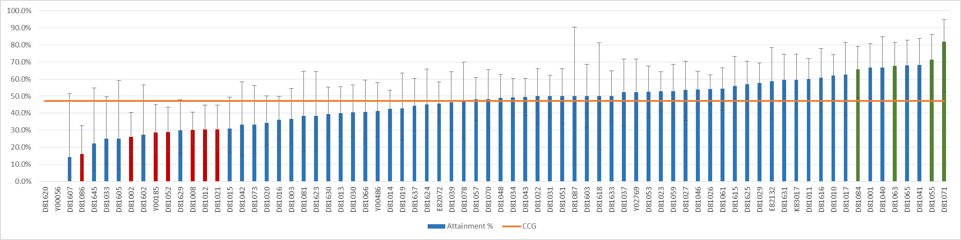
Practice Code | Name | LCG | Attainment %
D81086 | EAST BARNWELL HEALTH CENTRE | CAM HEALTH | 16.1%
D81002 | HUNTINGDON ROAD SURGERY | CATCH | 26.1%
Y00185 | CATHEDRAL MEDICAL CENTRE | ISLE OF ELY | 28.6%
D81052 | CORNERSTONE PRACTICE | HUNTS CARE PARTNERS | 28.9%
D81008 | NORTH BRINK PRACTICE | WISBECH | 30.2%
D81012 | CORNFORD HOUSE SURGERY | CATCH | 30.4%
D81021 | ST GEORGE'S MEDICAL CENTRE | ISLE OF ELY | 30.4%
D81084 | WILLINGHAM MEDICAL PRACTICE | CATCH | 65.7%
D81063 | WESTGATE | PETERBOROUGH | 67.7%
D81055 | BOTTISHAM MEDICAL PRACTICE | CAM HEALTH | 71.4%
D81071 | DODDINGTON MEDICAL CENTRE | ISLE OF ELY | 81.8%
 | CCG | - | 47.1%
Source: National Diabetes Audit, 2013/14 http://www.hscic.gov.uk/nda
7 GPs have a statistically significantly low attainment percentage for 2013/14, type 1, all 8 care processes, in comparison to the CCG (including 2 within the Isle of Ely LCG) and 4 GPs are significantly high in comparison to the CCG.

Figure 3: Type 1 Diabetes, All 8 Care Processes 2013-14, LCG Overview, Ranked by LCG Attainment %
LCG | LCG Attainment % | Participating Practices | Attainment % of Lowest Practice | Attainment % of Highest Practice | Practices in Quintile with Lowest Attainment % | Practices in Quintile with Highest Attainment %
HUNTS HEALTH | 52.5% | 5 | 38.5% | 62.0% | 0 | 1
PETERBOROUGH | 51.5% | 17 | 0.0% | 68.0% | 4 | 4
BORDERLINE | 50.1% | 9 | 34.2% | 59.4% | 0 | 1
HUNTS CARE PARTNERS | 46.5% | 8 | 28.9% | 66.7% | 1 | 1
CATCH | 45.1% | 21 | 0.0% | 68.2% | 6 | 5
ISLE OF ELY | 45.0% | 7 | 28.6% | 81.8% | 2 | 1
WISBECH | 40.0% | 3 | 30.2% | 60.0% | 1 | 1
CAM HEALTH | 39.8% | 4 | 16.1% | 71.4% | 1 | 1
CCG | 47.1% | 74 | 0.0% | 81.8% | 15 | 15
Source: National Diabetes Audit, 2013/14 http://www.hscic.gov.uk/nda
Attainment is highest within the Hunts Health (52.5%) and Peterborough (51.5%) LCGs and lowest in Wisbech (40.0%) and Cam Health (39.8%) LCGs.

Type 2 Diabetes, All 8 Care Processes 2013-14

Figure 4: Type 2 Diabetes, All 8 Care Processes 2013-14, General Practice Attainment & Statistically Significant General Practices
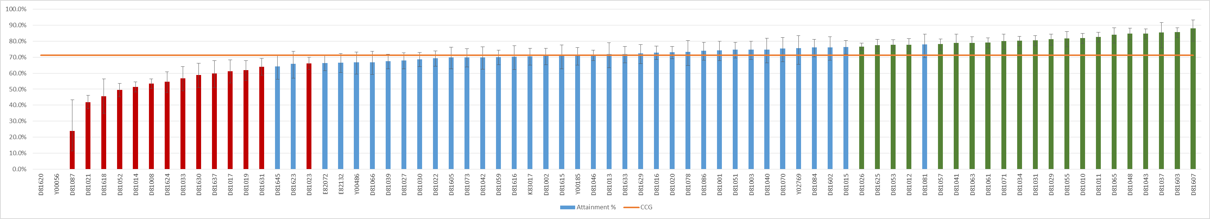
Source: National Diabetes Audit, 2013/14 http://www.hscic.gov.uk/nda
Practice Code | Name | LCG | Attainment %
D81087 | RAINBOW SURGERY | HUNTS HEALTH | 24.0%
D81021 | ST GEORGE'S MEDICAL CENTRE | ISLE OF ELY | 41.8%
D81618 | AILSWORTH MEDICAL CENTRE | PETERBOROUGH | 45.6%
D81052 | CORNERSTONE PRACTICE | HUNTS CARE PARTNERS | 49.5%
D81014 | STAPLOE MEDICAL CENTRE | ISLE OF ELY | 51.3%
D81008 | NORTH BRINK PRACTICE | WISBECH | 53.4%
D81624 | DOGSTHORPE MEDICAL CENTRE | PETERBOROUGH | 54.5%
D81033 | OVER SURGERY | CATCH | 56.7%
D81630 | HAMPTON HEALTH | BORDERLINE | 58.8%
D81637 | MONKFIELD MEDICAL PRACTICE | CATCH | 59.7%
D81017 | MILL ROAD SURGERY | CATCH | 61.3%
D81019 | MINSTER MEDICAL PRACTICE | PETERBOROUGH | 61.8%
D81631 | MILLFIELD MEDICAL CENTRE | PETERBOROUGH | 64.1%
D81023 | PASTON HEALTH CENTRE | PETERBOROUGH | 66.2%
D81026 | LINCOLN ROAD SURGERY | PETERBOROUGH | 76.6%
D81625 | THISTLEMOOR MEDICAL CENTRE | PETERBOROUGH | 77.5%
D81053 | BRETTON MEDICAL PRACTICE | BORDERLINE | 77.6%
D81012 | CORNFORD HOUSE SURGERY | CATCH | 77.7%
D81057 | CEDAR HOUSE SURGERY | HUNTS CARE PARTNERS | 78.1%
D81041 | BOURN SURGERY | CATCH | 78.8%
D81063 | WESTGATE | PETERBOROUGH | 78.9%
D81061 | GEORGE CLARE SURGERY | ISLE OF ELY | 79.0%
D81071 | DODDINGTON MEDICAL CENTRE | ISLE OF ELY | 79.9%
D81034 | ST MARY'S SURGERY | ISLE OF ELY | 80.3%
D81031 | YAXLEY GROUP PRACTICE | BORDERLINE | 80.4%
D81029 | OLD FLETTON SURGERY | BORDERLINE | 81.1%
D81055 | BOTTISHAM MEDICAL PRACTICE | CAM HEALTH | 81.7%
D81010 | PRIORY FIELDS SURGERY | HUNTS HEALTH | 81.8%
D81011 | CLARKSON SURGERY | WISBECH | 82.7%
D81065 | WELLAND MEDICAL PRACTICE | PETERBOROUGH | 84.1%
D81048 | LINTON HEALTH CENTRE | CATCH | 84.8%
D81043 | SAWSTON MEDICAL PRACTICE | CATCH | 84.8%
D81037 | BRIDGE STREET MEDICAL CENTRE | CAM HEALTH | 85.3%
D81603 | RIVERSIDE PRACTICE | HUNTS CARE PARTNERS | 85.6%
D81607 | SWAVESEY SURGERY | CATCH | 88.0%
 | CCG | - | 71.3%

Due to larger numbers of people with type 2 diabetes in comparison to those with type 1, there is a greater level of assurance around the data; therefore confidence intervals are smaller and a higher number of practices are adjudged to be statistically significant. 14 GPs are statistically significantly worse than the CCG average, including 5 within Peterborough LCG, 3 within CATCH LCG and 2 within Isle of Ely LCG. 21 GPs are statistically significantly better than the CCG and the LCGs with the highest representation within this group are CATCH (5 GPs) and Peterborough (4 GPs).

Figure 5: Type 2 Diabetes, All 8 Care Processes 2013-14, LCG Overview, Ranked by LCG Attainment %
LCG | LCG Attainment % | Participating Practices | Attainment % of Lowest Practice | Attainment % of Highest Practice | Practices in Quintile with Lowest Attainment % | Practices in Quintile with Highest Attainment %
CAM HEALTH | 76.3% | 4 | 72.9% | 85.3% | 0 | 2
HUNTS HEALTH | 75.8% | 5 | 24.0% | 81.8% | 1 | 1
CATCH | 74.0% | 21 | 0.0% | 88.0% | 4 | 3
BORDERLINE | 73.8% | 9 | 58.8% | 81.1% | 1 | 2
PETERBOROUGH | 71.3% | 17 | 0.0% | 84.1% | 5 | 2
HUNTS CARE PARTNERS | 70.2% | 8 | 49.5% | 85.6% | 1 | 1
WISBECH | 66.4% | 3 | 53.4% | 82.7% | 1 | 1
ISLE OF ELY | 66.0% | 7 | 41.8% | 80.3% | 2 | 3
CCG | 71.3% | 74 | 0.0% | 88.0% | 15 | 15
Source: National Diabetes Audit, 2013/14 http://www.hscic.gov.uk/nda
Attainment is highest within the Cam Health (76.3%) and Hunts Health (75.8%) LCGs and lowest in Wisbech (66.4%) and Isle of Ely (66.0%) LCGs .

Type 1 Diabetes, All 3 Treatment Targets 2013-14

Figure 6: Type 1 Diabetes, All 3 Treatment Targets 2013-14, General Practice Attainment & Statistically Significant General Practices
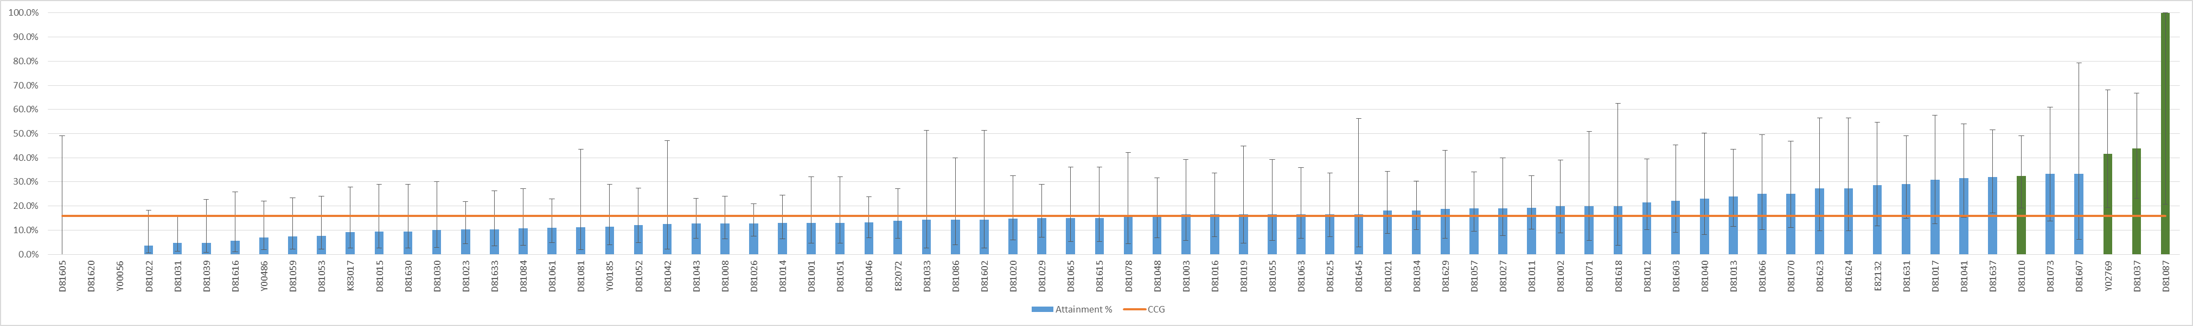
Practice Code | Name | LCG | Attainment %
D81010 | PRIORY FIELDS SURGERY | HUNTS HEALTH | 32.4%
Y02769 | ST NEOTS HEALTH CENTRE | HUNTS CARE PARTNERS | 41.7%
D81037 | BRIDGE STREET MEDICAL CENTRE | CAM HEALTH | 43.8%
D81087 | RAINBOW SURGERY | HUNTS HEALTH | 100.0%
 | CCG | - | 15.9%
Source: National Diabetes Audit, 2013/14 http://www.hscic.gov.uk/nda
No GPs are statistically significantly worse than the CCG for type 1 diabetes, all 3 treatment targets attainment, 2013-14; this is, in part, due to relatively low numbers resulting in relative difficulty in assessing whether attainment is due to random variation or is a genuine reflection of practice. Variation in attainment ranges widely across the CCG, from 0.0% for Huntly Grove Practice (Peterborough LCG), Parnwell Medical Centre (Peterborough) and Cambridge Access Surgery (CATCH) through to over 40.0% for St Neots Health Centre (Hunts Care Partners), Bridge Street Medical Centre (Cam Health) and Rainbow Surgery (Hunts Health). In total, 4 GPs are statistically significantly better than the CCG. Of these, 2 are in Hunts Health LCG, 1 in Hunts Care Partners LCG and 1 in Cam Health LCG.
Figure 7: Type 1 Diabetes, All 3 Treatment Targets 2013-14, LCG Overview, Ranked by LCG Attainment %
LCG | LCG Attainment % | Participating Practices | Attainment % of Lowest Practice | Attainment % of Highest Practice | Practices in Quintile with Lowest Attainment % | Practices in Quintile with Highest Attainment %
HUNTS HEALTH | 22.6% | 5 | 10.3% | 100.0% | 0 | 3
CAM HEALTH | 21.8% | 4 | 14.3% | 43.8% | 0 | 1
CATCH | 19.1% | 21 | 0.0% | 33.3% | 1 | 7
HUNTS CARE PARTNERS | 17.1% | 8 | 7.4% | 41.7% | 2 | 1
PETERBOROUGH | 15.0% | 17 | 0.0% | 33.3% | 5 | 3
ISLE OF ELY | 14.6% | 7 | 10.9% | 20.0% | 0 | 0
WISBECH | 14.6% | 3 | 9.5% | 19.1% | 1 | 0
BORDERLINE | 9.8% | 9 | 3.7% | 15.0% | 6 | 0
CCG | 15.9% | 74 | 0.0% | 100.0% | 15 | 15
Source: National Diabetes Audit, 2013/14 http://www.hscic.gov.uk/nda
Attainment is highest in the Hunts Health (22.6%) and Cam Health (21.8%) LCGs and lowest in the Borderline (9.8%) and Wisbech (14.6%) LCGs.

Type 2 Diabetes, All 3 Treatment Targets 2013-14

Figure 8: Type 2 Diabetes, All 3 Treatment Targets 2013-14, General Practice Attainment & Statistically Significant General Practices
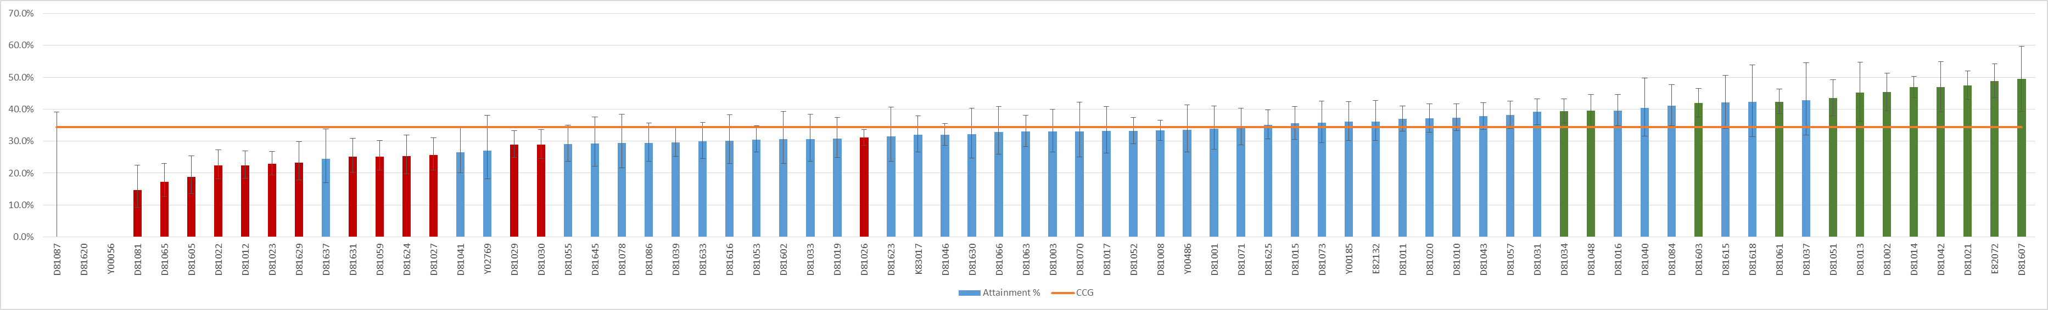
Practice Code | Name | LCG | Attainment %
D81081 | GREAT STAUGHTON SURGERY | HUNTS HEALTH | 14.7%
D81065 | WELLAND MEDICAL PRACTICE | PETERBOROUGH | 17.3%
D81605 | HUNTLY GROVE PRACTICE | PETERBOROUGH | 18.8%
D81022 | THORNEY | BORDERLINE | 22.4%
D81012 | CORNFORD HOUSE SURGERY | CATCH | 22.4%
D81023 | PASTON HEALTH CENTRE | PETERBOROUGH | 22.9%
D81629 | BUSHFIELD | PETERBOROUGH | 23.3%
D81631 | MILLFIELD MEDICAL CENTRE | PETERBOROUGH | 25.2%
D81059 | RAMSEY HEALTH CENTRE | HUNTS CARE PARTNERS | 25.2%
D81624 | DOGSTHORPE MEDICAL CENTRE | PETERBOROUGH | 25.4%
D81027 | WELLSIDE SURGERY | HUNTS CARE PARTNERS | 25.6%
D81029 | OLD FLETTON SURGERY | BORDERLINE | 28.9%
D81030 | CROMWELL PLACE SURGERY | HUNTS CARE PARTNERS | 28.9%
D81026 | LINCOLN ROAD SURGERY | PETERBOROUGH | 31.1%
D81031 | YAXLEY GROUP PRACTICE | BORDERLINE | 39.2%
D81034 | ST MARY'S SURGERY | ISLE OF ELY | 39.4%
D81603 | RIVERSIDE PRACTICE | HUNTS CARE PARTNERS | 42.0%
D81061 | GEORGE CLARE SURGERY | ISLE OF ELY | 42.3%
D81051 | BURWELL SURGERY | ISLE OF ELY | 43.5%
D81013 | TRUMPINGTON STREET MEDICAL PRACTICE | CATCH | 45.3%
D81002 | HUNTINGDON ROAD SURGERY | CATCH | 45.3%
D81014 | STAPLOE MEDICAL CENTRE | ISLE OF ELY | 46.9%
D81042 | WATERBEACH SURGERY | CATCH | 47.0%
D81021 | ST GEORGE'S MEDICAL CENTRE | ISLE OF ELY | 47.5%
E82072 | THE HEALTH CENTRE PRACTICE | CATCH | 48.8%
D81607 | SWAVESEY SURGERY | CATCH | 49.4%
 | CCG | - | 34.4%
Source: National Diabetes Audit, 2013/14 http://www.hscic.gov.uk/nda
14 GPs are statistically significantly worse than the CCG for type 2 diabetes, all three treatment target attainment, 2013-14. Of these, 7 GPs are in Peterborough LCG, 3 in Hunts Care Partners LCG, 2 in Borderline LCG and 1 each in CATCH and Hunts Health LCGs. 12 GPs are statistically significantly better than CCG and of these, 5 are in CATCH LCG, 5 are in Isle of Ely LCG and 1 each within Borderline LCG and Hunts Care Partners LCG.

Figure 9: Type 2 Diabetes, All 3 Treatment Targets 2013-14, LCG Overview, Ranked by LCG Attainment %
LCG | LCG Attainment % | Participating Practices | Attainment % of Lowest Practice | Attainment % of Highest Practice | Practices in Quintile with Lowest Attainment % | Practices in Quintile with Highest Attainment %
ISLE OF ELY | 42.7% | 7 | 34.4% | 47.5% | 0 | 4
CATCH | 36.6% | 21 | 0.0% | 49.4% | 3 | 6
WISBECH | 34.9% | 3 | 33.3% | 37.0% | 0 | 0
CAM HEALTH | 34.6% | 4 | 29.0% | 34.6% | 0 | 1
HUNTS CARE PARTNERS | 33.3% | 8 | 25.2% | 42.0% | 2 | 2
BORDERLINE | 32.1% | 9 | 22.4% | 39.2% | 1 | 0
HUNTS HEALTH | 32.0% | 5 | 0.0% | 37.4% | 2 | 0
PETERBOROUGH | 29.4% | 17 | 0.0% | 42.3% | 7 | 2
CCG | 34.4% | 74 | 0.0% | 49.4% | 15 | 15
Source: National Diabetes Audit, 2013/14 http://www.hscic.gov.uk/nda
Isle of Ely LCG (42.7%) and CATCH (36.6%) LCG have the highest attainment percentages for this indicator for 2013-14. Attainment is lowest in the Peterborough LCG (29.4%) which also has 7 practices in the lowest quintile for attainment across the CCG and attainment in next-lowest in Hunts Health LCG (32.0%).

Type 1 Diabetes, All 8 Care Processes 2014-15

Figure 10: Type 1 Diabetes, All 8 Care Processes 2014-15, General Practice Attainment & Statistically Significant General Practices
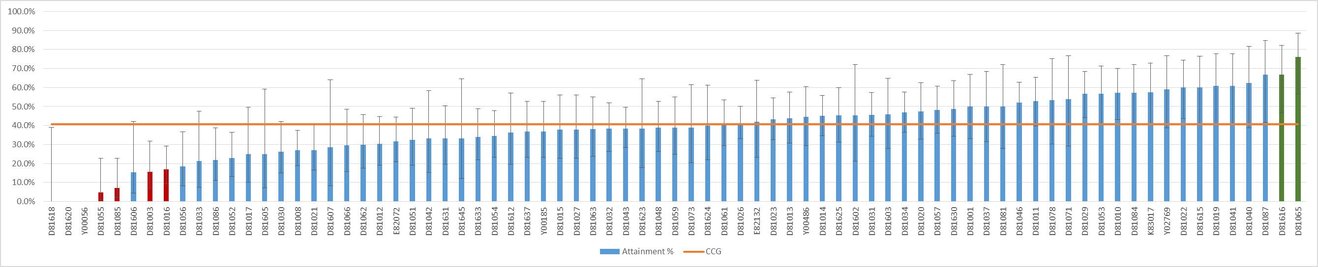
Practice Code | Name | LCG | Attainment %
D81055 | BOTTISHAM MEDICAL PRACTICE | CAM HEALTH | 4.8%
D81085 | PAPWORTH SURGERY | HUNTS HEALTH | 7.1%
D81003 | YORK STREET MEDICAL PRACTICE | CATCH | 15.6%
D81016 | ARBURY ROAD SURGERY | CAM HEALTH | 17.0%
D81616 | HODGSON MEDICAL CENTRE | PETERBOROUGH | 66.7%
D81065 | WELLAND MEDICAL PRACTICE | PETERBOROUGH | 76.0%
 | CCG |  | 40.8%
Source: National Diabetes Audit, 2014/15 http://www.hscic.gov.uk/nda
6 GPs are statistically significant in comparison to the CCG average for type 1 diabetes, all 8 care process attainment, 2014-15. 4 GPs are significantly worse than the CCG, of which 2 are in the Cam Health LCG and 2 GPs are significantly better than the CCG, both within the Peterborough LCG.

Figure 11: Type 1 Diabetes, All 8 Care Processes 2014-15, LCG Overview, Ranked by LCG Attainment %
LCG | LCG Attainment % | Participating Practices | Attainment % of Lowest Practice | Attainment % of Highest Practice | Practices in Quintile with Lowest Attainment % | Practices in Quintile with Highest Attainment %
BORDERLINE | 52.4% | 8 | 45.6% | 60.0% | 0 | 4
PETERBOROUGH | 45.1% | 16 | 0.0% | 76.0% | 3 | 4
HUNTS HEALTH | 40.6% | 7 | 7.1% | 66.7% | 1 | 2
ISLE OF ELY | 39.5% | 8 | 27.1% | 53.8% | 0 | 1
HUNTS CARE PARTNERS | 38.7% | 9 | 15.4% | 62.5% | 3 | 2
WISBECH | 37.3% | 3 | 27.1% | 52.7% | 1 | 0
CATCH | 36.9% | 21 | 0.0% | 60.9% | 5 | 3
CAM HEALTH | 24.3% | 5 | 4.8% | 50.0% | 3 | 0
CCG | 40.8% | 77 | 0.0% | 76.0% | 16 | 16
Source: National Diabetes Audit, 2014/15 http://www.hscic.gov.uk/nda
Attainment is highest in the Borderline (52.4%) and Peterborough (45.1%) LCGs and Lowest in the Cam Health (24.3%) and CATCH (36.9%) LCGs.

Type 2 Diabetes, All 8 Care Processes 2014-15

Figure 12: Type 2 Diabetes, All 8 Care Processes 2014-15, General Practice Attainment & Statistically Significant General Practices
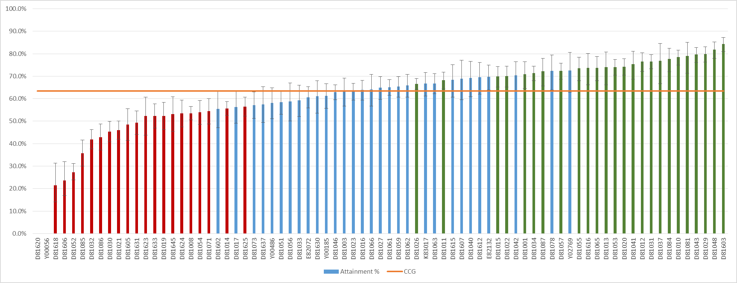
Practice Code | Name | LCG | Attainment % | CCG
D81618 | AILSWORTH MEDICAL CENTRE | PETERBOROUGH | 21.4% | 63.4%
D81606 | ORCHARD SURGERY, ST IVES | HUNTS CARE PARTNERS | 23.5% | 63.4%
D81052 | CORNERSTONE PRACTICE | HUNTS CARE PARTNERS | 27.3% | 63.4%
D81085 | PAPWORTH SURGERY | HUNTS HEALTH | 35.7% | 63.4%
D81032 | EATON SOCON HEALTH CENTRE | HUNTS HEALTH | 41.9% | 63.4%
D81086 | EAST BARNWELL HEALTH CENTRE | CAM HEALTH | 42.8% | 63.4%
D81030 | CROMWELL PLACE SURGERY | HUNTS CARE PARTNERS | 45.3% | 63.4%
D81021 | ST GEORGE'S MEDICAL CENTRE | ISLE OF ELY | 46.0% | 63.4%
D81605 | HUNTLY GROVE PRACTICE | PETERBOROUGH | 48.4% | 63.4%
D81631 | MILLFIELD MEDICAL CENTRE | PETERBOROUGH | 49.3% | 63.4%
D81623 | OLD EXCHANGE SURGERY | HUNTS HEALTH | 52.3% | 63.4%
D81633 | ACORN SURGERY | HUNTS HEALTH | 52.3% | 63.4%
D81019 | MINSTER MEDICAL PRACTICE | PETERBOROUGH | 52.3% | 63.4%
D81645 | THE GRANGE MEDICAL CENTRE | PETERBOROUGH | 53.2% | 63.4%
D81624 | DOGSTHORPE MEDICAL CENTRE | PETERBOROUGH | 53.4% | 63.4%
D81008 | NORTH BRINK PRACTICE | WISBECH | 53.5% | 63.4%
D81054 | RED HOUSE SURGERY | CATCH | 53.9% | 63.4%
D81071 | DODDINGTON MEDICAL CENTRE | ISLE OF ELY | 54.5% | 63.4%
D81014 | STAPLOE MEDICAL CENTRE | ISLE OF ELY | 55.6% | 63.4%
D81625 | THISTLEMOOR MEDICAL CENTRE | PETERBOROUGH | 56.5% | 63.4%
D81026 | LINCOLN ROAD SURGERY | PETERBOROUGH | 66.6% | 63.4%
D81011 | CLARKSON SURGERY | WISBECH | 68.2% | 63.4%
D81015 | PARSON DROVE SURGERY | WISBECH | 69.9% | 63.4%
D81022 | THORNEY | BORDERLINE | 70.1% | 63.4%
D81001 | LENSFIELD MEDICAL PRACTICE | CATCH | 70.8% | 63.4%
D81034 | ST MARY'S SURGERY | ISLE OF ELY | 71.3% | 63.4%
D81087 | RAINBOW SURGERY | HUNTS HEALTH | 72.2% | 63.4%
D81057 | CEDAR HOUSE SURGERY | HUNTS CARE PARTNERS | 72.4% | 63.4%
D81055 | BOTTISHAM MEDICAL PRACTICE | CAM HEALTH | 73.6% | 63.4%
D81616 | HODGSON MEDICAL CENTRE | PETERBOROUGH | 73.7% | 63.4%
D81065 | WELLAND MEDICAL PRACTICE | PETERBOROUGH | 73.7% | 63.4%
D81013 | TRUMPINGTON STREET MEDICAL PRACTICE | CATCH | 74.1% | 63.4%
D81053 | BRETTON MEDICAL PRACTICE | BORDERLINE | 74.1% | 63.4%
D81020 | NENE VALLEY MEDICAL PRACTICE | BORDERLINE | 74.3% | 63.4%
D81041 | BOURN SURGERY | CATCH | 75.4% | 63.4%
D81012 | CORNFORD HOUSE SURGERY | CATCH | 76.5% | 63.4%
D81031 | YAXLEY GROUP PRACTICE | BORDERLINE | 76.6% | 63.4%
D81037 | BRIDGE STREET MEDICAL CENTRE | CAM HEALTH | 76.8% | 63.4%
D81084 | WILLINGHAM MEDICAL PRACTICE | CATCH | 77.6% | 63.4%
D81010 | PRIORY FIELDS SURGERY | HUNTS HEALTH | 78.5% | 63.4%
D81081 | GREAT STAUGHTON SURGERY | HUNTS HEALTH | 78.9% | 63.4%
D81043 | SAWSTON MEDICAL PRACTICE | CATCH | 79.6% | 63.4%
D81029 | OLD FLETTON SURGERY | BORDERLINE | 79.9% | 63.4%
D81048 | LINTON HEALTH CENTRE | CATCH | 81.9% | 63.4%
D81603 | RIVERSIDE PRACTICE | HUNTS CARE PARTNERS | 84.4% | 63.4%
 | CCG |  | 63.4% | 63.4%
Source: National Diabetes Audit, 2014/15 http://www.hscic.gov.uk/nda
45 GPs are statistically significant in comparison to the CCG for type 2 diabetes, all 8 care processes attainment percentage, 2014-15. 20 practices are significantly worse than CCG and 25 are significantly better. Of the 20 significantly worse practices, Peterborough LCG has the highest number with 7, followed by Hunts Health with 4.

Figure 13: Type 2 Diabetes, All 8 Care Processes 2014-15, LCG Overview, Ranked by LCG Attainment %
LCG | LCG Attainment % | Participating Practices | Attainment % of Lowest Practice | Attainment % of Highest Practice | Practices in Quintile with Lowest Attainment % | Practices in Quintile with Highest Attainment %
BORDERLINE | 71.6% | 8 | 61.0% | 79.9% | 0 | 4
CATCH | 69.0% | 21 | 0.0% | 81.9% | 1 | 6
CAM HEALTH | 63.0% | 5 | 42.8% | 76.8% | 1 | 1
PETERBOROUGH | 60.9% | 16 | 0.0% | 73.7% | 6 | 2
WISBECH | 60.8% | 3 | 53.5% | 69.9% | 0 | 0
ISLE OF ELY | 60.0% | 8 | 46.0% | 71.3% | 1 | 0
HUNTS CARE PARTNERS | 58.8% | 9 | 23.5% | 84.4% | 3 | 1
HUNTS HEALTH | 58.5% | 7 | 35.7% | 78.9% | 4 | 2
CCG | 63.4% | 77 | 0.0% | 84.4% | 16 | 16
Source: National Diabetes Audit, 2014/15 http://www.hscic.gov.uk/nda
Attainment for this indicator is highest in the Borderline (71.6%) and CATCH (69.0%) LCGs and lowest in Hunts Health (58.5%) and Hunts Care Partners (58.8%).

Type 1 Diabetes, All 3 Treatment Targets 2014-15

Figure 14: Type 1 Diabetes, All 3 Treatment Targets 2014-15, General Practice Attainment & Statistically Significant General Practices
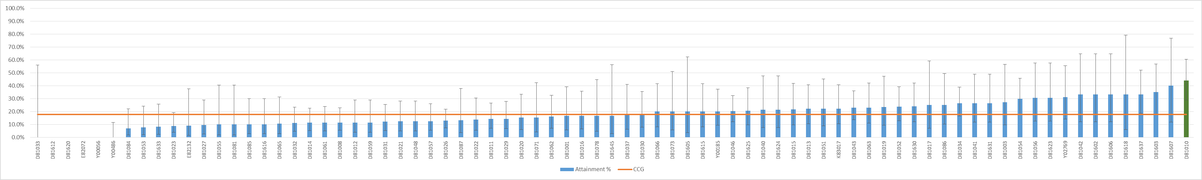
Practice Code | Name | LCG | Attainment %
Y00486 | BOTOLPH BRIDGE COMMUNITY HEALTH | PETERBOROUGH | 0.0%
D81010 | PRIORY FIELDS SURGERY | HUNTS HEALTH | 44.1%
 | CCG |  | 17.8%
Source: National Diabetes Audit, 2013/14 & 2014/15 http://www.hscic.gov.uk/nda
The only statistical significant GPs in comparison to the CCG for type 1 diabetes, all 3 treatment target attainment, 2014-15 are Botolph Bridge Community Health (Peterborough LCG, significantly worse than CCG due to 0.0% attainment) and Priory Fields Surgery (Hunts Health LCG, significantly better than CCG due to 44.1% attainment compared to CCG value of 17.8%). The distribution of attainment percentages across the CCG is relatively wide, with 18 GPs below 11.0% and 11 GPs above 30.0%.

Figure 15: Type 1 Diabetes, All 3 Treatment Targets 2014-15, LCG Overview, Ranked by Attainment %
LCG | LCG Attainment % | Participating Practices | Attainment % of Lowest Practice | Attainment % of Highest Practice | Practices in Quintile with Lowest Attainment % | Practices in Quintile with Highest Attainment %
CATCH | 21.5% | 21 | 0.0% | 40.0% | 5 | 8
HUNTS CARE PARTNERS | 19.8% | 9 | 9.5% | 35.0% | 1 | 3
HUNTS HEALTH | 19.3% | 7 | 8.3% | 44.1% | 3 | 2
CAM HEALTH | 17.9% | 5 | 0.0% | 25.0% | 2 | 0
ISLE OF ELY | 16.9% | 8 | 11.3% | 26.3% | 0 | 1
BORDERLINE | 16.5% | 8 | 7.7% | 24.1% | 1 | 0
PETERBOROUGH | 14.8% | 16 | 0.0% | 33.3% | 4 | 2
WISBECH | 14.5% | 3 | 11.5% | 21.7% | 0 | 0
CCG | 17.8% | 77 | 0.0% | 44.1% | 16 | 16
Source: National Diabetes Audit, 2014/15 http://www.hscic.gov.uk/nda
Attainment for this indicator is highest in the CATCH LCG (21.5%), which also has the most participating practices (21), followed by Hunts Care Partners (19.8%). Attainment is lowest in Wisbech (14.5%), which also has the lowest number of participating practices in 2014/15 (3), and Peterborough (14.8%).

11. Type 2 Diabetes, All 3 Treatment Targets 2014-15

Figure 16: Type 2 Diabetes, All 3 Treatment Targets 2014-15, General Practice Attainment & Statistically Significant General Practices
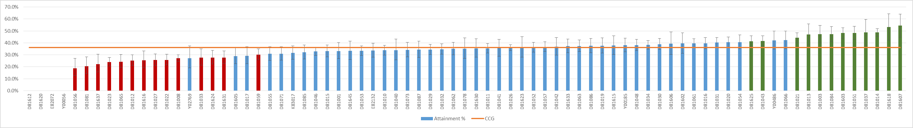
Practice Code | Name | LCG | Attainment %
D81056 | PETERSFIELD MEDICAL PRACTICE | CATCH | 18.8%
D81081 | GREAT STAUGHTON SURGERY | HUNTS HEALTH | 20.3%
D81637 | MONKFIELD MEDICAL PRACTICE | CATCH | 22.2%
D81023 | PASTON HEALTH CENTRE | PETERBOROUGH | 23.9%
D81065 | WELLAND MEDICAL PRACTICE | PETERBOROUGH | 24.2%
D81012 | CORNFORD HOUSE SURGERY | CATCH | 25.2%
D81616 | HODGSON MEDICAL CENTRE | PETERBOROUGH | 25.5%
D81027 | WELLSIDE SURGERY | HUNTS CARE PARTNERS | 25.6%
D81022 | THORNEY | BORDERLINE | 25.8%
D81008 | NORTH BRINK PRACTICE | WISBECH | 27.1%
D81033 | OVER SURGERY | CATCH | 27.6%
D81624 | DOGSTHORPE MEDICAL CENTRE | PETERBOROUGH | 27.7%
D81631 | MILLFIELD MEDICAL CENTRE | PETERBOROUGH | 27.7%
D81059 | RAMSEY HEALTH CENTRE | HUNTS CARE PARTNERS | 30.2%
D81625 | THISTLEMOOR MEDICAL CENTRE | PETERBOROUGH | 41.3%
D81043 | SAWSTON MEDICAL PRACTICE | CATCH | 41.6%
D81021 | ST GEORGE'S MEDICAL CENTRE | ISLE OF ELY | 44.2%
D81013 | TRUMPINGTON STREET MEDICAL PRACTICE | CATCH | 47.1%
D81003 | YORK STREET MEDICAL PRACTICE | CATCH | 47.2%
D81084 | WILLINGHAM MEDICAL PRACTICE | CATCH | 47.2%
D81603 | RIVERSIDE PRACTICE | HUNTS CARE PARTNERS | 48.2%
D81051 | BURWELL SURGERY | ISLE OF ELY | 48.4%
D81037 | BRIDGE STREET MEDICAL CENTRE | CAM HEALTH | 48.7%
D81014 | STAPLOE MEDICAL CENTRE | ISLE OF ELY | 48.7%
D81618 | AILSWORTH MEDICAL CENTRE | PETERBOROUGH | 53.3%
D81607 | SWAVESEY SURGERY | CATCH | 54.5%
 | CCG |  | 36.0%
Source: National Diabetes Audit, 2014/15 http://www.hscic.gov.uk/nda
26 GPs are statistically significant in comparison to the CCG for type 2 diabetes, all 3 treatment target attainment percentage, 2014-15. 14 practices are significantly worse than the CCG, of which 5 are in Peterborough LCG and 4 in CATCH LCG. 12 practices are significantly better than the CCG, the highest number of which are in CATCH LCG (5 practices) and Isle of Ely (3 practices).
Figure 17: Type 2 Diabetes, All 3 Treatment Targets 2014-15, LCG Overview, Ranked by Attainment %
LCG | LCG Attainment % | Participating Practices | Attainment % of Lowest Practice | Attainment % of Highest Practice | Practices in Quintile with Lowest Attainment % | Practices in Quintile with Highest Attainment %
ISLE OF ELY | 41.8% | 8 | 30.8% | 48.7% | 0 | 3
CAM HEALTH | 37.6% | 5 | 0.0% | 48.7% | 1 | 1
CATCH | 36.8% | 21 | 0.0% | 54.5% | 6 | 7
HUNTS CARE PARTNERS | 36.5% | 9 | 25.6% | 48.2% | 2 | 1
BORDERLINE | 34.8% | 8 | 25.8% | 40.5% | 1 | 1
PETERBOROUGH | 33.7% | 16 | 0.0% | 53.3% | 4 | 3
HUNTS HEALTH | 33.6% | 7 | 20.3% | 37.2% | 1 | 0
WISBECH | 30.8% | 3 | 27.1% | 35.4% | 1 | 0
CCG | 36.0% | 77 | 0.0% | 54.5% | 16 | 16
Source: National Diabetes Audit, 2014/15 http://www.hscic.gov.uk/nda
Attainment is highest in the Isle of Ely (41.8%) and Cam Health (37.6%) LCGs and lowest in the Wisbech (30.8%) and Hunts Health (33.6%) LCGs.
Report prepared by:
Ryan O’Neill
Advanced Public Health Analyst
Peterborough City Council
01733 207179, ryan.o’neill@peterborough.gov.uk

