

# Local Alcohol Profiles for England

# Summary for Cambridgeshire County Council & Peterborough City Council

# May 2018

## **Introduction**

The Local Alcohol Profiles for England[1] are produced by Public Health England and were updated in February 2018. They provide information for local government, health organisations, commissioners and other agencies to access the impact of alcohol on local communities and to assess the services and initiatives that have been put in place to prevent and reduce the harmful impact of alcohol.

Alcohol use has health and social consequences borne by individuals, their families, and the wider community.

Reducing harmful drinking is one of [seven priority areas](https://www.gov.uk/government/uploads/system/uploads/attachment_data/file/366852/PHE_Priorities.pdf) on which Public Health England is focusing efforts on securing improvement. The indicators contained within the web-tool were selected following consultation with stakeholders and a review of the availability of routine data. The Local Alcohol Profiles for England (LAPE) are part of a series of products by Public Health England that provide local data alongside national comparisons to support local health improvement.

Alcohol indicators are presented within the profiles that show how each area compares to the national average in order to highlight potential local issues. This report presents a summary of the key indicators and updates to provide a rapid overview for Cambridgeshire and Peterborough, and the Cambridgeshire districts.

For the purpose of this report, Cambridgeshire districts have been benchmarked against Cambridgeshire averages. Cambridgeshire and Peterborough local authorities and the Cambridgeshire and Peterborough Combined Authority have been benchmarked against England. Please see the key below.

|  |  |  |  |  |  |  |  |  |
| --- | --- | --- | --- | --- | --- | --- | --- | --- |
| Benchmark key: | | | | | | | | |
|  |  |  |  |  |  |  |  |  |
|  | Statistically significantly better than the Cambridgeshire/England average | | | | | | | |
|  | Statistically similar to the Cambridgeshire/England average | | | | | |  |  |
|  | Statistically significantly worse than the Cambridgeshire/England average | | | | | | | |

|  |
| --- |
| **The February 2018 update includes:** |
| Updated data for alcohol-related hospital admissions - statistical tables for England (formerly produced  by the Health and Social Care Information Centre - HSCIC) within the further resources section of the  Local Alcohol Profiles for England (LAPE). |
| **Restructure of Local Alcohol Profiles for England (LAPE) Fingertips profile** |
| Data, reports and documents that would have previously featured in the quarterly data, additional  data and reports and further information sections of LAPE can now be sourced within the  further resources section of LAPE. |
| **More recent data for 13 indicators:** |
| 5.02 Admission episodes for alcohol-specific conditions - Under 18s |
| 6.02 Admission episodes for alcohol-specific conditions |
| 9.01 Admission episodes for alcohol-related conditions (Broad) |
| 9.03 Admission episodes for alcohol-related cardiovascular disease conditions (Broad) |
| 9.04 Admission episodes for mental and behavioural disorders due to use of alcohol condition (Broad) |
| 9.05 Admission episodes for alcoholic liver disease condition (Broad) |
| 10.01 Admission episodes for alcohol-related conditions (Narrow) |
| 10.03 Admission episodes for alcohol-related unintentional injuries conditions (Narrow) |
| 10.04 Admission episodes for mental and behavioural disorders due to use of alcohol conditions (Narrow) |
| 10.05 Admission episodes for intentional self-poisoning by and exposure to alcohol condition (Narrow) |
| 10.06 Admission episodes for alcohol-related conditions (Narrow) - Under 40s |
| 10.07 Admission episodes for alcohol-related conditions (Narrow) - 40-64 years |
| 10.08 Admission episodes for alcohol-related conditions (Narrow) - Over 65s |
|  |
|  |
|  |
|  |
|  |
|  |
|  |
|  |
|  |
|  |
|  |
|  |
|  |
|  |
|  |

## **Hospital Admissions**

**Table 1: Hospital admissions for alcohol-specific conditions* - directly age-standardised rates (DASR) per 100,000 population for Cambridgeshire and Peterborough, 2016/17**



* Alcohol-specific conditions as primary or subsidiary cause of admission.

Data not available at combined authority level

Source: Calculated by Public Health England: Risk Factors Intelligence (RFI) team using data from NHS Digital - Hospital Episode Statistics (HES) and Office for National Statistics (ONS) - Mid Year Population Estimates.

**Figure 1: Hospital admissions for alcohol-specific conditions (persons) - directly age-standardised rates (DASR) per 100,000 population for Cambridge and Cambridgeshire, trend 2008/09 to 2016/17**

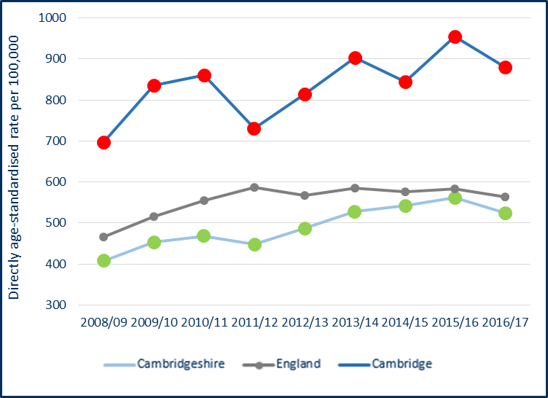



Source: Calculated by Public Health England: Risk Factors Intelligence (RFI) team using data from NHS Digital - Hospital Episode Statistics (HES) and Office for National Statistics (ONS) - Mid Year Population Estimates.

Key Points:

* The rates of **hospital admissions for alcohol-specific conditions** are statistically significantly lower than the England average in Cambridgeshire for persons and males.
* The rates of **hospital admissions for alcohol-specific conditions** are statistically significantly higher than the England and Cambridgeshire average in Cambridge for persons, males and females. The rates are also statistically significantly higher than the England rate in Fenland for men and women but these are not statistically significantly higher than the Cambridgeshire rate.
* The rate in Cambridge has been consistently above both the England and Cambridgeshire rates since 2008/09.

**Table 2: Hospital admission episodes for alcohol-specific conditions - Under 18s – crude rate per 100,000 population for Cambridgeshire and Peterborough, 2014/15 - 16/17**



*Aggregated from all known lower geography values

‘-' value suppressed for disclosure control reasons

Source: Calculated by Public Health England: Risk Factors Intelligence (RFI) team using data from NHS Digital - Hospital Episode Statistics (HES) and Office for National Statistics (ONS) - Mid Year Population Estimates.

Key Points:

* The crude, i.e. not age-standardised, rate of **hospital admissions for alcohol-specific conditions in under 18s** is statistically significantly higher than the England average among Cambridgeshire males.
* The rates of **hospital admissions for alcohol-specific conditions in under 18**s are statistically similar to the Cambridgeshire average in all districts for persons, males and females.
* When comparing the districts to England, the rates of **hospital admissions for alcohol-specific conditions in under 18s** in Cambridge and Huntingdonshire for persons and males are statistically significantly higher than England (not reflected in the shading of the table where the benchmark is the Cambridgeshire average).

**Table 3: Hospital admission episodes for alcohol-related conditions (broad definition)* - directly age-standardised rates (DASR) per 100,000 population for Cambridgeshire and Peterborough, 2016/17**



*Alcohol-related conditions as primary or subsidiary cause of admission. Broad measures are considered the best reflection of the burden of alcohol on the community and services.

Data not available at combined authority level

Source: Calculated by Public Health England: Risk Factors Intelligence (RFI) team using data from NHS Digital - Hospital Episode Statistics (HES) and Office for National Statistics (ONS) - Mid Year Population Estimates.

**Figure 2: Hospital admission episodes for alcohol-related conditions (narrow definition) (persons) - directly age-standardised rates (DASR) per 100,000 population for Cambridge, Fenland and Cambridgeshire, trend 2008/09 - 2016/17**

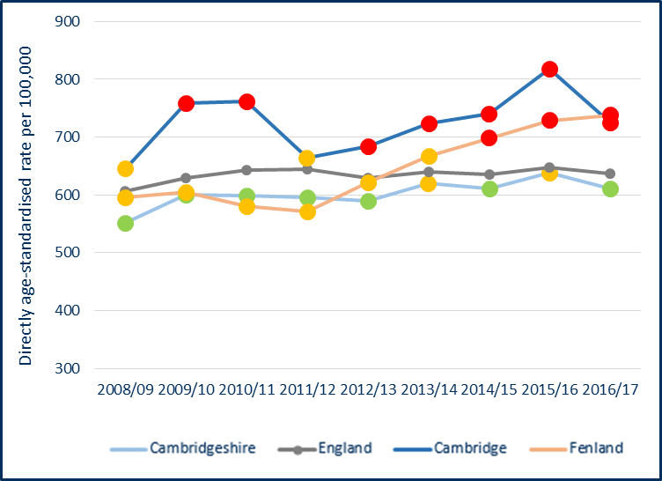



Source: Calculated by Public Health England: Risk Factors Intelligence (RFI) team using data from NHS Digital - Hospital Episode Statistics (HES) and Office for National Statistics (ONS) - Mid Year Population Estimates.

Key Points:

* The rates **of hospital admissions for alcohol-related conditions (broad definition)** are statistically significantly lower than the England average in Cambridgeshire for persons and males.
* The rates of **hospital admissions for alcohol-related conditions (broad definition)** are statistically significantly lower than the Cambridgeshire average in South Cambridgeshire persons and males and Huntingdonshire persons and females.
* The rates of **hospital admissions for alcohol-related conditions (broad definition)** are statistically significantly higher than the Cambridgeshire average in Cambridge and Fenland for persons, males and females. This picture is the same when these Districts are compared to England.
* The Cambridge rate of hospital admissions for **alcohol-related conditions (narrow definition)** has consistently been above Cambridgeshire and England since 2008/09. In Fenland the trend has been above Cambridgeshire and England since 2014/15.

**Table 4: Admission episodes for alcohol-related cardiovascular disease conditions (broad)* - directly age-standardised rates (DASR) per 100,000 population for Cambridgeshire and Peterborough, 2016/17**



*Alcohol-attributable cardiovascular conditions as primary or subsidiary cause of admission. Broad measures are considered the best reflection of the burden of alcohol on the community and services.

Data not available at combined authority level

Source: Calculated by Public Health England: Risk Factors Intelligence (RFI) team using data from NHS Digital - Hospital Episode Statistics (HES) and Office for National Statistics (ONS) - Mid Year Population Estimates.

Key Points:

* The rates of **hospital admissions for alcohol-related cardiovascular disease conditions (broad definition)** are statistically significantly higher than the England average in both Cambridgeshire and Peterborough for persons and males.
* The rates of **hospital admissions for alcohol-related cardiovascular disease conditions (broad definition)** are statistically significantly higher than the Cambridgeshire average in Fenland for persons and males and females. This picture is the same when Fenland is compared to England. Huntingdonshire males also have a statistically significantly higher rate of **hospital admissions for alcohol-related cardiovascular disease conditions (broad definition)** when compared to England (not reflected in the shading of the table where the benchmark is the Cambridgeshire average).

**Table 5: Hospital admission episodes for intentional self-poisoning by and exposure to alcohol condition (narrow)* - directly age-standardised rates (DASR) per 100,000 population for Cambridgeshire and Peterborough, 2016/17**



*Admissions to hospital where the secondary diagnoses is an alcohol-attributable intentional self-poisoning by and exposure to alcohol code.

Data not available at combined authority level

Source: Calculated by Public Health England: Risk Factors Intelligence (RFI) team using data from NHS Digital - Hospital Episode Statistics (HES) and Office for National Statistics (ONS) - Mid Year Population Estimates.

Key Points:

* The rates of **hospital admissions for intentional self-poisoning by and exposure to alcohol condition (narrow)** are statistically significantly higher than the England average in both Cambridgeshire and Peterborough for persons, males and females.
* The rates of **hospital admissions for intentional self-poisoning by and exposure to alcohol condition (narrow**) are statistically significantly higher than the Cambridgeshire average in Cambridge for persons and statistically significantly lower than the Cambridgeshire average in Huntingdonshire for persons and females.
* When compared to England both Cambridge and Fenland have statistically significantly higher rates for males and persons and Cambridge also for females along with South Cambridgeshire (not reflected in the shading of the table where the benchmark is the Cambridgeshire average).

**Table 6: Hospital admission episodes for mental and behavioural disorders due to use of alcohol condition (Broad)* - directly age-standardised rates (DASR) per 100,000 population for Cambridgeshire and Peterborough, 2016/17**



*Admissions to hospital where the primary diagnosis or any of the secondary diagnoses are an alcohol-attributable mental and behavioural disorders due to use of alcohol code. Broad measures are considered the best reflection of the burden of alcohol on the community and services.

Data not available at combined authority level

Source: Calculated by Public Health England: Risk Factors Intelligence (RFI) team using data from NHS Digital - Hospital Episode Statistics (HES) and Office for National Statistics (ONS) - Mid Year Population Estimates.

Key Points:

* The rates of **hospital admissions for mental and behavioural disorders due to use of alcohol condition (Broad)** are statistically significantly lower than the England average in both Cambridgeshire and Peterborough for persons and in Cambridgeshire males.
* The rates of **hospital admissions for mental and behavioural disorders due to use of alcohol condition (Broad)** are statistically significantly lower than the Cambridgeshire average in both East Cambridgeshire and Huntingdonshire for persons and males and Huntingdonshire females. Cambridge has statistically significantly higher rates of **hospital admissions for mental and behavioural disorders due to use of alcohol condition (Broad)** for persons, males and females when compared to Cambridgeshire.
* When compared to England, Cambridge also has statistically significantly higher rates for persons, males and females (not reflected in the shading of the table where the benchmark is the Cambridgeshire average).

**Table 7: Hospital admission episodes for alcoholic liver disease condition (Broad)* - directly age-standardised rates (DASR) per 100,000 population for Cambridgeshire and Peterborough, 2016/17**



*Admissions to hospital where the primary diagnosis or any of the secondary diagnoses are an alcohol-attributable alcoholic liver disease code.

Data not available at combined authority level

Source: Calculated by Public Health England: Risk Factors Intelligence (RFI) team using data from NHS Digital - Hospital Episode Statistics (HES) and Office for National Statistics (ONS) - Mid Year Population Estimates.

Key Points:

* The rates of **hospital admissions for alcoholic liver disease condition (Broad)** are statistically significantly higher than the England average in Cambridgeshire for persons, males and females and statistically significantly lower than England in Peterborough for persons, males and females.
* The rates of **hospital admissions for alcoholic liver disease condition (Broad**) are statistically significantly higher than the Cambridgeshire average in Cambridge for persons, males and females and East Cambridgeshire females and statistically significantly lower than Cambridgeshire average in Huntingdonshire and South Cambridgeshire persons and females.
* When compared to England, Cambridge also has statistically significantly higher rates for persons, males and females along with East Cambridgeshire and Fenland females (not reflected in the shading of the table where the benchmark is the Cambridgeshire average).

**Table 8: Hospital admission episodes for alcohol-related unintentional injuries conditions, (Narrow)* - directly age-standardised rates (DASR) per 100,000 population for Cambridgeshire and Peterborough, 2016/17**



* Admissions to hospital where the secondary diagnoses is an alcohol-attributable unintentional injuries code.

Data not available at combined authority level

Source: Calculated by Public Health England: Risk Factors Intelligence (RFI) team using data from NHS Digital - Hospital Episode Statistics (HES) and Office for National Statistics (ONS) - Mid Year Population Estimates.

Key Point

* The rates of **hospital admissions for alcohol-related unintentional injuries conditions (Narrow)** are statistically significantly lower than the England average in Cambridgeshire for persons and males.

## **Alcohol Treatment, Consumption and Other Impacts**

**Table 9: Successful completion of treatment for alcohol, Cambridgeshire and Peterborough, 2016**



Data not available at district or combined authority level

*Aggregated from all known lower geography values

CI – Confidence interval

Source: Calculated by Public Health England: Knowledge and Intelligence Team (North West) using data from the National Drug Treatment Monitoring System.

Key Point:

* The **% of alcohol users that left drug treatment successfully** are similar to the England average in both Cambridgeshire and Peterborough.

**Table 10: Drinking behaviours among adults 18+, Cambridgeshire and Peterborough, 2011-2014**



Data not available at district or combined authority level

Source: Public Health England Local Alcohol Profiles for England (Health Survey for England)

Key points:

* Overall, though not formally statistically assessed, the percentage of Cambridgeshire and Peterborough adults **who abstain from drinking alcoh**ol is lower (worse) than the England average; within both areas, **binge drinking** and **excess drinking levels** are similar to national averages.
* According to the Health Survey for England the percentage of Cambridgeshire adults who **abstain from drinking alcohol** is statistically significantly lower (worse) than the England average.
* In Peterborough for all indicators, drinking behaviour levels are similar to national averages.

**Table 11: Alcohol-related road traffic accidents, crude rate per 1,000 accidents, Cambridgeshire and Peterborough, 2013-15**



*Aggregated from all known lower geography values

CI – Confidence interval

Source: Calculated by Public Health England: Risk Factor Intelligence (RFI) team from STATS19 data provided by the Department of Transport.

Key points:

* The rate of **alcohol related road traffic accidents** is statistically significantly higher than the England average in Cambridgeshire. Although the Peterborough rate is higher than Cambridgeshire it is not statistically significantly higher than England. This is because the rate is based on numerically fewer road traffic accidents and hence the confidence interval (95% CI) used to calculate statistical significance is wider and overlaps the England levels.
* In Cambridge the rate of **alcohol related road traffic accidents** is statistically significantly lower than the Cambridgeshire rate.
* When compared to England, East Cambridgeshire, Huntingdonshire and South Cambridgeshire all have statistically significantly higher rates of **alcohol related road traffic accidents** (not reflected in the shading of the table where the benchmark is the Cambridgeshire average).
* It should be noted that this data largely represents those areas where there are greater numbers of road traffic accidents generally and not necessarily drinking behaviours by people living in those areas. Those areas with the greatest levels of motorised traffic have the most police recorded accidents and the people involved in those accidents may not be residents of the areas in which the accident occurs and may include people who live outside of Cambridgeshire and Peterborough but who are passing through.

**Table 12: Claimants of benefits due to alcoholism, crude rate per 100,000, Cambridgeshire and Peterborough, 2016**



**\***Aggregated from all known lower geography values

CI – Confidence interval

Source: Calculated by Public Health England: Risk Factors Intelligence (RFI) team using bespoke request data from Department for Work and Pensions and Office for National Statistics (ONS) - Mid Year Population Estimates

Key points:

* The rate of **claimants of benefits due to alcoholism** are statistically significantly lower than the England average in Cambridgeshire and Peterborough independently.
* In Cambridge the rate of **claimants of benefits due to alcoholism** is statistically significantly higher than the Cambridgeshire rate and the rate of **claimants of benefits due to alcoholism** in South Cambridgeshire is statistically significantly lower than the Cambridgeshire rate.
* When compared to England, all the districts have statistically significantly lower rates of **claimants of benefits due to alcoholism** (not reflected in the shading of the table where the benchmark is the Cambridgeshire average).

## **Mortality**

**Table 13: Alcohol-specific mortality (persons, males, females)* - directly age-standardised rates (DASR) per 100,000 population for Cambridgeshire and Peterborough, 2014 - 16**



*Deaths from alcohol-specific conditions (three years pooled) based on underlying cause of death registered in the calendar year for all ages. All causes of deaths from ethanol poisoning, methanol poisoning and the toxic effect of alcohol are now excluded from this indicator.

‘-‘ value cannot be calculated as number of cases is too small

Source: Calculated by Public Health England: Risk Factors Intelligence (RFI) team from the Office for National Statistics (ONS) Annual Death Extract Public Health Mortality File and ONS Mid-Year Population Estimates

Key points:

* **Alcohol-specific mortality rates** are statistically significantly lower than the England averages in Cambridgeshire and the Cambridgeshire and Peterborough Combined Authority. Rates in Peterborough are similar to national levels.
* The districts all have similar **alcohol-specific mortality rates** to the Cambridgeshire rate.
* When compared to England, East Cambridgeshire, Huntingdonshire and South Cambridgeshire have statistically significantly lower **alcohol-specific mortality rates** for persons,as do Huntingdonshire and South Cambridgeshire males (not reflected in the shading of the table where the benchmark is the Cambridgeshire average).

**Table 14: Alcohol-related mortality (persons, males, females)* - directly age-standardised rates (DASR) per 100,000 population for Cambridgeshire and Peterborough, 2016**



*Deaths from alcohol-related conditions based on underlying cause of death, registered in the calendar year for all ages. All causes of deaths from Ethanol poisoning, Methanol poisoning and Toxic effect of alcohol included.

‘-‘ value cannot be calculated as number of cases is too small

Source: Calculated by Public Health England: Risk Factors Intelligence (RFI) team from the Office for National Statistics (ONS) Annual Death Extract Public Health Mortality File and ONS Mid-Year Population Estimates

Key points:

* **Alcohol-related mortality rates are** statistically significantly lower than the England averages in Cambridgeshire and the Cambridgeshire and Peterborough Combined Authority. Rates in Peterborough are similar to national levels.
* The districts all have a similar **alcohol-related mortality rates** to the Cambridgeshire rates.
* When compared to England, Huntingdonshire and South Cambridgeshire have statistically significantly lower **alcohol-related mortality rates** for both persons and males (not reflected in the shading of the table where the benchmark is the Cambridgeshire average).

**Table 15: Years of life lost in adults aged <75 due to alcohol-related conditions (persons, males, females) - directly age-standardised rates (DASR) per 100,000 population for Cambridgeshire and Peterborough, 2016**



‘-‘ value cannot be calculated as number of cases is too small

Source: Public Health England Local Alcohol Profiles for England, Numerator: Analysis of Annual Mortality Extract from ONS by Public Health England Denominator: Mid-year population estimates published by ONS

Key points:

* Y**ears of life lost in adults aged <75 due to alcohol-related condition rate** are statistically significantly lower than the England averages in Cambridgeshire and the Cambridgeshire and Peterborough Combined Authority. Rates in Peterborough are similar to national levels.
* The districts all have similar **years of life lost in adults aged <75 due to alcohol-related conditions rate** to Cambridgeshire.
* When compared to England, East Cambridgeshire and Huntingdonshire both have statistically significantly lower rates of **years of life lost in adults aged <75 due to alcohol-related conditions rate** for persons and Huntingdonshire also has a statistically significantly lower rate of **years of life lost in adults aged <75 due to alcohol-related conditions rate** for males (not reflected in the shading of the table where the benchmark is the Cambridgeshire average).

Report prepared by:

Gen Fitzjohn

Public Health Information Analyst

Public Health Intelligence, Cambridgeshire and Peterborough Councils

[phi-team@peterborough.gov.uk](mailto:ryan.o'neill@peterborough.gov.uk)

1. https://fingertips.phe.org.uk/profile/local-alcohol-profiles