Innovators
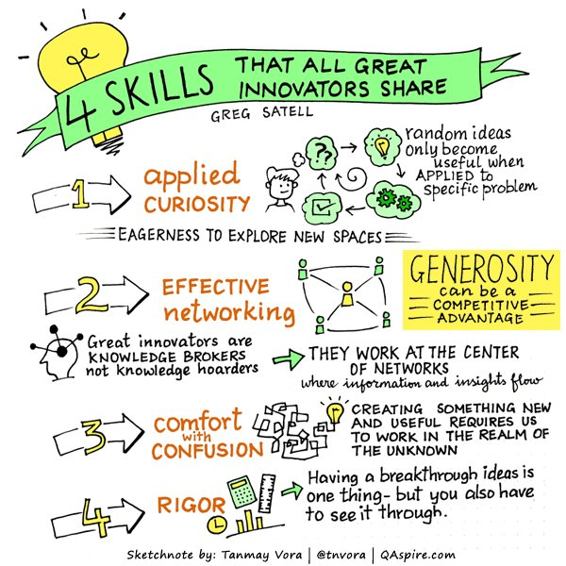
PEST analysis to use as a model
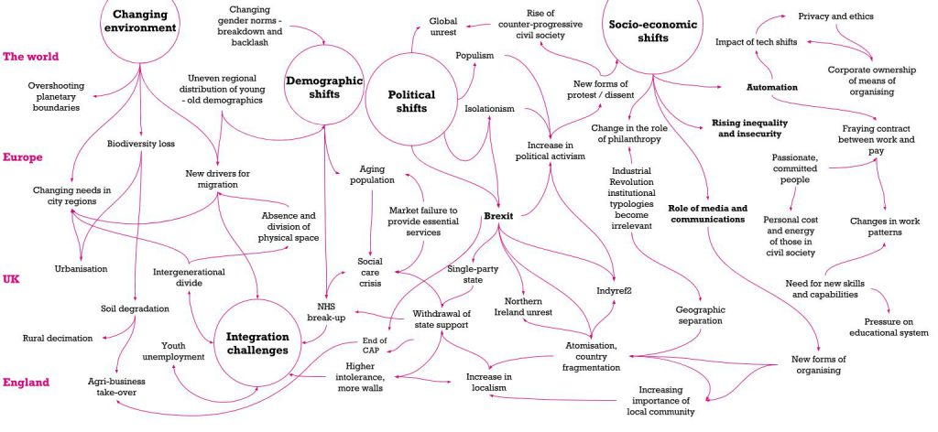
Place-making and healthy new communities
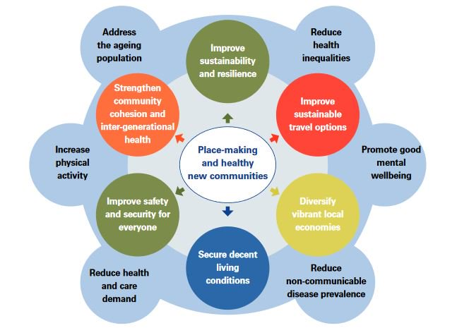
Our housing network
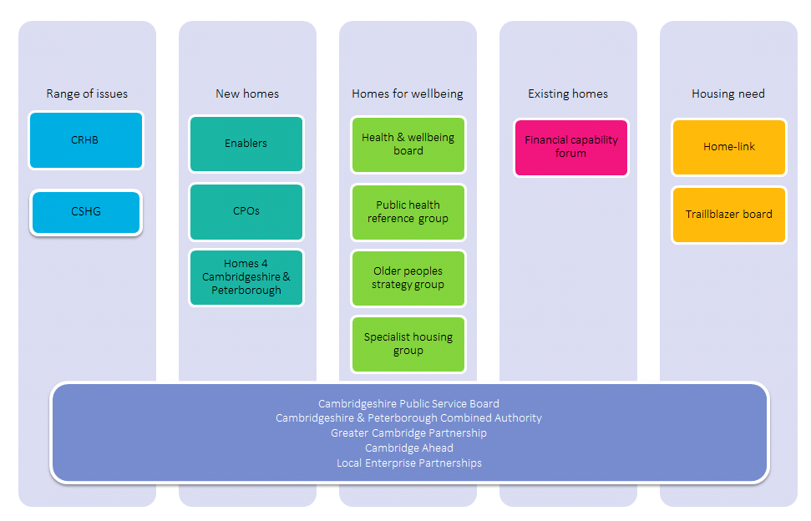

Housing priorities: working together
Housing is key to everyone’s health, wellbeing and employment opportunities. Good quality housing is also vital for a thriving local economy. Across Cambridge, East Cambridgeshire, Fenland, Huntingdonshire, South Cambridgeshire, Forest Heath and St Edmundsbury, the Cambridge sub-Regional Housing Board (CRHB) works with partners to share learning and experience to:
- Deliver new homes and communities to support economic success.
- Ensure homes and services support better health and wellbeing.
- Improve standards in existing homes and encourage best use of all homes.
- Identify and meet housing need, extend housing choice and tackle homelessness.
These are CRHB’s four priorities, all of which will only be achieved by working closely with our partners.
Many issues are very local and are best addressed by district councils, housing partners and communities themselves – but some are shared across a wider area and this is where collaboration can really help. Some partners have a role and a business plan which covers a broad area and cuts across district boundaries.
New homes and communities  - Building new homes: past delivery and planning for the future  - Our local housing market  - Housing affordability  - New homes, delivered new ways | Homes for wellbeing  - Links between housing and health  - Homes to support health and wellbeing  - Homes for older people and for people with disabilities  - Build standards and specialised housing
Existing homes  - It’s not all about new build: the importance of existing homes  - What do we know about the condition of our housing stock?  - Fuel poverty and older homes  - Building Better Opportunities and Work Routes | Housing need  - How housing partners work to identify and meet housing need  - Home-Link helping people access affordable housing  - Help to Buy for low cost home ownership  - When the system fails: homelessness and our homelessness trailblazer  - Housing against domestic violence.

